https://www.edureka.co/blog/interview-questions/top-node-js-interview-questions-2016/

1. What is Node.js?
Wikipedia defines Node.js as “an open-source, cross-platform runtime environment for developing server-side Web applications.” It is essentially server side scripting which is used to build scalable programs.
Node.js is a run-time JavaScript environment built on top of Chrome’s V8 engine. It uses an event-driven, non-blocking I/O model. It is lightweight and so efficient. Node.js has a package ecosystem called npm.
Node.js can be used to build different types of applications such as web application, real-time chat application, REST API server etc. However, it is mainly used to build network programs like web servers, similar to PHP, Java, or ASP.NET. Node.js was developed by Ryan Dahl in 2009.

2. What is the relation of Node.js with JavaScript?
Though Node.js is not a JavaScript framework,[3] many of its modules are written in JavaScript, allowing developers to create new modules in JavaScript. Node.js is a virtual machine that leverages JavaScript as its scripting language to achieve high output.

3. What is the fundamental difference between Node.js and Ajax?
While Ajax is a client-side technology, Node.js is a server-side JavaScript environment.

4. Explain the term I/O in the context of Node.js.
I/O stands for input and output. It is used to access anything outside of the application. I/O gets loaded on to the machine memory in order to run programs after the application is fired up.
https://medium.com/@vigowebs/frequently-asked-node-js-interview-questions-and-answers-b74fa1f20678
Q. What is the purpose of module.exports in Node.js?
A module encapsulates related code into a single unit of code. This can be interpreted as moving all related functions into a file. Imagine that we created a file called greetings.js and it contains the following two functions:
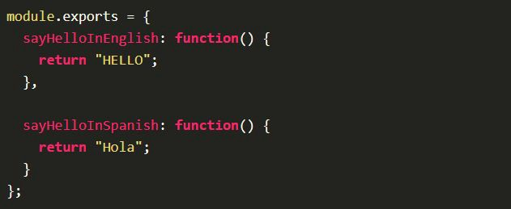
In the above code, module.exports exposes two functions to the outer world. We can import them in another file as follow:
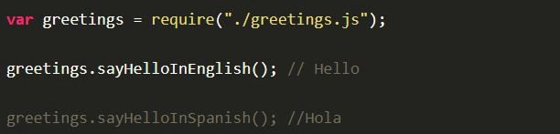
Q6. What is the difference between Asynchronous and Non-blocking?
Asynchronous literally means not synchronous. We are making HTTP requests which are asynchronous, means we are not waiting for the server response. We continue with other block and respond to the server response when we received.
The term Non-Blocking is widely used with IO. For example non-blocking read/write calls return with whatever they can do and expect caller to execute the call again. Read will wait until it has some data and put calling thread to sleep.
Q7. What is Tracing in Node.js?
Tracing provides a mechanism to collect tracing information generated by V8, Node core and userspace code in a log file. Tracing can be enabled by passing the --trace-events-enabled flag when starting a Node.js application.
The set of categories for which traces are recorded can be specified using the --trace-event-categories flag followed by a list of comma separated category names. By default the node and v8 categories are enabled.
Running Node.js with tracing enabled will produce log files that can be opened in the chrome://tracing tab of Chrome.
Q8. How will you debug an application in Node.js?
Node.js includes a debugging utility called debugger. To enable it start the Node.js with the debug argument followed by the path to the script to debug.
Inserting the statement debugger; into the source code of a script will enable a breakpoint at that position in the code:
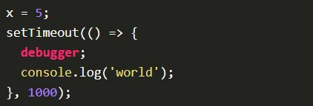
Q9. Difference between setImmediate() vs setTimeout()
setImmediate() and setTimeout() are similar, but behave in different ways depending on when they are called.
- setImmediate() is designed to execute a script once the current poll (event loop) phase completes.
- setTimeout() schedules a script to be run after a minimum threshold in ms has elapsed.
The order in which the timers are executed will vary depending on the context in which they are called. If both are called from within the main module, then timing will be bound by the performance of the process.
Q10. What is process.nextTick()
setImmediate() and setTimeout() are based on the event loop. But process.nextTick() technically not part of the event loop. Instead, the nextTickQueue will be processed after the current operation completes, regardless of the current phase of the event loop.
Thus, any time you call process.nextTick() in a given phase, all callbacks passed to process.nextTick() will be resolved before the event loop continues.
Q11. What is package.json? What is it used for?
This file holds various metadata information about the project. This file is used to give information to npm that allows it to identify the project as well as handle the project's dependencies.
Some of the fields are: name, name, description, author and dependencies.
When someone installs our project through npm, all the dependencies listed will be installed as well. Additionally, if someone runs npm install in the root directory of our project, it will install all the dependencies to ./node_modules directory.
Q12. What is libuv?
libuv is a multi-platform support library with a focus on asynchronous I/O. It was primarily developed for use by Node.js, but it’s also used by Luvit, Julia, pyuv, and others.
When the node.js project began in 2009 as a JavaScript environment decoupled from the browser, it is using Google’s V8 and Marc Lehmann’s libev, node.js combined a model of I/O – evented – with a language that was well suited to the style of programming; due to the way it had been shaped by browsers. As node.js grew in popularity, it was important to make it work on Windows, but libev ran only on Unix. libuv was an abstraction around libev or IOCP depending on the platform, providing users an API based on libev. In the node-v0.9.0 version of libuv libev was removed.
Some of the features of libuv are:
- Full-featured event loop backed by epoll, kqueue, IOCP, event ports.
- Asynchronous TCP and UDP sockets
- Asynchronous file and file system operations
- Child processes
- File system events
Q13. What are some of the most popular modules of Node.js?
There are many most popular, most starred or most downloaded modules in Node.js. Some of them are:
- express
- async
- browserify
- socket.io
- bower
- gulp
- grunt
Q14. What is EventEmitter in Node.js?
All objects that emit events are instances of the EventEmitter class. These objects expose an eventEmitter.on() function that allows one or more functions to be attached to named events emitted by the object.
When the EventEmitter object emits an event, all of the functions attached to that specific event are called synchronously.
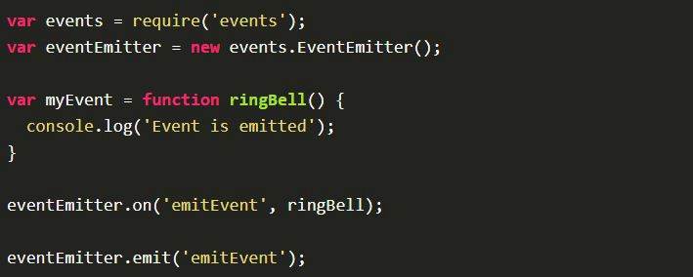
Q15. What is Streams in Node.js?
Streams are pipes that let you easily read data from a source and pipe it to a destination. Simply put, a stream is nothing but an EventEmitter and implements some specials methods. Depending on the methods implemented, a stream becomes Readable, Writable, or Duplex (both readable and writable).
For example, if we want to read data from a file, the best way to do it from a stream is to listen to data event and attach a callback. When a chunk of data is available, the readable stream emits a data event and your callback executes. Take a look at the following snippet:
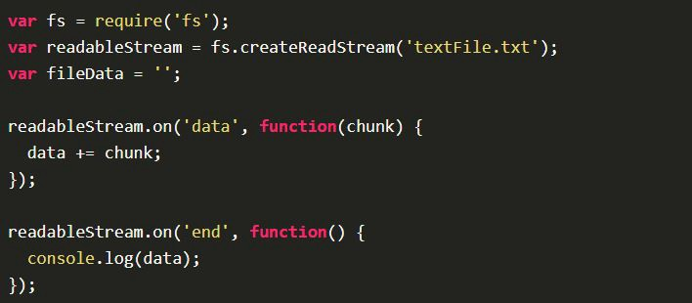
Types of streams are: Readable, Writable, Duplex and Transform.

5. State where Node.js can be used.
- Web apps
- Network applications
- Distributed systems
- General purpose applications

6. Which are the two types of API functions in Node.js?
Asynchronous, non-blocking functions and Synchronous, blocking functions.

7. List the tools and IDEs that are used for Node.js.
- Atom
- Nodeclipse Enide Studio
- JetBrains WebStorm
- JetBrains InteliJ IDEA
- MS Visual Studio
- NoFLo

8. Explain the role of the Callback function in Node.js.
In Node.js, the Callback function is used to cater to multiple requests made to the server. If there is a large file that is expected to take the server a long time to process, the Callback function can be invoked to ensure that other requests to the server are uninterrupted.

9. What is an error-first callback?
Error-first callbacks are used to pass errors and data as well. You have to pass the error as the first parameter, and it has to be checked to see if something went wrong. Additional arguments are used to pass data.
fs.readFile(filePath, function(err, data) {
if (err) {
// handle the error, the return is important here
// so execution stops here
return console.log(err)
}
// use the data object
console.log(data)
})

10. In the context of Node.js, differentiate between operational and programmer errors.
Operational errors are not real errors. They are system errors, for example “request timeout” or “hardware error”. Programmer errors are actual bugs in the code.

11. Which is the framework that is most commonly used in Node.js?
The most commonly used Node.js framework is “Express”.

12. Define “event-driven programming.
It is essentially a programming paradigm where the program flow is characterized by events such as messages from other programs.
Event-driven programming is building our application based on and respond to events. When an event occurs, like click or keypress, we are running a callback function which is registered to the element for that event.
Event driven programming follows mainly a publish-subscribe pattern.

13. What are the two sections of event-driven programming?
Event Selection and Event Handling are two sections of event-driven programming.

14. List some of the big advantages of using Node.js.
- Ability to build scalable programs
- Increased concurrency
- Asynchronous capabilities

15. Explain the Control Flow function.
It is a generic piece of code that runs concurrently between several asynchronous function calls.

16. List the steps involved in the Control Flow function.
Control the order of execution à Collect data à Limit concurrency à Call the next program step

17. Can a user access DOM in a Node?
No, you cannot access DOM.

Q3. What is Event loop in Node.js work? And How does it work?
The Event loop handles all async callbacks. Node.js (or JavaScript) is a single-threaded, event-driven language. This means that we can attach listeners to events, and when a said event fires, the listener executes the callback we provided.
Whenever we are call setTimeout, http.get and fs.readFile, Node.js runs this operations and further conitnue to run other code without waiting for the output. When the operation is finished, it receives the output and runs our callback function.
So all the callback functions are queued in an loop, and will run one-by-one when the response has been received.

18. In Node.js, how do you access the last expression?
We have to use the underscore (_) character to access the last expression.
ex. _ symbol returns the result of the last logged expression in REPL node console:
> 2 * 2
4
> _
4

19. In Node.js, which command is used to import external libraries?
A command called “require” is used for importing external libraries.

20. What is the biggest drawback of Node.js?
The biggest drawback is the fact that it is challenging to have one process with a single thread to scale up on multi core servers.
1. What is Node.js? Where can you use it?
Node.js is a server side scripting based on Google’s V8 JavaScript engine. It is used to build scalable programs especially web applications that are computationally simple but are frequently accessed.
You can use Node.js in developing I/O intensive web applications like video streaming sites. You can also use it for developing: Real-time web applications, Network applications, General-purpose applications and Distributed systems.

2. Why use Node.js?
Node.js makes building scalable network programs easy. Some of its advantages include:
It is generally fast
It almost never blocks
It offers a unified programming language and data type
Everything is asynchronous
It yields great concurrency

3. What are the features of Node.js?
Node.js is a single-threaded but highly scalable system that utilizes JavaScript as its scripting language. It uses asynchronous, event-driven I/O instead of separate processes or threads. It is able to achieve high output via single-threaded event loop and non-blocking I/O.

4. How else can the JavaScript code below be written using Node.Js to produce the same output?
console.log("first");
setTimeout(function() {
console.log("second");
}, 0);
console.log("third");
Output:
first
third
second
In Node.js version 0.10 or higher, setImmediate(fn) will be used in place of setTimeout(fn,0) since it is faster. As such, the code can be written as follows:
console.log("first");
setImmediate(function(){
console.log("second");
});
console.log("third");

5. How do you update NPM to a new version in Node.js?
You use the following commands to update NPM to a new version:
$ sudo npm install npm -g
/usr/bin/npm -> /usr/lib/node_modules/npm/bin/npm-cli.js
npm@2.7.1 /usr/lib/node_modules/npm

6. Why is Node.js Single-threaded?
Node.js is single-threaded for async processing. By doing async processing on a single-thread under typical web loads, more performance and scalability can be achieved as opposed to the typical thread-based implementation.

7. Explain callback in Node.js.
A callback function is called at the completion of a given task. This allows other code to be run in the meantime and prevents any blocking. Being an asynchronous platform, Node.js heavily relies on callback. All APIs of Node are written to support callbacks.

8. What is callback hell in Node.js?
Callback hell is the result of heavily nested callbacks that make the code not only unreadable but also difficult to maintain. For example:
query("SELECT clientId FROM clients WHERE clientName='picanteverde';", function(id){
query("SELECT * FROM transactions WHERE clientId=" + id, function(transactions){
transactions.each(function(transac){
query("UPDATE transactions SET value = " + (transac.value*0.1) + " WHERE id=" + transac.id, function(error){
if(!error){
console.log("success!!");
}else{
console.log("error");
}
});
});
});
});

9. How do you prevent/fix callback hell?
The three ways to prevent/fix callback hell are:
- Handle every single error
- Keep your code shallow
- Modularize – split the callbacks into smaller, independent functions that can be called with some parameters then joining them to achieve desired results.
The first level of improving the code above might be:
var logError = function(error){
if(!error){
console.log("success!!");
}else{
console.log("error");
}
},
updateTransaction = function(t){
query("UPDATE transactions SET value = " + (t.value*0.1) + " WHERE id=" + t.id, logError);
},
handleTransactions = function(transactions){
transactions.each(updateTransaction);
},
handleClient = function(id){
query("SELECT * FROM transactions WHERE clientId=" + id, handleTransactions);
};
query("SELECT clientId FROM clients WHERE clientName='picanteverde';",handleClient);
You can also use Promises, Generators and Async functions to fix callback hell.

10. Explain the role of REPL in Node.js.
As the name suggests, REPL (Read Eval print Loop) performs the tasks of – Read, Evaluate, Print and Loop. The REPL in Node.js is used to execute ad-hoc Javascript statements. The REPL shell allows entry to javascript directly into a shell prompt and evaluates the results. For the purpose of testing, debugging, or experimenting, REPL is very critical.
It is a virtual environment that comes with Node.js. We can quickly test our JavaScript code in the Node.js REPL environment.
To launch the REPL in Node.js, just opne the command prompt and type node. It will change the prompt to > in Windows and MAC.
Now we can type and run our JavaScript easily. For example, if we type 10 + 20, it will print 30 in the next line.

11. Name the types of API functions in Node.js.
There are two types of functions in Node.js.:
- Blocking functions - In a blocking operation, all other code is blocked from executing until an I/O event that is being waited on occurs. Blocking functions execute synchronously
For example:
const fs = require('fs');
const data = fs.readFileSync('/file.md'); // blocks here until file is read
console.log(data);
// moreWork(); will run after console.log
The second line of code blocks the execution of additional JavaScript until the entire file is read. moreWork () will only be called after Console.log
- Non-blocking functions - In a non-blocking operation, multiple I/O calls can be performed without the execution of the program being halted. Non-blocking functions execute asynchronously.
For example:
const fs = require('fs');
fs.readFile('/file.md', (err, data) => {
if (err) throw err;
console.log(data);
});
// moreWork(); will run before console.log
Since fs.readFile () is non-blocking, moreWork () does not have to wait for the file read to complete before being called. This allows for higher throughput.

12. Which is the first argument typically passed to a Node.js callback handler?
Typically, the first argument to any callback handler is an optional error object. The argument is null or undefined if there is no error.
Error handling by a typical callback handler could be as follows:
function callback(err, results) {
// usually we'll check for the error before handling results
if(err) {
// handle error somehow and return
}
// no error, perform standard callback handling
}

13. What are the functionalities of NPM in Node.js?
NPM (Node package Manager) provides two functionalities:
- Online repository for Node.js packages
- Command line utility for installing packages, version management and dependency management of Node.js packages

14. What is the difference between Node.js and Ajax?
Node.js and Ajax (Asynchronous JavaScript and XML) are the advanced implementation of JavaScript. They all serve completely different purposes.
Ajax is primarily designed for dynamically updating a particular section of a page’s content, without having to update the entire page.
Node.js is used for developing client-server applications.

15. Explain chaining in Node.js.
Chaining is a mechanism whereby the output of one stream is connected to another stream creating a chain of multiple stream operations.

16. What are “streams” in Node.js? Explain the different types of streams present in Node.js.
Streams are objects that allow reading of data from the source and writing of data to the destination as a continuous process.
There are four types of streams.
- to facilitate the reading operation

17. What are exit codes in Node.js? List some exit codes.
Exit codes are specific codes that are used to end a “process” (a global object used to represent a node process).
Examples of exit codes include:
- Unused
- Uncaught Fatal Exception
- Fatal Error
- Non-function Internal Exception Handler
- Internal Exception handler Run-Time Failure
- Internal JavaScript Evaluation Failure

18. What are Globals in Node.js?
Three keywords in Node.js constitute as Globals. These are:
- Global – it represents the Global namespace object and acts as a container for all other
- Process – It is one of the global objects but can turn a synchronous function into an async callback. It can be accessed from anywhere in the code and it primarily gives back information about the application or the environment.
- Buffer – it is a class in Node.js to handle binary data.

19. What is the difference between AngularJS and Node.js?
Angular.JS is a web application development framework while Node.js is a runtime system.

20. Why is consistent style important and what tools can be used to assure it?
Consistent style helps team members modify projects easily without having to get used to a new style every time. Tools that can help include Standard and ESLint

How can you avoid callback hells?
There are lots of ways to solve the issue of callback hells:
- modularization: break callbacks into independent functions
- use a control flow library, like async
- use generators with Promises
- use async/await (note that it is only available in the latest v7 release and not in

What are Promises?
Promises are a concurrency primitive, first described in the 80s. Now they are part of most modern programming languages to make your life easier. Promises can help you better handle async operations.
An example can be the following snippet, which after 100ms prints out the result string to the standard output. Also, note the catch, which can be used for error handling. Promises are chainable.
new Promise((resolve, reject) => {
setTimeout(() => {
resolve('result')
}, 100)
})
.then(console.log)
.catch(console.error)

What's a stub? Name a use case!
Stubs are functions/programs that simulate the behaviors of components/modules. Stubs provide canned answers to function calls made during test cases.

Q. When are background/worker processes useful? How can you handle worker tasks?
Worker processes are extremely useful if you'd like to do data processing in the background, like sending out emails or processing images.
There are lots of options for this like RabbitMQ or Kafka.

Q. How can you secure your HTTP cookies against XSS attacks?
XSS occurs when the attacker injects executable JavaScript code into the HTML response.
To mitigate(reduce) these attacks, you have to set flags on the set-cookie HTTP header:
- HttpOnly - this attribute is used to help prevent attacks such as cross-site scripting since it does not allow the cookie to be accessed via JavaScript.
- secure - this attribute tells the browser to only send the cookie if the request is being sent over HTTPS.
So it would look something like this: Set-Cookie: sid=<cookie-value>; HttpOnly. If you are using Express, with express-cookie session, it is working by default.

What's a test pyramid? Give an example!
A test pyramid describes the ratio of how many unit tests, integration tests and end-to-end test you should write.
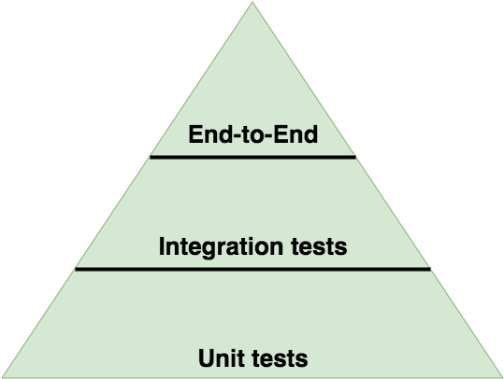

Q. How can you make sure your dependencies are safe?
When writing Node.js applications, ending up with hundreds or even thousands of dependencies can easily happen.
For example, if you depend on Express, you depend on 27 other modules directly, and of course on those dependencies' as well, so manually checking all of them is not an option!
The only option is to automate the update / security audit of your dependencies. For that there are free and paid options:
- npm outdated
- Trace by RisingStack
- NSP
- GreenKeeper
- Snyk

