Predicting Astronomical Seeing at ESO Paranal Observatory
Using Real Multi-Instrument Site Monitoring Data
A Machine Learning Case Study — Regression on Real-World Atmospheric Sensor Data

1. Executive Summary
This project builds a supervised regression model that predicts astronomical seeing — a measure of atmospheric turbulence that directly limits telescope image quality — at the European Southern Observatory's Paranal site in Chile. Rather than relying on generic weather-forecast APIs, the model is trained entirely on real, site-specific instrument records spanning April 2016 to July 2026: a Differential Image Motion Monitor (DIMM) for ground-truth seeing, a microwave radiometer (LHATPRO) for atmospheric water vapour and sky temperature, and a 30 m meteorological tower.
Several model families were evaluated — linear regression, ridge regression, polynomial regression, random forest, a deep neural network, and gradient-boosted trees (XGBoost) — with systematic hyperparameter optimisation (Optuna) and a leakage-free, chronologically held-out evaluation protocol. The best-performing model, XGBoost with Optuna-tuned hyperparameters and iteratively engineered features, reaches R² = 0.696 on a strict 1.5-year future hold-out period, a result consistent with published astroclimate-forecasting literature given the inherent stochasticity of atmospheric turbulence. An ensemble of XGBoost and the neural network was also tested but provided a negligible, within-noise improvement (R² = 0.699 at best) and was not adopted, in favour of the simpler single-model solution.

2. Motivation & Objective
Astronomical “seeing” quantifies the blurring of star images caused by atmospheric turbulence and directly determines the effective resolution achievable by a ground-based telescope on a given night. Reliable estimation of seeing from measurable atmospheric conditions is valuable for observatory operations planning, scientific site characterisation, and — as a longer-term goal of this project — as a decision-support tool for astronomers, complementary to an observatory's own instrumental seeing measurements.
This phase of the project set out to establish how much of the night-to-night and hour-to-hour variability in real, measured seeing can be explained by a data-driven model trained purely on historical instrument records from a single, well-instrumented site, and to identify which atmospheric variables carry genuine predictive signal.

3. Data Sources
All data were obtained from the public ESO Science Archive (archive.eso.org) for Paranal Observatory (24.6272°S, 70.4039°W, 2635 m a.s.l.), April 2016 – July 2026.
Instrument | Measures | Native resolution | Role
DIMM | Seeing (arcsec), Airmass | ~1–2 min | Target variable
LHATPRO | IR sky temperature, liquid water path, precipitable water vapour | ~1–2 min | Feature source
Meteo tower (30 m) | Temperature, wind (incl. vertical component), pressure, rain | ~1 min | Feature source

A fourth instrument, MASS (which separately measures free-atmosphere turbulence), was deliberately excluded from the feature set: its outputs are themselves real-time turbulence measurements co-derived with DIMM seeing, so including them as predictors would constitute target leakage rather than genuine forecasting signal.

4. Methodology

4.1 Temporal Alignment
Each instrument logs at a different, irregular native cadence. All sources were independently aggregated to hourly statistics (circular mean for wind direction; standard deviation, not mean, for vertical wind speed) and inner-joined on the shared hourly timestamp, guaranteeing exact temporal alignment. This produced 36,706 hourly real-world observations.

4.2 Feature Engineering
The final feature set (23 variables) was built iteratively, guided by permutation feature importance after each addition:
- Near-surface stability: temperature at 2 m / 30 m / ground level, and the ground–30 m gradient
- Turbulence proxy: standard deviation of vertical wind speed within each hour
- Wind shear: difference between 10 m and 30 m wind speed
- Circular encoding of wind direction as sine/cosine pairs (raw compass degrees are discontinuous at 0°/360° and mislead both tree-based and neural models)
- Short-term temporal context: 3-hour rolling means and 3-hour trends (current minus 3-hours-ago) for temperature, wind speed, vertical-wind turbulence, and pressure — turbulence responds to recent atmospheric change, not only the instantaneous state
- Moisture state: dew-point depression, precipitable water vapour
- Airmass, a fully deterministic geometric quantity known in advance for any pointing and time
A composite Richardson-number-style ratio of thermal stability to squared wind shear was also tested but contributed negligible additional signal once the individual gradient and shear terms were already present, and was not retained.

4.3 Correcting Target Imbalance
The seeing distribution is heavily right-skewed: roughly 92% of hourly observations fall between 0.5″ and 1.5″, while fewer than 0.3% exceed 3″. Training directly on raw seeing caused early models to collapse toward the population mean, under-representing the operationally important poor-seeing tail. This was corrected by training on log(1+seeing) and inverse-transforming predictions at evaluation time.

4.4 Train / Validation / Test Split
An initial random split allowed adjacent hours from the same night into different partitions — a subtle leakage source, since consecutive hours are highly autocorrelated. The final protocol partitions data into weekly blocks, assigning whole blocks to train/validation/test, with the most recent 15% of weeks (February 2025 – July 2026) held out as a strict, never-seen-during-training-or-tuning chronological test set.

4.5 Models Evaluated
Linear regression, ridge regression, polynomial regression, and random forest were evaluated as baselines; all were clearly outperformed by non-linear ensemble/neural approaches, consistent with the expectation that seeing depends non-linearly on the input variables. The two competitive models were:
- Deep neural network: Dense(48)→Dropout(0.3)→Dense(24)→Dropout(0.3)→Dense(8)→Dense(1), L2-regularised, trained with Adam and early stopping.
- XGBoost: hyperparameters (tree depth, learning rate, number of estimators, subsampling, column sampling, min child weight, L1/L2 regularisation, gamma) tuned via a 9-parameter Optuna search evaluated on the validation block set, with early stopping against the same validation set.
An ensemble (weighted average of XGBoost and DNN predictions) was also tested across a full weight sweep (0–2× XGBoost weight). The best ensemble point (0.8×XGBoost + 0.2×DNN) reached R² = 0.6988, only 0.0025 above XGBoost alone (0.6963) — within the noise level of this evaluation. Given the negligible gain relative to the added complexity of maintaining two models in production, XGBoost alone was retained as the final model.

5. Results
Model | R² (test) | MAE (arcsec) | RMSE (arcsec)
Linear / Ridge / Polynomial regression | < 0.10 | — | —
Random forest | ~ 0.45 | — | —
Deep neural network | 0.674 | 0.167 | 0.234
XGBoost (Optuna-tuned + engineered features) — final model | 0.696 | 0.160 | 0.225

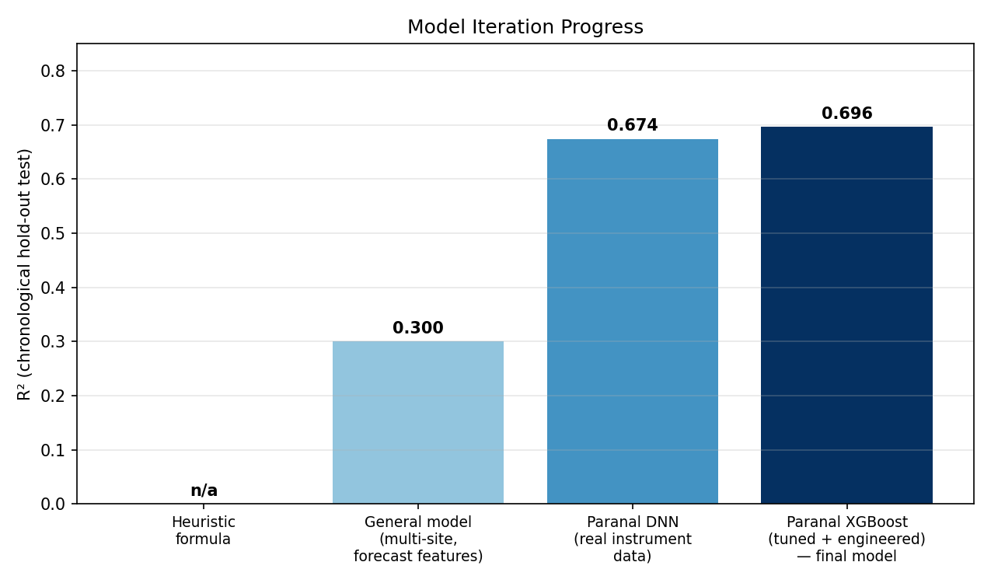
Figure 1. R² across successive iterations of the project, from an unvalidated heuristic through to the final tuned XGBoost model on real Paranal instrument data.
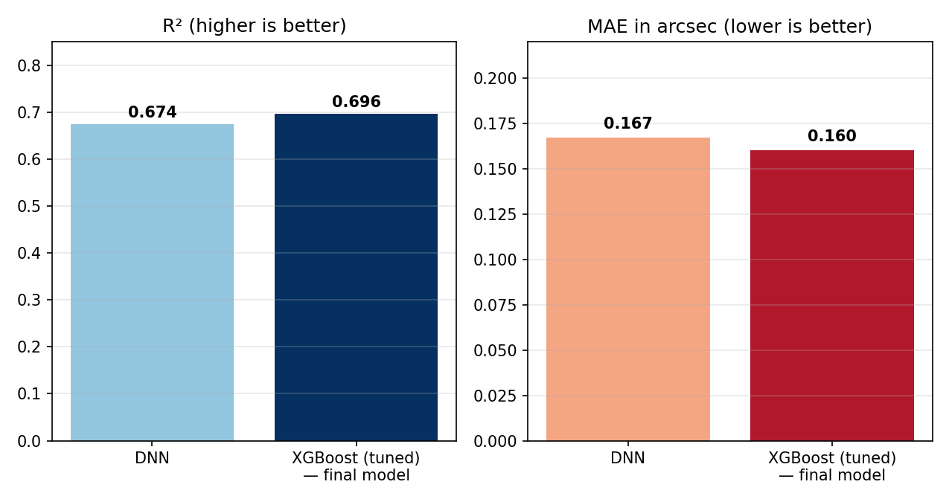
Figure 2. Final comparison of the two competitive model families.
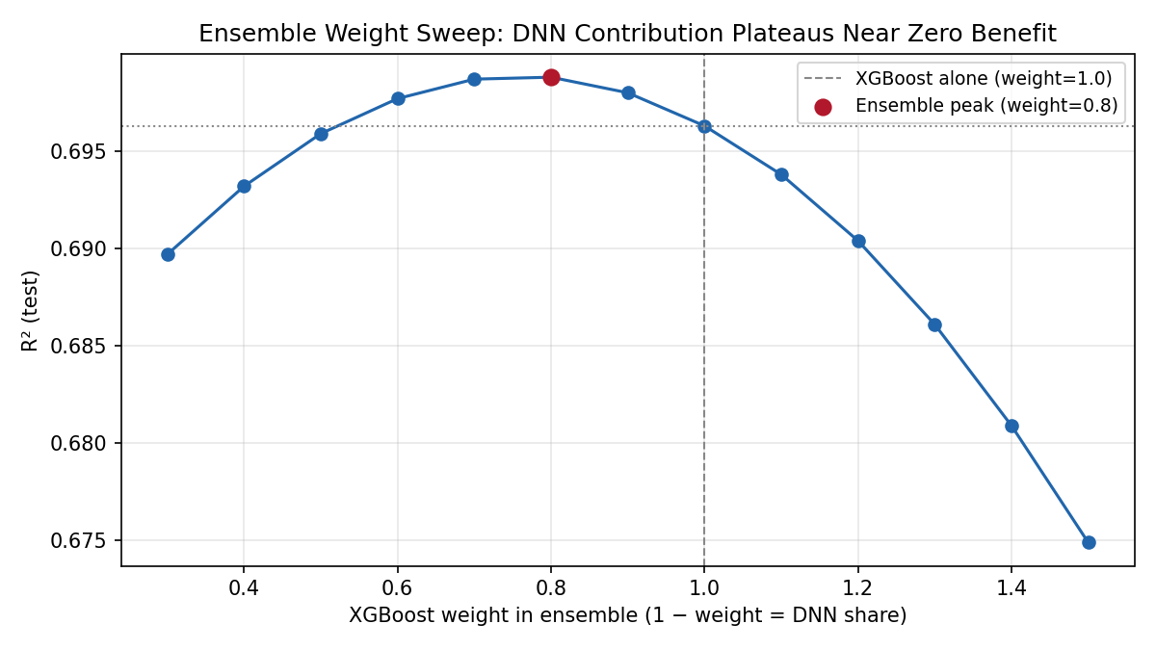
Figure 3. Ensemble weight sweep between XGBoost and DNN predictions. The best blend (80% XGBoost) improves R² by only 0.0025 over XGBoost alone — a negligible, within-noise difference that did not justify adopting a two-model ensemble in production.

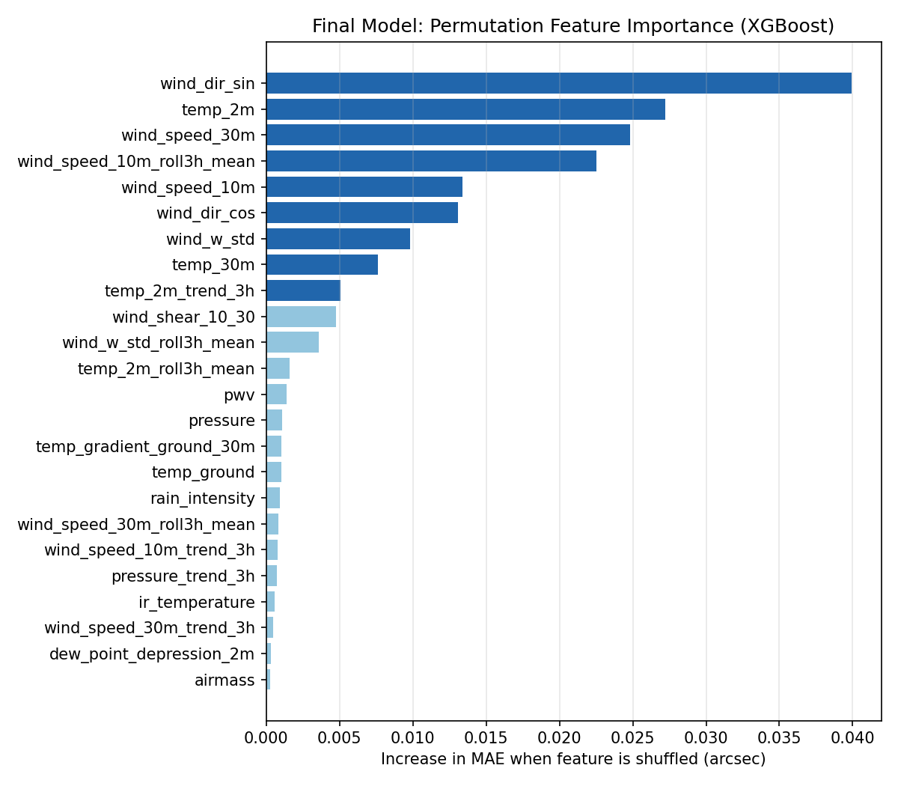
Figure 5. Permutation feature importance for the final XGBoost model. Wind direction, near-surface temperature, and horizontal wind speed dominate; the engineered 3-hour rolling wind feature ranks fourth, confirming that recent atmospheric trend carries genuine additional signal beyond the instantaneous state.

6. Key Findings
- Wind direction (as sine/cosine) and near-surface temperature are the strongest predictors, consistent with their role in the local mesoscale flow and surface heat-flux-driven turbulence.
- A 3-hour rolling mean of 10 m wind speed materially improved accuracy, showing that recent atmospheric trend — not only the current snapshot — carries predictive signal.
- Gradient-boosted trees (XGBoost) modestly but consistently outperformed the neural network on this tabular dataset. A full ensemble weight sweep confirmed the two models' errors are largely correlated rather than complementary here: the best blend improved R² by only 0.0025 over XGBoost alone, not enough to justify the added complexity of a two-model production system.
- Systematic hyperparameter search (9 parameters, Optuna, validated on a held-out block) and richer feature engineering produced only marginal further gains (R² improving by ~0.001–0.003 per iteration) after the first few engineering passes — evidence that the model is approaching the practical ceiling achievable from this feature set.
- A leakage-free, chronologically blocked evaluation protocol was essential: naive random splitting materially overstated model skill earlier in the project.

7. Limitations & Future Work
- Forecast availability: several of the strongest features are hyper-local to Paranal's own instrumentation and are not produced by any general weather-forecast model; Paranal's own ambient database itself updates once per local night rather than in real time. As built, this model is best suited to retrospective/statistical analysis; a live forecasting product would require re-training on forecast-compatible inputs, trading some accuracy for lead-time forecastability.
- Ceiling effects: repeated hyperparameter tuning and feature engineering iterations show diminishing returns, suggesting R² ≈ 0.70 is close to what this feature set can support; a substantial further improvement would likely require additional real turbulence-relevant instrumentation (e.g. a true vertical atmospheric profile) rather than further tuning.
- Historical depth: the DIMM archive used here begins April 2016; ESO's earlier-generation DIMM extends back to 1998, offering further real seeing data not yet incorporated.
- Site generalisation: this model is intentionally site-specific to Paranal. Extending the methodology to other observatories requires an equivalent multi-instrument dataset for each additional site — the primary motivation for this collaboration proposal.

8. Conclusion & Collaboration Proposal
This project demonstrates a complete, defensible machine-learning pipeline built on real multi-instrument astronomical site-monitoring data: careful multi-source temporal alignment, physically motivated feature engineering, principled handling of a skewed target, a leakage-free chronological evaluation protocol, systematic model comparison and hyperparameter search, and quantitative feature-importance analysis. The resulting R² of 0.696 (XGBoost) on a genuinely unseen future period represents a well-validated result for this class of problem, and the decision to forgo a marginally-improving ensemble in favour of a simpler single model reflects a deliberate engineering trade-off rather than a missed opportunity.
The same methodology can, in principle, be applied to any observatory with equivalent site-monitoring instrumentation (a seeing monitor and local meteorological/atmospheric sensors). I would welcome the opportunity to collaborate with observatories willing to share their historical site-monitoring data, with the goal of building an equivalent site-specific model as a complementary tool alongside their own instrumental seeing measurements.

