File 1

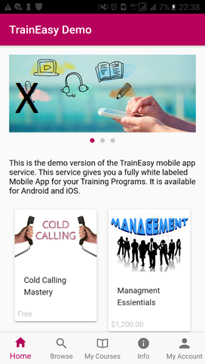

Content starts with “ This is demo version………… Its available for Android and iOS” = “ Welcome to the first and only employment App that will get you a guaranteed employment in your country and an internship opportunity in Dubai, United Arab Emirates”

Color under the text “TrainEasy Demo”= Purple color

The Image with X = Image 1

The “Cold Calling’ Image = Image 2

“Cold Calling” Tittle = “ Build A Healthy Self Image” tittle

The word Free = to be removed

The Image “Management” = Image 3

“Management” Tittle = “Motivation” tittle

The Price 1200$ = to be removed

File 2

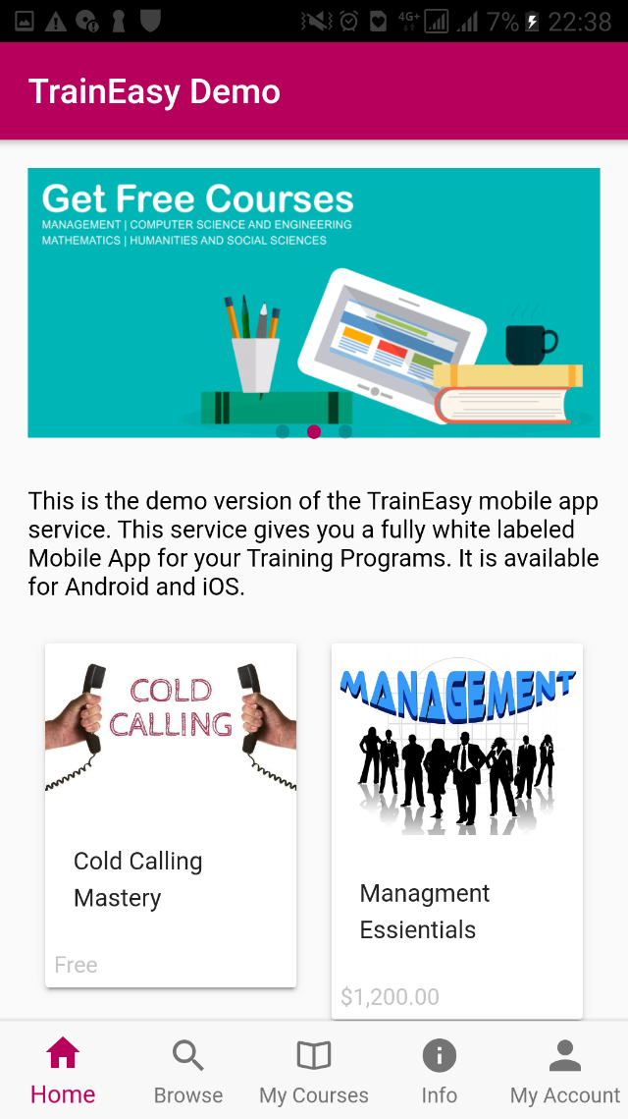

The Image with “ Get Free Courses” = Image 4

File 3

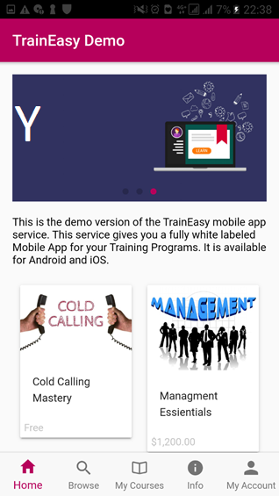

The Image with Y = Image 5

File 4

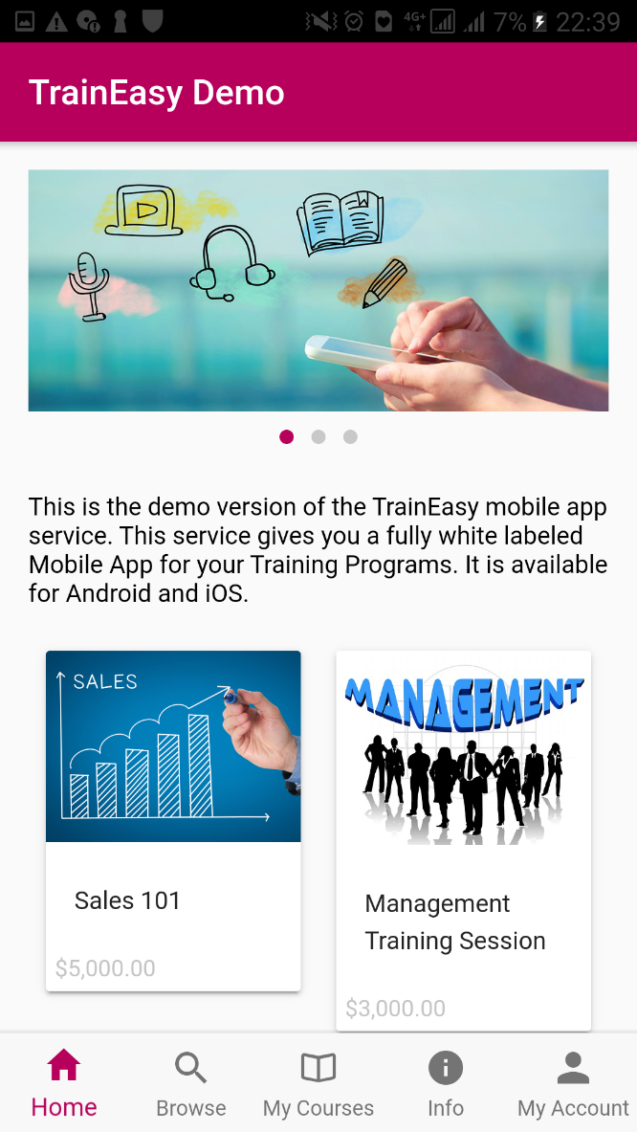

The “Sales 101” image = Image 6

“Sales 101” tittle = Tittle 1

The Price 5000$ = to be removed

The “ Management Training Session’ image = Image 7

“Management Training Session” tittle = Tittle 2

Price 3000$ = to be removed

File 5

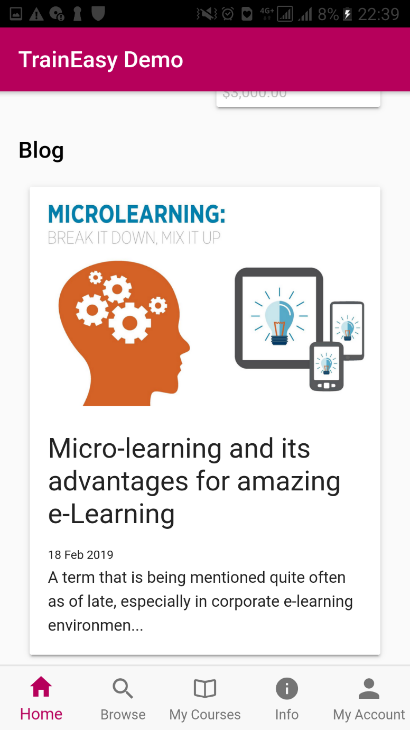

Blog to be removed.

File 6

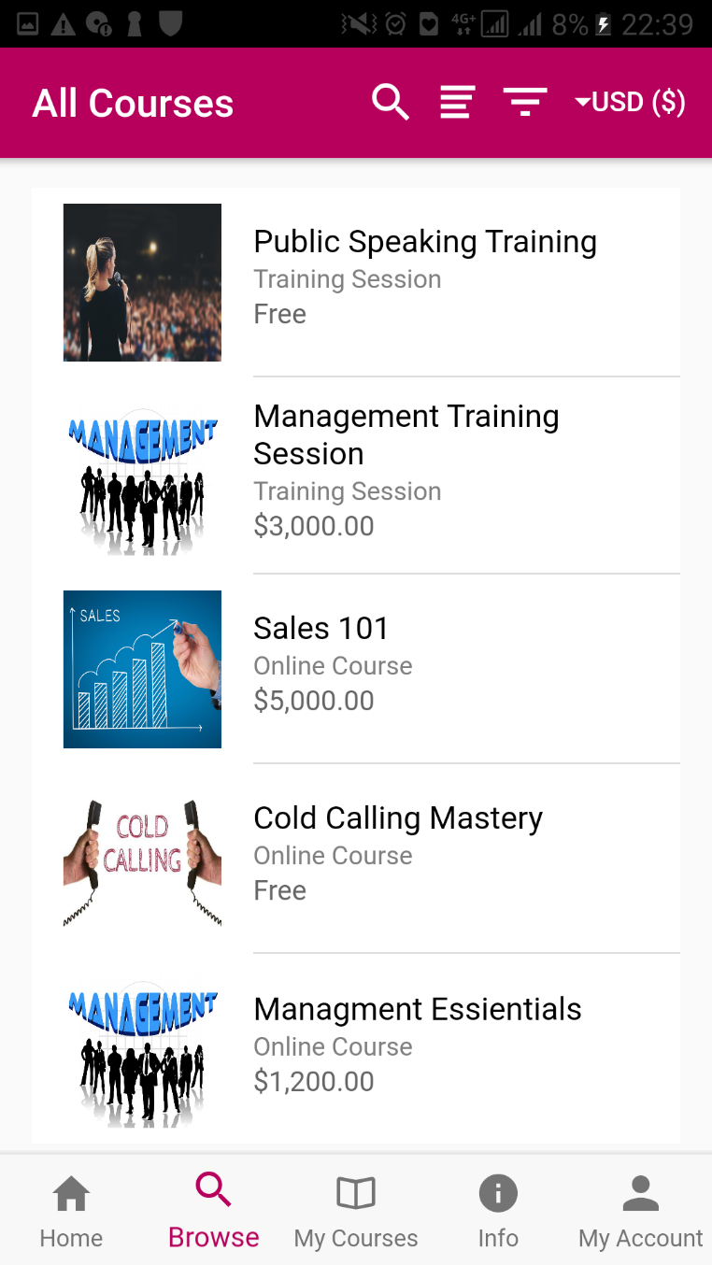

The price on the top right to be removed.

File 7

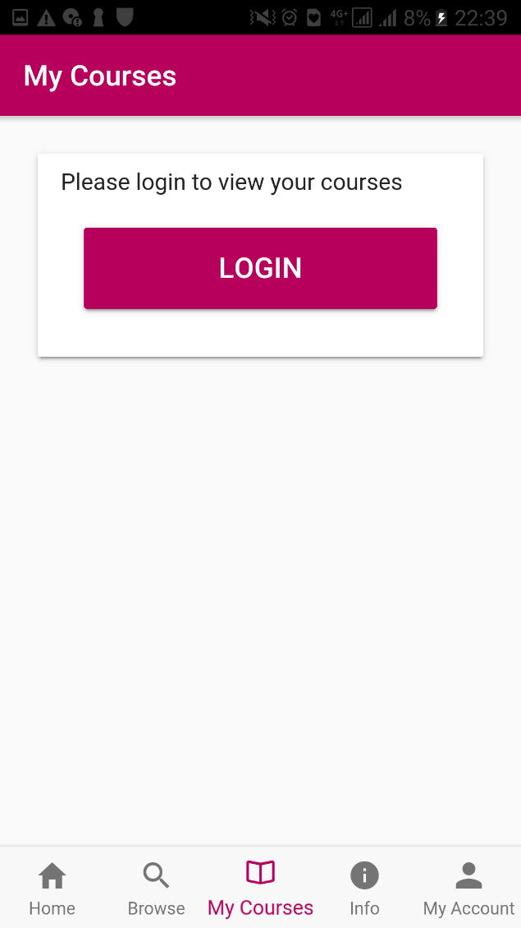

The color under “ My Courses” and “ Login’ = Purple color

File 8

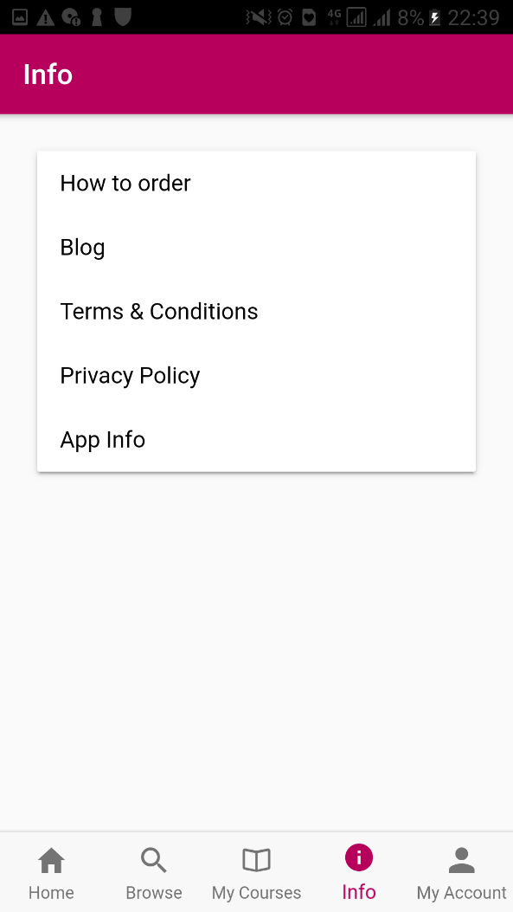

The color under “ info” = Purple color

“how to order’ and “Blog” = to be removed

File 9

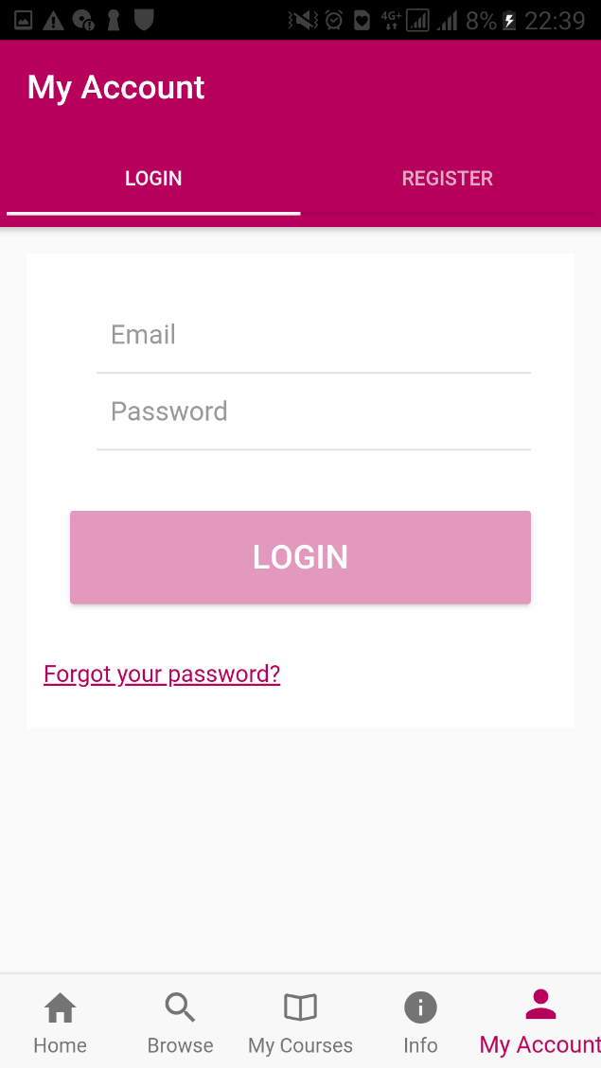

The Color under ‘My Account” and “Login” button = Purple color

“Forgot your password?” = Purple color

File 10

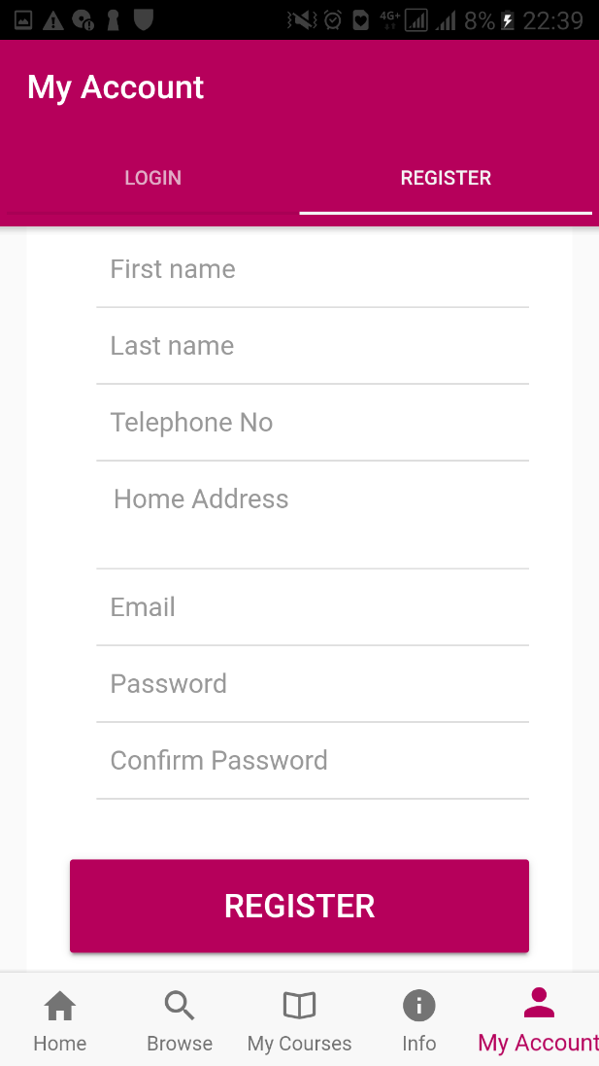

Registration requirements in the following order:

First name

Last name

Date Of Birth

Gender

Nationality ( Country of Origin)

Language

Telephone No

Email

Password

Confirm Password