

**COMPUTER DESIGN LAB**

**ENCS411**

**Course Project**

**System to monitor fire in a room**

**Prepared by:**

**Mohamad Bilal Alhajjah**

**1170580**

**Date: 20/8/2020**

# Table of Contents

Table of Contents 1

I. Abstract 2

II. Procedure 3

❖ Schematic 3

❖ Arduino code 4

III. Conclusion 7

IV. Reference 8

https://www.tinkercad.com/things/ddfOlbKf5Yl 8

# Abstract

In this project we will design an controller system monitor fire in a room , we will use many component that’s Arduino, gas sensor , temperature sensor , leds , wires , dc motor ,transistor , diode and resistors .

# Procedure

# Schematic

In this project we use programmable Arduino kit to design circuit in Tinkercad online simulator, the connecting of each component in our circuit can shown in figure 1 below and we can see that in Tinkercad and simulate it in the webpage : https://www.tinkercad.com/things/ddfOlbKf5Yl

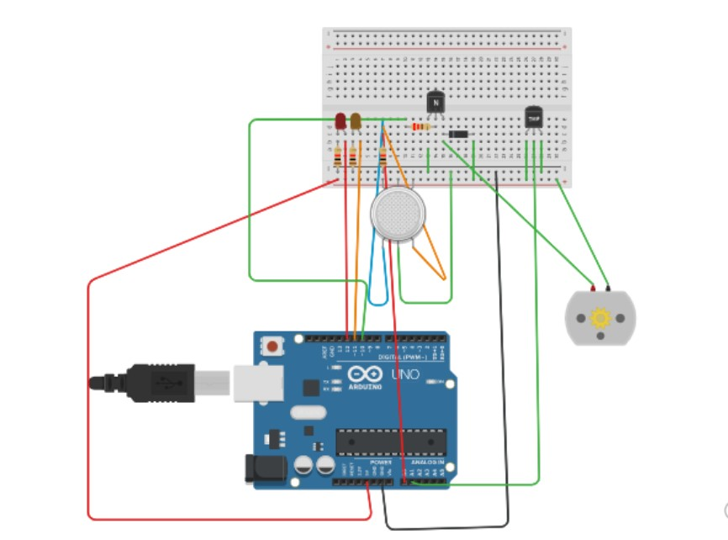

Figure

# Arduino code

The Arduino code make this project working as below:

* Gas sensor reading exceeds the smoke level threshold (100): orange LED will turn on.
* Temperature sensor reading exceeds the temperature threshold(150): red LED will turn on.
* If both the Gas Sensor and Temperature Sensor exceed the threshold in the same time, then the DC motor will work.

We can see that in the code as follow:

#include<SoftwareSerial.h>

//define each pin

int dcMotor = 10;

int orangeLed = 11;

int redLed = 12;

int smokeSen = A0;

int tempSen = A1;

void setup() {

pinMode(redLed, OUTPUT);

pinMode(orangeLed, OUTPUT);

pinMode(dcMotor, OUTPUT);

pinMode(smokeSen, INPUT);

pinMode(tempSen,INPUT);

Serial.begin(9600);

}

void loop() {

int smoke = analogRead(smokeSen);

Serial.print("smoke sensor:");

Serial.println(smoke);

//Gas sensor reading exceeds the smoke level threshold (100): orange LED will turn on.

if (smoke > 150)

{

Serial.println("be careful that's smoke!!!");

digitalWrite(redLed, HIGH);

digitalWrite(orangeLed, LOW);

}

else

{

digitalWrite(redLed, LOW);

digitalWrite(orangeLed, LOW);

noTone(dcMotor);

}

delay(200);

int tempreture = analogRead(tempSen);

Serial.println("Tempreture sensor:");

Serial.println(tempreture);

//Temperature sensor reading exceeds the temperature threshold(150): red LED will turn on.

if (tempreture > 100)

{

Serial.println("be careful that,s heigh temreture!!!");

digitalWrite(redLed,LOW);

digitalWrite(orangeLed,HIGH);

}

else

{

digitalWrite(redLed,LOW);

digitalWrite(orangeLed,LOW);

noTone(dcMotor);

}

delay(200);

//If both the Gas Sensor and Temperature Sensor exceed the threshold in the same time, then the DC motor will work.

if ( tempreture > 100 && smoke > 150){

Serial.println("Fire!!!");

tone(dcMotor,1000,200);

}

}

# Conclusion

Arduino kit is very useful in simple application like our project , this project is very useful to protect our home from fire .

If we want to update project we can add a bell that’s will ringing when the both leds is on that’s make the project more useful.

# Reference

# https://www.tinkercad.com/things/ddfOlbKf5Yl