**Simple URL Parser Documentation:**

**parser.exe compile and run on terminal:**

**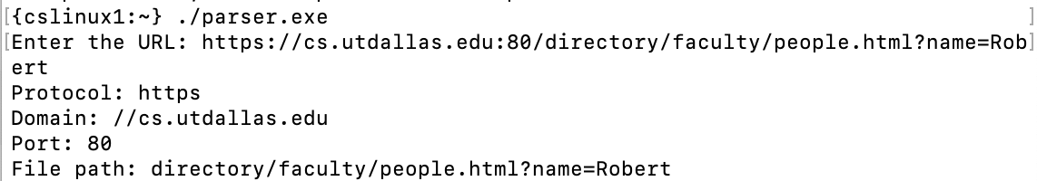  
parser.c in terminal:**

**Program asks for Url, entered by the user:**

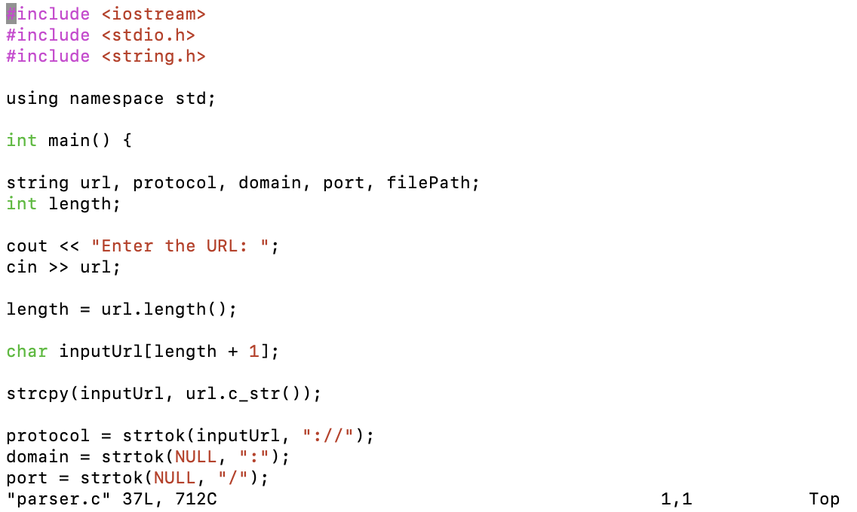

**Entered URL is then parsed using strtok**

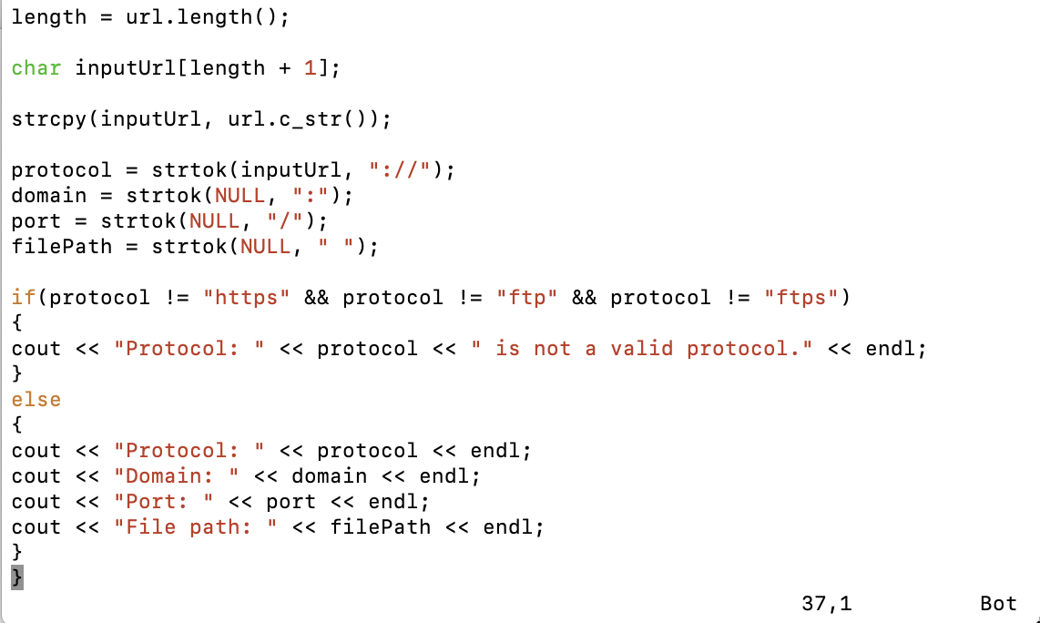

**The URL is parsed and the different components of the URL are displayed.**