WASHWISE – SMART HOSTEL LAUNDRY MANAGEMENT SYSTEM

GE23627 – DESIGN THINKING AND INNOVATION REPORT

Submitted by

MOHAMAD FAYAS N | – | 241701031
SIVARAM G | – | 241701054

in partial fulfilment for the award of the degree of

BACHELOR OF ENGINEERING IN
COMPUTER SCIENCE AND DESIGN



RAJALAKSHMI ENGINEERING COLLEGE

ANNA UNIVERSITY, CHENNAI

OCTOBER 2026

RAJALAKSHMI ENGINEERING COLLEGE

ANNA UNIVERSITY, CHENNAI

BONAFIDE CERTIFICATE

Certified that this Report titled “SMART CAMPUS LAUNDRY MANAGEMENT SYSTEM WITH AI-BASED CLOTHING DETECTION” is the bonafide work of MOHAMAD FAYAS N (241701031) and SIVARAM G (241701054) who carried out the work under my supervision. Certified further that to the best of my knowledge the work reported herein does not form part of any other thesis or dissertation on the basis of which a degree or award was conferred on an earlier occasion on this or any other candidate.

Certified further that the project contributes to SDG 6, SDG 9, SDG 11 and SDG 12, with a primary focus on SDG 12 - Encourages efficient use of washing machines and laundry resources.

Signature of the HOD  Dr. S. Vinodh Kumar  Professor, The Head of the Department  Department of Computer Science and Design  Rajalakshmi Engineering College  Chennai | Signature of the Supervisor  Dr. P. Revathy  Professor  Department of Computer Science and Design  Rajalakshmi Engineering College  Chennai

Submitted for the Project Viva-Voce examination held on ______________.

INTERNAL EXAMINER EXTERNAL EXAMINER

ABSTRACT

Hostel laundry services commonly depend on manual booking procedures, handwritten records, and verbal communication between students and laundry staff. These practices can lead to booking conflicts, inconsistent records, delays in information sharing, and difficulties in coordinating laundry activities across multiple hostels. WASHWISE is a smart campus laundry management system designed to integrate essential laundry operations into a unified web and Android application, improving accessibility and streamlining booking procedures. The application provides a centralized workflow for hostel selection, user authentication, laundry-slot management, booking, and order tracking while maintaining hostel-specific data and records. The frontend is developed using React and Vite, while the backend uses Node.js, Express, and TypeScript. Prisma ORM manages database interactions with PostgreSQL. The frontend is hosted on Vercel, and the backend and database are deployed on Render. Capacitor packages the web application as an Android application, supporting native features such as laundry image capture. For AI-assisted clothing detection, a separate Python Flask service has been prepared using the intended YOLOv8 object detection model to identify shirts, T-shirts, pants, jeans, shorts, towels, and bedsheets from images. The detection results are intended to support automated clothing identification and future laundry quantity estimation. Currently, mock mode is used to verify communication between the frontend, backend, and AI service. Actual model-based detection requires suitable trained weights, inference integration, and further accuracy evaluation. Future enhancements include improving clothing and weight estimation, refining automated slot allocation, and evaluating system performance under realistic hostel conditions. WASHWISE establishes a foundation for organized laundry management, improved resource utilization, and a more convenient experience for hostel residents and laundry administrators.
ACKNOWLEDGEMENT

Initially we thank the Almighty for being with us through every walk of our life and showering his blessings through the endeavour to put forth this report. Our sincere thanks to our Chairman Mr. S. MEGANATHAN, B.E, F.I.E., our Vice Chairman Mr. ABHAY SHANKAR MEGANATHAN, B.E., M.S., and our respected Chairperson Dr. (Mrs.) THANGAM MEGANATHAN, Ph.D., for providing us with the requisite infrastructure and sincere endeavouring in educating us in their premier institution.

Our sincere thanks to Dr. S.N. MURUGESAN, M.E., Ph.D., our beloved Principal for his kind support and facilities provided to complete our work in time. We express our sincere thanks to Dr. S. VINODHKUMAR, Ph.D., Professor and Head of the Department of Computer Science and Design for his guidance and encouragement throughout the project work. We convey our sincere and deepest gratitude to our internal guide, DR. P. REVATHY., Department of Computer Science and Design, for her valuable guidance throughout the course of the project. We are very glad to thank our Project Coordinator, Dr. S. P. KARUPPIAH, Ph.D., Department of Computer Science and Design, for his valuable guidance and useful tips during our reviews to build our project.

MOHAMAD FAYAS N (241701031)
SIVARAM G (241701054)
TABLE OF CONTENTS

CHAPTER NO. | TITLE | PAGE NO.
 | ABSTRACT | iii
 | LIST OF TABLES | x
 | LIST OF FIGURES | xi
 | LIST OF ABBREVIATIONS | xii
1. | INTRODUCTION | 1
 | 1.1 GENERAL | 1
 | 1.2 BACKGROUND | 1
 | 1.3 PROBLEM STATEMENT | 2
 | 1.4 MOTIVATION | 2
 | 1.5 OBJECTIVES | 3
 | 1.6 SCOPE OF THE PROJECT | 3
 | 1.6.1 INCLUDED SCOPE | 4
 | 1.6.2 SCOPE LIMITATIONS | 4
 | 1.7 EXISTING SYSTEM | 5
 | 1.8 LIMITATIONS OF EXISTING SYSTEM | 5
 | 1.9 PROPOSED SYSTEM | 5
 | 1.10 ADVANTAGES OF PROPOSED SYSTEM | 6
2. | LITERATURE REVIEW | 8
 | 2.1 INTRODUCTION | 8
 | 2.2 REVIEW OF RELATED WORK  2.2.1 SMART LAUNDRY MANAGEMENT SYSTEMS  2.2.2 DIGITAL BOOKING AND SLOT MANAGEMENT  2.2.3 COMPUTER VISION AND OBJECT DETECTION  2.2.4 YOLO-BASED OBJECT DETECTION  2.2.5 WEIGHT-BASED RESOURCE MANAGEMENT | 8  8  8  9  9  9
 | 2.3 COMPARATIVE ANALYSIS OF EXISTING APPROACHES | 10
 | 2.4 COMPARATIVE ANALYSIS OF THE PROPOSED SYSTEM | 10
 | 2.5 RESEARCH GAP | 11
3. | THEORETICAL BACKGROUND AND SYSTEM DESIGN | 13
 | 3.1 GENERAL | 13
 | 3.2 OVERVIEW OF WASHWISE | 13
 | 3.3 USER ROLES AND ACCESS CONTROL | 13
 | 3.4 LAUNDRY BOOKING AND SLOT MANAGEMENT | 14
 | 3.5 WEIGHT ESTIMATION AND LOAD MANAGEMENT | 14
 | 3.6 YOLO-BASED CLOTHING DETECTION | 15
 | 3.7 WEEKLY ALLOWANCE AND AUTOMATIC LOAD SPLITTING | 15
 | 3.8 SYSTEM ARCHITECTURE | 16
 | 3.9 DATA FLOW DIAGRAMS  3.9.1 DFD LEVEL 0  3.9.2 DFD LEVEL 1  3.9.3 DFD LEVEL 2 | 16  17  17  18
 | 3.10 USE CASE DIAGRAM | 19
 | 3.11 ACTIVITY DIAGRAM | 20
 | 3.12 OVERALL SYSTEM DIAGRAM | 21
 | 3.13 CORE DATA ENTITIES AND RELATIONSHIPS | 22
4. | METHODOLOGY AND PROJECT DESCRIPTION | 23
 | 4.1 GENERAL | 23
 | 4.2 REQUIREMENT ANALYSIS  4.2.1 FUNCTIONAL REQUIREMENTS  4.2.2 NON-FUNCTIONAL REQUIREMENTS | 23  23  24
 | 4.3 TECHNOLOGY SELECTION | 24
 | 4.4 SYSTEM MODULES  4.4.1 COLLEGE HOSTEL USER AND MANAGEMENT MODULE  4.4.2 PG HOSEL USER MANAGEMENT MODULE  4.4.3 LAUNDRY-BOOKING AND SLOT MANAGEMENT MODULE  4.4.4 CLOTHING INPUT AND WEIGHT ESTIMATION MODULE  4.4.5 AI-BASED CLOTHING DETECTION MODULE  4.4.6 WEEKLY ALLOWANCE MANAGEMENT MODULE  4.4.7 AUTOMATIC LOAD SPLITTING AND SCHEDULING MODULE | 25  25  25  25  26  26  26  26
 | 4.5 MODULE INTEGRATION | 27
 | 4.6 SYSTEM CONFIGURATION | 27
 | 4.6.1 SOFTWARE CONFIGURATION | 27
 | 4.6.2 HARDWARE CONFIGURATION | 27
 | 4.7 FEASIBILITY STUDY  4.7.1 TECHNICAL FEASIBILITY  4.7.2 ECONOMIC FEASIBILITY  4.7.3 OPERATIONAL FEASIBILITY | 28  28  28  28
 | 4.8 TESTING METHODOLOGY | 28
 | 4.9 IMPLEMENTATION RESULTS | 29
5. | RESULTS, DISCUSSION AND CONCLUSION | 30
 | 5.1 RESULTS AND DISCUSSION | 30
 | 5.2 PROJECT OUTCOMES | 31
 | 5.3 LIMITATIONS | 32
 | 5.4 CONCLUSION | 32
 | 5.5 FUTURE ENHANCEMENTS | 33
 | REFERENCES | 34
 | CO–SDG RELEVANCE RECORD | 35
 | PROGRAM OUTCOMES | 36
 | PROGRAM SPECIFIC OUTCOMES | 37
 | CO–PO–PSO MAPPING | 38

LIST OF TABLES

Table No. | Title | Page No.
Table 1.1 | Limitations of Existing Laundry Booking Systems | 5
Table 2.1 | Literature and Laundry Management Comparison | 10
Table 2.2 | Comparative Analysis of Laundry Management Approaches | 10
Table 4.1 | Technologies used in WASHWISE | 24
Table 4.2 | Main Testing Areas | 29

LIST OF FIGURES

Figure No. | Title | Page No.
Figure 3.1 | System Architecture of WASHWISE | 16
Figure 3.2 | Data Flow Diagram – Level 0 | 17
Figure 3.3 | Data Flow Diagram – Level 1 | 18
Figure 3.4 | Data Flow Diagram – Level 2 | 19
Figure 3.5 | Use Case Diagram | 20
Figure 3.6 | Activity Diagram | 21
Figure 3.7 | Overall System Diagram of WASHWISE | 22

LIST OF ABBREVIATIONS

Abbreviation | Meaning
AI | Artificial Intelligence
API | Application Programming Interface
CO | Course Outcome
CPU | Central Processing Unit
CSS | Cascading Style Sheets
DFD | Data Flow Diagram
HTML | HyperText Markup Language
HTTP | HyperText Transfer Protocol
IOT | Internet of Things
ML | Machine Learning
ORM | Object-Relational Mapping
PG | Paying Guest
PSO | Program Specific Outcome
PO | Program Outcome
SDG | Sustainable Development Goal
SQL | Structured Query Language
UI | User Interface
UX | User Experience
URL | Uniform Resource Locator
YOLO | You Only Look Once

CHAPTER 1

INTRODUCTION

1.1 GENERAL
Laundry management is an essential part of daily life for students living in college hostels and people staying in paying guest (PG) hostels. When many residents share a limited number of washing machines, managing laundry sessions can become difficult due to limited availability, waiting times, and uncertainty about suitable washing slots.
WASHWISE – Smart Hostel Laundry Management System is a web-based application developed to simplify laundry booking and improve the management of shared washing machines. It provides separate access for Rajalakshmi Engineering College hostel users and PG hostel users. The system combines laundry booking, clothing detection using YOLO, estimated weight calculation, weekly allowance management, and automatic slot allocation.
Users can enter clothing counts manually or use the camera-based YOLO feature to identify supported clothing categories. Based on the clothing counts and category-based weight estimates, the system calculates the estimated laundry load and helps users select suitable washing sessions. WASHWISE aims to make laundry booking more convenient, organized, and efficient.

1.2 BACKGROUND
Shared laundry facilities are commonly used in college hostels and PG accommodations. However, when several residents depend on the same washing machines, coordinating usage and finding suitable time slots can become challenging. Manual arrangements may also make it difficult to estimate laundry weight and distribute machine usage consistently.
WASHWISE addresses these challenges through a centralized booking platform. It allows users to view available slots, estimate their laundry loads, and make bookings according to predefined rules. The system also supports two methods of clothing identification: manual entry and YOLO-based image detection.
The application uses weight-based booking rather than relying only on the number of clothing items. It enforces a maximum session load of 4,500 grams and a weekly allowance of 7,000 grams per user. These rules, together with automatic load splitting and slot recommendations, help users plan their laundry requirements more effectively.

1.3 PROBLEM STATEMENT
Conventional laundry arrangements may depend on manual coordination and do not always provide a convenient way to check slot availability, estimate laundry weight, or manage weekly usage limits. Users may also find it difficult to determine whether their entire load fits within a washing machine's permitted capacity.
Counting clothing items alone is insufficient because different garments have different weights. Large loads may need to be divided into multiple sessions, while booking requests must be checked against available slots and the user's remaining weekly allowance.
WASHWISE addresses the need for an intelligent, weight-based laundry booking system that combines clothing detection, load estimation, weekly allowance management, and automatic slot allocation for college and PG hostel users.

1.4 MOTIVATION
The project is motivated by the need to make shared laundry facilities easier to access and manage. A digital booking system can help users plan their washing sessions without depending entirely on manual coordination.
Integrating YOLO-based clothing detection provides an alternative to manually counting clothing items. Combined with estimated weight calculation, booking validation, and automatic load splitting, this feature helps users plan loads according to the machine's capacity.
The system also aims to manage laundry usage consistently across college and PG hostel environments by applying defined booking rules and maintaining separate access for the two environments.

1.5 OBJECTIVES
The main objective of WASHWISE is to develop a smart laundry booking system that simplifies laundry management and supports efficient use of shared washing machines.
The specific objectives are:
- To provide a user-friendly web application for laundry booking.
- To support separate access for college hostels and PG hostels.
- To allow manual entry of clothing counts and camera-based clothing detection using YOLO.
- To estimate laundry weight using clothing counts and category-based weight values.
- To enforce a maximum load of 4,500 grams per washing session.
- To provide a weekly allowance of 7,000 grams per user, resetting every Monday at 12:00 AM.
- To deduct the allowance after successful booking and restore it when an eligible booking is cancelled before its slot starts.
- To split loads exceeding the session limit into additional sessions within the same booking process.
- To recommend suitable available slots and validate booking requests.
- To maintain separate user and administrative access for college and PG hostel environments.

1.6 SCOPE OF THE PROJECT

WASHWISE covers laundry booking, clothing detection, estimated weight calculation, weekly allowance management, and slot allocation for college hostel and PG hostel users.

1.6.1 Included Scope
The project includes the following features:
- College hostel access: Rajalakshmi Engineering College users can access the Girls, Thandalam, and Habitat hostel options.
- PG hostel access: The PG environment provides separate options for User 1, User 2, User 3, User 4, and a PG administrator.
- Separate account management: College and PG users and administrators operate within their respective environments.
- Laundry booking: Users can view available slots and book suitable washing sessions.
- Manual clothing entry: Users can enter counts for shirts, T-shirts, pants, jeans, and shorts.
- YOLO-based detection: The camera feature identifies supported categories, including shirts, T-shirts, pants, jeans, shorts, towels, bedsheets, and other items.
- Weight estimation: The system estimates the total load weight using clothing counts and category-based weight values.
- Weight and allowance validation: Each session has a maximum load of 4,500 grams, and each user has a weekly allowance of 7,000 grams.
- Automatic load splitting: Loads exceeding the session limit are divided into additional sessions within the same booking process.
- Slot recommendations: The system recommends suitable available slots for booking.
- Cancellation handling: Allowance is restored when a booking is cancelled before its slot starts, subject to the defined booking rules.

1.6.2 Scope Limitations
The system calculates estimated laundry weight rather than physically measuring the clothes. The accuracy of image-based detection depends on image quality, clothing visibility, and the capabilities of the trained YOLO model. Weight estimation depends on the category-based weight values used by the system.
Direct physical weight measurement using external weighing hardware is outside the defined project scope.

1.7 EXISTING SYSTEM
Traditional laundry arrangements in shared residential facilities may rely on manual coordination, informal scheduling, or checking machine availability in person. Such methods may not provide centralized slot information or automatic enforcement of laundry weight and weekly usage limits.
Users may also need to count clothing items and estimate their load manually. When a load exceeds the machine's permitted capacity, users may have to decide independently how to divide it into multiple sessions. These limitations can make laundry planning inconvenient and inconsistent.

1.8 LIMITATIONS OF EXISTING SYSTEM
The major limitations of conventional laundry booking arrangements are summarized in Table 1.1.
Table 1.1 Limitations of Existing Laundry Booking Systems
Limitation | Description
Manual coordination | Users may need to coordinate with others to determine machine availability
Limited slot visibility | Available washing times may not be accessible through a centralized interface
Difficulty estimating loads | Users may find it difficult to estimate total laundry weight
Lack of image-based assistance | Clothing identification may require manual counting
Inconsistent usage management | Weekly usage limits may be difficult to track without automation
Manual load planning | Users may need to divide oversized loads themselves
Separate user environments | Managing college and PG hostel users requires clear account and administrative separation
These limitations demonstrate the need for an integrated system that provides booking, clothing detection, estimated weight calculation, and automated validation.

1.9 PROPOSED SYSTEM

WASHWISE provides a centralized platform for laundry booking and load management. Users first select either Rajalakshmi Engineering College or PG Hostel. College users can access the Girls, Thandalam, or Habitat hostel options, while PG users access their designated user accounts or the separate PG administrator environment.

Users can enter clothing counts manually or use the YOLO-based camera feature to identify supported clothing categories. The system calculates an estimated total weight from the clothing counts and associated weight values.

The booking process checks the estimated load against the maximum session limit of 4,500 grams and the weekly allowance of 7,000 grams. The weekly allowance resets every Monday at 12:00 AM. If a load exceeds the session limit, the system automatically splits it into additional sessions during the same booking process, subject to slot availability and the remaining weekly allowance.

The system recommends suitable available slots and validates booking requests. After a successful booking, the corresponding weight is deducted from the weekly allowance. An eligible cancellation before the slot starts restores the allowance, while a failed booking is rejected.

The application uses React, TypeScript, Vite, and Tailwind CSS for the frontend; Node.js, Express, and TypeScript for the backend; PostgreSQL with Prisma ORM for database management; and Python, Flask, and YOLO for clothing detection. The frontend is deployed through Vercel, while the backend and database services use the configured Render environment.

1.10 ADVANTAGES OF PROPOSED SYSTEM
The major advantages of WASHWISE are:
- Convenient booking: Users can view available slots and book washing sessions through a web application.
- YOLO-based clothing detection: Camera-based detection helps identify supported clothing categories.
- Estimated weight calculation: Clothing-based weight estimates support better load planning.
- Machine load protection: The session limit helps prevent bookings that exceed the permitted load.
- Weekly allowance management: Automated tracking supports consistent usage limits.
- Automatic load splitting: Oversized loads can be divided into additional sessions.
- Slot recommendations: Users can identify suitable available washing times.
- Automated validation: Booking rules are applied consistently.
- Separate access environments: College and PG users have distinct account and administrative access.
- Integrated technology: The system combines web development, database management, and computer vision.
In conclusion, WASHWISE combines digital laundry booking, YOLO-based clothing detection, weight estimation, and automated scheduling to provide an organized self-service laundry management solution for college and PG hostel users.

CHAPTER 2

LITERATURE REVIEW

2.1 INTRODUCTION
A literature review helps understand existing technologies, methods, and systems related to the proposed project. WASHWISE focuses on improving laundry management through digital booking, AI-based clothing detection, estimated load weight, and efficient washing-machine slot allocation.
This chapter reviews smart laundry management, digital booking systems, computer vision, YOLO-based object detection, and weight-based resource management. The findings are used to identify the research gap and explain the need for WASHWISE.

2.2 REVIEW OF RELATED WORK
2.2.1 Smart Laundry Management Systems
Smart laundry management systems use digital technologies to improve machine utilization and reduce waiting time. Portase et al. [1] presented SmartLaundry, a system designed to support laundry allocation in smart cities using machine-usage forecasting and recommendations. Such approaches demonstrate how data-driven scheduling can improve access to shared laundry facilities.
However, hostel and paying guest (PG) environments also require user-specific booking rules, weekly usage limits, clothing-load estimation, and suitable slot recommendations. WASHWISE addresses these needs by integrating laundry booking with clothing detection and weight-based restrictions.
2.2.2 Digital Booking and Slot Management
Digital booking systems allow users to view available time slots and reserve services without depending on manual coordination. In laundry facilities, slot management can help distribute machine usage, reduce conflicts, and make service availability easier to understand.
WASHWISE provides separate access for college hostel users and PG hostel users. Users can view available slots and book suitable washing times. The system also recommends available slots and supports additional sessions when a clothing load exceeds the permitted weight for one session.
2.2.3 Computer Vision and Object Detection
Computer vision enables computers to identify and classify objects in images. Object detection is useful when a system needs to recognize multiple objects and determine their locations within an image.
In WASHWISE, users can use a camera to detect clothing items instead of entering every item count manually. The detection results help categorize clothing and estimate the total load using predefined category-based weight values. Since an ordinary image does not directly provide the actual physical weight of clothes, the calculated weight is an estimate rather than a direct measurement.
2.2.4 YOLO-Based Object Detection
You Only Look Once (YOLO) is an object-detection approach that processes an image to identify and locate objects. Redmon et al. [2] introduced YOLO as a unified, real-time object-detection method.
WASHWISE uses YOLO-based detection to recognize clothing categories, including shirts, T-shirts, pants, jeans, shorts, towels, bedsheets, and other items. The detected categories are used to calculate an estimated load weight. Users can also enter clothing counts manually, providing an alternative when camera-based detection is not required.
2.2.5 Weight-Based Resource Management
Weight-based resource management can help prevent washing machines from being overloaded and distribute usage more fairly. A system that considers only the number of clothing items may not accurately represent the total load because different clothing categories have different estimated weights.
WASHWISE applies two main limits: a maximum of 4,500 grams per machine session and a weekly allowance of 7,000 grams per user. The weekly allowance resets every Monday at 12:00 AM. If a load exceeds the session limit, the system can divide it into additional sessions, subject to slot availability and the user's remaining weekly allowance.

2.3 COMPARATIVE ANALYSIS OF EXISTING APPROACHES

Existing approaches address different parts of laundry management, including machine allocation, digital booking, and image-based object detection. However, these functions are not always combined with clothing-weight estimation and user-specific usage limits.
Table 2.1 Literature and Laundry Management Comparison
Approach | Main Function | Limitation
Manual laundry management | Users coordinate washing times manually | May cause conflicts and delays
Digital booking systems | Users reserve available time slots | May not consider clothing weight
Smart laundry allocation | Supports machine allocation and usage recommendations | May not provide clothing detection and weekly weight control
Object detection systems | Identify objects in images | Do not independently provide laundry booking and allowance management
Weight-based management | Controls load according to weight | Requires integration with booking and slot allocation
The comparison indicates that an effective laundry management system should combine booking, clothing identification, estimated load weight, and resource-allocation rules.

2.4 COMPARATIVE ANALYSIS OF THE PROPOSED SYSTEM
WASHWISE combines digital booking with AI-assisted clothing detection and weight-based load management. It supports both Rajalakshmi Engineering College hostel users and PG hostel users through separate access environments.
Table 2.2 Comparative Analysis of Laundry Management Approaches
Feature | Conventional Arrangements | Basic Digital Booking | WASHWISE
Digital slot booking | Not necessarily available | Available | Available
Clothing count entry | Manual | Depends on the system | Manual entry supported
Camera-based clothing detection | Not integrated | Not necessarily available | YOLO-based detection available
Estimated laundry weight | Usually manual or informal | May not be included | Included
Session weight validation | May be informal | Depends on the system | Maximum 4,500 g per session
Weekly allowance management | May be manual | Depends on the system | 7,000 g weekly allowance
Automatic load splitting | User-managed | Not necessarily available | Included
Slot recommendations | Manual coordination | Depends on the system | Available slots recommended
Separate college and PG access | Not applicable or separately managed | Depends on the system | Separate access environments
The proposed system integrates these functions into one platform. When a load exceeds 4,500 grams, WASHWISE can allocate the load across additional sessions in the same booking process, provided the required slots and weekly allowance are available. This approach supports better planning and helps users understand their remaining weekly allowance.

2.5 RESEARCH GAP
The literature review identifies a need for a laundry management system that combines digital booking, clothing detection, estimated load weight, and user-specific usage restrictions. Individual technologies can support machine allocation or object detection, but users also need these capabilities to work together in a practical hostel and PG environment.
WASHWISE addresses this gap through the following features:
- AI-assisted clothing detection: Identifies clothing categories from camera images using YOLO.
- Estimated load weight: Calculates an approximate load using predefined weights for detected or manually entered clothing categories.
- Weight-based restrictions: Applies a 4,500-gram session limit and a 7,000-gram weekly allowance.
- Automatic load splitting: Allocates loads exceeding the session limit across additional sessions, subject to availability and allowance.
- Digital slot booking: Helps users find and reserve available washing times.
- Separate user environments: Supports college hostel users and PG hostel users through distinct access options.
Therefore, WASHWISE provides an integrated approach to self-service laundry booking and load management. It combines AI-assisted clothing identification with practical booking rules to support more organized use of shared washing machines.

CHAPTER 3

THEORETICAL BACKGROUND AND SYSTEM DESIGN

3.1 GENERAL
This chapter explains the theoretical concepts and system design of WASHWISE, a smart laundry booking system developed for college hostel and paying guest (PG) hostel users. It describes the system architecture, user roles, laundry booking process, AI-based clothing detection, estimated weight calculation, weekly allowance management, and automatic load splitting.
The chapter also presents the data flow diagrams, use case diagram, activity diagram, and overall system diagram to illustrate how the system operates.

3.2 OVERVIEW OF WASHWISE
WASHWISE is a web-based self-service laundry management system that allows users to book washing-machine time slots and manage their laundry loads. It combines online booking with manual clothing-count entry or YOLO-based clothing detection.
The system supports two main environments: Rajalakshmi Engineering College and PG Hostel. College users can access the Girls, Thandalam, and Habitat hostel options, while PG Hostel provides separate accounts for individual users and a PG administrator.
Users can select clothing categories manually or use the camera-based detection feature. The system calculates an estimated load weight using predefined category-based weight values and checks whether the load satisfies the booking rules. Available slots are then used to allocate suitable washing sessions.

3.3 USER ROLES AND ACCESS CONTROL
WASHWISE provides separate access options according to the user's environment and role.
- College hostel users: Access the system through Rajalakshmi Engineering College and select the appropriate hostel.
- PG hostel users: Access the separate PG Hostel environment using their individual accounts.
- Administrators: Manage the functions and records permitted by their respective administrative roles.
College and PG accounts operate in separate environments to prevent the two user groups from sharing the same account context. The system provides users with access to laundry booking, clothing input, load estimation, slot selection, and weekly allowance information according to their permissions.

3.4 LAUNDRY BOOKING AND SLOT MANAGEMENT
The booking module allows users to view available washing-machine time slots and reserve a suitable session. Recommended available slots are presented to help users choose a convenient time. If a recommended slot is unavailable, another available slot can be selected.
Each washing-machine session has a maximum load of 4,500 grams. The booking process checks the estimated load, slot availability, and remaining weekly allowance before accepting the booking.
The system supports an approximately one-hour washing cycle. Users can review their remaining weekly allowance after booking, allowing them to plan future laundry sessions.

3.5 WEIGHT ESTIMATION AND LOAD MANAGEMENT
WASHWISE uses estimated clothing weight to manage washing-machine loads. Different clothing categories are assigned predefined weight values, which are used to calculate the estimated total weight.
The estimated weight is checked against two restrictions:
- Session limit: A maximum of 4,500 grams per washing-machine session.
- Weekly allowance: A maximum of 7,000 grams per user per week.
The weekly allowance resets every Monday at 12:00 AM. Following a successful booking, the corresponding estimated weight is deducted from the user's weekly allowance. An eligible cancellation made before the slot starts restores the deducted allowance.
If a booking fails, it is rejected rather than partially confirmed, and the user must submit a new booking request.

3.6 YOLO-BASED CLOTHING DETECTION
WASHWISE incorporates YOLO-based object detection to identify clothing items from camera images. This feature reduces the need for users to count every item manually.
The detection service identifies categories including shirts, T-shirts, pants, jeans, shorts, towels, bedsheets, and other items. The detected categories are then used to estimate the total clothing weight using predefined category-based values.
The AI service identifies clothing categories; it does not directly measure the actual physical weight of clothes from an ordinary image. Therefore, the resulting weight is an estimate used for booking and load management.
Users can also enter clothing counts manually as an alternative to camera-based detection.

3.7 WEEKLY ALLOWANCE AND AUTOMATIC LOAD SPLITTING
The weekly allowance mechanism helps distribute washing-machine usage and prevent users from exceeding their permitted load. Each user has a weekly allowance of 7,000 grams, while each session is limited to 4,500 grams.
When the estimated load exceeds the session limit, WASHWISE can split it into multiple sessions during the same booking process. For example, a load of 6,000 grams can be divided into a 4,500-gram session and an additional 1,500-gram session.
The additional session is subject to slot availability and the user's remaining weekly allowance. The system allocates the required sessions before confirming the booking, avoiding partial confirmation when the complete booking cannot be accommodated.
This approach supports organized scheduling while ensuring that both session and weekly restrictions are applied.

3.8 SYSTEM ARCHITECTURE
WASHWISE uses a web-based architecture consisting of a frontend, backend, database, and AI detection service.
The frontend is developed using React, TypeScript, Vite, and Tailwind CSS. It provides the user interface for authentication, clothing input, slot selection, booking, and allowance information.
The backend uses Node.js, Express, and TypeScript to handle application requests, booking rules, access control, and load management. PostgreSQL stores application data, while Prisma ORM supports database operations.
The AI service is developed using Python and Flask and integrates YOLO-based clothing detection. The frontend communicates with the backend, which interacts with the database and the AI service when required.
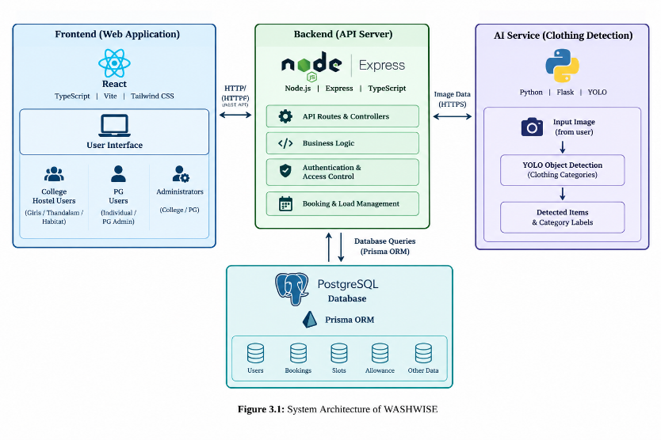
Figure 3.1: System Architecture of WASHWISE

3.9 DATA FLOW DIAGRAMS
Data Flow Diagrams (DFDs) illustrate how information moves between users, system processes, and data stores. The three DFD levels describe WASHWISE at different levels of detail.

3.9.1 DFD Level 0
The Level 0 DFD presents WASHWISE as a single system and shows its interactions with college hostel users, PG hostel users, and administrators. Users submit login details, clothing information, and booking requests. The system returns relevant account information, estimated load details, slot availability, booking results, and weekly allowance information.
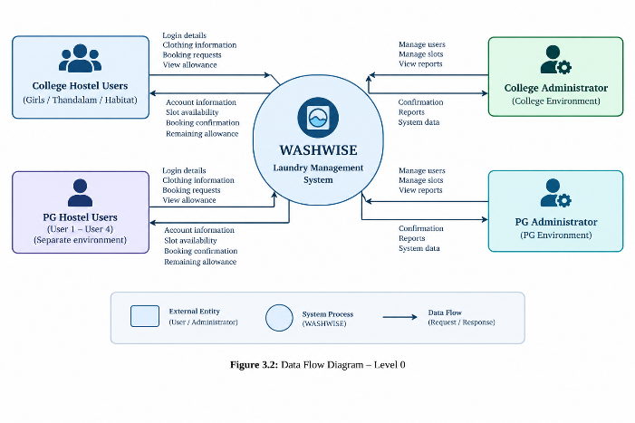
Figure 3.2: Data Flow Diagram – Level 0
3.9.2 DFD Level 1
The Level 1 DFD expands WASHWISE into its main processes: user access management, clothing input and detection, weight estimation, slot availability checking, booking validation, allowance management, and data storage.
These processes work together to validate requests and allocate washing sessions according to the system's booking rules.
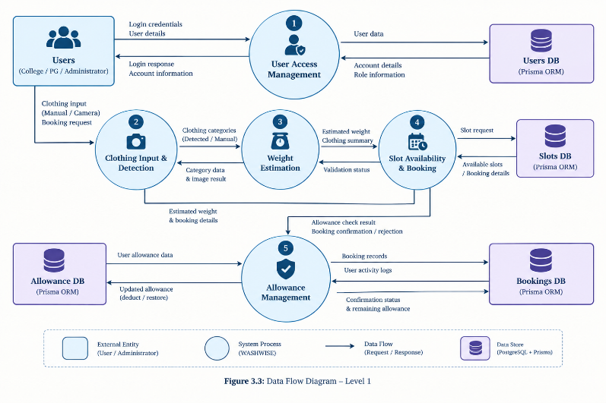
Figure 3.3: Data Flow Diagram – Level 1
3.9.3 DFD Level 2
The Level 2 DFD provides more detail about the clothing and booking workflow. It shows how clothing information is obtained through manual entry or YOLO detection, converted into an estimated weight, checked against the session and weekly limits, and used to determine whether one or more sessions are required.
The process also checks slot availability before confirming the booking and updating the user's remaining allowance.
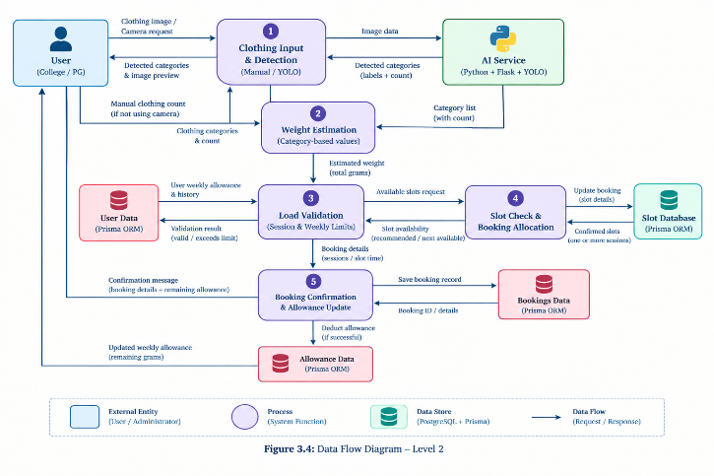
Figure 3.4: Data Flow Diagram – Level 2

3.10 USE CASE DIAGRAM
The use case diagram represents the interactions between WASHWISE users and the system. College hostel users and PG hostel users can access their respective environments, provide clothing information, estimate loads, view available slots, book sessions, and check their remaining weekly allowance.
Administrators can access the management functions available to their respective roles. The diagram illustrates the major functions without showing the internal implementation details.
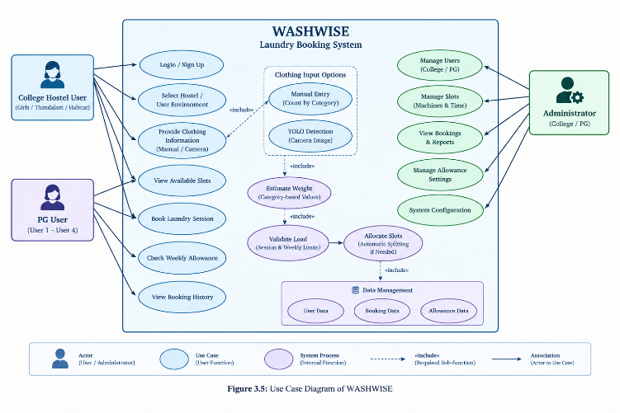
Figure 3.5: Use Case Diagram of WASHWISE

3.11 ACTIVITY DIAGRAM
The activity diagram represents the sequence followed during a laundry booking. The user signs in, selects manual clothing entry or camera-based detection, and obtains the estimated load weight. The system validates the load against the session limit and weekly allowance.
If additional sessions are required, the system checks whether suitable slots are available. The booking is confirmed only when the required sessions can be allocated and the booking rules are satisfied. Otherwise, the request is rejected and the user must submit a new request.
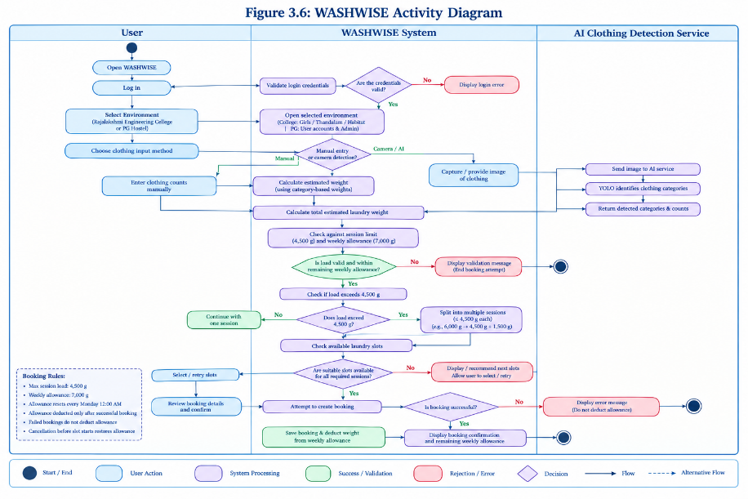
Figure 3.6: Activity Diagram of Laundry Booking

3.12 OVERALL SYSTEM DIAGRAM
The overall system diagram summarizes the main WASHWISE workflow, from user access to booking confirmation. It connects the user interface, manual clothing entry or YOLO detection, estimated weight calculation, booking validation, slot allocation, and weekly allowance updates.
The diagram provides a consolidated view of how the system's main components work together to support self-service laundry booking for college and PG hostel users.

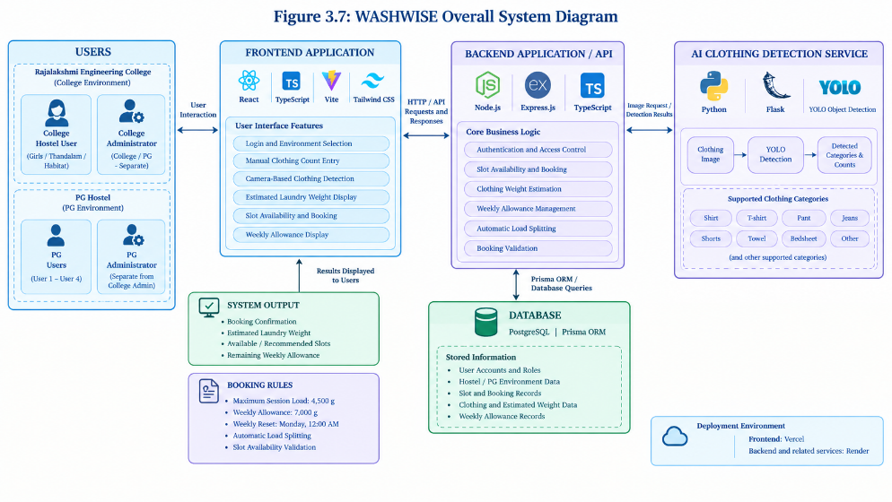
Figure 3.7: Overall System Diagram of WASHWISE

3.13 CORE DATA ENTITIES AND RELATIONSHIPS
WASHWISE uses structured data to manage user accounts, laundry bookings, washing-machine slots, and weekly allowance information. PostgreSQL serves as the database, while Prisma ORM supports communication between the application and the database.
The main logical entities include users, hostel or user-environment information, bookings, available slots, and allowance records. These entities support account separation, booking validation, load allocation, and allowance tracking. The exact relationships depend on the implemented database schema.

CHAPTER 4

METHODOLOGY AND PROJECT IMPLEMENTATION

4.1 GENERAL
This chapter describes the methodology and implementation of WASHWISE, a web-based laundry booking system for college hostel and PG hostel users. It explains the requirements, technologies, major modules, system integration, configuration, testing approach, and implementation outcomes.
The system combines online slot booking, manual clothing-count entry, YOLO-based clothing detection, estimated weight calculation, weekly allowance management, and automatic load splitting to support organized laundry usage.

4.2 REQUIREMENT ANALYSIS
Requirement analysis identifies the functions and constraints necessary for the system to operate effectively. WASHWISE is designed to provide a convenient booking process while enforcing session and weekly weight limits.
The main requirements include separate access for college and PG users, clothing input through manual entry or camera-based detection, estimated weight calculation, slot availability checking, booking confirmation, and weekly allowance tracking.
4.2.1 Functional Requirements
The functional requirements describe the operations performed by the system.
- Provide separate login environments for college hostel users and PG hostel users.
- Support the Girls, Thandalam, and Habitat college hostel options.
- Provide separate PG user accounts and PG administrator access.
- Allow users to enter clothing counts manually or use YOLO-based detection.
- Calculate estimated clothing weight using predefined category-based values.
- Display available and recommended washing-machine slots.
- Enforce the 4,500-gram session limit and 7,000-gram weekly allowance.
- Automatically split loads exceeding the session limit into additional sessions when suitable slots and sufficient weekly allowance are available.
- Update the remaining weekly allowance after successful booking.
- Restore the allowance when an eligible booking is cancelled before its slot starts.
4.2.2 Non-Functional Requirements
Non-functional requirements describe the expected quality and operational characteristics of the application.
- Usability: Provide a clear interface for selecting clothing and booking slots.
- Performance: Process booking requests and clothing-detection results within a practical response time.
- Security: Separate college and PG environments and restrict access according to user roles.
- Reliability: Validate booking requests and avoid confirming incomplete bookings.
- Maintainability: Use a modular application structure that supports changes to individual components.
- Data consistency: Maintain accurate booking records and weekly allowance information.

4.3 TECHNOLOGY SELECTION
WASHWISE uses web technologies for the user interface and backend operations, a relational database for storing application records, and a separate AI service for clothing detection.
Table 4.1 Technologies used in WASHWISE
Technology | Purpose
React | Builds the interactive user interface
TypeScript | Provides type checking for application code
Vite | Supports frontend development and building
Tailwind CSS | Provides interface styling
Node.js | Runs the backend application
Express.js | Handles API routes and requests
PostgreSQL | Stores application data
Prisma ORM | Supports database operations
Python | Supports the AI service
Flask | Provides the AI service interface
YOLO | Detects clothing categories in images
Vercel | Hosts the frontend
Render | Hosts the backend and associated services
These technologies separate the user interface, business logic, data storage, and AI processing. This modular structure allows each component to perform its specific role while communicating with the other components.

4.4 SYSTEM MODULES
WASHWISE is organized into modules that handle user access, clothing input, booking, load management, and administrative functions.
4.4.1 College Hostel User and Management Module
The college environment provides access to the Girls, Thandalam, and Habitat hostel options. Users can sign in, enter clothing information, estimate their laundry load, view available slots, and make bookings.
The module keeps college-related access separate from the PG environment and applies the booking restrictions to the user's laundry requests.
4.4.2 PG Hostel User Management Module
The PG environment provides separate accounts for User 1 through User 4 and a distinct PG administrator. It supports the same core laundry-booking functions while maintaining separation from college accounts and administration.
This arrangement allows the application to support both college hostel and PG hostel users without treating them as a single shared user environment.
4.4.3 Laundry Booking and Slot Management Module
This module displays available washing-machine slots and processes booking requests. It checks slot availability and presents recommended options to help users select suitable washing times.
If a preferred slot is unavailable, the user can choose another available slot. The booking is confirmed only when the required sessions can be allocated and the applicable rules are satisfied.
4.4.4 Clothing Input and Weight Estimation Module
Users can provide clothing information by entering item counts manually or using the camera-based detection feature. The system uses clothing categories and predefined weight values to calculate an estimated total load.
The estimated weight is used for booking validation. Since camera-based detection identifies clothing categories rather than directly measuring physical weight, the result is an estimate.
4.4.5 AI-Based Clothing Detection Module
The AI module uses Python, Flask, and YOLO to process clothing images and identify supported categories. The detected labels and counts are returned to the application for weight estimation and booking validation.
This feature reduces manual input and gives users an alternative way to provide clothing information.
4.4.6 Weekly Allowance Management Module
The allowance module enforces a weekly limit of 7,000 grams per user. The allowance resets every Monday at 12:00 AM and is deducted after a successful booking.
When an eligible booking is cancelled before its slot begins, the corresponding allowance is restored. This mechanism helps prevent users from exceeding their permitted weekly laundry weight.
4.4.7 Automatic Load Splitting and Scheduling Module
A single washing-machine session can accommodate a maximum estimated load of 4,500 grams. When a user's load exceeds this limit, the system can divide it into multiple sessions as part of the same booking process.
For example, a 6,000-gram load can be divided into a 4,500-gram session and an additional 1,500-gram session. The system must check slot availability and the user's remaining weekly allowance before confirming the complete booking.
If the complete booking cannot be accommodated, the request is rejected and the user must submit a new request. This prevents partial confirmation of a multi-session booking.

4.5 MODULE INTEGRATION
The WASHWISE modules operate together to complete the laundry-booking workflow. The frontend collects user input and displays the results. The backend processes requests, applies booking rules, and communicates with the database and AI service.
The database stores the records required for user access, bookings, slots, and allowance tracking. When camera-based detection is selected, the AI service returns detected clothing information to the application. The estimated weight is then used to validate the booking.
The integration ensures that clothing input, weight estimation, slot allocation, and allowance updates are handled as parts of the same booking process.

4.6 SYSTEM CONFIGURATION
The system is developed using a frontend application, backend service, relational database, and AI detection service.
4.6.1 Software Configuration
The software environment includes React, TypeScript, Vite, and Tailwind CSS for the frontend; Node.js, Express, and TypeScript for the backend; PostgreSQL and Prisma ORM for data management; and Python, Flask, and YOLO for clothing detection.
The frontend is deployed using Vercel, while the backend and associated services use Render-based hosting. This arrangement separates the application interface from its backend processing and data services.
4.6.2 Hardware Configuration
WASHWISE is designed to operate through a web browser on a compatible computer or mobile device. A camera-enabled device is required when users choose image-based clothing detection. Manual clothing entry remains available as an alternative.
No dedicated industrial hardware is required for the basic software-based booking workflow.

4.7 FEASIBILITY STUDY
4.7.1 Technical Feasibility
The project uses established web-development frameworks, a relational database, and a YOLO-based object-detection service. These technologies support the development of a modular application combining user access, booking, and AI-assisted clothing identification.
4.7.2 Economic Feasibility
The system is primarily software-based and uses web technologies and cloud-hosting services. It can reduce reliance on manual coordination and does not require a dedicated hardware-based weighing system for its estimated-weight workflow.
Actual operating costs depend on hosting usage, service plans, and future maintenance requirements.
4.7.3 Operational Feasibility
The system provides a straightforward process for selecting clothing input methods, viewing available slots, and booking laundry sessions. Separate college and PG environments allow different user groups to access the service through their respective accounts.
Weight limits and allowance information help users understand the restrictions that apply to their bookings.

4.8 TESTING METHODOLOGY
Testing is important for checking whether the application behaves according to its requirements. WASHWISE's main testing areas include user access, clothing detection, weight calculation, booking validation, slot allocation, and weekly allowance management.

Table 4.2: Main Testing Areas
Testing Area | Function Checked
User access | Separation of college and PG environments
Clothing input | Manual entry and camera-based detection
Weight estimation | Category-based estimated weight calculation
Session validation | Enforcement of the 4,500-gram session limit
Weekly allowance | Enforcement of the 7,000-gram weekly limit
Slot management | Availability checking and session allocation
Load splitting | Allocation of loads exceeding one session
Cancellation | Restoration of allowance for eligible cancellations
Booking consistency | Rejection of unsuccessful or incomplete booking requests
Testing should verify both normal and boundary cases, including loads at the session limit, loads exceeding the limit, insufficient weekly allowance, unavailable slots, and eligible cancellations. The table identifies the areas to be evaluated; it should not be interpreted as a numerical test-results table unless corresponding results have been recorded.

4.9 IMPLEMENTATION RESULTS
WASHWISE brings the main laundry-booking functions into one web-based application. Users can access their respective college or PG environments, provide clothing information manually or through YOLO-based detection, estimate load weight, and book available washing-machine sessions.
The system applies the configured session and weekly limits and supports automatic load splitting when the load exceeds one session. Booking records and allowance information are maintained through the application's database operations.
The implemented clothing-detection feature provides an alternative to manual clothing-count entry. Together, these functions demonstrate the integration of web application development, database management, and AI-assisted clothing recognition in a self-service laundry-booking system.

CHAPTER 5

RESULTS, DISCUSSION AND CONCLUSION

5.1 RESULTS AND DISCUSSION
WASHWISE is a smart laundry booking system developed to simplify laundry management for college hostel students and PG hostel residents. The system provides a digital platform through which users can estimate their laundry load, check available time slots, and book laundry sessions according to their requirements.
The application supports two separate environments: Rajalakshmi Engineering College and PG Hostel. College users can select their respective hostel, including Girls, Thandalam, or Habitat. PG users have a separate login environment with individual user accounts and a dedicated administrator. This separation helps maintain distinct access and management for both environments.
One of the main features of WASHWISE is clothing detection using the YOLO-based object detection model. Users can use the camera to detect clothing categories instead of entering every item manually. The system identifies supported clothing categories and uses predefined category-based weight estimates to calculate the approximate laundry load. Users can also enter clothing counts manually.
The system uses weight-based booking rules to manage machine usage. Each machine session has a maximum load limit of 4,500 grams, while each user has a weekly allowance of 7,000 grams. The weekly allowance resets every Monday at 12:00 AM. These limits help users plan their laundry and reduce the possibility of overloading the machine.
WASHWISE also supports automatic load splitting. When a laundry load exceeds the maximum weight allowed for one session, the system divides it into multiple sessions, subject to slot availability and the user's remaining weekly allowance. For example, a load of 6,000 grams can be divided into a 4,500-gram session and an additional 1,500-gram session.
The booking process includes allowance management. The weekly allowance is deducted after a successful booking. If a booking is cancelled before its slot begins and meets the cancellation rules, the corresponding allowance is restored. Failed bookings are rejected, requiring users to make a new booking.
Overall, the implemented features provide a structured way to manage laundry bookings, estimate clothing loads, and allocate available machine sessions. The system combines web technologies, database management, and computer vision to make the laundry booking process more convenient for college hostel students and PG residents.

5.2 PROJECT OUTCOMES
The development of WASHWISE resulted in a web-based laundry booking platform with the following outcomes:
- Digital booking: Users can book laundry sessions through an online interface.
- Separate user environments: College hostel users and PG hostel users access their respective environments.
- Clothing detection: The YOLO-based model helps identify clothing categories from camera input.
- Weight estimation: Predefined category-based weights are used to estimate the total laundry load.
- Load management: A maximum session load of 4,500 grams helps control the quantity of laundry assigned to a machine session.
- Weekly allowance: Each user is provided with a weekly allowance of 7,000 grams.
- Automatic load splitting: Loads exceeding the session limit can be divided into additional sessions, subject to availability and allowance rules.
- Allowance restoration: Eligible cancellations before the slot starts restore the deducted allowance.
These outcomes demonstrate how digital booking, computer vision, and weight-based rules can be combined to address common laundry scheduling and load management requirements.
.

5.3 LIMITATIONS
Although WASHWISE provides several useful features, certain limitations remain.
First, the weight calculation is an estimate based on predefined weights for clothing categories. It does not directly measure the physical weight of garments through the camera. Actual clothing weight may vary depending on fabric type, size, and thickness.
Second, the accuracy of camera-based clothing detection depends on image quality, lighting, garment visibility, and the positioning of clothing items. Poorly captured images or overlapping garments may affect detection results.
Third, the availability of laundry sessions depends on the slots configured in the system and the bookings already made by users. During periods of high demand, users may need to select a later available slot.
Finally, the system depends on a working internet connection and the availability of its deployed application services. These factors may affect access to booking and detection features when the services are unavailable.

5.4 CONCLUSION

WASHWISE was developed to provide a convenient and organized method for managing laundry bookings for college hostel students and PG hostel residents. The system combines user authentication, slot booking, YOLO-based clothing detection, estimated weight calculation, weekly allowance management, and automatic load splitting within a single application.

The use of weight-based limits helps regulate laundry loads and encourages users to plan their bookings according to machine capacity and weekly allowance. The separate college and PG environments also support the needs of different user groups without combining their accounts and administration.

The project demonstrates the practical application of web development, database management, and computer vision to a daily-life problem. WASHWISE provides a foundation for a more accessible and organized self-service laundry booking process.

5.5 FUTURE ENHANCEMENTS
WASHWISE can be extended in several ways in the future. The weight estimation model could be improved using real-world garment measurements to produce more accurate estimates. Clothing detection could also be enhanced to handle overlapping garments, different lighting conditions, and a wider range of clothing types.
Additional features could include notifications before booked slots, reminders about remaining weekly allowance, and improved visual summaries of booking history. A mobile application could also be developed to make the system more convenient for users.
In the future, the system could integrate with smart washing machines to obtain real-time machine availability and operational information. Further improvements to booking recommendations could help distribute demand more evenly across available sessions.
These enhancements could improve usability, estimation accuracy, and resource management while building on the existing WASHWISE platform.

REFERENCES
[1] Portase, R. L., Tolas, R., and Potolea, R. “SmartLaundry: A Real-Time System for Public Laundry Allocation in Smart Cities.” Sensors, vol. 24, no. 7, article 2159, 2024. https://www.mdpi.com/1424-8220/24/7/2159
[2] Redmon, J., Divvala, S., Girshick, R., and Farhadi, A. “You Only Look Once: Unified, Real-Time Object Detection.” Proceedings of the IEEE Conference on Computer Vision and Pattern Recognition (CVPR), pp. 779–788, 2016. https://openaccess.thecvf.com/content_cvpr_2016/html/Redmon_You_Only_Look_CVPR_2016_paper.html
[3] React. React documentation for building user interfaces. https://react.dev/
[4] Vite. Vite documentation for frontend development and build tools. https://vite.dev/
[5] Tailwind CSS. Tailwind CSS documentation for utility-first styling. https://tailwindcss.com/docs
[6] Node.js. Node.js documentation for JavaScript runtime development. https://nodejs.org/docs/latest/api/
[7] Express.js. Express documentation for web application and API development. https://expressjs.com/
[8] PostgreSQL Global Development Group. PostgreSQL documentation for relational database management. https://www.postgresql.org/docs/
[9] Prisma. Prisma ORM documentation for database access and data modelling. https://www.prisma.io/docs
[10] Python Software Foundation. Python documentation. https://docs.python.org/3/
[11] Ultralytics. Ultralytics YOLO documentation for object detection and computer vision. https://docs.ultralytics.com/
[12] United Nations. Sustainable Development Goals: Goals 6, 9, 11, and 12. https://sdgs.un.org/goals

CO–SDG RELEVANCE RECORD

Laundry System Title: WASHWISE - SMART CAMPUS LAUNDRY MANAGEMENT SYSTEM – AI-BASED CLOTHING DETECTION
Batch Members: Mohamad Fayas N (241701031)
Sivaram G (241701054)
Supervisor: Dr. P. REVATHY, Ph.D.

SDG (No. & Theme) | Addressed COs | Topic/Activity addressing SDG Theme
SDG 6 – Clean Water and Sanitation | CO2, CO4 | Promotes efficient laundry operations through organized slot scheduling and appropriate load management, supporting the responsible use of water resources.
SDG 9 – Industry, Innovation and Infrastructure | CO2, CO4 | Integrates web technologies, AI-assisted clothing detection, cloud deployment, and database management to modernize traditional laundry service operations.
SDG 11 – Sustainable Cities and Communities | CO1, CO3, CO4 | Improves access to organized laundry services for hostel residents and PG users through digital booking, centralized records, and efficient management of shared facilities.
SDG 12 – Responsible Consumption and Production | CO2, CO4, CO5 | Encourages responsible resource utilization through weight-based laundry management, optimized washing loads, and automated slot allocation to support efficient use of washing machines.

Signature of the Supervisor
COURSE OUTCOMES
CO1: Analyse laundry-management delivery problems and define requirements for a transparent, student-centred laundry order lifecycle.
CO2: Design a web-based reporting and staff assignment-routing workflow using structured data, hostel allocation rules and role-based access.
CO3: Develop traceable laundry order tracking, field-worker updates, student collection confirmation and staff review processes.
CO4: Apply geographic visualization and descriptive analytics to identify recurring laundry requests and present hostel-level information.
CO5: Evaluate usability, data quality, privacy, fairness and transparency, and identify limitations and future validation work.
PROGRAM OUTCOMES

PO | Outcome | Description
PO1 | Engineering Knowledge | Apply computing and software-engineering knowledge to design a structured laundry information system.
PO2 | Problem Analysis | Analyse reporting, routing, collection confirmation and transparency gaps using stakeholder needs and documented requirements.
PO3 | Design / Development of Solutions | Design role-based workflows, laundry order lifecycle and dashboards that address laundry-management needs.
PO4 | Conduct Investigations of Complex Problems | Plan tests for routing, privacy, status transitions and consistency of analytics using controlled sample data.
PO5 | Modern Tool Usage | Use modern web frameworks, databases, mapping libraries and version-control tools while recognizing their limits.
PO6 | The Engineer and Society | Consider student access, public accountability, privacy and fairness in the handling of laundry reports.
PO7 | Environment and Sustainability | Support visibility of infrastructure and environmental-service issues such as drainage, waste and laundry facilities.
PO8 | Ethics | Use source provenance, role permissions, audit history and non-partisan reporting principles.
PO9 | Individual and Team Work | Collaborate across interface design, backend workflow, data configuration, testing and documentation.
PO10 | Communication | Present technical decisions, laundry order status and laundry information in clear language.
PO11 | Laundry System Management and Finance | Prioritize a limited pilot scope and plan implementation phases within free-tier constraints.

PROGRAM SPECIFIC OUTCOMES

PSO | Area | Description
PSO1 | Computing Foundations | Apply programming, database and software design techniques to implement connected laundry workflow modules.
PSO2 | HCI and Digital Experience Design | Design accessible student reporting and role-based dashboards around user needs.
PSO3 | Research, Innovation and Professional Growth | Identify a laundry-management design gap and evaluate a prototype using structured requirements and tests.

CO–PO–PSO MAPPING

Laundry System Title: WASHWISE - SMART CAMPUS LAUNDRY MANAGEMENT SYSTEM - AI-BASED CLOTHING DETECTION
Batch Members: Mohamad Fayas N (241701031)
Sivaram G (241701054)
Supervisor: Dr. P. REVATHY, Ph.D.

CO | PO1 | PO2 | PO3 | PO4 | PO5 | PO6 | PO7 | PO8 | PO9 | PO10 | PO11 | PSO1 | PSO2 | PSO3
CO1 | 3 | 3 | 3 | 3 | 3 | 3 | 2 | 2 | -- | 2 | -- | 3 | 2 | --
CO2 | 3 | 3 | 3 | 3 | 3 | 3 | 2 | 2 | -- | 2 | -- | 3 | 2 | --
CO3 | 3 | 3 | 3 | 3 | 3 | 3 | 2 | 2 | 3 | -- | 3 | 3 | 2 | --
CO4 | -- | -- | -- | -- | -- | 3 | 3 | 3 | 3 | 3 | 3 | 2 | 3 | --
CO5 | -- | 2 | 2 | -- | 2 | 3 | 3 | 3 | 3 | 3 | 3 | 2 | 3 | --

1 – Slight (Low); 2 – Moderate (Medium); 3 – Substantial (High). If there is no correlation, put “--”.

Signature of the Supervisor

