**Name : Mohammed Saeed Hasan Habash**

**Student ID: 132801**

**Section: 3**

**My code:**

#include<iostream>

#include<string>

using namespace std;

struct record {

int id;

string firstname;

string lastname;

char grade;

};

class Students {

int length;

record* Record;

int maxSize;

public:

Students(int size) {

length = 0;

(size > 0) ? maxSize = size : maxSize = 100;

Record = new record[maxSize];

}

~Students() {

delete[] Record;

}

int getMaxSize() {

return maxSize;

}

void increaseLength() {

length++;

}

void decreaseLength() {

length--;

}

int getLength() {

return length;

}

record getRecord(int i) {

return Record[i];

}

void setRecord(int i,record r) {

Record[i] = r;

}

};

int Search(Students &s, int id) {

for (int i = 0; i < s.getLength(); i++) {

if (id == s.getRecord(i).id)

return i;

}

return -1;

}

bool noDuplicate(Students &s,record r) {

int flag = Search(s, r.id);

if (flag == -1) {

return true;

}

return false;

}

void insertSorted(Students &s,record r) {

if (noDuplicate(s,r)) {

int loc = 0;

for (int i = 0; i < s.getLength(); i++) {

if (r.id > s.getRecord(i).id) {

loc++;

}

}

for (int i = s.getLength(); i > loc; i--) {

s.setRecord(i, s.getRecord(i - 1));

}

s.setRecord(loc,r);

s.increaseLength();

}

else {

cout << "Student already exists\n";

}

}

void Insert(Students &s,record r) {

if (s.getLength() == s.getMaxSize()) {

cout << "list if full\n";

}

else if (s.getLength() == 0) {

s.setRecord(s.getLength(), r);

s.increaseLength();

}

else {

insertSorted(s, r);

}

}

void Delete(Students &s,int id) {

int loc = Search(s, id);

if (loc == -1) {

cout << "Student with This id number is not found" << endl;

}

else if(loc == s.getLength()) {

s.decreaseLength();

}

else {

for (int i = loc; i < s.getLength() - 1; i++) {

s.setRecord(i, s.getRecord(i + 1));

}

s.decreaseLength();

} }

void Retrieve(Students &s,int id) {

for (int i = 0; i < s.getLength(); i++) {

if (id == s.getRecord(i).id) {

cout << "Information of the Student with this ID : " << endl;

cout << "Student Name : " << s.getRecord(i).firstname << " " << s.getRecord(i).lastname << endl;

cout << "Student Grade : " << s.getRecord(i).grade << endl;

}

}

}

void Print(Students &s) {

cout << "\nThe records of the Students : " << endl;

for (int i = 0; i < s.getLength(); i++) {

cout << "Student ID : " << s.getRecord(i).id << endl;

cout << "Student Name : " << s.getRecord(i).firstname << " " << s.getRecord(i).lastname << endl;

cout << "Student Grade : " << s.getRecord(i).grade << endl;

cout << "------------------------------------------------" << endl;

}

}

int main() {

Students s(30);

record r1 = { 111111,"Feras","Mohammed",'A'}

, r2 = { 111112,"Suhaib","Mohammed",'A' }

, r3 = {111113,"Yahya","Mohammed",'B'}

, r4 = {111114,"Mohammed","Ahmed",'D'};

Insert(s, r1);

Insert(s, r2);

Insert(s, r3);

Insert(s, r4);

Delete(s, 111112);

record r5 ={132801,"Mohammed","Habash",'A'}//this is me

, r6={111115,"Mahmoud","Hasan",'C'}

, r7 = { 111116,"Hasan","Hosni",'B' };

Insert(s, r5);

Insert(s, r6);

Insert(s, r7);

Delete(s, 123456); //this does not exist

cout << "Location of Student with ID 132801 : " << Search(s, 132801) << endl;

Retrieve(s, 132801);

Print(s);

return 0;

}

**Inserting 4 records using Insert function:**

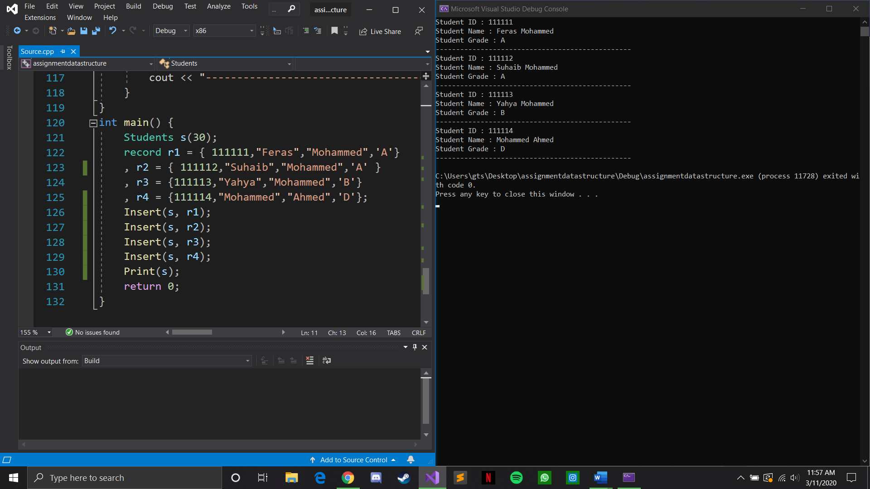

**Deleting one of the records using delete function :**

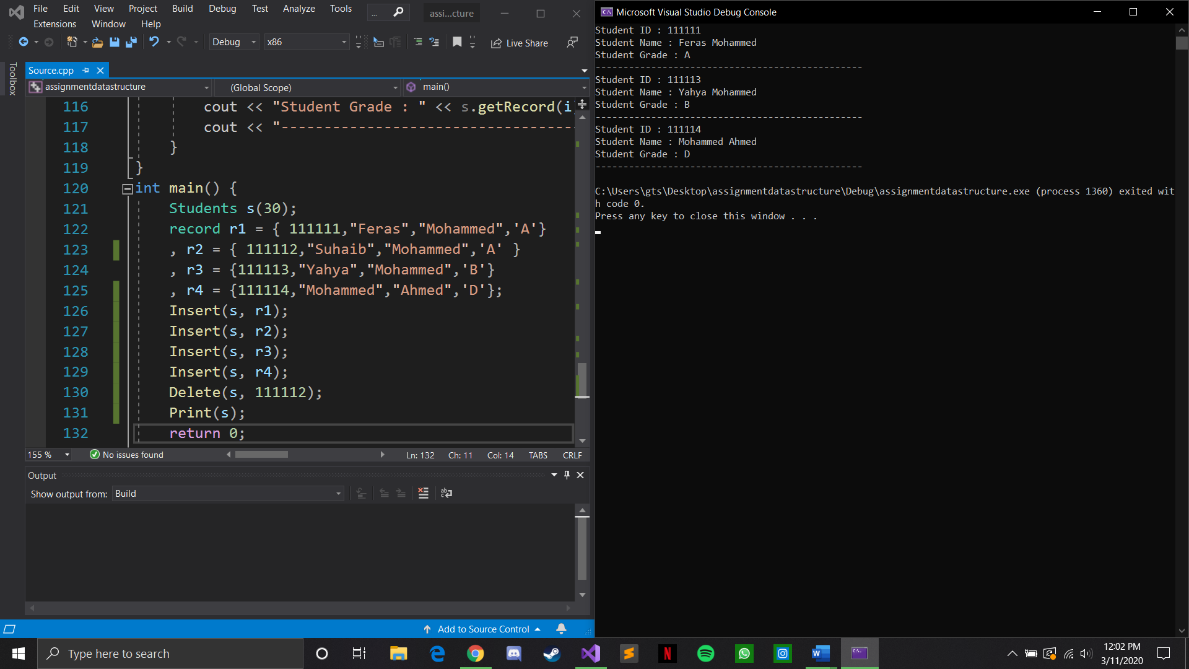

**Inserting 3 more records and deleting one that does not exist:**

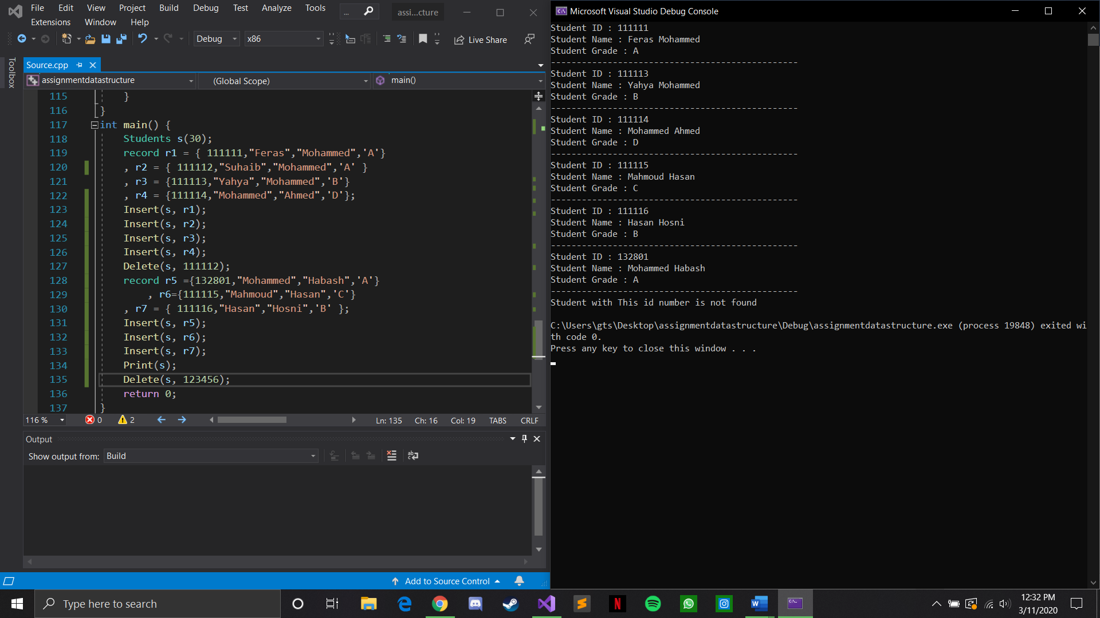

**Calling Search and Retrieve functions :**

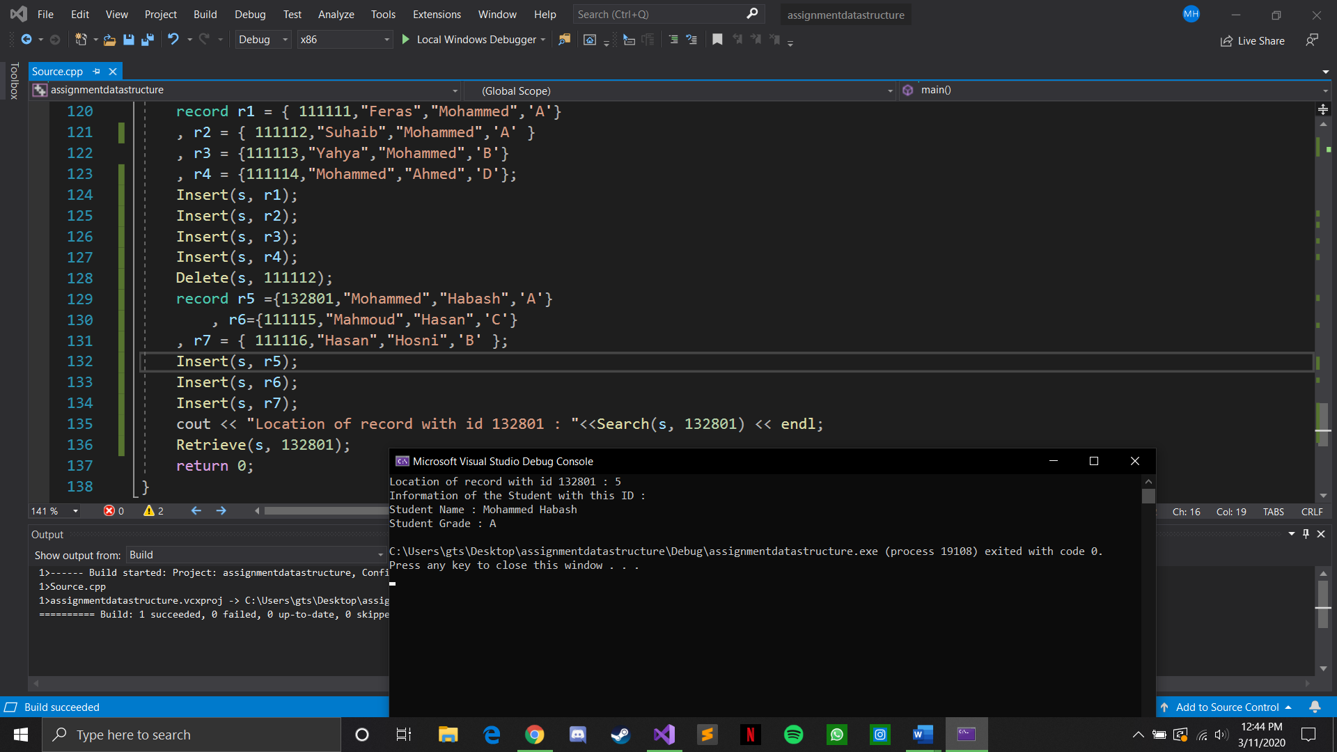

**Calling Print function to display all records:**

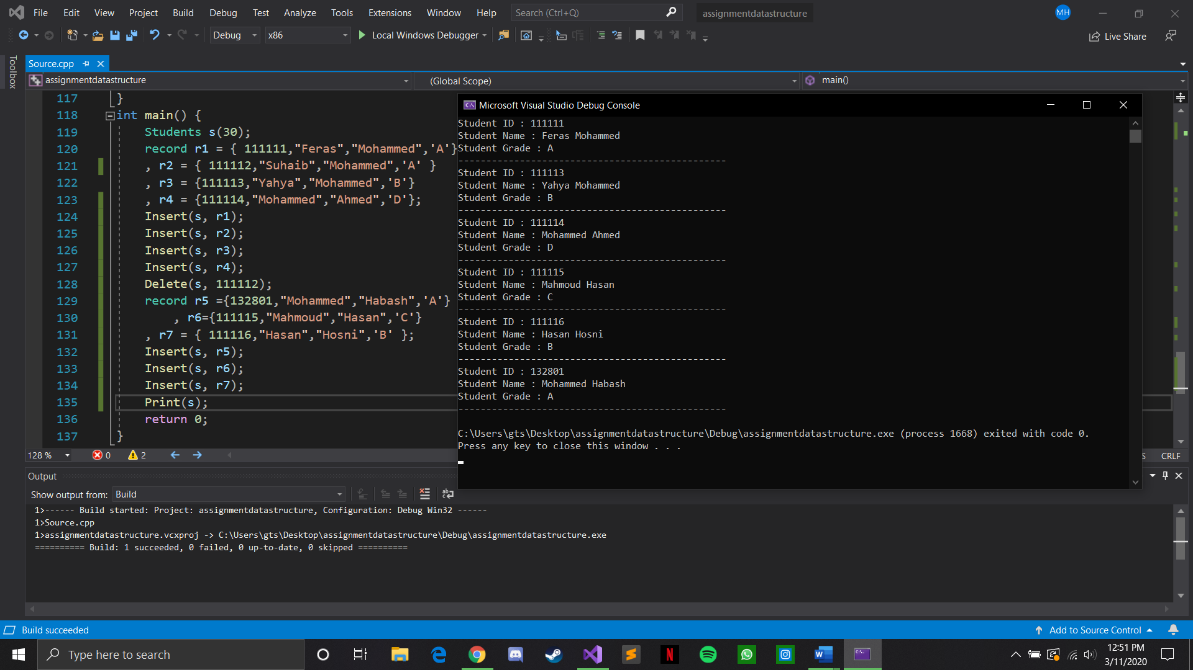

**main function with everything and the results of execution of the program:**

