**DATA DECISION REGIONS**

**NAME:** **Mohamadh Irfan**

**Batch: ai-elite-7**

**Deep Learning:**

Deep learning is a branch of machine learning which is based on artificial neural networks. It is capable of learning complex patterns and relationships within data. In deep learning, we don’t need to explicitly program everything. It has become increasingly popular in recent years due to the advances in processing power and the availability of large datasets. Because it is based on artificial neural networks (ANNs) also known as deep neural networks (DNNs). These neural networks are partially inspired by the structure and function of the human brain’s biological neurons, and they are designed to learn from large amounts of data.

**Data Set:**

A data set is an organized collection of data. They are generally associated with a unique body of work and typically cover one topic at a time. Information elements within a data set relate to one another, and analysts often categorize types of data to create relevant data sets that support important business processes, like financial metrics or sales transactions.

**Decision Regions:**

The boundary that distinguishes one class from another in a classification issue is known as a decision region in deep learning. It is the region of the input space that translates to a particular output or class.

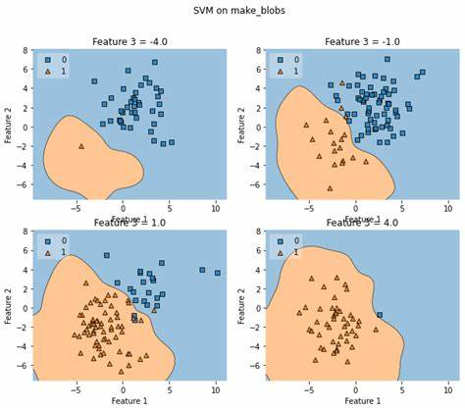

**Types of Decision Regions:**

* Linear decision surface
* Non – Linear decision surface

Linear decision surface:

A straight line or a hyperplane that divides the input space into two areas is referred to as a linear decision region because it may be used to represent a decision boundary in the input feature space. The usage of linear decision regions is common in linear classifiers like logistic regression, linear SVM, and perceptrons.

Non – Linear decision surface:

In other words, the decision boundary is a curved line, a surface, or a complex manifold that divides the input space into several parts. This type of decision boundary is known as a nonlinear decision region. It cannot be represented by a linear equation in the input feature space. Nonlinear decision regions are used by nonlinear classifiers like neural networks, random forests, and decision trees.

**Data Sets on which decision regions are performed:**

1. **U-shape:**

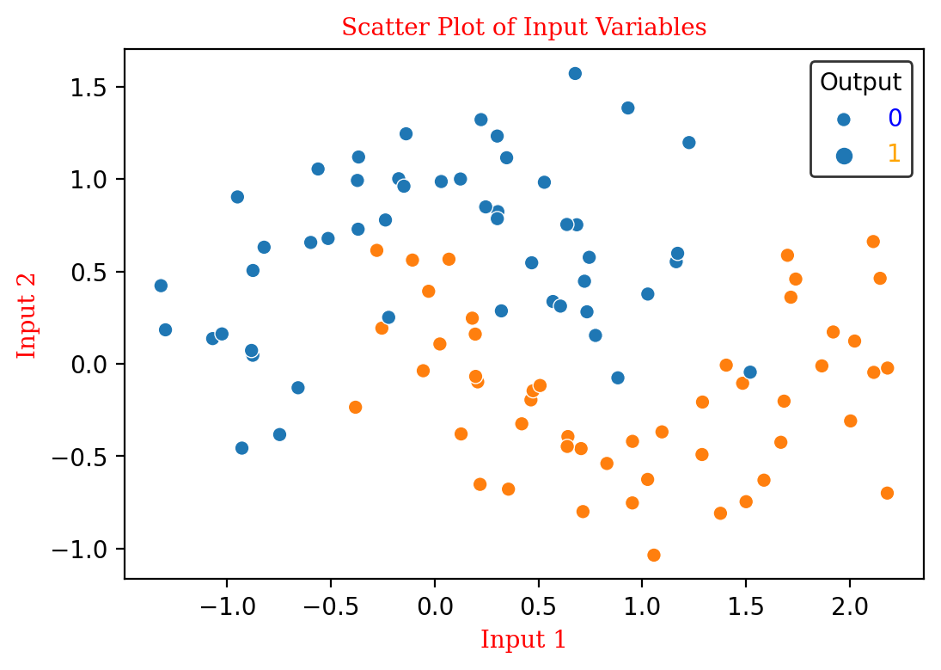

**Total Data points:** 100

**Number of features:** 3

**Values in label column:**[0,1]

**D-types:** Float64

**Descriptions:** One U-shape consists of labels as 1 and an inverted U-shape consists of 0 labelled data.

**2. Concerticcir-1:**

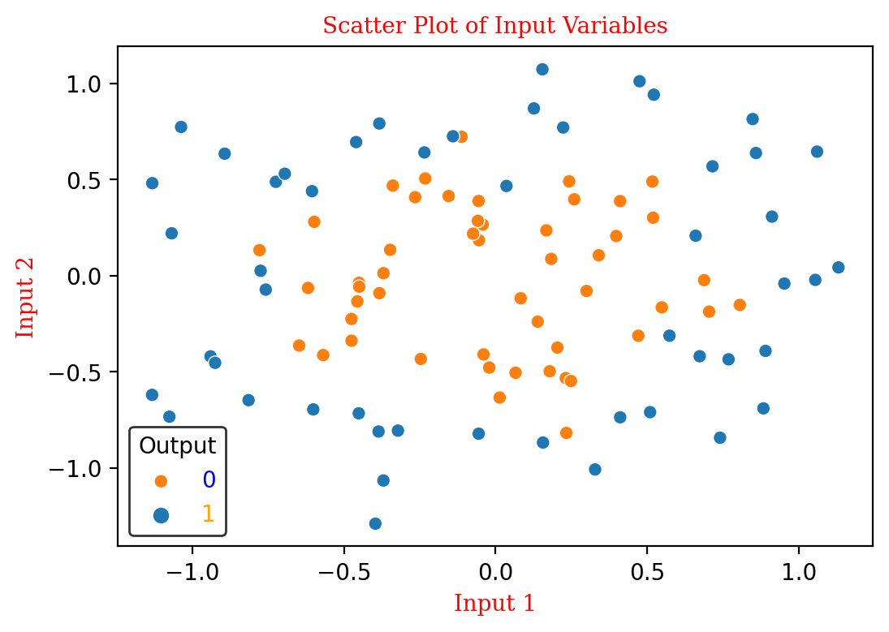

**Total Data points:** 100

**Number of features:** 3

**Values in label column:**[0,1]

**D-types:** Float64

**Descriptions:** The above dataset is in the shape of concentric in which 0 labelled data concentred the 1 labelled datapoints.

**3. Concertriccir-2:**

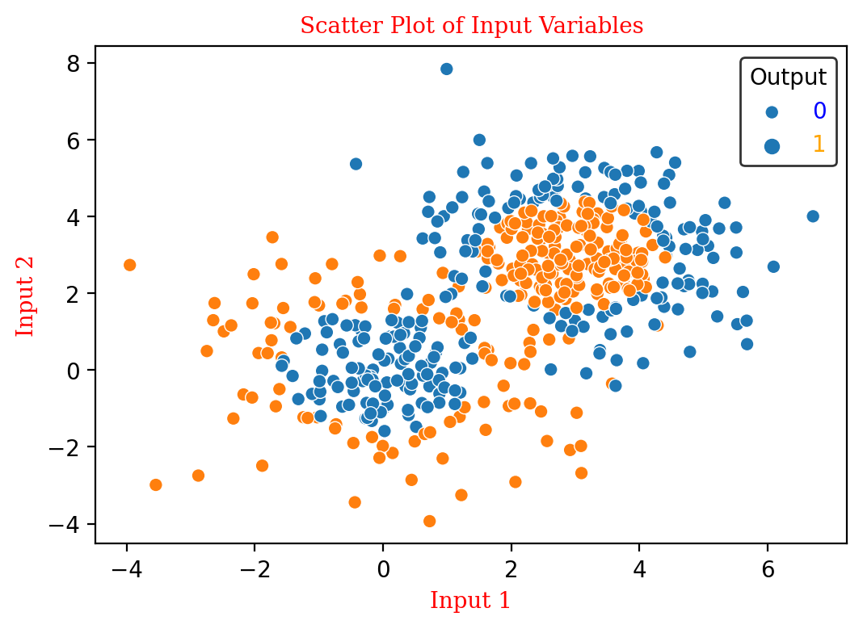

**Total Data points:** 500

**Number of features:** 3

**Values in label column:**[0,1]

**D-types:** Float64

**Descriptions:** The dataset consists of two concentric circled data points. One concentred the other labelled datapoints.

**4. Linear Separable:**

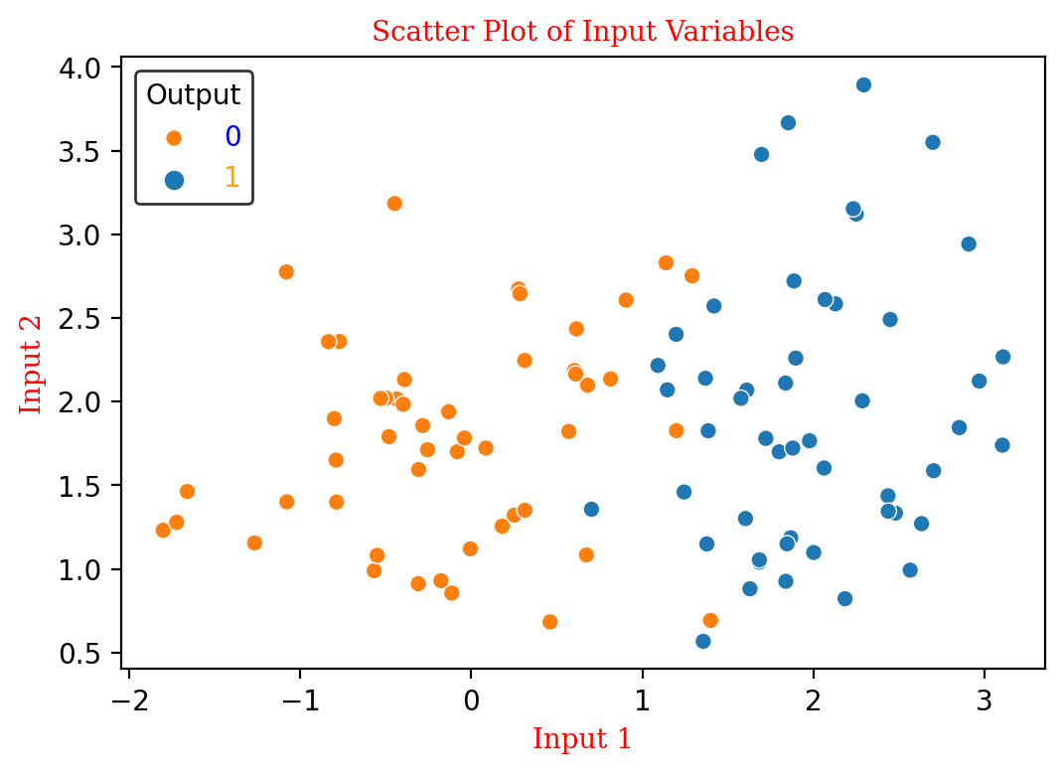

**Total Data points:** 100

**Number of features:** 3

**Values in label column:**[0,1]

**D-types:** Float64

**Descriptions:** The dataset consists of data points that are labelled as 0 and 1 and that are separable linearly.

**5. Outlier:**

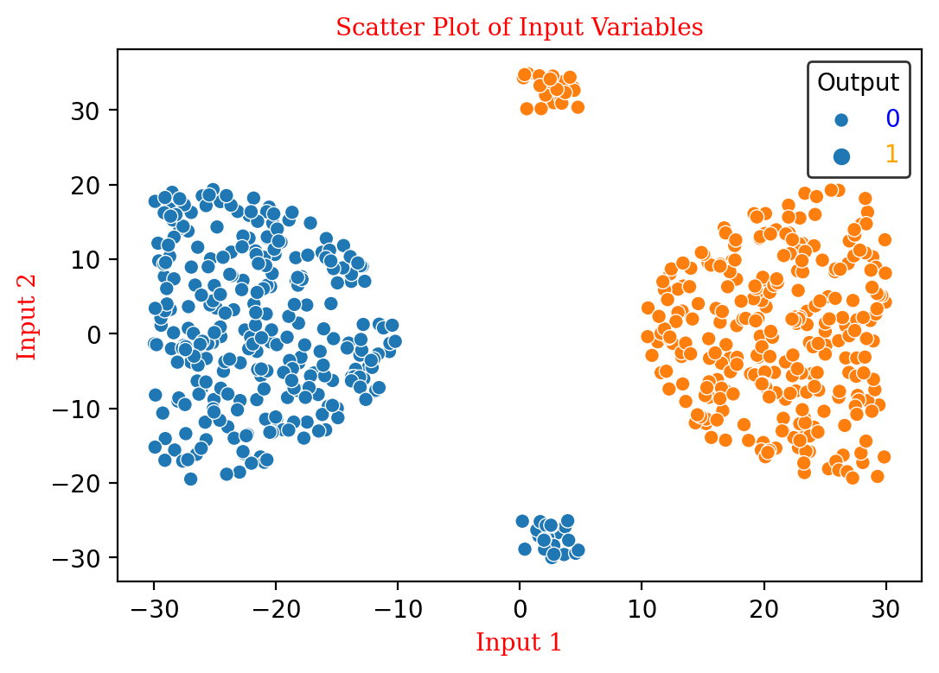

**Total Data points:** 600

**Number of features:** 3

**Values in label column:**[0,1]

**D-types:** Float64

**Descriptions:** In the above dataset the labels of 0 and 1 are classified properly but consists of few outliers in each class.

**6. Overlap:**

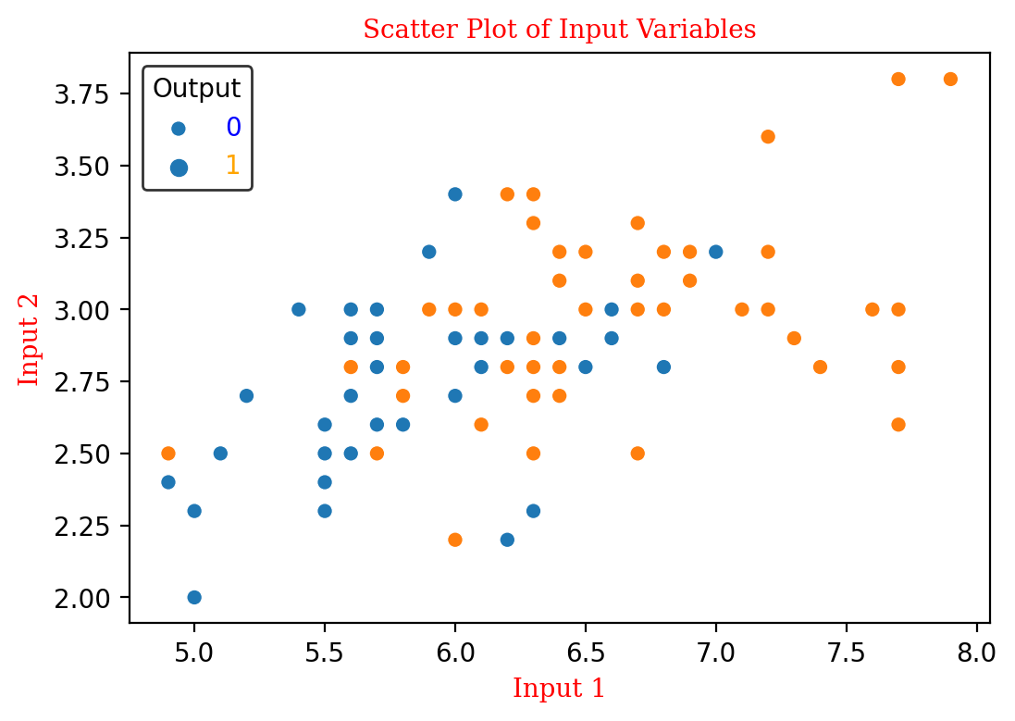

**Total Data points:** 100

**Number of features:** 3

**Values in label column:**[0,1]

**D-types:** Float64

**Descriptions:** The above dataset consists of 0 and 1 labelled datapoints in which few are overlapped on each other.

**7. XOR:**

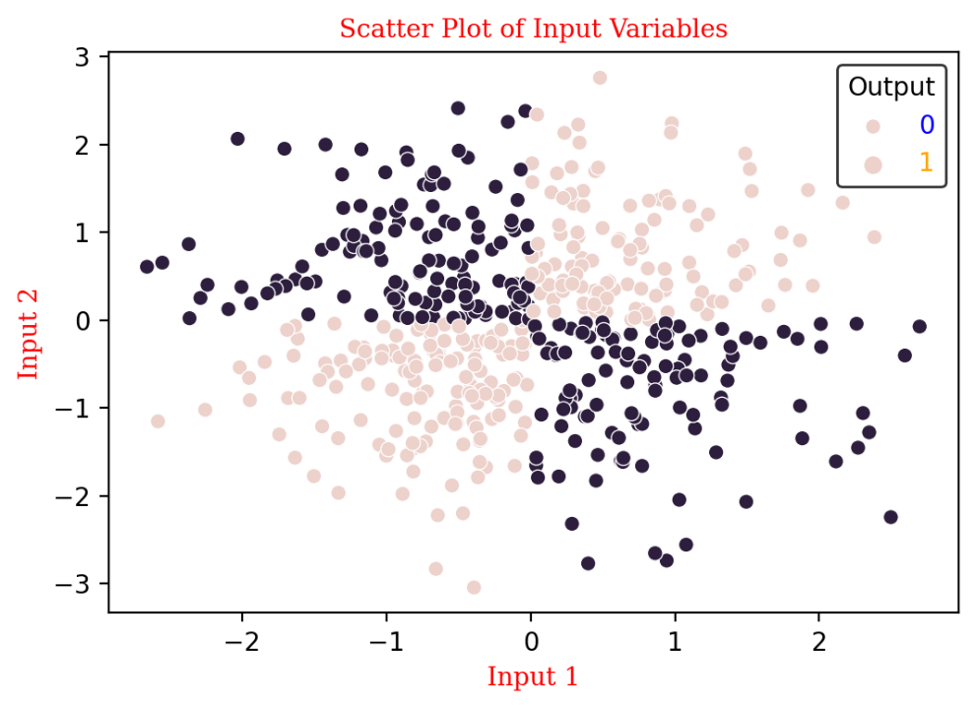

**Total Data points:** 500

**Number of features:** 3

**Values in label column:**[0,1]

**D-types:** Float64

**Descriptions:** The above dataset represents the XOR shaped data classified with 1 and 0 labelled datapoints.

**8. Two – Spirals:**

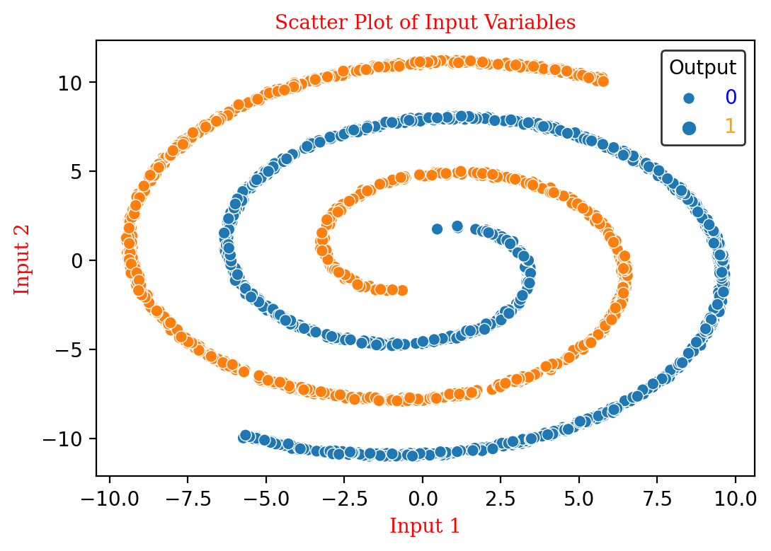

**Total Data points:** 2000

**Number of features:** 3

**Values in label column:**[0,1]

**D-types:** Float64

**Descriptions:** In the above dataset there are two spirals which consists of 0 and 1 as labels to their respective spirals

**9. Random:**

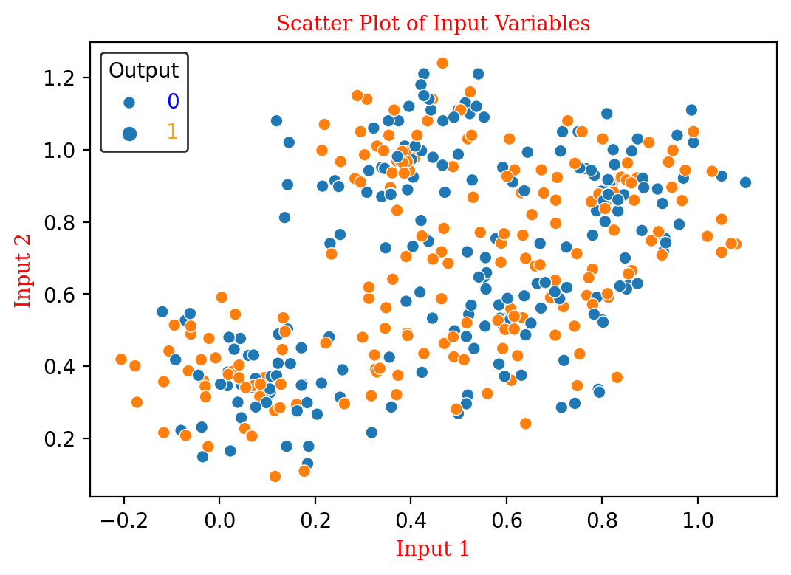

**Total Data points:** 400

**Number of features:** 3

**Values in label column:**[0,1]

**D-types:** Float64

**Descriptions:** In this dataset all the data points are randomly distributed across the plot. Few data points are overlapping on each other.

**DECISION REGIONS OF THE ABOVE DATASETS:**

