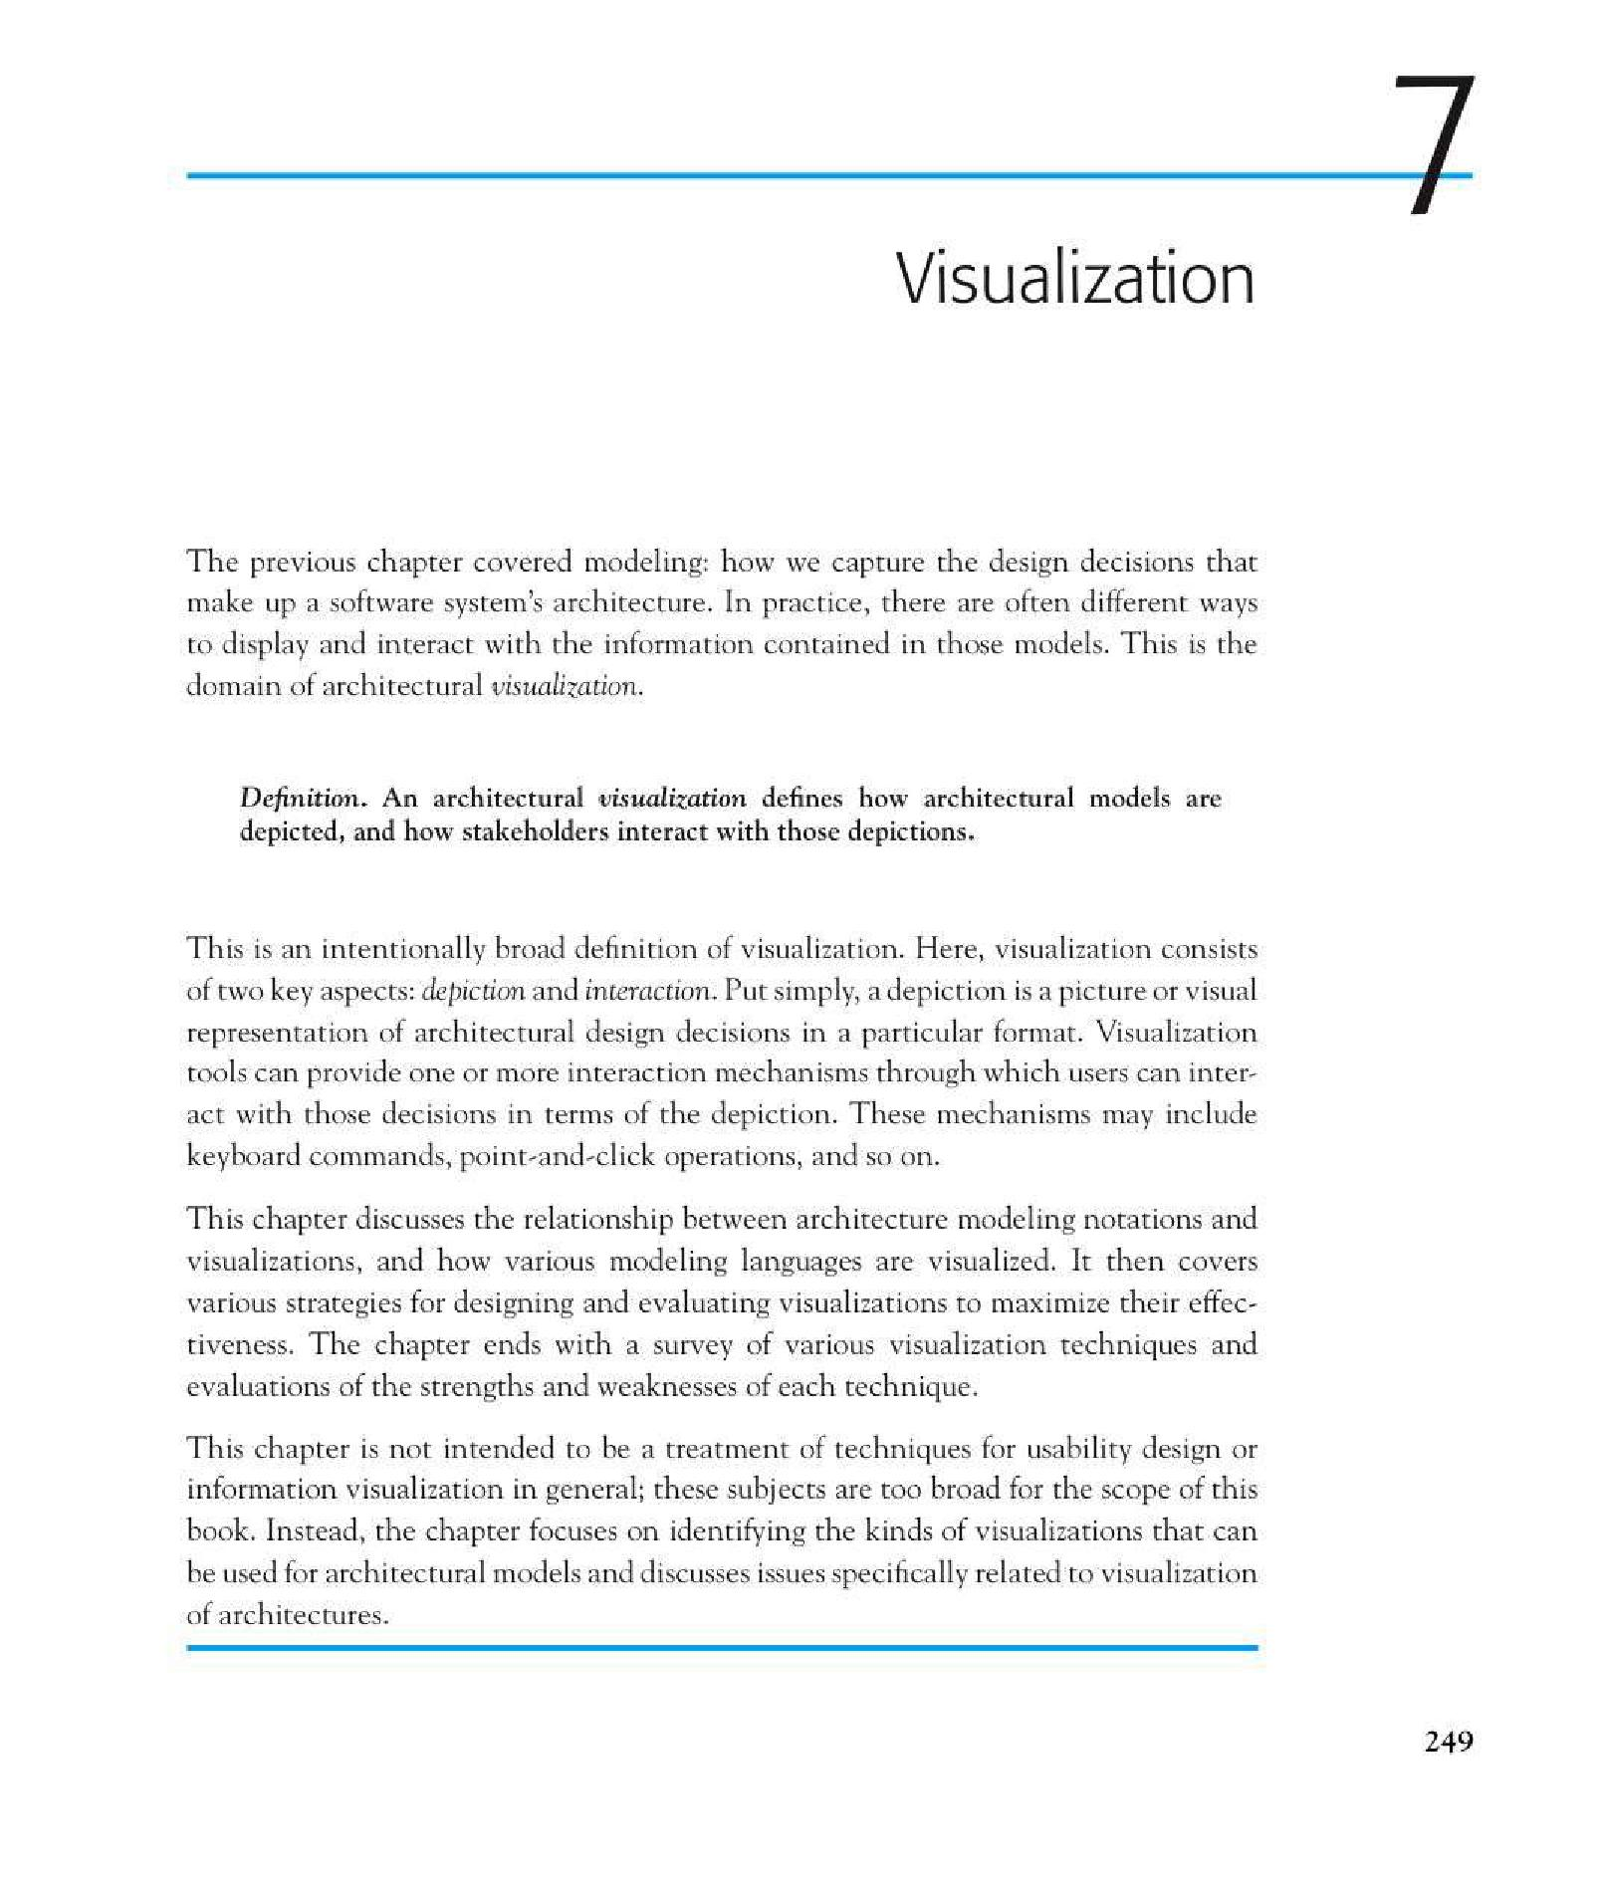
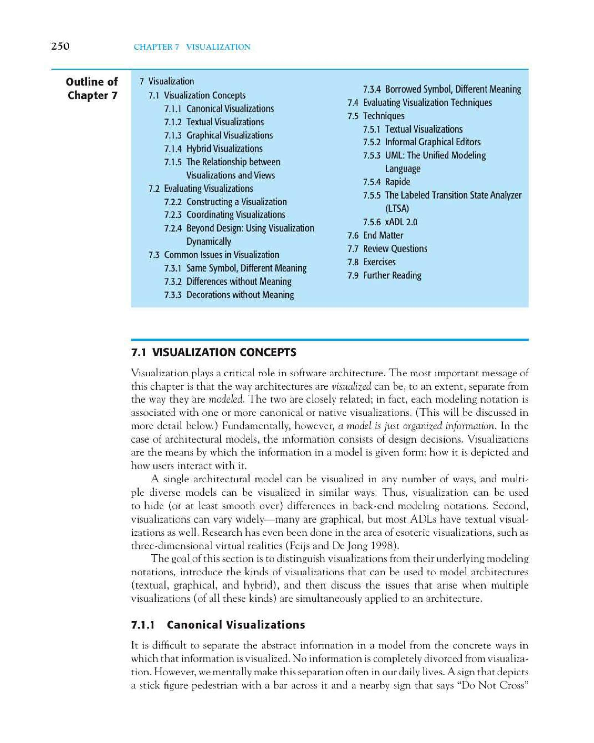
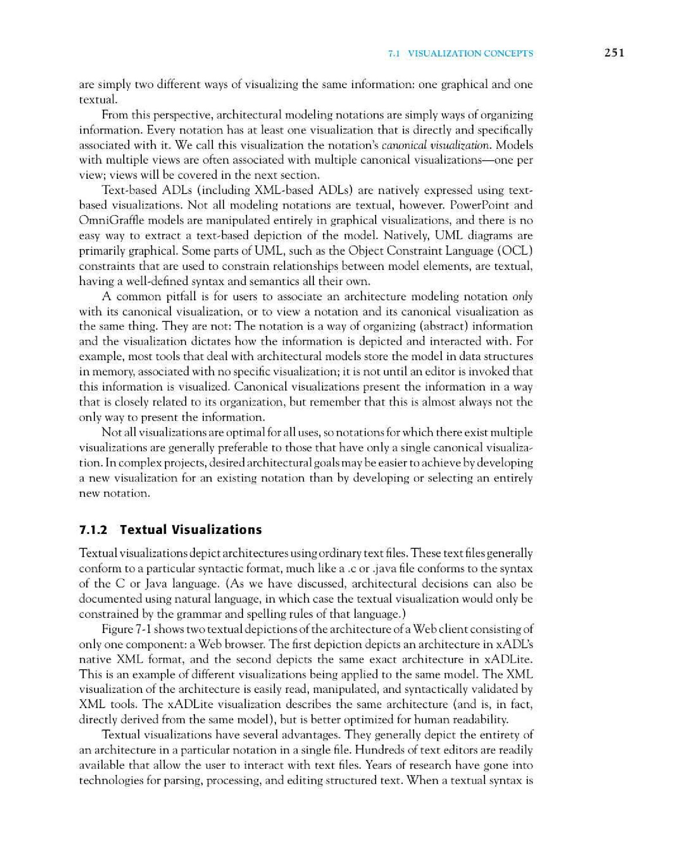
Thank you for evaluating
BCL easyConverter Desktop
This Word document was converted from PDF with an evaluation version of BCL easyConverter Desktop software that only converts the first 3 pages of your PDF.
CTRL+ Click on the link below to purchase
Activate your software for less than $20
http://www.pdfonline.com/easyconverter/

