Mohamad Issa

1. Project Overview
This project explores the interaction between cryptocurrencies and traditional economic forces through a data-driven economic analysis. The objective is to analyze the relationship between:


Bitcoin: and Ethereum :

, comparing trends, volatility, supply and demand behavior, and macroeconomic correlations such as inflation, exchange rates, and money supply. The goal is to understand how cryptocurrencies behave as economic assets during periods of instability.
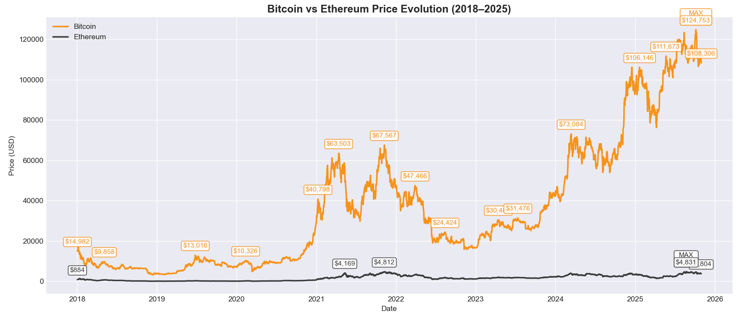
Figure 1: Bitcoin vs Ethereum – Price Evolution (2018–2025)
This visualization was produced in Python using time-series data processed through Pandas and plotted with Matplotlib. Data were obtained from CoinGecko API and processed using Python by packege yfinance
- This figure compares the price evolution of Bitcoin and Ethereum over the period 2018–2025, highlighting the major peaks and market trends for each asset. The annotations show key points such as starting prices, maximum values, and prices at the end of 2025, helping to visualize long-term growth patterns and the impact of significant market events.

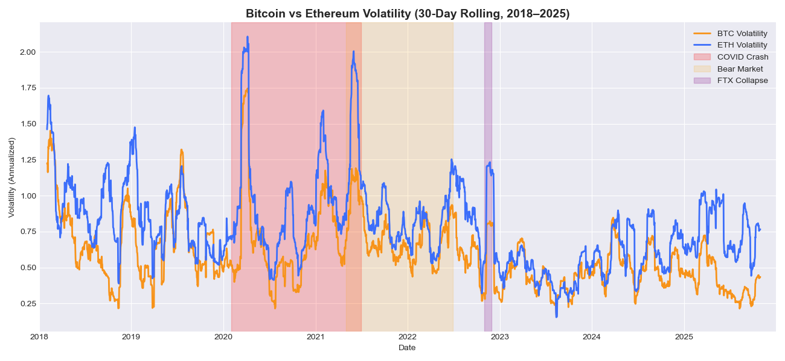
Figure2: Bitcoin vs Ethereum Volatility (30-Day Rolling, 2018–2025)

- This chart illustrates the annual price volatility of Bitcoin and Ethereum (30-Day Rolling Volatility) over the period from 2018 to 2025. It shows how each cryptocurrency responds to different market cycles and speculative phases, highlighting major events such as the COVID-19 pandemic, the 2021–2022 bear market, and the FTX collapse in November 2022. Ethereum is often observed to experience higher volatility than Bitcoin, reflecting a greater level of risk, while the shaded areas indicate the impact of major events on market stability.

Figure3:Correlations between bitcoin ,ethereum and gold

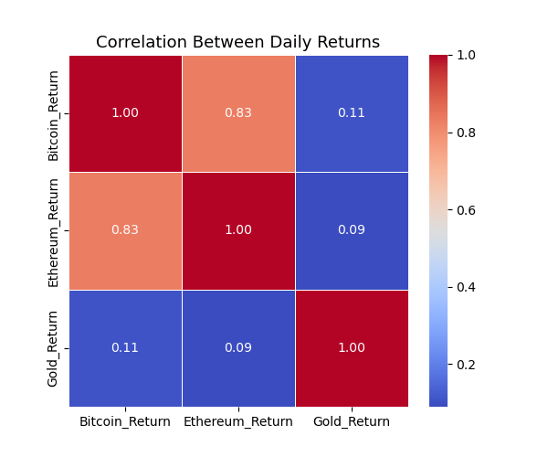

🔹 The correlation between Bitcoin and Ethereum is 0.83, indicating a strong positive correlation — they often move together in the same direction.
🔹 The correlation between Bitcoin and Gold is 0.11, indicating a weak positive correlation — the relationship is limited or occasional.
🔹 The correlation between Ethereum and Gold is 0.09, indicating no meaningful correlation — their movements are largely independent.

Strongest Positive Correlation: Bitcoin_Return ↔ Ethereum_Return (0.83)
Strongest Negative Correlation: Ethereum_Return ↔ Gold_Return (0.09)

Figure4:“Model relationships with inflation, exchange rate, and demand indicators.”
..\Desktop\bit and eth\btc_eth_indicators1_plot.html
Source: Plotly (Python Library)

📈 Correlation Results:
Indicator BTC_Correlation BTC_Strength ETH_Correlation ETH_Strength
Volume 0.569 Moderate correlation 0.565 Moderate correlation
AdrActCnt 0.018 Weak correlation 0.746 Strong correlation
Inflation -0.047 Weak correlation -0.001 Weak correlation
USD_LBP -0.085 Weak correlation 0.038 Weak correlation

- This section analyzes how Bitcoin and Ethereum prices correlate with key economic and demand indicators such as inflation, USD/LBP exchange rate, trading volume, and active address count (AdrActCnt).
An interactive chart below illustrates these relationships, supported by numerical correlation analysis to identify whether each link is strong, moderate, or weak.

Figure 5: “Bitcoin and Ethereum Prices with Halving Events (2018–2025)”
..\Desktop\bit and eth\btc_eth_prices_halving_secondary_y.html
Source: Plotly (Python Library)

The chart shows Bitcoin (yellow) and Ethereum (blue) prices from 2018 to October 31, 2025, with shaded areas indicating Bitcoin Halving events (±15 days). Bitcoin prices generally rise after each Halving, reflecting the reduced issuance rate and increased scarcity, which puts upward pressure on price. In contrast, Ethereum is not affected by Halving, and its price movements are mostly driven by general market factors. The chart highlights how supply constraints like Halving can influence cryptocurrency price behavior.

Figure 6: modeling(prophet)

..\Desktop\bit and eth\btc_eth_forecast_interactive_selected_events_CI_dual_y.html
This figure presents the actual and forecasted prices of Bitcoin (BTC) and Ethereum (ETH) ..\Desktop\bit and eth\btc_eth_forecast_2027.html
, including 95% confidence intervals. Key market events such as the COVID-19 crash, BTC Halving 3, and the 2022 Bear Market are highlighted with markers and shadows. Elasticity analysis shows how BTC and ETH prices respond to changes in supply and demand, providing insight into short-term market predictability.
Key Results:
- BTC Elasticity (Supply, Demand): [0.028, -0.038]
- ETH Elasticity (Supply, Demand): [0.00007, 0.0046]

Interpretation:
- BTC shows higher elasticity with respect to supply and demand compared to ETH in the studied period.
- ETH is less sensitive; its price changes only slightly with variations in supply and demand.
- These values provide an idea of how prices are affected by short-term economic factors and can help understand market expectations.

Interpretation of Results:
Bitcoin (BTC) and Ethereum (ETH) primarily behave as speculative assets, driven by investor sentiment and market activity rather than functioning as a hedge or a currency substitute. BTC demonstrates moderate sensitivity to supply changes, reflecting the impact of scarcity events such as halvings, which can temporarily influence its price. ETH, on the other hand, is less sensitive to supply and more influenced by network activity and demand indicators. Overall, short-term price movements for both cryptocurrencies are largely governed by market sentiment, trading activity, and investor expectations, while scarcity plays a secondary role, particularly for BTC.

7.social sentiment(a plus)
Source: Google Trends, https://trends.google.com by: pytrends in python
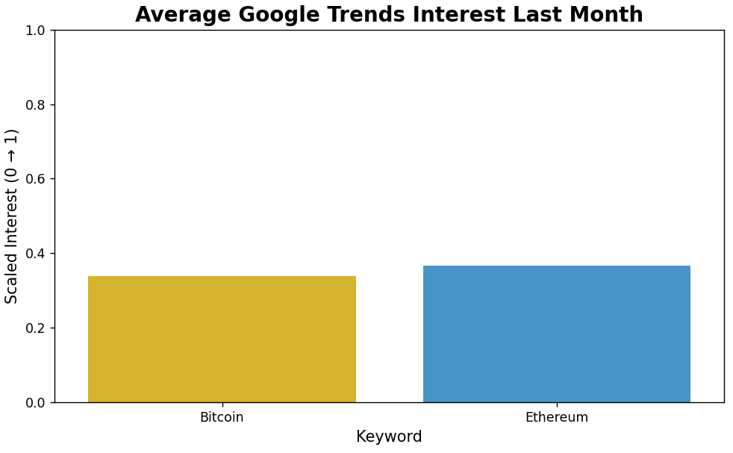

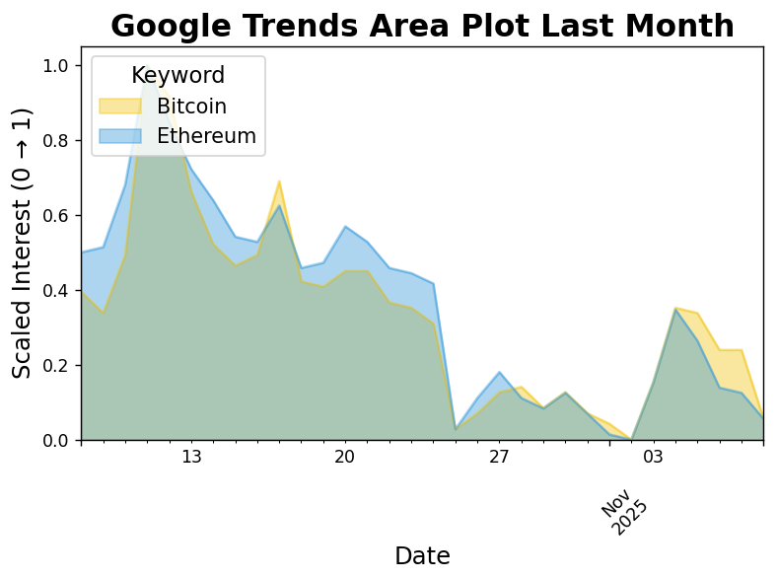
The data presented in this report represents the daily public interest in Bitcoin and Ethereum over the last month, collected from Google Trends. The values have been scaled between 0 and 1, where 0 represents the lowest interest during the month and 1 represents the highest interest. This scaling allows an easy comparison between the two cryptocurrencies and shows relative changes in public attention over time.

8. Recommendations
- .Future research should include more cryptocurrencies and macroeconomic factors to confirm results across different markets.
- .Adding social sentiment and using hybrid forecasting models (e.g., Prophet + ML) can improve prediction accuracy.
- .Bitcoin and Ethereum should be monitored as indicators of market confidence during economic instability.

Conclusion
This study explored the dynamics between Bitcoin and Ethereum in relation to economic indicators such as inflation, exchange rate, and market demand. The results show that both assets behave as speculative instruments, with Bitcoin exhibiting stronger sensitivity to supply events such as halvings, while Ethereum is more demand-driven. Overall, the analysis highlights the importance of monitoring cryptocurrency activity as a reflection of investor confidence and market sentiment during periods of economic instability.

References :
- CoinGecko. (2025). Cryptocurrency Market Data API. Retrieved from https://www.coingecko.com/en/api
- Yahoo Finance. (2025). Bitcoin (BTC-USD) and Ethereum (ETH-USD) Historical Market Data. Retrieved using the yfinance Python library.
- Plotly Technologies Inc. (2025). Plotly Python Graphing Library. Retrieved from https://plotly.com/python/
- Google Trends. (2025). Interest Over Time: Bitcoin vs Ethereum. Data collected using pytrends Python library. Retrieved from https://trends.google.com
- Facebook Research. (2025). Prophet Forecasting Model for Time Series Analysis. Integrated with yfinance for BTC and ETH price prediction. Retrieved from https://facebook.github.io/prophet/
- Issa, M. H. (2025). Bitcoin and Ethereum Interactive Analysis Files. [Local Python-generated HTML visualizations:
btc_eth_analysis.html,
btc_eth_prices_halving.html,
btc_eth_forecast_interactive_selected_events_CI.html].

