Normalization
Normalization or database normalization is a process to organize the data into database tables. To make a good database design, you have to follow Normalization practices. Without normalization, a database system might be slow, inefficient and might not produce the expected result. Normalization reduces data redundancy and inconsistent data dependency.
To make a good database design, you must know the normal forms and their best uses.
Normal Forms: Types of Normalization
We organize the data into database tables by using normal forms of rules or conditions. Normal forms help us to make a good database design. Generally, we organize the data up to the third normal form. We rarely use the fourth and fifth normal form.
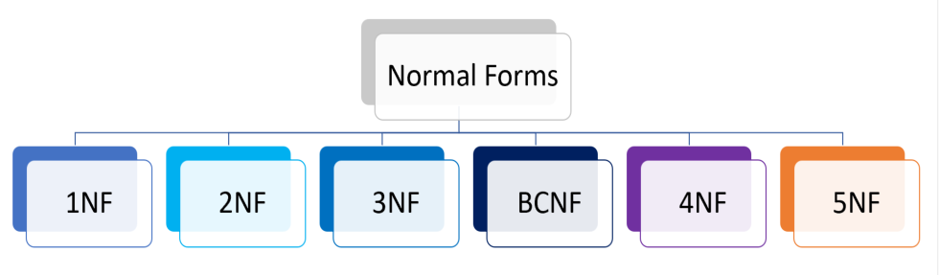
To understand normal forms consider the following unnormalized database table. Now we will normalize the data of below table using normal forms.
What is a Primary Key in SQL?
A Primary key is a unique column we set in a table to easily identify and locate data in queries. A table can have only one primary key.
The primary key column has a unique value and doesn’t store repeating values. A Primary key can never take NULL values.
For example, in the case of a student when identification needs to be done in the class, the roll number of the student plays the role of Primary key.
Similarly, when we talk about employees in a company, the employee ID is functioning as the Primary key for identification.
What is a Foreign key in SQL?
A Foreign key is beneficial when we connect two or more tables so that data from both can be put to use parallelly.
A foreign key is a field or collection of fields in a table that refers to the Primary key of the other table. It is responsible for managing the relationship between the tables.
The table which contains the foreign key is often called the child table, and the table whose primary key is being referred by the foreign key is called the Parent Table.
For example: When we talk about students and the courses they have enrolled in, now if we try to store all the data in a single table, the problem of redundancy arises.
To solve this table, we make two tables, one the student detail table and the other department table. In the student table, we store the details of students and the courses they have enrolled in.
And in the department table, we store all the details of the department. Here the courseId acts as the Primary key for the department table whereas it acts as the Foreign key in the student table.

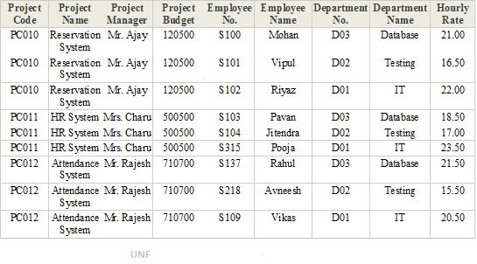
- First Normal Form (1NF)
A database table is said to be in 1NF if it contains no repeating fields/columns. The process of converting the UNF table into 1NF is as follows:
  - Separate the repeating fields into new database tables along with the key from the unnormalized database table.
  - The primary key of new database tables may be a composite key
- 1NF of above UNF table is as follows:
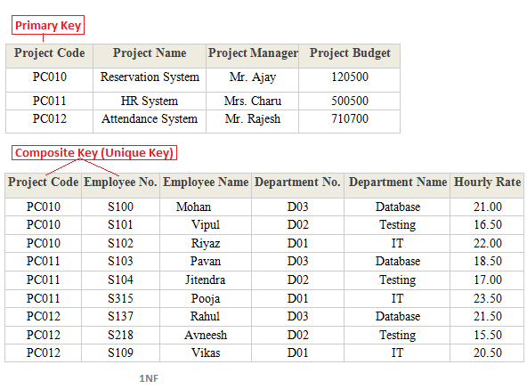
- Second Normal Form (2NF)
A database table is said to be in 2NF if it is in 1NF and contains only those fields/columns that are functionally dependent(means the value of the field is determined by the value of another field(s)) on the primary key. In 2NF we remove the partial dependencies of any non-key field.
The process of converting the database table into 2NF is as follows:
  - Remove the partial dependencies(A type of functional dependency where a field is only functionally dependent on the part of primary key) of any non-key field.
  - If field B depends on field A and vice versa. Also for a given value of B, we have only one possible value of A and vice versa, Then we put the field B into new database table where B will be the primary key and also marked as a foreign key in a parent table.
- 2NF of above 1NF tables is as follows:
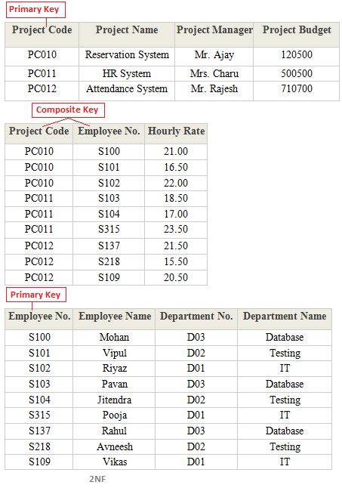
- Third Normal Form (3NF)
A database table is said to be in 3NF if it is in 2NF and all non-keys fields should be dependent on primary key or We can also say a table to be in 3NF if it is in 2NF and no fields of the table are transitively functionally dependent on the primary key. The process of converting the table into 3NF is as follows:
  - Remove the transitive dependencies(A type of functional dependency where a field is functionally dependent on the Field that is not the primary key. Hence its value is determined, indirectly by the primary key )
  - Make a separate table for transitive dependent Field.
- 3NF of above 2NF tables is as follows:
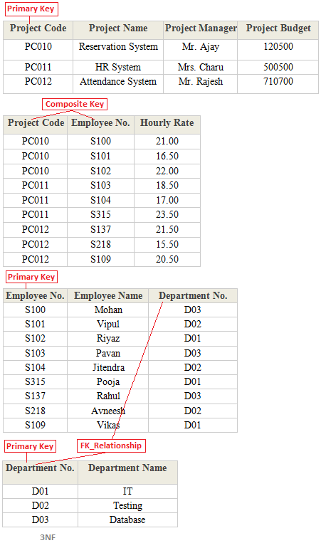
- Boyce Code Normal Form (BCNF)
A database table is said to be in BCNF if it is in 3NF and contains each and every determinant as a candidate key. The process of converting the table into BCNF is as follows:
  - Remove the nontrivial functional dependency.
  - Make a separate table for the determinants.
- BCNF of below table is as follows:
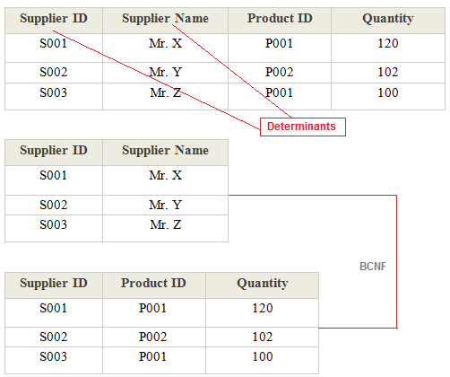

- Fifth Normal Form (5NF)
A database table is said to be in 5NF if it is in 4NF and contains no redundant values or We can also say a table to be in 5NF if it is in 4NF and contains no join dependencies. The process of converting the table into 5NF is as follows:
  - Remove the join dependency.
  - Break the database table into smaller and smaller tables to remove all data redundancy.
- 5NF of below table is as follows:
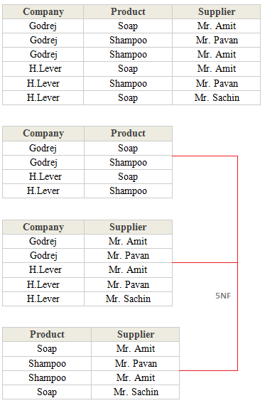

DDL:
DDL is Data Definition Language which is used to define data structures. For example: create table, alter table are instructions in SQL.
DML:
DML is Data Manipulation Language which is used to manipulate data itself. For example: insert, update, delete are instructions in SQL.
Difference between DDL and DML:
DDL | DML
It stands for Data Definition Language. | It stands for Data Manipulation Language.
It is used to create database schema and can be used to define some constraints as well. | It is used to add, retrieve or update the data.
It basically defines the column (Attributes) of the table. | It add or update the row of the table. These rows are called as tuple.
It doesn’t have any further classification. | It is further classified into Procedural and Non-Procedural DML.
Basic command present in DDL are CREATE, DROP, RENAME, ALTER etc. | BASIC command present in DML are UPDATE, INSERT, MERGE etc.
DDL does not use WHERE clause in its statement. | While DML uses WHERE clause in its statement.
SQL Queries –

Database creation

create database ABc

Create Table command
create table student
( St_Id varchar(10),
name char(10),
age int,
marks int)

Insert Command

insert into student values('s101','deepti',12,90)

Drop table and databases
drop table student
drop database ABc

Select Query with Where clause–
Th sql where clause is used to specify a condition while fetching the data from a single table or joining with multiple tables.

select * from Emp where salary <=200

With AND and OR operator
select * from Emp where salary >=2000 Or EMpAge <20

Update command

update Emp
set Empname='deeptishu' where Empid='e101'

Delete command
delete from Emp

Top command for retrieving top 3 rows

select top 3 * from student

Order by clause–

It is used to sort the data in ascending order or descending based on one or more column.

select * from student order by name,age desc

Group by clause–

It is used in collaboration with select statements to arrange identical data into groups .

select name,sum(marks) from student group by name

Distinct keyword

It is works with select statement to eliminate all the duplicate records.and fetching only unique records.

select distinct st_id,name from student order by name

Queries 👍
create database CB
create table student1
(Sid varchar(10),
name char(10),
age int,
address varchar(10))
select * from student1 where address='delhi' or age >=5
insert into student1 values('p106','amit',4,'Gurgaon')
drop table EMP
delete student1

update student1 set age=14 where sid ='p102'

select * from student1 order by name,age,address asc
select name,sum(age) from student1 group by name
select * from student1
select distinct sid,name,age,address from student1 order by name

Alter Table command

alter table student add email varchar(25)

Update command using case

update student set email =case st_id
when '101' then 'aarav@'
when '102' then 'manas@'
else email
end
where
st_id in('101','102')

Alter table -Drop column

alter table student
drop column email

Modify column

alter table student alter column name varchar(20)

In student table using alter command add 4 new columns math,eng,hindi,science and update values using update command with case statements.you can add stuid if its not there.

SQL Constraints
SQL constraints are used to specify rules for the data in a table.
Constraints are used to limit the type of data that can go into a table. This ensures the accuracy and reliability of the data in the table. If there is any violation between the constraint and the data action, the action is aborted.
Constraints can be column level or table level. Column level constraints apply to a column, and table level constraints apply to the whole table.
The following constraints are commonly used in SQL:
- NOT NULL - Ensures that a column cannot have a NULL value
- UNIQUE - Ensures that all values in a column are different
create table emp1
( id int not null unique,
fname varchar(10) not null,
lname varchar(20) not null,
age int)

alter table emp1 add constraint em_id unique(id)
- PRIMARY KEY - A combination of a NOT NULL and UNIQUE. Uniquely identifies each row in a table
- FOREIGN KEY - Prevents actions that would destroy links between tables
- CHECK - Ensures that the values in a column satisfies a specific condition
- DEFAULT - Sets a default value for a column if no value is specified
- CREATE INDEX - Used to create and retrieve data from the database very quickly

Primary Key Constraints

create table product1
(
pro_id int primary key (pro_id)not null,
pro_name varchar(10),
address varchar (10))

Primary Key Constraints with alter Table
alter table emp
add primary key(Empid)

alter table emp1
add constraint Pk primary key (id,fname)

Foreign Key Constraints
Create first table emp with id column as a primary key.
Create second table dept and take id column as a foreign key references.

create table dept1
(
DeptId int not null,
deptName varchar(20),
id int ,
primary key (deptId),constraint FK_EmpDept foreign key (id) references emp1(id))

With Alter Command

alter table student
add constraint FK_EmpSt
foreign key (id) references emp1(id)

Check constraint

It is used to check the value range that can be placed in a column.
If you define a check constraint on a column it will allow only certain values for the column.

create table person
(
id int not null,
fname varchar(20),
Lname varchar(20),
age int ,
check (age>=18))

insert into person values (101,'amit','singh',12)

Alter command

alter table person add constraint chk_abc check(age>=21 and city='Delhi')

Default Constraint

alter tABLE PERSON
ADD CONSTRAINT df default 'Mumbai' for city

CREATE TABLE G (
ID int NOT NULL,
Name varchar(255),
Age int,
Location varchar(255) DEFAULT 'Noida');

Task–

Create 3 table one is project manager,project ,developer apply multiple foreign key constraint concept.

Aggregate functions in SQL

In database management an aggregate function is a function where the values of multiple rows are grouped together as input on certain criteria to form a single value of more significant meaning.

Various Aggregate Functions
1) Count()-->select count(marks) as 'totalaverage' from student

2) Sum() → select sum(marks) as 'totalaverage' from student

3) Avg()-->select avg(marks) as 'totalaverage' from student

4) Min()
5) Max()

Problem statements:

1. WRITE A QUERY TO DISPLAY TOTAL SALARY NEEDED TO PAY EACH JOB IN EMPLOYEE TABLE.
2. WRITE A QUERY TO DISPLAY THE HIRE DATE ON WHICH AT LEAST 3 EMPLOYEES WHERE HIRED.
3. WRITE A QUERY TO DISPLAY THE DEPARTMENT NUMBER WHICH HAS MORE THAN 2 EMPLOYEES AND THE TOTAL AMOUNT REQUIRED TO PAY THE MONTHLY SALARIES OF ALL THE EMPLOYEES IN THAT DEPARTMENT SHOULD BE MORE THAN 9000.
4. WRITE A QUERY TO DISPLAY NUMBER OF EMPLOYEES WORKING IN EACH DEPARTMENT AND ITS’ AVERAGE SALARY BY EXCLUDING ALL THE EMPLOYEES WHOSE SALARY IS LESS THAN THEIR COMMISSION.
5. WRITE A QUERY TO DISPLAY THE SALARIES WHICH HAS REPETITIONS IN THE SAL COLUMN OF EMPLOYEE TABLE.
6. WRITE A QUERY TO DISPLAY THE EMPLOYEE NAME ONLY IF MORE THAN ONE PERSON IN THE EMPLOYEES OF THE COMPANY HAS SAME NAME.
7. WRITE A QUERY TO DISPLAY THE DEPARTMENT NUMBER WHOSE AVERAGE SALARY IS BETWEEN 2500 AND 3000. 8. WRITE A QUERY TO DISPLAY THE NUMBER OF EMPLOYEES

Bank Account System
Problem Statement:
Create a table BankAccounts with constraints:
- AccountNumber as Primary Key.
- Balance must always be ≥ 0.
- AccountType must allow only 'Savings' or 'Current'.
- CreatedDate should have default current date.
- AadharNumber must be unique.
5️⃣ Course Enrollment System
Problem Statement:
Create table Enrollments with:
- Composite Primary Key using StudentID and CourseID.
- EnrollDate default to current date.
- Grade must be between 0 and 100.
- StudentID must reference Students.
- CourseID must reference Courses.
6️⃣ Insurance Claim System (Advanced Scenario)
Since you're working on an insu

