- Asp
- Asp.net
- Asp.net MVC
- Asp.net core
- Asp.net Core MVC

What is ASP.NET Core
ASP.NET Core is the new version of the ASP.NET Web Framework mainly targeted to run on .NET Core Platform.
ASP.NET Core is a free, open-source, high-performance, light-weight, and cross-platform framework for building cloud-based applications, such as web apps, IoT apps, and mobile backend. It is designed to run on the cloud as well as on-premises.
Same as .NET Core, it was architected modular with minimum overhead, and then other more advanced features can be added as NuGet Packages as per application requirement. This results in high performance, require less memory, less deployment size, and easy to maintain.
ASP.NET Core Framework is completely rewritten of existing ASP.NET 4.x, with architectural changes that make it more modular, scalable, open-source, high-performance, lightweight, and a cross-platform web framework.
Unified MVC and Web API Framework:
The ASP.NET Core provides a unified programming model for developing both Web apps and Web APIs. That means a single controller class can be used to handle both. The Controller we create in ASP.NET Core (either Web APPs or Web APIs) application is going to inherit from the Controller base class and returns the IActionResult interface. The IActionResult interface provides several implementations. The built-in result types such as the JsonResult and the ViewResult and (like this there are so many result types available that we will discuss later) implement the IActionResult interface.
Handling Request and Response Pipeline:
We can handle the request and response in the ASP.NET Core application by using the new Middleware Components. In earlier ASP.NET 4.x we generally use Handlers and Modules to handle the Request and Response pipeline. The ASP.NET Core Framework provides a lot of built-in Middleware Components and we can use those Middleware Components to handle the request and response pipeline. If you want, then also you can create your own middleware components and use them in the request-response pipeline..

Hosting:
ASP.NET Core web application can be hosted on multiple platforms with any web server such as IIS, Apache, etc… It is not dependent only on IIS as a standard .NET Framework.
Code Sharing: It allows you to build a class library that can be used with .NET Frameworks such as .NET Framework 4.x or Mono. Thus, a single code base can be shared across frameworks.
Side-by-Side App Versioning: ASP.NET Core runs in .NET Core, which supports the simultaneous running of multiple versions of applications.
Extensible Framework:
The ASP.NET Core MVC Framework is designed to be highly extensible. That means you can create an application today, that can be extended to any levels in the future. Some of the key features provided by this framework that give it the extensible power are as follows.
- View Components
- Tag Helpers
- Routing
What the ASP.NET Core doesn’t have?
If you are coming from ASP.NET 4.x, then you will not find the following things in ASP.NET Core
- The Global.asax file
- Web.Config file
- HTTP Handlers and HTTP Modules
- ASP.NET Page Life-Cycle model
.NET Core vs ASP.NET Core:
.Net Core:
- .NET Core is open-source and cross-platform
- .NET Core is a runtime to execute applications which ate build on it.
- Install .NET Core Runtime to run applications and install .NET Core SDK to build applications.
- .NET Core 3.1 – latest version
ASP.NET Core:
- Asp.net core is Open-source and Cross-platform
- ASP.NET Core is a web framework to build web apps, IoT apps, and mobile backend on top of .NET Core.
- There is no separate runtime and SDK are available for ASP.NET Core. .NET Core runtime and SDK includes ASP.NET Core libraries.
- ASP.NET Core 3.1 – latest version
- There is no separate versioning for ASP.NET Core. It is the same as the .NET Core versions.
Language Support:
Dot Net Core Framework supports the following language i.e. using the following languages you can develop .NET Core applications. We are going to use C# as the programming language in this course.
- C#
- F#
- Visual Basic (VB)

What is MVC?
MVC stands for Model View and Controller. It is an architectural design pattern that means this design pattern is used at the architecture level of an application. So, the point that you need to remember is MVC is not a programming language, MVC is not a Framework, it is a design pattern. When we design an application, first we create the architecture of that application, and MVC plays an important role in the architecture of that particular application.
MVC Design Pattern is basically used to develop interactive applications. An interactive application is an application where there is user interaction involved and based on the user interaction some event handling occurred. The most important point that you need to remember is, it is not only used for developing web-based applications but also we can use this MVC design pattern to develop the Desktop or mobile-based application.
Working
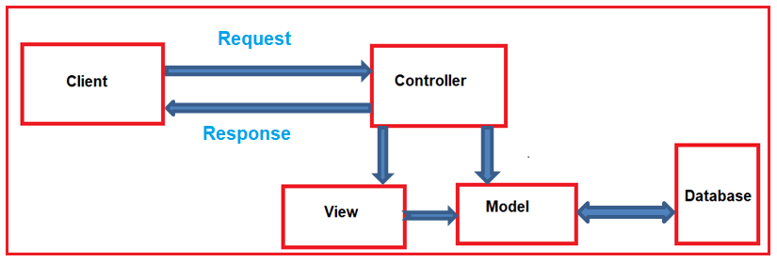
The controller is the component in the MVC design pattern, who actually handles the incoming request. In order to handle the request, the controller components do several things are as follows. The controller component creates the model that is required by a view. The model is the component in the MVC design pattern which basically contains classes that are used to store the domain data or you can say business data.
In the MVC design pattern, the Model component also contains the required logic in order to retrieve the data from a database. Once the model created by the controller, then the controller selects a view to render the domain data or model data. While selecting a view, it is also the responsibility of the controller to pass the model data.
In the MVC design pattern, the only responsibility of view is to render the model data. So, in MVC, the view is the component whose responsibility is to generate the necessary HTML in order to render the model data. Once the HTML is generated by the view, then that HTML is then sent to the client over the network, who initially made the request.
Model:
The Model is the component in the MVC Design pattern which is used to manage that data i.e. state of the application in memory. The Model represents a set of classes that are used to describe the application’s validation logic, business logic, and data access logic.
public class Student
{
public int StudentID { get; set; }
public string Name { get; set; }
public string Gender { get; set; }
public string Branch { get; set; }
public string Section { get; set; }
}
public class StudentBusinessLayer
{
public IEnumerable<Student> GetAll()
{
//logic to return all employees
}
public Student GetById(int StudentID)
{
//logic to return an employee by employeeId
Student student = new Student()
{
StudentID = StudentID,
Name = "James",
Gender = "Male",
Branch = "CSE",
Section = "A2",
};
return student;
}
public void Insert(Student student)
{
//logic to insert an student
}
public void Update(Student student)
{
//logic to Update an student
}
public void Delete(int StudentID)
{
//logic to Delete an student
}
}

View:
The view component in the MVC Design pattern is used to contain the logic to represent the model data as a user interface with which the end-user can interact. Basically, the view is used to render the domain data (i.e. business data) which is provided to it by the controller.
For example, we want to display Student data in a web page. In the following example, the Student model carried the student data to the view. As already discussed, the one and only responsibility of the view is to render that student data. The following code does the same thing.
@model ASPCoreApplication.Models.Student
<html>
<head>
<title>Student Details</title>
</head>
<body>
<br/>
<br/>
<table>
<tr>
<td>Student ID: </td>
<td>@Model.StudentID</td>
</tr>
<tr>
<td>Name: </td>
<td>@Model.Name</td>
</tr>
<tr>
<td>Gender: </td>
<td>@Model.Gender </td>
</tr>
<tr>
<td>Branch: </td>
<td>@Model.Branch</td>
</tr>
<tr>
<td>Section: </td>
<td>@Model.Section </td>
</tr>
</table>
</body>
</html>
Controller:
A Controller is a .cs (for C# language) file which has some methods called Action Methods. When a request comes on the controller, it is the action method of the controller which will handle those requests.
The Controller is the component in an MVC application that is used to handle the incoming HTTP Request and based on the user action, the respective controller will work with the model and view and then sends the response back to the user who initially made the request. So, it is the one that will interact with both the models and views to control the flow of application execution. In our example, when the user issued a request the following URL
Where MVC is used in the real-time three-layer application?
In general, a real-time application may consist of the following layers
- Presentation Layer: This layer is responsible for interacting with the user.
- Business Layer: This layer is responsible for implementing the core business logic of the application.
- Data Access Layer: This layer is responsible for interacting with the database to perform the CRUD operations.Create,Read,Update and delete
The MVC design pattern is basically used to implement the Presentation Layer of the application. Please have a look at the following diagram.
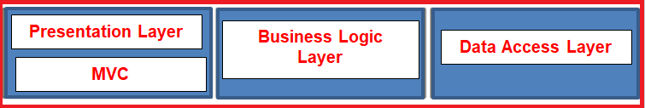
What is ASP.NET Core MVC?
The ASP.NET Core MVC is a lightweight, open-source, highly testable presentation framework that is used for building web apps and Web APIs using the Model-View-Controller (MVC) design pattern. So, the point that you need to remember is, MVC is a design pattern and ASP.NET Core MVC is the framework that is based on MVC Design Pattern.
The ASP.NET Core MVC Framework provides us with a patterns-based way to develop dynamic websites and web apps with a clean separation of concerns. This ASP.NET Core MVC framework provides us the full control over the mark-up. It also supports for Test-Driven Development and also uses the latest web standards.

