🔹 12. FUTURE WORK
- Add real-time satellite feed integration
- Support higher-res data (e.g., Sentinel-2 + LST)
- Integrate with weather forecasting models

🔹 11. CONCLUSION
The system successfully links land cover types to surface temperatures using satellite data and deep learning. It improves urban heat mapping accuracy and provides actionable insights for planners.

🔹 10. DEMO WORKFLOW
- Upload satellite RGB, TIR, and metadata
- Segment objects with SegFormer
- Compute temperature per object
- Export maps and tables

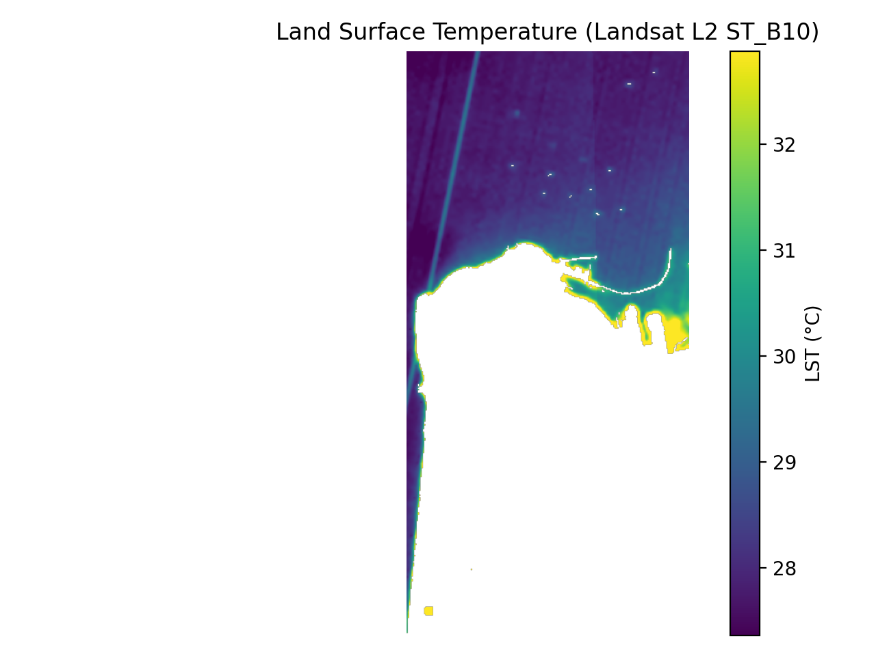

🔹 9. EVALUATION METRICS
Segmentation Accuracy:
Buildings IoU: 0.82, Dice: 0.90
Vegetation IoU: 0.85, Dice: 0.92
LST Error (vs. ground truth):
Tel Aviv: 33.6°C (error: 0.8°C)
Haifa: 31.2°C (error: 0.6°C)

🔹 8. CHALLENGES & SOLUTIONS
Challenge | Solution
Misalignment between RGB & Thermal | Co-registration & resampling
Poor segmentation of natural areas | Focused on object-level stats, not pixel
LST calibration complexity | Mono-window algorithm + metadata

🔹 7. RESULTS & ANALYSIS
Object Type | Mean Temp (°C) | Area (m²)
Buildings | 34.8 | 12,342
Roads | 36.1 | 8,104
Vegetation | 29.2 | 10,221
Water | 26.5 | 2,031

🔹 2. BACKGROUND & PROBLEM
- Traditional weather forecasts are region-based, lacking detail.
- Urban planners need object-level temperature info to identify heat sources.
- Existing satellite tools don’t link surface types to heat output.
- Objective: Map temperature by object (building, road, vegetation, water) using Landsat 8 + deep learning.

🔹 1. ABSTRACT
Rapid urbanization increases local temperatures via the Urban Heat Island (UHI) effect. Most forecasting systems lack spatial specificity, failing to show how individual buildings, roads, or trees contribute to localized heat.
Our project solves this by building an object-level analysis system that uses Landsat 8 infrared imagery and semantic segmentation (SegFormer) to measure surface temperature per object (e.g., buildings, roads, vegetation). The system outputs interpretable temperature maps and statistics, enabling better urban planning and climate analysis.

🔹 5. ARCHITECTURE DIAGRAM
RGB Image + Thermal Band + Metadata
↓
Semantic Segmentation (SegFormer)
↓
LST Computation (Radiance → BT → Emissivity → °C)
↓
Fusion: Object + Temperature + Area
↓
Outputs: Maps, Tables, Charts

🔹 4. TECHNOLOGIES USED
- Landsat 8 (Band 10 for thermal)
- SegFormer transformer model (semantic segmentation)
- Python (NumPy, Rasterio, Matplotlib, Pandas)
- Google Earth Engine (data sourcing)
- CSV output for temperature by object type

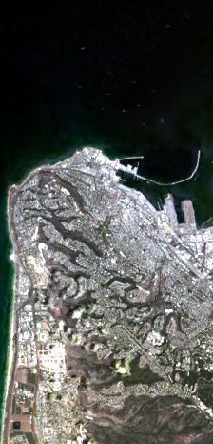

🔹 3. SYSTEM OVERVIEW
A modular pipeline:
- Data Ingestion (RGB + TIR + metadata)
- Semantic Segmentation (SegFormer)
- Thermal Calibration (LST computation)
- Object-level fusion (temperature + area)
- Visual & statistical outputs


Project Title:
Improving the Accuracy and Specificity of Weather Forecasts Using Landsat 8 Infrared Satellite Images
Team Code: 25-2-D-33
Students: Mohamad Khateeb, Joorj Ishak
Supervisor: Zakharia Frenkel
Institution: Braude College of Engineering, Karmiel

