Performance Analytics and Predictive Modeling in a Soccer Simulation Environment
Mohamad Al Sabbagh
School of Advanced Technology
Algonquin College
Ottawa, Canada
Mohamad.sabbagh707@gmail.com

Abstract—
This paper presents the development of a soccer simulation system designed to analyze performance metrics and explore predictive modeling techniques. The system generates match data during gameplay, including statistics such as shots, goals, saves, and power shot usage. The collected data is processed, visualized, and used to build a regression model for predicting goal outcomes. Although predictive accuracy is limited due to dataset simplicity, meaningful trends related to difficulty level and gameplay behavior were identified. The project demonstrates how simulation, data analysis, and basic machine learning can be integrated into a complete system.

Index Terms—
Data analysis, machine learning, predictive modeling, Power BI, Python, testing

I. INTRODUCTION
Interactive simulations provide a practical way to analyze performance data in controlled environments. This project focuses on a soccer simulation system where gameplay events are recorded and transformed into meaningful insights. The objective is to analyze performance metrics and apply predictive modeling techniques to estimate goal outcomes based on gameplay features.
The system connects gameplay, data processing, and analytics into a single workflow, demonstrating how raw simulation data can be used for business intelligence and predictive analysis. This project aligns with business intelligence principles by transforming raw data into insights that support decision-making.

II. METHODOLOGY
A. System Structure
The system is composed of three main components: the soccer simulation game, data storage, and analytical tools. The game generates match-level data, which is exported to a CSV file and later used for analysis in SQL, Power BI, and Python.

B. Gameplay and Data Generation
The simulation allows the user to perform shots toward a goal. Each session records statistics including total shots, goals scored, saves made, and power shot usage.
Two types of shots are available: normal shots and power shots. Additionally, three difficulty levels (Easy, Normal, Hard) influence gameplay by affecting scoring probability.
Each match generates one record in the dataset, creating structured data suitable for analysis.Each match consists of exactly 10 shots, ensuring consistency and comparability across all simulations
C. Data Processing
The dataset is cleaned and validated to ensure consistency. Logical checks confirm that goals do not exceed shots and that all values fall within valid ranges.
Feature engineering is applied by creating an accuracy metric, defined as the ratio of goals to shots. This provides a normalized measure of performance.

III. DATA ANALYSIS AND VISUALIZATION
A. Exploratory Data Analysis
Exploratory analysis was performed to understand patterns within the dataset. Summary statistics and visualizations were used to identify relationships between variables.

B. Power BI Visualizations
Several visualizations were created to analyze performance:
- Average goals by difficulty level
- Average accuracy by difficulty level
- Scatter plot of power shot count versus goals
These visualizations show that Easy difficulty results in the highest average goals and accuracy, while Hard difficulty produces the lowest performance, indicating that higher difficulty reduces scoring efficiency. The scatter plot suggests a moderate relationship between power shot usage and goals, though the effect is not strongly consistent. Overall, difficulty level has the greatest impact on performance.

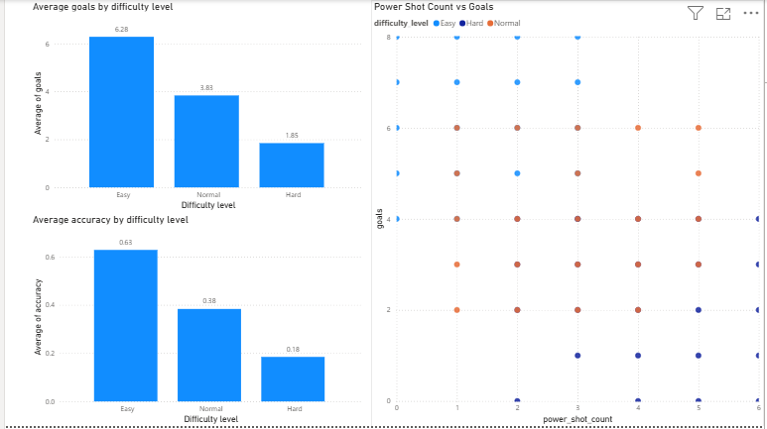

C. Key Findings
The analysis shows that lower difficulty levels result in higher goal counts, while higher difficulty reduces scoring efficiency. Power shot usage has a moderate effect on goals, although the relationship is not strongly linear. These findings indicate that difficulty level is the most influential factor affecting performance. A correlation analysis was conducted to examine relationships between variables. Goals showed a strong positive correlation with accuracy and a strong negative correlation with saves, indicating that shooting precision and defensive performance significantly influence scoring outcomes. Some perfect correlations were observed due to the simulated nature of the dataset.

D. Hypothesis Testing
A t-test was conducted to evaluate whether difficulty level affects the number of goals scored.
The null hypothesis (H₀) states that there is no significant difference in the average number of goals between difficulty levels, while the alternative hypothesis (H₁) states that a significant difference exists.
The results show that the average number of goals in Easy mode (M = 6.29) is higher than in Normal mode (M = 3.83). The t-test produced a p-value of 2.54 × 10⁻¹⁵, which is significantly below the 0.05 threshold.
Therefore, the null hypothesis is rejected, indicating that difficulty level has a statistically significant impact on scoring performance

IV. PREDICTIVE MODELING
A regression model was implemented to predict the number of goals scored using gameplay features. Difficulty level was encoded into numerical form to allow model processing.
The model uses selected variables to estimate scoring outcomes and demonstrates the application of predictive analytics within the system.

V. MODEL EVALUATION
Model performance was evaluated using standard metrics, including Mean Squared Error (MSE) and R-squared (R²). The model achieved an MSE of 3.78 and an R² of 0.24, indicating that the model captures general trends in the data but has limited predictive accuracy.
This limitation is due to the simplicity of the dataset, limited variability in features, and randomness in gameplay outcomes. Despite this, the model successfully identifies the strong impact of difficulty level on scoring performance.

VI. DATABASE AND SYSTEM DESIGN
The dataset is stored in a structured table representing match-level data. Each record corresponds to one match and includes attributes such as difficulty level, shots, goals, saves, power shot count, and accuracy.
The dataset is implemented as a single table (Match_Statistics), where each row represents one match. A unique identifier (match_id) is used as the primary key to ensure each record is uniquely distinguishable.
The database design satisfies normalization principles:
- First Normal Form (1NF): All attributes contain atomic values with no repeating groups.
- Second Normal Form (2NF): The primary key is a single attribute, so no partial dependencies exist.
- Third Normal Form (3NF): There are no transitive dependencies, as all attributes depend only on the primary key.
Although a multi-table design (e.g., separating match, player, and statistics tables) was considered, it was not implemented because the dataset represents analytical observations rather than transactional data. Splitting the data into multiple tables would increase complexity without providing significant benefits for analysis.
Therefore, a denormalized single-table structure was selected as it is more suitable for data analysis, machine learning, and visualization tasks. This design allows efficient processing and simplifies integration with tools such as Python and Power BI.

VII. TESTING
Automated testing was conducted using PyTest to verify system functionality. Tests were implemented to confirm correct behavior of shot tracking, goal detection, and logical constraints.
The results indicate that the system operates reliably and produces consistent data.

VIII. DISCUSSION
The project demonstrates how simulation data can be transformed into analytical insights. While the predictive model is limited in accuracy, it provides a foundation for future improvements.
Challenges included managing gameplay randomness and ensuring consistent data generation. Additionally, the limited dataset size restricted the model’s predictive capability. These insights can support decision-making in game design by helping developers adjust difficulty levels to balance player experience. For example, understanding that higher difficulty significantly reduces scoring efficiency can guide the tuning of game mechanics to maintain engagement while preserving challenge. Future improvements could include incorporating additional features such as player positioning, shot angle, or reaction time, which may improve the predictive accuracy of the model.

IX. CONCLUSION
This project successfully integrates simulation, data analysis, and predictive modeling into a unified system. The results show that gameplay data can be analyzed to identify meaningful trends and support predictive insights.
Future work may involve expanding the dataset, introducing additional features, and applying more advanced machine learning techniques to improve prediction accuracy.

REFERENCES
[1] Scikit-learn Documentation. [Online]. Available: https://scikit-learn.org
[2] Pandas Documentation. [Online]. Available: https://pandas.pydata.org
[3] Microsoft Power BI Documentation. [Online]. Available: https://learn.microsoft.com/power-bi

