

**Faculty of engineering - Shoubra Benha University**

# Research Article / Research Project / Literature Review

in fulfillment of the requirements of

|  |  |
| --- | --- |
| **Department** | **Engineering Mathematics and Physics** |
| **Division** | **--------------** |
| **Academic Year** | **2019-2020 Preparatory** |
| **Course name** | **Computer** |
| **Course code** | ECE006 |

**Title: -**

Computer Engineering Role in COVID-19 Pandemic

By:

|  |  |  |  |
| --- | --- | --- | --- |
|  | Name | Edu mail | B.N |
| 1 | محمد سلامة صالح أحمد صالح | muhammed195803@feng.bu.edu.eg | **719** |

## Approved by:

|  |  |
| --- | --- |
| Examiners committee | Signature |
| Dr.Ahmed Bayoumi |  |
| Dr.Shady Elmashad |  |
| Dr. Abdelhamid Attaby |  |

Project link : <https://github.com/mohamadsalama/html-project>

Github pages link : <https://mohamadsalama.github.io/html-project/>

# Abstract

Coronaviruses are important human and animal pathogens. At the end of 2019, a novel coronavirus was identified as the cause of a cluster of pneumonia cases in Wuhan, a city in the Hubei Province of China. It rapidly spread, resulting in an epidemic throughout China, followed by an increasing number of cases in other countries throughout the world. In February 2020, the World Health Organization designated the disease COVID-19, which stands for coronavirus disease 2019 [[1](https://www.uptodate.com/contents/coronavirus-disease-2019-covid-19-epidemiology-virology-clinical-features-diagnosis-and-prevention/abstract/1)]. The virus that causes COVID-19 is designated severe acute respiratory syndrome coronavirus 2 (SARS-CoV-2); previously, it was referred to as 2019-nCoV.

# Table of contents

Divide your research into sections or subjects, mention each section first page at this table

|  |  |
| --- | --- |
| **Subject / section** | **Page** |
| Introduction | 4 |
| Literature Review | 5 |
| Results and discussion | 8 |
| Conclusions | 9 |
|  |  |

**Introduction**

Coronavirus disease (COVID-19) is an infectious disease caused by a newly discovered coronavirus. Most people infected with the COVID-19 virus will experience mild to moderate respiratory illness and recover without requiring special treatment. Older people, and those with underlying medical problems like cardiovascular disease, diabetes, chronic respiratory disease, and cancer are more likely to develop serious illness. The best way to prevent and slow down transmission is be well informed about the COVID-19 virus, the disease it causes and how it spreads. Protect yourself and others from infection by washing your hands or using an alcohol based rub frequently and not touching your face. The COVID-19 virus spreads primarily through droplets of saliva or discharge from the nose when an infected person coughs or sneezes, so it’s important that you also practice respiratory etiquette (for example, by coughing into a flexed elbow). At this time, there are no specific vaccines or treatments for COVID-19. However, there are many ongoing clinical trials evaluating potential treatments. WHO will continue to provide updated information as soon as clinical findings become available.

# Literature Review

Before showing the role of computer Engineering Role in COVID-19 Pandemic I will show some screenshots from the website I created about covid-19 pandemic and source code too.

The website cosist of 5 pages.

1. Main page :

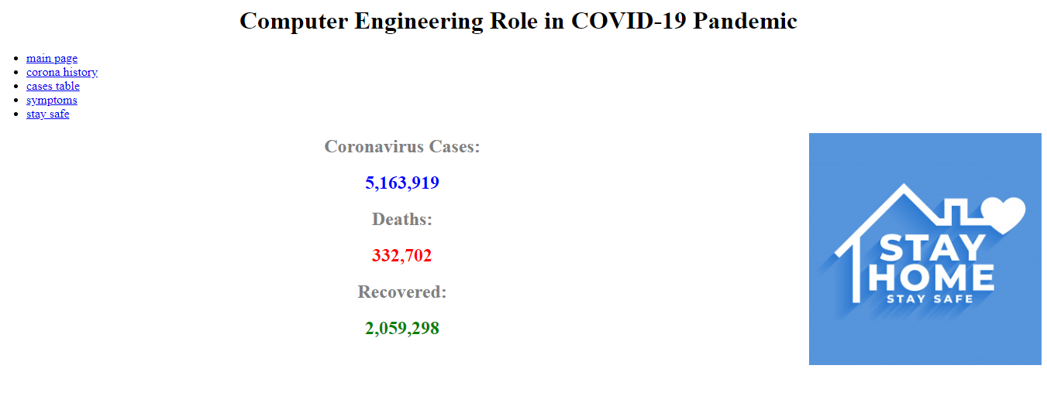

1. Cases table page

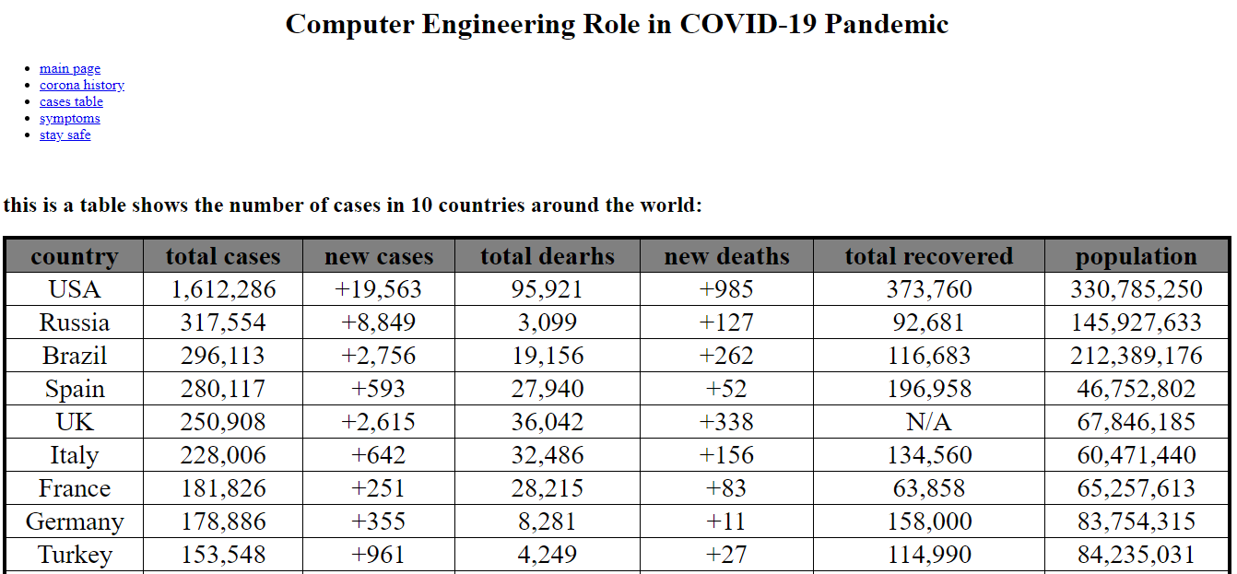

1. Symptoms page

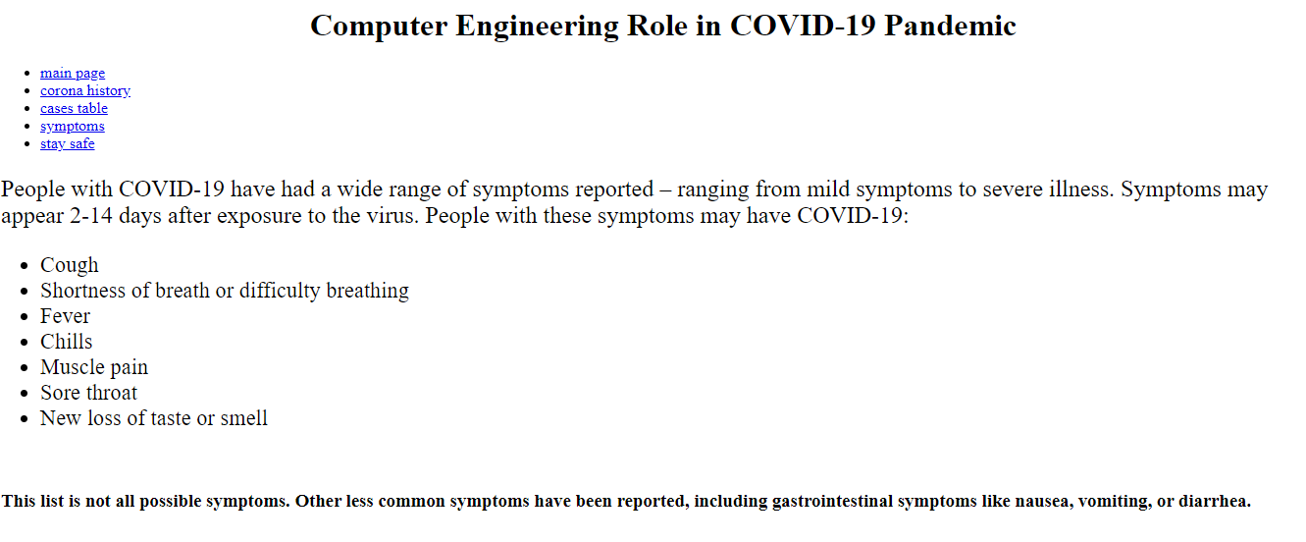

1. Corona history page

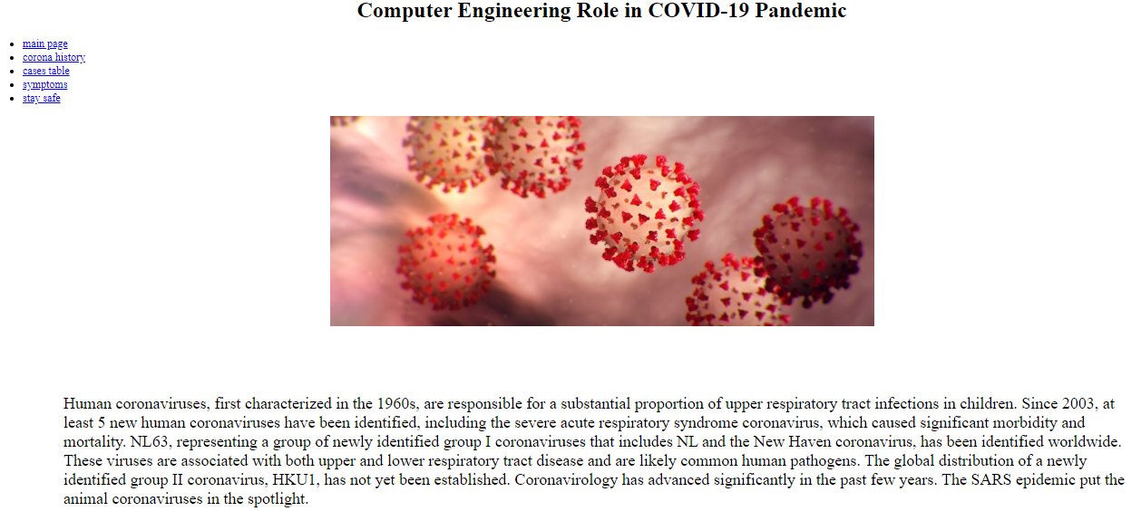

# Source code snapshots

# 

# 

# 

# Results and discussion

The question of how computers can contribute to controlling the COVID-19 pandemic is being posed to experts and there’s many tools appeared and being used currently in fighting against covid-19 such as :

1. **Positioning technologies:** Government agencies and first responders on the ground require precise positions to accurately assess the situation, pinpoint the most risky areas and carry out relief and rehabilitation efforts accordingly. In the case of epidemics and outbreaks too, GNSS comes in quite handy. In China, BeiDou, the country’s own GNSS constellation, helped track patients and affected places, thus containing the virus, apart from analyzing the pattern of the outbreak. With the help of reliable data and precise mapping and imagery, China could build thousands of new makeshift hospitals across the country.
2. Satellite monitoring: While dozens of makeshift hospitals were being constructed at breakneck pace, their progress was continuously being monitored using GaoFen, a constellation of high-resolution earth observation satellites. Zhuhai-1 hyperspectral imaging satellite and ESA’s Sentinel-1 also helped in non-stop monitoring of hospital construction. The Wuhan University actively collected and analyzed multiple data sources and identified which site would be best suitable for the hospital.
3. Robotics: From preparing meals at hospitals, doubling up as waiters in restaurants, spraying disinfectants to vending rice and dispensing hand sanitizers, robots were on the frontline to prevent the spread of Coronavirus. In many hospitals, robots were also performing diagnosis and conducting thermal imaging. Shenzhen-based company Multicopter is using robots to transport medical samples.
4. Drones: In some of the severely affected areas, where humans were at a risk of catching the virus, drones came to the rescue. Drones were transporting both medical equipment and patient samples, saving time and enhancing the speed of deliveries, while preventing contamination of medical samples.
5. Autonomous vehicles: autonomous vehicles are proving to be of great utility in delivering essential goods like medicines and food items. Apollo, which is Baidu’s autonomous vehicle platform, has joined hands with self-driving startup Neolix to deliver supplies and food to a big hospital in Beijing. Baidu Apollo has also made its micro-car kits and autonomous driving Cloud services available free to companies fighting the virus.

# Conclusions

# Technological innovation both in software and hardware have continuously increased efficiency, lowered costs, and created new opportunities through digitization and automation. Blockchain is currently leading the charge in the fight against Covid-19 by providing organizations, public and private, an opportunity to do more with less catering both to resource and physical contact limitations.