|  |  |  |
| --- | --- | --- |
| **شعار جامعة بنها الجديد**f |  | **logo.jpg** |
| Benha University |  | Faculty of Computers & Informatics |

**Attenddance Management System**

A summer training project submitted in partial fulfillment of the requirements for the degree of Bachelor of Computers and Informatics.

**1st Year Students Summer Training**

*Project Team*

1. Mohamed Ashraf Mohamed Abdallah
2. Mohamed Abo El-Fotouh Mohamed Anes Shabaan
3. Mohamed Khalid Hafez Mahmoud
4. Mohamed Samir Mohamed Mohamed Kozae
5. Mohamed Shawky Ahmed Mohamed Ali

Benha, August 2017

We hereby certify that this project, submitted by the project teamwork, conforms to acceptable standards and is fully adequate in scope and quality to fulfill the seminar requirements for the degree of Bachelor of Computers and Informatics.

**Discussion Committee:**

____________________________________ ________________

Date

____________________________________ ________________

Date

____________________________________ ________________

Date

**Abstract**

**First thing we should talk about the importance of the project is to handle the attendance of students and employees , the program can load file with all names of students or employees , it can add new students or employees then save them to get final file contain all names of students or employees**

**we can load it at student attendance then we can check from checkedlistbox if the student attended we do check on his name and the absent student we leave them without check , then we can show the attended student or employee in two listboxes with the number of attended students or employees up the listbox1 for example then the number of absent students will appear up the listbox2 ,the listbox 1 contain the name of attended students other listbox contain the absent students, at last we can save that in a file , the file show the name of attended and absent students**

**Introduction**

At the beginning we describe our obstacle to handle the project,the main obstacle is the time wasn't enough , so we can do better than this program but the time didn't help us to do that , we didn't use to work as a team yet ,that's the first time we work as a team so it was abit difficult for us to adapt with that , and finally we have done a project that can be usefull to handle the attendance of students or employees.

**Program Interface**

**This form just for login to be able to start the program //user name :developer & Password : bfci**

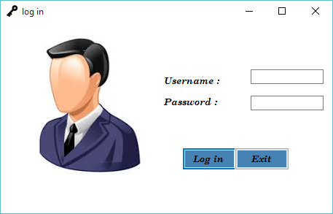

**This form contain 2 buttons , 2 textbox and 2 label**

**To let the program check if the user have logged with correct user name and password we do that with if else statement if he entered correct password and user name he can be able to move to the next form(named"Home") at the login button we write this code :**

if(textBox1->Text=="developer" &&textBox2->Text=="bfci")

{

Home^ frm = gcnew Home();

frm->ShowDialog();

this->Hide();

}

else

{MessageBox::Show("The username or Password May Be Incorrect , Try Again" , "Error" , MessageBoxButtons::OK ,MessageBoxIcon::Error);

textBox1->Text="";

textBox2->Text="";}

-First of all we must include (to be defined) the next form ( " Home " ) with this code : #include"begin.h"

**-the button called "Exit" exit the program with this code : Application::Exit();**

**-now if the user entered a wrong username or password , the program shows a message error contains the message below:**

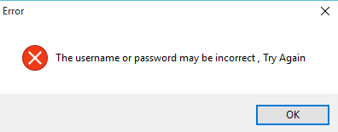

**-after entering correct user and password we be able to move to the next form called " Home "**

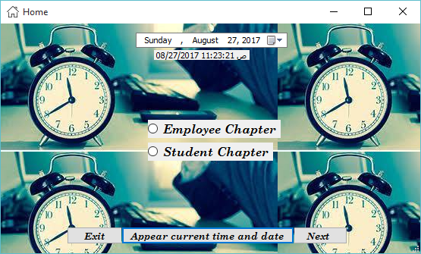

**-This form include 2 Radio buttons: Student Chapter that handle the attendance of students and employee Chapter that handle the attendance of employees**

**-Also contain 3 buttons ,1 label and DataTimePicker to appear the current time and date pressing the button specified that.**

**Code :**

DateTime time=DateTime::Now;

label1->Text=Convert::ToString(time);

**-to go to form of Employee Chapter , you can choose it from radiobuttons then click "next" button**

**-to go to form of Student Chapter , you can choose it from radiobuttons then click "next" button**

**Code at next button :**

if (radioButton1 -> Checked == true )

{

EmployeeChapter^ employee = gcnew EmployeeChapter();

employee -> ShowDialog();

}

else if (radioButton2 -> Checked == true )

{

StudentChapter^ student = gcnew StudentChapter();

student -> ShowDialog();

}

else;

**-first we must include the next forms called " StudentChapter" and "EmployeeChapter" by this code**

#include "EmployeeChapter.h"

#include "StudentChapter.h"

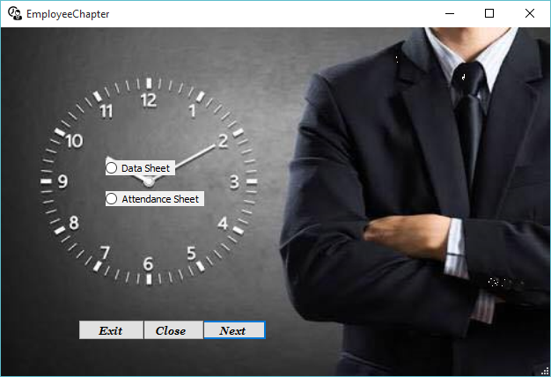

**-The form Contains 2 radiobuttons:Data Sheet and Attendance Sheet , the first is to load data of employees and their Vacation Days and the second is to take your attendance Sheet and save a report of it**

**Also Contains 3 buttons : "Exit" Button to get out of the program , close to Close the current form and Next to move forward after you selected radiobutton**

**Code :**

* **Next:**

if (radioButton1->Checked==true)

{

DataSheet^ data = gcnew DataSheet();

data -> ShowDialog();

}

else if (radioButton2->Checked==true)

{

AttendanceSheet^ attendance = gcnew AttendanceSheet();

attendance ->ShowDialog();

}

else;

**Remember : DataSheet form AttendanceSheet form must be included and AttendanceSheet form as shown:**

#include"DataSheet.h"

#include"AttendanceSheet.h"

* **Data Sheet Form**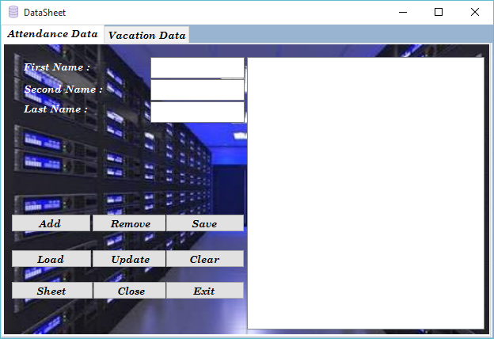

**This form has 2 tabes Attendance Data and Vacation Data :**

**Attendance Data contains 6 Buttons . 3 labels , 3 textBoxes abd listBox**

**-Add Button : you can fill textboxes with data required and prss add to include it in list box and clear data fron textboxes.**

**Code:**

stem::Void button1_Click(System::Object^ sender, System::EventArgs^ e) {

String^ box1= Convert::ToString(textBox1->Text);

String^ box2= Convert::ToString(textBox2->Text);

String^ box3= Convert::ToString(textBox3->Text);

String^ full_name=box1+" " +box2 + " " + box3;

listBox1->Items->Add(full_name);

textBox1->Text="";

textBox2->Text="";

textBox3->Text="";

**- Remove button : you can select any element at list box and press remove to delete it from list box**

**Code :**

listBox1->Items->Remove(listBox1->SelectedItem);

**-Save button : You can take a copy of your data on your computer from Browse window as shown**

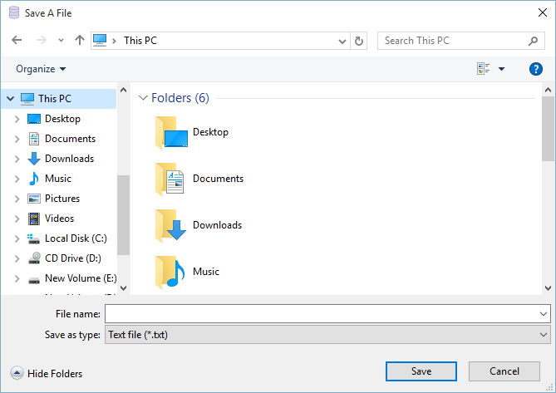

**Code :**

this-> saveFileDialog1->Filter="Text file|*.txt";

saveFileDialog1->Title="Save A File";

saveFileDialog1->ShowDialog();

if(saveFileDialog1->FileName!="")

{

StreamWriter^ savefile= gcnew StreamWriter(saveFileDialog1->FileName);

for(int i =0 ;i<listBox1->Items->Count;i++)

savefile->WriteLine(listBox1->Items[i]);

savefile->Close();

**-load button : to choose your file from your Desktop and show its data on listbox as shown**

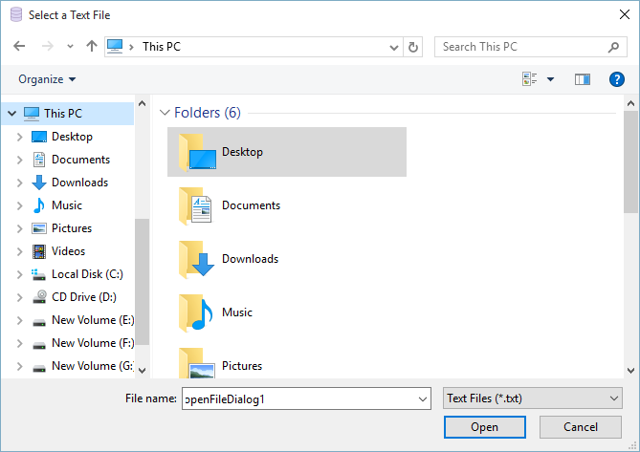

**Code :**

this->openFileDialog1->Filter = "Text Files|*.txt";

openFileDialog1->Title="Select a Text File";

if (openFileDialog1->ShowDialog() == System :: Windows::Forms::DialogResult::OK)

{

StreamReader ^ readfile = gcnew StreamReader(openFileDialog1->FileName);

while ( !readfile->EndOfStream)

{

listBox1 -> Items->Add(readfile->ReadLine());

}

readfile->Close();

}

**-Update button :to Change your inserted item from list box , select it from listbox , it appears in textboxes the change it and press update**

**Code:**

**//button**

String ^ fullname = textBox1->Text +" "+ textBox2->Text +" "+ textBox3->Text;

int index=listBox1->SelectedIndex;

listBox1->Items[index]=fullname;

**//listbox**

if (listBox1->SelectedIndex!=-1)

{

textBox1->Text="";

textBox2->Text="";

textBox3->Text="";

String ^ updated_data= listBox1->SelectedItem->ToString();

array<String^>^result;

array<Char>^splitChars = {' '};

result = updated_data->Split(splitChars);

textBox1->Text=result[0];

textBox2->Text=result[1];

textBox3->Text=result[2];

}

**-Clear button : To remove all data in listbox and textboxes**

**Code:**

listBox1->Items->Clear();

textBox1->Text="";

textBox2->Text="";

textBox3->Text="";

**-Sheet button : to move to attendance sheet**

**Remember : AttendanceSheet form must be included and AttendanceSheet form as shown:**

#include"AttendanceSheet.h"

**Code :**

AttendanceSheet^ attendance = gcnew AttendanceSheet();

attendance ->ShowDialog();

-**Close and exit buttons are demonstrated before**

* **Vacation Data**

**To Sreate a file with employee who have a vacation before**

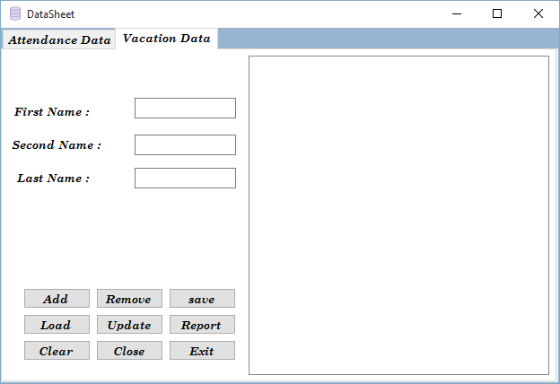

**Vacation Data contains 6 Buttons . 3 labels , 3 textBoxes abd listBox**

**-Add Button : you can fill textboxes with data required and prss add to include it in list box and clear data fron textboxes.**

**Code:**

String^ box1= Convert::ToString(textBox4->Text);

String^ box2= Convert::ToString(textBox5->Text);

String^ box3= Convert::ToString(textBox6->Text);

String^ full_name=box1+" " +box2 + " " + box3;

listBox2->Items->Add(full_name);

textBox4->Text="";

textBox5->Text="";

textBox6->Text="";

**- Remove button : you can select any element at list box and press remove to delete it from list box**

**Code :**

listBox2->Items->Remove(listBox1->SelectedItem);

**-Save button : You can take a copy of your data on your computer from Browse**

this-> saveFileDialog1->Filter="Text file|*.txt";

saveFileDialog1->Title="Save A File";

saveFileDialog1->ShowDialog();

if(saveFileDialog1->FileName!="")

{

StreamWriter^ savefile= gcnew StreamWriter(saveFileDialog1->FileName);

for(int i =0 ;i<listBox1->Items->Count;i++)

savefile->WriteLine(listBox1->Items[i]);

savefile->Close();

**-load button : to choose your file from your Desktop and show its data on listbox as shown Code :**

this->openFileDialog1->Filter = "Text Files|*.txt";

openFileDialog1->Title="Select a Text File";

if (openFileDialog1->ShowDialog() == System :: Windows::Forms::DialogResult::OK)

{

StreamReader ^ readfile = gcnew StreamReader(openFileDialog1->FileName);

while ( !readfile->EndOfStream)

{

listBox2 -> Items->Add(readfile->ReadLine());

}

readfile->Close();

}

**-Update button :to Change your inserted item from list box , select it from listbox , it appears in textboxes the change it and press update**

**Code:**

**// button**

String ^ fullname = textBox4->Text +" "+ textBox5->Text +" "+ textBox6->Text;

int index=listBox2->SelectedIndex;

listBox2->Items[index]=fullname;

**// listbox**

if (listBox2->SelectedIndex!=-1)

{

textBox4->Text="";

textBox5->Text="";

textBox6->Text="";

String ^ updated_data= listBox2->SelectedItem->ToString();

array<String^>^result;

array<Char>^splitChars = {' '};

result = updated_data->Split(splitChars);

textBox4->Text=result[0];

textBox5->Text=result[1];

textBox6->Text=result[2];

}

**-Clear button:**

**To remove all data in listbox and textboxes Code :**

listBox2->Items->Clear();

textBox4->Text="";

textBox5->Text="";

textBox6->Text="";

-**Close and exit buttons are demonstrated before**

* **Attendance Sheet**

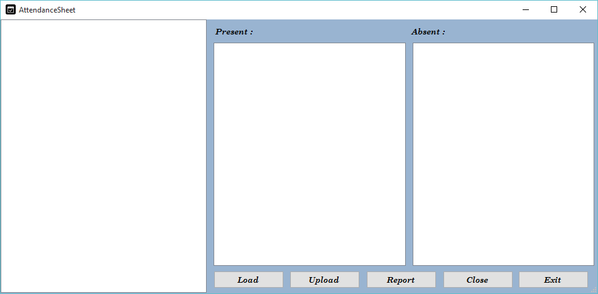

**This form contains Checked list box,4 labels , 2 listboxes and 5 buttons**

**Load button : to choose your file from your Desktop and show its data on Checked listbox**

**Code:**

**// button**

this->openFileDialog1->Filter="Text File|*.txt";

openFileDialog1->Title="Student Names";

if (openFileDialog1->ShowDialog()==System::Windows::Forms::DialogResult::OK)

{

StreamReader^ fr = gcnew StreamReader(openFileDialog1->FileName);

while(!fr->EndOfStream)

{

checkedListBox1->Items->Add(fr->ReadLine());}

fr->Close();

}

**Upload button : To classify checked item and unchecked items to listbox1 and listbox2**

**Code :**

for (int i = 0; i < checkedListBox1->Items->Count; i++)

{

if(Convert::ToString(checkedListBox1->GetItemCheckState(i))=="Checked")

{

listBox1->Items->Add(checkedListBox1->Items[i]);

}

else

{

listBox2->Items->Add(checkedListBox1->Items[i]);

}

**Report button : To create 2 files with data clasified**

**Code :**

StreamWriter^ fr = gcnew StreamWriter("Employee attendance Sheet.txt",true);

for(int i=0;i<listBox1->Items->Count;i++)

{

fr->WriteLine(listBox1->Items[i]);

}

fr->Close();

StreamWriter^ frm = gcnew StreamWriter("Employee Abscence Sheet.txt",true);

for(int i=0;i<listBox2->Items->Count;i++)

{

frm->WriteLine(listBox2->Items[i]);

}

frm->Close();

-**Close and exit buttons are demonstrated before.**

**-we have described Employee Chapter , now we are going to describe StudentChapter as well .**

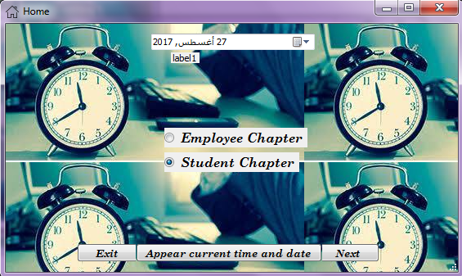

**-After Choosing Student Chapter we click next to go to**

**Student Chapter form .**

**-We have mentioned before the code of button called "Next" when we have described employee Chapter .**

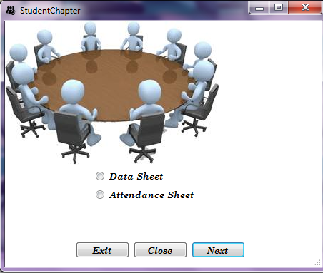

**-in this form we have 2 radioButtons and 3 buttons**

**-now we need to go Data Sheet form to load file with names of students or add new students then save final update of my total students ,this file we have saved we will need it in Attendance sheet to load it and take the attendance of all students .**

**- Button Called "Next" must include 2 forms with if condition, the code is :**

if (radioButton1->Checked == true )

{

studentdata^ stddata = gcnew studentdata();

stddata->ShowDialog();

}

else if (radioButton2->Checked == true )

{

StudentAttendance^ stdattend = gcnew StudentAttendance();

stdattend -> ShowDialog();

}

else;

**-now we check on radiobutton called "Data Sheet" then click next to go form "studentdata" .**

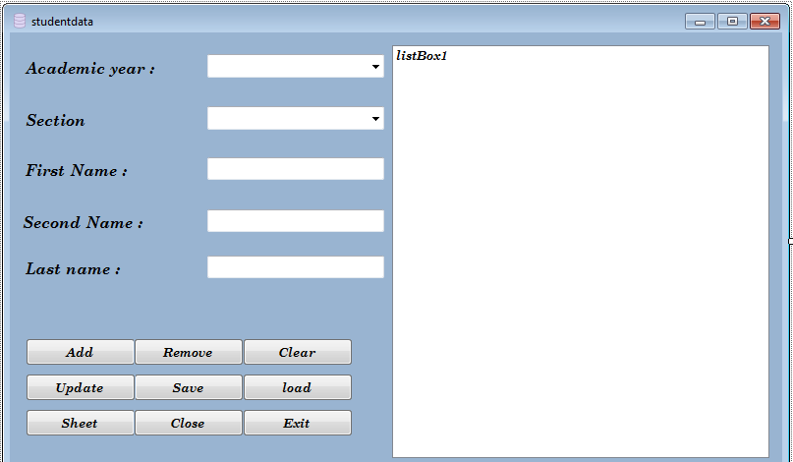

**-Add Button : you can fill textboxes and comboxes with data required and press add to include it in list box and clear data from textboxes.**

**Code:**

String^ combo1= Convert::ToString(comboBox1->SelectedItem);

String^ combo2= Convert::ToString(comboBox2->SelectedItem);

String^ box1= Convert::ToString(textBox1->Text);

String^ box2= Convert::ToString(textBox2->Text);

String^ box3= Convert::ToString(textBox3->Text);

String^ full_data=combo1 + "\t"+combo2+"\t"+ box1+" " +box2 + " " + box3;

listBox1->Items->Add(full_data);

comboBox1->SelectedItem="";

comboBox2->SelectedItem="";

textBox1->Text="";

textBox2->Text="";

textBox3->Text="";

**- Remove button : you can select any element at list box and press remove to delete it from list box**

**Code :**

listBox1->Items->Remove(listBox1->SelectedItem);

**-Save button : You can take a copy of your data on your computer from Browse**

this-> saveFileDialog1->Filter="Text file|*.txt";

saveFileDialog1->Title="Save A File";

saveFileDialog1->ShowDialog();

if(saveFileDialog1->FileName!="")

{

StreamWriter^ savefile= gcnew StreamWriter(saveFileDialog1->FileName);

for(int i =0 ;i<listBox1->Items->Count;i++)

savefile->WriteLine(listBox1->Items[i]);

savefile->Close();

}

**-load button : to choose your file from your Desktop and show its data on listbox as shown Code :**

this->openFileDialog1->Filter = "Text Files|*.txt";

openFileDialog1->Title="Select a Text File";

if (openFileDialog1->ShowDialog() == System :: Windows::Forms::DialogResult::OK)

{

StreamReader ^ readfile = gcnew StreamReader(openFileDialog1->FileName);

while ( !readfile->EndOfStream)

{

listBox1 -> Items->Add(readfile->ReadLine());

}

readfile->Close();

}

**-Update button :to Change your inserted item from list box , select it from listbox , it appears in textboxes the change it and press update**

**Code:**

**// button**

String ^ fulldata =comboBox1->SelectedItem +"\t"+comboBox2->SelectedItem+"\t"+ textBox1->Text +" "+ textBox2->Text +" "+ textBox3->Text;

int index=listBox1->SelectedIndex;

listBox1->Items[index]=fulldata;

**// listbox**

if (listBox1->SelectedIndex!=-1)

{

String ^ updated_data= listBox1->SelectedItem->ToString();

array<String^>^result;

array<Char>^splitChars = {'\t',' '};

result = updated_data->Split(splitChars);

comboBox1->SelectedItem= result [0];

comboBox2->SelectedItem= result [1];

textBox1->Text=result[2];

textBox2->Text=result[3];

textBox3->Text=result[4];

}

**-Clear button:**

**To remove all data in listbox Code :**

listBox1->Items->Clear();

-**Close and exit buttons are demonstrated before .**

**-Sheet button : to move to attendance sheet**

**Remember : StudentAttendance form must be included , StudentAttendance form as shown:**

#include"StudentAttendance.h"

**Code :**

StudentAttendance ^ attendance = gcnew StudentAttendance ();

attendance ->ShowDialog();

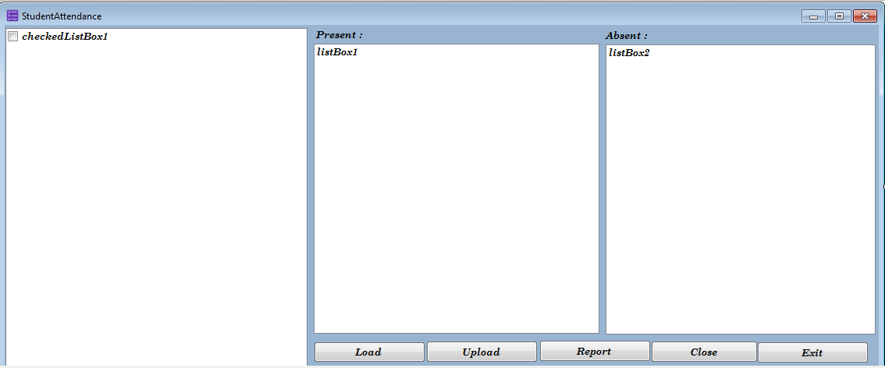

**-this form include 5 buttons ,2 listbox ,1 checklistbox and 4 label**

**-the button called " load" used to load file with all student name to check on the name of attended student and leave the absent student without check as shown**

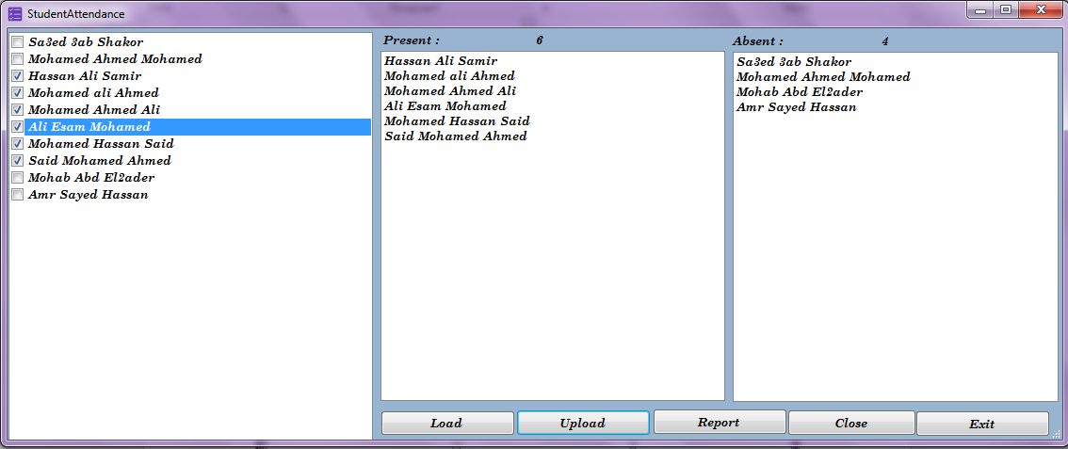

The checked items represented attended students and the unchecked items represented absent students

-after clicking on upload button it shows the number of attendant students and their names up the listbox1 ,and the number of absent students and their names up the listbox2 that can be done by this code :

for (int i = 0; i < checkedListBox1->Items->Count; i++)

{

if(Convert::ToString(checkedListBox1->GetItemCheckState(i))=="Checked")

{

listBox1->Items->Add(checkedListBox1->Items[i]);

}

else

{

listBox2->Items->Add(checkedListBox1->Items[i]);

}

}

String^ var1=Convert::ToString(checkedListBox1->Items->Count);

String^ var2=Convert::ToString(checkedListBox1->CheckedItems->Count);

label2->Text=var2;

double def =Convert::ToDouble(var1) - Convert::ToDouble(var2) ;

label4->Text=Convert::ToString(def);

-after clicking on button called "report" ,it takes the names in listbox1 and listbox2 and put them into 2 files ,listbox1's names will be added to file.txt named "Student Attendance Sheet" ,listbox2's names will be added to file.txt named "Student Absence Sheet" ,the code :

StreamWriter^ fr = gcnew StreamWriter("Student attendance Sheet.txt",true);

for(int i=0;i<listBox1->Items->Count;i++)

{

fr->WriteLine(listBox1->Items[i]);

}

fr->Close();

StreamWriter^ frm = gcnew StreamWriter("Student Abscence Sheet.txt",true);

for(int i=0;i<listBox2->Items->Count;i++)

{

frm->WriteLine(listBox2->Items[i]);

}

frm->Close();

-**Close and exit buttons are demonstrated before**

**Input and Output**

-in this form we add data from textboxes and comboxes to listbox1 ,we can also take data from an existed file from our desktop , the loaded file we can make changes on it and save to a location that we need ,that happen in this form :

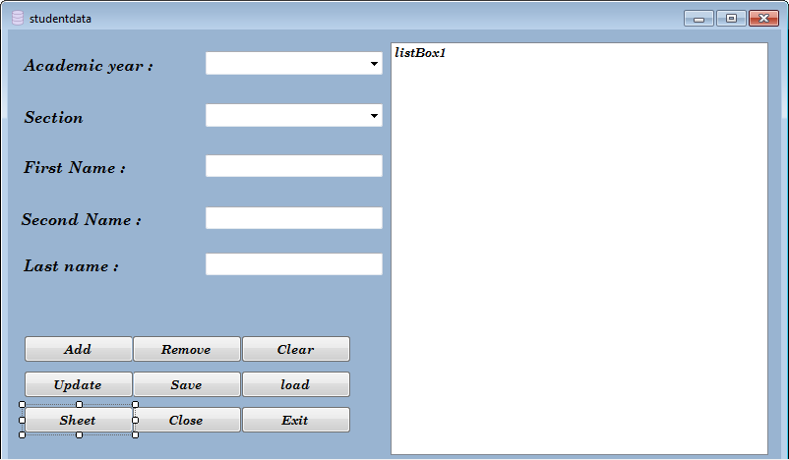

-in this form we add data from textboxes to listbox1 ,we can also take data from an existed file from our desktop through a button called"load", the loaded file we can make changes on it and save to a location that we need ,this file which we have saved we will need it in Student Attendance form to check on who attended and leave the absents without check ,that happen in this form :

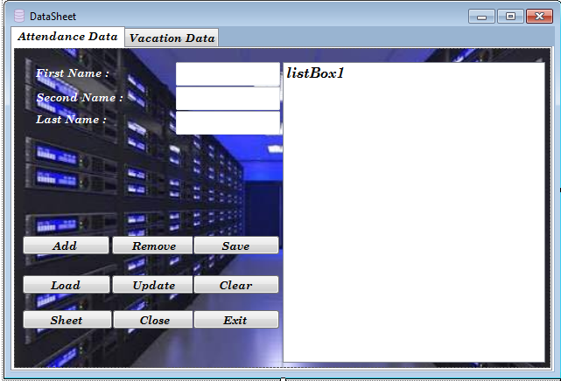

-in this form we take the file which we have saved from the previous form and load it to this form to check on who attended and leave the absents without check to move CheckedNames to listbox1 (Special for Attended Students) and move the UncheckedNames to listbox2 (Special for Absent Students) ,then save the attended Students in a special file .txt named " Student Attendance Sheet.txt" and the absent students in a special file.txt named "Student Absence Sheet" ,all that happen in this following form :



-in this form if we entered incorrect data ,user name and password (input) the output will be a message tells us "the password or user name is incorrect ,try again " (output) ,that happen in the following form :

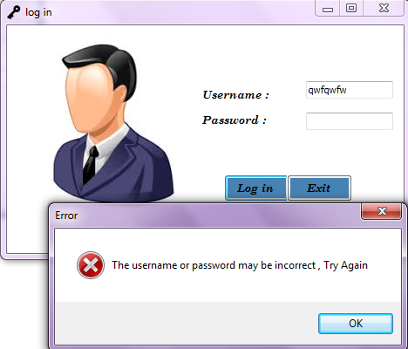

**Difficulties Encountered**

**Two difficulties have faced us , first difficult is the time wasn't enough for us, that obstacle us to make better than this program ,second difficult is how to work as a team ,we didn't use to adapt with teamwork project that was a first time for us to work as a team , but finally we solved this problem and finished this program .**

**Conclusion**

This section is for the conclusions about the project.

The purpose of the Conclusion is to restate in a shortened form the most important points of your project. These must be clear and positive. Never introduce new material in the conclusions.