University of Michigan – Dearborn

CIS 476

MyPass: Password Manager Term Project

Team: Ahmad Hashem | Jad Jonaidi
Mohamad Syaj

Submission Date: Dec 1, 2025



1. Introduction 3
2. Functional Requirements and How They Are Met 3
3. Architecture Overview (High Level) 5
4. Design Patterns in MyPass 6
4.1 Singleton – Session Management 6
4.2 Observer – User Notifications 7
4.3 Mediator – User Interface Coordination 7
4.4 Builder – Password Generation 8
4.5 Proxy – Masking and Unmasking Sensitive Data 9
4.6 Chain of Responsibility – Master Password Recovery 10
5. Database Schema and Descriptions 12
6. User Interface Screens and Descriptions 14
7. Security Considerations 19
8. Conclusion 20
9. References 20

1. Introduction
This report describes the design and implementation of MyPass, a password management application built as a Flask-based web system. The goal of MyPass is to securely store and manage sensitive user data such as logins, credit cards, and identity documents, while applying several software design patterns required by the term project: Singleton, Observer, Mediator, Builder, Proxy, and Chain of Responsibility.
MyPass allows users to register with an email address, choose a strong master password, set up three security questions, and then manage items in a secure vault. The system encrypts sensitive data before storing it in the database, masks sensitive fields when displaying them, and provides options to unmask or copy values only when appropriate. It also enforces auto-lock on inactivity and clears copied secrets from the clipboard after a short period to reduce the risk of exposure.

2. Functional Requirements and How They Are Met
The project specification lists a set of required features for MyPass. Below is a description of each requirement and how the implemented system satisfies it.
1. User registration with email, master password, three security questions
The User model stores email, a hashed password_hash, and three pairs of sec_q1/sec_a1, sec_q2/sec_a2, sec_q3/sec_a3.
The registration page collects the email, master password, and three security questions with their answers. Passwords are never stored in plain text; they are hashed using Werkzeug’s password hashing utilities.
2. Password generator (suggest strong password)
The PasswordBuilder class implements a flexible password generator that supports configurable length and character categories.
A Flask route (/generate_password) uses this builder to create a strong password, and the front-end JavaScript calls this endpoint and places the generated password into the password field on the registration and recovery forms.
3. Weak master password warning
On the client side, JavaScript checks basic strength rules (length, presence of digits, upper/lower case) and displays a short message if the chosen master password appears weak.
On the server side, the application also enforces minimum strength rules before accepting the master password, ensuring that weak passwords are rejected even if the browser checks are bypassed.
4. Access to vault after login
After successful login, the user is redirected to the vault/dashboard. All vault items associated with that user are fetched from the database and displayed in a list view. The currently logged-in user is tracked using both Flask’s session and a Singleton UserSession object.
5. Built-in data types in the vault (Login, Credit Card, Identity, Secure Notes)
When adding a new item, the user selects an item type from a dropdown (Login, CreditCard, Identity, SecureNote).
The form dynamically shows or hides relevant fields for each type (e.g., username/password/URL for Login, card number/CVV/expiry for Credit Card, SSN/passport/license data for Identity, and a free-text field for Secure Notes).
6. Create/modify/delete vault items
Create: A dedicated “Add Item” page lets the user enter details for the chosen type. The application serializes the fields into a JSON object and encrypts it before saving into the encrypted_data column of VaultItem.
Modify: The user can edit existing items; the application decrypts the data, loads it into a form, and then re-encrypts the updated data when the form is submitted.
Delete: Items can be removed via a delete action, which deletes the corresponding VaultItem record.
7. Easy copying of login and credit card data
On the item view page, each sensitive field has Copy and Unmask buttons.
When the user clicks Copy, JavaScript requests the value from the server (with appropriate checks) and writes it to the clipboard. For Login items, username/password/URL can be copied; for Credit Card items, the card number and CVV can be copied.
8. Masking of sensitive data
A DataProxy masks sensitive fields (such as passwords, card numbers, CVV, passport numbers, license numbers, SSN) when presenting previews of vault items. For example, only the first and last characters might be visible, with the middle characters replaced by asterisks.
Masked values are used both in the vault list view and in the detailed view, unless the user explicitly chooses to unmask a field.
9. Option to unmask masked data
For each masked field, the UI provides an Unmask button.
The server uses UnmaskToken and the UserSession Singleton to enforce that unmask actions are limited and short-lived. This prevents automated scraping or abuse.
10. Auto-lock after X minutes of inactivity
The UserSession Singleton maintains the last activity time and a configured inactivity timeout.
A Flask before_request hook checks whether the session has been idle for too long. If so, it clears the session, resets the singleton, and redirects the user to the login page.
On the client side, JavaScript also sets a timer to automatically navigate to the logout route after a period of no user activity, providing an additional layer of protection.
11. Auto delete copied sensitive data from clipboard
After copying a value to the clipboard, the front-end schedules a timer that overwrites the clipboard with an empty string after a short period (for example, 30 seconds).
This reduces the time window during which sensitive data remains available in the clipboard.

3. Architecture Overview (High Level)
MyPass follows a simple web-based three-layer structure:
Presentation Layer (UI):
Implemented using HTML templates (Flask/Jinja2), CSS, and JavaScript.
Handles forms for registration, login, adding/editing items, viewing items, and initiating recovery.
Uses a Mediator pattern (in JavaScript) to coordinate between UI components such as the item type selector and the dynamic form fields.
Application Layer (Flask + Patterns):
app.py defines routes for authentication, vault operations, password generation, copying/unmasking data, and password recovery.
This layer integrates the design patterns:
UserSession Singleton for global session state and timeouts.
Observer for notifications about expiring items.
Builder for password generation.
Proxy for masking/unmasking.
Chain of Responsibility for recovery via multiple security questions.
Data Layer (Database + Encryption):
SQLAlchemy models (User, VaultItem, Notification, UnmaskToken) represent persistent data.
A cryptography utility (encrypt_json, decrypt_json) uses symmetric encryption (Fernet) to secure sensitive fields before storing them in the database.
Class diagrams will be provided separately to illustrate the relationships between these components.

4. Design Patterns in MyPass
Note: This section describes each design pattern and maps it to the concrete classes in the application. Class diagrams for these patterns will be added later in the report.

4.1 Singleton – Session Management
Intent:
Ensure that session-related security state is controlled by a single global object and enforce centralized logic for inactivity timeouts and unmask rate limiting.
Key Classes:
SingletonMeta: Metaclass that creates exactly one instance per class.
UserSession: Uses SingletonMeta to guarantee only one session manager:
Tracks user_id of the logged-in user.
Stores last_activity timestamp.
Stores inactivity_timeout value.
Implements methods such as set_user, clear, touch, is_locked, can_unmask, and record_unmask.
Usage in the application:
After successful login, UserSession().set_user(user.id) associates the session manager with the current user.
A Flask before_request hook calls UserSession().is_locked() to check for inactivity and logs the user out if necessary.
When unmasking data, UserSession() enforces an internal rate limit on how many unmask operations can occur per time window.
This centralizes all session-related security concerns and prevents scattered, inconsistent timeout logic.

4.2 Observer – User Notifications
Intent:
Notify users when important events occur in the vault, such as upcoming or expired dates on stored items (e.g., credit cards, passports, licenses), without tightly coupling the vault logic to notification delivery.
Key Classes:
BookingSubject: Maintains a list of observers and provides attach and status_changed methods.
UserObserver: Represents a user as an “observer.” When update(message) is called, it creates a Notification record tied to that user.
Usage in the application:
When a user logs in or visits the home page, the system checks all of that user’s VaultItem records for fields that look like expiration dates (for example, credit card expiry).
If an item is expired or about to expire, the code constructs a meaningful message and calls BookingSubject.status_changed(message).
The UserObserver receives that message and writes a new Notification row to the database. The front-end can then display these notifications to the user.
This pattern separates change detection logic (checking expirations) from the actual notification mechanism and allows future expansion to other notification channels if needed.

4.3 Mediator – User Interface Coordination
Intent:
Encapsulate how different UI components interact so they do not need to reference each other directly.
Key Components:
Python side:
UIComponent and UIMediator classes (server-side abstractions).
JavaScript side:
A JavaScript mediator object (for example, UIMediatorJS) that registers components such as:
The item type dropdown.
The dynamic form that shows/hides fields.
Usage in the application:
On the “Add Item” page, when the user chooses an item type (Login, CreditCard, Identity, SecureNote), the mediator receives a typeChanged event.
The mediator then notifies the form component to show or hide specific fields. For example:
For Login, show username, password, URL fields.
For CreditCard, show card number, CVV, expiry fields.
For Identity, show SSN, passport, license fields.
For SecureNote, show only the notes field.
This keeps UI logic more organized and avoids having every component directly query and modify others.

4.4 Builder – Password Generation
Intent:
Provide a flexible way to construct complex password strings with different configurations (length, use of upper/lower case, digits, symbols).
Key Class:
PasswordBuilder:
Default length and character categories.
Chainable methods such as set_length, with_upper, with_lower, with_digits, with_symbols.
build() method that randomly assembles a password from the selected character sets.
Usage in the application:
The /generate_password route creates a PasswordBuilder instance, configures it based on request parameters (or defaults), and calls build().
The front-end fetches this generated password and fills it into the master password field, helping users pick strong passwords without guessing.
This pattern keeps password generation logic modular and easy to adjust or extend.

4.5 Proxy – Masking and Unmasking Sensitive Data
Intent:
Control access to sensitive data by inserting an intermediary that can return masked previews instead of the raw values, and by centralizing logic for unmasking.
Key Components:
DataProxy:
List of sensitive substrings (e.g., “password”, “card”, “cvv”, “ssn”, “social”, “passport”, “license”).
Methods to produce masked strings or masked dictionaries, hiding the middle characters of sensitive fields.
UnmaskToken model:
Stores a random token, user ID, item ID, field name, expiration time, and usage status.
Helps ensure unmask operations are short-lived and user-specific.
Usage in the application:
When displaying the vault list or item details, the server uses DataProxy to replace sensitive values with masked versions.
When the user clicks Unmask, the application checks the associated UnmaskToken and uses UserSession to rate-limit unmasking.
For copying to clipboard, the system can similarly enforce checks before returning the raw value.
This pattern ensures that raw sensitive data is only revealed when explicitly requested and under controlled conditions.

4.6 Chain of Responsibility – Master Password Recovery
Intent:
Implement a recovery process where multiple independent checks are applied one after another. Each check decides whether the request should continue down the chain or stop, so that all three security questions must be answered correctly before the master password can be reset.
Key Classes and Functions:
AnswerHandler (abstract base class)
Declares the common interface for all handlers in the chain.
Holds a reference to the next handler (_next) and provides:
set_next(next_handler): sets the next handler and returns it so handlers can be chained fluently.
handle(user, form): template method that:
Calls the internal _check(user, form) implemented by each concrete handler.
If the check fails, returns False and stops the chain.
If the check passes and a next handler exists, forwards the call to the next handler.
If there is no next handler and all checks have passed, returns True.
Declares the abstract method _check(user, form) that subclasses must implement.
Answer1Handler, Answer2Handler, Answer3Handler
Each class extends AnswerHandler and implements _check for a single security question:
Answer1Handler compares the user’s first answer (a1) with user.sec_a1.
Answer2Handler compares the second answer (a2) with user.sec_a2.
Answer3Handler compares the third answer (a3) with user.sec_a3.
All comparisons normalize case and whitespace and use secure comparison to avoid timing attacks.
build_recovery_chain()
Creates the actual chain:
first = Answer1Handler()
second = first.set_next(Answer2Handler())
second.set_next(Answer3Handler())
return first
The resulting chain is:
Answer1Handler → Answer2Handler → Answer3Handler.
verify_security_answers(user, form)
This is the function used by app.py in the recovery route.
It builds the chain with build_recovery_chain() and then calls chain.handle(user, form).
The return value is True only if all handlers in the chain approve the request.
Usage in the Application:
On the Recover Account page, the user submits:
Their email.
Answers a1, a2, a3 to the three security questions.
A proposed new master password.
In app.py, after looking up the user by email, the system calls:
if not verify_security_answers(user, request.form):
# Recovery denied, answers did not all pass the chain.
Internally, the request travels through the chain:
Answer1Handler checks the first security answer.
If correct, the request moves to Answer2Handler.
If that is also correct, it moves to Answer3Handler.
If at any point a handler’s _check fails, the chain returns False and recovery is denied.
Only if all three handlers succeed does the chain return True, and only then is the new master password accepted (subject to the usual strength checks).
Why this is a proper Chain of Responsibility:
Each check (each security question) is encapsulated in its own handler object.
Handlers are linked together, and each one decides whether to:
handle and stop the request (on failure), or
pass it to the next handler (on success).
The recovery logic becomes flexible: additional checks could be added in the future by inserting new handlers in the chain, without changing the existing ones.

5. Database Schema and Descriptions
This section documents the main database tables used in MyPass.

5.1 User
Table: User
Purpose: Store login credentials and security question data for each account.
Columns:
id: Integer (PK) – Unique identifier for each user.
email: String(255) – User’s email address (unique, used as username).
password_hash: String(255) – Hashed master password.
sec_q1: String(255) – Text of first security question.
sec_a1: String(255) – Answer to first security question (stored securely).
sec_q2: String(255) – Text of second security question.
sec_a2: String(255) – Answer to second security question.
sec_q3: String(255) – Text of third security question.
sec_a3: String(255) – Answer to third security question.

5.2 VaultItem
Table: VaultItem
Purpose: Store encrypted vault items belonging to users.
Columns:
id: Integer (PK) – Unique identifier for the item.
user_id: Integer – ID of the user who owns this item (foreign key to User.id).
item_type: String(100) – Type of item (Login, CreditCard, Identity, SecureNote).
title: String(255) – Human-readable title for the item.
encrypted_data: Text – Encrypted JSON containing all the item’s fields.
Example fields inside encrypted_data (after decryption) may include:
For Login: username, password, url.
For CreditCard: card_number, cvv, expiry.
For Identity: ssn, passport, passport_expiry, license, license_expiry.
For SecureNote: notes.

5.3 Notification
Table: Notification
Purpose: Record messages generated by the Observer pattern (e.g., expiring items).
Columns:
id: Integer (PK) – Unique identifier for each notification.
user_id: Integer – User who should see this notification.
content: Text – Notification message (e.g., “Card X expires soon”).
timestamp: DateTime – When the notification was created.
is_read: Boolean – Whether the user has viewed this notification.

5.4 UnmaskToken
Table: unmask_tokens
Purpose: Store short-lived tokens that authorize unmask operations.
Columns:
id: Integer (PK) – Unique identifier for each token.
token: String(128) – Random token string (indexed, unique).
user_id: Integer – ID of the user who may use this token.
item_id: Integer – Optional ID of the vault item this token applies to.
field: String(128) – Optional name of the field this token applies to.
expires_at: DateTime – When the token stops being valid.
used: Boolean – Whether the token has already been used.
created_at: DateTime – When the token was created.
These tables work together with encryption utilities and the design patterns to provide secure storage and controlled access to sensitive data.

6. User Interface Screens and Descriptions

6.1 Registration Screen
Description:
Shows fields for email, master password, and three security questions with answers.
Includes a Generate Password button that fills the master password field using the Builder pattern.
Shows a strength hint below the password field (e.g., warning if the password looks weak).
Screenshot:
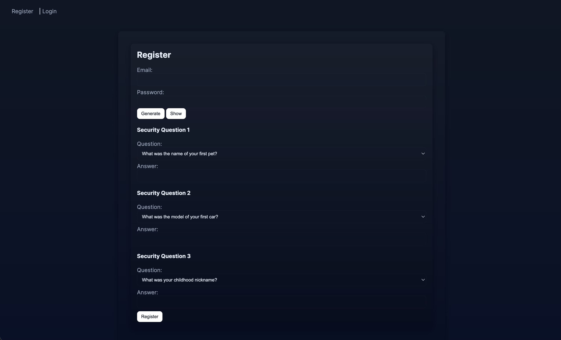
6.2 Login Screen
Description:
Contains fields for email and master password.
Shows an error message if authentication fails.
On success, redirects the user to their vault.
Screenshot:
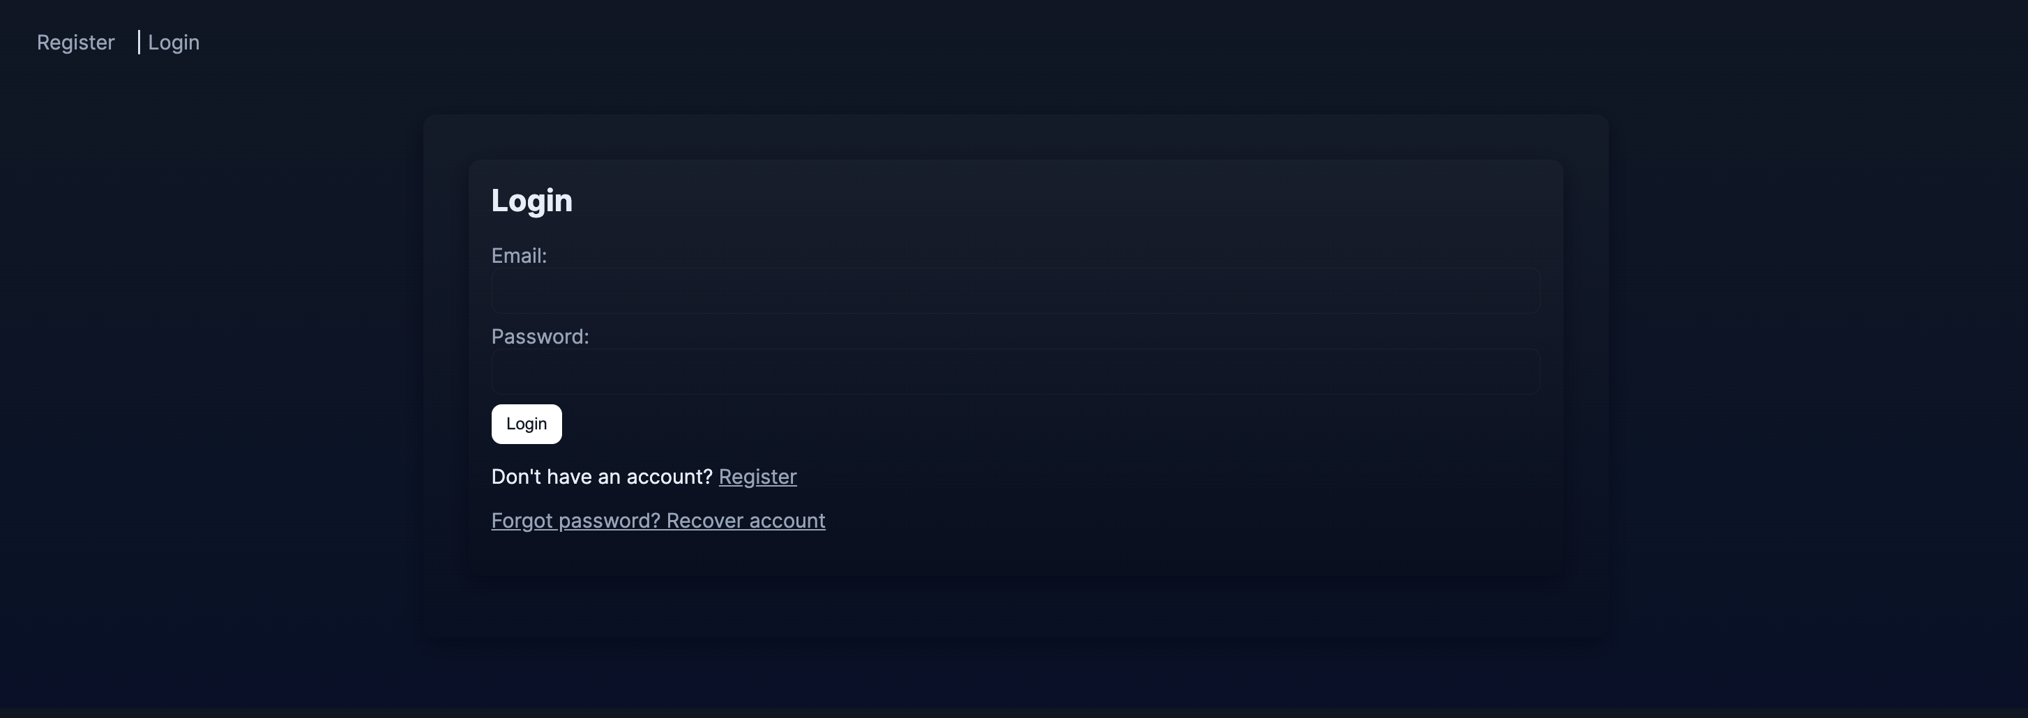
6.3 Home / Dashboard Screen
Description:
Displays a welcome message and any notifications generated by the Observer pattern (e.g., expired or soon-to-expire items).
Provides navigation links to the vault, create item page, and logout.
Screenshot:
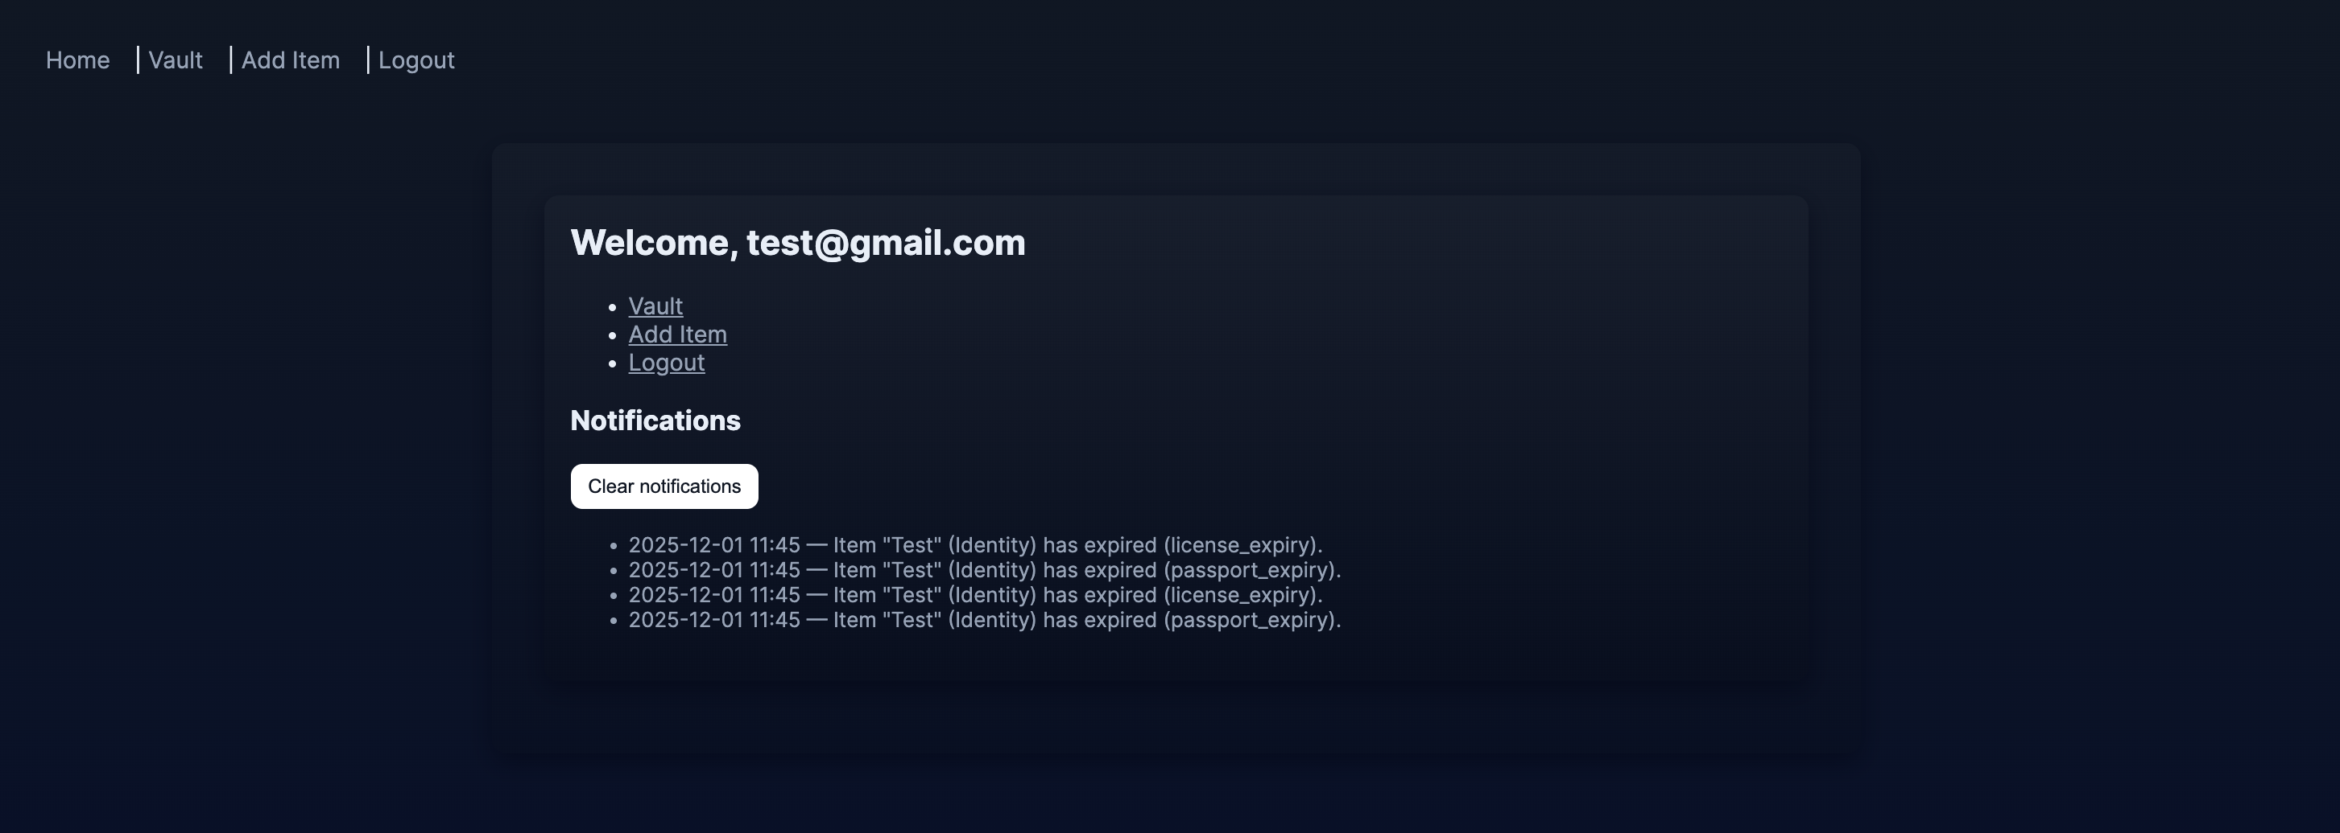

6.4 Vault List Screen
Description:
Lists all vault items for the current user.
Each item shows a masked preview of its sensitive data using the Proxy (DataProxy) logic.
Provides actions such as View, Edit, and Delete.
Screenshot:
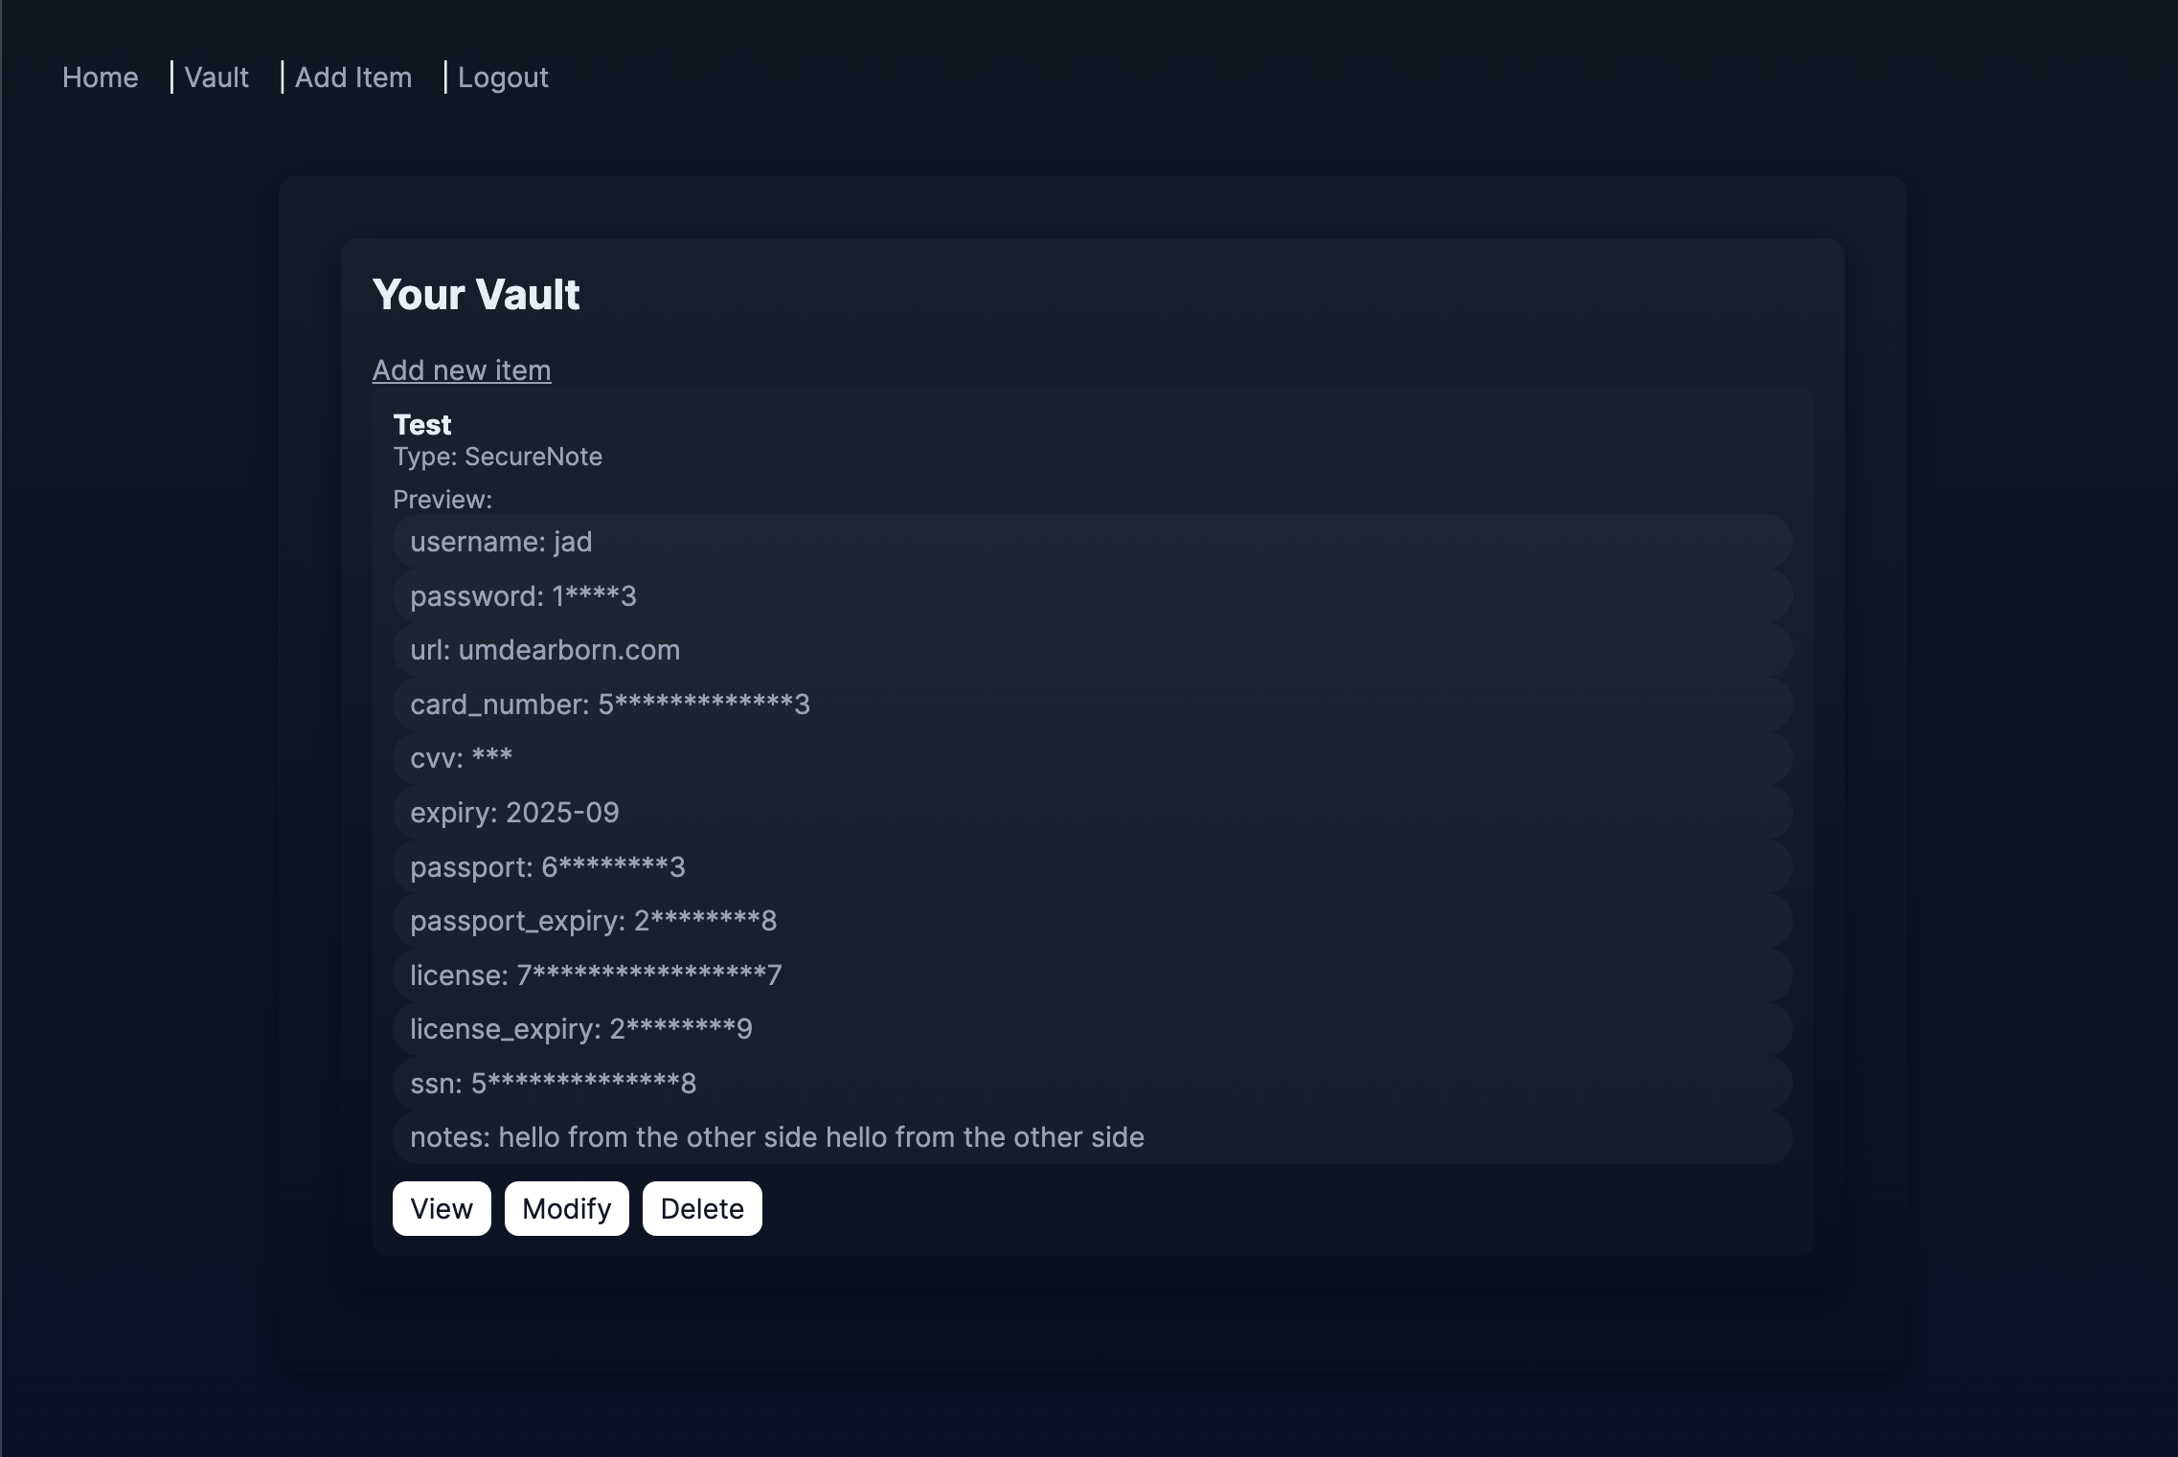

6.5 Add / Edit Item Screen
Description:
Contains a dropdown for item type (Login, CreditCard, Identity, SecureNote).
Uses the Mediator pattern to show/hide relevant fields depending on the chosen type.
Allows the user to save or update items; on submit, values are encrypted and stored as encrypted_data.
Screenshot:
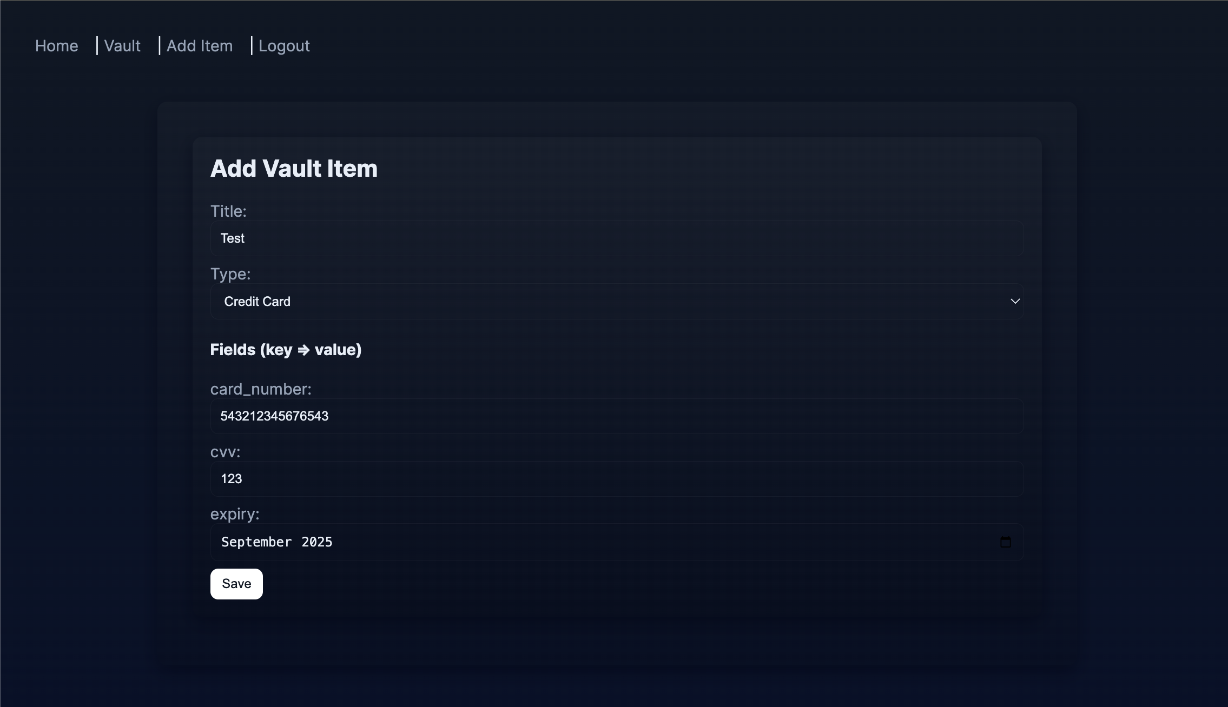

6.6 View Item Screen
Description:
Shows all fields for a single vault item, with sensitive values masked by default.
Each sensitive field has Unmask and Copy buttons:
Unmask triggers the unmask flow governed by UnmaskToken and the UserSession Singleton.
Copy copies the value to clipboard and schedules automatic clipboard clearing.
Screenshot:
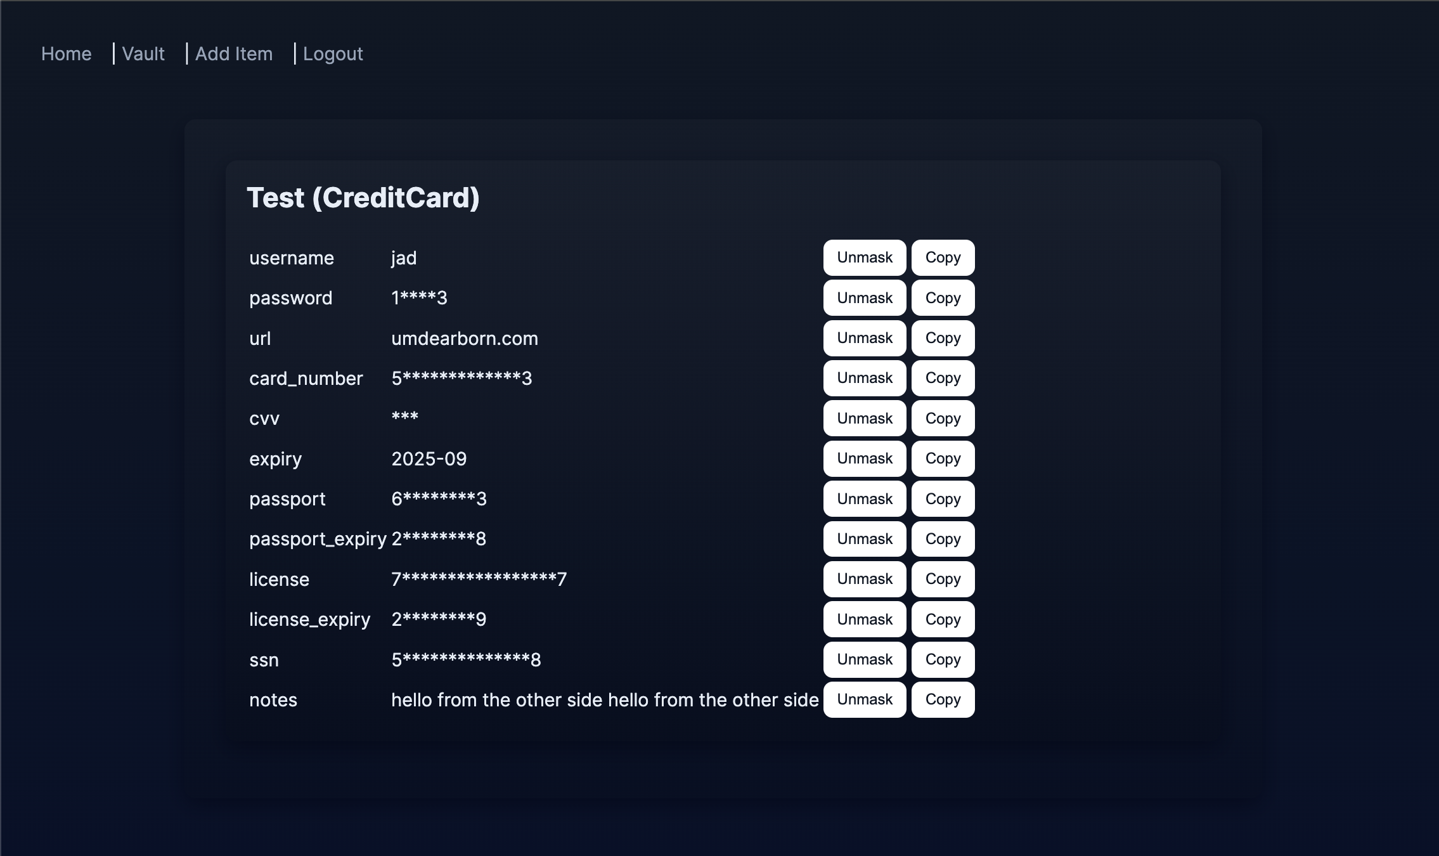

6.7 Recovery Screen
Description:
Allows users to start master password recovery by entering their email and answering three security questions.
Implements the Chain of Responsibility check: all three answers must be correct before a new master password is accepted.
Screenshot: 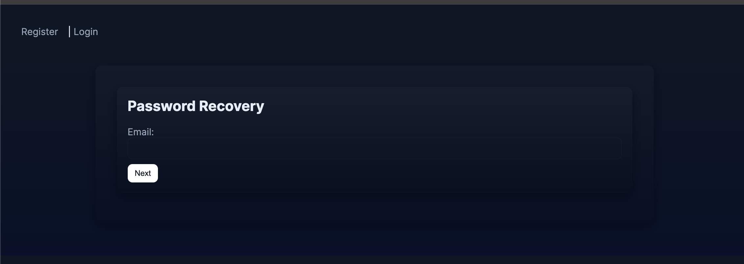
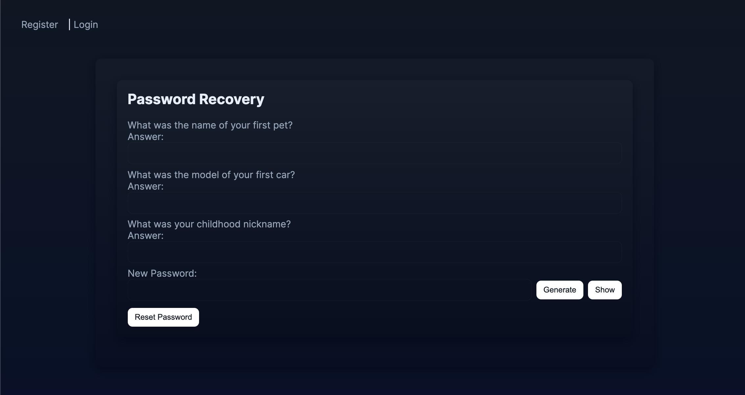

7. Security Considerations
MyPass includes several security measures beyond basic functionality:
Password Hashing:
Master passwords are never stored in plain text. They are hashed using a reputable algorithm via the Werkzeug security utilities.
Symmetric Encryption of Vault Data:
Sensitive fields inside vault items are serialized as JSON and encrypted using a symmetric key (Fernet).
The encryption key is stored separately and loaded by a dedicated crypto utility.
Session Management and Auto-Lock:
The Singleton UserSession keeps track of the logged-in user and enforces an inactivity timeout.
Flask’s before_request hook applies this timeout to all routes, ensuring that inactive sessions are automatically logged out.
Front-end JavaScript provides an additional auto-logout mechanism based on client-side inactivity.
Data Masking and Controlled Unmasking:
Sensitive fields are masked whenever possible using the Proxy pattern.
Unmasking is restricted by short-lived UnmaskToken records and unmask rate limiting in UserSession.
Clipboard Clearing:
When secrets are copied, the clipboard is automatically cleared after a brief delay, limiting how long sensitive information is exposed.
These measures together make MyPass a safer environment for storing and handling sensitive data.

8. Conclusion
The MyPass project demonstrates how classic software design patterns can be applied in a real-world security-focused application. The Singleton pattern centralizes session handling and inactivity timeouts; the Observer pattern decouples expiration checks from user notifications; the Mediator pattern keeps front-end interactions organized; the Builder pattern simplifies secure password generation; the Proxy pattern controls access to sensitive data; and the Chain of Responsibility secures the master password recovery process with a clear, extensible chain of answer validation handlers.
In addition to satisfying the functional requirements of a password manager, the design emphasizes encryption, data masking, and careful handling of sensitive information. Overall, MyPass achieves the main goals of the CIS 476 term project: implementing non-trivial application logic while actively using multiple design patterns to improve structure, maintainability, and security.

9. References

Flask Web Framework Documentation.
SQLAlchemy ORM Documentation.
Python Cryptography (Fernet) Documentation.
OWASP Foundation, “Password Storage and Management Best Practices.”

