Joystick

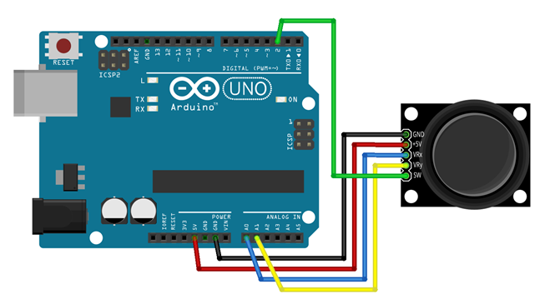

Using the joystick pins
VCC
GND
VRx -> Variable resistance x
VRY -> Variable resistance Y
SW -> Switch / Button

Connection
MODULE -> ARDUINO
VCC -> 5V
GND -> GND
VRx -> A0
VRy -> A1
SW -> Pin 2

int VRx = A0;
int VRy = A1;
int SW = 2;

int xPosition = 0;
int yPosition = 0;
int SW_state = 0;
int mapX = 0;
int mapY = 0;

void setup() {
Serial.begin(9600);

pinMode(VRx, INPUT);
pinMode(VRy, INPUT);
pinMode(SW, INPUT_PULLUP);

}

void loop() {
xPosition = analogRead(VRx);
yPosition = analogRead(VRy);
SW_state = digitalRead(SW);
mapX = map(xPosition, 0, 1023, -512, 512);
mapY = map(yPosition, 0, 1023, -512, 512);

Serial.print("X: ");
Serial.print(mapX);
Serial.print(" | Y: ");
Serial.print(mapY);
Serial.print(" | Button: ");
Serial.println(SW_state);

delay(100);

}

