Alexandria University
Faculty of Engineering
Computer Engineering and Systems dept.
4th year
2004-2005

Internet Programming
Final Project
Bank Simulation Process

Submitted by:

- Mohamed Abd El Aziz Khamis (56)

Supervisor:

- Dr. Hesham Sowailem

- Problem statement:

A newly established bank branch provides services to clients in two steps:
- Make a financial transaction; deposit or withdrawal.
- Approve the transaction after its completion.

The first step sometimes incur long processing time according to the transaction size, whereas the second step almost takes a few minutes for both transaction types. Since the new branch is located in a relatively crowded district, the branch manager is concerned with providing service quickly in the first step to help speeding up the whole process.

Three servicing windows were dedicated for the transactional stage, and two approaches were proposed to provide the service during in this stage.

The first approach suggests that a separate queue will be dedicated for each service window. The second approach suggests that one queue is used for the three windows, and queued client goes to the empty window when his turn comes.

You are required to help the manager decide which approach in better by simulating both approaches as queuing networks. You can do that by entering random or selective samples of clients to both systems, where each client will be assigned a different processing time upon entering the system. In case of first approach, you can assume that a new customer entering the system selects the smallest queue to join (this is instinctively, because he does not know the expected processing time for all the preceding ones).

W1
W2
W3
Wout
Q1 in
W1
W2
W3
Q2 in
Q3 in
Qout
Wout
Qin
First step
Second Step
First approach
Second approach
Qout

Implementation requirements

- Simulation program should be implemented using threading in JAVA.
- Simulation program should be constructed using visual effects indicating which client in which location in the network now (server or queue).

Deliverables

- A diskette or CD containing the simulation program and the source java files.
- A report contains details of your work and the conclusion you reached.

Notes

- In order to facilitate the input process, you can categorize your clients into a number of classes, each of which has a predefined service time, instead of entering the service time for each client when he enters the system. Thus you have only to choose the class to which he belongs

- The pseudo code:
1-BankSimulation.java:
→BankSimulation class extends the JFrame class
→Constructor:
- Get the content pane into the container and set its background color.
- Specify the label, location, and size of “window1” and add it to the container.
- Specify the label, location, and size of “window2” and add it to the container.
- Specify the label, location, and size of “window3” and add it to the container.
- Specify the label, location, and size of “out window” and add it to the container.
- Specify the label, location, and size of the “first approach” button and handle the action
performed when it is clicked by disable it as well as the “second approach” button and
enables the “add client” button and call test approach1 then add that button to the
container.
- Specify the label, location, and size of the “second approach” button and handle the
action performed when it is clicked by disable it as well as the “first approach” button
and enables the “add client” button and call test approach2 then add that button to the
container.
- Specify the label, location, and size of the “add client” button and handle the action
performed when it is clicked by constructing a new user and assign to it an id, a
service time, a label then add it to the container, if it is approach1 then add user by
test approach1 else add it by test approach2, add that button to the container.
- In the main function, construct an object from the BankSimulation class.

2 -FirstApproach.java:
→FirstApproach class extends the thread class.
→Declare:
- A synchronized queue (for each window).
- A synchronized output queue (for all objects).
- doService: initially =0 (i.e.: No one is currently served in the
window)
- index: the index of the window.
→Constructor: Takes as arguments an out synchronized queue and an index.
→The add user method enqueue a user into the q.
→Run method:
- Dequeue the user.
- Begin the queue.
- Loop on the users in the queue: set the location of each user by the user’s
position in the queue using test approach1.
- Service the user by sleeping an amount equals to the service time.
- Stop the service and enqueue the user into the output queue.
- Set the location of the user by the user’s position in the output queue using test
approach1.

3 -TestFirstApproach.java:
→Declare 3 windows of type Approach1.
→Declare the output window of type SecondStep.
→Specify the constants: X, Y, STEPX, STEPY, LWIDTH, and LHIGHT.
→Constructor:
- Construct 3 windows: w1, w2, w3 of type Approach1 with arguments:
the queue of the output window and the window index: 0, 1, 2 respectively.
- Construct the output window.
- Start w1, w2, w3 and the output window.
→Specify the position of the user in the queue by using the user order and the
window index.
→Specify the position of the user in the output queue by using the user order.
→Add user:
- Find the minimum of the 3 windows.
- Enqueue the user in the minimum window queue.
- Set the location of the user according to the length of the queue of the
minimum window and its index.
→Minimum of the 3 windows:
- Find the minimum of (w1, (w2,w3))
→Minimum of (w2,w3):
- Compare the queue length of each of the 2 windows + 1(if there exists a user
being served)

4 -SecondApproach.java:
→SecondApproach class extends the thread class.
→Declare:
- A synchronized queue (for all windows).
- A synchronized output queue (for all objects).
- doService: initially =0 (i.e.: No one is currently served in the
window)
- index: the index of the window.
→Constructor: Takes as arguments an out synchronized queue and an index.
→The add user method enqueue a user into the q.
→Run method:
- Dequeue the user.
- Begin the queue.
- Loop on the users in the queue: set the location of each user by the user’s
position in the queue using test approach2.
- Service the user by sleeping an amount equals to the service time.
- Stop the service and enqueue the user into the output queue.
- Set the location of the user by the user’s position in the output queue using test
approach2.

5 -TestSecondApproach.java:
→Declare 3 windows of type Approach2.
→Declare the output window of type SecondStep.
→Specify the constants: X, Y, STEPX, STEPY, LWIDTH, and LHIGHT.
→Constructor:
- Construct 3 windows: w1, w2, w3 of type Approach2 with arguments:
the queue of the output window and the window index: 0, 1, 2 respectively.
- Construct the output window.
- Start w1, w2, w3 and the output window.
→Specify the position of the user in the queue by using the user order and the
window index.
→Specify the position of the user in the output queue by using the user order.
→Add user:
- Enqueue the user in the second approach window queue.
- Set the location of the user according to the length of the second approach
window queue.

6 -SecondStep.java:
→SecondStep class extends the thread class.
→Declare:
- A synchronized queue.
- A constant: WAIT_TIME = 1.5 sec.
→Run method:
- Dequeue the user.
- Begin the queue.
- Loop on the users in the queue: set the location of each user by the user’s
position in the queue.
- Sleep an amount equals to the wait time.
- Set the location of the user.

7 -SynchronizedQueue.java:
→Extends the class List.
→Synchronized enqueue method:
- Insert at the back of the list
- Make all waiting threads not waiting
→Synchronized dequeue method:
- Loop: while the queue is empty: wait
- When the queue becomes not empty:
- Make all waiting threads not waiting
- Return: remove from front value.

8 -User.java:
→Constructor: Specify user id and service time.

- Sample Runs:

The first approach:

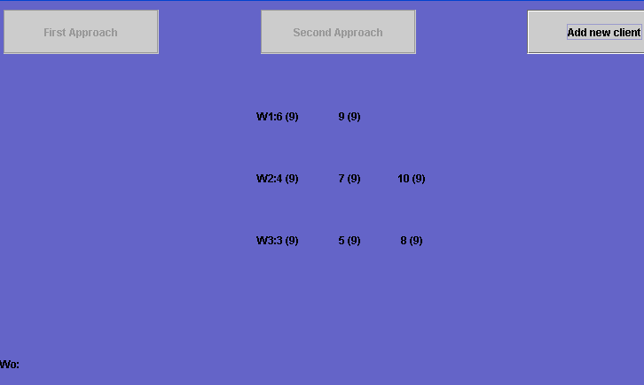

The second approach:

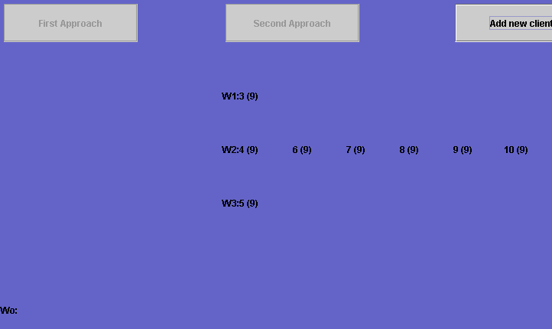

- Conclusion:

The first approach:
- There exists a separate queue dedicated for each one of the 3 service windows.
- The new customer entering the system selects the smallest queue to join, because he does
not know the expected processing time for all the preceding ones.

The second approach:
- One queue is used for the 3 service windows, and queued client goes to the empty window
when his turn comes.

*We could decide which approach is better by simulating both approaches as queuing networks.

*We could do that by entering selective samples of clients to both systems, where each client will be assigned a processing time upon entering the system.

From the sample runs:

The first approach:
- Not fair: Client₆ will be served before Client₅ at the same conditions.
- The left time to end the process ≈ 3 (levels of clients) * 9 (unit of time) = 27 (unit of time)

The second approach:
- Fair: Client_{i} will be served before Client_{i+1} at the same conditions.
- The left time to end the process ≈ 1 (level of clients) * 9 (unit of time)
+[ 5 (clients) / 3 (servicing windows) ] * 9 (unit of time) ≈27 (unit of time)

→ The two approaches are similarly having the same performance.

