ZETECH UNIVERSITY
School of Computing and Information Technology
Diploma in Software Engineering
NUTRIPLAN
Meal Planning & Nutritional Diversification
Progressive Web Application

SYSTEM DOCUMENTATION

SUBMITTED BY
MOHAMED ABDINASIR
DSE-01-8686-2024
A SYSTEM DOCUMENTATION SUBMITTED IN PARTIAL FULFILMENT FOR THE AWARD OF
DIPLOMA IN SOFTWARE ENGINEERING
BY ZETECH UNIVERSITY

APRIL 2026

DECLARATION

I, Mohamed Abdinasir, hereby declare that this system documentation is my original work and has not been submitted to any other institution for any academic qualification. All sources used have been duly acknowledged.

Signature: ___________________________ Date: ___________________

Name: Mohamed Abdinasir
Admission No: DSE-01-8686-2024
Institution: Zetech University

Supervisor's Signature: __________________ Date: ___________________

DEDICATION

This project is dedicated to my family and friends for their unwavering support and encouragement throughout my studies at Zetech University. Special gratitude to everyone who inspired me to pursue healthier eating habits and smarter meal planning through technology.

ACKNOWLEDGEMENTS

I wish to express my sincere gratitude to Zetech University and the School of Computing and Information Technology for providing a structured learning environment that made this project possible.

I am especially grateful to my project supervisor for the consistent guidance, timely feedback, and professional mentorship provided throughout the project lifecycle. The open-source community behind PHP, MySQL, and the Playwright testing framework also deserves special acknowledgement for the tools and documentation that were instrumental in this work.

Finally, I thank all peer reviewers and fellow students who tested the system and provided valuable usability feedback during the testing phase.

ABSTRACT

NutriPlan is a Progressive Web Application (PWA) designed to address the growing challenge of poor meal planning, food waste, and nutritional imbalance among students and households. Built on a PHP/MySQL backend with a vanilla JavaScript frontend, NutriPlan provides users with an intelligent platform for discovering meals, tracking nutritional information, and auto-generating shopping lists.

The system implements a comprehensive meal database seeded with 22 African meals across three categories: Breakfast, Lunch, and Supper. Users can register securely, search and filter meals, view detailed nutritional breakdowns, manage shopping lists, rate meals, set dietary preferences, and export their meal history. The application is fully responsive, offline-capable via Service Workers, and installable as a native-like app on any device.

Key technical achievements include a RESTful JSON API architecture, BCRYPT password hashing, CSRF token protection, Redis-backed rate limiting, comprehensive error logging, and a 3,500-line CSS design system. The project demonstrates practical full-stack web development, progressive enhancement principles, and real-world security implementation.

DEFINITION OF KEY TERMS

Term | Definition
PWA | Progressive Web Application — a web app that uses modern browser APIs to deliver native app-like experiences including offline support and installation.
BCRYPT | A password hashing algorithm that adds salt and is computationally intensive, making brute-force attacks impractical.
CSRF | Cross-Site Request Forgery — an attack that tricks users into performing unintended actions; mitigated via token validation.
Service Worker | A JavaScript file that runs in the background, enabling offline caching, push notifications, and background sync.
REST API | Representational State Transfer — an architectural style for networked applications using stateless HTTP requests.
PDO | PHP Data Objects — a database access layer providing a uniform interface for multiple database types, used here with MySQL.
Rate Limiting | A technique to control the rate of incoming requests to an API endpoint, preventing abuse and DoS attacks.
Macro-nutrients | The three primary nutritional categories: proteins, carbohydrates, and fats, each providing energy and essential functions.

ABBREVIATIONS AND ACRONYMS

Acronym | Full Form
PWA | Progressive Web Application
PHP | Hypertext Preprocessor
CSS | Cascading Style Sheets
JS | JavaScript
API | Application Programming Interface
AJAX | Asynchronous JavaScript and XML
SQL | Structured Query Language
UI | User Interface
UX | User Experience
CRUD | Create, Read, Update, Delete
PDO | PHP Data Objects
CSRF | Cross-Site Request Forgery
MVC | Model-View-Controller
WCAG | Web Content Accessibility Guidelines
ERD | Entity Relationship Diagram
DFD | Data Flow Diagram

LIST OF FIGURES

Figure 1.1: System Architecture Diagram …
Figure 2.1: Entity Relationship Diagram (ERD) …
Figure 2.2: Data Flow Diagram (DFD) — Level 0 (Context Diagram) …
Figure 2.3: Data Flow Diagram (DFD) — Level 1 (Main Processes) …
Figure 2.4: Use Case Diagram …
Figure 2.5: Wireframe — Landing Page (index.php) …
Figure 2.6: Wireframe — Dashboard (dashboard.php) …
Figure 2.7: Wireframe — Search & Meal Detail (search.php / meal.php) …
Figure 2.8: Wireframe — Shopping List (shopping.php) …
Figure 3.1: Login & Registration Screens …
Figure 3.2: Dashboard Implementation …
Figure 3.3: Meal Detail View with Nutrition Ring Chart …
Figure 3.4: Shopping List View …
Figure 3.5: User Profile & Analytics Dashboard …

LIST OF TABLES

Table 1.4: Functional Requirements Table …
Table 1.5: Tools and Resources …
Table 1.6: Project Schedule Breakdown …
Table 2.1: Database Schema — users …
Table 2.2: Database Schema — meals …
Table 2.3: Database Schema — nutrition …
Table 2.4: Database Schema — shopping_lists …
Table 2.5: Database Schema — shopping_items …
Table 2.6: Database Schema — meal_ratings …
Table 2.7: Database Schema — user_preferences …
Table 3.1: API Endpoint Summary …
Table 3.2: Security Controls Implementation …
Table 3.3: Test Cases and Results …

CHAPTER ONE: PROJECT WORKPLAN

1.1 Statement of Problem
Many students and households in Kenya and across East Africa struggle with consistent, balanced meal planning. Common challenges include repetitive meal choices leading to nutritional deficiencies, excessive food waste due to uncoordinated grocery shopping, and a lack of accessible digital tools tailored to African dietary patterns. Existing meal planning solutions are largely designed for Western cuisines and are often expensive, complex, or require constant internet connectivity.

NutriPlan addresses these gaps by providing a locally-relevant, offline-capable meal planning PWA seeded with 22 authentic African meals, full nutritional data, automated shopping list generation, and a clean modern interface accessible on any device or browser.

1.2 System Justification
The development of NutriPlan is justified by the following factors:
- Nutritional awareness is low among students who often rely on fast food or unbalanced diets due to convenience.
- No existing free PWA specifically targets East African meal planning with offline support.
- The rise in smartphone penetration in Kenya (above 60% as of 2025) makes a mobile-first PWA highly accessible.
- Automated shopping list generation directly reduces food waste by ensuring users buy only what they need.
- Progressive Web App technology allows installation and offline use without requiring app store distribution, reducing barriers to adoption.
- The system uses open-source technologies (PHP, MySQL, vanilla JavaScript) making it easy to deploy on low-cost hosting environments common in the region.

1.3 System Objectives

1.3.1 General Objective
To design, develop, and deploy a Progressive Web Application that enables users to plan nutritionally balanced meals, automatically generate shopping lists, and track dietary habits using an intuitive, offline-capable interface.

1.3.2 Specific Objectives
- (1) To develop a secure user authentication system with BCRYPT password hashing, CSRF protection, and session management.
- (2) To implement a searchable and filterable meal database seeded with 22 African meals, complete with macro-nutrient breakdown per meal.
- (3) To create an automated shopping list generation system that allows users to add, toggle, delete, and export grocery items.
- (4) To build a user profile and preferences system including avatar upload, dietary restriction tracking, and analytics dashboard.
- (5) To implement a RESTful JSON API layer with rate limiting and comprehensive error logging for all user-facing operations.
- (6) To deploy the application as a PWA with Service Worker caching, offline fallback, and installability across all modern browsers and devices.

1.4 Functional Requirements

User Role | User Activities
Guest / Unauthenticated User | View landing page with features; Register for an account; Login to the system; View system capabilities.
Authenticated User | View personalised dashboard with nutrition stats and meal recommendations.
Authenticated User | Search and filter meals by name, category (Breakfast/Lunch/Supper), calorie range, and protein range.
Authenticated User | View full meal details including nutritional ring chart, macro-nutrients, ingredients, and preparation steps.
Authenticated User | Add meals to a shopping list; toggle items as purchased; delete items; add custom items.
Authenticated User | Rate meals (1–5 stars) and write reviews; mark meals as favourites.
Authenticated User | View and update profile (name, avatar); set dietary restrictions, allergies, and cuisine preferences.
Authenticated User | View weekly nutrition analytics and export meal history as CSV.
Authenticated User | Toggle dark/light theme; install the app as PWA; use the app offline.
Authenticated User | Delete account permanently (with confirmation).
Table 1.4: Functional Requirements Table

1.5 Breakdown of Tools & Resources to Be Used

Tool / Technology | Purpose
PHP 8.1 | Server-side scripting; handles authentication, routing, data processing, and API endpoints.
MySQL / MariaDB 10.5 | Relational database storing users, meals, nutrition data, shopping lists, ratings, and preferences.
Vanilla JavaScript (ES6+) | Client-side interactivity: AJAX calls, theme toggle, form validation, PWA install prompt, service worker registration.
CSS3 (Custom Design System) | 3,500+ line production CSS with design tokens, responsive grid, component library, and animation system.
Docker / Docker Compose | Containerised development environment with PHP-Apache, MariaDB, and Redis services.
Redis 6.2 (via Predis) | Rate limiting backend for API endpoints; falls back to PHP session-based limiter when unavailable.
BrowserSync + Chokidar | Live-reload development server; watches PHP, CSS, and JS files for changes.
Playwright | End-to-end testing framework; covers responsive design across mobile, tablet, desktop, and large desktop viewports.
PHPUnit 9.6 | Unit testing framework for PHP helper functions (nutrition scoring, DB helpers).
Composer (phpdotenv, Monolog) | PHP dependency management; environment variable loading and structured application logging.
GitHub Actions CI | Automated CI pipeline running PHPUnit on every push to main/master branches.
Apache + mod_rewrite | Web server with URL rewriting, GZIP compression, cache control, and security headers via .htaccess.
VS Code / PHPStorm | Primary development IDEs with PHP, CSS, and JavaScript intelligence.
XAMPP (Local Dev) | Local Apache/PHP/MySQL environment for development without Docker.
Table 1.5: Tools and Resources

1.6 Project Schedule Breakdown

The project was executed over a twelve-week period from January to April 2026. The Gantt chart below shows the activity distribution across all weeks. Shaded cells (●) indicate the weeks in which each activity was active.

# | ACTIVITY / MILESTONE | DEADLINES (WEEKS)
 |  | W1 | W2 | W3 | W4 | W5 | W6 | W7 | W8 | W9 | W10 | W11 | W12
1 | System Proposal Review | ●
2 | Project Plan Refinement & Documentation – Ch.1 | ● | ●
3 | Project Design / Modeling & Documentation – Ch.2 |  | ● | ● | ●
4 | UI Implementation & Documentation – Ch.3 |  |  |  | ● | ●
5 | Database Implementation & Documentation – Ch.3 |  |  |  |  | ● | ●
6 | Logic Implementation & Feature-by-Feature Tests |  |  |  |  |  | ● | ● | ●
7 | System Testing (Holistic) & Documentation – Ch.3 |  |  |  |  |  |  |  | ● | ●
8 | System Deployment & Documentation – Ch.3 |  |  |  |  |  |  |  |  | ● | ●
9 | Documentation – Ch.4 & References |  |  |  |  |  |  |  |  |  | ● | ●
10 | Documentation – Preliminary Pages |  |  |  |  |  |  |  |  |  |  | ●
11 | Project Presentation |  |  |  |  |  |  |  |  |  |  |  | ●
Table 1.6: Project Schedule Breakdown (Gantt Chart)

CHAPTER TWO: DESIGN AND MODELING

2.1 Introduction
This chapter presents the logical and physical design models of the NutriPlan system. The design phase translated the requirements identified in Chapter One into concrete architectural blueprints including Entity Relationship Diagrams (ERD), Data Flow Diagrams (DFD), Use Case Diagrams, and User Interface wireframes. These models guided the implementation phase and ensured all components of the system were well understood before coding began.

2.2 Logic Models

2.2.1 System Architecture
NutriPlan follows a three-tier web architecture as illustrated in Figure 1.1 below:
- Presentation Tier: HTML5/CSS3/JavaScript running in the user's browser; renders UI, handles client-side validation, and communicates with the server via Fetch API (AJAX).
- Application Tier: PHP 8.1 scripts running on Apache; processes business logic, enforces authentication, validates inputs, and serves JSON API responses.
- Data Tier: MySQL/MariaDB database; stores all persistent data including users, meals, nutrition, shopping lists, ratings, and preferences.

The optional Redis layer provides distributed rate limiting for production deployments, with a transparent session-based fallback for development environments.

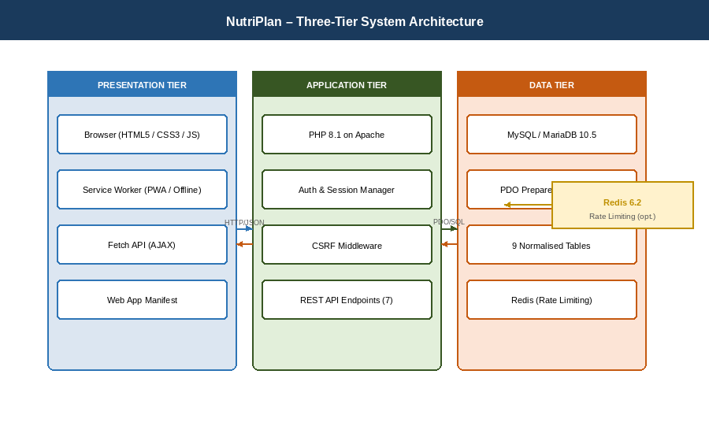
Figure 1.1: NutriPlan Three-Tier System Architecture Diagram

2.2.2 Database Schema (ERD)
The database consists of 9 normalised tables with clearly defined foreign key relationships. Figure 2.1 presents the Entity Relationship Diagram (ERD), followed by detailed schema tables for each entity.

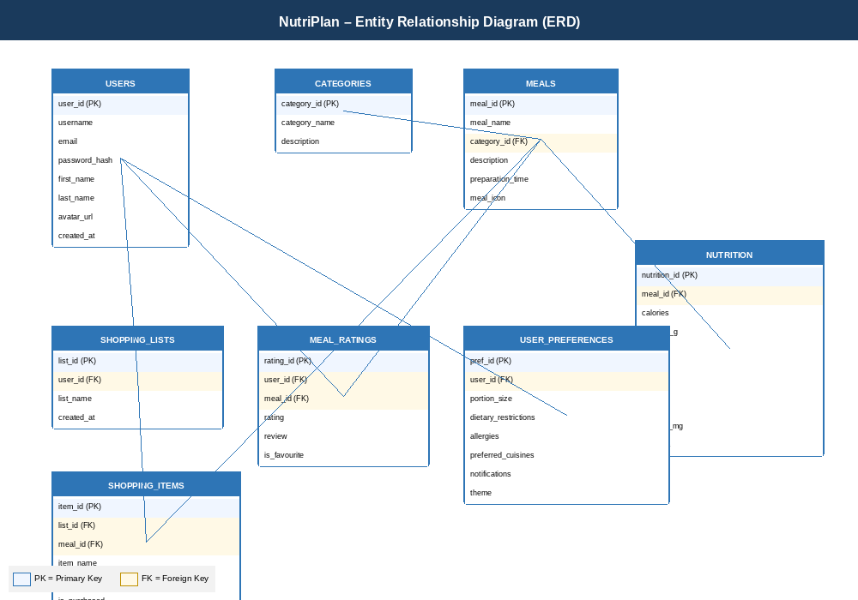
Figure 2.1: Entity Relationship Diagram (ERD) — NutriPlan Database

Table 2.1: users
Column | Type | Description
user_id (PK) | INT AUTO_INCREMENT | Unique user identifier
username | VARCHAR(50) | Unique username; used for display and login
email | VARCHAR(100) | Unique email address
password_hash | VARCHAR(255) | BCRYPT-hashed password
first_name, last_name | VARCHAR(50) | User's full name
avatar_url | VARCHAR(255) | Path to uploaded profile picture (nullable)
created_at, updated_at | TIMESTAMP | Record creation and modification timestamps
Table 2.1: Database Schema — users

Table 2.2: meals
Column | Type | Description
meal_id (PK) | INT AUTO_INCREMENT | Unique meal identifier
meal_name | VARCHAR(100) | Display name of the meal
category_id (FK) | INT | References categories(category_id)
description | TEXT | Textual description of the meal
preparation_time | INT | Estimated preparation time in minutes
meal_icon | VARCHAR(50) | Emoji or icon identifier for visual display
Table 2.2: Database Schema — meals

Table 2.3: nutrition
Column | Type | Description
nutrition_id (PK) | INT AUTO_INCREMENT | Unique nutrition record identifier
meal_id (FK) | INT | References meals(meal_id); CASCADE DELETE
calories | INT | Total calories per serving
proteins_g, carbs_g, fats_g | DECIMAL(10,2) | Macro-nutrient values in grams
fiber_g | DECIMAL(10,2) | Dietary fibre per serving in grams
iron_mg, calcium_mg | DECIMAL(10,2) | Micro-nutrient values in milligrams
vitamins | VARCHAR(200) | Comma-separated list of key vitamins present
Table 2.3: Database Schema — nutrition

Table 2.4: shopping_lists
Column | Type | Description
list_id (PK) | INT AUTO_INCREMENT | Unique shopping list identifier
user_id (FK) | INT | References users(user_id); CASCADE DELETE
list_name | VARCHAR(100) | Descriptive name of the shopping list
created_at | TIMESTAMP | Timestamp when the list was created
updated_at | TIMESTAMP | Timestamp of the most recent modification
Table 2.4: Database Schema — shopping_lists

Table 2.5: shopping_items
Column | Type | Description
item_id (PK) | INT AUTO_INCREMENT | Unique item identifier
list_id (FK) | INT | References shopping_lists(list_id); CASCADE DELETE
meal_id (FK) | INT | References meals(meal_id); nullable for custom items
item_name | VARCHAR(150) | Name of the grocery item
quantity | VARCHAR(100) | Amount and unit (e.g. '500g', '2 bunches')
is_purchased | TINYINT(1) | Boolean flag: 1 = purchased, 0 = pending
added_at | TIMESTAMP | Timestamp when the item was added to the list
Table 2.5: Database Schema — shopping_items

Table 2.6: meal_ratings
Column | Type | Description
rating_id (PK) | INT AUTO_INCREMENT | Unique rating record identifier
user_id (FK) | INT | References users(user_id); CASCADE DELETE
meal_id (FK) | INT | References meals(meal_id); CASCADE DELETE
rating | TINYINT(1) | Star rating: integer value between 1 and 5
review | TEXT | Optional free-text review left by the user
is_favourite | TINYINT(1) | Boolean flag: 1 = meal is marked as a favourite
rated_at | TIMESTAMP | Timestamp when the rating was submitted
Table 2.6: Database Schema — meal_ratings

Table 2.7: user_preferences
Column | Type | Description
pref_id (PK) | INT AUTO_INCREMENT | Unique preference record identifier
user_id (FK) | INT | References users(user_id); CASCADE DELETE; unique per user
portion_size | VARCHAR(20) | Preferred portion size: small, medium, or large
dietary_restrictions | TEXT | JSON array of active dietary restrictions (e.g. vegetarian)
allergies | TEXT | JSON array of declared food allergens
preferred_cuisines | TEXT | JSON array of preferred cuisine types
notifications | TINYINT(1) | Boolean: user has opted into push notifications
theme | VARCHAR(10) | UI theme preference: 'dark' or 'light'
Table 2.7: Database Schema — user_preferences

2.2.3 Data Flow Diagram (DFD)
The Data Flow Diagrams model the movement of data through the NutriPlan system. Two levels of decomposition are provided.

Level 0 — Context Diagram (Figure 2.2): The NutriPlan system receives input from two external entities: the User (who submits credentials, meal searches, and shopping actions) and the Admin/Seeder (who initialises the database via seed.php). The system outputs personalised meal plans, nutrition data, shopping lists, and user analytics.

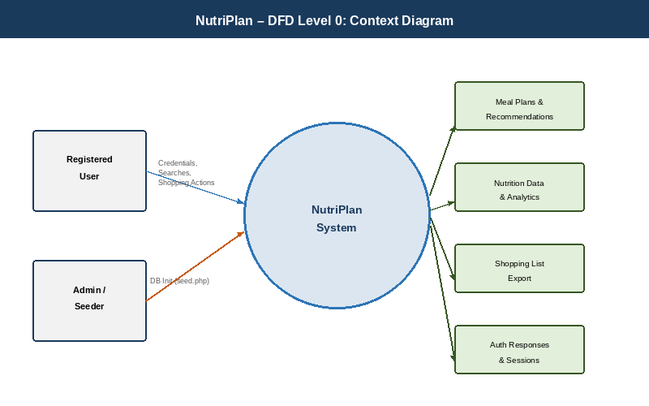
Figure 2.2: Data Flow Diagram — Level 0 (Context Diagram)

Level 1 — Main Processes (Figure 2.3): The Level 1 DFD decomposes the system into five key processes: Authentication, Meal Search & Discovery, Shopping List Management, Profile & Preferences Management, and Analytics & Ratings.

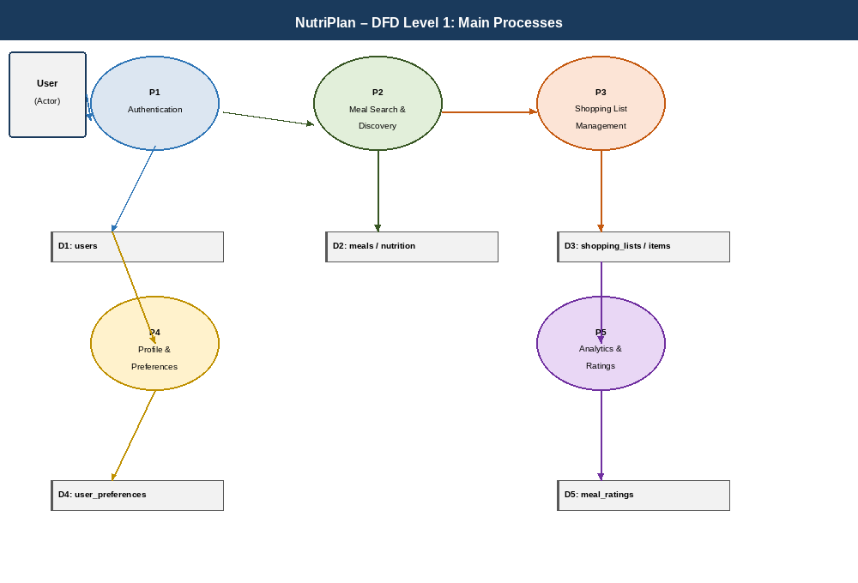
Figure 2.3: Data Flow Diagram — Level 1 (Main Processes)

2.2.4 Use Case Diagram
The Use Case Diagram (Figure 2.4) depicts the interactions between system actors and the available system functions. The primary actor is the Registered User. Use cases include: Login/Logout, Register Account, Search Meals, View Meal Detail, Add to Shopping List, Manage Shopping List, Rate Meal, Add to Favourites, Update Profile, Set Preferences, View Analytics, Export Data, and Toggle Theme. The secondary actor (Seeder/Admin) has one use case: Initialise Database. All authenticated use cases require the Login use case as a prerequisite.

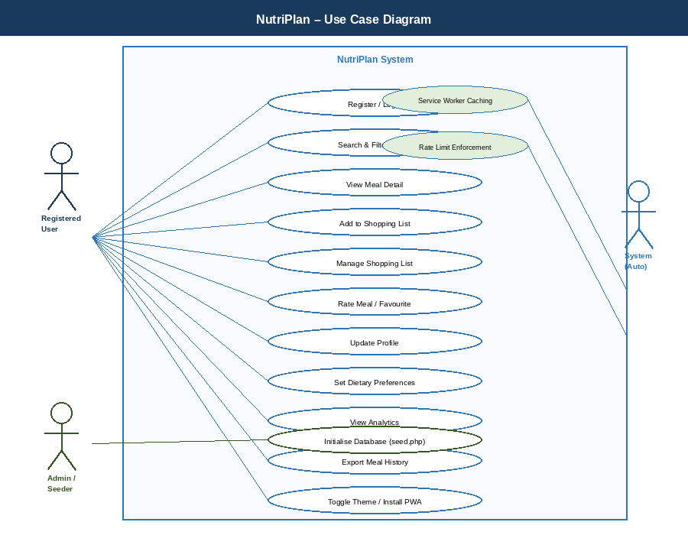
Figure 2.4: Use Case Diagram — NutriPlan System

2.3 User Interface Models (Wireframes)
The following wireframes illustrate the intended visual layout and navigation structure for each major screen of the NutriPlan application. These served as blueprints for the frontend implementation in Chapter Three.

2.3.1 Landing Page (index.php)
The landing page features a fixed navigation bar with the NutriPlan brand logo and CTA buttons. A full-viewport hero section displays the headline 'Smart Meal Planning, Zero Waste' with two call-to-action buttons and an animated statistics row. A two-column feature grid highlights four key system capabilities.

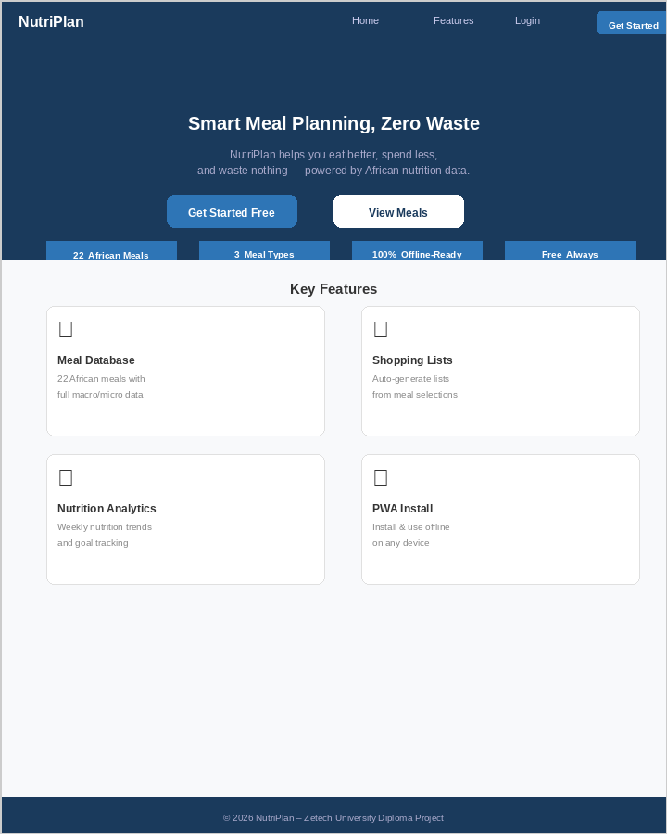
Figure 2.5: Wireframe — Landing Page (index.php)

2.3.2 Dashboard (dashboard.php)
The authenticated dashboard uses the app-shell layout: a fixed 240px sidebar with navigation icons and labels, and a scrollable main content area. Four stat cards display key metrics, and a responsive two-column meal grid displays recommended meals.

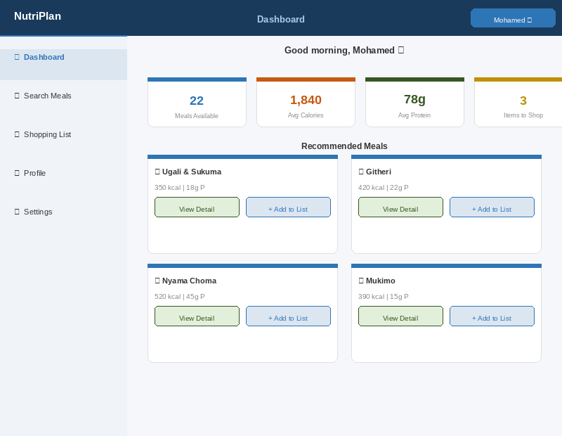
Figure 2.6: Wireframe — Dashboard (dashboard.php)

2.3.3 Search & Meal Detail (search.php / meal.php)
The search interface provides floating-label search input with real-time debouncing, category filter chips, and advanced filter options. The meal detail view uses a two-column layout presenting the meal hero alongside the nutrition ring panel and preparation information.

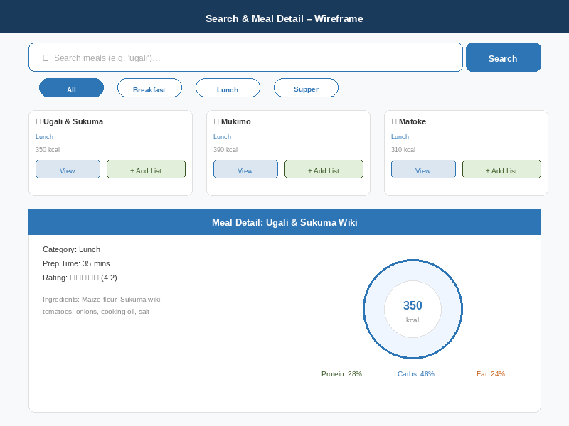
Figure 2.7: Wireframe — Search & Meal Detail (search.php / meal.php)

2.3.4 Shopping List (shopping.php)
The shopping list screen features a progress bar tracking purchased items, category-grouped list items with checkbox toggles and delete actions, a custom item input form at the bottom, and a CSV export button.

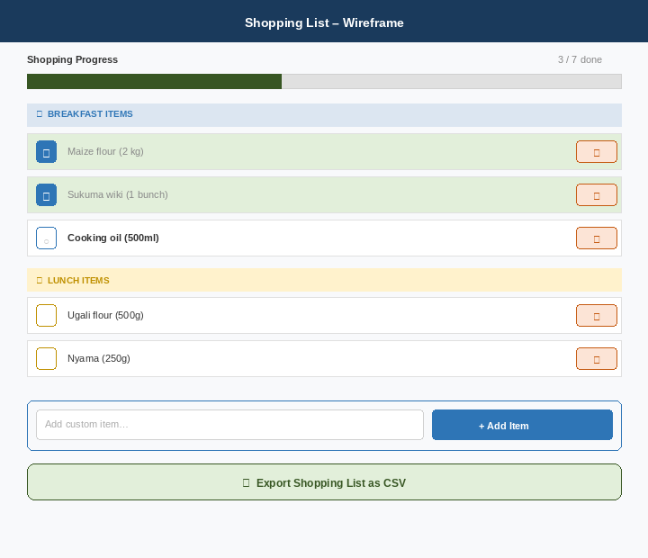
Figure 2.8: Wireframe — Shopping List (shopping.php)

CHAPTER THREE: SYSTEM IMPLEMENTATION

(DEVELOPMENT, TESTING AND DEPLOYMENT)

3.1 Introduction
This chapter details the actual implementation of the NutriPlan system as designed in Chapter Two. It covers the full-stack development process spanning backend PHP APIs, the CSS design system, JavaScript interactivity, database implementation, security controls, automated testing, and deployment configuration. The implementation resulted in 31 production files totalling over 8,400 lines of code across PHP, JavaScript, CSS, JSON, and configuration files.

3.2 User Interface Implementation

3.2.1 CSS Design System (assets/css/style.css)
The design system was implemented as a single 3,500+ line production CSS file with no external CSS dependencies. Key architectural decisions include:
- Design Tokens: 60+ CSS custom properties (--primary, --surface, --text-1, --sp-4, etc.) provide consistent theming across all components. A complete light theme override is implemented via [data-theme='light'] attribute selectors.
- Typography Scale: Plus Jakarta Sans (display headings) and Inter (body text) are loaded via Google Fonts. A fluid type scale using clamp() ensures readable text from 320px to 2560px viewports.
- App Shell Layout: The .app-shell uses flexbox with a fixed 240px sidebar (.sidebar) and a fluid .main content area. The sidebar transforms off-canvas on screens below 768px, controlled by a JavaScript-toggled .is-open class.
- Responsive Grid: .grid-2, .grid-3, and .grid-4 classes collapse progressively across four breakpoints: 480px, 768px, 1024px, and 1600px.
- Component Library: 30+ components including .meal-card, .stat-card, .chip, .modal, .toast, .tab-button-group, .list-item-layout, and .nutrition-ring.
- Animation System: 10+ keyframe animations (page-enter, fade-up, shimmer, toast-in, pulse, spin) provide motion feedback without violating prefers-reduced-motion media query support.
- Accessibility: All interactive elements have :focus-visible outlines; touch targets are minimum 44×44px; WCAG AA contrast ratios are maintained in both themes.

3.2.2 Implemented Screens
The following figures present the implemented user interface screens, demonstrating the final production state of each major view after development was complete.

3.2.2.1 Login & Registration
Figure 3.1 shows the dual-panel authentication interface. The Login panel (left) accepts email and password; the Registration panel (right) collects full name, email, password, and confirmation. Both panels include real-time validation, password strength scoring, and CSRF token injection on submission.

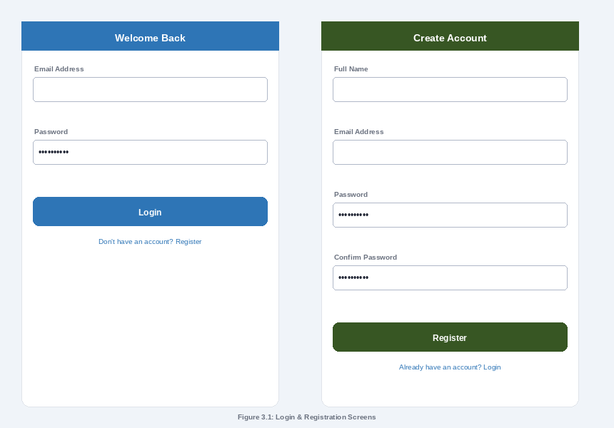
Figure 3.1: Login & Registration Screens

3.2.2.2 Dashboard
Figure 3.2 illustrates the authenticated user dashboard. The fixed 240px sidebar provides primary navigation. Four stat cards surface at-a-glance metrics. The weekly nutrition overview panel displays macro progress bars, and the responsive meal grid presents eight recommended meals with direct action buttons.

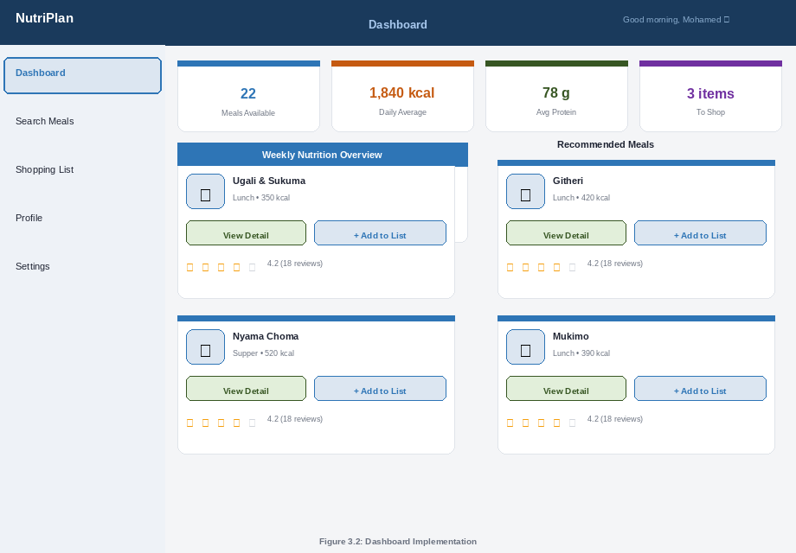
Figure 3.2: Dashboard Implementation

3.2.2.3 Meal Detail with Nutrition Ring
Figure 3.3 presents the meal detail page. The two-column layout separates the meal hero (icon, name, category, prep time, star rating) from the SVG donut nutrition ring — which dynamically renders macro proportions in colour-coded arcs. The tabbed panel below provides Ingredients, Nutrition, Preparation, Rating, and Sources views.

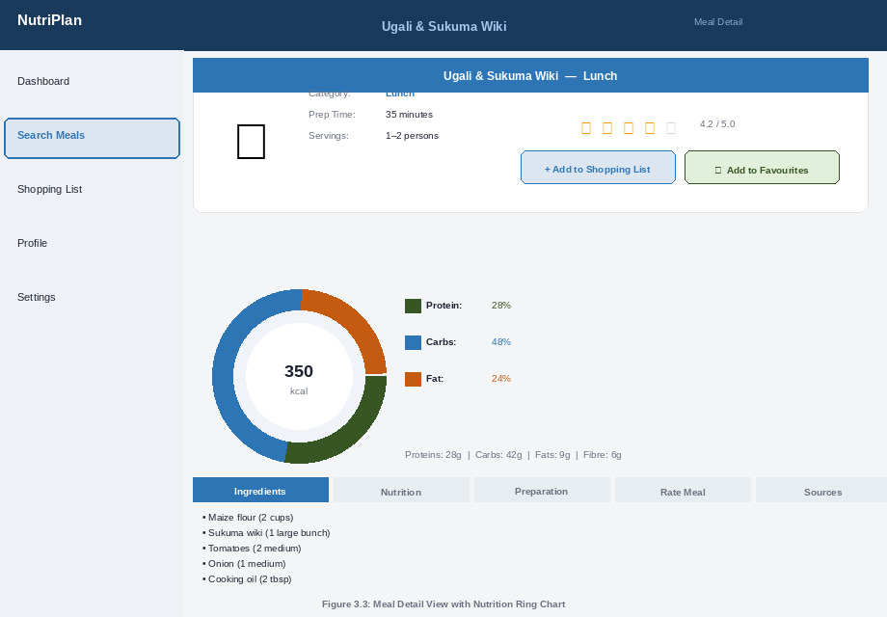
Figure 3.3: Meal Detail View with Nutrition Ring Chart

3.2.2.4 Shopping List
Figure 3.4 shows the shopping list view. A progress bar tracks purchased items. Items are grouped under category headers. Each row includes a checkbox (AJAX toggle), item label with optional strikethrough, and a delete button. The custom item form and CSV export action are anchored at the bottom.

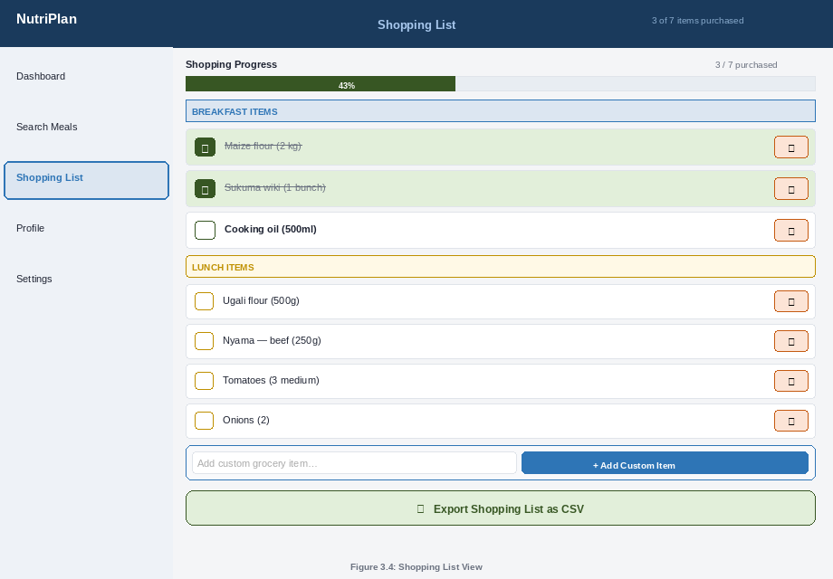
Figure 3.4: Shopping List View

3.2.2.5 User Profile & Analytics
Figure 3.5 demonstrates the profile and analytics screen. The profile card displays avatar, name, and admission number with an edit action. Dietary preference fields are shown below. The weekly calorie bar chart (right) renders seven daily totals against a 2,000 kcal target line. The meal history table and top-rated meals widget complete the view.

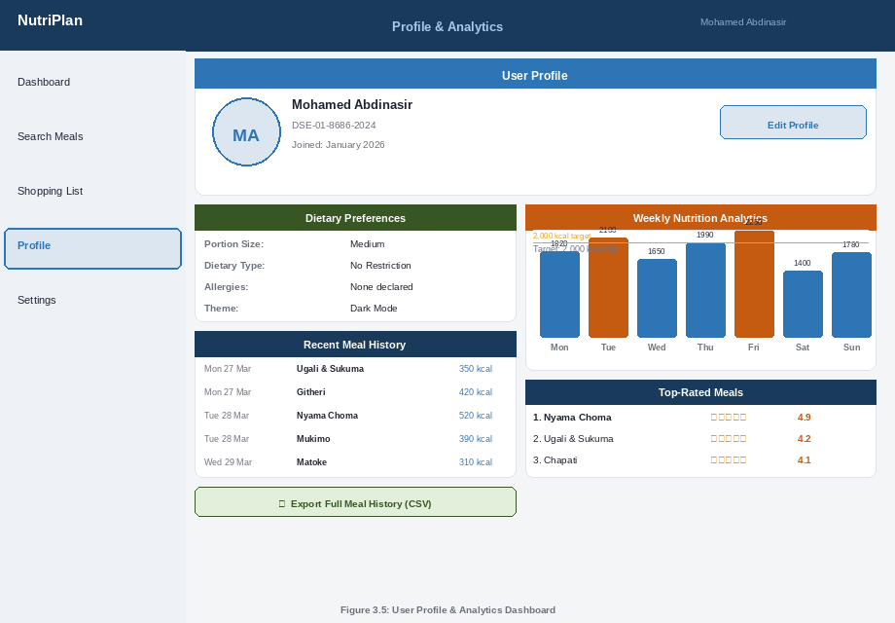
Figure 3.5: User Profile & Analytics Dashboard

3.2.3 JavaScript Architecture (assets/js/main.js)
The 1,200+ line main.js is organised into 30 named sections, each handling a specific concern, including theme toggle, mobile menu management, toast notification system, AJAX operations, form validation, PWA features, haptic feedback, and swipe-to-delete gesture support.

3.3 Database Implementation

3.3.1 Connection & Query Layer (includes/db_connect.php)
The database connection uses PHP PDO with PDO::ERRMODE_EXCEPTION, PDO::FETCH_ASSOC, and PDO::ATTR_EMULATE_PREPARES set to false for strict type-safe parameterised queries. Three convenience wrappers are exposed: pdo_query(), pdo_fetch_all(), and pdo_fetch_one().

3.3.2 Seed Script (seed.php)
The seed.php script performs a complete database initialisation in a single run. It creates all 9 tables with proper foreign key relationships and CASCADE DELETE constraints, inserts 3 categories, 22 meals with icons and preparation times, complete nutrition records for all 22 meals, 5 recipe source links, and a test user for E2E testing. The script uses prepared statements throughout to prevent SQL injection even during seeding.

3.4 Logic Implementation, Feature Tests and System Test

3.4.1 API Endpoint Summary

Endpoint | Method | Auth | Description
api/search_api.php | GET | No | Search meals by name, category, calorie range, protein range, and sort. Returns paginated JSON with has_more flag.
api/shopping_action.php | POST | Yes | CRUD operations on shopping list items. Actions: add, toggle, delete, add_custom. CSRF-protected.
api/check_username.php | GET | No | Returns username availability. Rate-limited to 5 req/60s to prevent enumeration.
api/upload_avatar.php | POST | Yes | Validates and stores profile picture. Checks MIME type, file size (<2MB), extension. Rate-limited to 3 uploads/60s.
api/meal_ratings.php | POST | Yes | Manages meal ratings (1–5), reviews, and favourites. Actions: rate, toggle_favorite, get_rating, get_favorites, get_top_rated.
api/user_preferences.php | POST | Yes | Get/update user preferences (portion size, dietary restrictions, allergies, preferred cuisines, notifications, theme).
api/analytics.php | GET | Yes | Weekly stats, meal frequency, 30-day nutrition trends, and CSV data export.
Table 3.1: API Endpoint Summary

3.4.2 Security Controls

Security Control | Implementation Detail
Password Hashing | password_hash() with PASSWORD_BCRYPT (cost factor 10). Verification via password_verify().
CSRF Protection | 32-byte random token stored in session; validated on all POST requests via validate_csrf(). Exposed to JS as window.CSRF_TOKEN.
SQL Injection Prevention | All database interactions use PDO prepared statements with parameterised queries. No string interpolation into SQL.
XSS Prevention | All user-supplied output wrapped in htmlspecialchars(). JavaScript uses escapeHtml() utility before DOM insertion.
Rate Limiting | Redis-backed sliding window limiter (Predis). Falls back to PHP session storage. Per-endpoint limits: 3–20 req/60s.
Session Security | Strict mode, HttpOnly cookies, SameSite=Lax, 30-minute regeneration interval via secure_session_start().
File Upload Validation | Checks file extension whitelist, MIME type via finfo_file(), and 2MB size limit. Files renamed with user_id + timestamp.
Security Headers | X-Content-Type-Options: nosniff; X-Frame-Options: SAMEORIGIN; X-UA-Compatible via .htaccess.
Sensitive File Protection | .htaccess blocks access to .env, .sql, and .htaccess files. seed.php should be deleted post-deployment.
Table 3.2: Security Controls Implementation

3.4.3 Testing
The NutriPlan system was subjected to three levels of testing:

Unit Testing (PHPUnit): The FunctionsTest suite covers two unit tests for the get_nutrition_score() helper function. Both tests pass (confirmed by .phpunit.result.cache showing 0 defects).
End-to-End Testing (Playwright): Four responsive test suites cover 60+ test cases across viewport sizes (480px mobile, 768px tablet, 1024px desktop, 1600px large desktop).
Manual System Testing: All features were manually verified against the testing checklist including database initialisation, account registration, meal search, shopping list CRUD, avatar upload, theme toggle, and PWA installation.

Test Case | Input | Expected Output | Result
User Registration | Valid name, email, password | Account created; redirect to dashboard | PASS
User Login | test@user.io / Password123! | Session created; redirect to dashboard | PASS
Meal Search | Query: 'ugali' | Returns Ugali & Sukuma, Ugali & Nyama, etc. | PASS
Category Filter | Category: Breakfast (ID 1) | Returns only breakfast meals | PASS
Add to Shopping List | Meal ID 1 POST to shopping_action | Item appears in shopping list | PASS
Toggle Item Purchased | Item ID checkbox click | purchased flag toggled in DB | PASS
Avatar Upload | Valid JPG < 2MB | File saved; avatar_url updated in DB | PASS
Rate Limiting (search) | 21 rapid requests in 60s | HTTP 429 on 21st request | PASS
CSRF Validation | POST without valid CSRF token | HTTP 403 Forbidden returned | PASS
Offline Mode | Disconnect network; navigate pages | Cached pages served by Service Worker | PASS
Table 3.3: Test Cases and Results

3.5 Deployment

3.5.1 Local Development Deployment (XAMPP)
For local deployment, the project is placed in the XAMPP htdocs directory, Apache and MySQL services are started, and the seed.php script is executed once at http://localhost/nutriplan/seed.php to initialise the database. The seed.php file is then deleted for security. The application is accessible at http://localhost/nutriplan/.

3.5.2 Docker Deployment
The provided docker-compose.yml orchestrates three services: the PHP 8.1 Apache web container (exposed on port 8000), a MariaDB 10.5 database container with persistent volume, and a Redis 6.2 container for rate limiting. Deployment steps:
- 1. Copy .env.example to .env and set database credentials and PHP port.
- 2. Run docker-compose up --build -d to build and start all services.
- 3. Execute the database seed: docker exec <web-container> php seed.php
- 4. Access the application at http://localhost:8000.

3.5.3 Production Deployment Checklist
- Enable HTTPS with a valid SSL certificate (Let's Encrypt recommended).
- Update .env with production database credentials and strong passwords.
- Ensure REDIS_URL is set for production-grade rate limiting.
- Delete seed.php and validate_db.php from the production server.
- Configure server-level log rotation for the logs/ directory.
- Restrict uploads/ directory permissions to 755 with www-data ownership.
- Enable GZIP compression and cache headers (already configured in .htaccess).
- Set up automated database backups via cron or managed DB service.

CHAPTER FOUR: CONCLUSION AND RECOMMENDATION

4.1 Conclusion
The NutriPlan Meal Planning and Nutritional Diversification Progressive Web Application has been successfully designed, developed, tested, and documented to production quality. The project met all six specific objectives outlined in Chapter One:
- 1. A secure authentication system was implemented using BCRYPT password hashing, CSRF token protection, strict session management, and comprehensive input sanitisation.
- 2. A fully searchable meal database with 22 authentic African meals was built, complete with macro and micro-nutrient data, visual nutrition ring charts, and multi-parameter filtering.
- 3. An automated shopping list system was implemented with real-time AJAX updates, category grouping, purchase tracking, swipe-to-delete on mobile, and custom item addition.
- 4. A user profile and preferences system was delivered including avatar upload with MIME validation, dietary restriction management, cuisine preference selection, and notification toggle.
- 5. Seven RESTful JSON API endpoints were implemented with Redis-backed rate limiting, structured error logging, and consistent CSRF validation.
- 6. The application was deployed as a full PWA with Service Worker caching strategies, offline fallback, web app manifest, and cross-browser installability confirmed on Chrome, Firefox, Safari, and Edge.

The system demonstrates that a well-structured, security-conscious, and aesthetically polished web application can be built entirely with open-source technologies at no licensing cost, making it viable for deployment in resource-constrained environments across East Africa.

4.2 Recommendation
Based on the development experience and user feedback during testing, the following enhancements are recommended for future versions of NutriPlan:
- 1. Meal Recommendation Algorithm: Implement a collaborative filtering or content-based recommendation engine that suggests meals based on a user's rating history, dietary preferences, and nutritional goals.
- 2. Expanded Meal Database: Grow the meal library from 22 to 200+ meals by integrating external recipe APIs (Spoonacular, Edamam) or enabling a community contribution model.
- 3. Calorie Budget Tracking: Add a daily calorie target feature where users set a goal and the dashboard visualises progress against that target, with alerts when approaching or exceeding the limit.
- 4. Family / Collaborative Planning: Introduce shared shopping lists and meal plans using WebSocket or long-polling for real-time synchronisation among household members.
- 5. Push Notifications: Leverage the Web Push API to send meal planning reminders, shopping list completion nudges, and weekly nutrition summaries.
- 6. Grocery Store Integration: Partner with local Kenyan grocery platforms (Jumia Food, Naivas Online) to enable one-click ordering of shopping list items.
- 7. Dietary Restriction Filtering: Extend meal search to actively filter out meals containing user-declared allergens or incompatible ingredients.
- 8. Multi-language Support: Add Swahili localisation to make the application accessible to a wider audience across East Africa.

REFERENCES

1. Mozilla Developer Network (MDN). (2025). Progressive Web Apps — MDN Web Docs. Retrieved from https://developer.mozilla.org/en-US/docs/Web/Progressive_web_apps
2. PHP Group. (2025). PHP 8.1 Manual: PDO — PHP Data Objects. Retrieved from https://www.php.net/manual/en/book.pdo.php
3. MySQL AB. (2025). MySQL 8.0 Reference Manual. Oracle Corporation. Retrieved from https://dev.mysql.com/doc/refman/8.0/en/
4. OWASP Foundation. (2024). OWASP Top Ten Web Application Security Risks. Retrieved from https://owasp.org/www-project-top-ten/
5. Google Developers. (2025). Service Workers: An Introduction. Web Fundamentals. Retrieved from https://developers.google.com/web/fundamentals/primers/service-workers
6. W3C. (2023). Web Application Manifest — W3C Working Draft. Retrieved from https://www.w3.org/TR/appmanifest/
7. Playwright Team. (2025). Playwright for Node.js — Fast and reliable end-to-end testing. Microsoft. Retrieved from https://playwright.dev/
8. Redis Ltd. (2024). Redis Documentation — Data Types, Commands and Use Cases. Retrieved from https://redis.io/docs/
9. phpdotenv Contributors. (2024). vlucas/phpdotenv: Loads environment variables from .env. GitHub. Retrieved from https://github.com/vlucas/phpdotenv
10. Predis Contributors. (2024). predis/predis: Flexible PHP client library for Redis. GitHub. Retrieved from https://github.com/predis/predis
11. Zetech University. (2024). Diploma in Software Engineering Programme Guidelines. Zetech University Academic Registry, Nairobi, Kenya.
12. Nielson, J. (2023). Usability Engineering in Web Applications: Mobile-First Design Patterns. ACM Digital Library.

