

**Task1**

* One application of a capacitor is the **bypass capacitor.** Discuss briefly that application and the importance of it.
* Applications of inductors vary according to the **type of the material of the core**. Discuss the previous sentence then mention these applications.
* Talk about pullup and pulldown resistors

Report should not exceed 1 page and should be submitted in PDF format

**Task 2, 3 and 4 will submitted as TinkerCad link**

**Please make sure the link is public otherwise we won't be able to see you work!!**

**Task2**

* Implement the following circuit using **TinkerCad** you should use the following components:
* Bread board
* Battery
* Regulator
* Optocoupler
* Motor
* Diodes

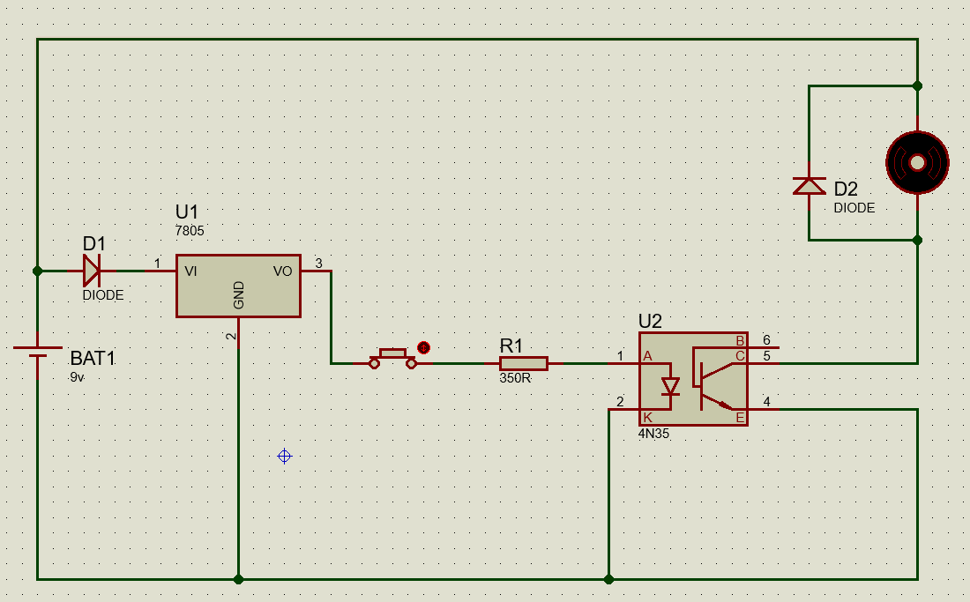

**Task3**

* We have discussed the H-Bridge in the session using normal switches to control the direction now we want to implement this circuit using the transistors as switches you should use the following:
* Battery
* Regulator
* 2NPN
* 2PNP
* Motor
* Resistors

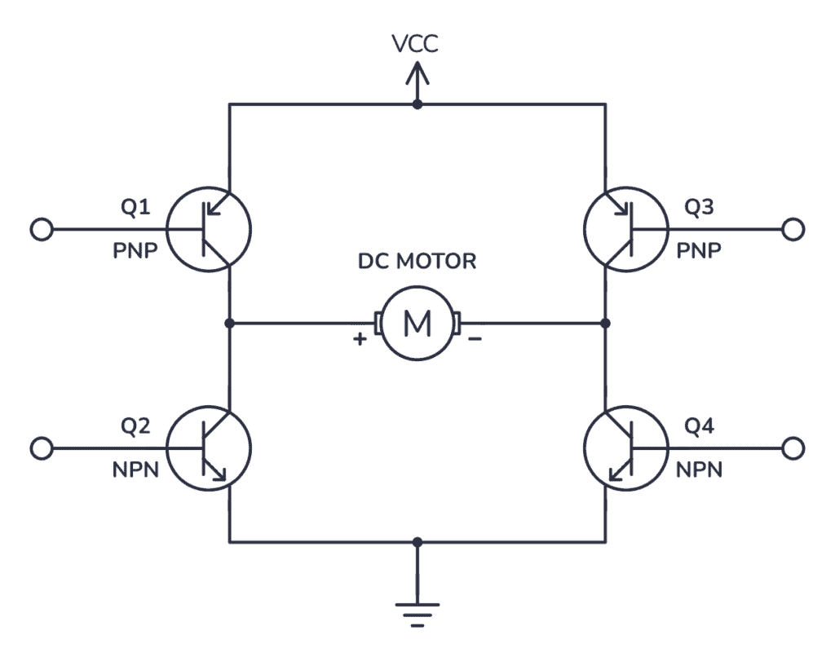

Notes: VCC= 5 volts , each base should have resistor of 1k ohm in series, the voltage input to the transistor should be 5v out of the regulator.

**Bonus : Task4**

* We have implemented the H-Bridge circuit using switches and 4 transistors now it’s time to implement the same circuit using the relays you should use the following:
* 2 relays
* Motor
* Battery

