**Task :PCB Report**

**Designators :**

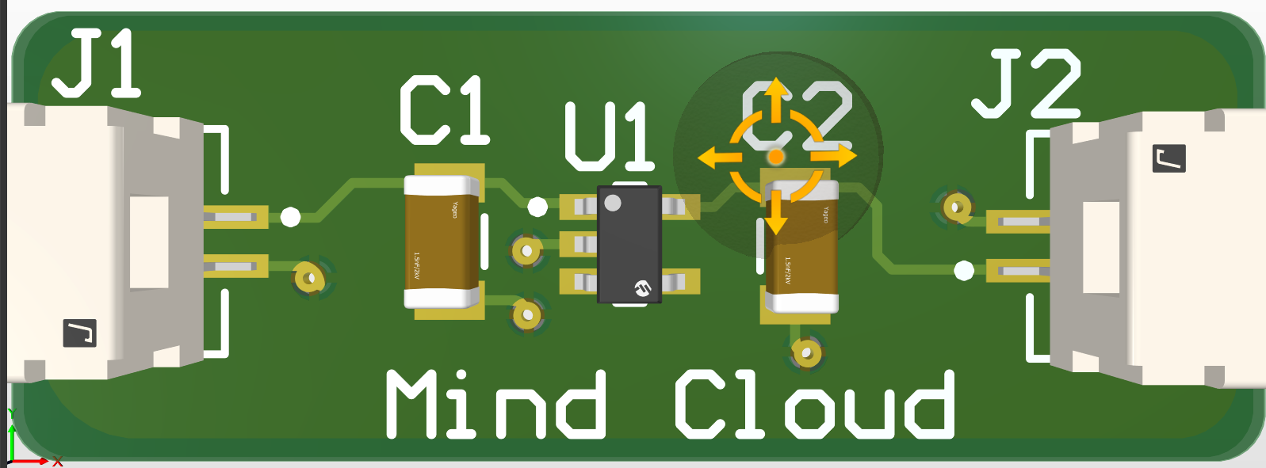 Figure 1.

*Designators* are used to identify the location of the components that you use in your PCB, and each element has its own symbol. For example, you can use the symbol “R” for resistances, “C” for capacitors, “L” for inductors, and so on.

*Designators* consist of two parts: the symbol of the component and a number that indicates the number of this component according to its group. For example, as you see in Figure 1, the designer uses two capacitors, and each of them has its own designator, “C1” and "C2" .Two designators share the symbol but differ in the number.

**Some Designators :**

|  |  |  |  |
| --- | --- | --- | --- |
| R | [Resistor](https://en.wikipedia.org/wiki/Resistor) | D, CR | [Diode](https://en.wikipedia.org/wiki/Diode) (all types, including [LED](https://en.wikipedia.org/wiki/Light-emitting_diode)), [thyristor](https://en.wikipedia.org/wiki/Thyristor) |
| L | Inductor | ZD | [Zener diode](https://en.wikipedia.org/wiki/Zener_diode) |
| C | [Capacitor](https://en.wikipedia.org/wiki/Capacitor) | VR | [Voltage regulator](https://en.wikipedia.org/wiki/Voltage_regulator) or  [variable resistor](https://en.wikipedia.org/wiki/Variable_resistor) |
| LD, LED | LED | BT, BAT | [Battery](https://en.wikipedia.org/wiki/Battery_(electricity)) or [battery holder](https://en.wikipedia.org/wiki/Battery_holder) |
| CB | [Circuit breaker](https://en.wikipedia.org/wiki/Circuit_breaker) | BR | [Bridge rectifier](https://en.wikipedia.org/wiki/Bridge_rectifier) |

**Polygons :**

*Polygons* Can be located in several layers, like top_layer and bottom_layer. It can be shaped to any area you need and provide a reference voltage for this area.

**When should I use polygons over traces in routing?**

* **High Current:** Polygons provide a large copper area. so the current can spread to a wider surface. leads to a lower temperature.
* **Low Power Dissipation:** According to increasing the area of the pass, the resistance will decrease. so the power dissipation will decrease.
* **Electromagnetic Interference:** In high-frequency polygons, the impedance is low, which minimizes the potential for electromagnetic interference and crosstalk.

**What to do if there is no place for designators?**

In this case*,* you should provide some documents to clear the PCB, like a PDF file, then put all the components,their places and any information you think it’s important. After that, put this file with the project files before sending it to the manufacturer.

**Reasons for the solder bridge occurring although having a solder mask layer?**

* Designing solder pads that are too big in relation to the gap between pads.
* Placing components imprecisely or having a reduced component leads to pad size relationship.
* Having an insufficient layer of solder resistance applied between the pads on your board.

**What are gerber files and what are they used for?**

These files describe the copper of every layer in your PCB in a way that a computer-aided manufacturing system (CAM) can understand.

They were used to provide instructions to a photoplotter machine that would create a picture of your PCB using light on a unexposed piece of film. These days, Gerbers are used to controls a laser plotting machine to make an image of all the traces, holes, vias on your PCB layout.

**References :**

ref: [Designators](https://en.wikipedia.org/wiki/Reference_designator" \l ":~:text=A%20reference%20designator%20unambiguously%20identifies,%2C%20D1%2C%20R4%2C%20U15.)

ref: [Polygons](https://electronics.stackexchange.com/questions/636296/when-and-why-is-it-important-to-route-with-polygons-vs-traces)

ref: [Solder Bridge](https://www.autodesk.com/products/fusion-360/blog/solder-bridging-pcb/" \l ":~:text=Solder%20bridging%20is%20just%20one,of%20solder%2C%20creating%20a%20bridge.)

ref: [Gerber Files](https://www.autodesk.com/products/fusion-360/blog/gerber-nc-drill-pcb-manufacturing-basics-1/?us_oa=dotcom-us&us_si=1eaa41de-8b84-4228-8132-330bd25c942c&us_st=gerber%20files)