OSPF Multi-Area Lab
Implementation & Verification Documentation
Lab implemented by
Mohamed Elafndy
Platform: PNETLab
Date: November 8, 2026

1. Lab Requirements
The lab objectives are listed below exactly as given in the assignment.
# | Requirement
1 | Configure basic OSPF for the network shown. Advertise all networks attached to each router into OSPF using the simplest method available. To inject external networks into the OSPF domain, redistribute the static routes on R1. These routes should be marked as type E1.
2 | OSPF should never form neighbor relationships on any interface where other OSPF routers don’t exist.
3 | All routers in Area 0 should use MD5 authentication for OSPF neighbors. Routers in Area 23 should be configured to support clear text authentication for OSPF neighbors.
4 | Routers in Area 45 are limited in their capacity and should not receive routes for networks outside the OSPF system. These routers should reach the external network using a default route which cannot be configured statically.
5 | Routers in Area 23 must not receive any type 3, 4 or 5 LSAs from the rest of the OSPF network. These routers should reach the external network using a default route with an initial OSPF cost of 100.
6 | When this exercise is complete, all routers should ping every route in the OSPF routing table.

External networks redistributed on R1 (static routes): 172.31.0.0/24, 172.31.1.0/24, 172.31.2.0/24, 172.31.3.0/24.

2. Network Topology (PNETLab)
The topology below was built in PNETLab. Area 0 connects R1, R2, R4 and R6 through a switch (10.100.1.0/24). R1 is the ASBR that redistributes the external static routes.
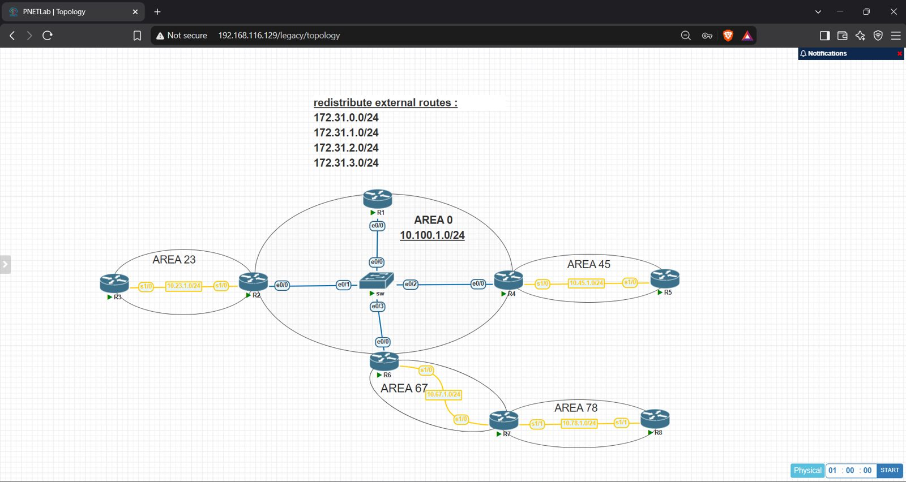
Figure 1 – OSPF multi-area topology in PNETLab

Areas, Routers and Roles
Area | Network | Routers | Role / Type
Area 0 | 10.100.1.0/24 | R1, R2, R4, R6 | Backbone (MD5 authentication). R1 = ASBR
Area 23 | 10.23.1.0/24 | R2 (ABR), R3 | Totally stub, clear-text authentication, default cost 100
Area 45 | 10.45.1.0/24 | R4 (ABR), R5 | Stub area
Area 67 | 10.67.1.0/24 | R6 (ABR), R7 | Transit area for the virtual link
Area 78 | 10.78.1.0/24 | R7 (ABR), R8 | Connected to Area 0 through a virtual link R6–R7

Router IDs
Router | Router ID | Connected interfaces
R1 | 1.1.1.1 | Ethernet0/0 (10.100.1.1)
R2 | 2.2.2.2 | Ethernet0/0 (10.100.1.2), Serial1/0 (10.23.1.2)
R3 | 3.3.3.3 | Serial1/0 (10.23.1.3)
R4 | 4.4.4.4 | Ethernet0/0 (10.100.1.4), Serial1/0 (10.45.1.4)
R5 | 5.5.5.5 | Serial1/0 (10.45.1.5)
R6 | 6.6.6.6 | Ethernet0/0 (10.100.1.6), Serial1/0 (10.67.1.6)
R7 | 7.7.7.7 | Serial1/0 (10.67.1.7), Serial1/1 (10.78.1.7)
R8 | 8.8.8.8 | Serial1/1 (10.78.1.8)

3. Implementation Steps

Step 1 – Basic OSPF and redistribution of static routes as E1
OSPF was enabled directly on each interface with the area number (simplest method). On R1, the four static routes were redistributed into OSPF as external type 1.
interface Ethernet0/0
ip ospf 1 area 0
!
router ospf 1
router-id 1.1.1.1
redistribute static metric-type 1 subnets

Step 2 – Prevent neighbors on empty interfaces
All interfaces were made passive by default, then only the interfaces connected to other OSPF routers were re-enabled.
router ospf 1
passive-interface default
no passive-interface Ethernet0/0 ! only links that have OSPF neighbors
no passive-interface Serial1/0

Step 3 – Authentication
- Area 0 (R1, R2, R4, R6): MD5 authentication on Ethernet0/0.
- Area 23 (R2 and R3): clear-text authentication on Serial1/0, same key on both sides.
! Area 0 routers
router ospf 1
area 0 authentication message-digest
interface Ethernet0/0
ip ospf message-digest-key 1 md5 cisco123

! Area 23 (R2 and R3)
router ospf 1
area 23 authentication
interface Serial1/0
ip ospf authentication-key cisco23

Step 4 – Area 45 as Stub
A stub area blocks type 5 LSAs, and the ABR (R4) automatically injects a default route, which satisfies the requirement that the default route is not static.
! R4 and R5
router ospf 1
area 45 stub

Step 5 – Area 23 as Totally Stubby with default cost 100
! R3 (internal router)
router ospf 1
area 23 stub

! R2 (ABR)
router ospf 1
area 23 stub no-summary
area 23 default-cost 100

Step 6 – Virtual link for Area 78
Area 78 is not directly attached to Area 0, so R8 learned no inter-area or external routes at first. A virtual link between R6 and R7 across Area 67 fixed this (see Section 5).
! R6
router ospf 1
area 67 virtual-link 7.7.7.7 message-digest-key 1 md5 cisco123

! R7
router ospf 1
area 67 virtual-link 6.6.6.6 message-digest-key 1 md5 cisco123

4. Verification of OSPF on Each Router
For each router, the neighbor table, OSPF routing table, interface summary and protocol details were checked.

R1 (ASBR)
R1 has FULL adjacencies with R2, R4 and R6 in Area 0 and is an autonomous system boundary router redistributing static routes.
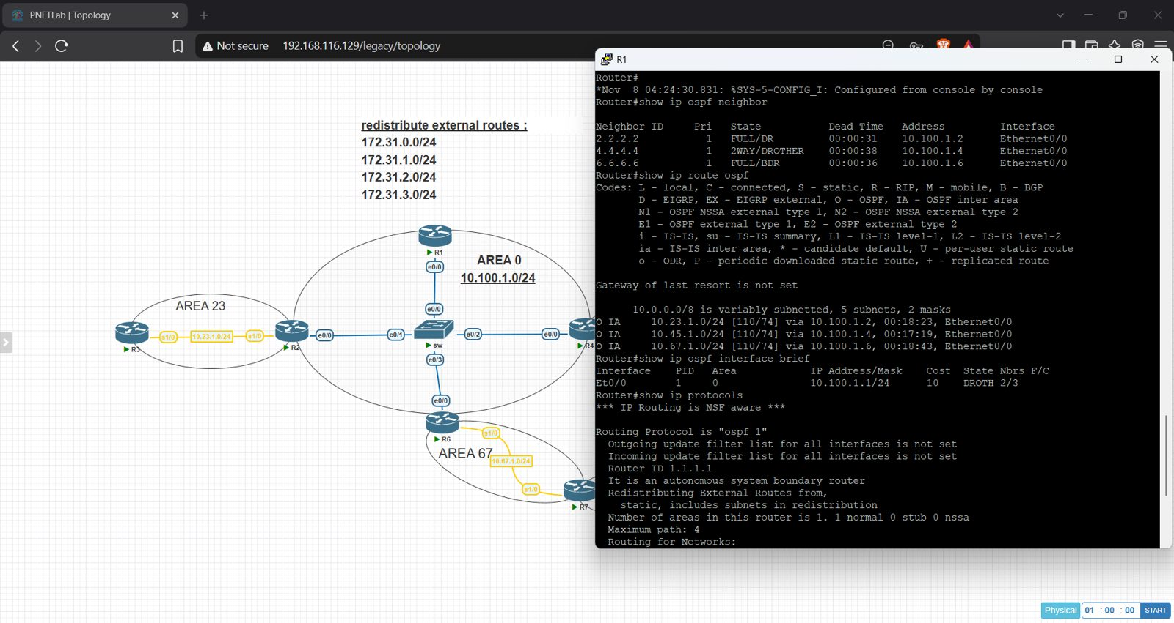
Figure 2 – R1: neighbors and OSPF routes
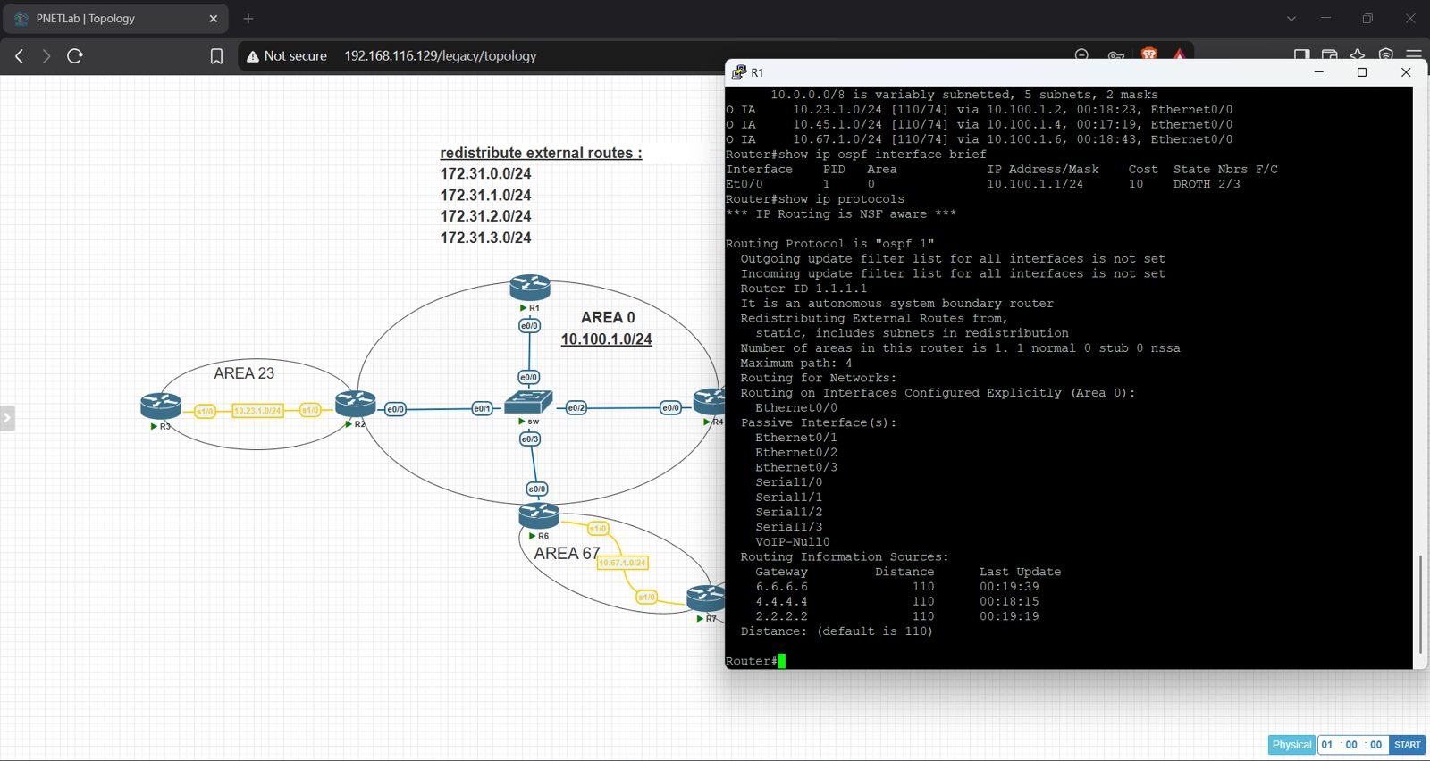
Figure 3 – R1: OSPF interfaces and protocol information

R2 (ABR – Area 0 / Area 23)
R2 has neighbors R1, R4, R6 in Area 0 and R3 in Area 23; it runs Area 23 as stub with no-summary.
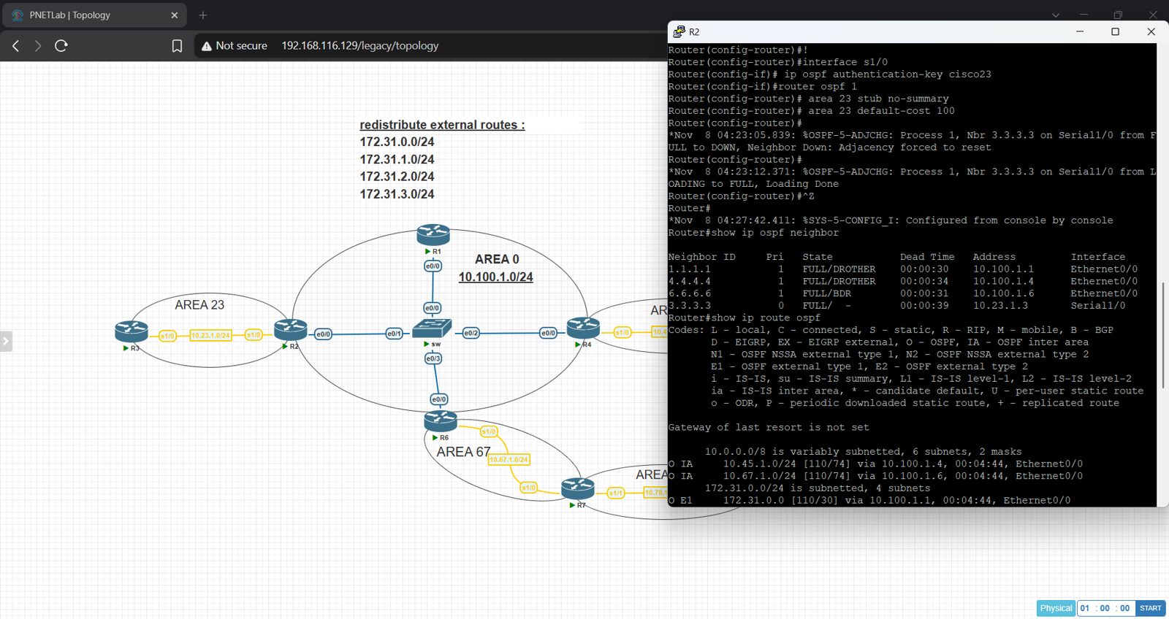
Figure 4 – R2: neighbors and OSPF routes
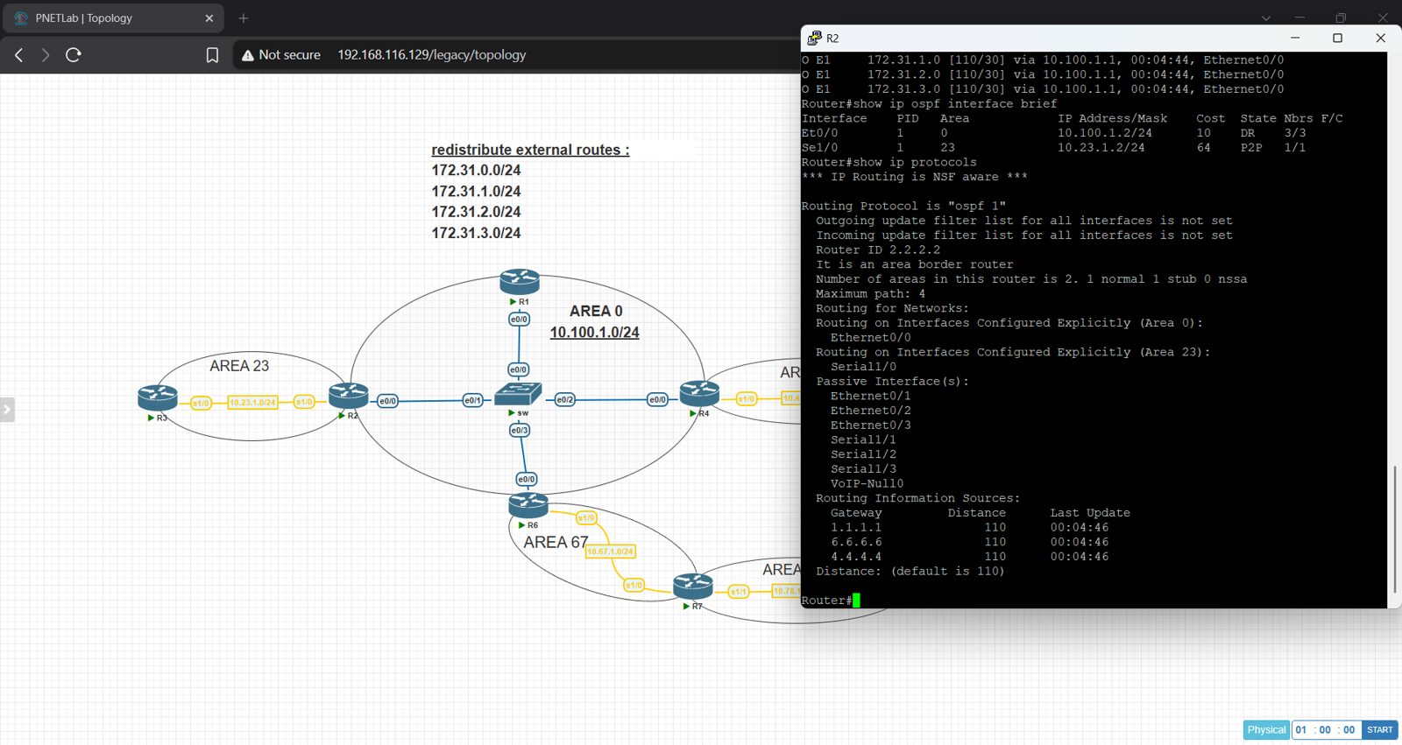
Figure 5 – R2: OSPF interfaces and protocol information

R3 (Area 23 – totally stub)
R3 receives only a default route (O*IA 0.0.0.0/0) with cost 164 (100 default cost + 64 link cost) via R2.
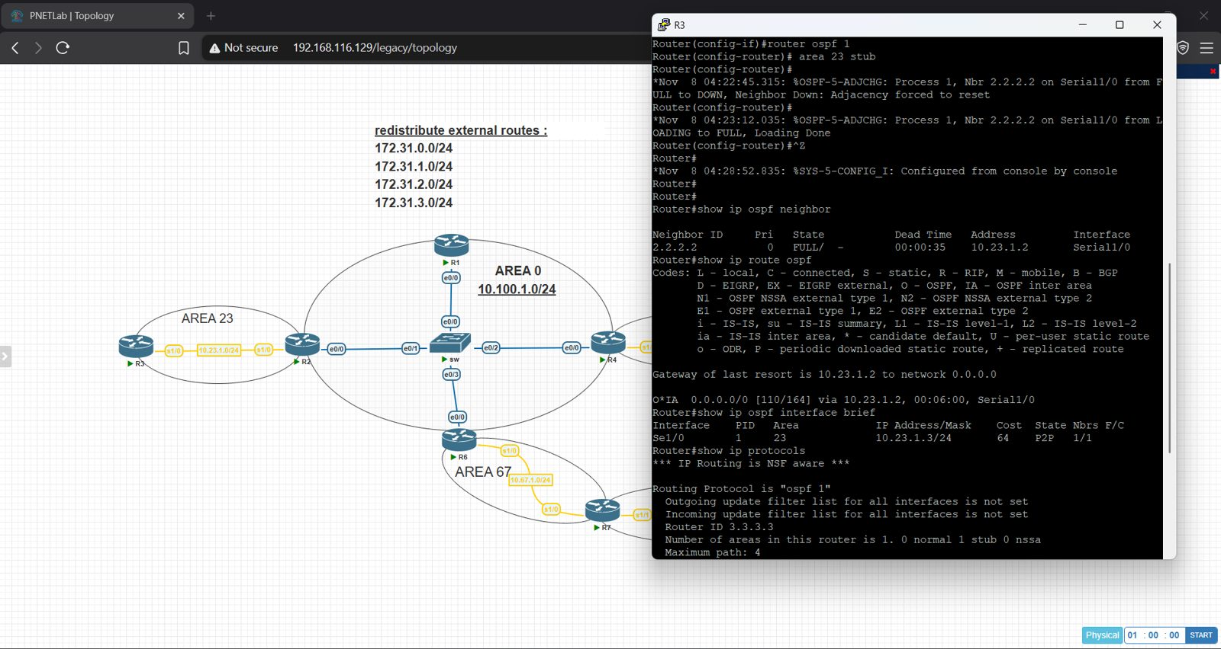
Figure 6 – R3: neighbors and OSPF routes
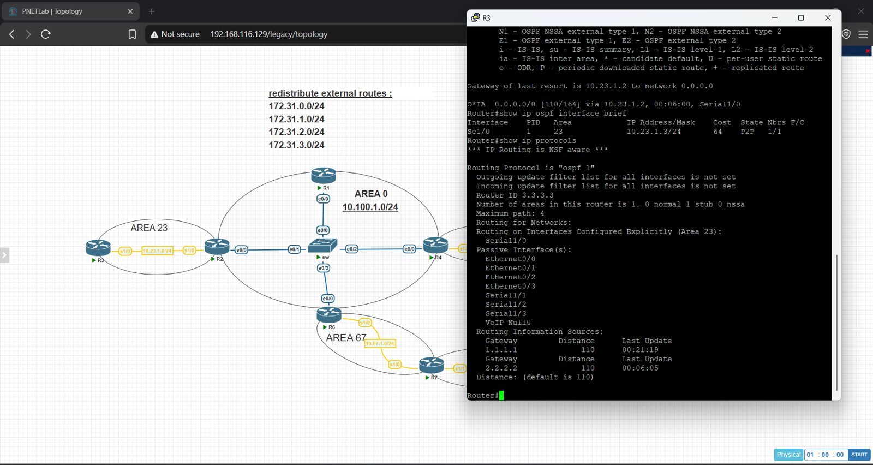
Figure 7 – R3: OSPF interfaces and protocol information

R4 (ABR – Area 0 / Area 45)
R4 has neighbors in Area 0 and R5 in Area 45. External routes appear as O E1.
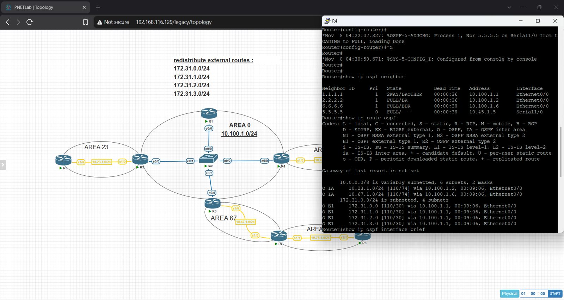
Figure 8 – R4: neighbors and OSPF routes
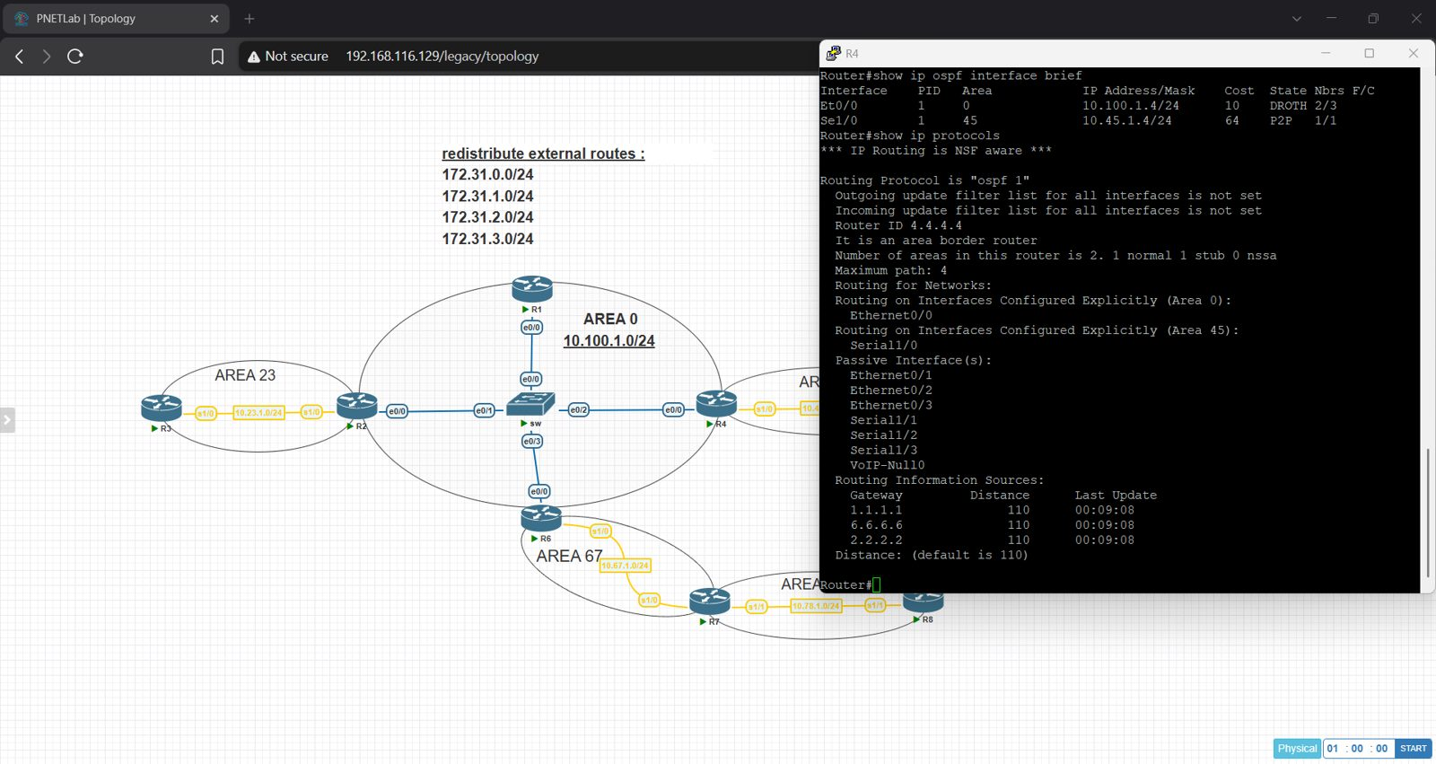
Figure 9 – R4: OSPF interfaces and protocol information

R5 (Area 45 – stub)
R5 receives the default route O*IA 0.0.0.0/0 from R4 and no external (E1) routes.
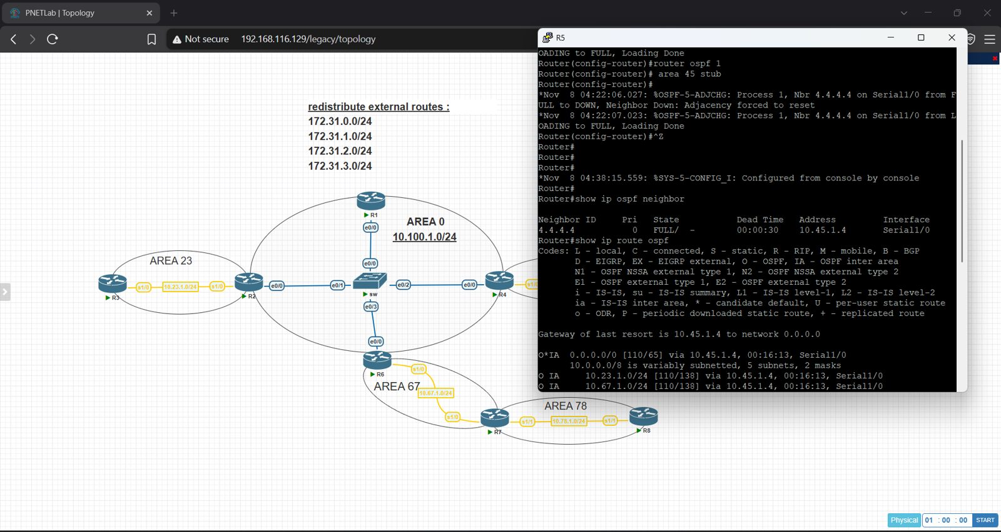
Figure 10 – R5: neighbors and OSPF routes
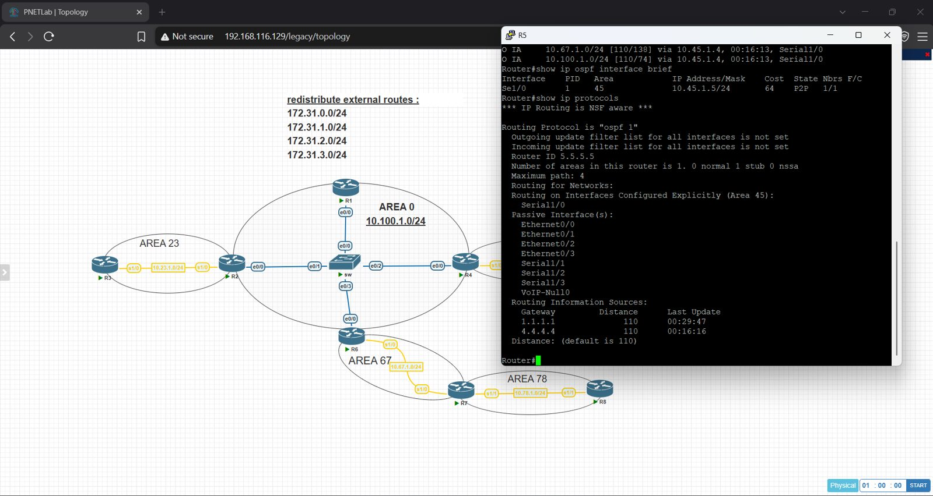
Figure 11 – R5: OSPF interfaces and protocol information

R6 (ABR – Area 0 / Area 67)
R6 has FULL neighbors R1, R2, R4 in Area 0 and R7 in Area 67; MD5 key configured on Ethernet0/0.
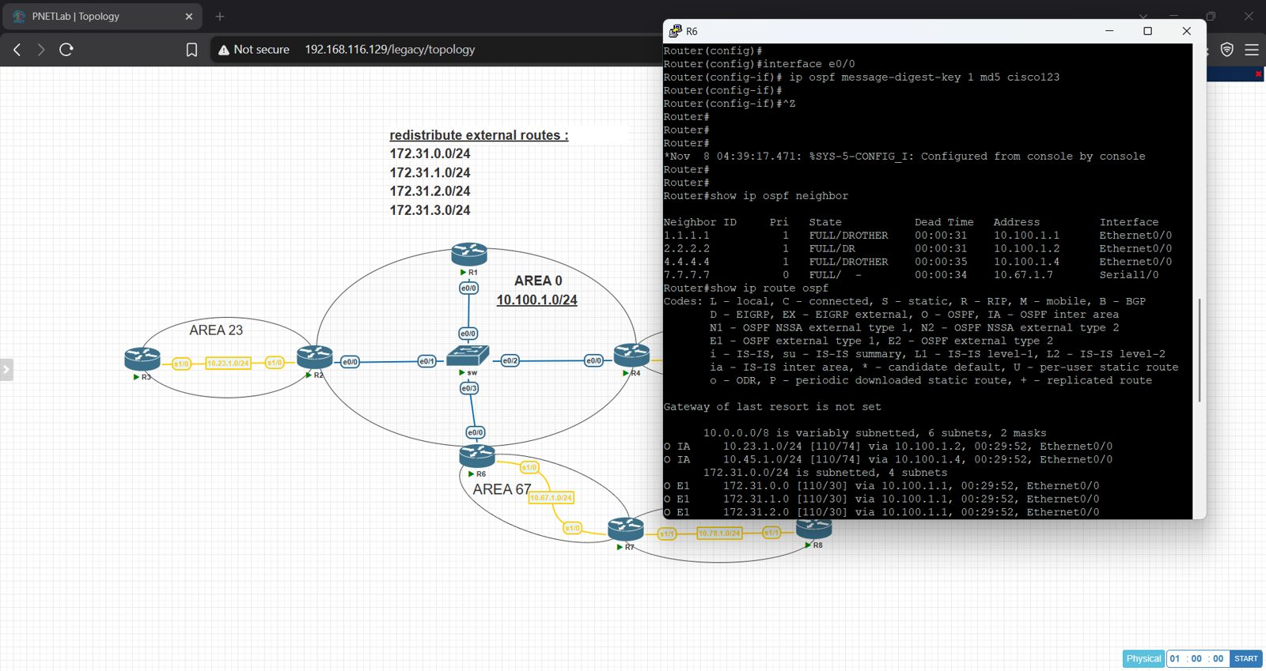
Figure 12 – R6: neighbors and OSPF routes
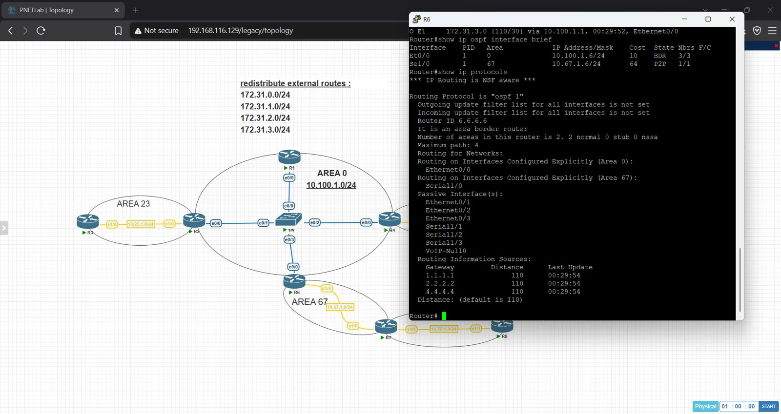
Figure 13 – R6: OSPF interfaces and protocol information

R7 (ABR – Area 67 / Area 78)
R7 has FULL neighbors R6 (Area 67) and R8 (Area 78).
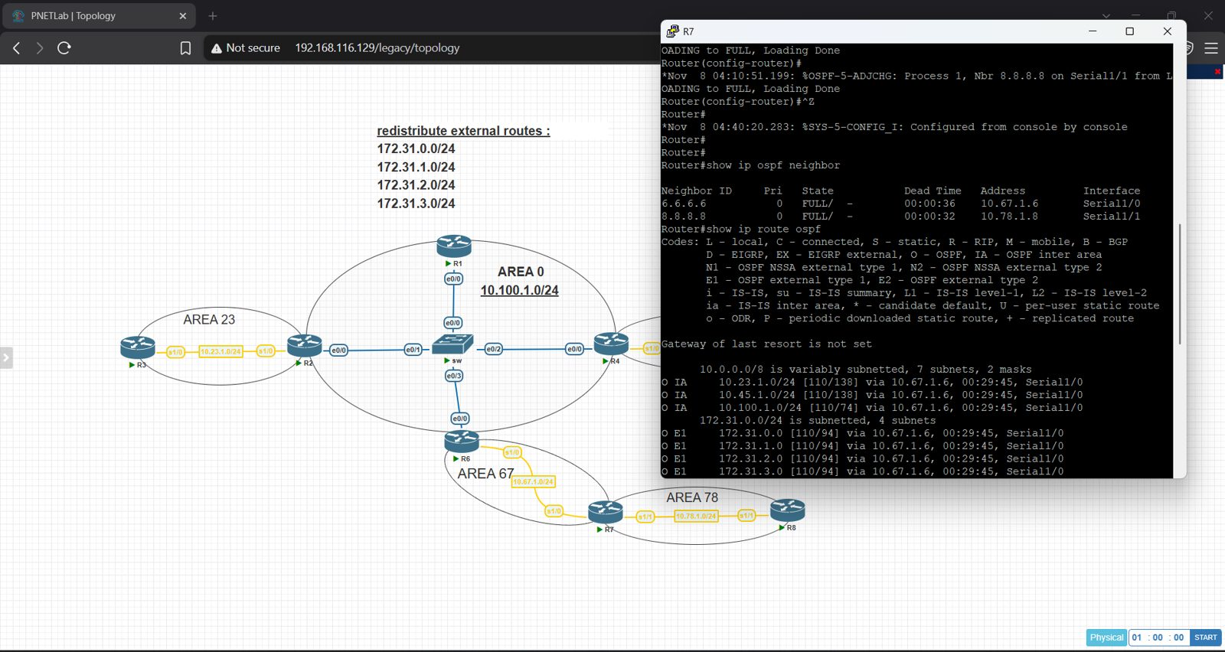
Figure 14 – R7: neighbors and OSPF routes
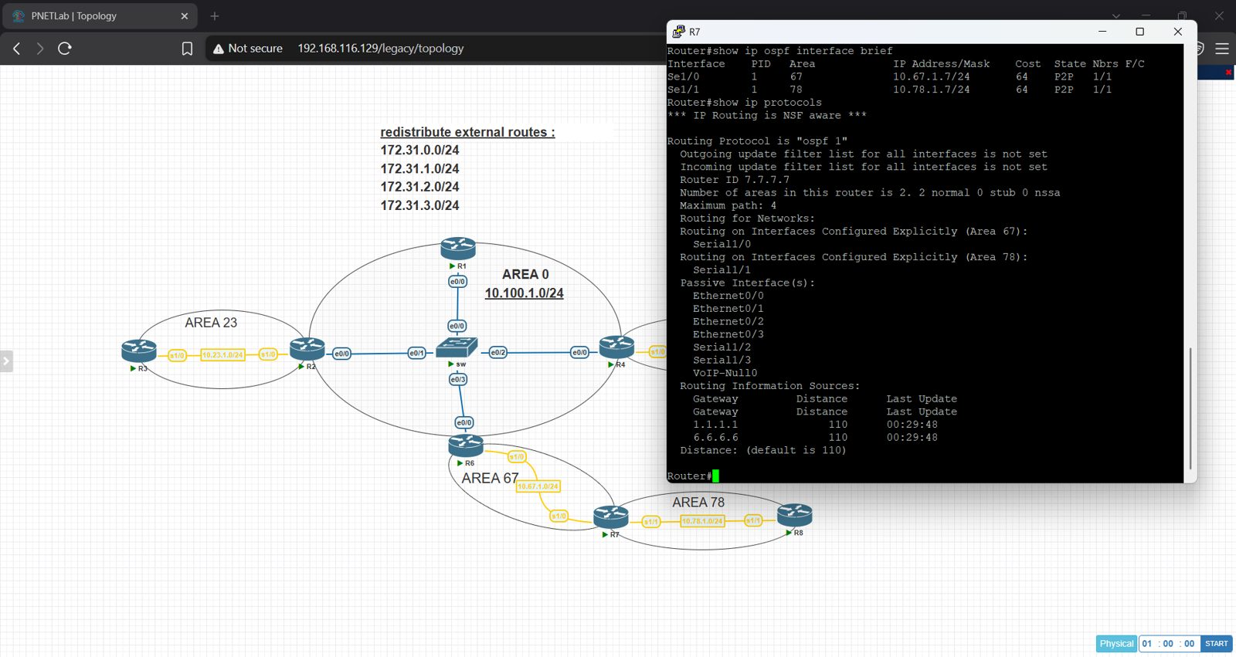
Figure 15 – R7: OSPF interfaces and protocol information

5. Troubleshooting R8 (Area 78)
R8 had a FULL adjacency with R7, but its routing table contained no OSPF routes and the Router/Type-5 LSAs only were in its database. Area 78 had no connection to the backbone, so R7 was not passing summary (type 3/4) LSAs into it.
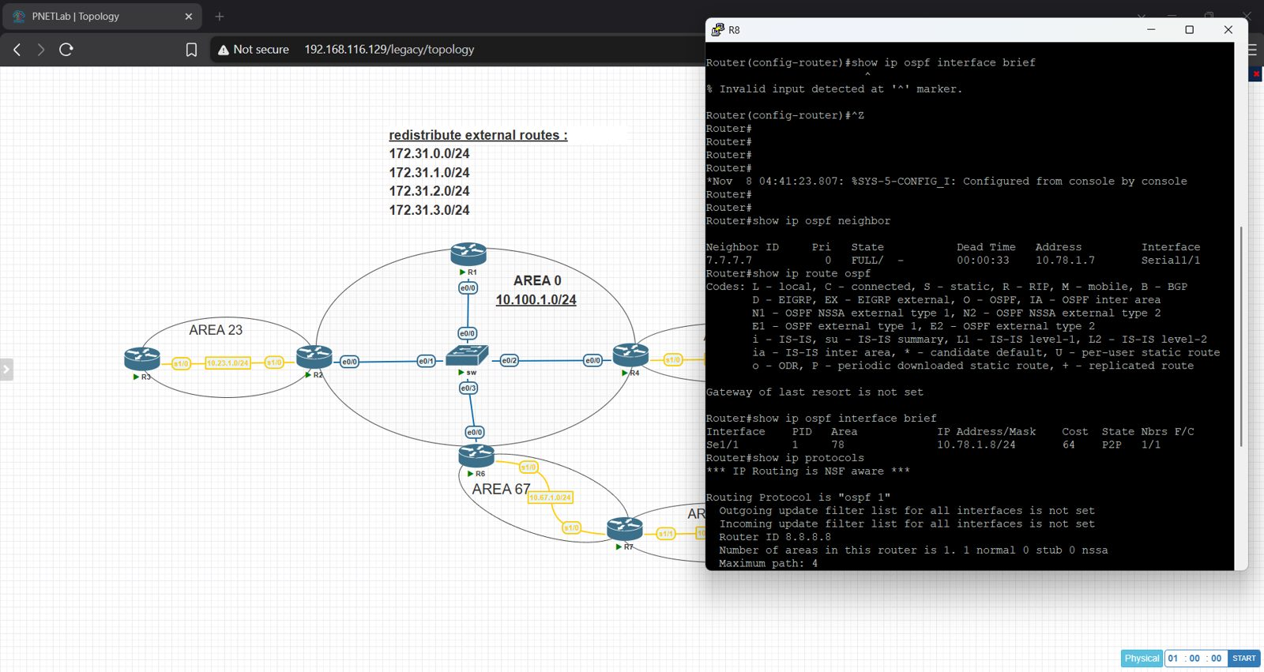
Figure 16 – R8 before the fix: neighbor FULL but no OSPF routes
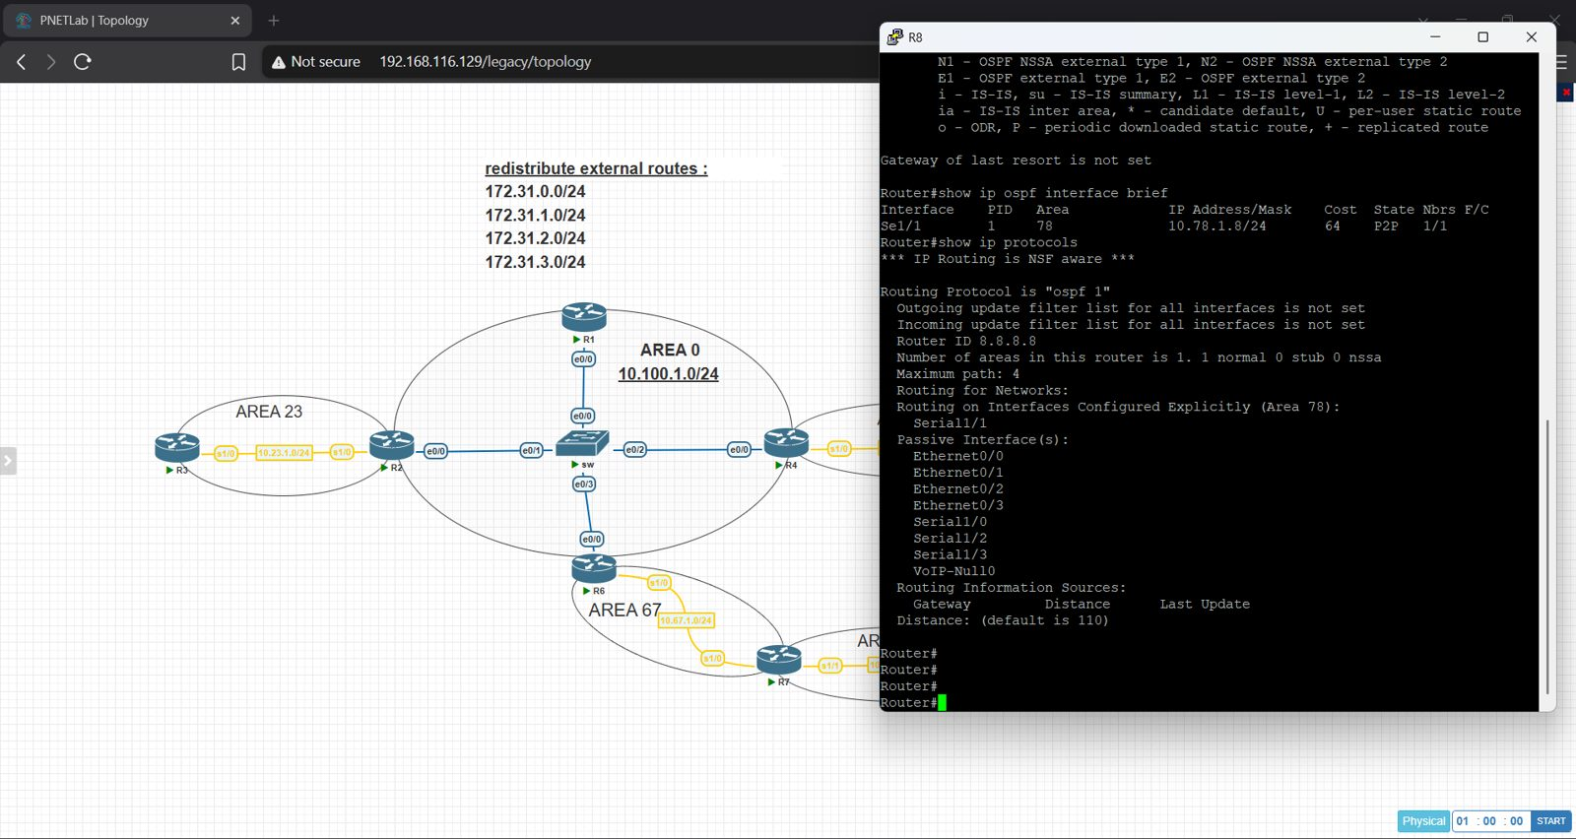
Figure 17 – R8 before the fix: OSPF protocol information
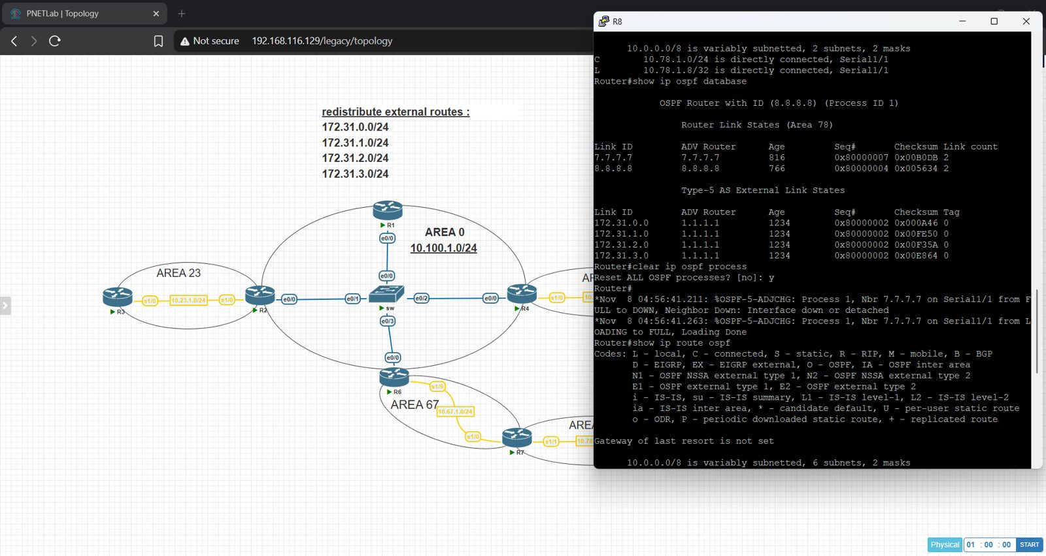
Figure 18 – R8: database without Type 3 LSAs

Solution: virtual link between R6 and R7 through Area 67
After adding the virtual link, R8 received Type 3 (Summary Net) and Type 4 (Summary ASB) LSAs, and all inter-area and E1 routes were installed in the routing table.
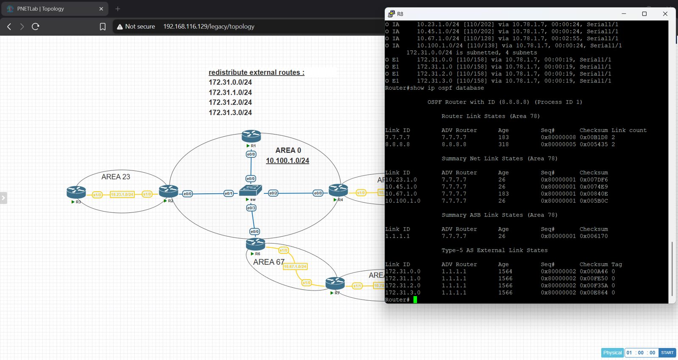
Figure 19 – R8 after the fix: routes and OSPF database with Type 3 and Type 4 LSAs

6. Connectivity Test (Ping)
A TCL script was used on every router to ping all interface addresses of the OSPF networks. Every ping returned 100 percent success (5/5).
tclsh
foreach address {10.100.1.1 10.100.1.2 10.100.1.4 10.100.1.6 10.23.1.2 10.23.1.3 10.45.1.4 10.45.1.5 10.67.1.6 10.67.1.7 10.78.1.7 10.78.1.8} { ping $address }

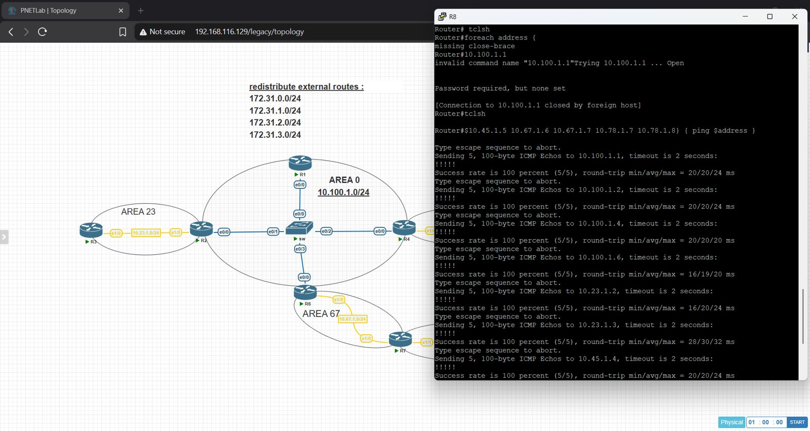
Figure 20 – R8: ping test results
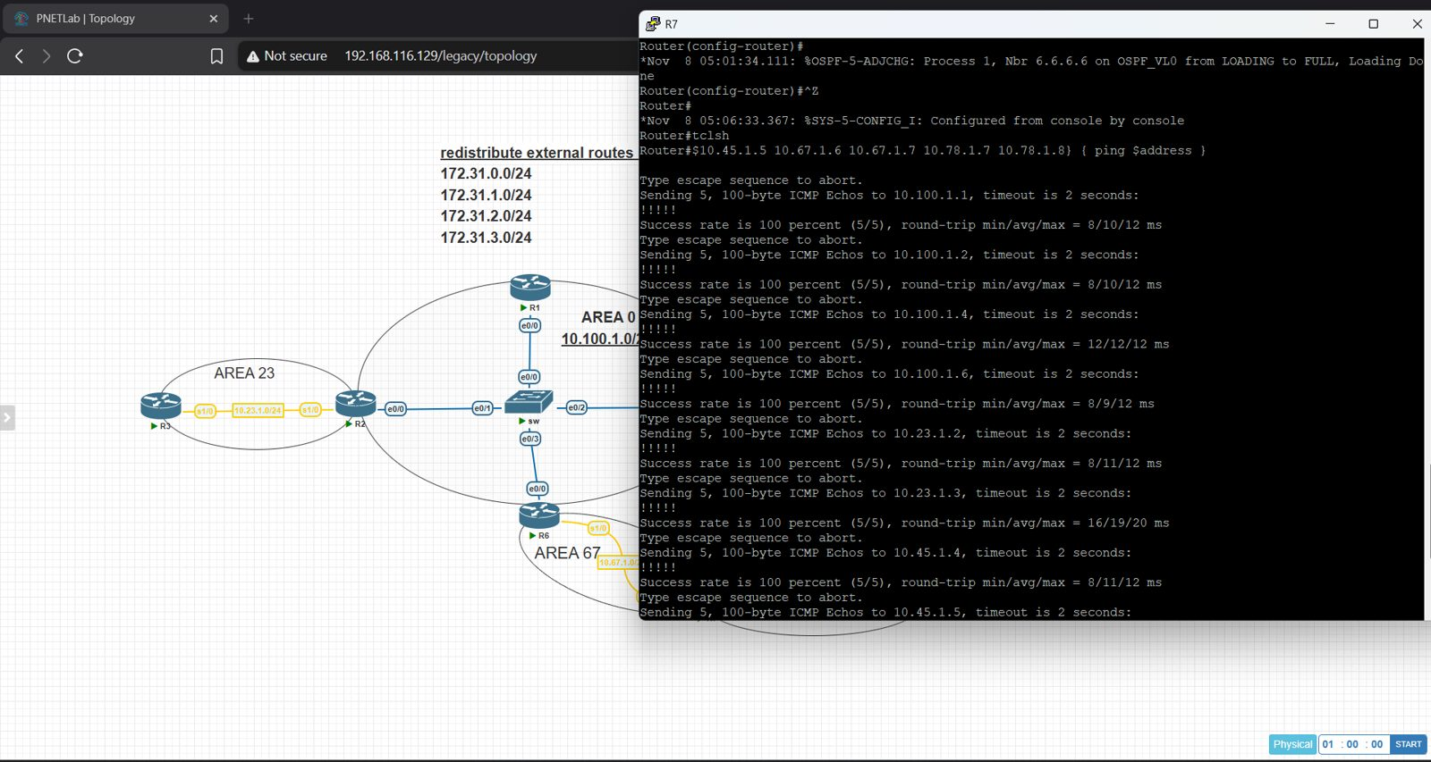
Figure 21 – R7: ping test results
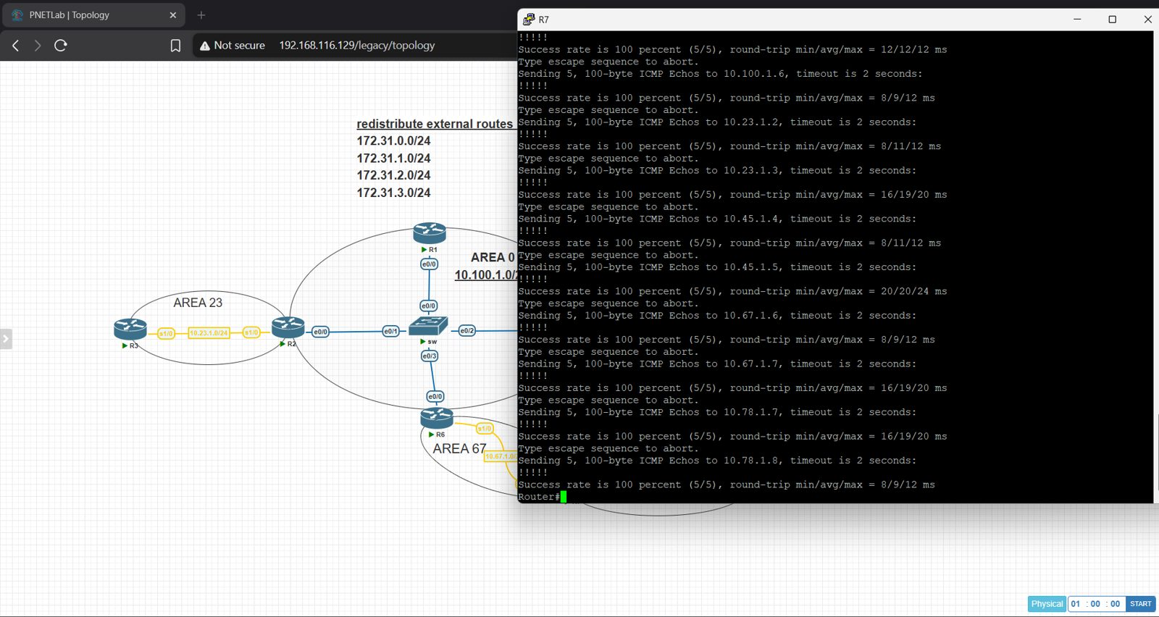
Figure 22 – R7: ping test results (continued)
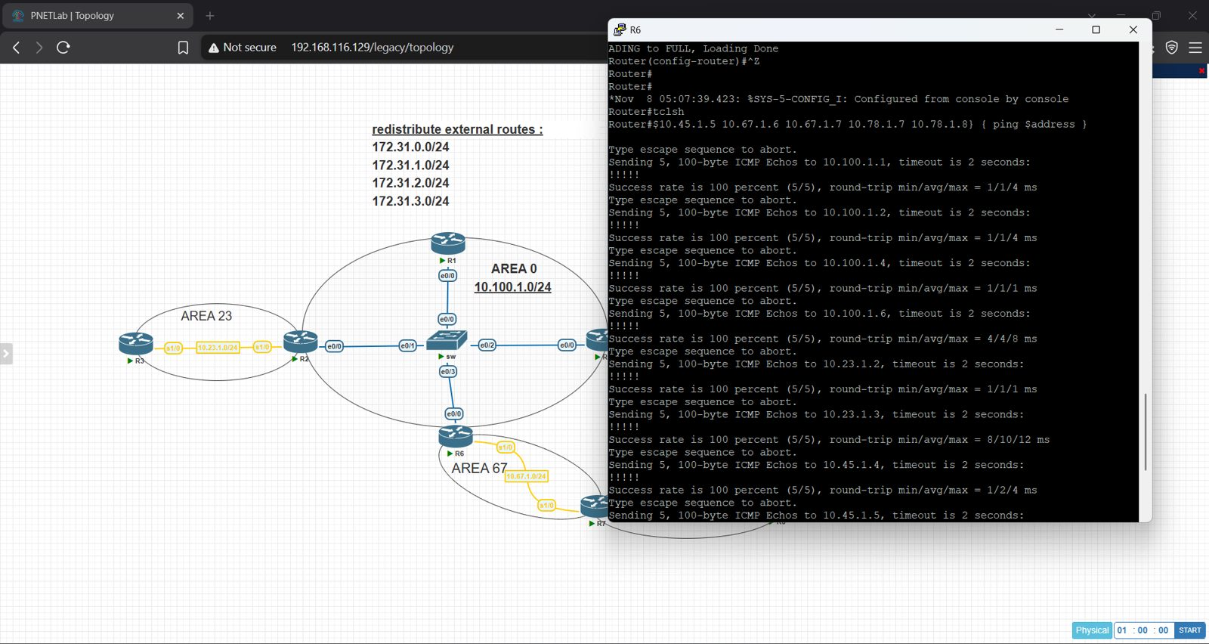
Figure 23 – R6: ping test results
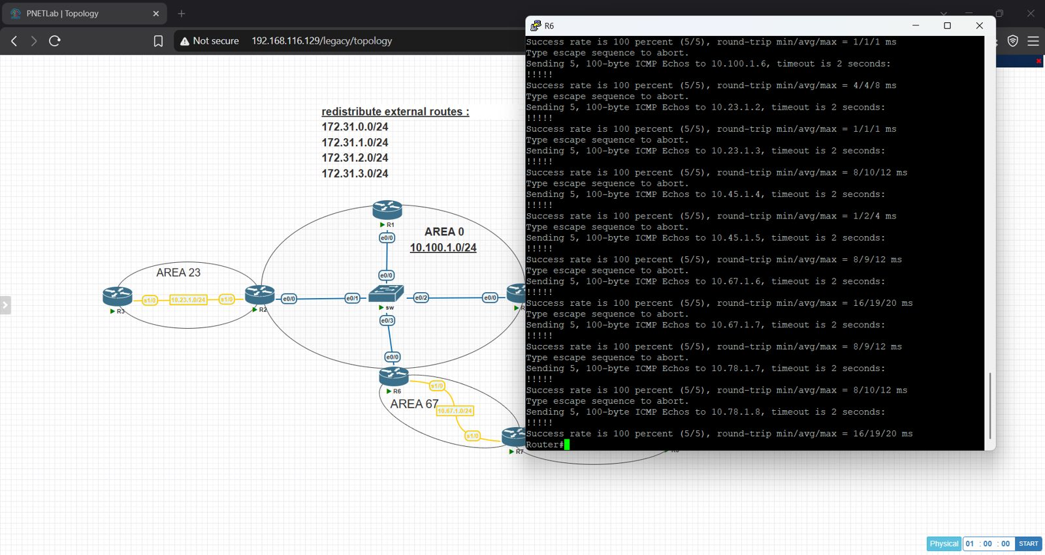
Figure 24 – R6: ping test results (continued)
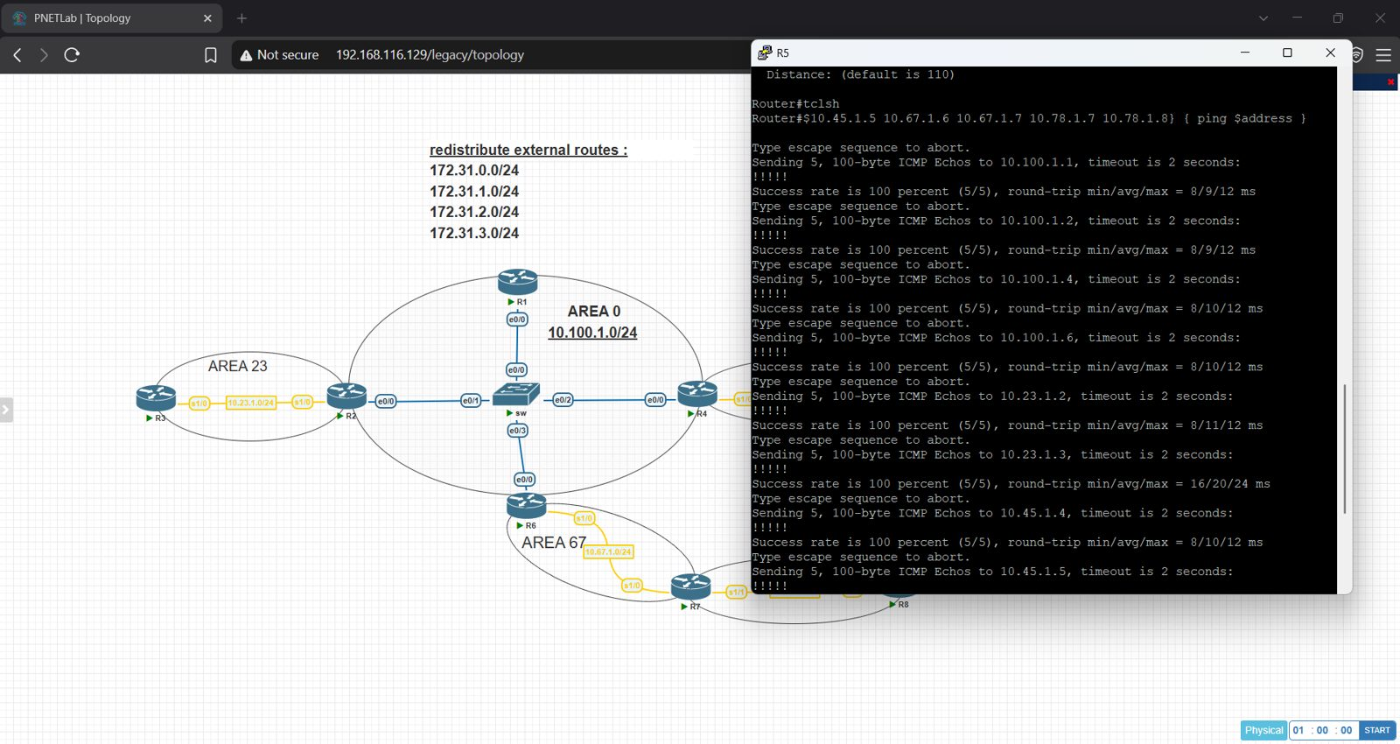
Figure 25 – R5: ping test results
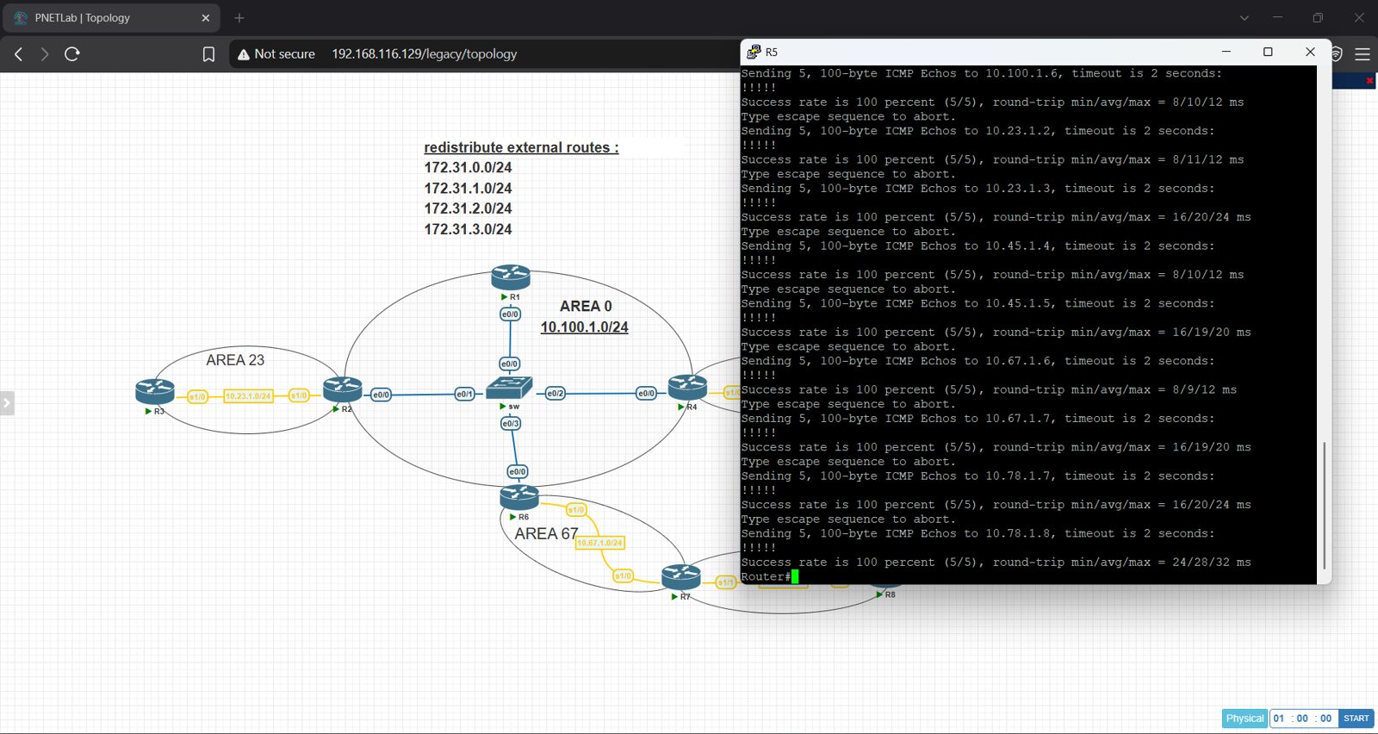
Figure 26 – R5: ping test results (continued)
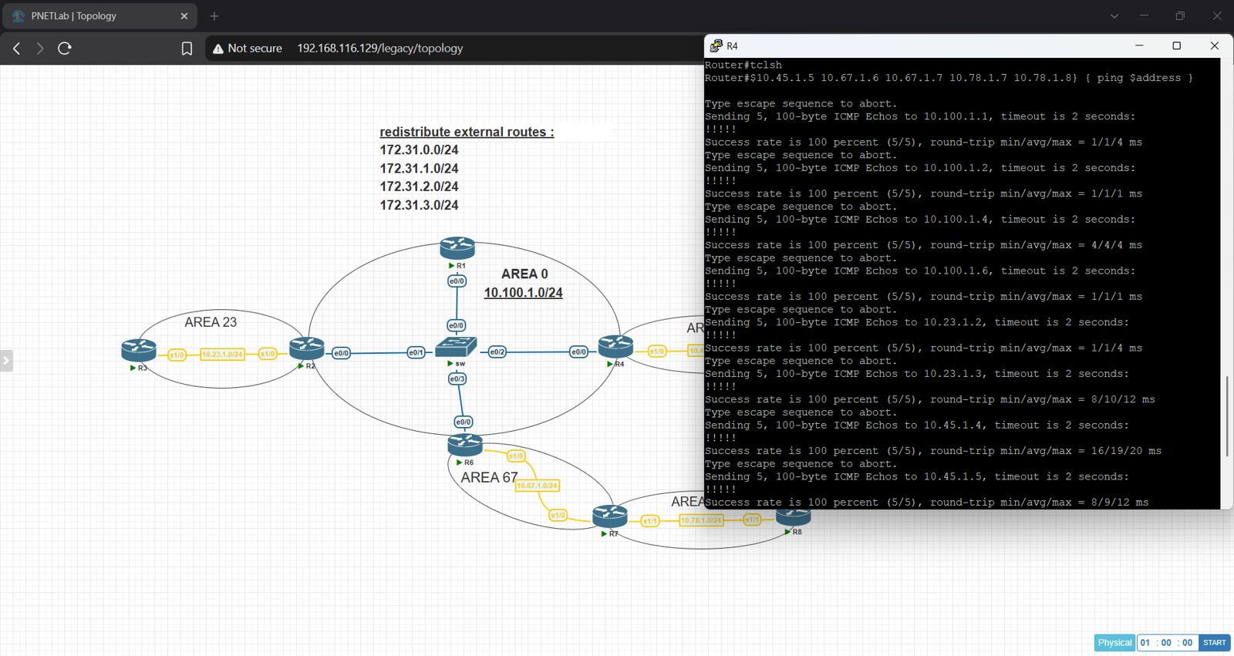
Figure 27 – R4: ping test results
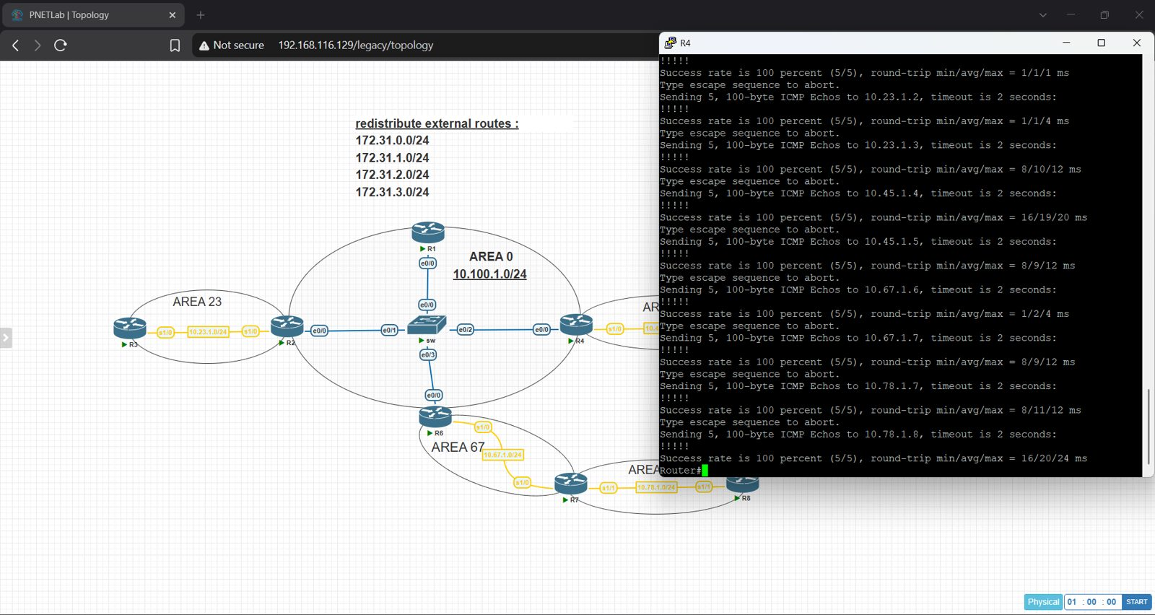
Figure 28 – R4: ping test results (continued)
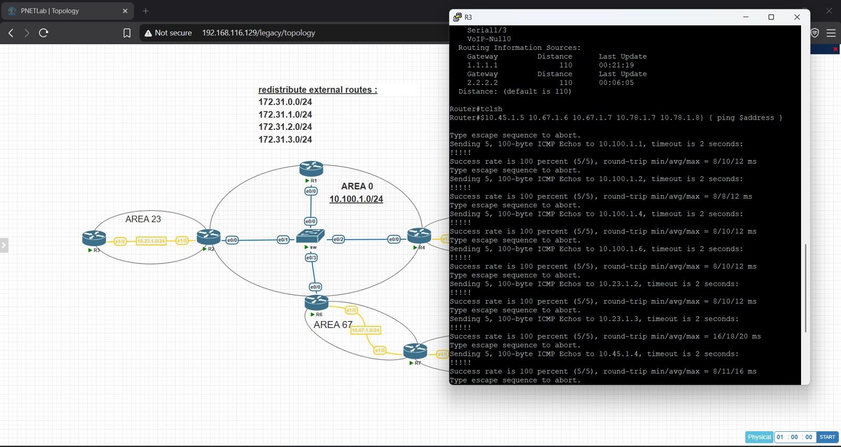
Figure 29 – R3: ping test results
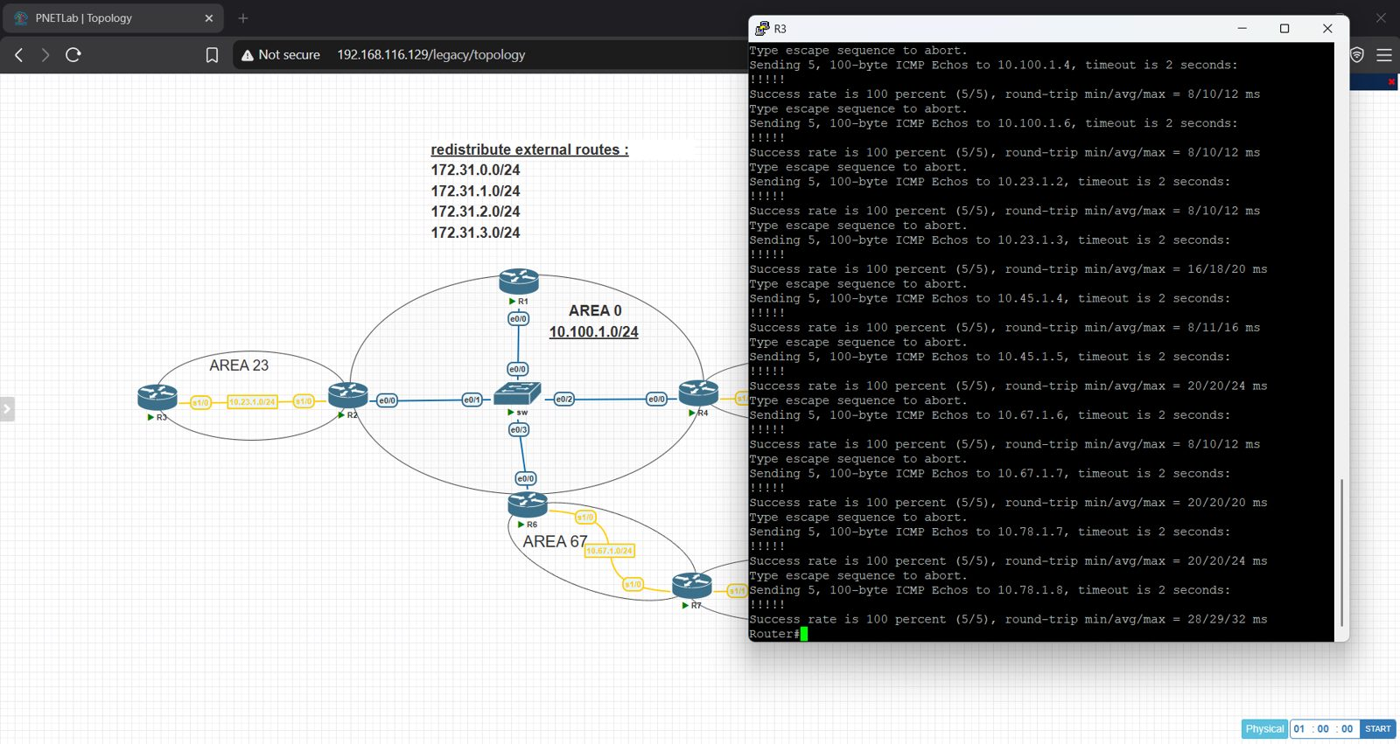
Figure 30 – R3: ping test results (continued)
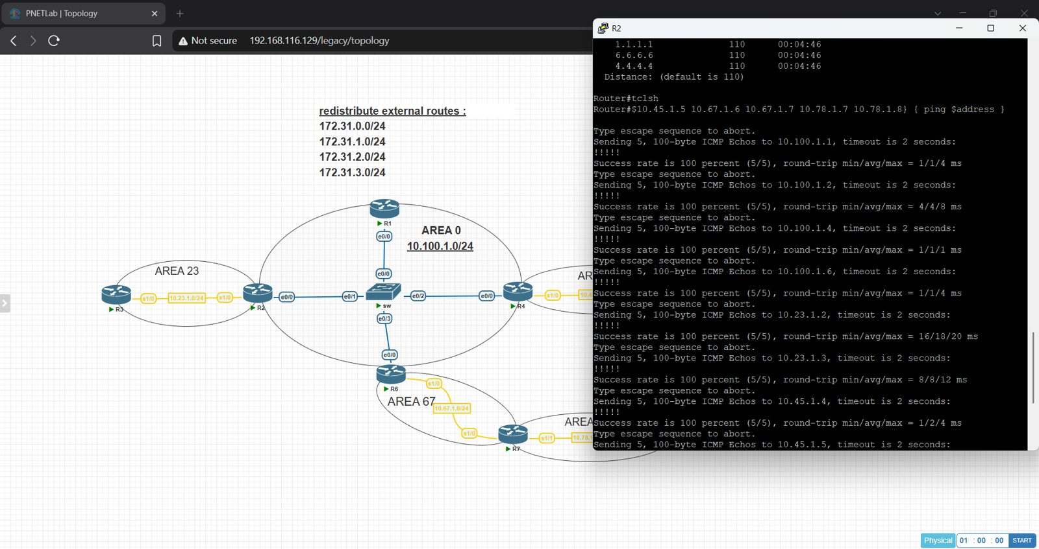
Figure 31 – R2: ping test results
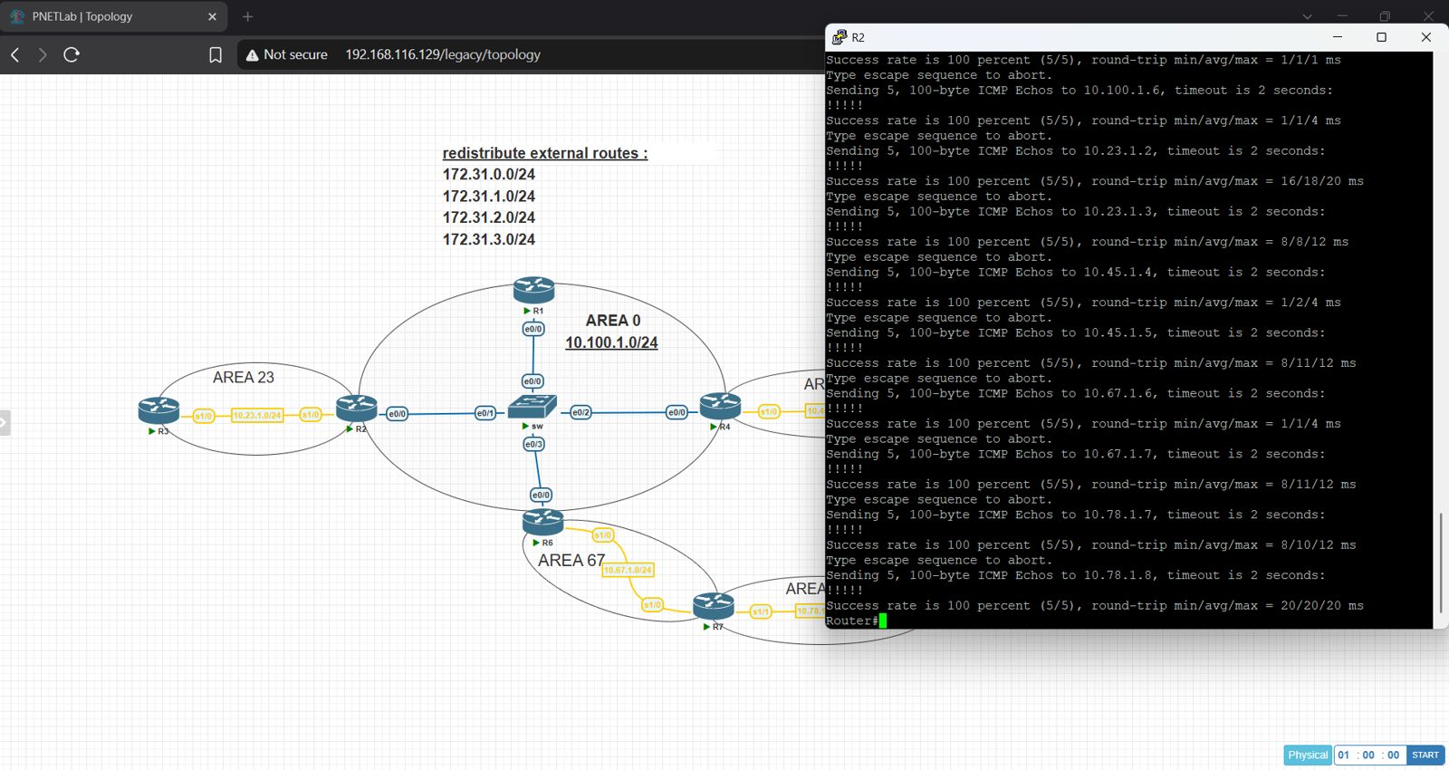
Figure 32 – R2: ping test results (continued)
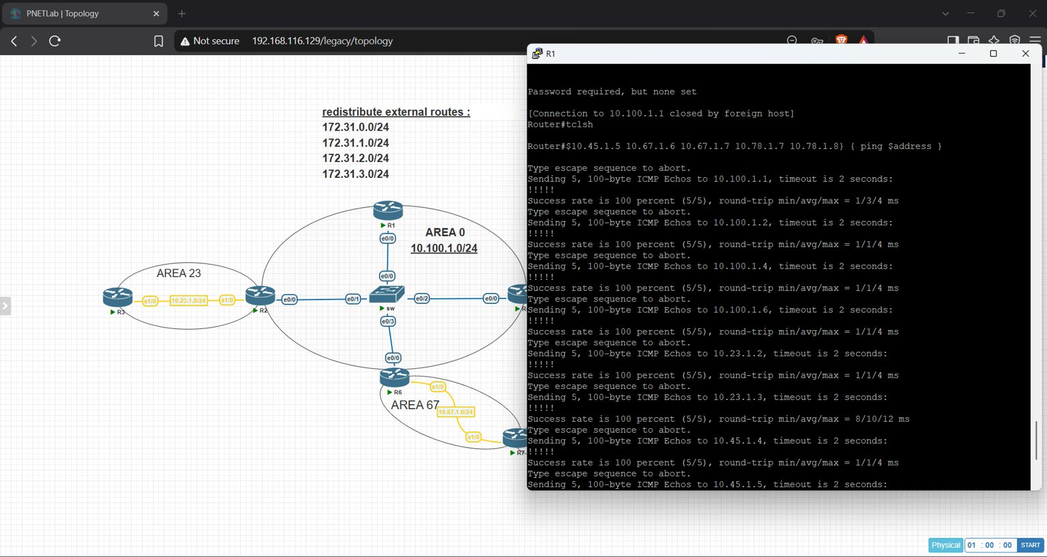
Figure 33 – R1: ping test results
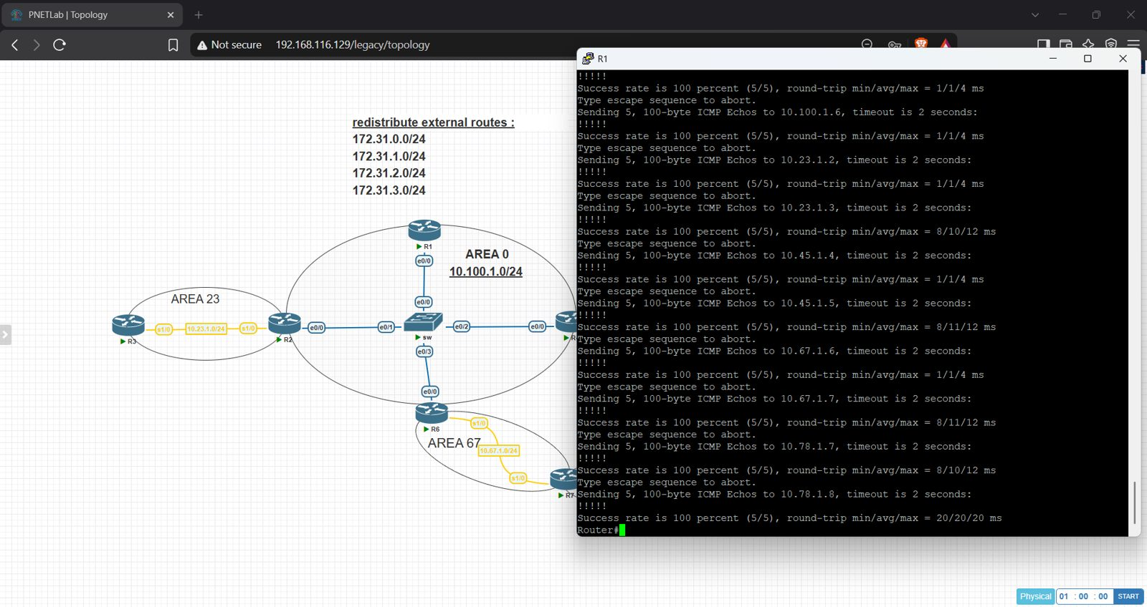
Figure 34 – R1: ping test results (continued)

7. Final Topology
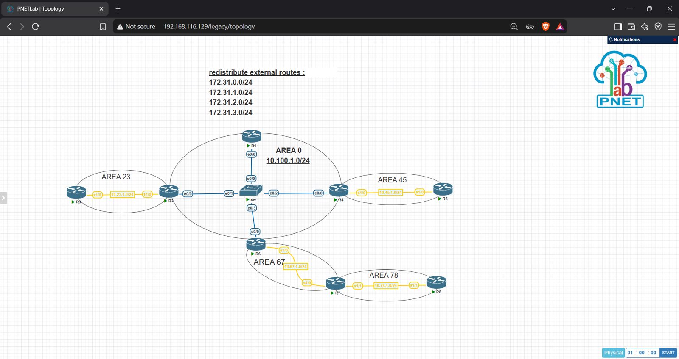
Figure 35 – Final topology in PNETLab

8. Results Summary
# | Objective | Result
1 | Basic OSPF + redistribution of static routes as E1 | Done – O E1 routes present
2 | No neighbors on empty interfaces | Done – passive-interface default
3 | MD5 in Area 0, clear text in Area 23 | Done
4 | Area 45 without external routes, default not static | Done – stub area
5 | Area 23 without type 3/4/5, default cost 100 | Done – totally stub, cost 164 on R3
6 | All routers ping every OSPF route | Done – 100% success; virtual link added for Area 78

Implemented by: Mohamed Elafndy

