Name: mohamed fathi mohamed awad

Group: 6

SC: 35

BN :14

Topic : Artificial Intelligence

Brief: I choosed this application because I think it will be the tool of developing in the future .

AI is ability of a computer to learn by itself without programed to do that

Screen:

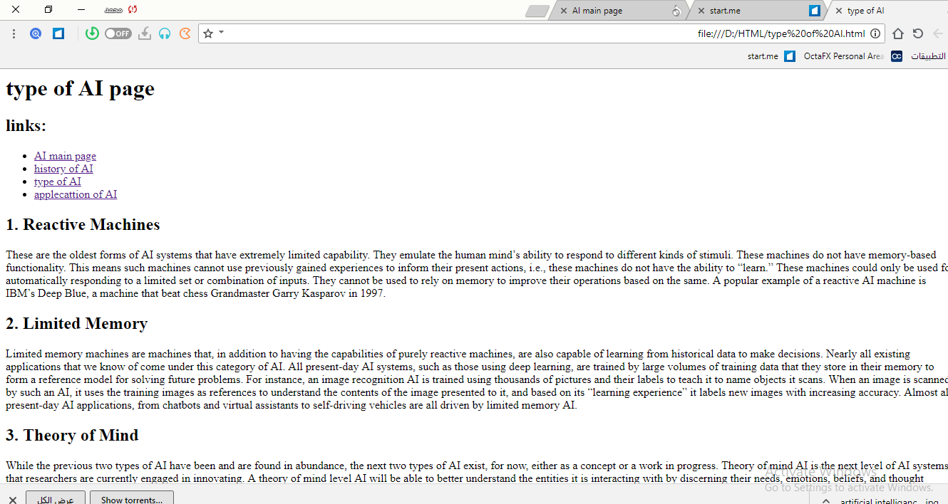

Screen:

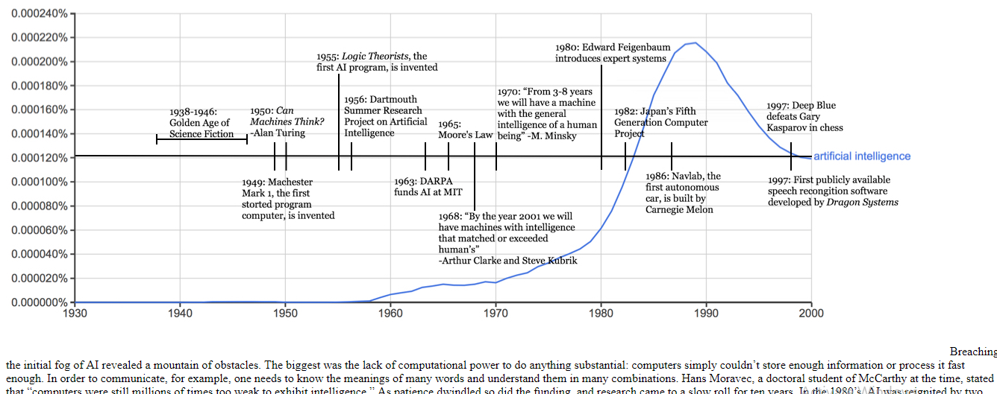

Screen:

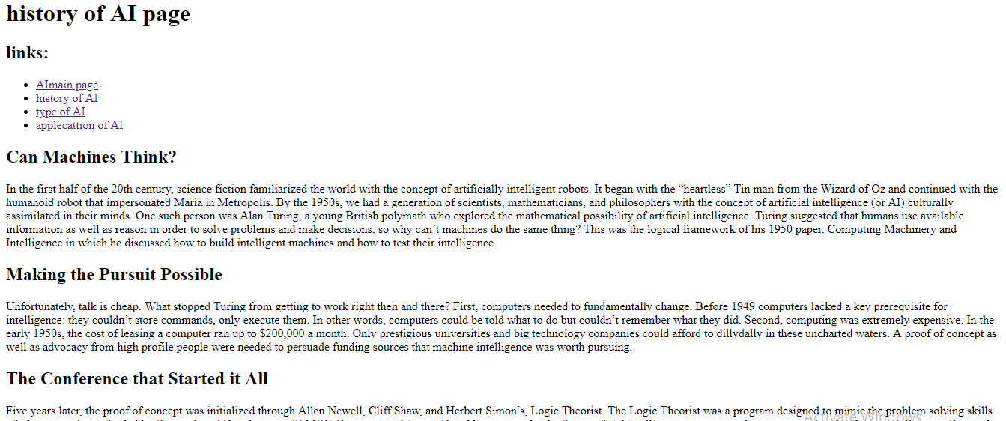

Screen:

