End-to-End Olist E-Commerce Analytics Project

1. Project Title
Improving Revenue Growth and Customer Satisfaction in a Multi-Seller E-Commerce Marketplace

2. Executive Summary
Data inconsistencies were resolved to uncover two critical insights: late deliveries lead to a 40% drop in customer ratings, and 89% of repeat customers come from orders delivered on time.

3. Business Context
Olist operates as a multi-seller e-commerce marketplace in Brazil, where independent sellers fulfill customer orders through logistics partners. This decentralized model generates transactional, delivery, and customer feedback data that captures the customer journey from purchase to post-delivery evaluation.

4. Problem Framing & Analytical Questions
As the marketplace scales, there is limited visibility into how delivery performance, seller behavior, and customer purchasing patterns relate to revenue trends and customer satisfaction. This analysis explores these relationships using historical transaction data to better understand overall marketplace performance.
Analytical Questions:
- How many orders and how much revenue are generated each month?
- Are late deliveries associated with lower customer review scores?
- What percentage of completed orders are delivered late?
- Which product categories have the highest delivery delay rates?
- Which sellers contribute the most to delivery delays?
- What percentage of customers make repeat purchases?
- Do customers who experience late deliveries return to purchase less often?
- Which months show the highest delivery delay rates?
- Are non-completion or cancellation rates associated with payment method?
- Are delivery delays concentrated in specific customer cities?

5. Objectives & Scope
- Objective (SMART): Identify and quantify key operational and customer behavior factors associated with revenue growth and customer satisfaction using historical transactional data from 2016–2018.

- Scope: The analysis focuses on core transactional and operational data, including orders, customers, sellers, products, payments, delivery performance, and customer reviews, using historical data from 2016 to 2018.

6. Data Overview & Schema
The analysis uses the Brazilian E-Commerce Public Dataset by Olist, covering approximately 100,000 orders from 2016 to 2018. The dataset follows a marketplace structure where orders are linked to customers, order items, sellers, products, payments, reviews, and geographic data, enabling end-to-end analysis of the customer journey from purchase to post-delivery feedback.
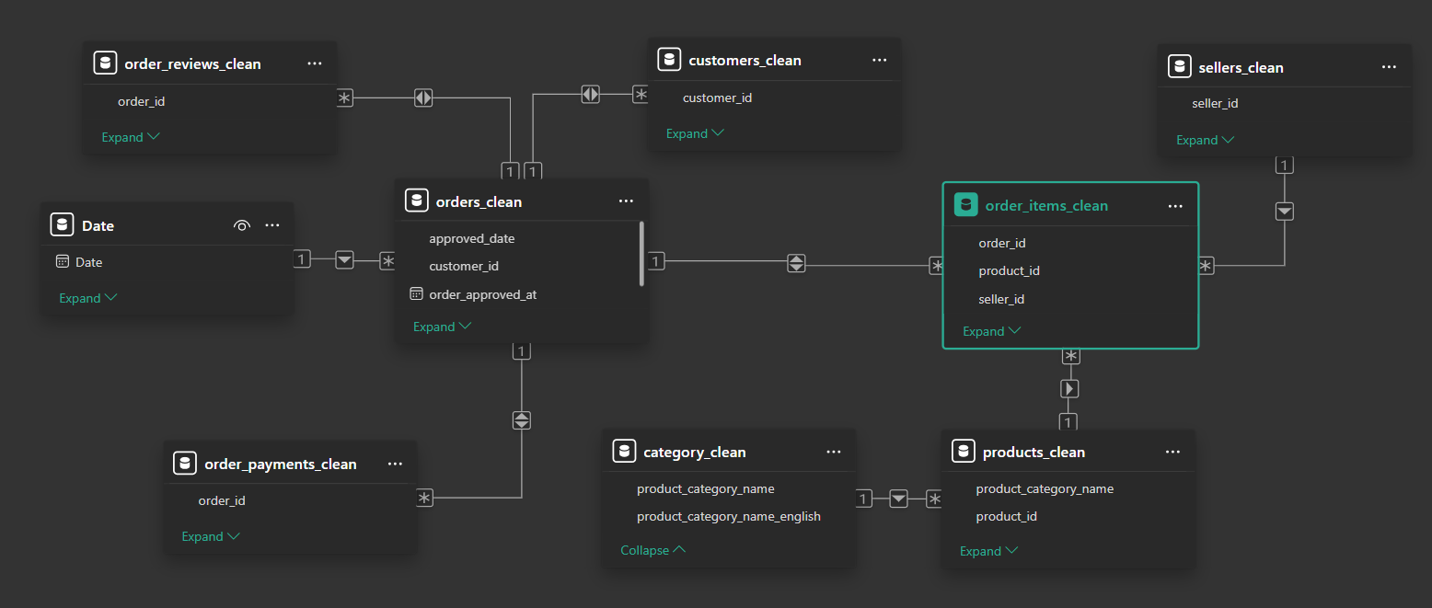

7. Tools & Analytical Methodology

Python (Data Quality Assessment & Preparation)
Python was used as the primary tool to review and improve data quality before conducting the analysis.
Action Taken: Missing review texts were preserved using clear placeholders to maintain dataset integrity. Additionally, new analytical columns were engineered, including approved_date for daily trend analysis, delivery_delay_days to quantify shipping performance, and order_stage to segment transaction completion. Explicit indicator and flag columns, such as timeline_issue_flag and On-Time vs Late, were also created to highlight delivery performance and timeline inconsistencies, ensuring insights are derived from reliable and transparent data

SQL (Data Analysis)
SQL was used to write clear and structured queries that directly answer the core business questions.

Power BI (Visualization & Storytelling)
Power BI was the final layer used to build an interactive dashboard featuring three dedicated pages:
- Overview Page: For high-level executive KPIs, providing a holistic view of sales and order volume.
- Payment & Completion Behavior: To analyze the relationship between payment methods and order success rates, ensuring system stability.
- Delivery Performance & Customer Experience: To drill down into shipping efficiency

8. Dashboard Gallery
Power BI was the final layer used to build an interactive dashboard. It transformed the raw SQL outputs into a navigatable visual story, featuring three dedicated pages:
- Overview Page: Provides a holistic view of total sales trends, monthly order volume, and high-level KPIs to track the marketplace's growth trajectory.
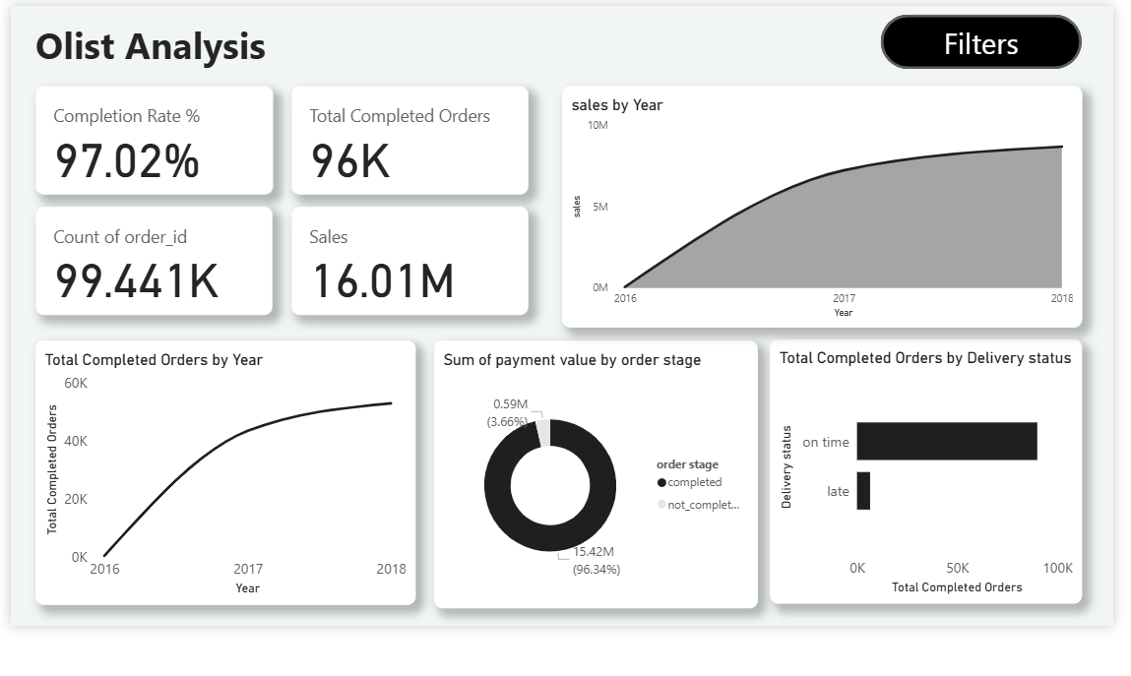
- Payment & Completion Behavior: Analyzes the relationship between payment methods and order success rates, ensuring system stability and identifying any payment-related bottlenecks.
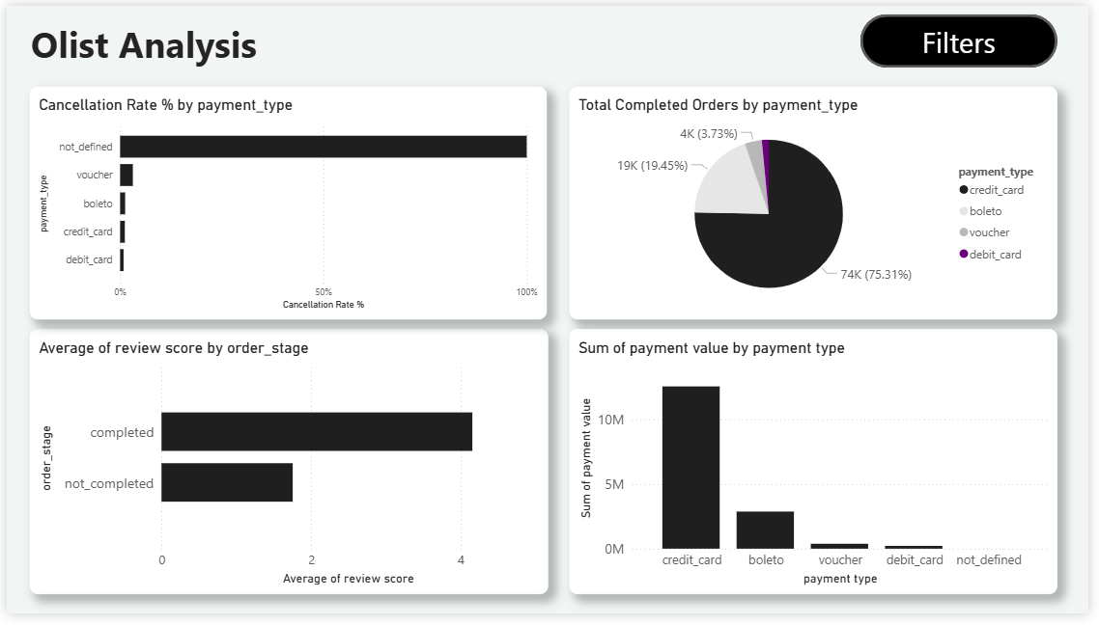
- Delivery Performance & Customer Experience: Focuses on shipping efficiency and its direct impact on review scores, highlighting geographic delay hotspots and satisfaction gaps.
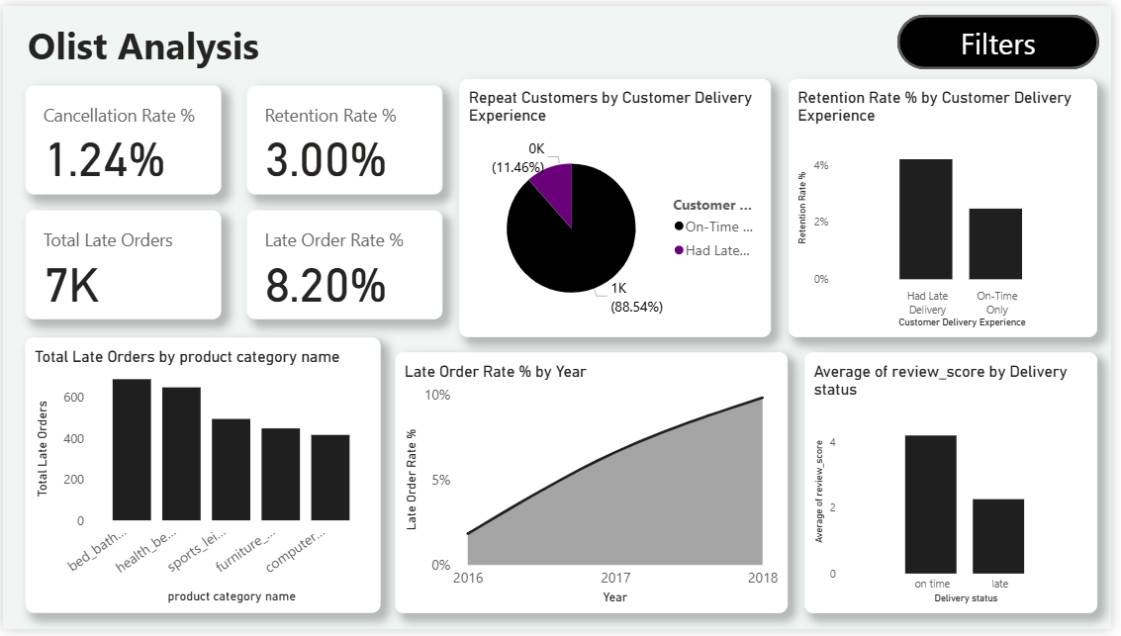

9. Key Metrics & Insights

How many orders and how much revenue are generated each month?
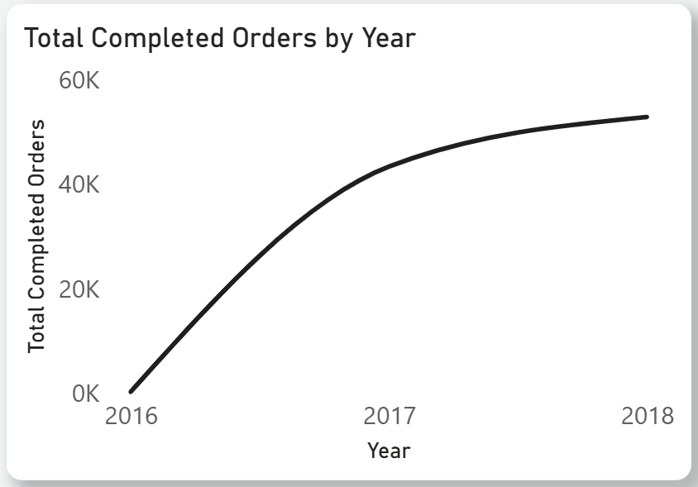
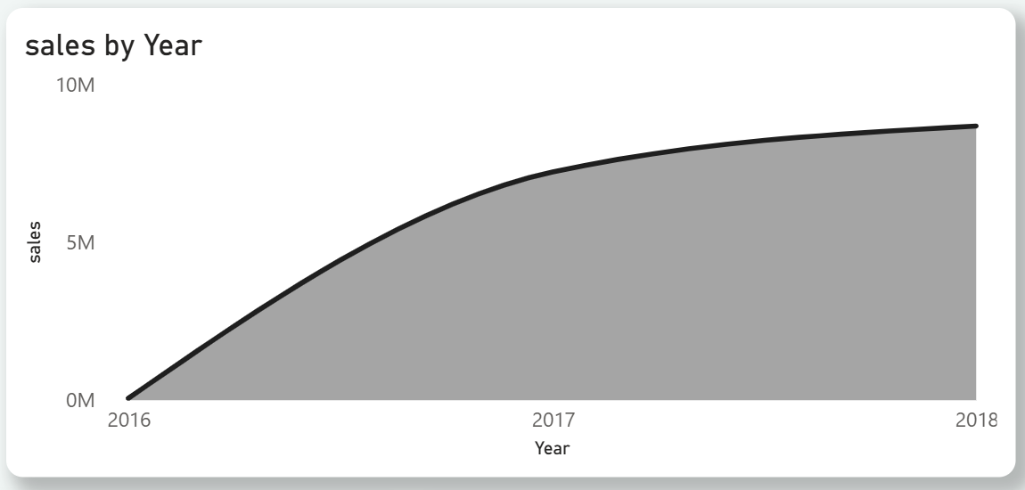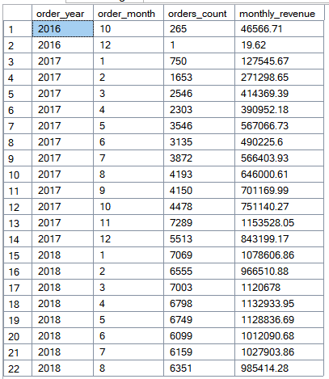
Key Insights:
- Exponential Revenue & Order Growth: Sales surged from near-zero in 2016 to over 16M by 2018 , driven by a massive leap in total order volume reaching approximately 99K orders.
- Market scalability: The continued upward trend reflects high operational scalability and sustainable market expansion throughout the analyzed period.

Are late deliveries associated with lower customer review scores?
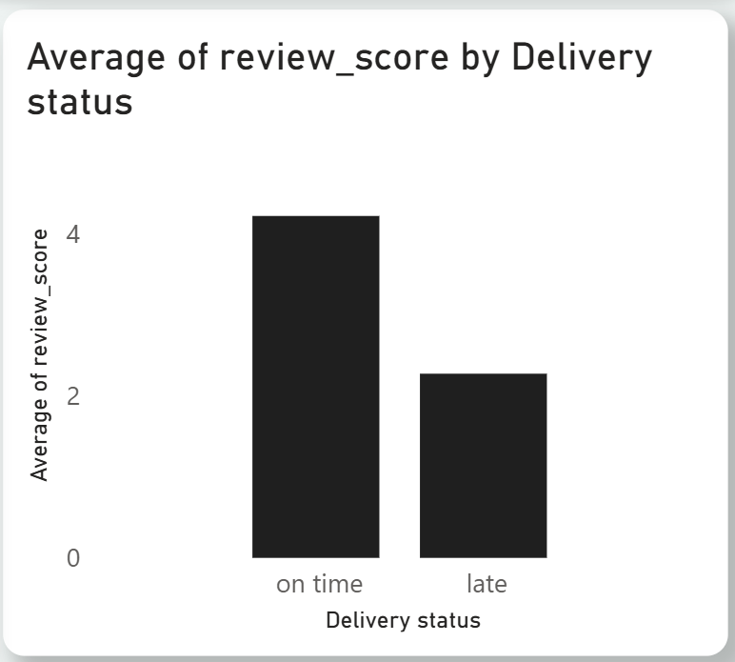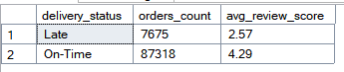
Key Insights:
Delays Hurt Customer Satisfaction: Ratings drop sharply from 4.29

What percentage of completed orders are delivered late?
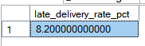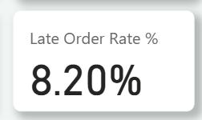
Key Insights:
- 8% Late Rate: Approximately 8.2% of all completed orders miss their delivery deadline.
- Room for Improvement: While the majority arrive on time, this 8.2% represents thousands of orders, pointing to a specific bottleneck in the shipping process that needs fixing.

Which product categories have the highest delivery delay rates?
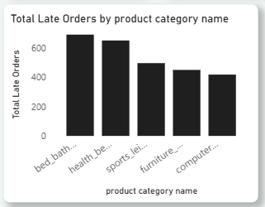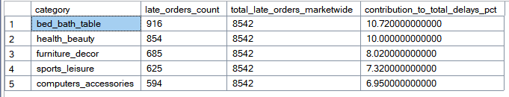
Key Insights:
- Most Delayed Categories:
Bed_Bath_Table and Health_Beauty have the highest number of late deliveries (916 and 854 orders), making them the main sources of delivery delays.

- Highest Business Impact:
These two categories alone represent over 20% of all delayed orders. Improving delivery performance in just these areas would significantly reduce overall delays and customer complaints.

Which sellers contribute the most to delivery delays?
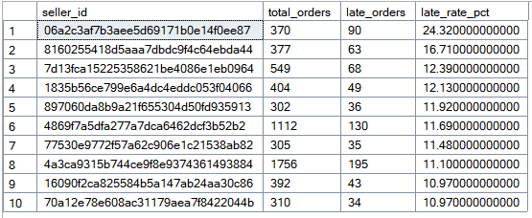

Key Insights:
Seller Performance Gap: A clear outlier exists, with the top underperforming seller delaying nearly 1 in 4 orders (24.3%), identifying a critical target for immediate intervention or suspension.

What percentage of customers make repeat purchases?
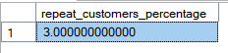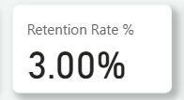
Key Insights:
Low Retention Warning: With only 3% of customers returning for a second purchase, the business relies heavily on one-time transactions, signaling a critical need for loyalty programs to boost Customer Lifetime Value.

Do customers who experience late deliveries return to purchase less often?
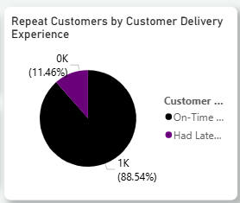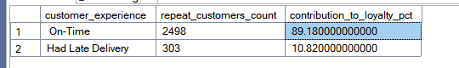
Key Insights:

The analysis reveals a clear relationship between delivery speed and customer retention.
- Customer Behavior Insight:
Around 89% of repeat customers come from orders delivered on time, indicating that positive delivery experiences drive loyalty.

- Business Impact:
Customers who experience delivery delays account for only ~11% of repeat purchases, confirming that logistics performance is a key driver of Customer Lifetime Value (CLV).

Which months show the highest delivery delay rates?
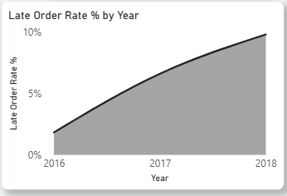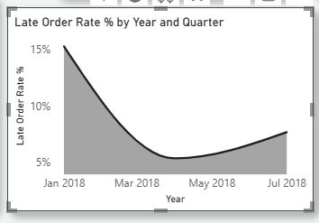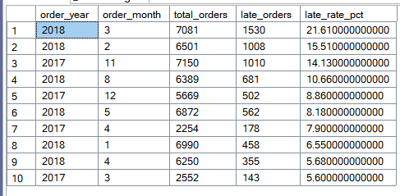

Key Insights:
- Logistics Disruption (Late 2017 – Early 2018): A major disruption impacted the supply chain during this period, peaking in March 2018 with a 21.6% delivery delay rate.
- System Overload: The spike began in Nov 2017 (14.1%), likely triggered by Black Friday volume, but the failure to recover for months suggests a deeper external issue or carrier collapse.

Are non-completion or cancellation rates associated with payment method?

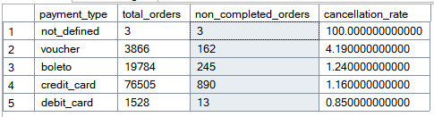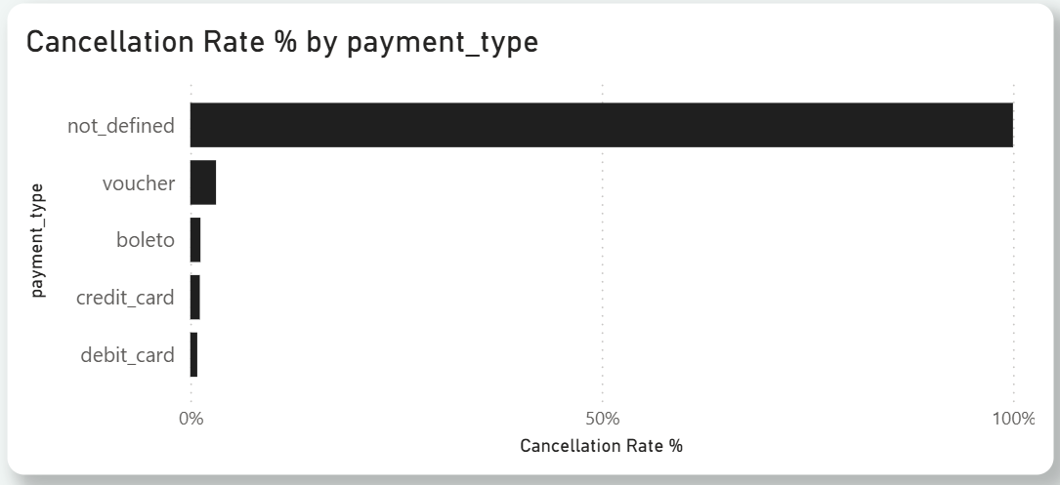

Key Insights:
- System Stability: There is no significant correlation between payment methods and order failure. Major methods like Credit Cards and Boleto show high reliability with cancellation rates staying below 1.5%.

- Data Artifacts: The 100% failure rate for "not_defined" is a statistical outlier driven by negligible volume (only 3 orders), likely representing system glitches rather than actual customer behavior.

Are delivery delays concentrated in specific customer cities?
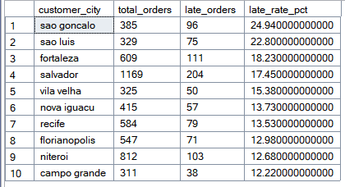
Key Insights:
- Critical Geographic Failures: Logistics performance collapses in specific regions. Sao Goncalo is the worst-performing city with a massive 24.9% delay rate, meaning 1 in every 4 customers there receives their order late.
- High-Volume Risk: Salvador represents a major operational threat; despite having high demand (1,169 orders), it suffers from a 17.5% delay rate, generating the highest absolute number of dissatisfied customers (204) in this list.

10. Impact & Next Steps
Based on the data-driven insights gathered throughout this analysis, the following strategic actions are recommended to drive revenue growth and improve customer satisfaction:
- Launch a Targeted Customer Loyalty Program:
  - The Issue: Data indicates a critical retention challenge, with only 3% of customers returning for a second purchase.
  - The Action: Implement a tiered loyalty program or "Prime-like" subscription that rewards frequent buyers. Since 89% of returning customers are those who experienced on-time delivery, focusing retention efforts on this satisfied segment will yield the highest ROI.
- Strengthen Logistics Resilience against External Shocks:
  - The Issue: The historical analysis revealed a massive spike in delays during Late 2017 – Early 2018 (reaching 21.6%), indicating the supply chain’s vulnerability to external disruptions or seasonal peaks.
  - The Action: Diversify logistics partners to avoid "single-point-of-failure" risks. Developing a predictive model to forecast demand surges (like Black Friday) will allow for proactive capacity planning, ensuring the network remains robust ("immune") against future volatility.
- Enforce Stricter Seller Performance Standards:
  - The Issue: A significant performance gap exists, with specific sellers delaying nearly 1 in 4 orders (24%).
  - The Action: Establish a strict Service Level Agreement (SLA) for sellers. Implement a warning system where sellers exceeding a 10% delay rate face temporary suspension or reduced visibility until performance improves.
- Regional Logistics Optimization (Focus on Northeast):
  - The Issue: High-demand cities like Salvador and Sao Goncalo are suffering from severe delay rates (17% - 25%).
  - The Action: Investigate the root cause in these specific regions. This may require contracting local "last-mile" delivery specialists in these cities or setting up regional warehousing hubs to bypass long-haul shipping bottlenecks.

11. Project Notes

- Timeframe: This analysis is based on historical data from 2016 to 2018. Results reflect the market conditions of that period and may differ from current trends.

- Root Cause Scope: While the data shows where and when delays happened , it doesn't include external factors (like weather or strikes) that explain the exact reason for each delay.

