**Decomposing the virtual water of the Global South**

**embedded within the global economic market**

**Abstract**

Water had a great influence on the rise and collapse of ancient civilizations. Nowadays, mankind faces water-related problems exacerbated by intensive farming, rapid urbanization, and climate change strikes. The world’s population is becoming increasingly dependent on water resource. However, most of the water humanity is currently consuming is invisible in nature, and we know less how this virtual water is circulating within the global economic supply chains. While the water footprint of cities of the Global North are profoundly analyzed, Global Southern cities remain poorly documented. To bridge this gap, we compute and decompose cities’ virtual water (Bleu and Grey) of the Global South, we used Extended Environmental Input-Output Analysis (EE-IOA) coupling global supply chain database of a Multi-Region Input-Output (MRIO) tables and cities’ final demand vectors (in form of consumers expenditures surveys). Results showed that the average, across all the selected cities, virtual bleu water is estimated to 253 liters per capita/yr and for grey water is estimated to 285 liters per capita/yr which means that cities of the Global South are causing transboundary water pollution more than they import fresh water embedded within products and services. When decomposing the virtual water of the Global South we found that the major responsible sectors transport accounts for X% of the total footprint, followed by X with x% and x with X%.

To place the climate-induced uncertainties in perspective, it is better to act in a pro-active approach and spread environmental consciousness regarding the purchase of products and services that are associated with less virtual water intensities (both Blue and Grey).

**Keywords**

Virtual water; input-output analysis; cities; water security; urban sustainability; global south.

**Graphical abstract**



1. **Introduction**

**The status of water and the role of global warming**

Water is a finite resource and plays a major role in urban development and ecosystems sustainability. Thorough history, the first mankind’s revolutions testifies on the relevance and the safety of water as resource (e.g., ancient human civilizations: Mesopotamia, Egyptian, Greek and Roman). 97% of the water on Earth is saltwater, leaving only 3% as freshwater, only 1% of which is readily available for human consumption including power generation, irrigation, industrial activities, and daily use.

The World Water Council’ Vision Report stated that there is a water management crisis which led both billions of people and the environment to suffer.

According to the World Water Council, XXX live without a cleaned water, ….etc (set countries too). From a planetary scale, agriculture is ranked the first for consummating water with …… However, these values are biased in industrialized countries, where the industry accounts for ½ of the total water consumption.

Yet, the direct water is clearly stated and monitored but what about the virtual water, the water we don’t see.

The world’s population is becoming increasingly dependent on this valuable resource. Water is considered to be a *“human right”* that is currently under sever strikes. The Millennium Development Goal defined *water security* as *“access to safe drinking water and sanitation”*.

Health problems and environmental risks can be abstained.

Unfortunately, we’re living in a changing climate, climate change is currently effecting water planning include changes in precipitation events, runoff patterns, and droughts. Despite recent advancements in climate research, there is still a lot of uncertainty about how and when the climate will change, and how these changes will affect water availability within an increasing demand for water, worldwide.

Many areas around the world are facing water-related issues such as Cape Twon in 2018 where the city experienced the Day-Zero.

**Virtual water, what does it means?**

Contrary to the direct water that is used to produce commodities, goods and services, for instance, a car manufacture uses direct water throughout the production processes including surface treatment, paint spray booths, coating, washing, hosing, and rinsing that happened inside the manufacturing facilities. Summing up together, the value display the required amount of water to produce a product (a car in this example), that total is “virtual”, given the fact that the final consumers (owner of a car) it not aware of such water consumption; moreover, the final user also uses direct water (which stays qualified as “directed”) while using the car including washing, cooling, air-conditioning system. The virtual water, also known in the scientific literature as indirect, embedded, embodied water, is the quantity of water that has been consumed across the value chain of goods and services purchased from the global economic market, and it is often hidden from final consumers.

Despite the existence the existence of the Virtual Water Trade (VWT),

However, virtual water (also including virtual carbon, energy, nitrogen, phosphorus, human appropriation …) is not yet regulated by any national or international protocol.

**The role of water in urban development and sustainability future (urban metabolism approach)**

Supply and demand for water encompasses other non-climatic factors that might have a considerable effect on water including demographic growth, economic growth, affluence, and geopolitics. Cities are hyper-complex system that require inputs from the national and international markets to satisfy their development needs.

In addition, water pollution is increasing across the world which further shrink the available water for anthropogenic activities.

Water supply is bound with time, geography and climate hazards, therefore, societies of the global south should innovate new lifestyle patterns and

Developing economies are trying to grow so fast, without paying attention to the environmental degradation generated during this process.

**The novelty of this article**

The novelty of this study is that it computes the different types of virtual water namely blue and grey water for 181 cities belonging to the Global South (focusing on Upper Middle-Income -UMICs- and Lower Middle-Income -LMICs- classes) and decomposes each water footprint by major final consumptions categories (construction, electronics, food, goods, services, Transport, and Others) in order to allocate responsibilities to final demand sectors and trigger potential policy leverages. The final sample used for our analysis is based on 181 cities belonging to the Global South covering 23 countries and representing X% of the world’s population.

1. **Methods and Materials**

**Data collection**

To answer our research questions, two types of data were harvested. The first is urban expenditures surveys (UES) or consumers expenditures surveys (CES) (also denoted as city final demand vector - -) following COICOP-categorization of the 181 selected cities belonging to 23 countries belonging to the Global South, see electronic supplementary information (ESI) file for further details. Data were retrieved from the office of statistics of each host-country. Notice that data collection methods and quality may vary from a country to country, hence, from a city to city (took as-is). Because of data scarcity in the Global South, cities final demand vectors - - were not taken at the same year because of the internal protocol of each host-country to establish and deploy the consumer expenditures surveys, some countries establish the surveys annually, while others quinquennial as such several limitations are to encounter while comparing results among selected cities (also highlighted in (Hachaichi and Baouni, 2021, 2020)). The second data constitutes of global Multi-Regional Input-Output (MRIO) tables which were retrieved from Eora global supply chain database (Lenzen et al., 2013, 2012). Eora provides multi-region input-output table (MRIO) model that provides a time series (from 1990 to 2021) of high-resolution Input-Output (IO) tables (capturing the inter-sectoral transfers amongst 15,909 sectors) with corresponding environmental and social satellite accounts () for 190 nations. We used Input-Output tables (version 199.82) harmonized to 26 sectors to enable a transparent and an accurate comparison across selected cities. Notice that the current virtual water estimations of the Global South exclude footprints attributable to (i) government final consumption and (ii) gross fixed capital formation for which city-specific data was not available.

**Method**

For this study we used an Environmental Extended Input-Output Analysis (EE-IOA) (Haberl et al., 2019; Kitzes, 2013; Miller and Blair, 2009; Raa, 2006, 2007). Our analysis process is divided into two parallel pre-processing steps (Fig.1). The first in which we collected raw CES data in local currencies and transformed into cities’ final demand vectors () that matches to the respective sectoral used by Eora (26 sectors), we aggregated the values (via a distributive process) to match Eora 26 sectors classification by constructing “correspondence table” that maps each value from the raw CES data to match Eora’s sectors. To use the virtual water coefficients provided by the Eora satellite accounts (), we converted cities’ final demand arrays () from local currencies into $US using the World Bank exchange rates (World Bank, 2021) and were mapped accordingly to the national import structure for each country to be used in the input-output calculations. In the second step, we computed the direct intensity vectors () as shown in Equation (1) (for each year corresponding the selected city’s final demand vector) for each virtual water category (Grey, and Blue water), after we computed the final demand vector () using the Leontief inverse (Leontief, 1986) as shown in Equation (2).

…(Eq.1)

… (Eq.2)

Next, cities final demand vectors - - were converted from purchases price (PP) to base price (BP) on a sector by sector basis using national BP/PP ratios computed from Eora’s Multi-Regional Input-Output (MRIO) tables as preformed in (Pichler et al., 2017). To compute cities’ virtual water footprints (for each sector), we multiplied element wise the total demand vector () with the city final demand vector () as shown in Equation (3).

... (Eq.3)

Where is the virtual water per capita for a given city (m3/year), is the total intensity vector, and is the city final demand vector ($US/year).

**Figure 1:** Method utilized to compute cities’ virtual water of the Global South and data dissemination by final major consumption categories.

1. **Results and discussions**

In this section, we will …..

* 1. **Urban virtual water of the Global South: Learning from contexts**

Results (Fig.2) shows that, on average, Middle-Income Countries (MICs) are associated with

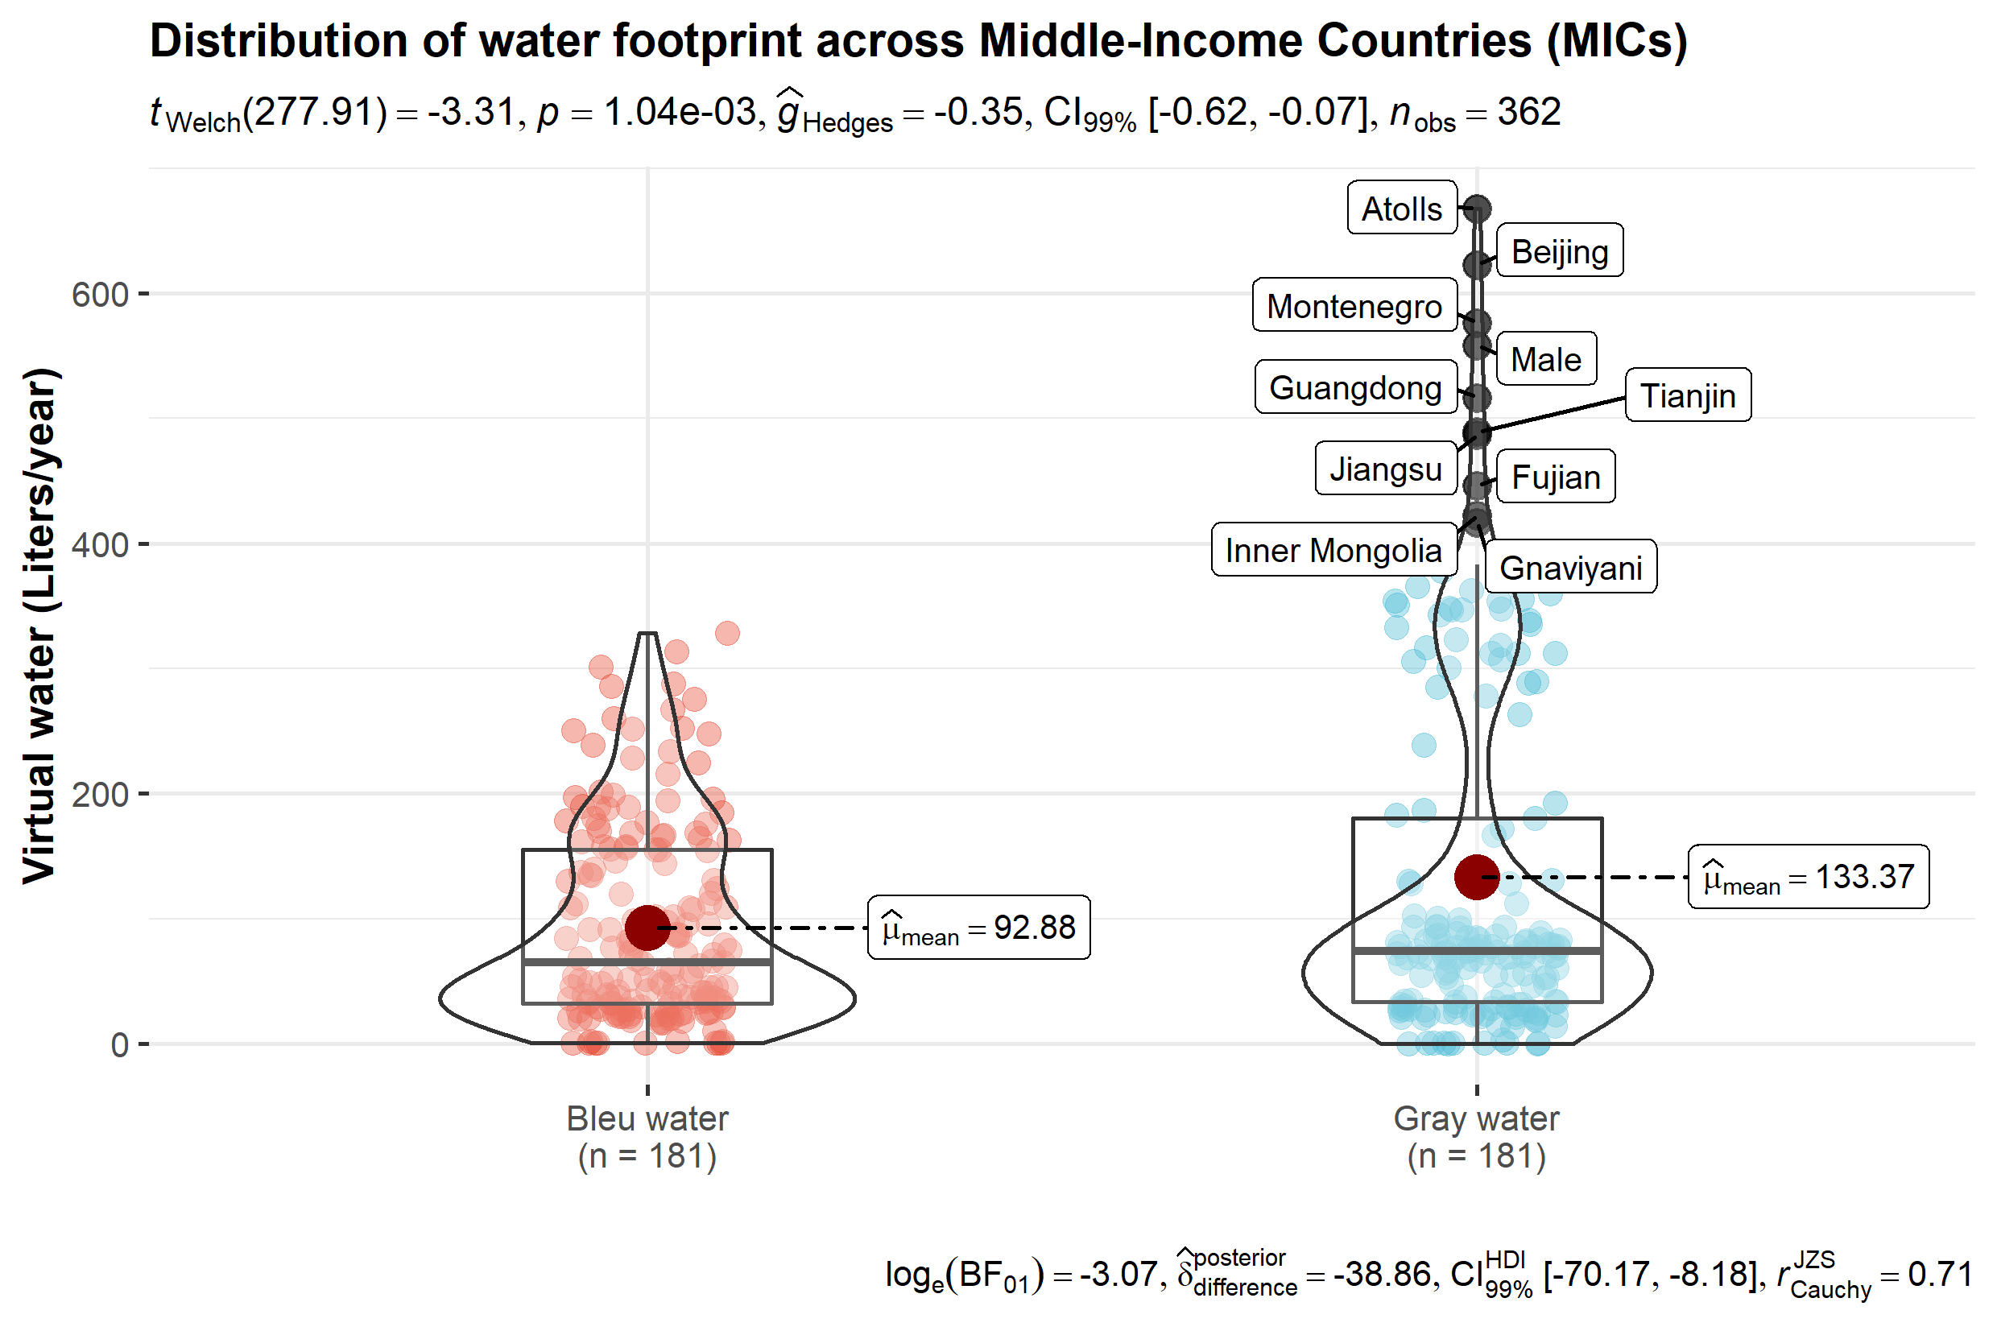

What can we see …..

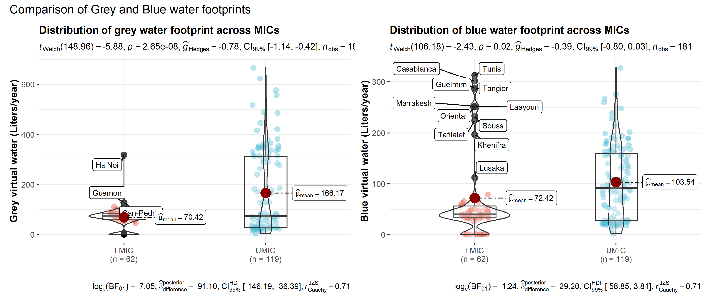

What can we spot …..

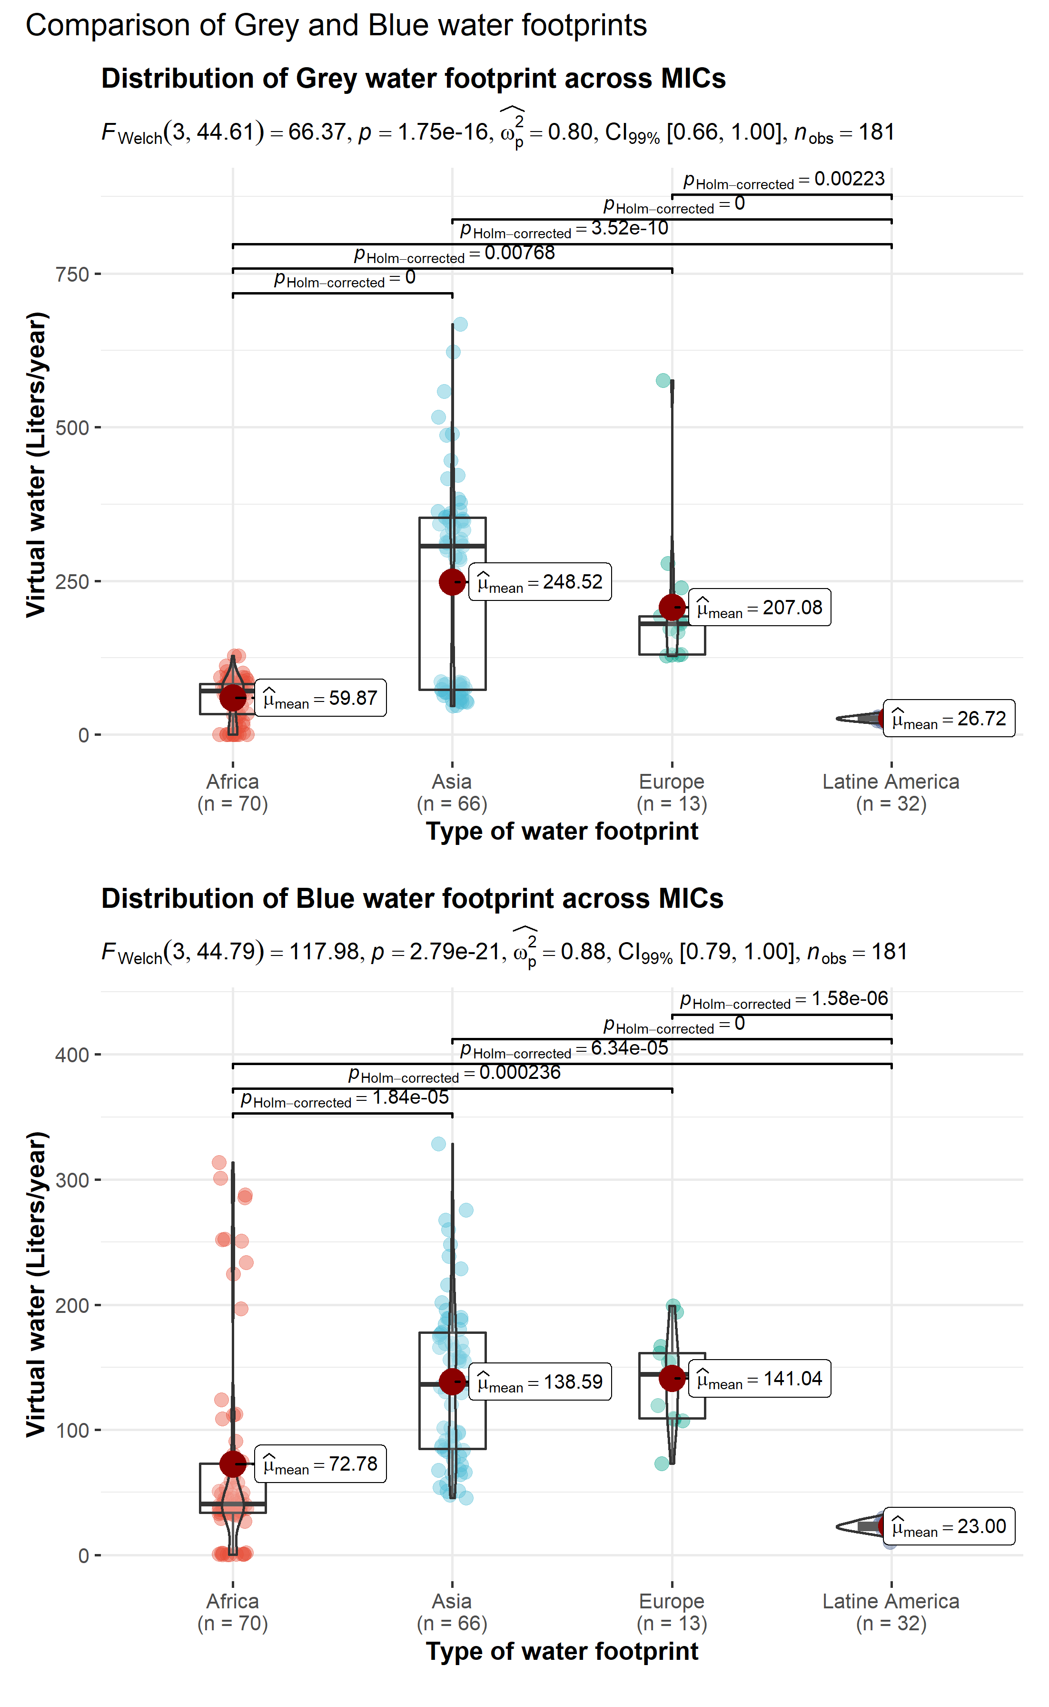

What can we see …..

Results (Fig.02) for the Bleu water category shows that Asian and North African cities are the among the highest Global Southern cities that imports fresh water from the global economic market. For Asia, three Chinese’s cities have the highest quantities of imported water embedded within goods and services namely Beijing with 328.45 liters per capita/yr, followed by Guangdong with 267.42 liters per capita/yr, and Jiangsu with 248 liters per capita/yr. From North African region, we find Tunis (Tunisia) is associated with 314.65 liters per capita/yr, while Casablanca, Tangier and Laayoun (Morocco) are associated with the respected total embedded fresh water 301.1, 285.6, and 251.65 liters per capita/yr.

On the other hand, results for the Grey water category showed that Atolls (Maldives) have the highest virtual water consumption across all the selected cities with value estimated to 667.99 liters per capita/yr, followed by the three Chinese’ major cities Beijing with 622.8 liters per capita/yr, followed Montenegro with 576.64 liters per capita/yr. Chinese cities represent a share of the top Global Southern cities’ fresh water footprint Guangdong with 516.64 liters per capita/yr, and Tianjin with 486.80 liters per capita/yr.



**Figure 2:** Top 20 Global Southern cities’ with highest values of virtual water.

A deeper look to Fig.02 regarding the sectoral composition of the fresh/Bleu water footprint we found that

North African cities are collecting water/ while major cities are causing water pollution.

Footprint decomposition by income class



Footprint decomposition by cities



Typologies of cities (PCA)

* 1. **Urban virtual water policy: Hotspots and architectures of handicaps**

Water is not only a unique problem, but instead it is a part of a holistic complex system denoted Water-Food-Energy nexus. Therefore, actions that are placed on water are also affecting the other two sub-systems (energy and food).

**Food**

**Transport**

The Australian Industry Group (AIG) further discusses

**Energy**

1. **Conclusion**

Water is not unequally distributed across countries and regions, and it’s availability is highly dependent on the future pathways of Earth’s climate system. Moreover, most of the water humanity is currently consuming is invisible by nature. It is embedded within goods and services purchased from the global economic market. Hence, it is also vital to be prepared to manage the virtual part of water while making fundamental decisions or evaluating future choices and strategies.

Cities of the Global South can import goods and services that require massive water input from the global economic market in order to amortize the current and future climate impacts on the local water sources.

1. **References**

Haberl, H., Wiedenhofer, D., Pauliuk, S., Krausmann, F., Müller, D.B., Fischer-Kowalski, M., 2019. Contributions of sociometabolic research to sustainability science. Nat Sustain 2, 173–184. https://doi.org/10.1038/s41893-019-0225-2

Hachaichi, M., Baouni, T., 2021. Virtual carbon emissions in the big cities of middle-income countries. Urban Climate 40, 100986. https://doi.org/10.1016/j.uclim.2021.100986

Hachaichi, M., Baouni, T., 2020. Downscaling the planetary boundaries (Pbs) framework to city scale-level: De-risking MENA region’s environment future. Environmental and Sustainability Indicators 5, 100023. https://doi.org/10.1016/j.indic.2020.100023

Kitzes, J., 2013. An Introduction to Environmentally-Extended Input-Output Analysis. Resources 2, 489–503. https://doi.org/10.3390/resources2040489

Lenzen, M., Kanemoto, K., Moran, D., Geschke, A., 2012. Mapping the structure of the world economy. Environmental science & technology 46, 8374–8381.

Lenzen, M., Moran, D., Kanemoto, K., Geschke, A., 2013. Building Eora: a global multi-region input–output database at high country and sector resolution. Economic Systems Research 25, 20–49.

Leontief, W., 1986. Input-Output Economics. Oxford University Press.

Miller, R.E., Blair, P.D., 2009. Input-Output Analysis: Foundations and Extensions. Cambridge University Press.

Pichler, P.-P., Zwickel, T., Chavez, A., Kretschmer, T., Seddon, J., Weisz, H., 2017. Reducing Urban Greenhouse Gas Footprints. Sci Rep 7, 14659. https://doi.org/10.1038/s41598-017-15303-x

Raa, T. ten, 2006. The Economics of Input-Output Analysis. Cambridge University Press.

Raa, T.T., 2007. The Extraction of Technical Coefficients from Input and Output Data. Economic Systems Research 19, 453–459. https://doi.org/10.1080/09535310701698597

World Bank, 2021. Official exchange rate (LCU per US$, period average) | Data [WWW Document]. URL https://data.worldbank.org/indicator/PA.NUS.FCRF (accessed 11.1.21).