Name: Mohamed Mostafa Elsayed Hadhoud.
Name: Omar Mohamed Ahmed Abdallah.
Name: Mohamed Adel Mohamed Saeed Eltanty.

Expense Claim Reimbursement System
Task: Methodology, Time Estimation, PERT Diagram & Gantt Chart

1. Methodology

methodology: Waterfall (Sequential Development)
The project will be developed using the Waterfall methodology. In Waterfall, the project moves through a fixed sequence of phases, and each phase must be finished and approved before the next one starts: Requirements, Analysis, Design, Development, Testing, and Deployment.

Why Waterfall is suitable
- Clear requirements: the business requirements of the system (submit claim, attach receipt, review/approve/reject, track status, reports, authentication) are already identified and are unlikely to change much.
- Fixed deadline and controlled scope: the system request states that the project needs a clear deadline and a controlled development scope. Waterfall gives a predictable schedule.
- Academic project: each phase produces clear deliverables (SRS, diagrams, database design, code, test report) that fit the course tasks.
- Small team and well-known technology: a web application with a relational database is a standard type of system, so there is low technical uncertainty.
- Easy to plan and track: because the phases are sequential, it fits naturally with PERT and Gantt planning.

Phases and deliverables
Phase | Main activities | Deliverable
Requirements | Gather needs from Finance/Administration, employees and reviewers; analyse and document them | Requirements document (SRS)
Analysis | Model the system: Use Case, DFD, ERD | Analysis models
Design | Database design, user interface design, architecture and security design | Design documents, wireframes
Development | Backend, frontend, receipt upload, reports and search, integration | Working system
Testing | Unit, integration and user acceptance testing, then bug fixing | Test report
Deployment | Install on the server, train employees and reviewers, final documentation | Deployed system, user guide

Advantages and limitations
- Advantages: simple and easy to manage, clear milestones, good documentation, easy to estimate time and cost.
- Limitations: changes are harder after a phase is finished, and the user sees the working system late. This risk is accepted here because the requirements are stable, and it is reduced by user acceptance testing before deployment.

2. Time Estimation

Task breakdown and duration
The project was divided into 15 tasks (A to O). Durations are in working days (5 working days = 1 week). For each task, three estimates were made using the PERT three-point technique:
- O (Optimistic): the shortest time if everything goes well.
- M (Most likely): the realistic time under normal conditions.
- P (Pessimistic): the longest time if problems happen.
Expected time: TE = (O + 4M + P) / 6
The most likely value gets the heaviest weight (4), so the result is a weighted average that is closer to reality than a single guess.
ID | Task | Predecessors | O | M | P | TE (days)
A | Requirements gathering | - | 2 | 3 | 4 | 3.0
B | Requirements analysis & SRS | A | 2 | 3 | 6 | 3.3
C | System analysis (Use Case, DFD, ERD) | B | 3 | 5 | 7 | 5.0
D | Database design | C | 2 | 3 | 4 | 3.0
E | User interface design (wireframes) | C | 3 | 4 | 5 | 4.0
F | Architecture & security design | C | 2 | 3 | 4 | 3.0
G | Backend development (login, claims, approval) | D, F | 8 | 10 | 14 | 10.3
H | Frontend development | D, E | 6 | 8 | 10 | 8.0
I | Receipt upload module | D, F | 3 | 4 | 6 | 4.2
J | Reports & search module | G | 3 | 4 | 5 | 4.0
K | System integration | G, H, I, J | 2 | 3 | 4 | 3.0
L | Testing (unit, integration, UAT) | K | 4 | 6 | 8 | 6.0
M | Bug fixing | L | 2 | 3 | 5 | 3.2
N | Deployment & user training | M | 2 | 3 | 4 | 3.0
O | Final documentation | M | 2 | 3 | 4 | 3.0

Total effort (sum of all TE) = 66 days, but because several tasks run in parallel, the actual project duration is shorter. It is calculated in the PERT section below.

3. PERT Diagram
The PERT diagram shows the tasks as boxes, the arrows show dependencies (a task cannot start before its predecessors finish). Each box shows the task, its expected duration, and four time values:
- ES (Earliest Start) and EF (Earliest Finish) = EF = ES + TE. ES of a task = the largest EF of its predecessors (forward pass).
- LF (Latest Finish) and LS (Latest Start) = the latest the task can end/start without delaying the project; LS = LF - TE (backward pass).
- Slack = LS - ES. If slack = 0, the task is critical.
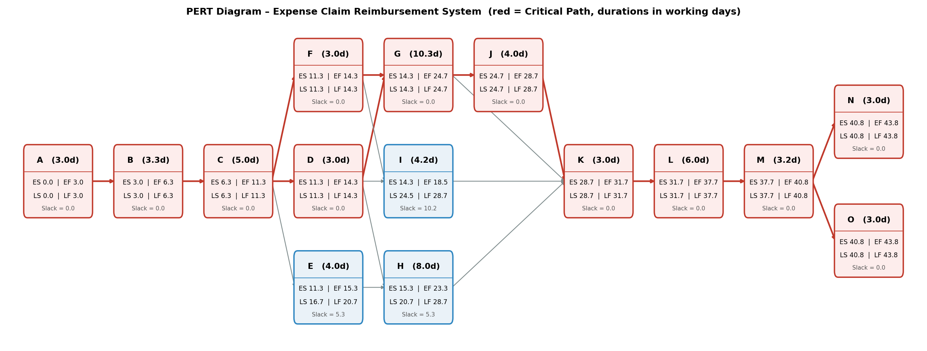

PERT Diagram
ID | Task | TE | ES | EF | LS | LF | Slack
A | Requirements gathering | 3.0 | 0.0 | 3.0 | 0.0 | 3.0 | 0.0
B | Requirements analysis & SRS | 3.3 | 3.0 | 6.3 | 3.0 | 6.3 | 0.0
C | System analysis (Use Case, DFD, ERD) | 5.0 | 6.3 | 11.3 | 6.3 | 11.3 | 0.0
D | Database design | 3.0 | 11.3 | 14.3 | 11.3 | 14.3 | 0.0
E | User interface design (wireframes) | 4.0 | 11.3 | 15.3 | 16.7 | 20.7 | 5.3
F | Architecture & security design | 3.0 | 11.3 | 14.3 | 11.3 | 14.3 | 0.0
G | Backend development (login, claims, approval) | 10.3 | 14.3 | 24.7 | 14.3 | 24.7 | 0.0
H | Frontend development | 8.0 | 15.3 | 23.3 | 20.7 | 28.7 | 5.3
I | Receipt upload module | 4.2 | 14.3 | 18.5 | 24.5 | 28.7 | 10.2
J | Reports & search module | 4.0 | 24.7 | 28.7 | 24.7 | 28.7 | 0.0
K | System integration | 3.0 | 28.7 | 31.7 | 28.7 | 31.7 | 0.0
L | Testing (unit, integration, UAT) | 6.0 | 31.7 | 37.7 | 31.7 | 37.7 | 0.0
M | Bug fixing | 3.2 | 37.7 | 40.8 | 37.7 | 40.8 | 0.0
N | Deployment & user training | 3.0 | 40.8 | 43.8 | 40.8 | 43.8 | 0.0
O | Final documentation | 3.0 | 40.8 | 43.8 | 40.8 | 43.8 | 0.0

Critical Path
Critical Path: A → B → C → (D and F) → G → J → K → L → M → (N and O)
These are the tasks with zero slack. Any delay in one of them delays the whole project. D and F run in parallel and both are critical (same for N and O). Tasks E (UI design), H (frontend) and I (receipt upload) are not critical: E and H have 5.3 days of slack and I has 10.2 days, so they can be delayed a little without affecting the end date.
Expected project duration ≈ 43.8 working days ≈ 9 weeks.

4. Gantt Chart
The Gantt chart shows the same tasks on a timeline. Each bar starts at the task's Earliest Start and its length equals the expected duration. Red bars are critical tasks, blue bars are non-critical, and the hatched area shows how long a non-critical task can slide (slack).
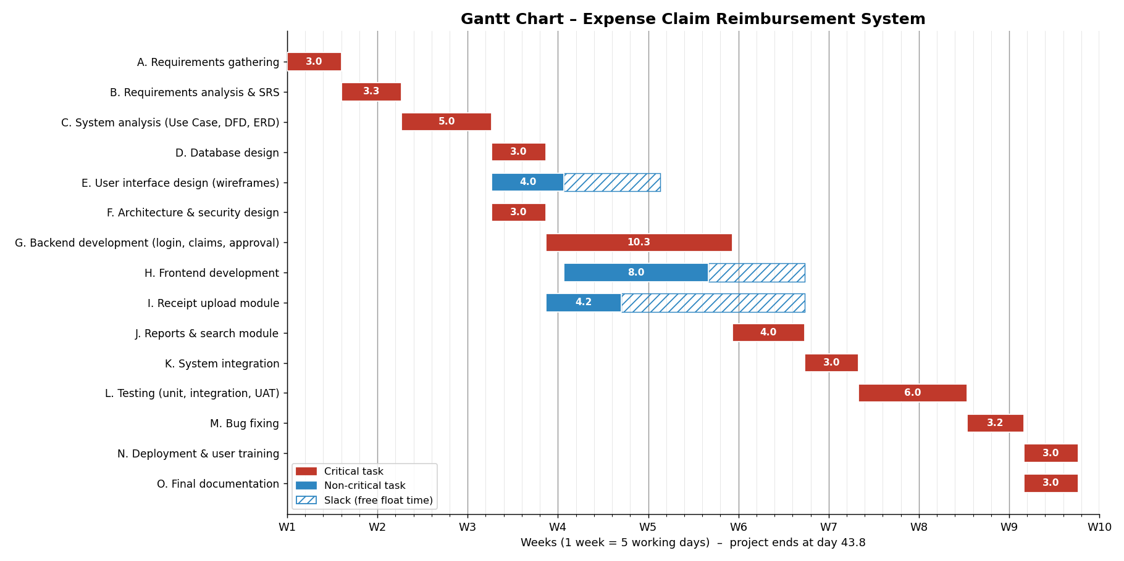

5. Conclusion
The Expense Claim Reimbursement System will be developed with the Waterfall methodology in 15 tasks. Using PERT three-point estimation, the expected project duration is about 43.8 working days (around 9 weeks). The critical path goes through requirements, analysis, database/architecture design, backend development, reports module, integration, testing, bug fixing, and deployment/documentation. The project manager should focus on these tasks to keep the schedule on time.

