**Project : Pick and Place Robot arm**

**Kinematic Analysis**

By evaluating the kr210.urdf.xacro I was able to write the dh table as following :

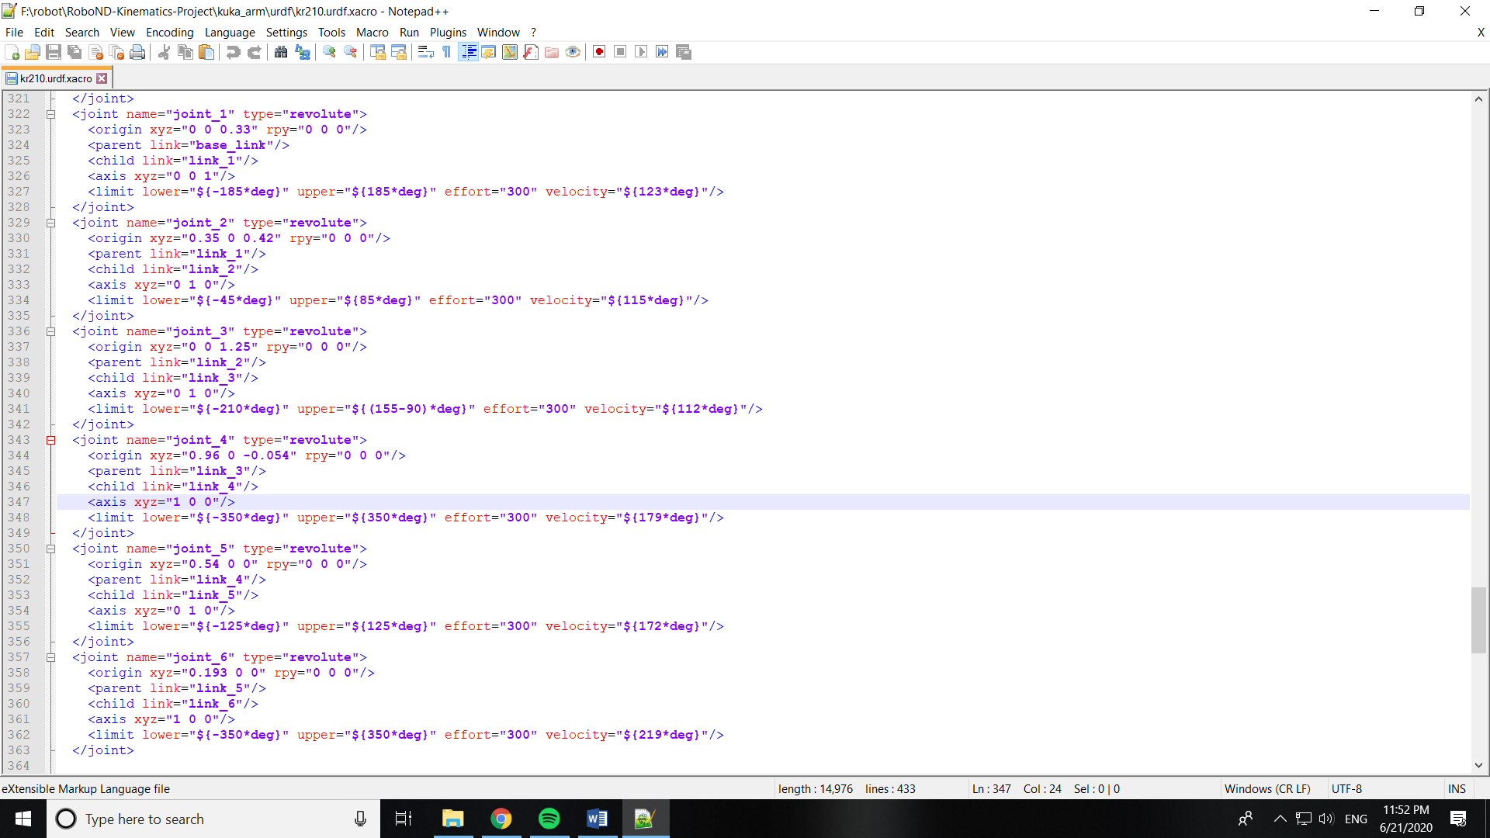

dh = {alpha0: 0, a0: 0, d1: 0.75, q1: q1,

alpha1: -pi/2, a1: 0.35, d2: 0, q2: q2-pi/2,

alpha2: 0, a2: 1.25, d3: 0, q3: q3,

alpha3: -pi/2, a3: -0.054, d4: 1.5, q4: q1,

alpha4: pi/2, a4: 0, d5: 0, q5: q5,

alpha5: -pi/2, a5: 0, d6: 0, q6: q6,

alpha6: 0, a6: 0, d7: 0.303, q7: 0}

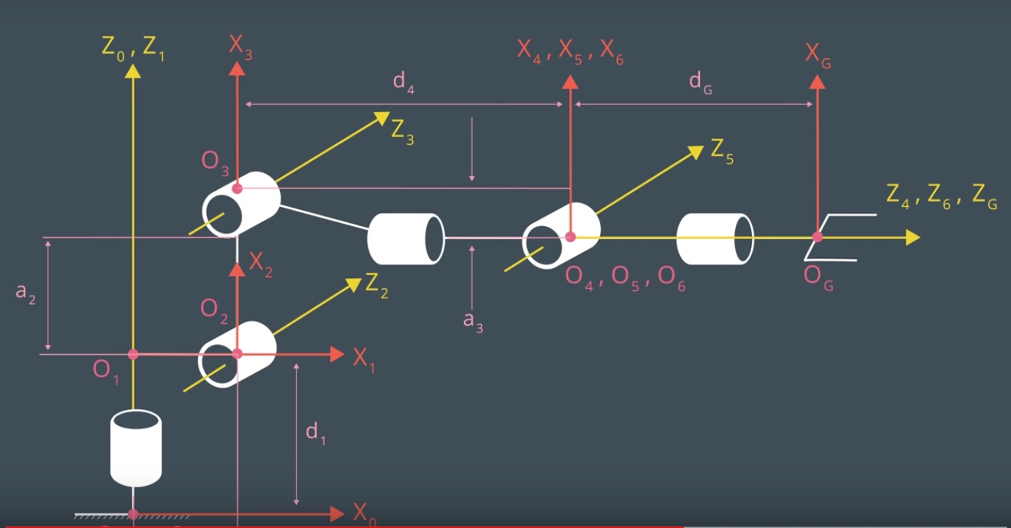after applying the transformation on each joint we get the following code :

T0_1=transform_matrix(alpha0, a0, d1, q1).subs(dh)

T1_2=transform_matrix(alpha1, a1, d2, q2).subs(dh)

T2_3=transform_matrix(alpha2, a2, d3, q3).subs(dh)

T3_4=transform_matrix(alpha3, a3, d4, q4).subs(dh)

T4_5=transform_matrix(alpha4, a4, d5, q5).subs(dh)

T5_6=transform_matrix(alpha5, a5, d6, q6).subs(dh)

T6_G=transform_matrix(alpha6, a6, d7, q7).subs(dh)

By multiplying the above matricies we get the transform matrix from base link to the end effector frame:

T0_G=T0_1 * T1_2 * T2_3 * T3_4 * T4_5 * T5_6 * T6_G

**Inverse Kinematic**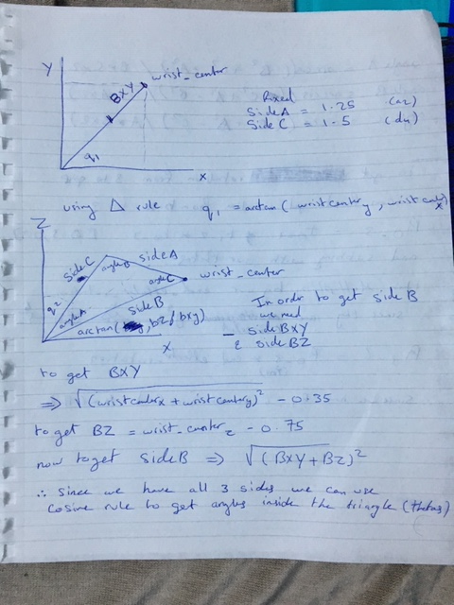

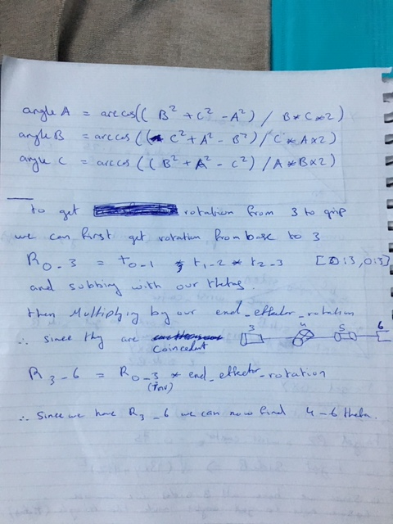

**Images for the process**

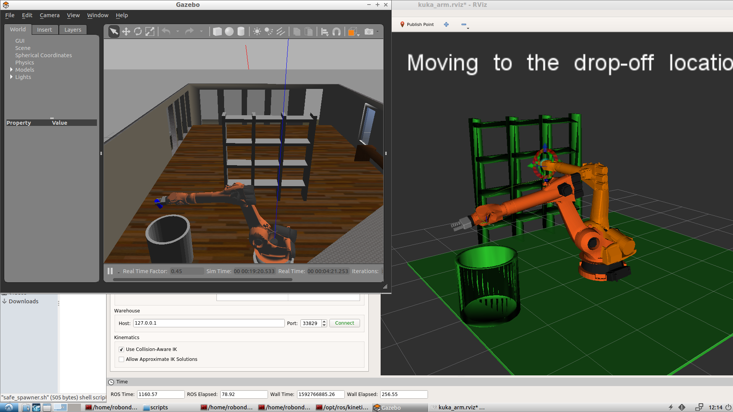

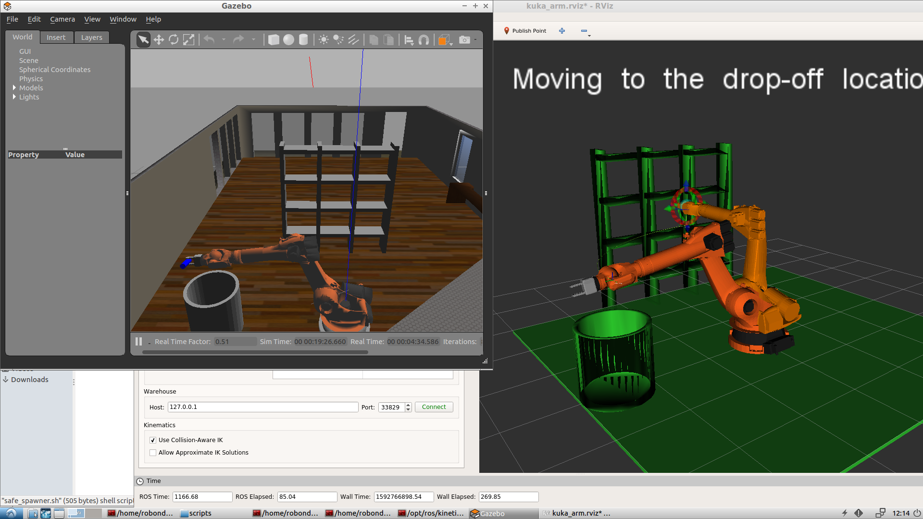

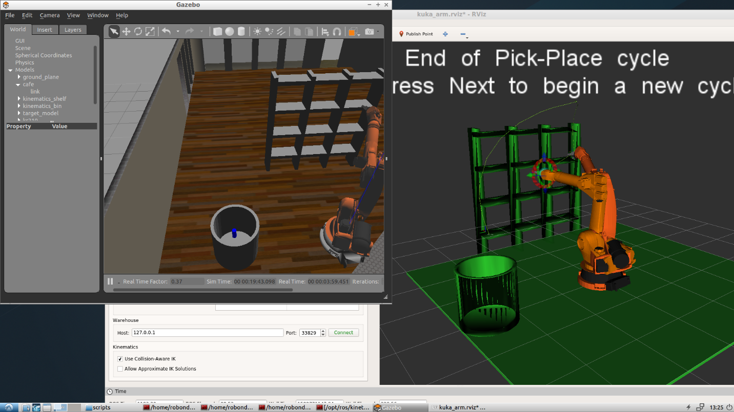

**Running the simulator**

I have modified the safe_spawn.sh to include the running of the KI_server.py and set the inverse kinematic flag to false so all u have to do is:

cd ~/catkin_ws/

catkin_make

./src/RoboND-Kinematics-Project/kuka_arm/scripts/safe_spawner.sh

Keep pressing next on rviz and watch as the simulation runs showing each step and reflected onto the gazebo environment.