**3D Perception**

This is a summary of what I did in order to complete this project

***The numbers correspond to the lines of code***

1. Statistical Outlier Filtering:

This was done in order to reduce noise and have a better and clean image

(58-62)

2. VoxelGrid Downsampling:

Here i want to reduce the points in the point cloud without losing out the essential information required to identify them and have a faster processing

(65-68)

3. Filtering and RANSAC plane fitting:

We apply passthrough filter in order to isolate the table and objects in the scene

Passthrough filter was applied twice:

z-axis: in order to locate the table

y-axis: in order to decrease the table’s length

(71-84)

Next comes RANSAC to identify the table and objects separately

For table inliner will identify it while objects are identified by outliner

(RANSAC 87-92, Extraction 95-97)

4. Euclidean Clustering:

Segment the remaining points into individual objects.

(100-107),

After that I convert to ros and send the filters in order to see them in rviz.

(110-129)

For training the model I loaded objectes with 20 different orientation and converted the images to hsv and extracted features using histogram.

Here is the confusion matrix :

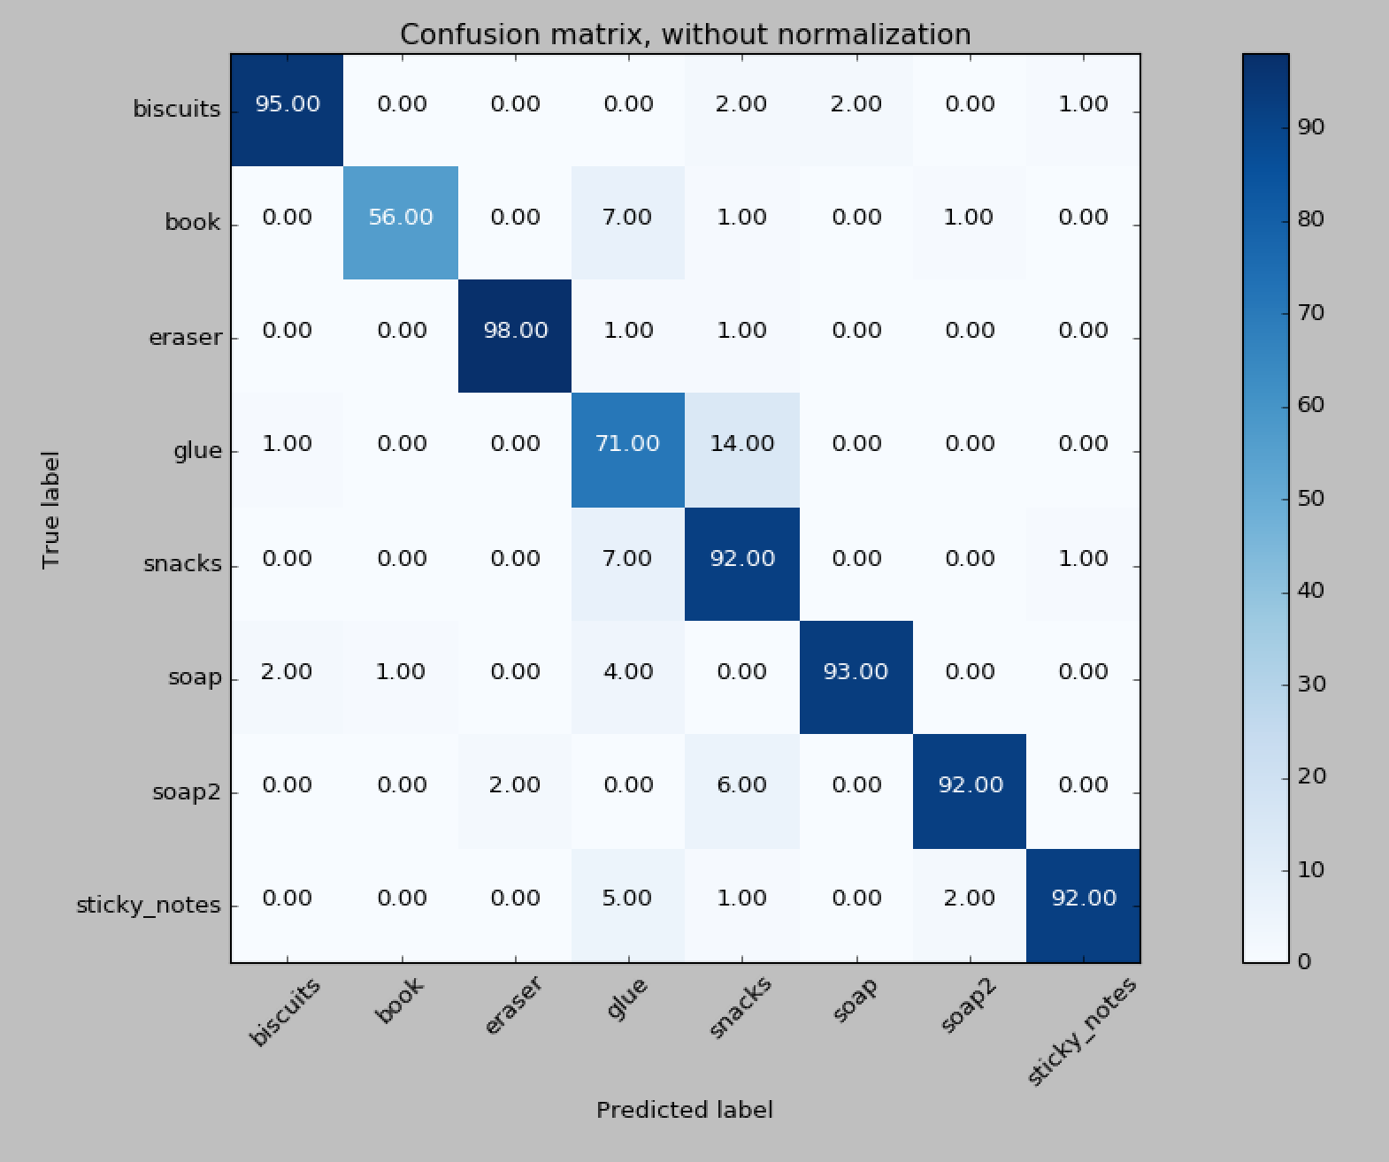

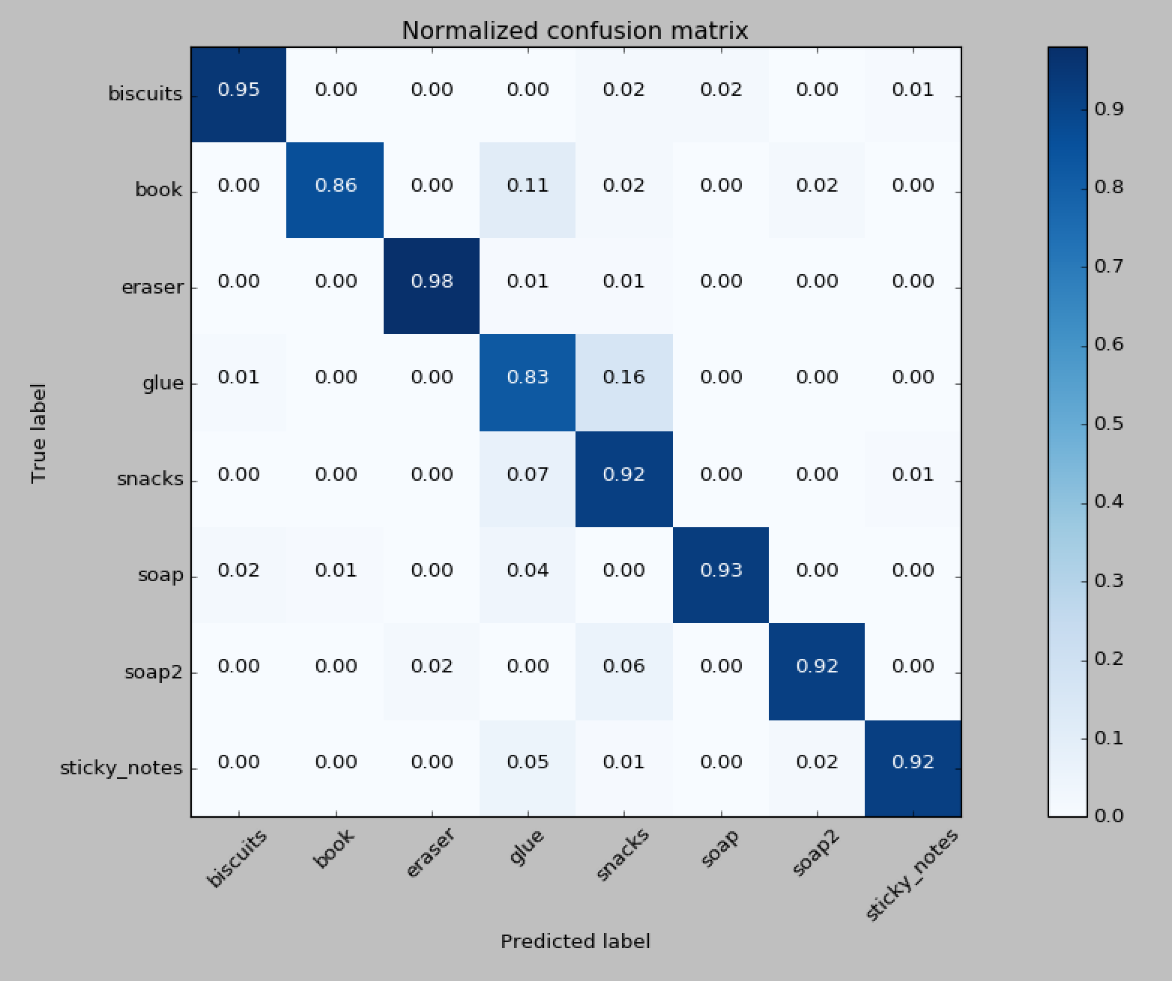

Modified functions :

Both compute_color_histograms() and compute_normal_histograms()

Can be found in functions.py

**Pick and place :**

Output yaml for the 3 world can be found named output_{num}.yaml

Steps:

* Calculate centroid for each object in order to know their center and orientation.
* Classify each object into 2 groups in order to determine which are (right or left will pick it up)
* Output the resultant data to yaml

Results:

World 1

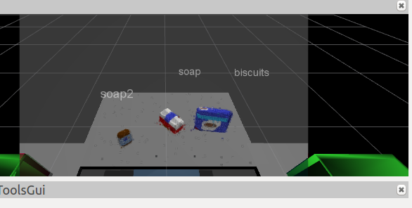

World 2

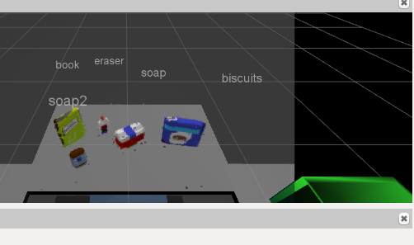

World 3

