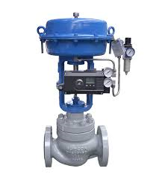

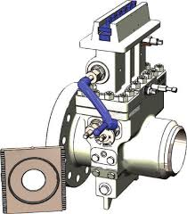

DPU/DPsensor

**Air supply**

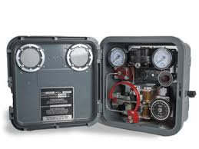

**Air Scrubber**

**Separator level sight glass**

**Shrinkage sight glass**

**Positive choke side bleeder**

Tank

**Annulus Bleeder**