



**Name:**Mohamed Sayed Hassan Mhany

**Year:**engineering prep

**Groub:**6

**Section:**33

**B.n:**3

**Sitting number:**720

**Topic:**Artificial intelligence

**APPLICATION BRIEF:**

The roots of modern Artificial Intelligence, or AI, can be traced back to the classical philosophers of Greece, and their efforts to model human thinking as a system of symbols. More recently, in the 1940s, a school of thought called “Connectionism” was developed to study the process of thinking. In 1950, a man named Alan Turing wrote a paper suggesting how to test a “thinking” machine. He believed if a machine could carry on a conversation by way of a teleprinter, imitating a human with no noticeable differences, the machine could be described as thinking. His paper was followed in 1952 by the Hodgkin-Huxley model of the brain as neurons forming an electrical network, with individual neurons firing in all-or-nothing (on/off) pulses. These events, at a conference sponsored by Dartmouth College in 1956, helped to spark the concept of Artificial Intelligence.

## **What Is Artificial Intelligence (AI)?**

Artificial intelligence (AI) refers to the simulation of human intelligence in machines that are programmed to think like humans and mimic their actions. The term may also be applied to any machine that exhibits traits associated with a human mind such as learning and problem-solving.

 The ideal characteristic of artificial intelligence is its ability to rationalize and take actions that have the best chance of achieving a specific goal. A subset of artificial intelligence is  machine learning, which refers to the concept that computer programs can automatically learn from and adapt to new data without being assisted by humans.  Deep learning  techniques enable this automatic learning through the absorption of huge amounts of unstructured data such as text, images, or video.

## **Understanding Artificial Intelligence (AI)**:

When most people hear the term artificial intelligence, the first thing they usually think of is  robots . That's because big-budget films and novels weave stories about human-like machines that wreak havoc on Earth. But nothing could be further from the truth.

 Artificial intelligence is based on the principle that human intelligence can be defined in a way that a machine can easily  mimic it and execute tasks, from the most simple to those that are even more complex. The goals of artificial intelligence include mimicking human cognitive activity. Researchers and developers in the field are making surprisingly rapid strides in mimicking activities such as learning, reasoning, and perception, to the extent that these can be concretely defined. Some believe that innovators may soon be able to develop systems that exceed the capacity of humans to learn or reason out any subject. But others remain skeptical because all cognitive activity is laced with value judgments that are subject to human experience.

As technology advances, previous benchmarks that defined artificial intelligence become outdated. For example, machines that calculate basic functions or recognize text through optical character recognition are no longer considered to embody artificial intelligence, since this function is now taken for granted as an inherent computer function.

AI is continuously evolving to benefit many different industries. Machines are wired using a cross-disciplinary approach based on mathematics, computer science, linguistics, psychology, and more.

## **Categorization of Artificial Intelligence:**

Artificial intelligence can be divided into two different categories: weak and strong. Weak artificial intelligence embodies a system designed to carry out one particular job. Weak AI systems include video games such as the chess example from above and personal assistants such as Amazon's Alexa and Apple's Siri. You ask the assistant a question, it answers it for you.

Strong artificial intelligence systems are systems that carry on the tasks considered to be human-like. These tend to be more complex and complicated systems. They are programmed to handle situations in which they may be required to problem solve without having a person intervene. These kinds of systems can be found in applications like self-driving cars or in hospital operating rooms.

## **What Is Weak AI?**

Weak artificial intelligence (AI)—also called narrow AI—is a type of  artificial intelligence  that is limited to a specific or narrow area. Weak AI simulates human cognition. It has the potential to benefit society by automating time-consuming tasks and by analyzing data in ways that humans sometimes can’t. Weak AI can be contrasted to  strong AI, a theoretical form of machine intelligence that is equal to human intelligence.

## **Understanding Weak AI:**

Weak AI lacks human consciousness, although it may be able to simulate it at times. The classic illustration of weak AI is John Searle’s Chinese room thought experiment. This experiment says that a person outside a room may be able to have what appears to be a conversation in Chinese with a person inside a room who is being given instructions on how to respond to conversations in Chinese. In this experiment, the person inside the room would appear to speak Chinese. In reality, they couldn’t actually speak or understand a word of Chinese absent the instructions they’re being fed. That's because the person is good at following instructions, not at speaking Chinese. They might appear to have strong AI—machine intelligence equivalent to human intelligence—but they really only have weak AI.

Narrow or weak AI systems do not have general intelligence; they have specific intelligence. An AI that is an expert at telling you how to drive from point A to point B is usually incapable of challenging you to a game of chess. In the same way, a form of AI that can pretend to speak Chinese with you probably cannot sweep your floors.

Weak AI helps turn  big data  into usable information by detecting patterns and making predictions. Examples of weak AI include Facebook’s newsfeed, Amazon’s suggested purchases and Apple’s Siri, the iPhone technology that  answers users’ spoken questions. Email spam filters are another example of weak AI; a computer uses an algorithm to learn which messages are likely to be spam, then redirects them from the inbox to the spam folder.

## **Limitations of Weak AI:**

Besides its limited capabilities, some of the problems with weak AI include the possibility to cause harm if a system fails­. For example, consider a driverless car that miscalculates the location of an oncoming vehicle and causes a deadly collision. The system also has the possibility to cause harm if the system is used by someone who wishes to cause harm; consider a terrorist who uses a self-driving car to deploy explosives in a crowded area.

A further concern related to weak AI is the loss of jobs caused by the automation of an increasing number of tasks. Will unemployment skyrocket, or will society come up with new ways for humans to be economically productive? Although the prospect of a large percentage of workers losing their jobs may be terrifying, advocates of AI claim that it is also reasonable to expect that should this happen, new jobs will emerge that we can’t yet predict as the use of AI becomes increasingly widespread.

## **Special Considerations:**

Since its beginning, artificial intelligence has come under scrutiny from scientists and the public alike. One common theme is the idea that machines will become so highly developed that humans will not be able to keep up and they will take off on their own, redesigning themselves at an exponential rate.

Another is that machines can hack into people's privacy and even be weaponized. Other arguments debate the ethics of artificial intelligence and whether intelligent systems such as  robots  should be treated with the same rights as humans.

Self-driving cars have been fairly controversial as their machines tend to be designed for the lowest possible risk and the least casualties. If presented with a scenario of colliding with one person or another at the same time, these cars would calculate the option that would cause the least amount of damage.

Another contentious issue many people have with artificial intelligence is how it may affect human employment. With many industries looking to automate certain jobs  through the use of intelligent machinery, there is a concern that people would be pushed out of the workforce. Self-driving cars may remove the need for taxis and car-share programs, while manufacturers may easily replace human labor with machines, making people's skills more obsolete.

## **What Is a Trading Robot?**

At the most basic level, an algorithmic trading robot is a computer code that has the ability to generate and execute buy and sell signals in financial markets. The main components of such a robot include  entry rules  that signal when to buy or sell, exit rules indicating when to close the current position, and  position sizing  rules defining the quantities to buy or sell.

## **Algorithmic Trading Strategies:**

One of the first steps in developing an algo strategy is to reflect on some of the core traits that every algorithmic  trading strategym  should have. The strategy should be market prudent in that it is fundamentally sound from a market and economic standpoint. Also, the mathematical model used in developing the strategy should be based on  sound statistical methods .

Next, determine what information your robot is aiming to capture. In order to have an automated strategy, your robot needs to be able to capture identifiable, persistent  market inefficiencies. Algorithmic trading strategies follow a rigid set of rules that take advantage of market behavior, and the occurrence of one-time market inefficiency is not enough to build a strategy around. Further, if the cause of the market inefficiency is unidentifiable, then there will be no way to know if the success or failure of the strategy was due to chance or not.

## **Backtesting and Optimization:**

Backtesting  focuses on validating your trading robot, which includes checking the code to make sure it is doing what you want and understanding how the strategy performs over different time frames, asset classes, or different market conditions, especially in  black swan  type events such as the 2007-2008 financial crisis.

Now that you have coded a robot that works, maximize its performance while minimizing the  overfitting bias. To maximize performance, you first need to select a good performance measure that captures risk and reward elements, as well as consistency (e.g.,  Sharpe ratio. Meanwhile, an overfitting bias occurs when your robot is too closely based on past data; such a robot will give off the illusion of high performance, but since the future never completely resembles the past, it may actually fail.

## **Live Execution:**

You are now ready to begin using real money. However, aside from being prepared for the emotional ups and downs that you might experience, there are a few technical issues that need to be addressed. These issues include selecting an appropriate broker and implementing mechanisms to manage both  market risks  and  operational risks, such as potential hackers and technology downtime.

**Screen shots for the project:**

* The main page:

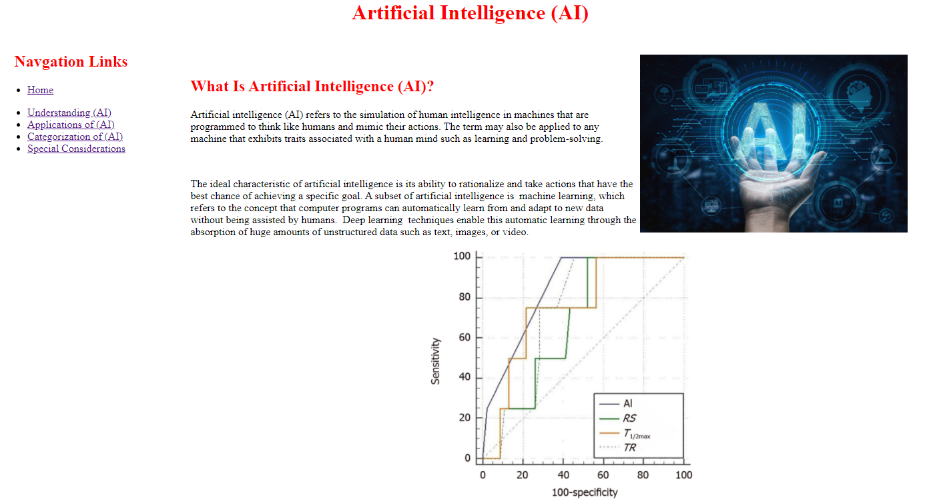

* Page 1 (Understanding (AI) ):

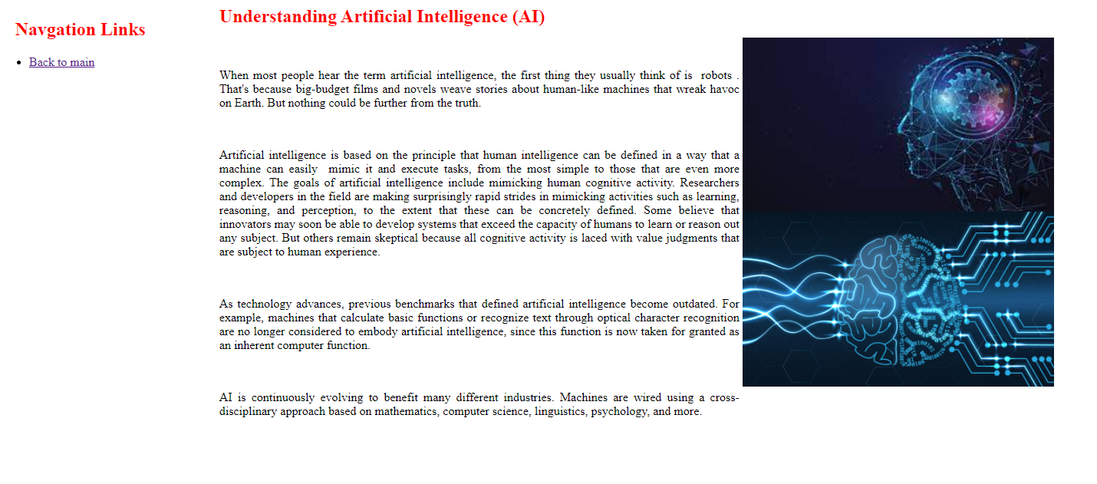

* Page 2 (Applications of (AI)):

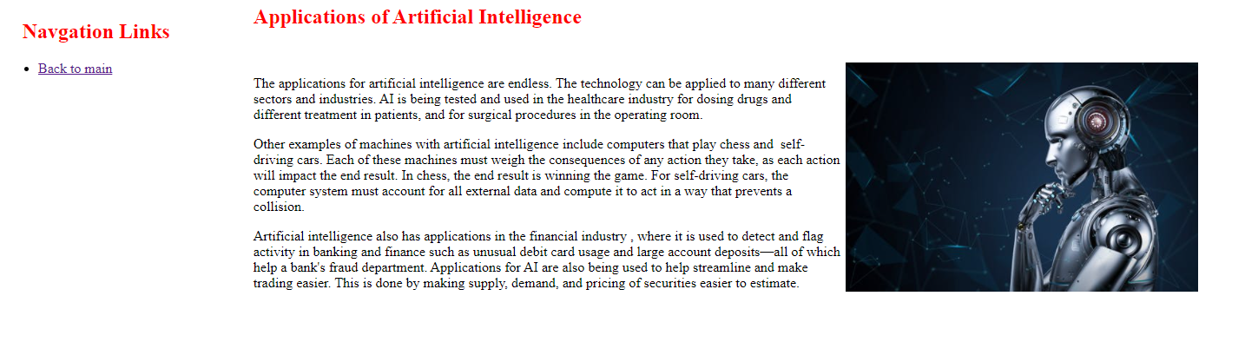

* Page 3 (Categorization of (AI)):

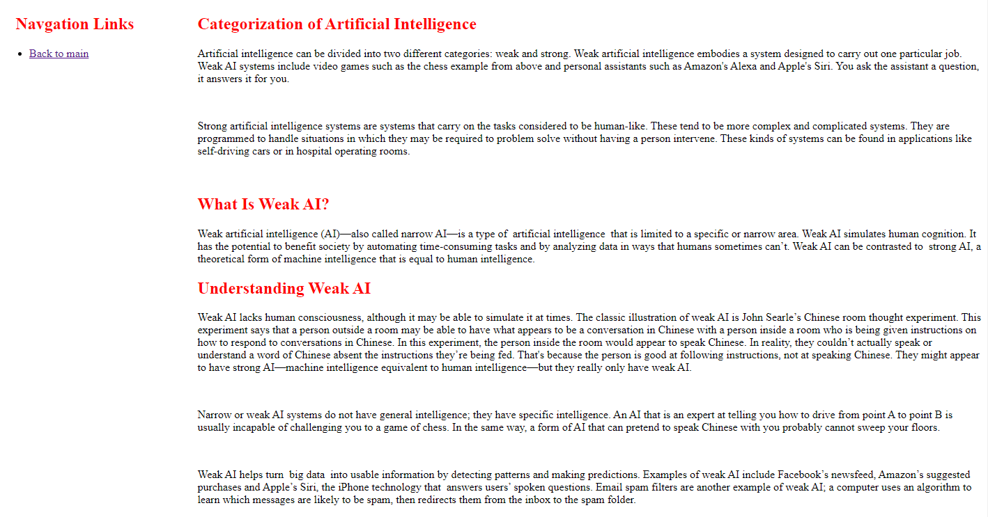

* Page 4 (Special Considerations):

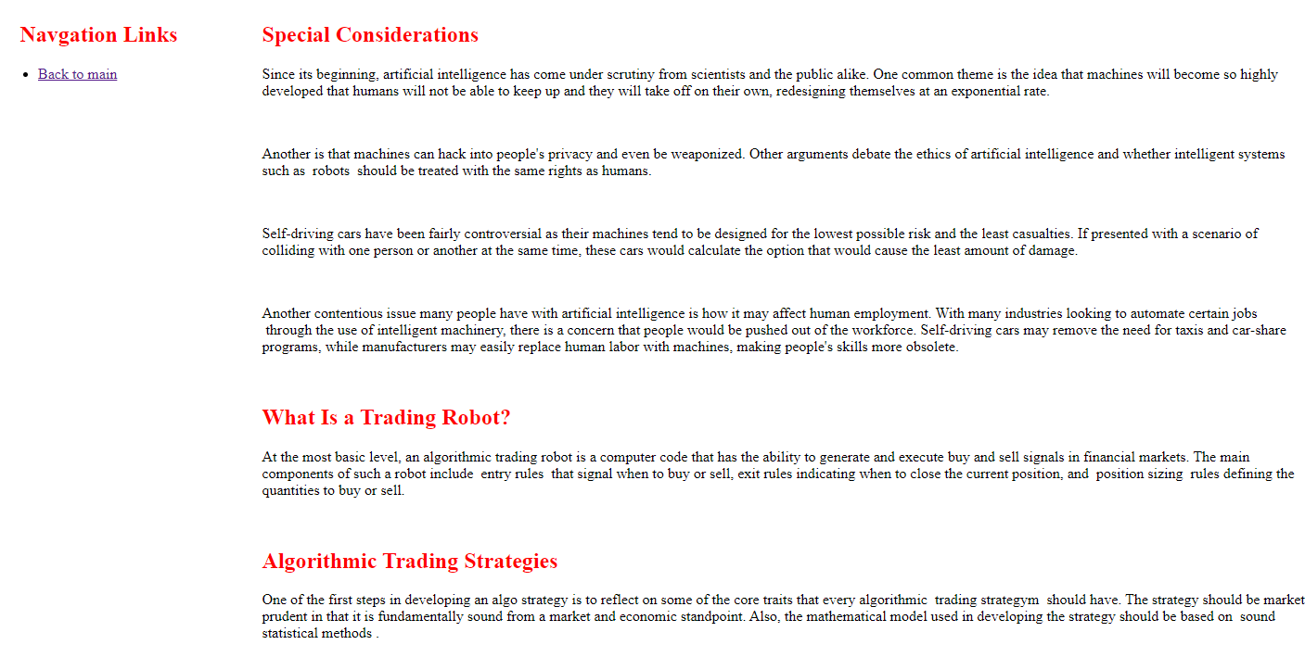

**Screen shoots of the source cood:**

* The main page:

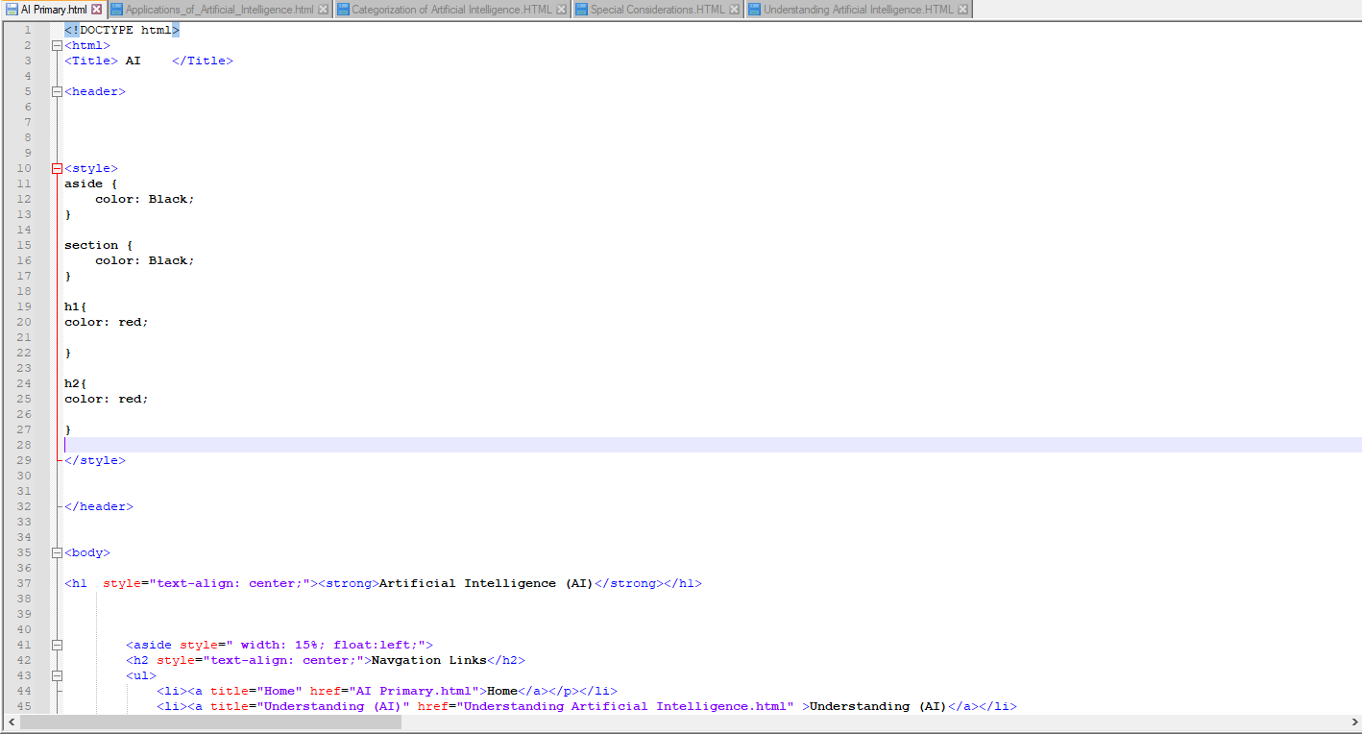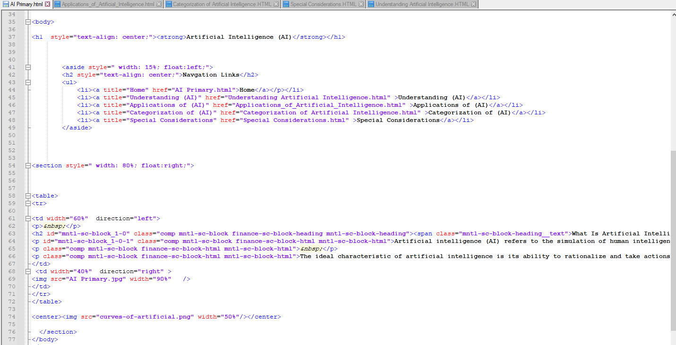

* Page(1):

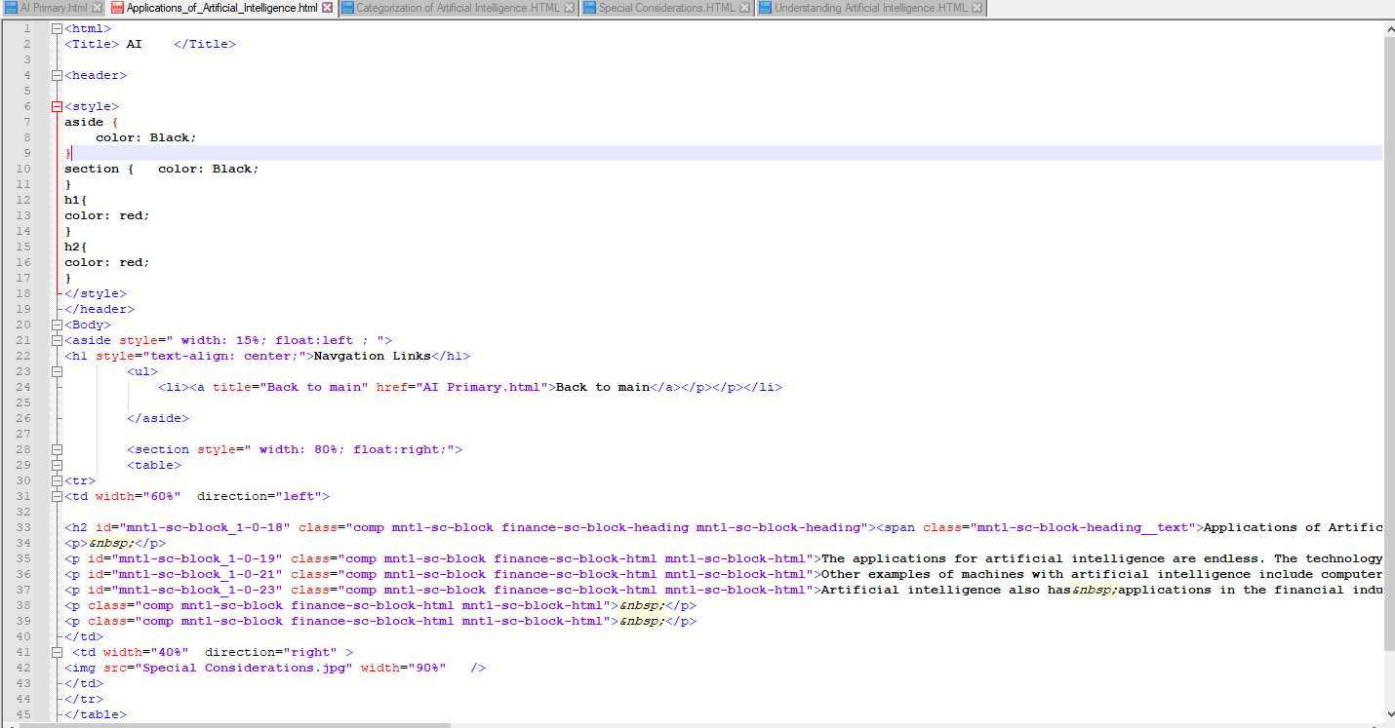

* Page(2):

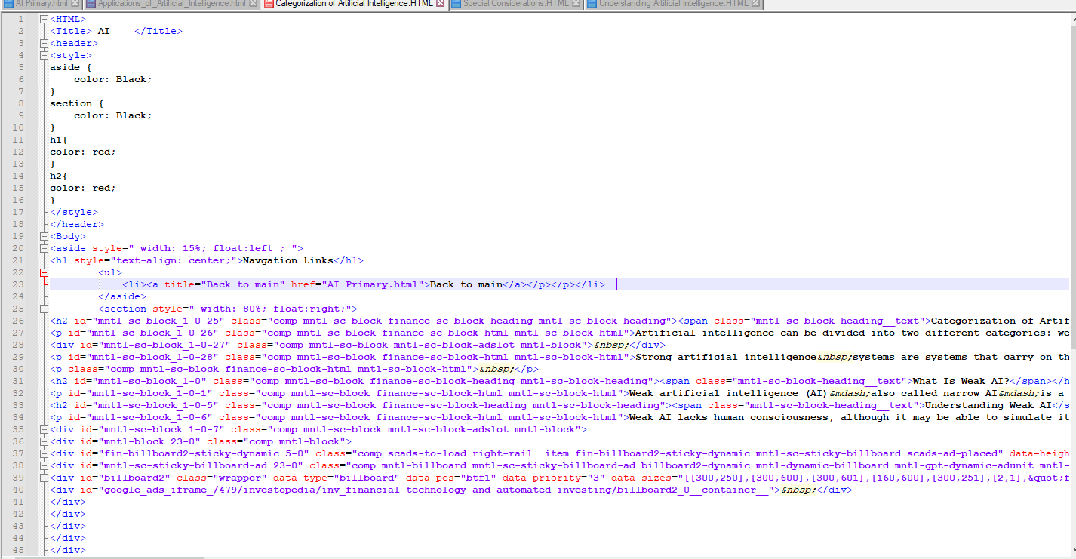

* Page(3):

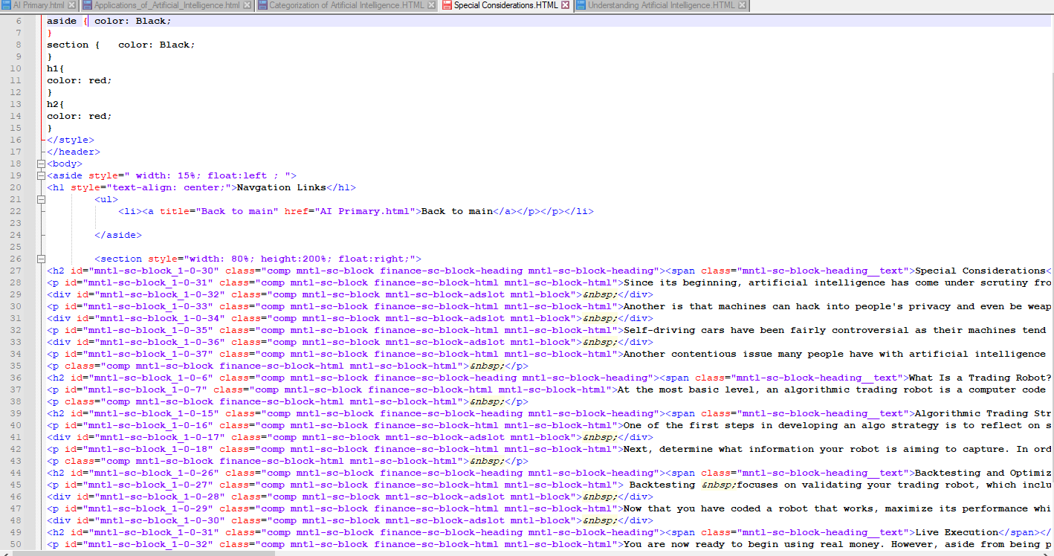

* Page(4):

