Automotive Door Control

Dynamic Design

# ECU-1 operation State Diagram

# ECU-1 Components State Diagram

# ECU-1 Sequence Diagram

# ECU-1 CPU Load[1]*

|  |  |  |  |
| --- | --- | --- | --- |
| SWC | Periodicity | Burst | CPU Load |
| Reading and Sending Door State | 10ms | 1ms | 10 % |
| Reading and Sending Switch State | 20ms | 1ms | 5 % |
| Reading and Sending Car Speed | 5ms | 2ms | 40 % |

CPU Load = Load-1 + Load-2 + Load-3 = 10 % + 5 % + 40 % = 55 %

# ECU-2 operation State Diagram

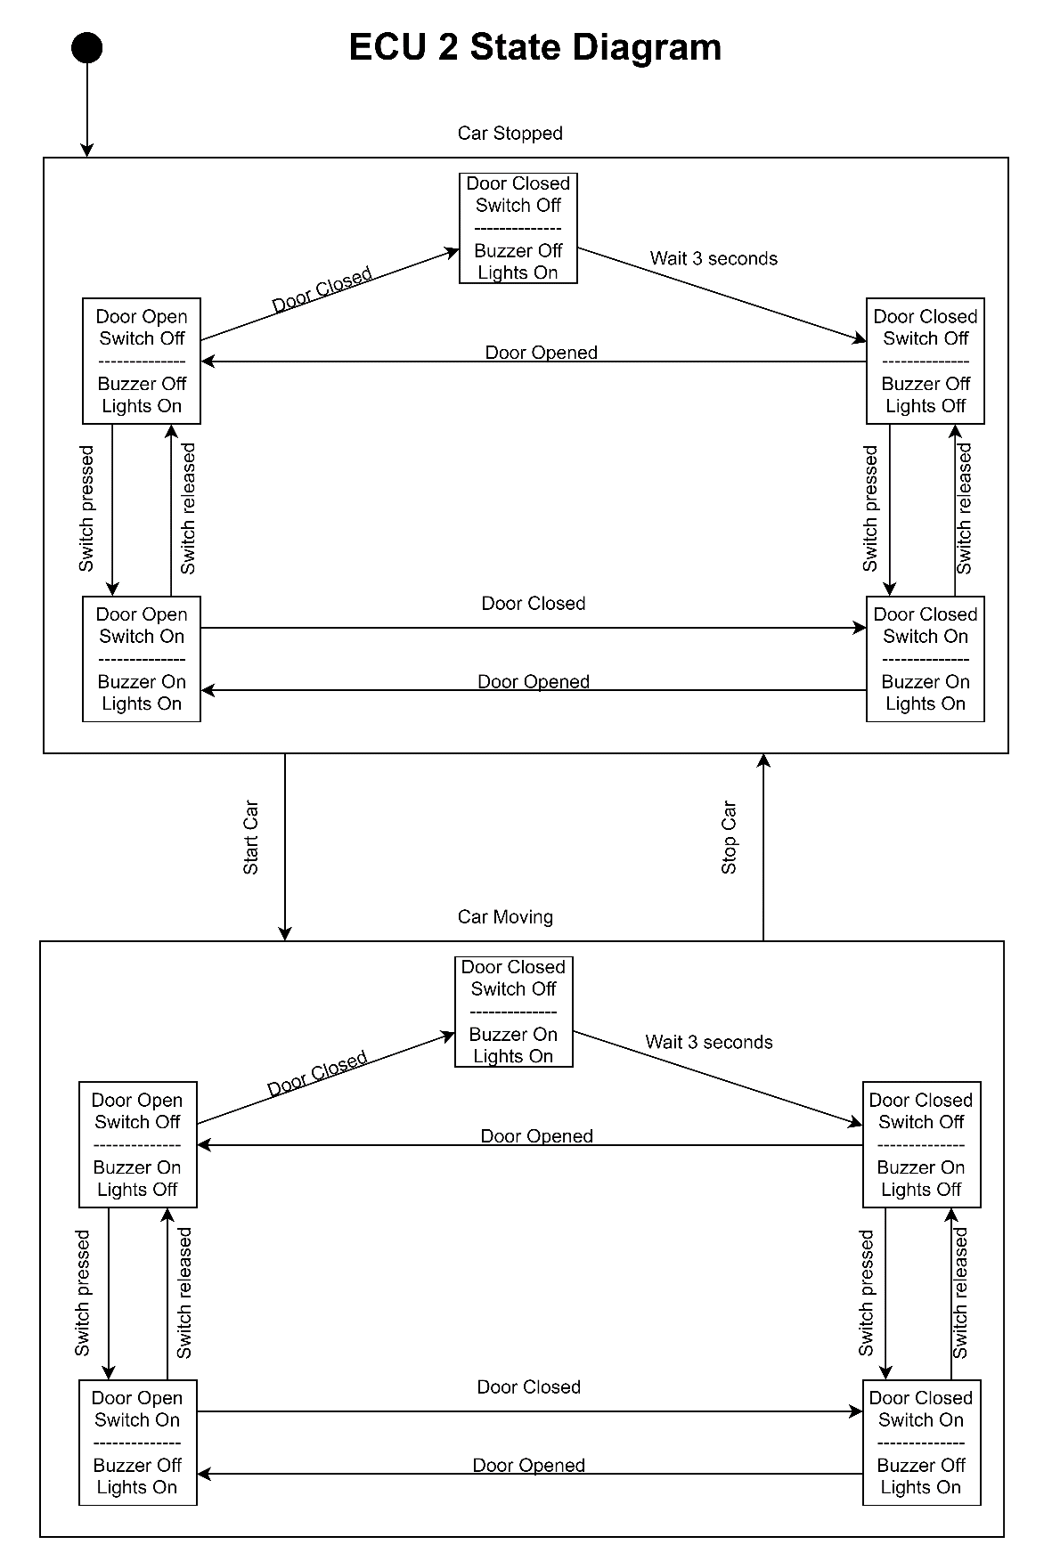

# ECU-2 Components State Diagram

# ECU-2 Sequence Diagram

# ECU-2 CPU Load[2]*

|  |  |  |  |
| --- | --- | --- | --- |
| SWC | Periodicity | Burst | CPU Load |
| Updating Left Light State | 10ms | 1ms | 10 % |
| Updating Right Light State | 10ms | 1ms | 10 % |
| Updating Buzzer State | 10ms | 2ms | 20 % |

CPU Load = Load-1 + Load-2 + Load-3 = 10 % + 10 % + 20 % = 40 %

1. * All Periodicity and Burst values are assumed to show the proof of concept.
2. * All Periodicity and Burst values are assumed to show the Proof of Concept