Automotive Door Control

Static Design

# System Components

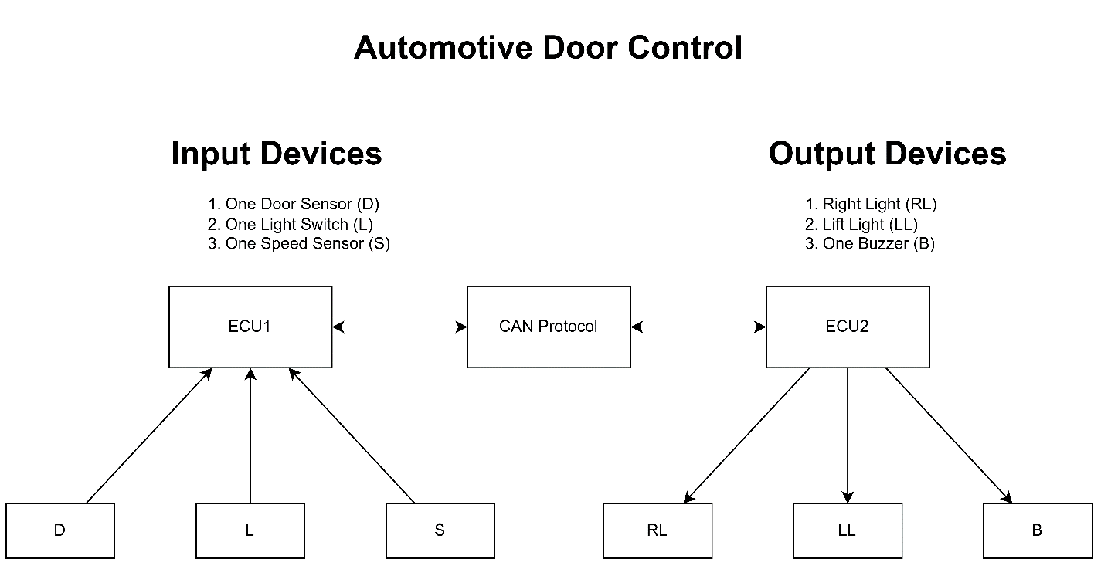

# ECU-1 Layered Architecture

# ECU-1 Components and Modules

## MCAL

* Port Driver
* DIO Driver
* EXTI Driver
* Timer Driver
* CAN Driver

## HAL

* Door Sensor Driver
* Light Switch Driver
* Speed Sensor Driver

# ECU-2 Layered Architecture

# ECU-2 Components and Modules

## MCAL Layer

* Port Driver
* DIO Driver
* EXTI Driver
* CAN Driver
* Timer Driver

## HAL Layer

* Buzzer Driver
* Lift Light Driver
* Right Light Driver