CSE211 Web Programming, Fall Semester 24/25

Assignment #1: Websites conceptual Design and mock-up

Mohmed **2.3.1Part 1:resarch**

**1.Defining Characteristics of Web 2.0 to Web 4.0**

* **Web 2.0**: Known as the "Social Web," this phase focuses on user-generated content, interactivity, and social networking. Key features include blogs, social media platforms, and content sharing.
* **Web 3.0**: Known as the "Semantic Web," Web 3.0 aims to provide a more personalized browsing experience using AI and machine learning to interpret data more contextually. It focuses on data integration, meaning, and AI-driven insights.
* **Web 4.0**: Often referred to as the "Intelligent Web," this phase emphasizes a seamless integration between humans and machines. It includes the Internet of Things (IoT), automation, and smarter AI capabilities, leading to highly personalized interactions.

**2. Key Features of Web 2.0 and How It Empowers Networks**

* **Features**: User-generated content, social networking, tagging, and community collaboration.
* **Empowerment**: By allowing users to create, share, and interact with content, Web 2.0 transformed the web from a one-way information channel into a two-way interactive platform. It enabled individuals and businesses to connect and build communities around shared interests.

**3. Key Features of Web 3.0 and How It Empowers Data and Knowledge Connections**

* **Features**: Semantic search, personalization, machine learning, and data-driven insights.
* **Empowerment**: Web 3.0 enables the web to understand and interpret user data in a way that leads to more relevant results and recommendations. This approach enhances knowledge connections by creating a more meaningful interaction between users and content.

**4. Key Features of Web 4.0 and How It Empowers Intelligence Connections**

* **Features**: Integration of AI, IoT, automation, real-time communication, and virtual assistants.
* **Empowerment**: Web 4.0 creates an intelligent ecosystem where devices and systems can communicate seamlessly, allowing for real-time responses and actions. It empowers "intelligence connections," making interactions more intuitive and tailored to individual needs.

**5. Importance of Collective Intelligence, Social Networking, Social Media, and Social Bookmarking**

* **Collective Intelligence**: The combined knowledge and insights from a large number of users help create more accurate information and innovative ideas.
* **Social Networking**: Enables users to connect, share, and collaborate on a massive scale, fostering communities and professional networks.
* **Social Media**: Platforms where people can share content and ideas, contributing to a diverse, global conversation.
* **Social Bookmarking**: Allows users to save and organize content, making it easier to access resources and share valuable information with others. All of these elements contribute to creating a more connected and knowledge-driven web environment.

**6. How These Technologies Empower Current and Future Business Plans**

* **Current Business**: The technologies in Web 2.0 to Web 4.0 allow businesses to interact with customers more effectively, personalize user experiences, and use data-driven insights to improve decision-making.
* **Future Business**: Future businesses will benefit from even more automated, intelligent processes and deeper insights into consumer behavior. This can lead to more innovative business models and increased efficiency in meeting customer needs.

**7. How You Intend to Use the Latest Technologies in Your Profession**

* Describe how advancements in the web (such as AI, IoT, or big data) could be applied to your field. For example, if you’re in marketing, you might use Web 3.0 and Web 4.0 technologies for personalized advertising and real-time customer engagement. If you’re in healthcare, you might discuss the role of IoT and AI in improving patient care and managing health data.

**• Define the purpose of your intended website:**

* **The purpose of the "Learning Hub" website is to provide a comprehensive online resource for students, teachers, and lifelong learners. It will offer educational materials, courses, and interactive tools to enhance learning and facilitate knowledge sharing.**

**• What would you like the website to accomplish?**

* **The website aims to:**
  + **Offer a range of educational resources, including articles, videos, and interactive tools.**
  + **Facilitate online courses and workshops.**
  + **Provide information about events, promotions, and educational initiatives.**
  + **Foster a community of learners and educators.**

**• Who is your intended audience?**

* **The intended audience includes:**
  + **Students of all ages seeking supplemental learning materials.**
  + **Educators looking for teaching resources and professional development.**
  + **Parents interested in educational tools for their children.**
  + **Lifelong learners pursuing personal or professional development.**

**• What opportunities, problems, or issues does your planned website address?**

* **Opportunities include:**
  + **Reaching a wider audience through online educational content.**
  + **Increasing engagement through interactive learning tools.**
  + **Building a community of learners and educators.**
* **Problems addressed:**
  + **Difficulty accessing quality educational resources.**
  + **Lack of opportunities for professional development for educators.**
  + **Limited platforms for connecting learners and educators.**

**• What kind of content could be incorporated on your website?**

* **The website could include:**
  + **A library of articles, videos, and tutorials on various subjects.**
  + **An online course platform with interactive modules and assessments.**
  + **A blog featuring tips for students and educators, along with educational trends.**
  + **User-generated content like testimonials and success stories.**
  + **Information on workshops, webinars, and community events.**

**• How will the site serve the client?**

* **The site will serve clients by:**
  + **Providing easy navigation to access resources and courses.**
  + **Offering support and guidance through FAQs and contact options.**
  + **Allowing users to sign up for newsletters to stay informed about new content and events.**

**• What's the best method for the user to do what's wanted?**

* **The best method for users to engage with the site includes:**
  + **A clear navigation menu for easy access to resources, courses, and community forums.**
  + **Prominent call-to-action buttons for enrolling in courses and signing up for newsletters.**
  + **A search function to quickly find specific topics or materials.**

**• How will users find the function?**

* **Users will find functions through:**
  + **An intuitive layout that highlights key features (courses, resources, community).**
  + **SEO-optimized content to improve visibility in search engines.**
  + **Social media promotion and partnerships with educational institutions.**

**• How will the results of the function be received?**

* **Results from functions on the website, such as course enrollments and inquiries, will be received through:**
  + **Email notifications sent to both the user and the education team for each course enrollment.**
  + **On-screen confirmation messages displayed after actions like course registration.**
  + **User dashboards to track course progress and access materials.**

**• What will the receiver do with the received entries?**

* **The receiver (education team) will:**
  + **Review enrollments to prepare course materials and communicate with participants.**
  + **Respond to user inquiries and feedback received through contact forms or emails.**
  + **Maintain a database of users for analytics and marketing purposes.**

**• How will the receiver deal with results?**

* **The education team will deal with results by:**
  + **Organizing course materials and scheduling classes or webinars.**
  + **Communicating with users about course details and resources.**
  + **Analyzing user feedback to improve offerings and user experience.**

**• What follow-up will be needed?**

* **Follow-up activities may include:**
  + **Sending thank-you emails to users after course completion and inviting feedback.**
  + **Offering special promotions or discounts on future courses.**
  + **Conducting surveys to assess user satisfaction and gather suggestions for improvement.**

**• List at least two related or similar sites found on the Web. Explain why you chose them.**

* **Khan Academy**
  + **Reason for selection: Khan Academy provides free educational resources on a wide range of subjects. Its user-friendly design, extensive library of videos, and interactive exercises serve as a great reference for creating engaging educational content and a supportive learning community.**
* **Coursera**
  + **Reason for selection: Coursera partners with universities to offer online courses. Its structured approach to learning, user feedback systems, and emphasis on community engagement can provide valuable insights into effective course design and student interaction.**

**14. Planning Analysis Sheet**

**a. Website Goal**

The goal of the "Learning Hub" website is to create a comprehensive online platform that provides educational resources, facilitates online learning, and fosters a community of students and educators through engagement, collaboration, and knowledge sharing.

**b. Working Title of Pages**

* About Us
* Our Resources
* Online Courses
* Special Promotions
* Events & Workshops
* Blog
* Student Testimonials
* Contact Us
* FAQs
* Community Gallery

**c. Description of Contents for Each Page**

**Homepage**

* **Content:** A brief introduction to the Learning Hub, highlighting the mission and vision. Featured resources and courses with promotional banners for upcoming events. Includes engaging visuals, a welcome video, and prominent call-to-action buttons for course enrollment and newsletter sign-up.

**About Us**

* **Content:** The history and mission of the Learning Hub. Includes background on the team, educational philosophy, and values. Accompanied by images and a short video that shares the story behind the website.

**Our Resources**

* **Content:** Detailed listings of all educational materials available (articles, videos, tools), categorized by subject area. Each resource includes descriptions, tags for easy navigation, and user ratings.

**Online Courses**

* **Content:** A catalog of available online courses with descriptions, objectives, and pricing. Users can filter by subject, skill level, or format (e.g., video, text). Each course page includes a syllabus and a registration option.

**Special Promotions**

* **Content:** Information on discounts, seasonal promotions, and special offers for courses. Engaging visuals and text highlighting current deals, with a subscription option for alerts on future promotions.

**Events & Workshops**

* **Content:** Details about upcoming workshops, webinars, and events, including registration links. Images from past events and testimonials to showcase the community aspect of learning.

**Blog**

* **Content:** Regularly updated posts featuring educational tips, resources, success stories, and news about the Learning Hub. Posts may include images, videos, and downloadable resources.

**Student Testimonials**

* **Content:** A collection of quotes and reviews from students and educators about their experiences. Includes photos and a submission form for new testimonials to encourage community engagement.

**Contact Us**

* **Content:** A contact form for inquiries, location map (if applicable), hours of operation, and links to social media profiles. Includes a section for submitting FAQs.

**FAQs**

* **Content:** A list of frequently asked questions regarding courses, resources, and policies, with concise answers. Users can submit additional questions through a form for further assistance.

**Community Gallery**

* **Content:** A visually rich gallery showcasing images from events, student projects, and community engagement. Users can upload their own photos featuring their learning experiences with the Learning Hub.

**d. User Forms for Information Collection**

1. **Course Enrollment Form:**
   * **Users can select courses they wish to enroll in, specify any prerequisites, and enter their contact information for registration.**
2. **Newsletter Subscription Form:**
   * **Collects email addresses and names for users to subscribe to updates about new resources, courses, and events.**
3. **Contact Form:**
   * **Allows users to send inquiries or comments directly to the Learning Hub. It will include fields for name, email, subject, and message.**
4. **Student Testimonial Submission Form:**
   * **A form where students can submit their reviews or testimonials about courses and resources, including their name and optional photo.**
5. **Event Registration Form:**
   * **Collects information for users to register for workshops or events, including name, email, and the specific event they wish to attend.**
6. **Feedback and Suggestions Form:**
   * **Allows users to provide feedback on courses, resources, and the website itself, helping to improve the overall user experience.**
7. **Community Contribution Form:**
   * **A form for users to submit their own educational resources, articles, or project images to be featured in the Community Gallery.**

e. Flowchart (Storyboard/Website Organization)

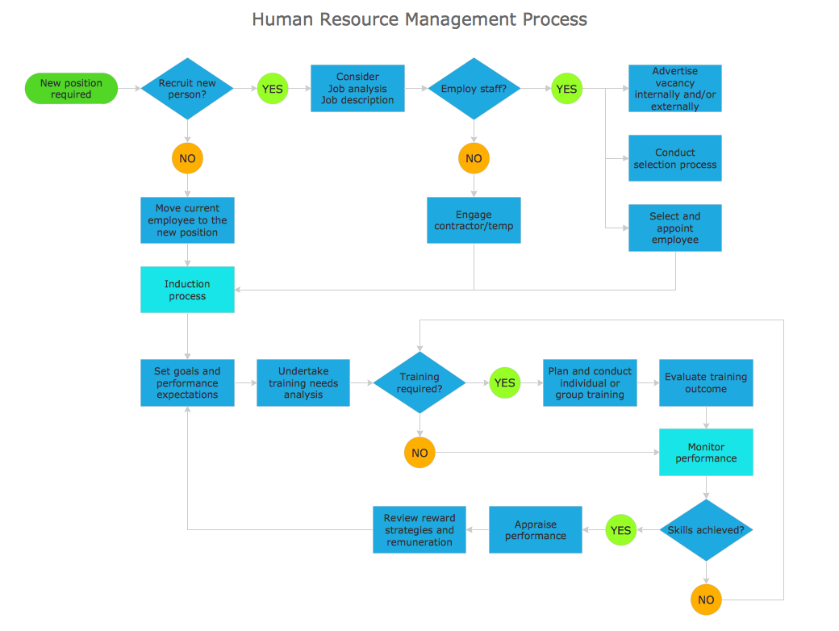

**f. Create a wireframe for each page of your website using any computer tool. Make sure the logo, navigation, content, and footer regions are apparent. Save the produced wireframes as jpg or gif files**

**Gestalt Web Design Principles Implementation for a Learning Website**

1. **Law of PRAGNANZ (Good Figure, Law of Simplicity)**
   * **Implementation: The website will feature a clean, uncluttered design that highlights essential elements. Each page will focus on delivering information in a straightforward manner, using clear typography and engaging visuals.**
   * **Example: On the Courses page, each course will be presented with a simple, high-quality image and a brief description, allowing users to quickly grasp the course content without distractions.**
2. **Closure (Linking Individual Elements to Form a Pattern)**
   * **Implementation: Course cards, testimonials, and articles will be organized in a grid layout to create a sense of unity, even though they are distinct items.**
   * **Example: On the Blog page, articles will be displayed in a grid format, allowing users to see them as a cohesive collection of resources.**
3. **Symmetry and Order (Effectively Communicate Information Quickly)**
   * **Implementation: Each page will employ balanced layouts and consistent navigation to enhance information clarity, enabling users to easily locate content.**
   * **Example: On the Homepage, a balanced three-column layout will separate featured courses, upcoming webinars, and popular articles, allowing for quick navigation.**
4. **Figure/Ground (Relationship Between Positive Elements and Negative Space)**
   * **Implementation: Generous white space will be incorporated around images and text to clearly distinguish key elements and improve readability.**
   * **Example: On the Sign-Up page, the registration form will be surrounded by ample white space, making it the focal point of the page.**
5. **Uniform Connectedness (Relationship Between Elements)**
   * **Implementation: Interactive elements like buttons and links will have a consistent design across the site.**
   * **Example: Across all pages, buttons such as “Enroll Now” and “Learn More” will share the same color and style, helping users quickly recognize actionable items.**
6. **Common Region (Connection Between Elements)**
   * **Implementation: Related content will be grouped within visual boundaries, such as boxes or color backgrounds, to indicate relationships.**
   * **Example: On the Courses page, different subject areas will be visually grouped with background colors, making it easier for users to navigate related topics.**
7. **Proximity (Utilizing Empty Space to Create Relationships)**
   * **Implementation: Related elements will be positioned closely together, while unrelated sections will have adequate space between them to help users navigate.**
   * **Example: On the Resources page, related articles will be grouped together, with space separating different categories, facilitating easier scanning.**
8. **Continuation (Continuous Perception of Shapes)**
   * **Implementation: The layout will use lines and visual flow to guide users naturally through content as they scroll.**
   * **Example: A continuous scrolling effect on the Homepage will take users from an introductory message through featured courses and resources, enhancing user engagement.**
9. **Common Fate (Synchrony: Items Moving or Changing Together are Perceived as Related)**
   * **Implementation: Elements that share functionality will exhibit simultaneous interactions.**
   * **Example: On the Webinars page, all upcoming webinar listings will highlight when hovered over, signaling to users that these items are interactive.**
10. **Parallelism (Parallel Elements are Seen as More Related)**
    * **Implementation: Aligned elements will be used to indicate relationships between items or sections.**
    * **Example: On the Events page, two parallel columns will display event details and registration options, reinforcing the connection between them.**
11. **Similarity (Elements with Similar Characteristics are More Related)**
    * **Implementation: Consistent design elements, such as colors, shapes, and fonts, will indicate related items across the website.**
    * **Example: Action buttons like “Start Learning,” “Subscribe,” and “Download” will have similar designs, helping users identify actionable elements quickly.**
12. **Past Experience (Utilizing Observer’s Past Experience)**
    * **Implementation: Familiar web elements, such as icons and standard navigation patterns, will be used to meet user expectations and facilitate ease of use.**
    * **Example: On the Contact Us page, recognizable icons (e.g., an envelope for email, a phone for contact) will be used to ensure users understand the functions instantly, similar to common e-commerce sites.**

### Gestalt Web Design Principles Implementation for a Learning Website

### Law of PRAGNANZ (Good Figure, Law of Simplicity)

### Implementation: Each page will feature a clean design with essential elements only, ensuring clarity and minimal distractions.

### Example: On the Courses page, each course will have a high-quality image and a concise description, allowing users to quickly understand offerings.

### Closure (Linking Individual Elements to Form a Pattern)

### Implementation: Course cards, testimonials, and articles will be organized in a grid layout for a cohesive visual experience.

### Example: The Blog page will display articles in a grid format, encouraging users to see them as a unified collection of resources.

### Symmetry and Order (Effectively Communicate Information Quickly)

### Implementation: Balanced layouts with consistent navigation will be used across all pages.

### Example: The Homepage will utilize a three-column layout to separate featured courses, news, and resources, facilitating quick navigation.

### Figure/Ground (Relationship Between Positive Elements and Negative Space)

### Implementation: Ample white space around text and images will enhance readability.

### Example: On the Sign-Up page, the registration form will be distinctly set apart from other content.

### Uniform Connectedness (Relationship Between Elements)

### Implementation: Buttons and links will have a consistent style to reinforce their interactive nature.

### Example: Buttons like “Enroll Now” and “More Info” will have a unified color scheme across all pages.

### Common Region (Connection Between Elements)

### Implementation: Related content will be visually grouped to indicate relationships.

### Example: Categories on the Courses page will be distinctly colored to indicate related subject matter.

### Proximity (Utilizing Empty Space to Create Relationships)

### Implementation: Related elements will be placed closely together, with sufficient spacing between unrelated sections.

### Example: On the Resources page, articles will be grouped by category, clearly delineating different topics.

### Continuation (Continuous Perception of Shapes)

### Implementation: The design will utilize lines and layout flow to guide users naturally through content.

### Example: A smooth scrolling effect on the Homepage will guide users from introductory content to featured courses.

### Common Fate (Synchrony: Items Moving or Changing Together are Perceived as Related)

### Implementation: Elements that interact together will be visually connected.

### Example: On the Webinars page, all listings will highlight similarly when hovered over.

### Parallelism (Parallel Elements are Seen as More Related)

### Implementation: Aligned elements will visually connect related content.

### Example: Event details and registration options will be presented in parallel columns.

### Similarity (Elements with Similar Characteristics are More Related)

### Implementation: Consistent design styles will be used throughout the site.

### Example: Action buttons will maintain similar shapes and colors to facilitate recognition.

### Past Experience (Utilizing Observer’s Past Experience)

### Implementation: Familiar web patterns and icons will be used for intuitive navigation.

### Example: Familiar icons for contact methods will be used on the Contact Us page.

### Additional Elements for Accessibility and Development

### Minimum Contrast for Accessibility

### Implementation: The site will adhere to WCAG standards with a minimum contrast ratio of 4.5:1 for text and background colors.

### Example: The color palette will be evaluated using Contrast Checker tools to ensure readability.

### Front-End Development Technologies

### Technologies: HTML5, CSS3, JavaScript, and frameworks like React.js or Vue.js for interactive user experiences.

### Frameworks: Bootstrap or Tailwind CSS for responsive layouts, enhancing the overall user interface.

### Content Management Systems (CMS)

### Choice: WordPress or Shopify, depending on eCommerce needs.

### Rationale: WordPress offers flexible customization, while Shopify is suited for advanced eCommerce features.

### Back-End Development Technologies

### Technologies: Node.js and Express for server-side logic, with MongoDB or MySQL for database management.

### Security: Use of HTTPS for secure data transmission and encryption for user information.

### Metrics for Measuring Website Performance

### Key Metrics:

### Page Load Speed: Measured using Google PageSpeed Insights.

### Bounce Rate: To assess user engagement.

### Conversion Rate: Particularly for online course enrollments.

### User Behavior Flow: To analyze navigation paths and optimize content layout.

### Accessibility Score: Assessed using tools like WAVE or Lighthouse.

### <!DOCTYPE html>

### <html lang="en">

### <head>

### <meta charset="UTF-8">

### <meta name="viewport" content="width=device-width, initial-scale=1.0">

### <title>Learning Platform - [Page Title]</title>

### <link rel="stylesheet" href="styles.css">

### </head>

### <body>

### <!-- Header Section -->

### <header>

### <nav>

### <a href="index.html">Home</a>

### <a href="about.html">About Us</a>

### <a href="courses.html">Courses</a>

### <a href="resources.html">Resources</a>

### <a href="contact.html">Contact Us</a>

### </nav>

### </header>

### <!-- Main Content Section -->

### <main>

### <section id="hero">

### <!-- Hero content specific to the page -->

### </section>

### <section id="content">

### <!-- Main content for each page, such as course listings, blog posts, etc. -->

### </section>

### </main>

### <!-- Footer Section -->

### <footer>

### <p>© Learning Platform - All Rights Reserved</p>

### <div>

### <a href="privacy.html">Privacy Policy</a>

### <a href="terms.html">Terms of Service</a>

### </div>

### </footer>

### </body>

### </html>