

**Faculty of engineering - Shoubra**

**Benha University**

# Research Article / Research Project / Literature Review

in fulfillment of the requirements of

|  |  |
| --- | --- |
| **Department** | **Electrical Engineering department** |
| **Division** | **Electronics and Communications** |
| **Academic Year** | **First year 2019/2020** |
| **Course name** | **Computer application (1)** |
| **Course code** | **ECE 124C** |

By:

|  |  |  |  |
| --- | --- | --- | --- |
|  | Name | Edu mail | B.N |
| 1 | Mohamed Nabil Mohamed | Mohamed180764@feng.bu.edu.eg | 141082 |

## Title: -

## Restaurants and food

**Approved by:**

|  |  |
| --- | --- |
| Examiners committee | Signature |
|  |  |
|  |  |
|  |  |

Topic: restaurants and food

Github link :

## Website contents:

the website consists of 5 pages 1-index.html 2-login.html 3-home.html 4-restaurants.html 5-profile.html

I used in it (HTML, CSS, JavaScript) also I used (Bootstrab) only on the navigation bar to make the site more convenient.

The navigation bar and the footer are constant in the 5 pages.

Next I am going to show each page of what it contains and photo of it and photo for a code of it.

1. Index.html :

This is the first page and its title is registration it consists of navigation bar and a form to register and the footer, and this is a photo from the page.

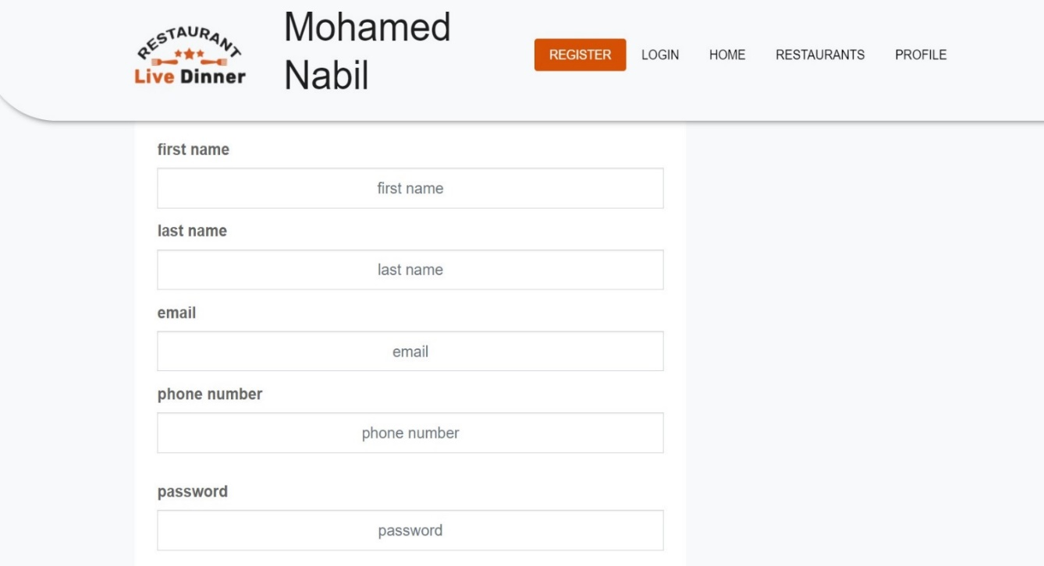

The navigation bar contain an image, a heading and a list of links refers to the other pages of website and this is the navigation bar code: 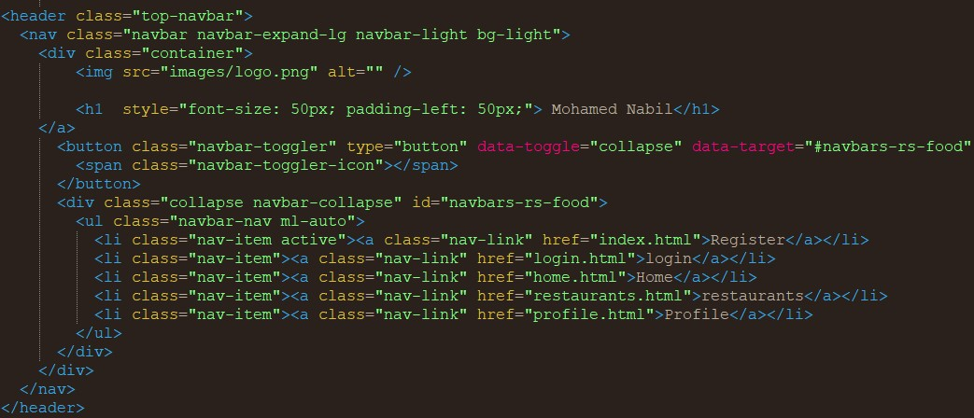

The form contain text of first and last name, email, telephone, address, radio of gender and password. The password must contain upper and lower letter and special character and at least one digit. And this is the password code:

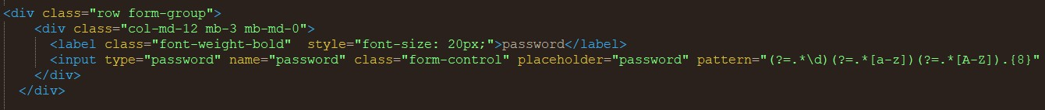

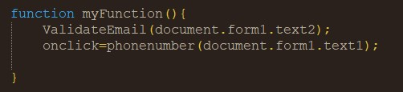I used the Javascript in email to check if it is in the right form and telephone to check if it is 11 digits and this is the code of javascript :

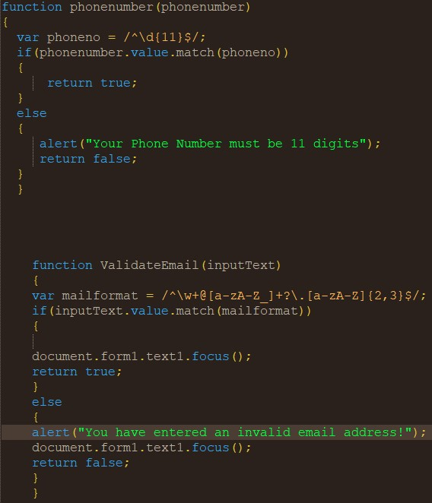

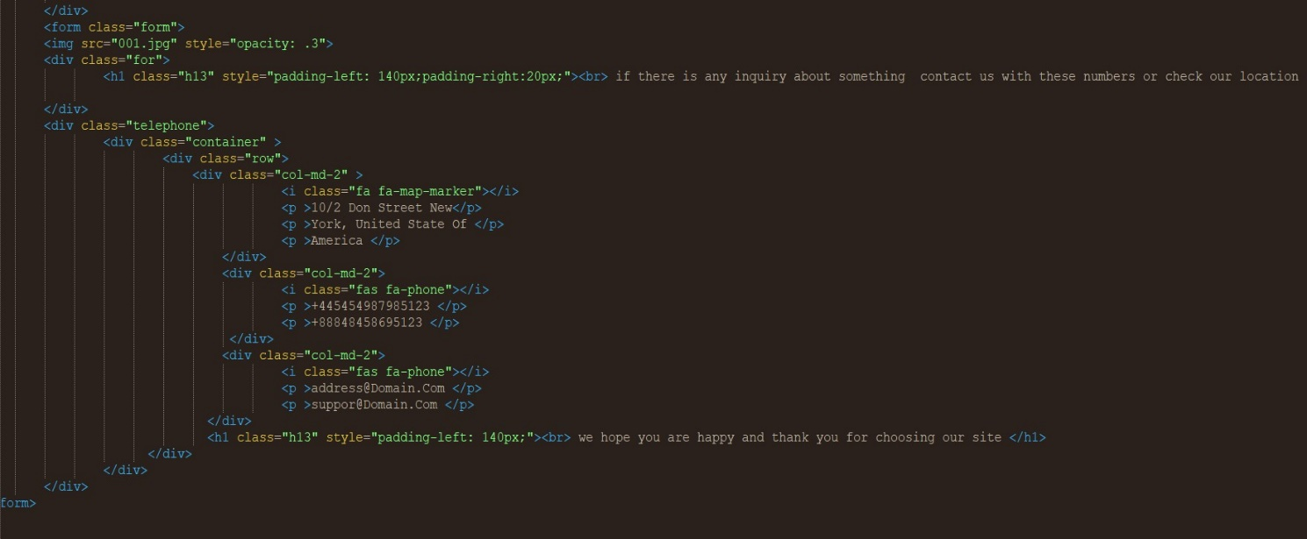The footer and it contains a photo of google map and paragraphs and an email input to subscribe And this is a photo for the footer code:

# 2-Login.html:

# This is the second page and its title is login it consists of navigation bar and a form to login and the footer, and this is a photo from the page.

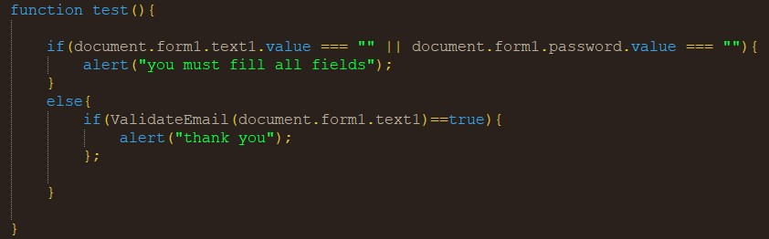i also used JS to check the fields and if the email in the right form or not and this is the code of the form and JS code:

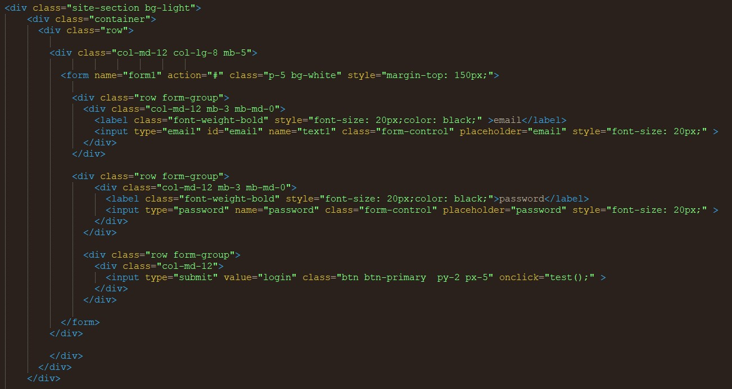

## 3-home.html:

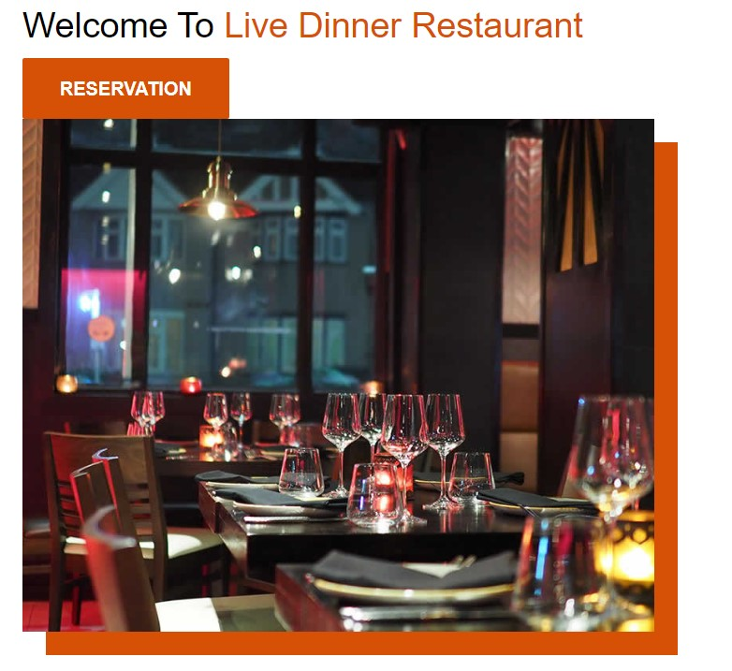**This is the third page and its title is home it consists of navigation bar, paragraphs, gallery of images each image is a link and the footer and this is a photo from the page.**

And this is the code of the gallery :

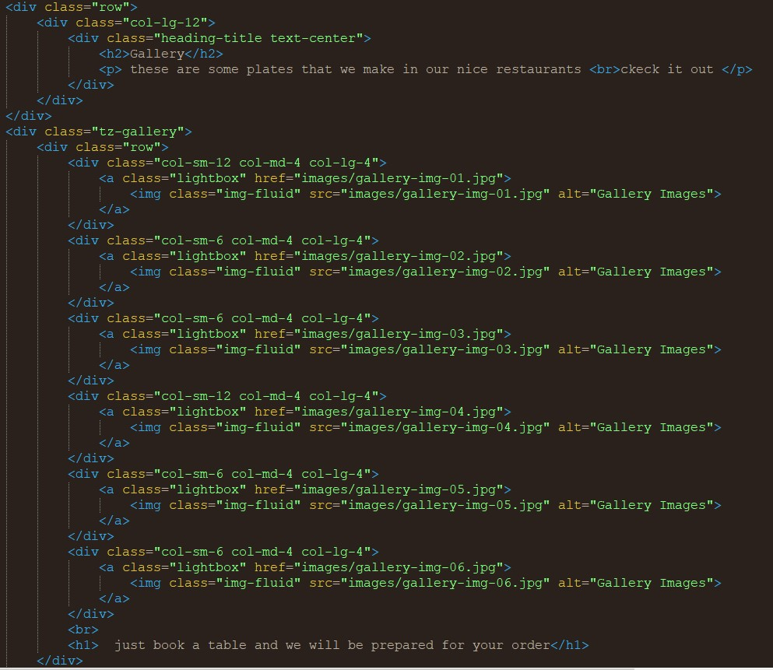

## 4-Restaurants.html:

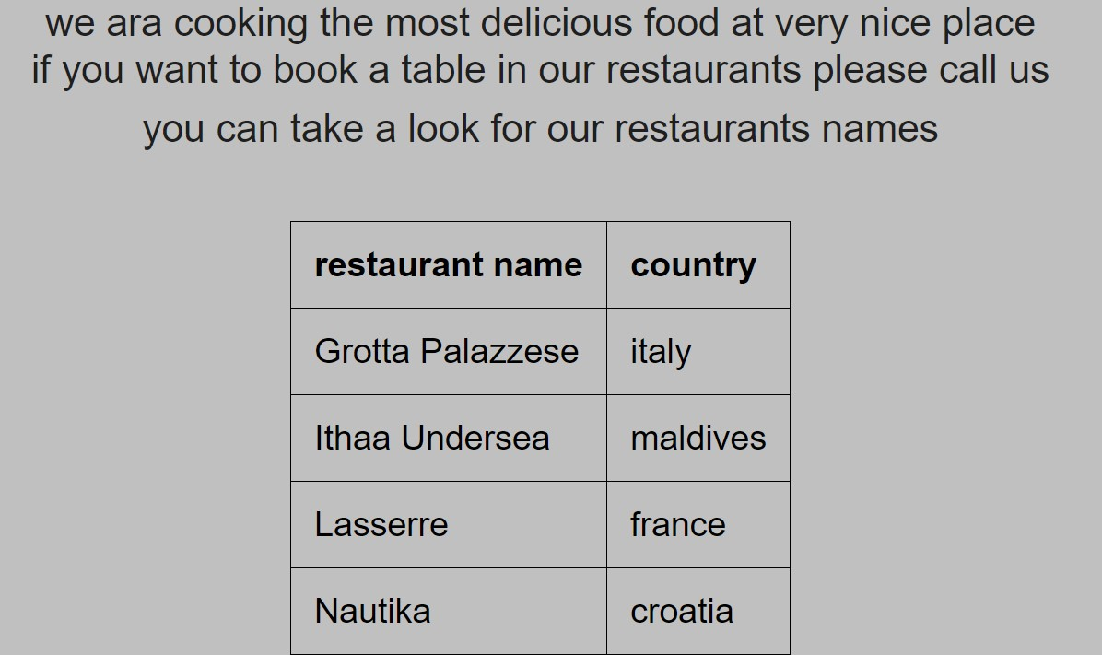This is the fourth page and its title is restaurants it contains navigation bar and paragraphs and a table of some restaurants name and the footer and this is a photo from the

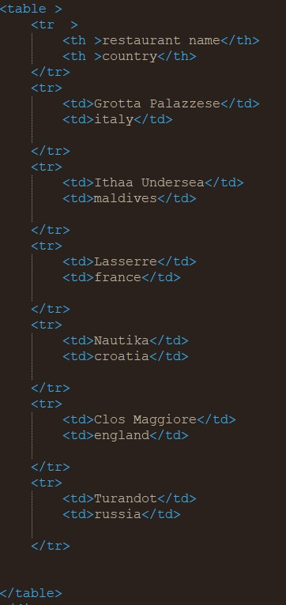And this is the code of the table :

5- profile.html :

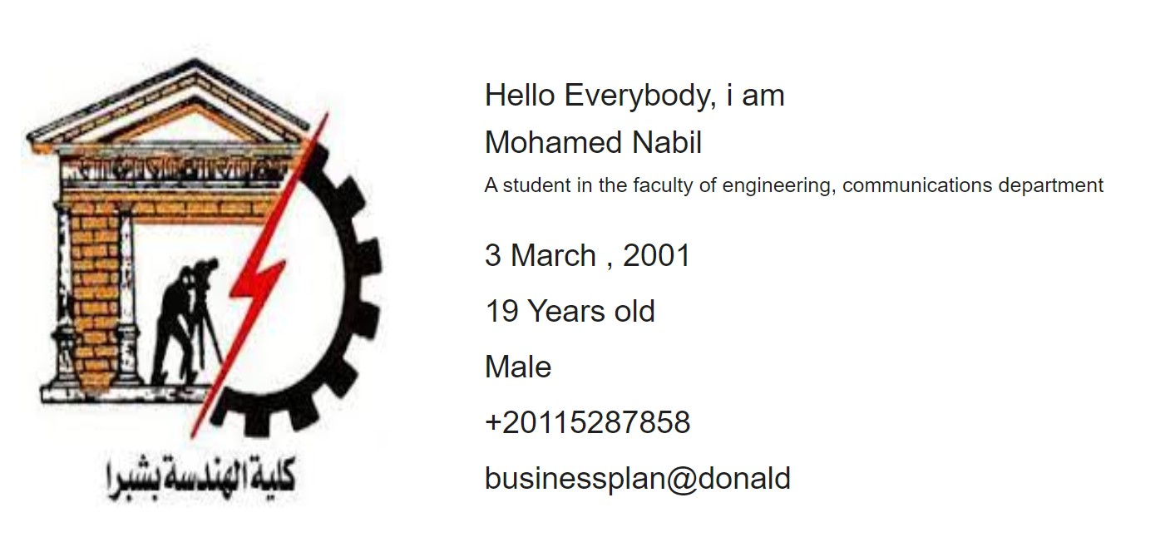This is the fifth page and its title is profile it is not a big page but I used in it a photo, the navigation bar, the footer, paragraphs and headings and this is a photo from the page.

And this is the profile code:

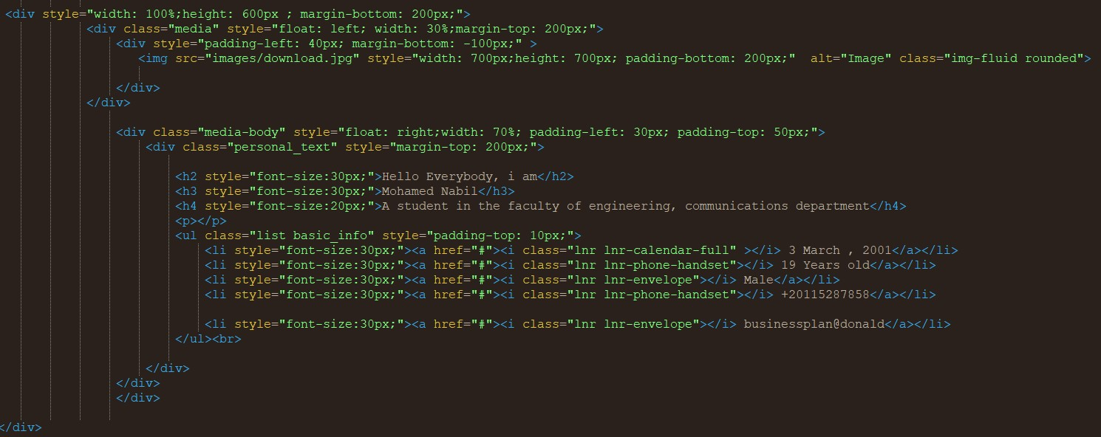

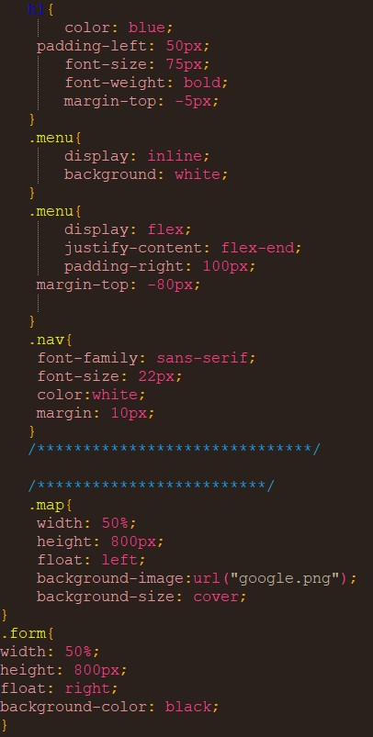Now this is screenshots for the CSS codes:

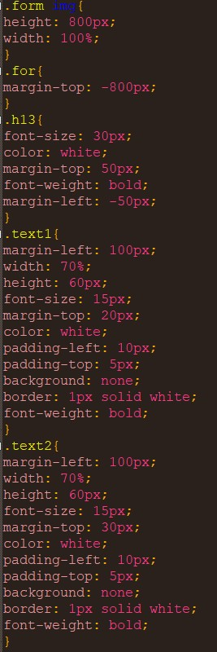

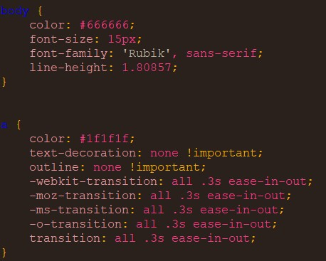

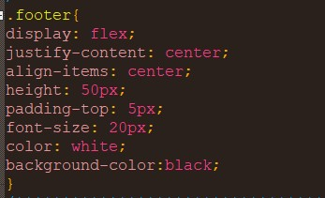

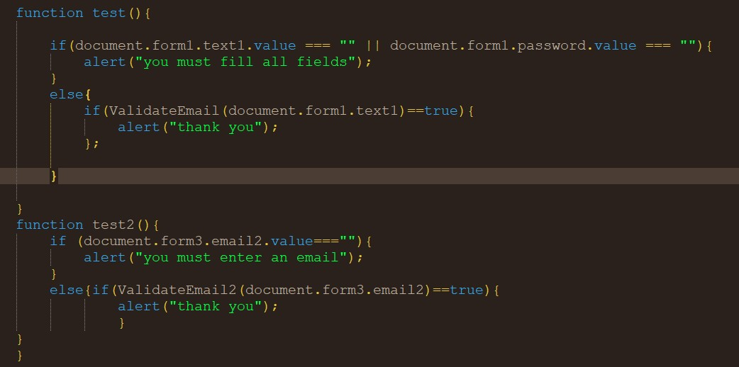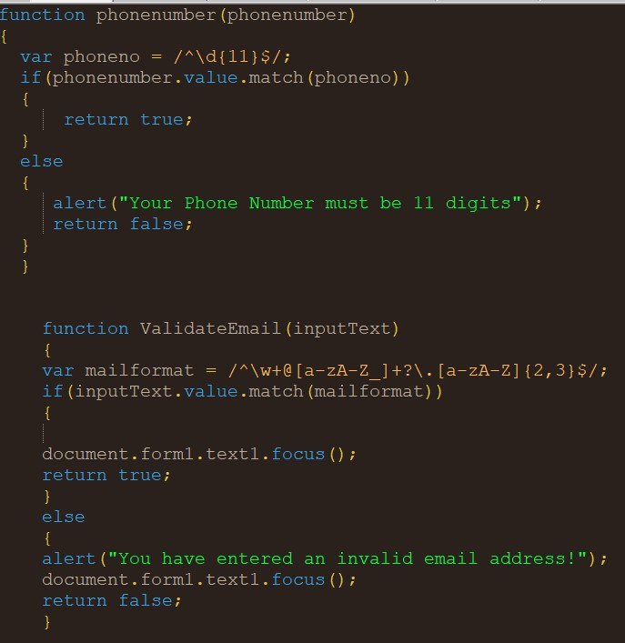And these are screenshots for javascript codes: