0

**1. Adversarial Search:**



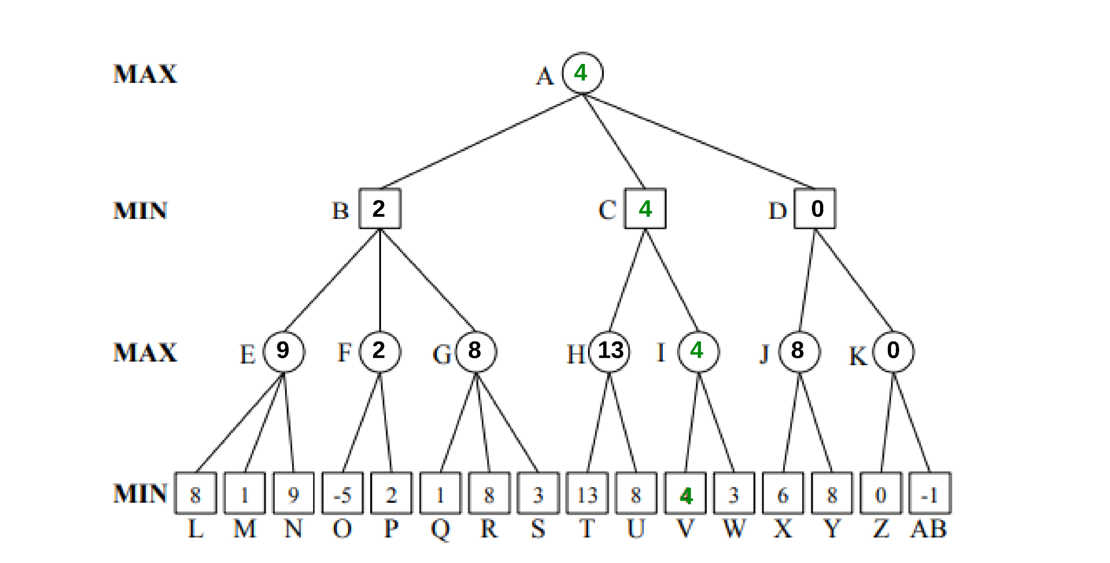

1. A-C-I-V

**2. Alpha-beta Pruning:**

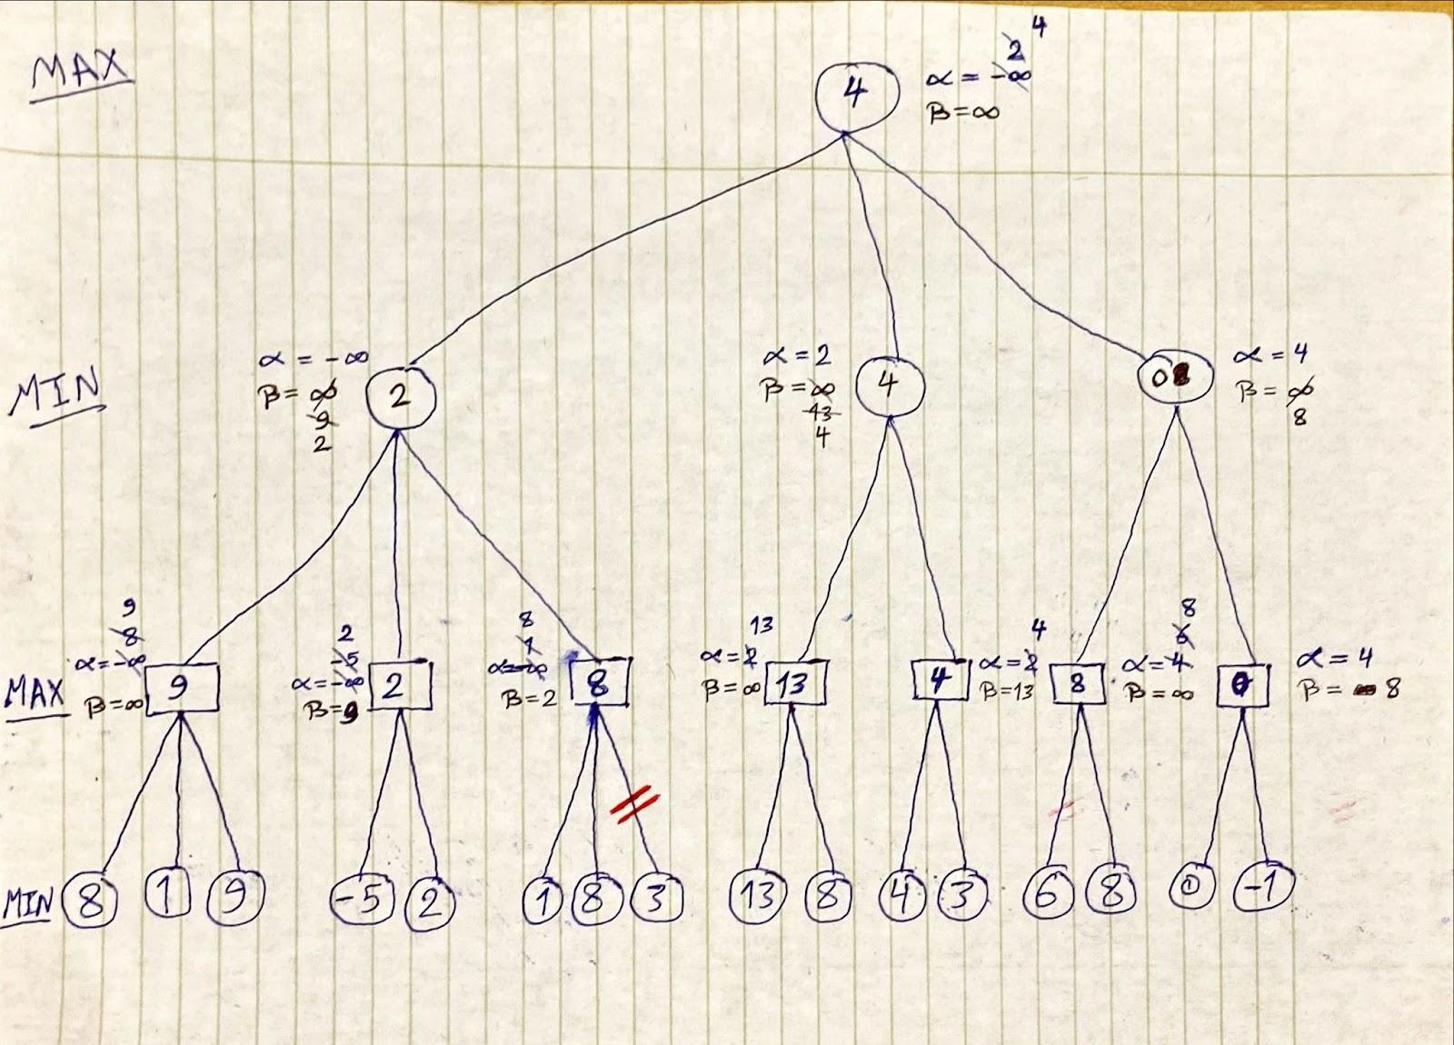

**3. Chapter 5, Exercise 8:**

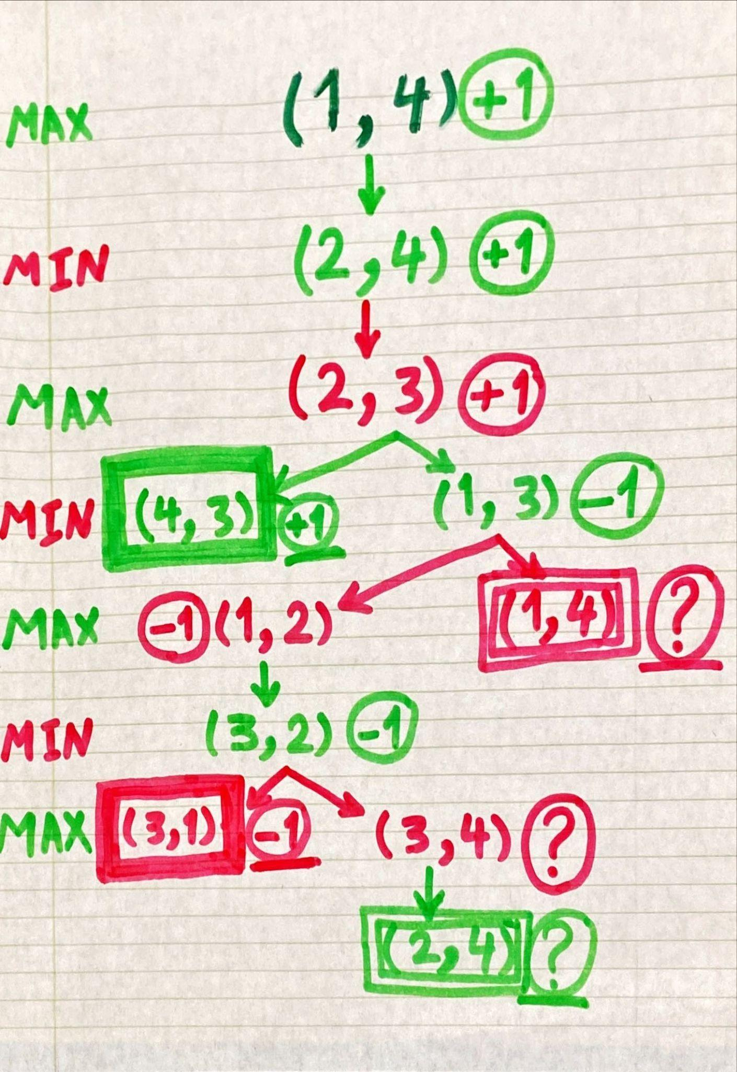

1. When player A has to choose between +1 and ?, he will choose +1. Similarly, When player B has to choose between -1 and ?, he will choose -1. Otherwise, if they have no choice rather than ?, they will choose it.
2. The issue is that the algorithm would run in an infinite loop. To fix this, we can use techniques like dynamic programming, heuristic functions, or depth-limited search. However, it might not guarantee optimal decisions for all games with loops.
3. **Base Cases:** When n = 3, B wins.

When n = 4, A wins.

**Inductive Hypothesis:** For n > 4, A and B get into a subgame of size n-2 from the locations 2 to n-1 after each round. So, if one of the players wins in the subgame of size n-2, this player wins the game of size n.

Assuming that players only move towards.

**Inductive Step:** After K rounds, A and B get into a subgame of size n-2k.

For n even, when n-2k = 4, A wins in the subgame of size 4. According to the inductive hypothesis, A wins in the game of size n.

Similarly, For n odd, when n-2k = 3, B wins in the subgame of size 3. According to the inductive hypothesis, B wins in the game of size n.