**THE REPORT**

**Architecture**

The model is a series of linear layers composed of different nodes to eventually output

8 digits (batch_size, output_size) and combine them into real date as the input is shape

of (batch_size, 10 - features).

Each layer is followed by a batch normalization, dropout and finally activation function.

(batch_size, 10) |=> **64** node

=> **128** node => **512** node => **1024** node => **512** node => **128** node

=> **64** node =>| (batch_size, 8)

The model is trained with nn.MSELoss function and nn.L1Loss function in different

experiments, but nn.MSELoss function seems giving better results. Here

we’ve used Adam optimizer along with momentum, adaptive learning rate and

L2 regularization some runs switched on / off interchangeably.

The model takes [ [day condition] [month condition] [leap year condition] [decade

condition] ] as inputs and outputs a predicted date then export them in 2 variant files

[‘output_file.txt’, ‘output_file_smote.txt’]. The 2 output files will be in the format as

[ [day condition] [month condition] [leap year condition] [decade condition] [date] ].

The prediction is 8 integer numbers each in range [0, 9]. Then convert them into date

format.

Input features: ['day_scaled', 'day_sin', 'day_cos', 'month_scaled', 'month_sin',

'month_cos', 'leap_year', 'decade_scaled', 'decade_sin', 'decade_cos'].

Target: [‘date_int’].

**Loss:**

Loss from Model:-

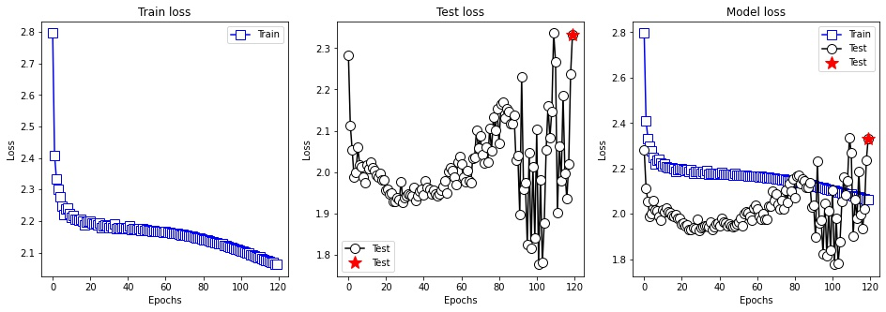

Loss from Model SMOTE:-

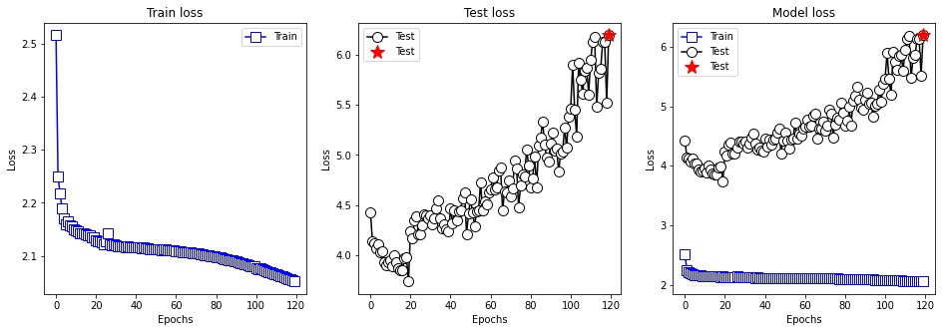

**Accuracy:**

Accuracy from Model:-

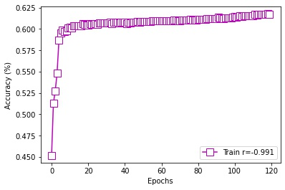

Accuracy from Model SMOTE:-

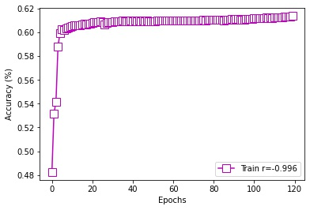

**EDA and tokenization:**

Using pandas to read and parse the data, firstly trying to infer date and then into numpy

array 2d shape as target. Going through parsing input conditions into aside pandas

dataframe then encode into number, scale them with scikit learn scaler and calculate

sine and cosine on them (since as a pair it’s hard to repeat, ending as unique pairs).

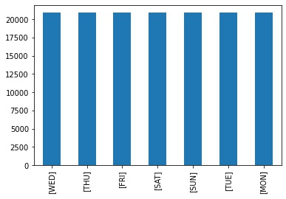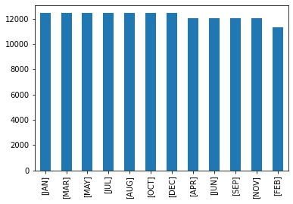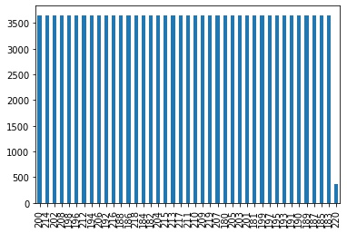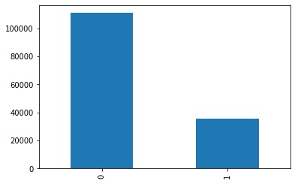

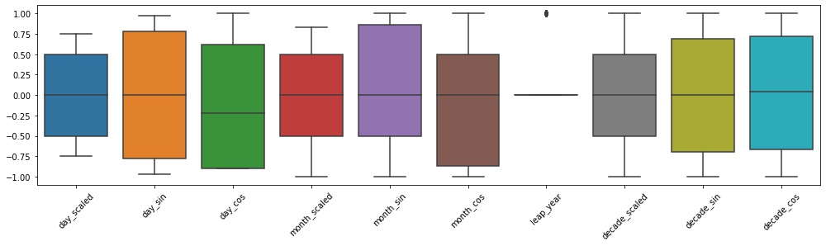

It’s been used SMOTE technique to solve the imbalance in data [‘leap_year’] column

and training the model again using new balanced data.

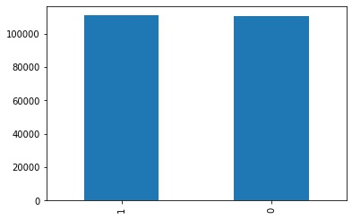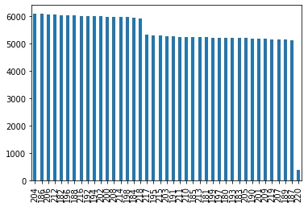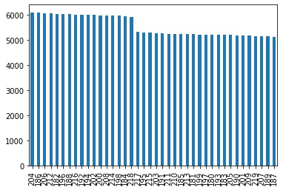

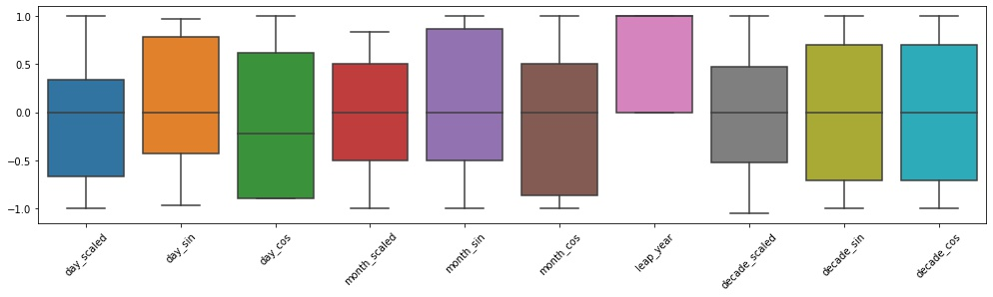

**your analysis of the outputs:**

- it’s quite impressive and unexpected to predict date with only 4 features and does quietly

decently well.

**make sure to reflect on your choices and analysis briefly:**

- I’ve tried different architectures and techniques like normalization and scaling to come

up with convenient results. There are mainly 2 variants of models. One output as predict

a continues number then convert back to datetime object. The other - winner – model

predicts a single number in range [0, 9] then concatenate them into an integer then

datetime object. The Model could be found in:

repo/model/8/MSE3/The Model-v2 [try number 4 (1024 node)]/

- Also, there is a GANs model, but the performance is really bad in repo/model/8_GANs/

- I see that we can solve that problem as a classification problem and I think it would give

a much higher result. We can discuss that together.

**Can we make the same conclusions you made, fast ?**

- I think it could be. First thing first use GPU to run the experiment faster. Try to switch off

L2 regularization (weight decay), dropout (since it puts an overhead to calculate the

probability for each node to drop), momentum and adaptive learning rate.

**Can we visually and logically validate that your results are ok ? Provide some output examples, maybe also provide examples where your model failed and your reflection on them.**

- Might be by comparing the predicted date and real date, through extracted the 4 features

from the predicted date and real date features, comparing the right predicted features

with features of predicted date features individually one by one, see the correlation and

covariance and use regression evaluation metrics to check out the model performance

in total.

- For sure the model that trained on SMOTE data predicted higher date than exceeds the

range which is unexpected e.g. ‘2305-11-15’ which is far beyond out of the bounds.