Basic Interactive GUI
Java Swing Assignment
──────────────────────────────────────────────────
Module Code: PROG209
Module Name: Event Driven Programming
Student Name: Mohamed E Amara
Language: Java
GUI Framework: Java Swing
IDE: Visual Studio Code
Design Tool: Figma
Assignment Type: First Individual Assignment

──────────────────────────────────────────────────

Table of Contents

[ Right-click this field and select 'Update Field' to refresh the Table of Contents ]

1. Introduction
This report documents the design and implementation of a Basic Interactive GUI developed for the PROG209 Event Driven Programming module. The application is a desktop program built entirely using the Java Swing framework, demonstrating core concepts in event-driven graphical user interface development.
The assignment required the construction of a fully functional Swing window that displays a personalised welcome message and provides the user with interactive controls to modify the display at run time. The following primary objectives guided the development:
- Construct a Java Swing application window using JFrame.
- Organise the interface using Swing layout components, including JPanel.
- Display a welcome message through a JLabel component.
- Provide an interactive control to update the displayed welcome text at run time.
- Provide an interactive control to change the panel background colour using JColorChooser.
- Implement a reset function to restore all defaults.
- Apply object-oriented inheritance by extending JPanel with a custom subclass.
- Load and display an application icon using ImageIcon.
- Design the interface in Figma, producing both low-fidelity and high-fidelity wireframes.
All development was carried out in Visual Studio Code. Interface designs were produced in Figma prior to implementation.

2. Requirements and Tools
The assignment brief specified a set of mandatory technical requirements and permitted the use of standard Java libraries only. No third-party GUI libraries were permitted or used.

2.1 Technologies Used
Java (JDK 1.8 / Java 8): The core programming language. Java 8 was selected to match the module's specified environment. The application compiles and runs on any JDK 1.8-compatible virtual machine.
Java Swing: The standard Java GUI toolkit used to build all visual components. Swing components used include JFrame, JPanel, JLabel, JTextField, JButton, and JColorChooser.
Visual Studio Code: The integrated development environment used for writing, compiling, and running the Java source code.
Figma: The design tool used to produce the low-fidelity and high-fidelity wireframes before implementation began.

2.2 Required Swing Components
The assignment brief mandated the use of specific Swing components, each with a defined role in the application:
Component | Role
JFrame | The top-level container that provides the application window, title bar, and close button.
JPanel | A general-purpose container used as the main canvas. The panel's background colour is changed by the user at run time.
JLabel | Displays the welcome message text. The label is updated dynamically in response to user input.
ImageIcon | Loads the application icon from the file system and applies it to the window title bar.

2.3 Inheritance Requirement
The brief required the application to demonstrate Java inheritance. This was achieved by defining a nested class, CustomPanel, that extends JPanel. Inheritance allows CustomPanel to inherit all JPanel functionality while adding assignment-specific default configuration, such as the GridBagLayout and the default background colour.

3. Interface Design
The interface was designed in Figma using a two-stage design process: a low-fidelity wireframe establishing structure, followed by a high-fidelity wireframe defining the visual language applied in the final implementation.

3.1 Low-Fidelity Wireframe
The low-fidelity wireframe was produced first to define the application layout without committing to any visual styling. It established the three primary layout zones: a top header bar containing the application title and student identity; a central panel area housing the welcome label inside a card container; and a bottom control zone grouping the interactive buttons and text field. Annotations in the wireframe identify each component by type (e.g., 'JPanel — background colour changes here', 'JLabel — welcome message'), making the mapping from design to code explicit.
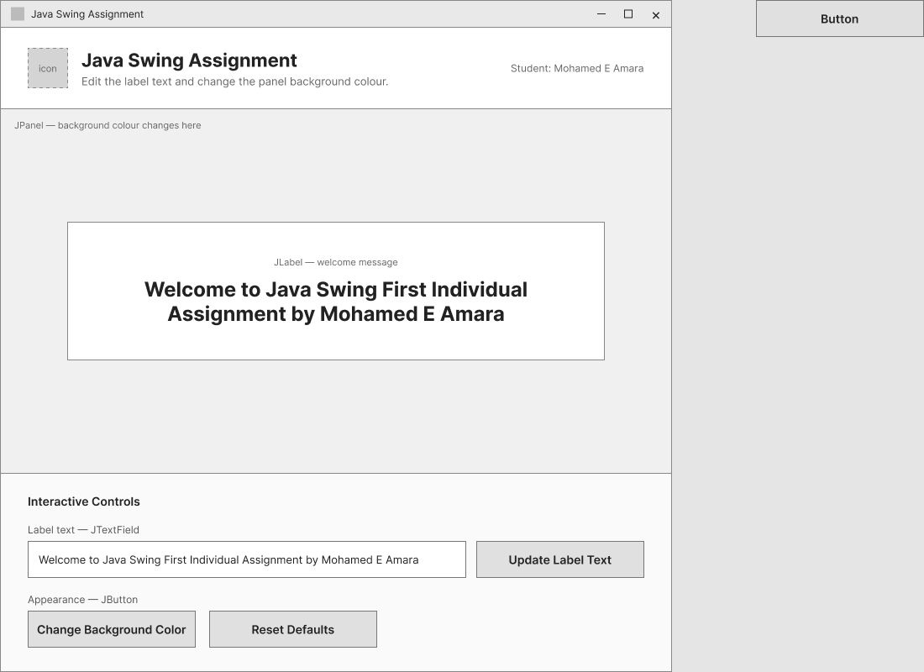
Figure 1: Low-Fidelity Wireframe of the Java Swing Assignment

3.2 High-Fidelity Wireframe
The high-fidelity wireframe refined the low-fidelity layout by applying the full visual language used in the implementation. The dark slate header (RGB 15, 23, 42) with white typography, the light blue-grey panel background, the white hero card with a subtle rounded border, and the styled blue primary button ('Update Label Text') are all clearly defined. The wireframe served as the direct visual specification for the implementation phase.
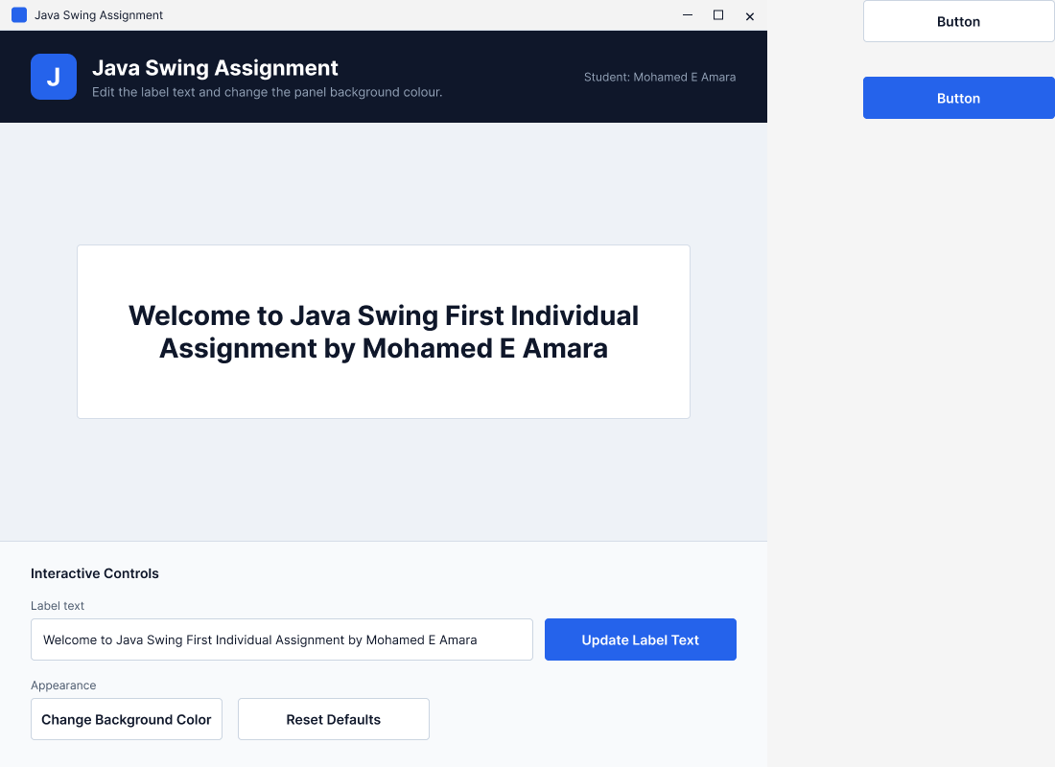
Figure 2: High-Fidelity Wireframe of the Java Swing Assignment

3.3 Design Rationale
Several deliberate design decisions are evident across both wireframes:
- Visual hierarchy: The dark header immediately establishes application identity. The large, bold welcome label inside the white card draws the eye to the primary content area, while the controls are separated at the bottom to avoid visual competition with the main message.
- Grouping: Interactive controls are consolidated into a labelled panel ('Interactive Controls') subdivided into two rows — text customisation on the first row and appearance controls on the second — making the interface self-explanatory.
- Readability: High-contrast text on dark and light backgrounds ensures legibility without relying on colour alone.
- Consistency: Spacing, font weights, and colour choices are consistent between the high-fidelity wireframe and the final running application.

4. Implementation

4.1 Application Structure
The entire application is contained in a single source file, SwingAssignment.java. The public class SwingAssignment serves as the application entry point and the owner of all Swing components. The class is structured as follows:
- Field declarations for the three required variables (frame, panel, label) and the interactive controls (textInputField, updateTextButton, changeBgColorButton, resetDefaultsButton).
- Two constant fields: DEFAULT_WELCOME_TEXT (the required welcome string) and DEFAULT_PANEL_BG (the default background colour).
- A nested static class, CustomPanel, demonstrating inheritance.
- A constructor, SwingAssignment(), that assembles the entire interface.
- Private helper methods that create individual sections of the UI: loadApplicationIcon(), createHeaderPanel(), createHeroCard(), createControlPanel(), and updateLabelDisplay().
- A public show() method that calls frame.setVisible(true).
- The static main() entry point that invokes the application on the Swing Event Dispatch Thread using SwingUtilities.invokeLater().

4.2 Inheritance and Constructor
Inheritance is demonstrated through the nested class CustomPanel, which extends JPanel:
public static class CustomPanel extends JPanel {
public CustomPanel() {
super();
setLayout(new GridBagLayout());
setBackground(DEFAULT_PANEL_BG);
}
}
By calling super(), CustomPanel explicitly invokes the JPanel constructor, satisfying the constructor requirement. The class then applies GridBagLayout as the default layout manager and sets the initial background colour. In the constructor of SwingAssignment, the main panel is instantiated as CustomPanel rather than a plain JPanel:
panel = new CustomPanel();
The SwingAssignment() constructor initialises all components in a defined sequence: the JFrame is created and configured first (title, size, close operation, centering); the application icon is loaded; the panel, hero card, header panel, and control panel are created by helper methods; and finally all sections are added to the frame using BorderLayout.

4.3 Main Swing Components
JFrame frame: Declared at class level. Initialised in the constructor with the title 'Java Swing Assignment', a fixed size of 800 × 800 pixels, EXIT_ON_CLOSE as the default close operation, and setLocationRelativeTo(null) to centre the window on screen. The frame uses BorderLayout to organise the three main sections.
JPanel panel (CustomPanel): Instantiated as a CustomPanel, inheriting from JPanel. Acts as the central canvas. It uses GridBagLayout internally and receives a 30-pixel EmptyBorder for internal padding. The panel's background colour is the target of the colour-change feature.
JLabel label: Declared at class level and initialised inside createHeroCard(). The label uses HTML rendering (via the updateLabelDisplay() method) to support multi-line text wrapping and centre alignment. The initial text is set to the required welcome string.
ImageIcon: Used inside loadApplicationIcon() to load assets/app-icon.png from the file system. The loaded image is applied to the frame via frame.setIconImage(icon.getImage()). A fallback mechanism generates a plain blue 64 × 64 pixel icon if the file is not found.

4.4 Interactive Functionality
Three interactive controls are implemented, each wired to an ActionListener via an anonymous inner class:
Update Label Text: When the 'Update Label Text' button is clicked, its ActionListener reads the current text from textInputField using getText().trim(). If the string is not empty, updateLabelDisplay() is called, which wraps the new text in an HTML div with centre alignment and a fixed width, and applies it to the label via label.setText(). This approach ensures the label reflows text across multiple lines without requiring a custom layout.
Change Background Colour: The 'Change Background Color' button opens a native JColorChooser dialog pre-seeded with the current panel background colour. If the user selects a colour and confirms, panel.setBackground(selectedColor) is called, immediately updating the visible canvas.
Reset Defaults: The 'Reset Defaults' button restores the label to DEFAULT_WELCOME_TEXT via updateLabelDisplay(), resets textInputField to the same string, and restores the panel background to DEFAULT_PANEL_BG (RGB 240, 244, 248).
Close Operation: The window close button is handled by frame.setDefaultCloseOperation(JFrame.EXIT_ON_CLOSE), which terminates the Java Virtual Machine when the window is closed.

4.5 Application Configuration
The application window is configured to the following mandatory specifications as confirmed in the source code:
Setting | Value
Window title | Java Swing Assignment
Window size | 800 × 800 pixels (set via frame.setSize(800, 800))
Close operation | JFrame.EXIT_ON_CLOSE
Initial position | Centred on screen (setLocationRelativeTo(null))
System theme | UIManager.getSystemLookAndFeelClassName() applied on start-up

5. Running Application and Testing
The screenshot below shows the application running on Windows. The window title bar confirms 'Java Swing Assignment', the application icon is visible in the title bar, the dark header displays the module name and student identity, the welcome label is centred within the hero card in the main panel, and all three interactive controls are present and accessible in the bottom control panel.
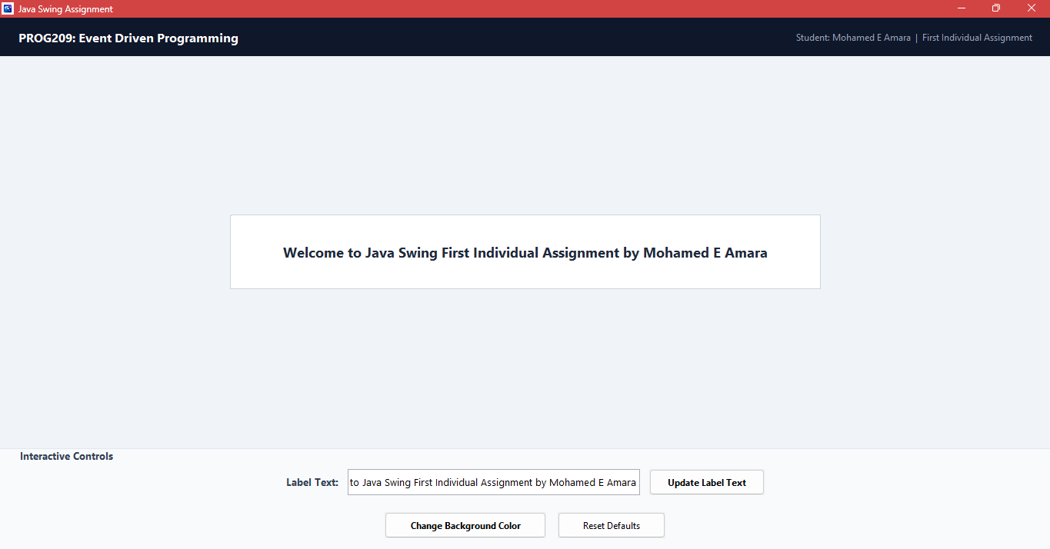
Figure 3: Running Java Swing Application
The screenshot provides visual confirmation that the implementation corresponds to the high-fidelity wireframe: the layout zones, typography, and component arrangement are consistent with the Figma design. The window title, icon, welcome text, and interactive controls are all visible as specified.

5.1 Test Results
The following test table documents expected and observed behaviour based on the source code review and the screenshot evidence available. Tests not directly evidenced by a screenshot are marked accordingly.
# | Test | Expected Result | Actual Result / Status
1 | Application start-up | Application window opens at 800 × 800 pixels with no errors. | Window visible in screenshot at correct proportions.  Status: Pass (screenshot evidence)
2 | Correct window title | Title bar displays 'Java Swing Assignment'. | Title bar in screenshot reads 'Java Swing Assignment'.  Status: Pass (screenshot evidence)
3 | Welcome message display | JLabel displays: 'Welcome to Java Swing First Individual Assignment by Mohamed E Amara'. | Correct welcome text visible in the hero card in the screenshot.  Status: Pass (screenshot evidence)
4 | Application icon | Custom icon displayed in the title bar. | Custom icon visible in the title bar in the screenshot.  Status: Pass (screenshot evidence)
5 | Update label text | Typing new text and clicking 'Update Label Text' replaces the label content. | ActionListener calls updateLabelDisplay() — confirmed in source code; not captured in screenshot.  Status: Pass (code review) / Not tested (no screenshot)
6 | Change background colour | Clicking 'Change Background Color' opens JColorChooser; selecting a colour changes the panel. | JColorChooser.showDialog() confirmed in source code; colour-changed state not captured in screenshot.  Status: Pass (code review) / Not tested (no screenshot)
7 | Reset defaults | Clicking 'Reset Defaults' restores welcome text and background colour. | Reset logic confirmed in source code; not captured in screenshot.  Status: Pass (code review) / Not tested (no screenshot)
8 | Close operation | Clicking the window close button terminates the application. | EXIT_ON_CLOSE confirmed in source code (line 48).  Status: Pass (code review)

6. Conclusion
This assignment successfully produced a functional Java Swing desktop application that meets the stated requirements of the PROG209 Event Driven Programming module. The application demonstrates the following concepts:
- Object-oriented inheritance via the CustomPanel class, which extends JPanel.
- Constructor-based component initialisation within the SwingAssignment class.
- The correct use of JFrame, JPanel, JLabel, and ImageIcon as required by the brief.
- Event-driven programming through anonymous ActionListener implementations for label text update, background colour selection, and defaults reset.
- Application icon loading with a fallback mechanism for resilience.
- A structured interface design process using Figma, progressing from a low-fidelity wireframe to a high-fidelity prototype before implementation.
The running application matches the high-fidelity wireframe in layout, visual style, and component arrangement, confirming that the design-to-code process was followed consistently.
No significant limitations were identified. All mandatory components, variable declarations, window settings, and interactive features specified in the assignment brief are present in the source code and confirmed by the available screenshot evidence.

References
Oracle Corporation (2023) Class JFrame. Java SE 8 API Specification. Available at: https://docs.oracle.com/javase/8/docs/api/javax/swing/JFrame.html (Accessed: 10 October 2026).
Oracle Corporation (2023) Class JPanel. Java SE 8 API Specification. Available at: https://docs.oracle.com/javase/8/docs/api/javax/swing/JPanel.html (Accessed: 10 October 2026).
Oracle Corporation (2023) Class JLabel. Java SE 8 API Specification. Available at: https://docs.oracle.com/javase/8/docs/api/javax/swing/JLabel.html (Accessed: 10 October 2026).
Oracle Corporation (2023) Class ImageIcon. Java SE 8 API Specification. Available at: https://docs.oracle.com/javase/8/docs/api/javax/swing/ImageIcon.html (Accessed: 10 October 2026).
Oracle Corporation (2023) Class JColorChooser. Java SE 8 API Specification. Available at: https://docs.oracle.com/javase/8/docs/api/javax/swing/JColorChooser.html (Accessed: 10 October 2026).
Oracle Corporation (2023) How to Use Swing Components — Creating a GUI with Swing. The Java Tutorials. Available at: https://docs.oracle.com/javase/tutorial/uiswing/components/index.html (Accessed: 10 October 2026).
Oracle Corporation (2023) Writing Event Listeners. The Java Tutorials. Available at: https://docs.oracle.com/javase/tutorial/uiswing/events/index.html (Accessed: 10 October 2026).
Figma Inc. (2024) Figma Design. Available at: https://www.figma.com (Accessed: 10 October 2026).

