Warehouse Database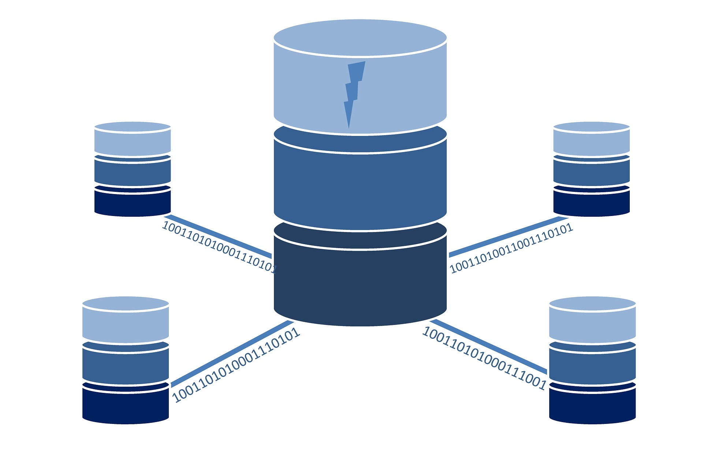

Database systems (1) CSE227

Submitted to: Dr. hoda korashy

Mohamed Sameh Abdelhakim 16p3061

Nour E-din Osama Mohamed 16p6043

Youssef Khaled Hussein 16p6040

Contents

Description 2

Requirements 2

Entities 2

Derived entities 2

Assumptions 3

EER Diagram 4

Relational Model 5

SQL Sample 6

Creating tables 6

Inserting into tables 8

Updating tables’ tuples 9

Deleting tables’ tuples 9

Retrieving from tables 9

ER ERD lab Sample 10

Relational Model ERD lab Sample 10

# Description

This project’s aim is to build a database system for a warehouse specialized in storing tech merchandise (TVs, Mobiles, Games, etc.) from the point they are received from a supplier till they are handed off to the proper distributor.

The database shall be responsible for keeping track of the complete life span of items inside the warehouse including all the data. However, this database will not include data like staff data, operating hours, etc. which can be added easily if needed.

# Requirements

## Entities

**Initial** conversation with the stakeholders resulted in the following entities:

* Item: representing any singular item in the database, meaning that if we have 2 identical phones in the warehouse they will be saved in the database as 2 entries because it is required to have information about every single item inside the warehouse to be able to ship different amounts to different distributors.  
  For each entity we need to keep its type, ID, time of arrival, time or shipping, location, color, size, description, producing company, screen size for TVs and Mobiles, Genre and platform for video games and voltage for chargers. It should be noticed that some of those attributed like size will be common among all identical items in the warehouse.
* Supplier: represent the company that supplies items to the warehouse. Every item has a supplier, but a supplier may not have supplied current items at a time.  
  For each Supplier we need to keep their ID, contract start and termination dates, identifying information like mail, phone, address, etc. A supplier must be a company not an individual or a store.
* Distributor: The entity that receives items from the warehouse.  
  For each Distributor we need to keep their ID, Tax register number, some identifying info like in the supplier as well as SSN for individual suppliers and commerce register number for companies.

## Derived entities

The following entities were derived based on the initial requirement to represent conflicts in attribute under the same entity:

* Category: represents the model of an item to keep the common attributes across multiple items like weight, size, available colors, description and Name.
* Video Game: a category that holds platform information and genre.
* Mobile: a category that holds screen size and model number.
* Charger: a category that holds output voltage.
* TV: a category that holds Model no. and screen type .
* Person: a distributor representing a person with an SSN.
* Company: a distributor representing a company with a commercial register number.
* Entity: a superclass for distributor and supplier to hold their common information like email, fax, address, Name, etc.

# Assumptions

1. Item must be supplied by one supplier only while a supplier may supply many items
2. Distributor may receive many items, item may be sent to multiple distributors
3. Item must have one category, but a category may have many items.
4. platform is a multivalued composite attribute in videogame
5. A distributor is either a company or a person
6. Both distributors and suppliers have a common superclass called entity
7. Color is a multivalued attribute in category as one category can have multiple possible colors; however, an item has one color only.
8. Location is a composite attribute in item consisting of a letter and a number(E.g. A5).
9. TIMESTAMP is used for attributes associated with time.
10. INTEGER is used for all IDs and any value that is an integer in nature
11. FLOAT is used for size, voltage and screen size.
12. VARCHAR and CHAR are used for all other generic attributes like SSN.

# EER Diagram

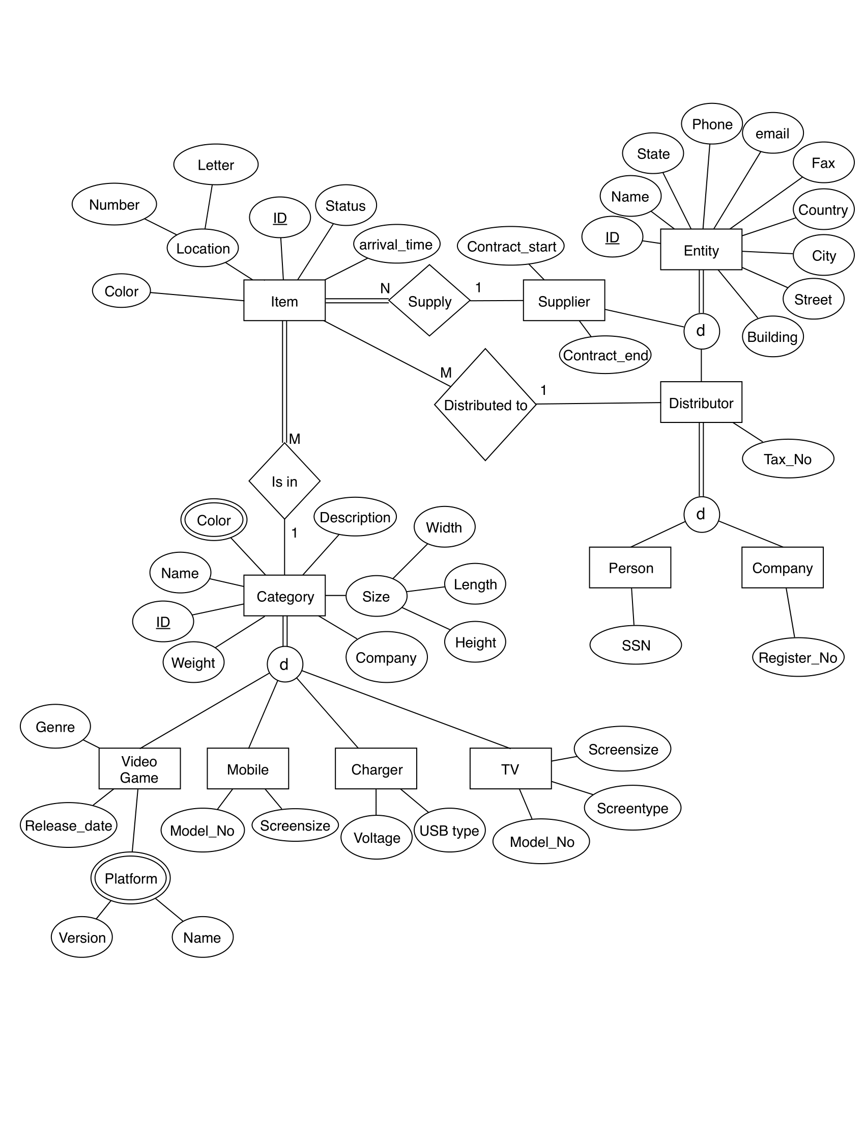

# Relational Model

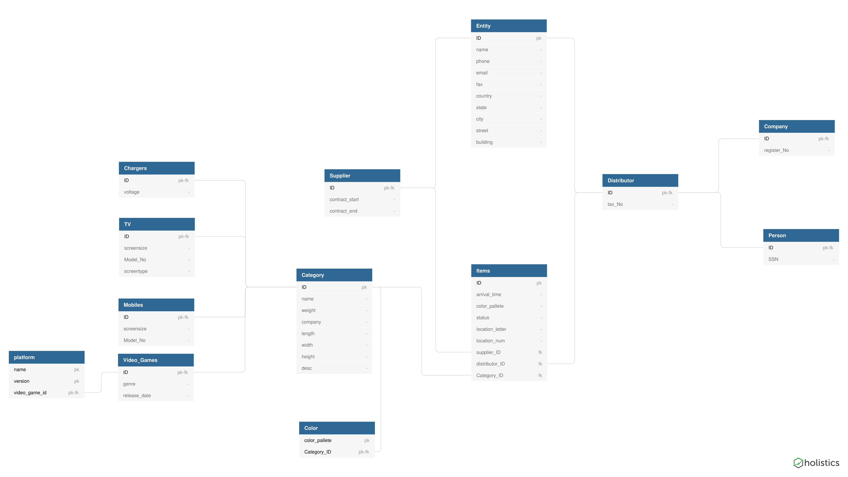

# SQL Sample

## Creating tables

1. **CREATE** **TABLE** Entity
2. (
3. ID **INTEGER** **PRIMARY** **KEY**,
4. **name** **VARCHAR**(100),
5. phone **VARCHAR**(20),
6. email **VARCHAR**(25),
7. fax **VARCHAR**(30),
8. country **VARCHAR**(20),
9. state **VARCHAR**(20),
10. city **VARCHAR**(20),
11. street **VARCHAR**(20),
12. building **VARCHAR**(20)
13. );
15. **CREATE** **TABLE** Supplier
16. (
17. ID **INTEGER** **PRIMARY** **KEY**,
18. contract_start **DATE**,
19. contract_end **DATE**
20. );
22. **CREATE** **TABLE** Items
23. (
24. ID **INTEGER** **PRIMARY** **KEY**,
25. arrival_time **TIMESTAMP**,
26. color_pallete **VARCHAR**(10),
27. status **varchar**(255),
28. location_letter **CHAR**(1),
29. location_num **CHAR**(3),
30. supplier_ID **INTEGER**,
31. distributor_ID **INTEGER**,
32. Category_ID **INTEGER**
33. );
35. **CREATE** **TABLE** Distributor
36. (
37. ID **INTEGER** **PRIMARY** **KEY**,
38. tax_No **VARCHAR**(40)
39. );
41. **CREATE** **TABLE** Company
42. (
43. ID **INTEGER** **PRIMARY** **KEY**,
44. register_No **VARCHAR**(40)
45. );
47. **CREATE** **TABLE** Person
48. (
49. ID **INTEGER** **PRIMARY** **KEY**,
50. SSN **VARCHAR**(20)
51. );
53. **CREATE** **TABLE** TV
54. (
55. ID **INTEGER** **PRIMARY** **KEY**,
56. screensize **FLOAT**,
57. Model_No **VARCHAR**(20),
58. screentype **VARCHAR**(10)
59. );
61. **CREATE** **TABLE** Chargers
62. (
63. ID **INTEGER** **PRIMARY** **KEY**,
64. voltage **FLOAT**
65. );
67. **CREATE** **TABLE** Category
68. (
69. ID **INTEGER** **PRIMARY** **KEY**,
70. **name** **VARCHAR**(100),
71. weight **FLOAT**,
72. company **VARCHAR**(50),
73. length **FLOAT**,
74. width **FLOAT**,
75. height **FLOAT**,
76. **desc** **VARCHAR**(500)
77. );
79. **CREATE** **TABLE** Mobiles
80. (
81. ID **INTEGER** **PRIMARY** **KEY**,
82. screensize **FLOAT**,
83. Model_No **VARCHAR**(20)
84. );
86. **CREATE** **TABLE** Video_Games
87. (
88. ID **INTEGER** **PRIMARY** **KEY**,
89. genre **VARCHAR**(20),
90. release_date **DATE**
91. );
93. **CREATE** **TABLE** platform
94. (
95. **name** **VARCHAR**(20) **PRIMARY** **KEY**,
96. version **VARCHAR**(20) **PRIMARY** **KEY**,
97. video_game_id **INTEGER** **PRIMARY** **KEY**
98. );
100. **CREATE** **TABLE** Color
101. (
102. color_pallete **VARCHAR**(10) **PRIMARY** **KEY**,
103. Category_ID **INTEGER** **PRIMARY** **KEY**
104. );
106. **ALTER** **TABLE** Supplier **ADD** **FOREIGN** **KEY** (ID) **REFERENCES** Entity (ID);
108. **ALTER** **TABLE** Items **ADD** **FOREIGN** **KEY** (supplier_ID) **REFERENCES** Supplier (ID);
110. **ALTER** **TABLE** Items **ADD** **FOREIGN** **KEY** (distributor_ID) **REFERENCES** Distributor (ID);
112. **ALTER** **TABLE** Items **ADD** **FOREIGN** **KEY** (Category_ID) **REFERENCES** Category (ID);
114. **ALTER** **TABLE** Distributor **ADD** **FOREIGN** **KEY** (ID) **REFERENCES** Entity (ID);
116. **ALTER** **TABLE** Company **ADD** **FOREIGN** **KEY** (ID) **REFERENCES** Distributor (ID);
118. **ALTER** **TABLE** Person **ADD** **FOREIGN** **KEY** (ID) **REFERENCES** Distributor (ID);
120. **ALTER** **TABLE** TV **ADD** **FOREIGN** **KEY** (ID) **REFERENCES** Category (ID);
122. **ALTER** **TABLE** Chargers **ADD** **FOREIGN** **KEY** (ID) **REFERENCES** Category (ID);
124. **ALTER** **TABLE** Mobiles **ADD** **FOREIGN** **KEY** (ID) **REFERENCES** Category (ID);
126. **ALTER** **TABLE** Video_Games **ADD** **FOREIGN** **KEY** (ID) **REFERENCES** Category (ID);
128. **ALTER** **TABLE** platform **ADD** **FOREIGN** **KEY** (video_game_id) **REFERENCES** Video_Games (ID);
130. **ALTER** **TABLE** Color **ADD** **FOREIGN** **KEY** (Category_ID) **REFERENCES** Category (ID);

## Inserting into tables

1. **INSERT** **INTO** Entity
2. **Values** (1, "Westroos Company",+20111, "amidn@westros.com",+20112,"Egypt","Cairo","Mokattam","nine","8127");
4. **INSERT** **INTO** Supplier
5. **Values** (1,'2019-5-8','2019-12-30');


9. **INSERT** **INTO** Entity
10. **Values** (2, "winterfell Company",+20111, "amidn@winterfell.com",+20223,"Spain","barcelona","NAN","81","54");
12. **INSERT** **INTO** Distributor
13. **Values** (2,"99987887");
15. **INSERT** **INTO** Company
16. **values** (2,"555555");


20. **INSERT** **INTO** Category
21. **values** (1,"Samsung Mobile Phone",400,"Samsung",5,3,4,"Mobile Phone comes with charger and headphone");
23. **INSERT** **INTO** Category
24. **values** (2,"LG TV",2500,"LG",20,10,5,"Smart TV comes with remote and two AAA batteries");


28. **INSERT** **INTO** Mobiles
29. **values** (1,5,"Note 4");
31. **INSERT** **INTO** TV
32. **values** (2,43,"Smart ooo","LED");


36. **INSERT** **INTO** item
37. **values** (1,'2019-1-10 01:56:11',"Blue","Pending",'A','33',1,NULL,1);
39. **INSERT** **INTO** item
40. **values** (2,'2019-5-8 12:24:01',"Black","Orderd",'S','21',1,2,2);

## Updating tables’ tuples

1. **UPDATE** Entity **set** Country = "USA" **WHERE** ID = 1;
2. **UPDATE** Supplier **set** contract_start = '2019-5-7' **WHERE** ID = 1;
3. **UPDATE** Distributor **set** Tax_no = "48928347" **WHERE** ID = 2;
4. **UPDATE** Category **set** Company  = "Huawei" **WHERE** ID = 1;
5. **UPDATE** Mobile **set** Model_no = "P7" **WHERE** ID = 1;

## Deleting tables’ tuples

1. **DELETE** **FROM** Entity **WHERE** ID = 1;
2. **DELETE** **FROM** Supplier **WHERE** contract_start = '2019-5-7';
3. **DELETE** **FROM** Entity **WHERE** Tax_no = "48928347";
4. **DELETE** **FROM** Entity **WHERE** Company = "Huawei";
5. **DELETE** **FROM** Entity **WHERE** Model_no = "P7";

## Retrieving from tables

1. **SELECT** * **FROM** Category **WHERE** ID = 2;
3. **SELECT** email, Tax_no -- select email and tax_no of all distributors from spain
4. **FROM** Entity, Distributor
5. **WHERE** Entity.ID = Distributor.ID
6. AND Country = "spain";
8. **SELECT** contract_start, **Name** -- select contract date and name all distributors
9. **FROM** Entity, Distributor
10. **WHERE** Entity.ID = Distributor.ID;
12. **SELECT** **Name**, COUNT(*) -- number of huawei phones in the warehouse
13. **FROM** Mobile, Category
14. **WHERE** Mobile.ID = Category.ID
15. AND Category.Company = "Huawei";
17. **SELECT** Company, COUNT(*) --group phones by company and select all companies with more than 5 phones
18. **FROM** Mobile, Category
19. **WHERE** Mobile.ID = Category.ID
20. **GROUP** **BY** Category.Company
21. **HAVING** COUNT(*) > 5;

# ER ERD lab Sample

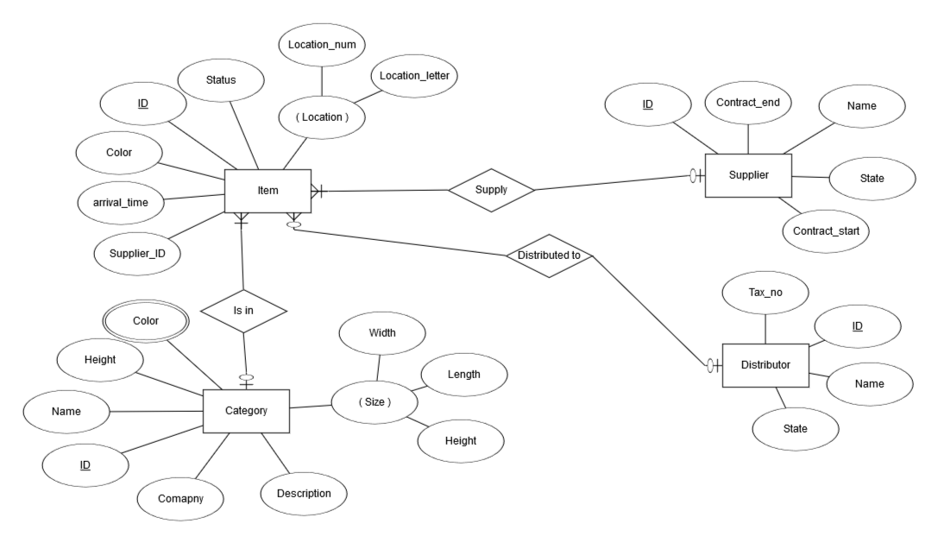

# Relational Model ERD lab Sample

