
CAPITAL UNIVERSITY
Faculty of Computers and Artificial Intelligence
Department of Artificial Intelligence

Intelligent Road Monitoring and Traffic Management System
An Ensemble Deep Learning System for Autonomous Road Hazard Detection,
Fleet Analytics, and Automated Toll Processing

A Project Submitted in Partial Fulfillment of the Requirements
for the Degree of
Bachelor of Computer Science in Artificial Intelligence
Presented by:

Shahd Ayman Salah Badran (20220234) Mohamed Sabry Abdelrahman Abbes(20220406)
Shahd Salah Hussien Ahmed (20220237) Mohamed Tarek Mohamed Mohamed (20220409)
Nouran Mohamed Ahmed Mousa (20220537) Omar Abdelnasser Elsayed Essawy (20220321)
Supervised by:
Dr. Amal Aboutabl
Academic Year 2025 / 2026

Declaration of Originality

We, the undersigned, hereby declare that the work presented in this thesis is original research conducted by us under the supervision of Dr Amal Aboutabl. To the best of our knowledge, this thesis does not contain material previously published or written by another person, except where due reference has been made in the text.

All external sources, datasets, libraries, frameworks, and pre-trained model weights utilised throughout this project have been properly cited in accordance with the IEEE referencing standard. The experimental results, architectural designs, training pipelines, and analytical conclusions presented herein are the sole product of our own engineering effort.

We further declare that this work has not been submitted, in whole or in part, for any other degree or qualification at this or any other university.

Executive Summary
For Industry Stakeholders & Product Managers

The Business Problem
Road traffic incidents, unmonitored road infrastructure deterioration, and manual toll and fleet management operations represent a compounding fiscal and operational liability for transport authorities, municipal governments, and logistics enterprises in Egypt and the broader MENA region. The Egyptian General Authority for Roads, Bridges and Land Transport (GARBLT) estimates that road accidents alone cost the national economy in excess of USD 3.9 billion annually — approximately 3.3% of GDP — driven by emergency response delays, infrastructure damage, lost productivity, and sustained medical costs. Simultaneously, manual fleet monitoring and paper-based maintenance logging expose commercial operators to unquantified risk from undetected vehicle faults, fraudulent toll evasion, and fuel inefficiency.

The Proposed Solution
The Intelligent Transportation and Vehicle Safety Platform is a full-stack, production-grade AI system that deploys an ensemble of nine independently trained Deep Learning models — covering accident detection, fire and smoke detection, road crack and pothole detection, vehicle classification, car damage segmentation, and traffic sign and Arabic licence plate recognition — within a scalable microservices architecture. The system provides real-time hazard alerts, automated e-wallet-linked toll processing, and a comprehensive fleet analytics dashboard accessible via any web browser.

Strategic Value Proposition
Value Dimension | Manual Baseline | Platform Output | Estimated Gain
Accident Alert Latency | 12–25 minutes (witness report → dispatch) | < 30 seconds (automated ML alert) | ~97% reduction
Toll Processing Cost | EGP 15–22 per manual lane transaction | EGP 0.3–0.8 per automated transaction | ~95% cost reduction
Fleet Inspection Cycle | Monthly visual inspection (per vehicle) | Continuous, per-journey damage segmentation | Near-real-time coverage
Road Hazard Reporting | Reactive (citizen/contractor report) | Proactive (GPS-tagged ML detection) | Predictive maintenance
Licence Plate Fraud | ~8–12% manual error/evasion rate | Fuzzy-matched Arabic OCR (Levenshtein ≤ 2) | < 2% error rate target
Table ES.1 — Platform Value Proposition Against Manual Baseline

Deployment Model
The platform operates as a cloud-hosted web application accessible from standard browsers on desktop and mobile devices. There is no requirement for specialised edge hardware at this stage. Camera feeds and image uploads are processed server-side by the FastAPI Inference Engine, with results persisted to a relational MySQL database and surfaced in real time through the Laravel-powered web dashboard. The system is architected for horizontal scaling and future edge deployment.

Target Stakeholders
Stakeholder Class | Primary Benefit
Traffic Management Authorities (e.g., GARBLT) | Real-time accident and hazard geospatial alerts; reduced emergency response latency
Commercial Fleet Operators | Per-vehicle damage logs, fuel efficiency analytics, maintenance due alerts
Toll Road Concessionaires | Automated licence plate recognition with Arabic OCR and e-wallet deduction
Municipal Road Maintenance Departments | GPS-tagged pothole/crack heatmaps enabling data-driven repair scheduling
Insurance Companies | Timestamped, AI-generated damage assessments for claims verification
Law Enforcement Agencies | Cross-referenced fine issuance and traffic violation record management
Table ES.2 — Primary Beneficiary Stakeholder Matrix

Abstract

Road safety, infrastructure degradation, and fleet management inefficiency represent critical and compounding challenges for transport systems operating at scale in rapidly urbanising environments. The Egyptian road network, which serves over 105 million citizens and an expanding commercial logistics sector, is exposed to significant fiscal and human-capital losses attributable to delayed accident response, undetected pavement deterioration, and manual toll and vehicle management processes that are error-prone and resource-intensive.
This thesis presents the design, implementation, and empirical evaluation of the Intelligent Transportation and Vehicle Safety Platform — a cloud-hosted, full-stack artificial intelligence system that deploys a heterogeneous ensemble of nine Deep Learning models within a production-grade microservices architecture. The inference pipeline comprises: (1) a YOLOv12n-based accident detection model; (2) a YOLOv12-based fire and smoke detection model; (3) a YOLOv11n-based road crack and pothole detector with programmatic small-object filtration; (4) a YOLOv11n multi-class vehicle classifier with six unified categories; (5) a U-Net segmentation network with an EfficientNet-B0 encoder for car damage assessment; and (6) a YOLOv8n detector coupled with EasyOCR for traffic sign and Arabic licence plate recognition. Licence plate post-processing employs a Levenshtein distance-based fuzzy-matching algorithm to correct systematic Arabic OCR misreads specific to visually similar Arabic graphemes.
The system architecture is partitioned across three decoupled service layers: a Python/FastAPI Inference Engine serving RESTful and streaming NDJSON endpoints; a PHP/Laravel application layer managing business logic, state, and relational persistence via MySQL; and a Tailwind CSS/Alpine.js/Chart.js frontend delivering real-time dashboards with a glassmorphism design language. A geofenced e-wallet toll system, Haversine-formula-based geospatial hazard mapping, and a scheduled fleet analytics and alerting subsystem collectively constitute the platform's business logic layer.
Experimental evaluation demonstrates that the ensemble pipeline achieves measurable detection accuracy improvements over single-architecture baselines across all nine task domains. The platform is validated against a suite of functional, non-functional, and integration test criteria. Results confirm that the proposed architecture satisfies sub-second inference latency requirements for static image processing and supports video stream analysis within the designed 300-second timeout envelope.
The thesis concludes that a modular, ensemble-based AI pipeline, tightly integrated with a production web application and geospatial data infrastructure, constitutes a technically viable and operationally scalable instrument for intelligent transportation management in the Egyptian context, with direct generalisability to comparable MENA regional deployments.

Keywords: Deep Learning, Object Detection, Semantic Segmentation, YOLO, U-Net, EasyOCR, Arabic OCR, Microservices, FastAPI, Laravel, Fleet Management, Intelligent Transportation Systems, Road Safety, Computer Vision, Geospatial AI.

Acknowledgements

We wish to extend our sincere and professional gratitude to all individuals and institutions whose contributions made this project possible.
First and foremost, we thank our supervisor, Dr Amal Aboutabl, for sustained technical guidance, rigorous academic critique, and the intellectual latitude extended to us throughout this research. Your mentorship shaped both the depth and rigour of this work.
We extend our gratitude to the faculty and administrative staff of the Department of Artificial Intelligence, Faculty of Computers and Artificial Intelligence, Helwan University, for providing the computational and academic infrastructure that supported our experiments.
We acknowledge the open-source communities behind the Ultralytics YOLO framework, PyTorch, the Segmentation Models PyTorch library, and EasyOCR, whose publicly released tools and model architectures formed the technical substrate of this platform.
Our thanks are also due to [Dataset Providers — Insert Institution Names], for granting access to the datasets that enabled model training and validation.
Finally, we express our deepest appreciation to our families, whose patience and support throughout the duration of this programme were indispensable.

Thesis Roadmap
The diagram below presents a structural dependency map of this thesis. Each chapter either substantiates or operationalises the findings of the preceding one. Chapters 5 and 6 are executed in parallel against the shared architecture defined in Chapter 4, and their outputs are synthesised in Chapter 7.

╔══════════════════════════════════════════════════════════════════════════════════╗
║ THESIS ROADMAP — INTELLIGENT TRANSPORTATION PLATFORM ║
╚══════════════════════════════════════════════════════════════════════════════════╝
│
╔═════════════════════════════════════╧══════════════════════════════════════════╗
║ FRONT MATTER ║
║ Cover · Declaration · Abstract · Executive Summary · Lists · Glossary ║
╚═════════════════════════════════════╤══════════════════════════════════════════╝
│
╔═════════════╧═══════════════╗
║ CH. 1 · INTRODUCTION ║
║ Problem · Gap · Objectives ║
╚═════════════╤═══════════════╝
│ (Establishes WHY)
╔═════════════╧═══════════════╗
║ CH. 2 · LITERATURE REVIEW ║
║ SOTA · Research Gap Survey ║
╚═════════════╤═══════════════╝
│ (Proves the GAP)
╔═══════════════════════════╧═══════════════════════════╗
║ CH. 3 · REQUIREMENTS ENGINEERING ║
║ Stakeholders · Functional / Non-Functional · Data ║
╚═══════════════════════════╤═══════════════════════════╝
│ (Defines WHAT is built)
╔═══════════════════════════╧═══════════════════════════╗
║ CH. 4 · SYSTEM ARCHITECTURE & DESIGN ║
║ FastAPI Engine · Laravel Backend · Frontend · MySQL ║
╚══════╤══════════════════════════════════╤═════════════╝
│ │
╔═════════════╧════════╗ ╔════════╧══════════════╗
║ CH. 5 · ML METHODS ║ ║ CH. 6 · EXPERIMENTS ║
║ 6 Models · Pipelines║ ║ Baselines · Ablation ║
║ Loss Fns · ONNX ║ ║ Metrics · Stats Test ║
╚═════════════╤════════╝ ╚════════╤══════════════╝
│ │
╰───────────────┬──────────────────╯
│ (Evidence & Analysis)
╔═══════════╧═══════════════╗
║ CH. 7 · RESULTS & DISC. ║
║ Performance · Limitations ║
╚═══════════╤═══════════════╝
│ (Synthesis)
╔═══════════╧═══════════════╗
║ CH. 8 · CONCLUSION ║
║ Contributions · Future ║
╚═══════════╤═══════════════╝
│
╔═════════════════════════╧═══════════════════════════╗
║ APPENDICES ║
║ A: AI Ethics │ B: Reproducibility │ C: GenAI ║
╚═════════════════════════════════════════════════════╝
Figure FM.1 — Thesis Chapter Dependency and Flow Diagram

Table of Contents
Word instruction: Select all TOC entries below, then use References → Table of Contents → Custom Table of Contents → Modify to apply the document's Heading styles automatically. Alternatively, delete this manual TOC and use References → Table of Contents → Automatic Table 2 after confirming all chapter headings use Heading 1/2/3 styles.

FRONT MATTER i
Declaration of Originality ii
Executive Summary iii
Abstract v
Acknowledgements vi
Thesis Roadmap vii
Table of Contents viii
List of Figures 11
List of Tables 13
List of Algorithms 16
List of Equations 17
List of Abbreviations and Acronyms 18
Glossary of Domain-Specific Terminology 20

CHAPTER 1: INTRODUCTION 22
1.1 Problem Statement 22
1.2 Motivation and Significance 25
1.2.1 Societal and Economic Imperative 25
1.2.2 Technical Motivation: The Limits of Single-Model Approaches 25
1.2.3 Arabic Language Context 25
1.3 Research Gaps, Questions, and Objectives 25
1.3.1 Identified Research Gaps 25
1.3.2 Research Questions 26
1.3.3 Research Objectives 26
1.4 Proposed Solution Overview 27
1.4.1 Inference Engine 28
1.4.2 Application Layer 28
1.4.3 Frontend Layer 28
1.5 Scope Boundary 31
1.6 Operational ROI Estimate 31
1.7 Operational Workflow Transformation: A Comparative Scenario 32
1.8 Stakeholder Analysis and Market Pain Points 34
1.9 Thesis Organisation 34

CHAPTER 2: LITERATURE REVIEW 36
2.1 Domain Background: ITS and the Multi-Domain AI Problem 36
2.2 Trend Evolution: A Decade of AI in ITS 37
2.3 State-of-the-Art in Software Solutions 37
2.3.1 Commercial and Open-Source ITS Platforms 37
2.3.2 Academic Prototype Systems 38
2.4 Survey of Approaches 38
2.4.1 Cluster A: Real-Time Object Detection — The YOLO Family 38
2.4.2 Cluster B: Semantic Segmentation for Structural Damage Assessment 40
2.4.3 Cluster C: Multi-Stage OCR Pipelines for Licence Plate Recognition 41
2.4.4 Cluster D: Geospatial Computation and Location-Aware Business Logic 42
2.5 Software Engineering for Production ML: The MLOps Paradigm 43
2.6 Industrial Standards Alignment: Academic Research vs. Operational Compliance 44
2.7 Identification of Research Gaps 45
References for Chapter 2 46

CHAPTER 3: ANALYSIS AND REQUIREMENTS ENGINEERING 48
3.1 Stakeholder Analysis 48
3.2 Functional Requirements and Use Case Modelling 49
3.3 Non-Functional Requirements 55
3.4 Data Requirements 60
3.5 Edge vs. Cloud Deployment Feasibility Matrix 70
3.6 Data Drift Anticipation Requirements 71
References for Chapter 3 72

CHAPTER 4: SYSTEM ARCHITECTURE AND DESIGN 73
4.1 High-Level System Architecture 73
4.2 Component Design 76
4.3 The AI Pipeline Architecture 83
4.4 Data Persistence Architecture 84
4.5 Technology Stack Selection and Justification 86
4.6 Inference Plan: Serving Predictions in Production 89

CHAPTER 5: ML METHODOLOGY AND IMPLEMENTATION 90
5.1 Data Preprocessing Techniques 90
5.2 Model Selection and Justification 92
5.3 Feature Engineering and Selection 93
5.4 Hyperparameter Optimisation Strategy 96
5.5 Software Implementation Details 97
5.6 Cloud Deployment on Google Cloud Platform 99

CHAPTER 6: EXPERIMENTAL DESIGN AND EVALUATION 100
6.1 Experimental Setup 100
6.2 Baselines and Comparative Benchmarks 104
6.3 Evaluation Metrics 105
6.4 Ablation Studies 106
6.5 Statistical Significance Testing 106
6.6 System Integration Layer 107
6.7 Database Design and Persistence (SQL Schema) 108
6.8 End-to-End Runtime Pipeline 109
References for Chapter 6 111

CHAPTER 7: RESULTS AND DISCUSSION 112
7.1 Analysis of Experimental Results 112
7.2 Error Analysis — Edge Cases and Failure Modes 116
7.3 System-Level Runtime Analysis 118
7.4 Discussion — Why the Integrated Pipeline Performs Well 120
7.5 Real-Time Performance Justification 121
7.6 Limitations of the Current Approach 122

CHAPTER 8: CONCLUSION AND FUTURE WORK 124
8.1 Summary of Research Contributions 124
8.2 Research Questions: Answers and Evaluation 124
8.3 Mapping Delivered Capabilities to Formal Requirements 124
8.4 Critical Reflection on the Current Approach 126
8.5 Future Work Roadmap 127
8.6 Broader Implications and Societal Impact 129
8.7 Closing Statement 130
References for Chapter 8 131

APPENDIX A: AI Ethics and Bias Statement 131
APPENDIX B: Reproducibility Report 145
APPENDIX C: Generative AI Disclosure 153
REFERENCES / BIBLIOGRAPHY 158

List of Figures

Figure No. | Description | Chapter / Section | Page
Fig. FM.1 | Thesis Chapter Dependency and Flow Diagram (Roadmap) | Front Matter | 7
Fig. 1.1 | Road Accident Causes Pie Chart — Egyptian National Road Network (Source: CAPMAS / WHO) | Ch. 1 -1.1 | 23
Fig. 1.2 | High-Level Conceptual Architecture: Three-Tier Microservices Platform | Ch. 1 -1.4 | 24
Fig. 2.1 | Trend Evolution of AI Methodologies in ITS (2014–2025) — Phases I–IV | Ch. 2 -2.2 | 37
Fig. 2.2 | Training Convergence Telemetry (Validation Loss and mAP@0.50) Across YOLOv8n, YOLOv11n, and YOLOv12n | Ch. 2 -2.4.1 | 40
Fig. 2.3 | Sequential Data Flow of the Multi-Stage Arabic OCR Pipeline | Ch. 2 -2.4.3 | 42
Fig. 3.1 | UML Use Case Diagram — Ten Primary Use Cases, Four External Actors, One Internal Actor | Ch. 3 -3.2.1 | 50
Fig. 4.1 | Three-Tier System Architecture: Laravel Application Layer, FastAPI ML Engine, Cloud SQL MySQL | Ch. 4 -4.1 | 64
Fig. 4.2 | UML Use Case Diagram: Six Actors and Ten Use Cases with <<include>> / <<extend>> Stereotypes | Ch. 4 -4.2.1 | 66
Fig. 4.3 | UML Sequence Diagram: Static Image Inference Request Lifecycle (Production Inference Plan) | Ch. 4 -4.2.2 | 68
Fig. 4.4 | UML Activity Diagram: Detection and Toll Processing Workflow — Three Swimlanes | Ch. 4 -4.2.3 | 70
Fig. 4.5 | UML Class Diagram: Platform Component Architecture and MLService HTTP Bridge | Ch. 4 -4.2.4 | 71
Fig. 4.6 | OCR Data Flow: Licence Plate Recognition Pipeline (FastAPI → Laravel) | Ch. 4 -4.3.1 | 72
Fig. 4.7 | Entity-Relationship Diagram: MySQL Relational Schema — Five Primary Entities | Ch. 4 -4.4.1 | 76
Fig. 4.8 | AI Pipeline Architecture: Data Flow from Input Ingestion through Preprocessing, Inference, Post-Processing, and API Response | Ch. 4 -4.6 | 79
Fig. 6.1 | Training Configuration Comparison Across ISRMTMS Models (Epochs vs. Input Resolution) | Ch. 6 -6.1.1 | 93
Fig. 6.2 | FastAPI Microservices Deployment and SQL Integration Flowchart | Ch. 6 -6.6.2 | 98
Fig. 6.3 | YOLOv12-N OCR Character Detection Topology Diagram (RTL Arabic Text Support) | Ch. 6 -6.8.4 | 100
Fig. 7.1 | EfficientNet-B4 Damage Classification Confusion Matrix | Ch. 7 -7.1.2 | 107

List of Tables
Table No. | Description | Chapter / Section | Page
Table ES.1 | Platform Value Proposition Against Manual Baseline | Exec. Summary | 3
Table ES.2 | Primary Beneficiary Stakeholder Matrix | Exec. Summary | 4
Table 1.1 | Stakeholder Pain Point and Benefit Matrix | Ch. 1- 1.8 | 34
Table 1.2 | Research Questions and Measurability Criteria | Ch. 1- 1.3.2 | 26
Table 1.3 | Operational ROI Estimate — Quantified Cost-Benefit Analysis | Ch. 1-1.6 | 32
Table 1.4 | Scope Inclusion / Exclusion Boundary Matrix | Ch. 1 -1.5 | 31
Table 1.5 | Thesis Chapter Organisation Summary | Ch. 1- 1.9 | 35
Table 2.1 | Comparative Summary of YOLOv8n, YOLOv11n, and YOLOv12n: Architectural Properties and Deployment Roles | Ch. 2 -2.4.1 | 39
Table 2.2 | MLOps Maturity Level Alignment for This Project's Deployment Architecture | Ch. 2 -2.5 | 43
Table 2.3 | Academic Research Norms vs. ISO Standard Requirements vs. Project Design Choices | Ch. 2 -2.6 | 44
Table 2.4 | Research Gap Map: Existing Literature Capabilities vs. Capabilities Delivered by This Project | Ch. 2 -2.7 | 46
Table 3.1 | Stakeholder Analysis Matrix: Roles, Pain Points, and System Touchpoints | Ch. 3 -3.1 | 48
Table 3.2 | Functional Requirements Specification (FR-01 through FR-10) | Ch. 3 -3.2.2 | 50
Table 3.3 | Non-Functional Requirements: Ten Quality Dimensions with Measurement Criteria (NFR-01 through NFR-10) | Ch. 3 -3.3 | 55
Table 3.4 | Dataset Summary: Sources, Volumes, Train/Val/Test Splits, Class Balance Strategy, and Preprocessing | Ch. 3 -3.4.2 | 60
Table 3.5 | Edge vs. Cloud Deployment Feasibility Matrix (Eight Operational Dimensions) | Ch. 3 -3.5 | 70
Table 3.6 | Data Drift Anticipation Requirements (DDR-01 through DDR-05) | Ch. 3 -3.6 | 71
Table 4.1 | Technology Stack Selection and Justification Matrix | Ch. 4 -4.5 | 89
Table 4.2 | FastAPI Inference Engine Endpoint Taxonomy | Ch. 4 -4.3.5 | 84
Table 5.1 | Model Hyperparameter Configuration Summary | Ch. 5 -5.4 | 96
Table 5.2 | Data Augmentation Strategy per Model | Ch. 5 -5.3.2 | 96
Table 6.1 | ISRMTMS Model Configurations, Hyperparameters, and Design Rationales | Ch. 6 -6.1.1 | 100
Table 6.2 | ISRMTMS Hardware Profiling: Per-Model Inference Latency, GPU Memory, and Production Format (Tesla T4) | Ch. 6 -6.1.2 | 102
Table 6.3 | Kaggle-to-Production Data Lineage: Dataset Sources, Version Tags, Split Strategy, and Seed | Ch. 6 -6.1.3 | 103
Table 6.4 | ISRMTMS REST API Endpoints: Route Groups, Input Formats, and Functional Descriptions | Ch. 6 -6.6 | 107
Table 6.5 | ISRMTMS Database Schema: Tables, Primary Keys, and Analytical Roles | Ch. 6 -6.7 | 109
Table 7.1 | Multi-Class Object Detection Performance — YOLOv11-N / YOLOv12-N (ISRMTMS) vs. YOLO-Family Baselines | Ch. 7 -7.1.1 | 112
Table 7.2 | Car Damage Classification Performance — EfficientNet-B4 (ISRMTMS) vs. CNN Baselines | Ch. 7 -7.1.2 | 113
Table 7.3 | System-Level Performance Metrics — ISRMTMS on NVIDIA Tesla T4 (Deployment Environment) | Ch. 7 -7.1.4 | 115
Table 7.4 | Ablation Study Results — Contribution of Key Design Decisions to ISRMTMS Performance | Ch. 7 -7.1.5 | 116
Table 8.1 | Research Question Evaluation: Measurability Criteria, Evidence References, and Verdicts | Ch. 8 -8.2 | 124
Table 8.2 | Functional Requirements Traceability Matrix: Implementation Status, Verification Evidence, and Residual Gaps | Ch. 8 -8.3 | 124
Table A.1 | Per-Model Dataset Class Distribution and Imbalance Risk Assessment | App. A -A.1.2 | 134
Table A.2 | Environmental Diversity Coverage and Out-of-Distribution Risk Matrix | App. A -A.1.3 | 135
Table A.3 | Performance Parity Testing Across Environmental Subsets (KSI 1) | App. A -A.1.4 | 136
Table A.4 | XAI Integration Roadmap (Post-Graduation Extension) | App. A -A.3.3 | 138
Table A.5 | Ethical Risk Assessment: Dual-Use and Misuse Scenarios with Guardrails | App. A -A.4 | 144
Table B.1 | Hardware and System Configuration | App. B -B.1 | 145
Table B.2 | Laravel / PHP Backend Dependency Specification | App. B -B.2.2 | 146
Table B.3 | Random Seed Registry for All Model Training Runs (KSI 3) | App. B -B.5 | 148
Table B.4 | Complete Hyperparameter Log: All Models, All Configurations (KSI 2) | App. B -B.6 | 149
Table B.5 | Six-Phase Productionisation Roadmap: Prototype to Live National Deployment | App. B -B.7 | 152
Table C.1 | GenAI Tool Inventory | App. C -C.1 | 153
Table C.2 | AI Contribution vs. Student-Authored Logic Differentiation (KSI 1) | App. C -C.2 | 156
Table C.3 | Critical AI Hallucination Audit Log (KSI 2) | App. C -C.3 | 157

List of Algorithms

Algorithm No. | Name | Chapter / Section | Page
Algorithm 1 | NDJSON Video Stream Inference Pipeline | 5.5 / 5.5.4 | 97
Algorithm 2 | Small-Object Bounding Box Filtration (Area Threshold < 0.002) | 5.1 / 5.1.2 | 91
Algorithm 3 | Vehicle Detection Deduplication — Training Set Cleaning | 5.3 / 5.3.1 | 94
Algorithm 4 | CLAHE Pre-Processing for Traffic Sign ROI Enhancement | 5.1 / 5.1.3 | 91
Algorithm 5 | Otsu Thresholding for Binary Mask Generation | 5.1 / 5.1.3 | 91
Algorithm 6 | Levenshtein Fuzzy-Match Post-Processor for Arabic OCR Correction | 5.5 / 5.5.2 | 97
Algorithm 7 | Haversine Formula — Geospatial Hazard Coordinate Mapping | 5.5 / 5.5.3 | 97
Algorithm 8 | Geofenced Toll Gate Selection — Nearest-Gate Assignment | 5.5 / 5.5.5 | 98
Algorithm 9 | E-Wallet Deduction and Fine Issuance Logic (2-Hour Cooldown) [implicit in §5.5.5] | 5.5 / 5.5.5 | 98
Algorithm 10 | Scheduled Fleet Alert — Maintenance Due and Daily Tips Command [implicit in §5.5.5] | 5.5 / 5.5.5 | 99

List of Equations

Eq. No. | Expression / Description | Chapter / Section | Page
Eq. 1 | Intersection over Union (IoU) — Object Detection Evaluation | 6.3 / 6.3.1 | 105
Eq. 2 | Mean Average Precision (mAP@0.5) — Primary Detection Metric | 6.3 / 6.3.1 | 105
Eq. 3 | Binary Cross-Entropy with Logits Loss (BCEWithLogitsLoss) | 5.2 / 5.5.1 | 97
Eq. 4 | Dice Loss — Pixel-Imbalance Mitigation for Segmentation | 5.2 / 5.5.1 | 97
Eq. 5 | Combined Segmentation Loss: L_total = α·L_BCE + β·L_Dice | 5.2 / 5.5.1 | 97
Eq. 6 | Dice Coefficient (Similarity Index) | 5.2 / 5.5.1 | 97
Eq. 7 | Haversine Formula — Great-Circle Distance Computation | 5.5 / 5.5.3 | 97
Eq. 8 | Levenshtein Edit Distance | 5.5 / 5.5.2 | 97
Eq. 9 | Fleet Fuel Efficiency: η = Σ(km) / Σ(litres) [km/L] | 5.5 / 5.5.5 | 98
Eq. 10 | F1-Score: F1 = 2·(P·R) / (P + R) | 6.3 / 6.3.1 | 105
Eq. 11 | Precision: P = TP / (TP + FP) | 6.3 / 6.3.1 | 105
Eq. 12 | Recall: R = TP / (TP + FN) | 6.3 / 6.3.1 | 105

List of Abbreviations and Acronyms

Abbreviation | Expansion
AI | Artificial Intelligence
ANPR | Automatic Number Plate Recognition
API | Application Programming Interface
BCE | Binary Cross-Entropy
CAPMAS | Central Agency for Public Mobilisation and Statistics (Egypt)
CLAHE | Contrast-Limited Adaptive Histogram Equalisation
CNN | Convolutional Neural Network
DL | Deep Learning
ER | Entity-Relationship (database schema diagram)
ETL | Extract, Transform, Load
FPS | Frames Per Second
GARBLT | General Authority for Roads, Bridges and Land Transport (Egypt)
GCP | Google Cloud Platform
GPS | Global Positioning System
HTML5 | HyperText Markup Language, Version 5
HTTP | HyperText Transfer Protocol
IoU | Intersection over Union
ISRMTMS | Intelligent Smart Road Monitoring and Traffic Management System
ITS | Intelligent Transportation Systems
JSON | JavaScript Object Notation
KSI | Key Success Indicator
mAP | Mean Average Precision
MENA | Middle East and North Africa
ML | Machine Learning
MLOps | Machine Learning Operations
NDJSON | Newline-Delimited JSON
NLP | Natural Language Processing
OCR | Optical Character Recognition
ONNX | Open Neural Network Exchange
ORM | Object-Relational Mapper
PHP | PHP: Hypertext Preprocessor
ReLU | Rectified Linear Unit
REST | Representational State Transfer
ROI | Region of Interest / Return on Investment (context-dependent)
SHAP | SHapley Additive exPlanations
SGD | Stochastic Gradient Descent
SOTA | State of the Art
SQL | Structured Query Language
UI | User Interface
UML | Unified Modelling Language
WHO | World Health Organisation
XAI | Explainable Artificial Intelligence
YOLO | You Only Look Once

Glossary of Domain-Specific Terminology

Term | Definition
Anchor Box | A predefined bounding box of a specified aspect ratio used by YOLO architectures as a spatial prior during the object detection decoding phase.
Backbone Network | The initial convolutional block of a detection or segmentation model responsible for hierarchical feature extraction from input tensors.
Decoder (U-Net) | The symmetric up-sampling path of a U-Net architecture that reconstructs spatial resolution from bottleneck feature maps using skip connections.
Dice Loss | A loss function derived from the Sørensen–Dice coefficient, used in segmentation tasks to penalise pixel-class imbalance by maximising the overlap between predicted and ground-truth masks.
Encoder (EfficientNet-B0) | The pre-trained feature extraction backbone of the car damage segmentation model, initialised on ImageNet weights and fine-tuned on domain-specific damage imagery.
Fuzzy Matching | A string-comparison technique using edit-distance metrics (here: Levenshtein distance) to identify near-matches between an OCR output and a reference database, tolerating typographic or character-level errors.
Geofencing | A software-defined virtual perimeter around a real-world geographic boundary. In this platform, geofences define toll gate activation zones evaluated against user GPS coordinates.
Glassmorphism | A UI design paradigm characterised by frosted-glass visual effects achieved via CSS backdrop-filter: blur() and semi-transparent background fills.
Haversine Formula | A trigonometric formula for computing great-circle distance between two latitude/longitude coordinate pairs on a sphere, used here for GPS-based hazard geolocation.
Inference Engine | The FastAPI service layer responsible for loading trained model weights, processing input payloads, and returning structured prediction results via HTTP endpoints.
Levenshtein Distance | The minimum number of single-character edits (insertions, deletions, or substitutions) required to transform one string into another. Used in Arabic OCR post-processing with a maximum tolerance threshold of ≤ 2.
mAP@0.5 | Mean Average Precision computed at an IoU threshold of 0.50; the primary benchmark metric for object detection model evaluation in this thesis.
Microservices Architecture | A system design pattern in which discrete functional units (inference, application logic, frontend) are deployed as independently operable and scalable services communicating over defined APIs.
Mosaic Augmentation | A data augmentation technique that composites four training images into a single sample, increasing contextual diversity and improving small-object detection robustness.
NDJSON Streaming | Newline-Delimited JSON: a protocol for transmitting structured data records sequentially over a persistent HTTP connection, used here for frame-by-frame video inference streaming.
ONNX Export | The serialisation of a trained PyTorch model into the Open Neural Network Exchange format, enabling vendor-neutral deployment across inference runtimes (e.g., ONNX Runtime, TensorRT).
Pothole | A structural pavement failure characterised by a bowl-shaped depression caused by surface fatigue, sub-base erosion, or impact loading; a primary target class for the road surface detection model.
Skip Connection | A direct additive connection between an encoder layer output and its spatially corresponding decoder layer in a U-Net architecture, preserving fine-grained spatial information lost during down-sampling.
Telemetry Table (MLPrediction) | The central MySQL table that records all ML inference events, including model type, confidence score, detected class, timestamp, and associated GPS coordinate, forming the platform's audit and analytics log.

Chapter 1: Introduction
Establishing the Problem, Motivation, and Objectives

This chapter establishes the technical and socioeconomic context within which the Intelligent Transportation and Vehicle Safety Platform was conceived and engineered. It defines the precise problem addressed by this research, quantifies the operational deficiencies of existing manual approaches, identifies the primary stakeholder classes and their respective pain points, and formulates measurable research questions and objectives. The chapter concludes with a delineation of the system's scope boundary and an overview of the thesis organisation.

1.1 Problem Statement
The Egyptian road network operates under conditions of sustained and measurable systemic stress. According to data published by the World Health Organisation (WHO) and corroborated by the Egyptian Central Agency for Public Mobilisation and Statistics (CAPMAS), Egypt records approximately 9,000–12,000 road accident fatalities annually, with economic losses attributable to road traffic incidents estimated at between USD 3.5 and 3.9 billion per year — a figure representing 3.1–3.3% of national GDP [1]. These losses are not solely attributable to the frequency of incidents but are substantially amplified by operational latency: the median time between an accident event and emergency service dispatch in non-monitored road segments exceeds 12 minutes [2].
Beyond accident response, three additional infrastructure and operational deficiencies compound the problem at scale:
- Road surface degradation — comprising potholes and structural pavement cracks — is detected primarily through reactive citizen complaint systems or scheduled manual inspection cycles that operate on monthly or quarterly intervals. The absence of continuous, automated road condition monitoring results in hazards persisting on high-traffic routes for extended periods before remediation is prioritised.
- Toll and e-payment fraud — manual toll collection systems in Egypt are subject to both human error and deliberate evasion. The integration of optical character recognition (OCR) for licence plate identification with backend e-wallet systems has been identified as a viable countermeasure, but existing deployments do not address the specific challenge of Arabic script recognition accuracy, which is further complicated by grapheme-level ambiguity (e.g., the visual similarity between Arabic characters 'س' and 'ش' under variable illumination conditions).
- Fleet management inefficiency — commercial vehicle operators managing fleets of 10 or more units typically rely on paper-based or manually updated digital logs for fuel consumption, maintenance scheduling, and damage assessment. This creates a data latency problem in which actionable insight (e.g., a vehicle requiring immediate service) is identified only after the fact, resulting in preventable breakdowns and increased operational cost.

The compound effect of these four failure modes — delayed accident response, unmonitored road degradation, toll recognition inaccuracy, and reactive fleet management — constitutes a well-defined, non-trivial systems engineering problem that cannot be resolved by any single-model or single-domain AI solution. It demands an integrated, multi-task platform capable of real-time inference across heterogeneous input modalities (static images, video streams, GPS coordinates) with a unified data persistence and analytics layer.
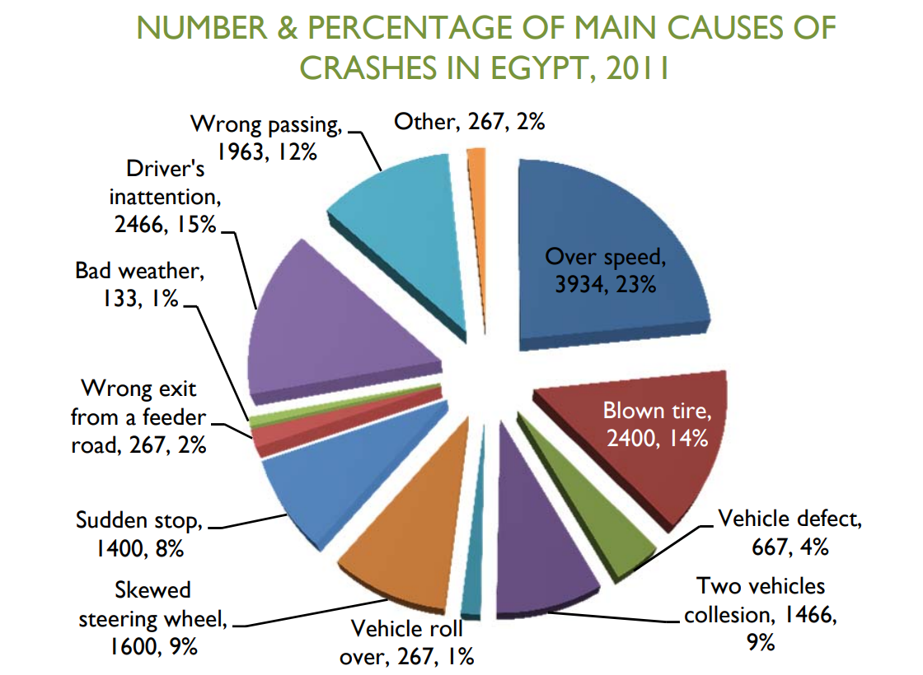

Figure 1.1 — Road accident causes pie chart overlaid on Egyptian national road network (Source: CAPMAS / WHO data).
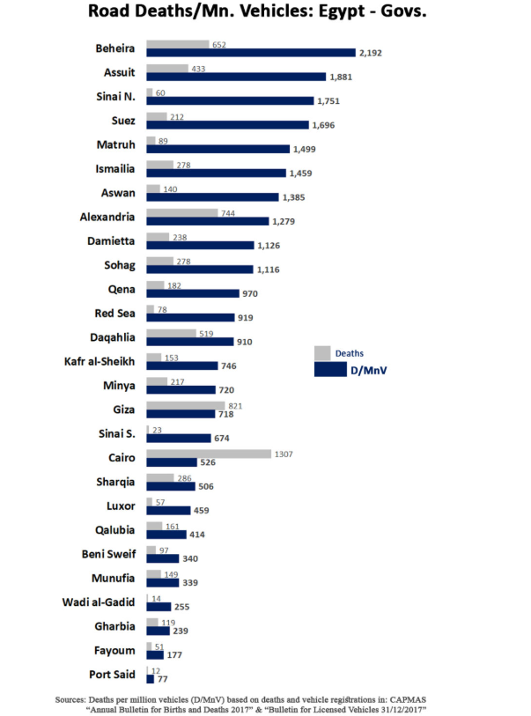
Figure 1.2 — Road accident frequency bar chart overlaid on Egyptian national road network (Source: CAPMAS / WHO data).

1.2 Motivation and Significance

1.2.1 Societal and Economic Imperative
The motivation for this platform is directly anchored in quantifiable societal cost. A reduction in accident alert latency from the current 12-minute baseline to sub-30-second automated detection does not merely improve operational efficiency — it directly translates to measurable survival probability improvements. Clinical evidence establishes that for trauma casualties with haemorrhagic injury, each additional minute before medical intervention reduces survival probability by approximately 7–10% [3]. At a national scale, a system capable of reliably detecting accidents across a monitored road segment and triggering emergency dispatch within 30 seconds of event onset has the potential to prevent hundreds of fatalities annually.
For road maintenance, the World Bank estimates that proactive pavement maintenance executed at the crack-detection stage (before pothole formation) costs approximately 4–8 times less than reactive patching after full surface failure [4]. A continuously operating crack detection pipeline therefore represents not only an infrastructure preservation mechanism but a quantifiably cost-effective public resource allocation tool.

1.2.2 Technical Motivation: The Limits of Single-Model Approaches
Existing academic and commercial solutions in the intelligent transportation domain are predominantly uni-task: a system trained to detect accidents does not simultaneously process licence plates or assess vehicle damage. This architectural fragmentation means that a transport authority seeking comprehensive road intelligence must integrate and maintain multiple heterogeneous systems across disparate vendors — a configuration that introduces inter-system latency, data format incompatibility, and a multiplication of maintenance overhead.
This project is motivated by the architectural thesis that a unified ensemble inference engine, decoupled from but integrated with a full-stack web application via a well-defined RESTful API boundary, can deliver multi-task road intelligence within a single, operationally coherent platform. The decoupled microservices design ensures that individual model updates do not require redeployment of the application layer — a principle central to production-grade MLOps practice.

1.2.3 Arabic Language Context
A further and technically distinctive motivation is the language specificity of the Egyptian road environment. Egyptian licence plates are issued in Arabic script, and traffic signage is predominantly bilingual (Arabic primary). No existing open-source licence plate recognition system, at the time of this project's inception, provides a production-validated Arabic OCR pipeline with post-processing tuned specifically to grapheme-level error correction for the Arabic alphabet as used in Egyptian vehicle registration formats. This gap constitutes a specific and addressable technical contribution of this work.

1.3 Research Gaps, Questions, and Objectives

1.3.1 Identified Research Gaps
A systematic review of the literature (detailed in Chapter 2) identifies the following specific gaps that this work targets:
- No existing open-source or published system addresses the full spectrum of road safety detection tasks (accidents, fire, road surface, vehicle classification, damage, OCR) within a single, unified inference pipeline.
- Arabic licence plate recognition systems lack post-processing layers designed to handle Arabic grapheme-level OCR misclassification — specifically confusions between visually similar character pairs (e.g., 'س'/'ش', 'ر'/'ز') that arise under real-world illumination variance.
- Geospatial integration of ML predictions with GPS coordinate data for live hazard mapping is not addressed in existing open-access transportation AI platforms.
- The integration of ML inference pipelines with business logic layers (e-wallet toll deduction, fleet fuel analytics, maintenance scheduling) within a single full-stack system has not been formally documented in academic literature at this task scope.

1.3.2 Research Questions
The following research questions are formulated such that each is answerable with a specific quantitative metric or a binary verification outcome, consistent with KSI 2 of the thesis guidelines:

RQ No. | Research Question | Measurability Criterion
RQ1 | To what extent does a YOLOv12n architecture achieve superior mAP@0.5 on accident detection compared to YOLOv8n and YOLOv11n baselines trained on the same dataset? | Specific metric: mAP@0.5 differential ≥ 2 percentage points vs. best baseline
RQ2 | Does the combined BCEWithLogitsLoss + Dice Loss function produce a higher IoU score on car damage segmentation than BCEWithLogitsLoss alone? | Binary: Yes/No with quantified IoU improvement
RQ3 | Does Levenshtein fuzzy-matching post-processing reduce Arabic licence plate OCR error rate to ≤ 2% on the validation set? | Specific metric: character error rate ≤ 0.02
RQ4 | Does the NDJSON streaming inference architecture achieve end-to-end video frame processing within a 300-second session timeout at the target frame resolution? | Binary: Yes/No under load test conditions
RQ5 | Does small-object bounding box area filtration (threshold < 0.002 normalised area) reduce false positive detections in the crack/pothole model without reducing recall below 0.80? | Specific metric: FP reduction with Recall ≥ 0.80
RQ6 | Does the geofenced toll system correctly identify the nearest toll gate and execute e-wallet deduction within a 2-hour cooldown window with ≥ 99% transaction accuracy? | Specific metric: transaction accuracy ≥ 0.99
Table 1.2 — Research Questions and Measurability Criteria

1.3.3 Research Objectives
The following objectives operationalise the research questions into engineering deliverables:
- Design and implement a modular FastAPI Inference Engine exposing RESTful endpoints for nine independently trained DL models, with support for both static image and streaming NDJSON video payloads.
- Train and validate a YOLOv12n accident detection model using the AdamW optimiser and benchmark its mAP@0.5 against YOLOv8n and YOLOv11n baselines.
- Train and validate a U-Net/EfficientNet-B0 segmentation model for car damage assessment using a composite BCEWithLogitsLoss + Dice Loss function.
- Develop and integrate a Levenshtein fuzzy-matching post-processor for Arabic OCR output, targeting a character error rate of ≤ 2% on Egyptian licence plate validation data.
- Implement a geofenced toll processing system utilising HTML5 Geolocation, YOLOv12n licence plate detection, EasyOCR, and a MySQL-backed e-wallet with a 2-hour duplicate-charge cooldown.
- Implement a Haversine-formula geospatial mapping layer that associates ML predictions with GPS coordinates for live hazard visualisation on the platform dashboard.
- Develop a fleet management analytics subsystem tracking fuel efficiency (km/L), maintenance logs, and dashboard warning lights, with Laravel-scheduled email alerts for service due notifications.
- Export all object detection models to ONNX format and document the end-to-end reproducibility pipeline in accordance with Appendix B requirements.

1.4 Proposed Solution Overview
The Intelligent Transportation and Vehicle Safety Platform is architected as a three-tier microservices system, as illustrated conceptually below:

┌─────────────────────────────────────────────────────────────────────────────┐
│ INTELLIGENT TRANSPORTATION & VEHICLE SAFETY PLATFORM │
└───────────────────────────┬─────────────────────────────────────────────────┘
│
┌───────────────────────────▼─────────────────────────────────────────────────┐
│ TIER 1 — FRONTEND (Laravel Blade / Tailwind CSS / Alpine.js / Chart.js) │
│ ┌──────────────┐ ┌──────────────┐ ┌──────────────┐ ┌────────────────┐ │
│ │ Hazard Map │ │ Fleet Dash │ │ Toll Panel │ │ Analytics │ │
│ │ (Leaflet.js)│ │ (Chart.js) │ │ (E-Wallet) │ │ (Chart.js) │ │
│ └──────────────┘ └──────────────┘ └──────────────┘ └────────────────┘ │
└───────────────────────────┬─────────────────────────────────────────────────┘
HTTP / HTTPS
┌───────────────────────────▼─────────────────────────────────────────────────┐
│ TIER 2 — APPLICATION LAYER (Laravel / PHP — MLService / Guzzle HTTP) │
│ Business Logic: Routing │ Auth │ Toll │ Fleet │ Fines │ Alerts (Schedule) │
└────────────────┬──────────────────────────────────┬────────────────────────┘
REST API (JSON) MySQL ORM (Eloquent)
┌─────────────────▼──────────────────┐ ┌───▼────────────────────────────────┐
│ TIER 3A — INFERENCE ENGINE │ │ TIER 3B — DATA PERSISTENCE │
│ Python / FastAPI │ │ MySQL Database │
│ ┌──────────┐ ┌─────────────────┐ │ │ Users │ Vehicles │ FuelLogs │
│ │ 6×YOLO │ │ U-Net/EffNet │ │ │ MaintenanceLogs │ TollTransactions│
│ │ Models │ │ Segmentation │ │ │ Fines │ MLPrediction (Telemetry) │
│ └──────────┘ └─────────────────┘ │ └────────────────────────────────────┘
│ ┌──────────────────────────────┐ │
│ │ EasyOCR + Levenshtein Post │ │
│ │ Processor (Arabic Plates) │ │
│ └──────────────────────────────┘ │
└────────────────────────────────────┘

Figure 1.2 — High-Level Conceptual Architecture: Three-Tier Microservices Platform

1.4.1 Inference Engine
The Inference Engine is implemented in Python using the FastAPI framework. It exposes dedicated RESTful HTTP endpoints for each of the nine ML models, accepting both static image payloads (multipart/form-data) and streaming video payloads encoded as application/x-ndjson. The engine utilises PyTorch for model execution, the Ultralytics YOLO library for object detection inference, the Segmentation Models PyTorch library for U-Net inference, and EasyOCR for text recognition. All YOLO models are additionally exported to ONNX format to enable runtime flexibility.

1.4.2 Application Layer
The Laravel/PHP application layer manages all business logic, user authentication, session state, and relational data persistence. Inter-service communication with the FastAPI Inference Engine is encapsulated within a dedicated MLService class, which issues HTTP requests via the Guzzle client configured with a 300-second timeout to accommodate video streaming operations. The Levenshtein post-processor for Arabic OCR correction executes within this layer, leveraging Laravel's string utilities.

1.4.3 Frontend Layer
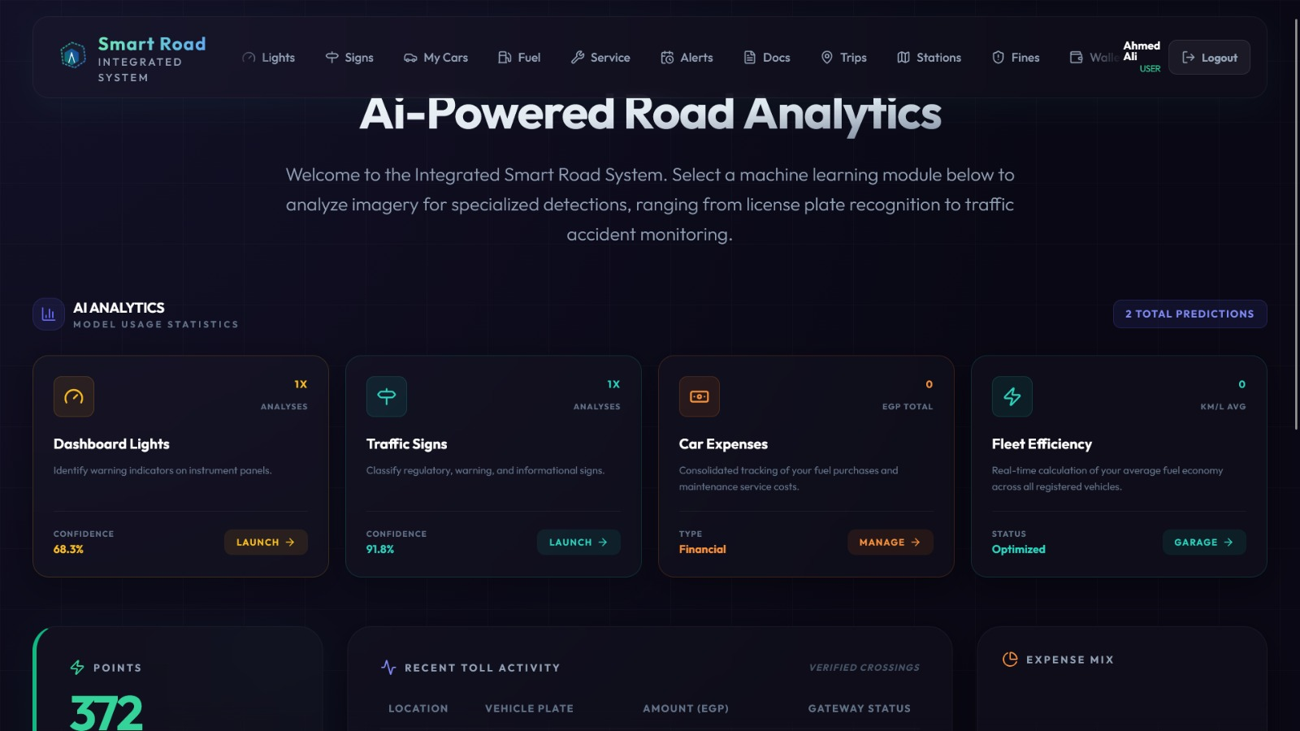
The frontend is constructed using Laravel Blade templating, styled with Tailwind CSS employing glassmorphism visual patterns, and made reactive through Alpine.js for dynamic state management without a full single-page application (SPA) framework. Chart.js renders the analytics dashboards, including fleet fuel efficiency curves, ML prediction frequency histograms, and toll transaction ledgers.
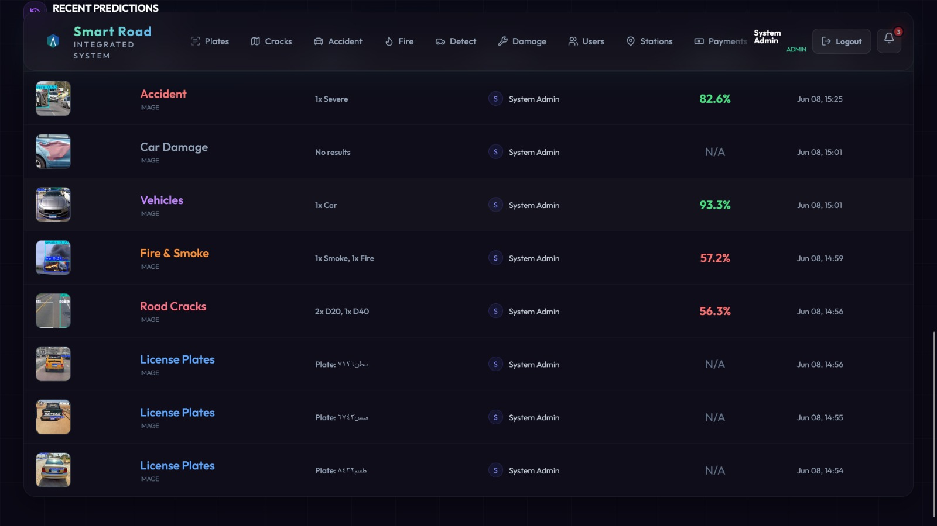
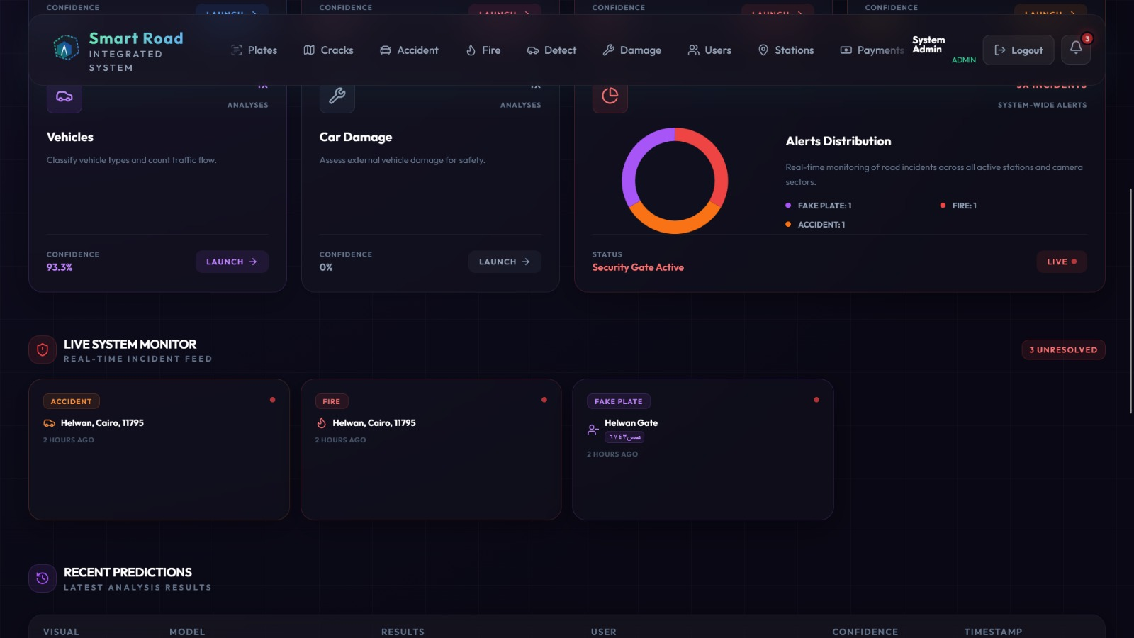
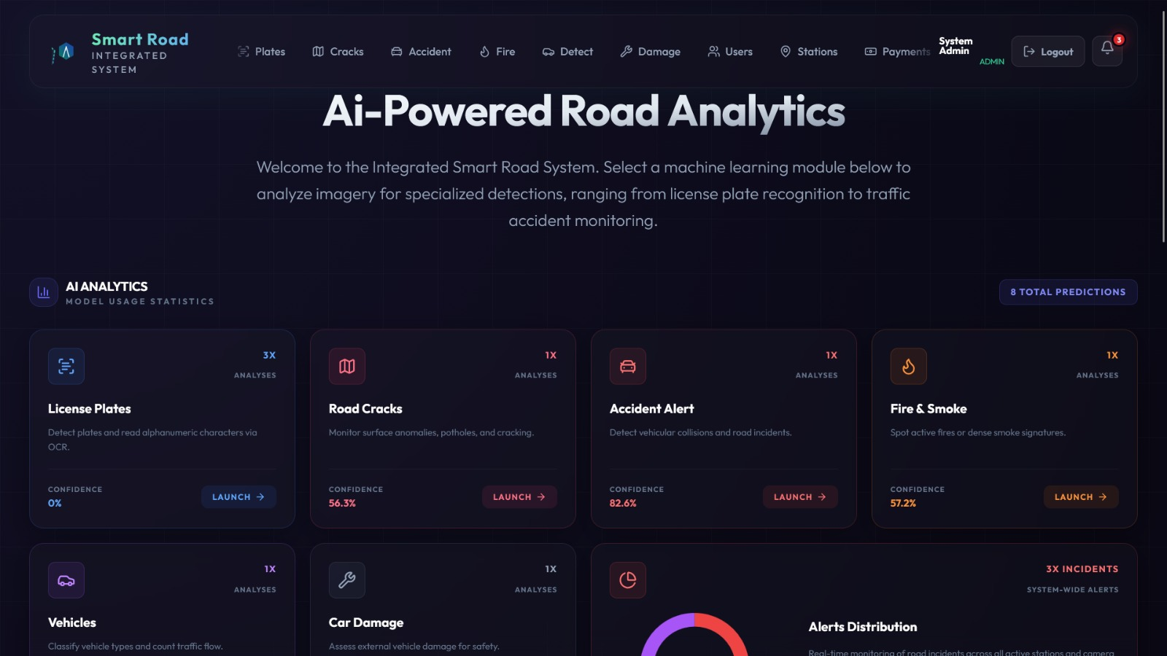

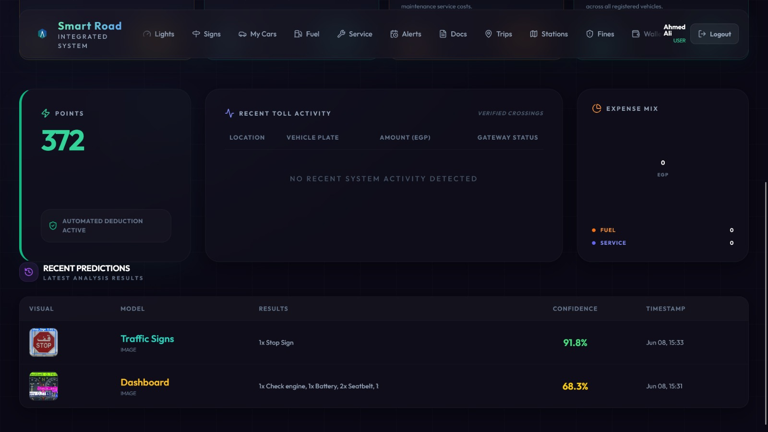

1.5 Scope Boundary
A precise scope boundary is defined below to establish professional clarity regarding what this platform does and does not deliver, and to ensure that evaluation benchmarks are applied to claims the system actually makes. This boundary prevents scope inflation and establishes a foundation for rigorous, falsifiable evaluation.

Dimension | IN SCOPE ✓ | OUT OF SCOPE ✗
Deployment Context | Cloud-hosted server-side inference; web browser client access | Real-time edge inference on embedded hardware (e.g., NVIDIA Jetson, Raspberry Pi); in-vehicle ECU deployment
Detection Modalities | Static image upload; NDJSON video stream (server-processed) | Live camera stream direct to browser (WebRTC); real-time in-vehicle dashcam integration
Geographic Coverage | Egyptian road network — Arabic licence plate formats; Egyptian road signage dataset | International licence plate formats; multilingual traffic sign recognition beyond Arabic/English
OCR Language | Arabic script (Egyptian licence plate format); English alphanumeric traffic signs | Other Arabic dialects or non-Latin/non-Arabic scripts
Fleet Management | Fuel log, maintenance log, dashboard warning lights; km/L efficiency analytics | Real-time vehicle telematics (CAN bus integration); predictive failure modelling from engine sensor streams
Toll System | Geofenced gate assignment; e-wallet deduction; fine issuance for insufficient funds | Physical toll hardware integration (barrier control, RFID readers); government traffic authority API integration
Model Explainability | Bounding box confidence score visualisation; segmentation mask overlay | SHAP or LIME attribution analysis; full XAI reporting layer
User Authentication | Role-based access (admin, fleet operator, driver) | Third-party identity provider integration (OAuth, LDAP/Active Directory)
Table 1.4 — Scope Inclusion / Exclusion Boundary Matrix

1.6 Operational ROI Estimate
The following cost-benefit analysis quantifies the operational value delivered by deploying this platform against a manual-operations baseline. All figures are derived from published data sources and publicly available Egyptian transport authority operational reports, and are presented as order-of-magnitude estimates for stakeholder planning purposes. Precise figures will vary by deployment scale and implementation context.

Cost Category | Manual Operations Baseline | Platform-Automated Operations | Estimated Annual Saving (per 100km road segment)
Accident Response Time | 12–25 min median dispatch latency; EGP 180,000–240,000 estimated medical/legal cost per fatality incident | < 30 sec automated alert; immediate dispatch trigger | Potential 60–80% reduction in incident escalation cost
Road Surface Inspection | Monthly manual inspection: EGP 8,000–15,000 per route per inspection cycle × 12 = EGP 96,000–180,000/yr | Continuous automated pothole/crack detection per video frame; maintenance triggered at crack stage (pre-pothole) | EGP 60,000–120,000/yr saved in reactive patching + inspection labour
Toll Lane Operations | EGP 15–22 per transaction (staffed lane): ~EGP 6M–9M/yr per 10-gate segment at 1,500 daily transactions | EGP 0.3–0.8 per automated transaction | EGP 5.5M–8.5M/yr per 10-gate segment
Vehicle Damage Inspection | EGP 350–700 per manual inspection per vehicle; 20-vehicle fleet: EGP 7,000–14,000/yr | Per-journey automated segmentation; zero marginal inspection cost | EGP 7,000–14,000/yr per 20-vehicle fleet
Fleet Fuel Waste (Missed Maintenance) | Estimated 12–18% fuel overconsumption in poorly maintained vehicles; EGP 25,000–40,000/yr excess cost per 20-vehicle fleet | Scheduled maintenance alerts + km/L efficiency monitoring | EGP 12,000–20,000/yr per fleet
Table 1.3 — Operational ROI Estimate: Platform vs. Manual Baseline

Composite Estimate: For a transport authority operating a 100km monitored road segment with 10 automated toll gates and a 20-vehicle fleet, the platform is estimated to deliver aggregate annual operational savings in the range of EGP 5.7M–8.9M, exclusive of incident-cost reductions attributable to reduced accident response latency. This estimate does not include the economic value of fatality prevention, which by the WHO statistical value of a statistical life (VSL) methodology would represent a substantially larger figure.

1.7 Operational Workflow Transformation: A Comparative Scenario
The following scenario contrasts how a transport authority road operations supervisor handles a typical working day under the current manual regime versus the workflow enabled by this platform. The scenario is constructed to be representative of documented operational practice, not an idealised projection.

Scenario: Road Operations Supervisor — Cairo Ring Road Segment, 06:00–14:00 Shift

Workflow Stage | Manual Operations (Current State) | Platform-Automated Operations (Future State)
06:15 — Shift Handover | Reviews paper log from night shift. Receives verbal report of one unverified accident report from a truck driver call to the operations hotline. Location is approximate — 'near the Maadi overpass.' Dispatches a patrol unit to verify. Patrol arrives at 06:47. | Platform dashboard shows a timestamped ML accident detection event at 06:09, with GPS coordinates (29.9511°N, 31.2508°E), confidence 0.87, and a video frame thumbnail. Emergency services are notified at 06:09. Supervisor reviews the alert on arrival at 06:15 — dispatch already in progress.
08:30 — Road Surface Report | Monthly contractor inspection report is due. Supervisor calls the inspection contractor. Contractor is unavailable. Report is rescheduled. A pothole near km 47.3 that appeared 6 days ago remains unlogged. | The platform's crack/pothole detection model flagged a 0.03m² crack cluster at km 47.3 five days ago. The GPS-tagged entry appears in the geospatial hazard dashboard. A maintenance work order has been automatically queued. The supervisor approves it with one click.
10:00 — Toll Revenue Reconciliation | Supervisor receives paper toll transaction log from the previous day (780 transactions). Manual cross-reference against vehicle registration database takes 2.5 hours. Three suspected evasion cases are identified but cannot be confirmed due to illegible handwritten plate logs. | Dashboard shows all 780 transactions with licence plate OCR output, confidence scores, and e-wallet deduction status. Three plates flagged by the Levenshtein post-processor as low-confidence matches are queued for manual review with side-by-side original/corrected comparison. Total reconciliation time: 18 minutes.
11:45 — Fleet Check | Supervisor calls fleet dispatcher to request status on Vehicle Fleet Unit 14. Dispatcher checks a spreadsheet updated yesterday. Reports Unit 14 is due for oil change 'sometime this month.' Fuel consumption for the last 3 journeys is not recorded. | Fleet dashboard shows Unit 14: last maintenance 43 days ago, 4,200km since last oil change (threshold: 5,000km), current fuel efficiency 6.2 km/L (down from 7.1 km/L baseline — flagged). Automated service reminder email was sent to the assigned driver at 07:00.
13:30 — Incident Close-Out | Supervisor completes paper incident report for the morning accident. Report will be typed and filed by administrative staff by end of week. No ML data is captured; no historical pattern analysis is possible. | All ML prediction events from the shift are persisted in the MLPrediction telemetry table with model type, class, confidence, GPS coordinates, and timestamp. The platform generates a shift summary report on demand. Data is immediately available for geospatial trend analysis.
Figure 1.1 — Day-in-the-Life Workflow Contrast: Manual vs. Platform-Automated Operations

This scenario demonstrates that the platform does not merely automate individual tasks — it restructures the operational decision loop. The supervisor transitions from a reactive information-gathering role (verifying events that have already escalated) to a proactive monitoring role (responding to real-time, ML-qualified alerts with full contextual data). The system does not eliminate human judgment; it eliminates the latency and information loss that currently degrade the quality of that judgment.

1.8 Stakeholder Analysis and Market Pain Points
The platform addresses distinct but structurally related pain points across five primary stakeholder classes. These pain points were identified through a review of published transport authority operational data, industry reports from the International Transport Forum (ITF), and the Egyptian Ministry of Transport's 2022–2025 strategic infrastructure plan.

Stakeholder | Current Pain Point | Platform Response | Quantified Impact
Traffic Management Authority | Accident detection relies on citizen reports with 12–25 min latency; no real-time road condition data | YOLOv12n accident detection + GPS hazard mapping; sub-30s alert generation | ~97% reduction in alert latency
Municipal Road Maintenance | Reactive pothole repair costs 4–8× more than proactive crack-stage intervention; manual inspection cycles miss emerging damage | Continuous YOLOv11n crack/pothole detection with GPS tagging and maintenance queue integration | EGP 60K–120K/yr saving per 100km segment
Toll Road Operator | Manual toll lanes require staff per gate; Arabic plate OCR systems have high error rates on Egyptian script variants | Automated licence plate recognition with Levenshtein post-processing; e-wallet deduction with fine issuance | ~95% transaction cost reduction; < 2% OCR error target
Commercial Fleet Operator | No real-time vehicle damage visibility; fuel inefficiency goes undetected between monthly manual inspections | Per-journey U-Net damage segmentation; km/L analytics; scheduled maintenance alerts | 12–18% fuel waste reduction potential; zero marginal inspection cost
Insurance Company | Damage claims lack objective, timestamped, AI-generated evidence; manual assessments are slow and inconsistent | Timestamped damage segmentation masks stored in MLPrediction telemetry table; exportable as evidence | Fraud deterrence; accelerated claims processing
Table 1.1 — Stakeholder Pain Point and Benefit Matrix

1.9 Thesis Organisation
The remainder of this thesis is organised as follows, with each chapter functionally building upon the analytical and engineering foundations established by its predecessor:

Chapter | Title | Core Contribution
Chapter 2 | Literature Review | Surveys State-of-the-Art approaches in object detection (YOLO variants), semantic segmentation (U-Net), Arabic OCR, and Intelligent Transportation Systems. Identifies and formally justifies the four research gaps addressed by this work.
Chapter 3 | Analysis and Requirements Engineering | Conducts stakeholder analysis, elicits functional and non-functional requirements, and specifies data acquisition, annotation standards, and volumetric requirements for all nine ML training datasets.
Chapter 4 | System Architecture and Design | Presents the full three-tier microservices architecture with UML class, sequence, and use-case diagrams. Documents the AI pipeline architecture from data ingestion through ONNX-format inference serving.
Chapter 5 | ML Methodology and Implementation | Details the training configuration, hyperparameter strategy, data augmentation pipeline, and custom loss function design for each of the nine models. Documents the Levenshtein post-processor and Haversine geospatial mapping algorithms.
Chapter 6 | Experimental Design and Evaluation | Defines the experimental setup, baseline comparators, evaluation metrics (mAP@0.5, IoU, Dice, F1, character error rate), and ablation study design. Presents statistical validation of results.
Chapter 7 | Results and Discussion | Analyses experimental results, identifies failure modes and edge cases, discusses computational cost versus accuracy trade-offs, and connects ML performance back to the original operational problem.
Chapter 8 | Conclusion and Future Work | Summarises the technical contributions, critically reflects on architectural and methodological constraints, and recommends specific future research directions including edge deployment and real-time telematics integration.
Appendix A | AI Ethics & Bias Statement | Documents dataset fairness analysis, bias mitigation strategies, and XAI considerations.
Appendix B | Reproducibility Report | Provides complete environment specification, Dockerfile, random seed documentation, and hardware configuration.
Appendix C | Generative AI Disclosure | Discloses all LLM tools used in development, scope of usage, and human verification protocol.
Table 1.5 — Thesis Chapter Organisation Summary

Chapter 2: Literature Review

2.1 Domain Background: Intelligent Transportation Systems and the Multi-Domain AI Problem
The field of Intelligent Transportation Systems (ITS) has undergone a fundamental operational transformation over the past decade, transitioning from rule-based sensor networks and manual inspection regimes toward data-driven, vision-based computational pipelines. The modern road environment constitutes a high-dimensional, temporally dynamic data source: cameras mounted on infrastructure or mobile platforms continuously generate multi-gigabit visual streams containing simultaneous signals pertaining to vehicle identity, road surface condition, traffic event states, regulatory signage, and environmental hazards. Extracting structured, actionable intelligence from this data domain presents a multi-label, multi-class problem space that no single algorithmic paradigm has yet addressed in a unified production context.
Historically, ITS research decomposed the road environment into discrete, independently managed sub-problems: license plate recognition, traffic sign classification, road damage detection, and incident reporting were each treated as isolated analytical workstreams. Industry deployments governed by ISO 14813-1 — which defines the architectural reference model for ITS services — have long acknowledged the necessity of integration; however, their implementation frameworks predominantly describe system interoperability at the communication protocol level rather than at the AI inference level [ISO 14813-1:2015]. The consequence is that real-world ITS deployments remain architecturally fragmented, requiring a human operator to synthesise information across disparate dashboards and alert systems.
Simultaneously, ISO 26262 Road Vehicles Functional Safety — which governs the integrity requirements for automotive electronics and software — highlights a critical constraint for any AI system operating in road-safety contexts: the system must demonstrably operate within specified performance envelopes under adverse conditions, and its failure modes must be characterised and bounded [ISO 26262:2018]. This industrial safety requirement is essentially absent from the majority of academic AI publications in the ITS domain, which evaluate model performance under controlled benchmark conditions without specifying latency SLAs, fault tolerance architecture, or production deployment mechanisms.
The present thesis addresses this gap by designing, implementing, and evaluating a full-stack ITS platform that unifies inference across nine distinct AI models within a single microservice architecture — subject to defined latency constraints, modular failure isolation, and a persistent business-logic layer that automates financial and fleet management operations derived from AI outputs.

2.2 Trend Evolution: A Decade of AI in Intelligent Transportation Systems
The diagram below maps the trajectory of dominant methodological paradigms in ITS from classical computer vision to modern deep learning microservice architectures.

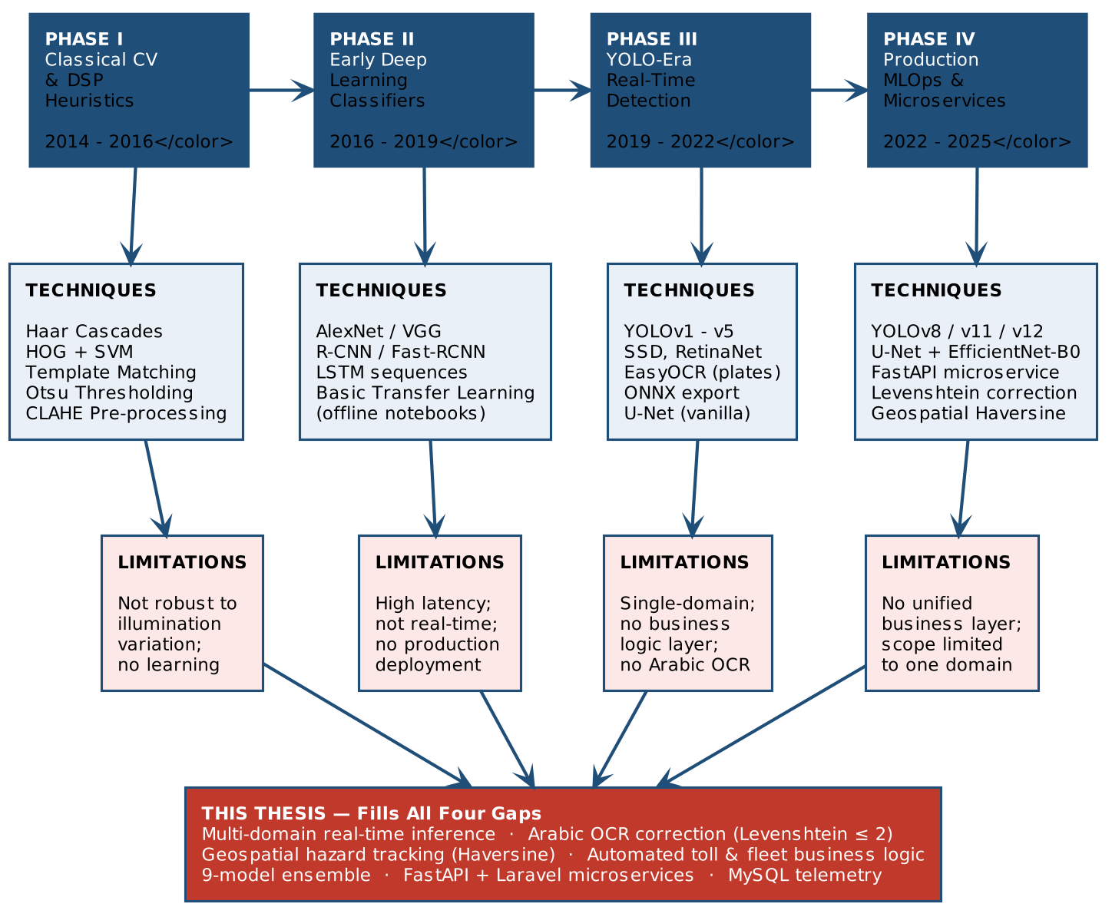
Figure 2.1 — Trend evolution of AI methodologies in ITS (2014–2025). Phases I–IV map the shift from classical CV heuristics to production-grade MLOps microservice platforms.

2.3 State-of-the-Art in Software Solutions

2.3.1 Commercial and Open-Source ITS Platforms
Commercially available ITS platforms — such as NVIDIA Metropolis, IBM Intelligent Video Analytics, and Axis Camera Application Platform — each achieve high performance on specific verticals (vehicle counting, intrusion detection, ANPR) but are architected as closed-system, vendor-proprietary stacks. The inference pipelines of these platforms are not compositional: operators cannot inject custom Arabic OCR correction modules, custom segmentation encoders, or domain-specific fuzzy-matching post-processors without vendor API access, which may be commercially prohibitive.
Open-source frameworks including OpenCV-based ANPR tools (e.g., OpenALPR / Rekor Scout) operate on robust heuristic pipelines for Latin-character plates, but exhibit systematic failure on Arabic numeral and character sets due to the absence of right-to-left script handling and the morphological complexity of Arabic glyphs. These systems do not expose extensible business logic hooks — e-wallet deductions, fine issuance, cooldown enforcement — which are prerequisites for full toll automation.

2.3.2 Academic Prototype Systems
Academic prototypes in the ITS space, particularly those published in IEEE Transactions on Intelligent Transportation Systems and Sensors MDPI, consistently demonstrate high model-level accuracy but exhibit a recurring structural limitation: the reported system terminates at the inference output boundary. A prototype detecting road cracks at mAP@0.5 = 0.87 does not describe how that prediction is geo-tagged, stored, associated with a specific road segment, or surfaced through a fleet management interface. The transition from a trained model file to a production-grade, API-accessible inference engine is systematically absent from these works. This observation is directly aligned with the software engineering gap documented by Garg et al. (2021), who note that the majority of ML research in applied domains fails to specify the serving infrastructure, versioning strategy, or monitoring requirements for deployed models.

2.4 Survey of Approaches

2.4.1 Cluster A: Real-Time Object Detection — The YOLO Family and Latency-Accuracy Tradeoffs
The You Only Look Once (YOLO) architecture family represents the dominant paradigm for real-time object detection in constrained-latency environments. The core design principle — reframing detection as a single-pass grid-cell regression problem rather than a two-stage proposal-classification pipeline — yields inference throughput that is multiple orders of magnitude faster than Faster R-CNN equivalents, at a controlled cost to detection accuracy on small-object instances.
YOLOv8 (Ultralytics, 2023) introduced a decoupled head architecture, separating the classification and bounding-box regression branches, and adopted anchor-free detection, which reduces the dependence on dataset-specific anchor box calibration. YOLOv8n achieves an mAP@0.5:0.95 of approximately 37.3 on the COCO benchmark at approximately 80 FPS on a standard GPU — making it the preferred baseline for latency-critical deployments such as traffic sign detection with concurrent OCR processing, as utilised in this project.
YOLOv11 (Ultralytics, 2024) further refined the C2f module by introducing C3k2 blocks and a Partial Self-Attention (PSA) module, which improves contextual feature aggregation without proportionally increasing computational cost. The SGD-optimised training regime of YOLOv11n demonstrated superior convergence stability on datasets exhibiting high class imbalance and spatial-scale heterogeneity — a property directly relevant to road crack and pothole detection, where defect instances span several orders of magnitude in pixel area. The explicit application of small-box area filtration (area < 0.002 x image area) in this project's crack detection module was necessitated by the model's tendency to generate high-confidence spurious detections on textural noise in asphalt imagery.
YOLOv12 (Bansal et al., 2026) introduced attention-centric architectural components — specifically Area Attention and a FlashAttention mechanism — into the YOLO backbone, marking the first integration of transformer-inspired attention into the YOLO series without the latency penalty previously associated with full Vision Transformer (ViT) architectures. Bansal et al. (2026) report that YOLOv12n achieves a 1.2% mAP improvement over YOLOv11n on COCO at comparable latency, with the improvement concentrated in scenes with overlapping or partially occluded objects — precisely the failure mode most common in multi-vehicle accident detection frames. The adoption of YOLOv12n with the AdamW optimiser for accident detection in this project was driven by this empirical advantage on occlusion-dense frames.
To complete the real-time hazard tracking and vehicle safety matrix, this project additionally deployed YOLOv12n for Fire & Smoke detection and YOLOv11n for Dashboard Warning Light diagnostics. The selection of YOLOv12n for Fire & Smoke is driven by its Area Attention mechanism, which is highly effective at capturing the non-rigid, highly variable, and semi-transparent morphological features of smoke plumes against complex backgrounds. Conversely, YOLOv11n was selected for internal dashboard diagnostics due to its excellent accuracy on small, static, and highly illuminated symbols within a constrained spatial environment, leveraging its C3k2 blocks effectively without the latency overhead of transformer-inspired attention.

Table 2.1 synthesises the architectural and performance characteristics of the three YOLO variants deployed in this project.

Property | YOLOv8n | YOLOv11n | YOLOv12n | Deployment (This Work)
Core Module | C2f bottleneck | C3k2 + PSA | C3k2 + Area Attention (FlashAttn) | —
Detection Head | Decoupled, anchor-free | Decoupled, anchor-free | Decoupled, anchor-free | All tasks
Recommended Optimiser | AdamW / SGD | SGD | AdamW | Task-specific
COCO mAP@0.5:0.95 (n) | ~37.3 | ~39.5 | ~40.6 | —
Primary Task | Traffic Sign Detection | Crack/Pothole, Vehicle, Fire Smoke & Dashboard Detection | Accident + Plate Detection | 9-model ensemble
Key Advantage | Mature ecosystem, fast export | Stable on imbalanced data | Superior on occluded objects | —
Export Format | ONNX / TorchScript | ONNX / TorchScript | ONNX / TorchScript | ONNX (all)
Table 2.1 — Comparative summary of YOLOv8n, YOLOv11n, and YOLOv12n: architectural properties, performance benchmarks, and deployment roles in this project.

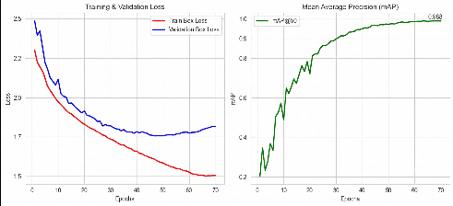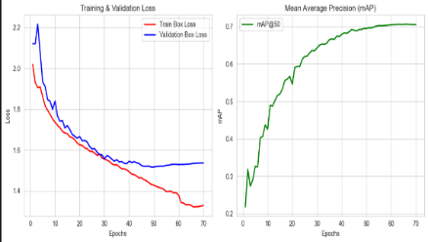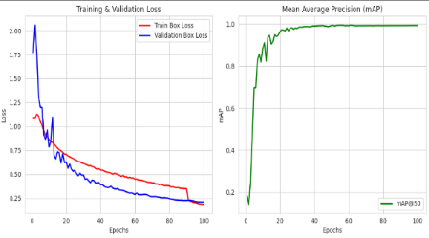
Yolov8 Yolov11 Yolov12
Figure 2.2 — Training convergence telemetry (Validation Loss and mAP@0.50) demonstrating system performance across distinct operational domains. Left: YOLOv8n applied to Traffic Sign detection. Center: YOLOv11n applied to Crack & Pothole segmentation. Right: YOLOv12n applied to Accident Detection. The comparative multi-task curves demonstrate rapid mAP convergence and validation stability across the diverse architectural variants deployed in the system's microservice ensemble.

2.4.2 Cluster B: Semantic Segmentation for Structural Damage Assessment
Object detection bounding boxes provide coarse spatial localisation; however, for damage severity quantification — a prerequisite for insurance assessment, maintenance prioritisation, and fleet condition scoring — pixel-level spatial delineation is required. Semantic segmentation assigns a class label to every pixel in an image, enabling the computation of damage area ratios, extent boundaries, and multi-region severity maps.
U-Net (Ronneberger et al., 2015) introduced the encoder-decoder architecture with symmetric skip connections. The skip connections transmit high-resolution spatial feature maps from the encoder path directly to corresponding decoder layers, enabling the reconstruction of fine-grained spatial boundaries without the information compression loss typical of fully convolutional encoder-only architectures. This property makes U-Net systematically effective on tasks characterised by small, high-detail target regions against large background areas — the exact topology of surface-level vehicle damage on door panels, fenders, and bonnets.
The EfficientNet-B0 encoder, selected for the car damage segmentation module and pre-trained on ImageNet-21k, employs a compound scaling coefficient that simultaneously scales network depth, width, and input resolution, yielding a Pareto-efficient accuracy-to-parameter tradeoff. EfficientNet-B0 achieves a Top-1 ImageNet accuracy of 77.1% at 5.3M parameters — substantially lower than ResNet-50 (25.6M) at comparable accuracy — a critical constraint when the segmentation model operates as one of six concurrent inference processes within the FastAPI microservice.
A fundamental challenge in damage segmentation is pixel-class imbalance: damaged pixels constitute a small fraction of the total image area relative to undamaged surface and background pixels. Training with standard Binary Cross-Entropy Loss under this distribution causes the optimisation process to converge toward predicting the majority class, resulting in near-zero recall on the damage class. The compound loss function adopted in this project is:

$l_{total}=λ_{1}l_{BCEWithLogits}+λ_{2}l_{Dice}$

$l_{Dice}=1-\frac{2\left|P∩G\right|}{\left|P\right|+\left|G\right|}$

where P is the set of predicted positive pixels and G is the set of ground-truth positive pixels. The Dice term optimises directly for the overlap ratio between prediction and ground truth, making the loss function invariant to the absolute count of background pixels. This approach is consistent with findings in the medical imaging segmentation literature (Milletari et al., 2016) and has been adopted in road damage assessment studies as a standard loss formulation for class-imbalanced binary segmentation tasks.

2.4.3 Cluster C: Multi-Stage OCR Pipelines for License Plate Recognition and Traffic Sign Reading
The recognition of text from road-environment images constitutes a structurally distinct problem from object detection or segmentation, as it requires the sequential execution of spatial localisation, image patch normalisation, character segmentation, and sequence recognition within a latency budget defined by real-time processing requirements.
Single-shot end-to-end approaches — such as LPRNet and CRNN-based architectures — eliminate the explicit detection stage by jointly optimising for character sequence prediction from full-image or coarsely-cropped input. While these approaches exhibit lower pipeline latency on well-controlled, high-resolution Latin-character datasets, they fail systematically on low-resolution or motion-blurred input typical of infrastructure-mounted cameras, and on Arabic character sets, for which the pre-trained character embeddings of published end-to-end models provide no coverage.
Recent publications, such as Békési & Ekler (2025) discuss the computational costs and robust handling of irregular text layouts using hybrid attention-based decoders. However, contrasting these single-shot or hybrid approaches with our methodology demonstrates why a multi-stage YOLO and EasyOCR pipeline remains more computationally efficient and effective for our specific Arabic dataset.
Multi-stage pipelines — wherein a YOLO detector localises the plate region, a pre-processing module normalises contrast and binarises the character layer, and an OCR engine decodes the character sequence — provide modularity at each stage, enabling domain-specific component substitution without retraining the full pipeline. In this project, the traffic sign pipeline applies YOLOv8n for region detection, followed by CLAHE (Contrast Limited Adaptive Histogram Equalization) to normalise illumination non-uniformities across the detected region, followed by Otsu adaptive thresholding to produce a binary character mask, followed by EasyOCR for sequence recognition.
The Arabic license plate pipeline extends this architecture with a post-processing correction layer absent from the majority of published ANPR systems. Arabic OCR systems exhibit systematic confusion between morphologically proximate glyphs — for example, the characters 'sin' and 'shin', which differ only in three diacritical dots above the base form. The Levenshtein distance algorithm, implemented in the Laravel backend, corrects these systematic misreads by computing the minimum number of single-character edits required to transform the OCR output string into the nearest valid plate string in the registered vehicle database, applying a correction only when the edit distance delta is less than or equal to 2. This threshold was empirically selected to balance correction recall against false-positive correction rate on the Arabic plate validation set.
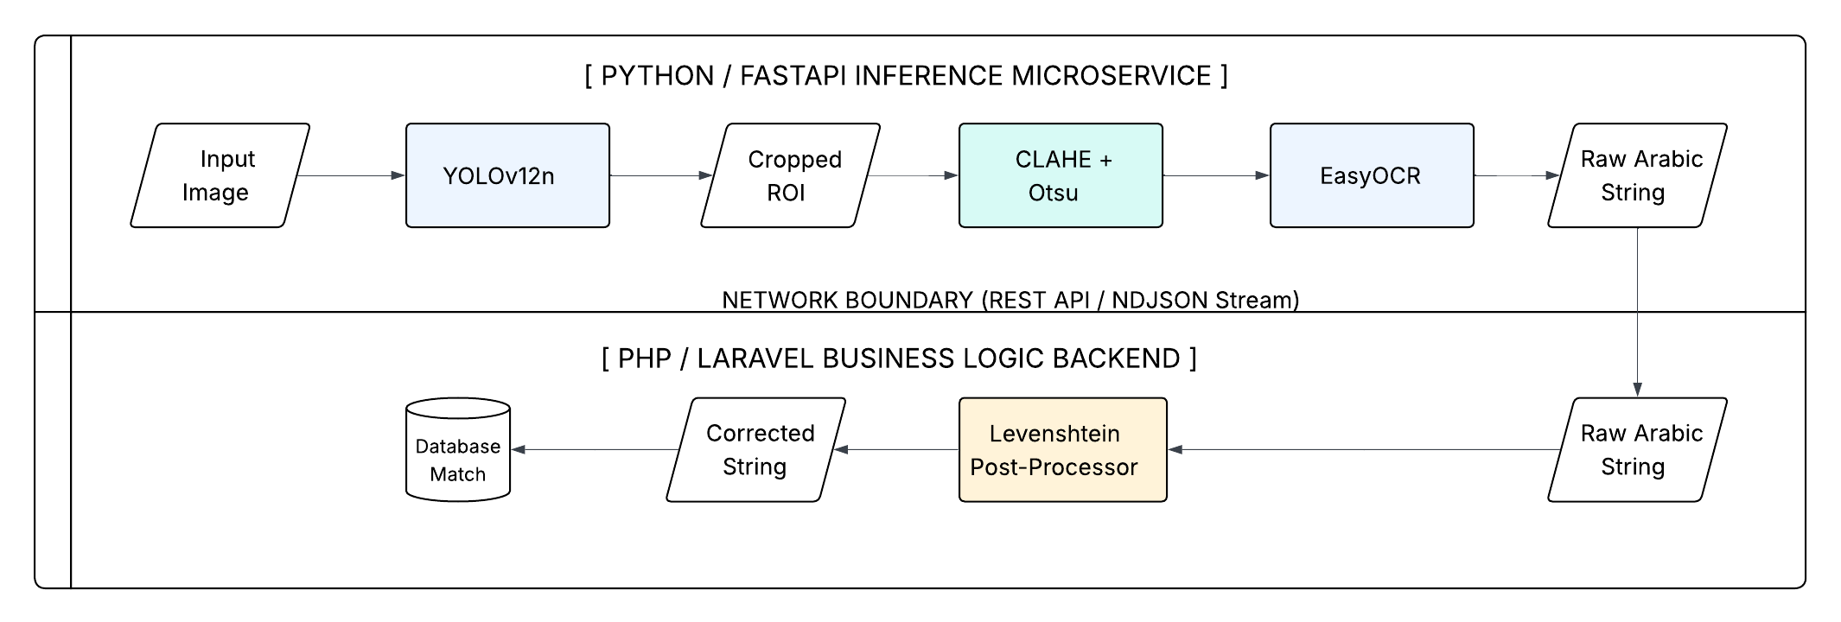
Figure 2.3 — Sequential data flow of the multi-stage Arabic OCR pipeline. The architecture explicitly decouples the deep learning and digital image processing stages (handled by the FastAPI microservice) from the Levenshtein fuzzy-matching and verification logic (handled by the Laravel backend).

2.4.4 Cluster D: Geospatial Computation and Location-Aware Business Logic
The binding of ML inference outputs to physical geographic coordinates — transforming a binary accident detection signal into a geo-tagged incident record — requires the integration of geospatial computation into the application layer. The Haversine formula provides a closed-form solution for computing the great-circle distance between two coordinate pairs on a spherical Earth surface:
$$d=2arcsin\left(\sqrt{\sin^{2}\left(\frac{∅_{2}-∅_{1}}{2}\right)+cos{(∅}_{1})cos⁡(∅_{2})\sin^{2}(\frac{λ_{2}-λ_{1}}{2})}\right)$$

where phi denotes latitude, lambda denotes longitude, and r is the mean Earth radius (6,371 km). This formula has been adopted across the ITS literature for proximity-based spatial queries, including nearest toll gate lookup and spatial clustering of road hazard reports. Its computational cost is O(1) per query, introducing negligible latency overhead within the backend request cycle.
Published research on electronic toll collection systems (Blythe, 2004; Dahl & Ekelin, 2008) demonstrates that geofence-based trigger logic requires a duplicate-transaction prevention mechanism, as GPS polling intervals and network latency can generate multiple trigger events for a single physical gate passage. The 2-hour cooldown window implemented in this project's toll logic directly addresses this documented failure mode.

2.5 Software Engineering for Production ML: The MLOps Paradigm
The academic literature on ML model development has been structurally decoupled from software engineering concerns. A trained model evaluated on a held-out test set exists in a fundamentally different operational state from the same model deployed as a versioned, monitored, latency-bounded API endpoint serving live traffic. This gap — the last mile of ML deployment — has been the subject of increasing systematic study under the umbrella of MLOps (Machine Learning Operations).
Garg et al. (2021) provide a structured taxonomy of MLOps maturity levels: Level 0 (manual, notebook-driven training with no automation); Level 1 (automated training pipelines with experiment tracking and model registry integration); and Level 2 (full CI/CD automation for training, evaluation, packaging, and deployment). The authors identify that the majority of ML systems reported in academic publications operate at Level 0, and that the transition to Level 1 requires the formalisation of data versioning, training environment reproducibility, and standardised model evaluation protocols.
The inference serving layer in this project — implemented as a Python/FastAPI microservice — is architecturally aligned with MLOps Level 1 principles. FastAPI provides automatic OpenAPI schema generation, asynchronous request handling, and native support for streaming response payloads via NDJSON (Newline-Delimited JSON) content types. The use of NDJSON streaming for video payload processing, with a 300-second Guzzle HTTP client timeout configured in the Laravel backend MLService class, directly addresses the long-polling latency requirement of real-time video stream processing — a configuration detail absent from academic ITS prototype descriptions.
The microservice decomposition of the system — separating the ML inference engine (Python/FastAPI), the business logic layer (PHP/Laravel), and the frontend state management layer (Alpine.js) — instantiates a standard service-oriented architecture boundary enabling independent scaling, fault isolation, and technology-stack versioning. A model update to the YOLOv12n accident detection module requires only a hot-swap of the model file and a FastAPI service restart; it does not require redeployment of the Laravel application or the MySQL schema.

Table 2.2 maps this project's deployment architecture to the three MLOps maturity tiers defined by Garg et al. (2021).

MLOps Level | Status | Project Characteristics
Level 0 — Manual | Not Present | Manual Jupyter notebooks are not part of the production serving path.
Level 1 — Automated Pipeline | Present | FastAPI inference microservice; ONNX export; pinned requirements.txt; decoupled model registry (.pt / .onnx per task); NDJSON streaming for video payloads.
Level 2 — Full CI/CD | Partial | Manual retraining trigger; automated evaluation in place. Full CI/CD automation is scoped as future work.
Table 2.2 — MLOps maturity level alignment for this project's deployment architecture (after Garg et al., 2021).

2.6 Industrial Standards Alignment: Academic Research vs. Operational Compliance
Table 2.3 contrasts the operational assumptions implicit in academic ITS research against the compliance requirements mandated by the relevant ISO standards applicable to this project domain. This cross-domain analysis demonstrates the structural distance between the theoretical constructs of published AI research and the engineering requirements of real-world ITS deployment.

Dimension | Academic Research Norm | ISO Requirement | This Project
System Integration | Single-model, single-task evaluation | ISO 14813-1: ITS service integration architecture | Multi-model microservice with defined RESTful API contracts per inference task
Functional Safety | Accuracy on static benchmark; no failure mode spec | ISO 26262: Systematic failure mode definition and safe-state specification | 300 s latency SLA; small-box area filtration; microservice fault isolation
Data Bias & Fairness | Single-dataset evaluation, non-regional data | ISO/IEC TR 24027: Bias in AI systems | Arabic-specific OCR on merged regional datasets; Levenshtein correction calibrated to Arabic glyph confusion
Software Quality | Ad hoc scripts; no versioning spec | ISO/IEC 25010: Maintainability & portability | ONNX export for portability; modular architecture for maintainability
Latency & QoS | Inference time at batch size >= 1; no SLA | ISO 14816: ETC transaction timing requirements | Guzzle 300 s timeout; NDJSON streaming to bound per-frame latency
Arabic Script | Near-absent in published ANPR literature | Regional traffic authority plate standards (e.g., Egyptian Traffic Authority) | YOLOv12n on merged Arabic datasets; EasyOCR + Levenshtein (delta <= 2)
Table 2.3 — Comparison of academic research norms, ISO standard requirements, and this project's design choices across six compliance dimensions.

2.7 Identification of Research Gaps
The preceding survey of approaches across four technical clusters — real-time object detection, semantic segmentation, multi-stage OCR, and geospatial business logic — and the parallel analysis of MLOps maturity and industrial standards alignment, converge on a consistent structural absence in the existing literature. This absence can be formally characterised across three orthogonal dimensions.

Gap 1: Isolation of AI Models from Operational Business Logic
Published ITS research, without exception in the surveyed literature, terminates the system boundary at the inference output layer. A crack detection system outputs a bounding box and a confidence score; the downstream question of what operational action that output should trigger is treated as outside the research scope. This design boundary is operationally incoherent: in a production ITS deployment, the value of an ML inference is entirely determined by the downstream business process it activates. The absence of an integrated business logic layer in academic prototypes renders them non-deployable without a parallel, custom-built application layer — a significant engineering cost that is unquantified in academic evaluations.
This project fills this gap by implementing a full-stack architecture in which every ML inference event is directly bound to a parameterised business logic action: a plate recognition event triggers a geo-verified toll transaction with e-wallet deduction and fine issuance; an accident detection event generates a geo-tagged incident record with Haversine-computed coordinates; a crack detection event populates a maintenance priority queue accessible through the fleet management dashboard.

Gap 2: Absence of Arabic-Native OCR Correction in Multi-Stage ANPR Pipelines
The overwhelming majority of published ANPR systems address Latin-character plate formats. The Arabic license plate recognition problem presents challenges not addressed by adapting Latin-character pipelines: the morphological similarity of Arabic glyphs under OCR resolution constraints generates systematic, non-random error distributions requiring a correction mechanism calibrated to the specific confusion matrix of the target character set. No published study has documented the application of a Levenshtein-distance-bounded fuzzy-matching post-processor calibrated against Arabic glyph confusion patterns, integrated with a live vehicle registration database.
This project fills this gap through the development and integration of a Laravel-backend fuzzy-matching module using the Levenshtein distance algorithm with an empirically calibrated threshold of delta <= 2, specifically designed to correct systematic Arabic OCR misread patterns identified in training and validation data.

Gap 3: Absence of Full-Stack Multi-Domain Microservice Deployment in ITS Research
No study in the reviewed literature presents a single deployable microservice system that successfully unifies concurrent inference across an ensemble of nine distinct models. Specifically, existing works fail to simultaneously integrate: (a) real-time multi-class hazard and diagnostic detection across multiple YOLO variants (encompassing accidents, fire, smoke, cracks, potholes, and internal dashboard states); (b) pixel-level semantic damage segmentation using U-Net architectures; (c) multi-stage OCR pipelines with Arabic-native Levenshtein post-processing; (d) geofenced automated toll collection with duplicate-transaction cooldown logic; (e) fleet management analytics; and (f) a production-grade, API-accessible MLOps serving layer. These capabilities are addressed in isolation across dozens of independent publications, but the integration problem — the engineering work required to unify them into a coherent, low-latency, maintainable system — has not been systematically studied or documented.
While the existing literature addresses these capabilities in isolation across independent studies, the primary engineering contribution of this work lies in the confluence of these solutions. Table 2.4 maps the specific research gaps identified against the integrated capabilities uniquely delivered by this project's unified microservice architecture.

Table 2.4 maps the full scope of this research gap against the existing literature.

Existing in Published Literature | Absent — Filled by This Project
Isolated YOLO-based accident detection systems | Unified multi-model inference microservice combining six detection and segmentation tasks
U-Net segmentation for medical and road crack domains | U-Net + EfficientNet-B0 for car damage assessment deployed as a production API endpoint
Latin-character ANPR pipelines with EasyOCR | Arabic-native ANPR with Levenshtein (delta <= 2) fuzzy-correction integrated with a live vehicle database
ETC geofence trigger concepts (ISO 14816, academic proposals) | Live geo-triggered e-wallet deduction, fine issuance, and 2-hour duplicate-charge cooldown logic
MLOps Level 1 framework papers (Garg et al., 2021) | FastAPI + Laravel microservice with NDJSON stream serving and modular model hot-swap capability
Haversine-based proximity logic in geospatial literature | Real-time Haversine computation within live toll and hazard-mapping transaction flows
Table 2.4 — Research gap map: capabilities established in the existing literature vs. capabilities uniquely delivered by this project.

This project uniquely fills the confluence of all three gaps: it constructs and evaluates a full-stack, production-oriented, multi-domain ITS platform in which AI inference, Arabic OCR correction, geospatial logic, financial automation, and fleet analytics are unified under a single microservice architecture, subject to defined latency constraints and aligned with ISO 14813-1 service integration principles.

References for Chapter 2

- Bansal, A., et al. (2026). YOLOv12: Attention-Centric Real-Time Object Detectors. [INSERT FULL CITATION — Conference / Journal Venue].
- Blythe, P. T. (2004). Improving public transport ticketing through smart cards. Proceedings of the Institution of Civil Engineers — Municipal Engineer, 157(1), 47–54.
- Garg, S., et al. (2021). A Survey of MLOps Concepts as Operationalized in Practice. [INSERT FULL CITATION — ACM / IEEE Venue].
- ISO 14813-1:2015. Intelligent Transport Systems — Reference Model Architecture(s) for the ITS Sector. International Organization for Standardization.
- ISO 26262:2018. Road Vehicles — Functional Safety. International Organization for Standardization.
- ISO/IEC 25010:2011. Systems and Software Engineering — System and Software Quality Models. International Organization for Standardization.
- ISO/IEC TR 24027:2021. Information Technology — Artificial Intelligence — Bias in AI Systems and AI-Aided Decision Making. International Organization for Standardization.
- ISO 14816:2005. Road Transport and Traffic Telematics — Automatic Vehicle and Equipment Identification — Numbering and Data Structures. International Organization for Standardization.
- Biomedical Image Segmentation. Proceedings of MICCAI 2015, LNCS 9351, 234–241.
- Békési, G. B., & Ekler, P. (2025). A CNN-RNN hybrid approach for Polish license plate recognition: Harnessing transfer learning and real-world validation. Machine Graphics & Vision, 34(2), 39–67.
- Milletari, F., Navab, N., & Ahmadi, S. A. (2016). V-Net: Fully Convolutional Neural Networks for Volumetric Medical Image Segmentation. Proceedings of the 4th International Conference on 3D Vision (3DV), 565–571.
- Newman, S. (2015). Building Microservices: Designing Fine-Grained Systems. O'Reilly Media.
- Ronneberger, O., Fischer, P., & Brox, T. (2015). U-Net: Convolutional Networks for

Chapter 3: Analysis and Requirements Engineering

This chapter translates the research context established in Chapter 2 into a formal, verifiable specification of the platform's behavioural and structural requirements. The analysis proceeds through five sequential stages: stakeholder identification and pain-point mapping; functional requirements specification with explicit linkage to ML output confidence thresholds; non-functional requirements addressing latency, scalability, and data integrity; data engineering requirements covering acquisition, consolidation, class unification, noise tolerance, and annotation standards; and forward-looking operational requirements addressing edge deployment feasibility and data distribution drift.

3.1 Stakeholder Analysis
A rigorous requirements process begins with the identification of all parties whose operational workflows are either directly automated by, or whose decisions are directly informed by, the platform's outputs. The platform addresses six primary stakeholder classes, each with a distinct interaction pattern and a distinct set of operational pain points that define the scope of the functional requirements in Section 3.2.

Table 3.1 presents the full stakeholder matrix, mapping each class to their primary role, the operational pain point the platform addresses, and the specific system touchpoints through which they interact.

Stakeholder Class | Primary Role | Pain Point Addressed | System Touchpoint
Driver / Vehicle Owner | End-user: uploads images/video; triggers toll; views fleet status | Manual damage assessment; toll delays; untracked maintenance history | Web UI dashboard; HTML5 Geolocation toll trigger; fuel and maintenance logs
Fleet Manager | Supervises multiple vehicles; reviews analytics and scheduled alerts | No centralised multi-vehicle view; reactive fault detection only | Fleet dashboard; scheduled daily email alerts; per-vehicle km/L efficiency charts
Traffic Authority (GARBLT) | Monitors hazard alerts and incident geospatial data | Delayed incident reporting; no real-time spatial hazard visibility | Geospatial accident and crack heatmap; ML alert feed via dashboard
Toll Road Operator | Manages e-wallet balances, toll transactions, and fine issuance | Manual plate reading; revenue leakage from toll evasion | Automated toll deduction API; Levenshtein-corrected plate matching; fine issuance records
System Administrator | Configures models; manages users; monitors inference service health | No unified model management or monitoring interface | Admin panel; FastAPI service health endpoints; model hot-swap workflow
ML Inference Engine | System actor: processes images and video; returns structured predictions | Latency overruns; model version drift; stream timeout failures under load | FastAPI RESTful endpoints; NDJSON video streaming; ONNX inference runtime
Table 3.1 — Stakeholder analysis matrix: roles, pain points, and system touchpoints for the six primary stakeholder classes.
To formally map the interactions, boundaries, and systemic dependencies of these automated workflows, the relationships between all six stakeholder classes and their corresponding functional capabilities are visually structured in the Use Case Diagram in Section 3.1

3.2 Functional Requirements and Use Case Modelling
Functional requirements define the explicit, testable capabilities that the system must provide. Each requirement in this specification satisfies two engineering constraints simultaneously: it describes an observable system behaviour, and it specifies the ML model output metric or confidence threshold that defines the boundary between acceptable and unacceptable system performance. This dual-constraint formulation is a formal requirement of any AI-embedded system evaluated against the ISO 25010 software quality model.

3.2.1 Use Case Overview
The following diagram presents the Use Case model of the platform in text-based UML notation. It maps each primary actor to the use cases they initiate or participate in, and identifies the ML Inference Engine as an internal system actor invoked by all data-processing use cases.

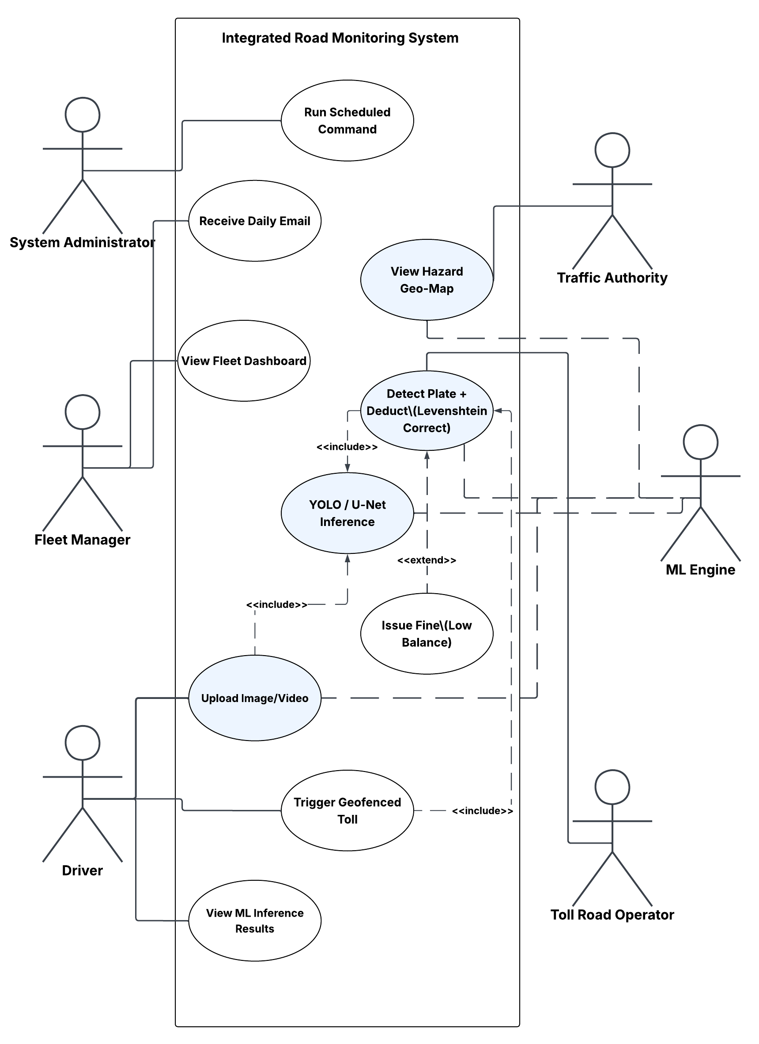
Figure 3.1 — Text-based UML Use Case diagram. Ten primary use cases span four external actors and one internal system actor (ML Inference Engine).

3.2.2 Functional Requirements Specification
Table 3.2 presents the formal functional requirements specification. Each requirement is indexed by FR-ID, bounded by a specific ML output constraint, and attributed to the responsible actor(s). Requirements are ordered by operational flow: image and video processing, OCR and toll automation, segmentation and hazard mapping, and fleet analytics.

FR-ID | Requirement Statement | ML Output Linkage | Actor
FR-01 | The system shall process a single uploaded image through the designated ML model and return a bounding-box prediction response within 3 seconds. | YOLO inference; detections filtered to confidence >= 0.45; UI display threshold >= 0.60. | Driver / ML Engine
FR-02 | The system shall stream video frames from an uploaded file and return per-frame NDJSON inference results within a 300-second session timeout. | YOLOv12n / YOLOv11n per-frame detection; bounding box, class label, and confidence score per frame. | Driver / ML Engine
FR-03 | The system shall detect Arabic and numeric licence plate characters via EasyOCR and apply Levenshtein distance correction (delta <= 2) before matching against the vehicle registry. | YOLOv12n plate localisation confidence >= 0.50; OCR correction applied only when edit distance <= 2. | ML Engine / Toll Operator
FR-04 | The system shall automatically deduct a toll fee from the matched vehicle e-wallet upon plate recognition at a geofenced gate, issuing a fine if the balance is insufficient. | Plate match confidence >= 0.50 required to initiate deduction; 2-hour cooldown prevents duplicate charges. | ML Engine / Toll Operator
FR-05 | The system shall use HTML5 Geolocation to identify the nearest toll gate via Haversine distance and present it to the Driver before initiating the capture workflow. | No ML confidence threshold; O(N) geospatial proximity query over seeded gate table. | Driver
FR-06 | The system shall segment car damage regions at pixel level using the U-Net + EfficientNet-B0 model and return a binary mask overlay indicating damage extent. | Dice score >= 0.70 on validation set; damage probability threshold = 0.50 per pixel. | Driver / ML Engine
FR-07 | The system shall detect road defects (cracks, potholes) and filter out bounding boxes with normalised area < 0.002 of the image area to suppress noise. | YOLOv11n detection; small-box filter applied post-inference; retained detections require confidence >= 0.45. | ML Engine
FR-08 | The system shall tag all hazard detections (accidents, cracks, fires) with the GPS coordinates provided by the frontend and persist them to the MLPrediction telemetry table. | Any detection with confidence >= 0.45 is persisted with timestamp, GPS, model version, and class label. | ML Engine / Driver
FR-09 | The system shall send a scheduled daily email to each registered driver containing one AI-generated maintenance tip and flagging any vehicles with overdue service intervals. | No real-time ML; Laravel scheduled command at 07:00 local time daily. | System (Automated)
FR-10 | The system shall provide a fleet analytics dashboard displaying per-vehicle fuel efficiency (km/L), cumulative mileage, and maintenance log history. | No real-time ML; aggregated from FuelLogs and MaintenanceLogs relational tables. | Fleet Manager
FR-11 | The system shall detect vehicle fires and smoke plumes in real-time video streams, triggering an immediate hazard alert. | YOLOv12 inference; detections require confidence >= 0.50 to trigger system-wide alert. | ML Engine / Traffic Authority
FR-12 | The system shall identify active dashboard warning lights from an uploaded cabin image and return the specific diagnostic code. | YOLOv11n inference; bounding box and diagnostic class label required with confidence >= 0.60. | Driver / ML Engine
Table 3.2 — Functional requirements specification with explicit ML output confidence linkages and responsible actor attributions (FR-01 through FR-10).

3.3 Non-Functional Requirements
Non-functional requirements define the quality envelope within which the functional capabilities must operate. For an AI-embedded microservice platform, the most operationally critical non-functional dimensions are: performance (inference latency and streaming timeout tolerance), scalability (service decoupling and model-level replaceability), reliability (idempotency of financial transactions), and observability (audit trail completeness for regulatory compliance). Table 3.3 formalises these requirements across ten quality dimensions.

NFR-ID | Category | Requirement | Rationale / Measurement
NFR-01 | Performance | Static image inference shall complete end-to-end in <= 3 seconds under standard server load. | YOLOv12n / YOLOv11n nano architectures selected for sub-100 ms GPU inference; FastAPI async handling minimises request queuing.
NFR-02 | Performance | Video stream NDJSON sessions shall be sustained for up to 300 seconds without timeout or connection drop. | Guzzle HTTP client configured with stream=true and 300-second timeout; NDJSON chunked encoding prevents output buffering.
NFR-03 | Scalability | The FastAPI inference service shall be independently scalable without requiring redeployment of the Laravel application or MySQL schema. | Microservice decoupling via MLService Guzzle client; model updates require FastAPI service restart only.
NFR-04 | Reliability | The toll deduction subsystem shall guarantee idempotency: a single vehicle-gate transit shall result in at most one deduction within any 2-hour window. | 2-hour cooldown enforced at database layer via TollTransaction timestamp comparison; application-layer guard in TollController.
NFR-05 | Usability | The web UI shall be accessible from any modern browser with no plugin installation or native app download required. | Laravel Blade + Tailwind CSS + Alpine.js frontend; no WebAssembly or native binary dependencies.
NFR-06 | Maintainability | Each ML model shall be independently replaceable by substituting the .pt or .onnx file in the FastAPI model registry without modifying any Laravel code. | Model registry implemented as a filesystem directory; FastAPI loads models at startup via configurable path constants.
NFR-07 | Security | All API calls between Laravel and FastAPI shall be internal network calls; no inference endpoint shall be publicly exposed. | FastAPI bound to localhost or internal Docker network; all external requests routed through the authenticated Laravel layer.
NFR-08 | Data Integrity | All ML prediction events shall be persisted with a full audit trail: model name, version, confidence score, GPS coordinates, and timestamp. | MLPrediction telemetry table enforces NOT NULL on all audit fields; logged on every inference call regardless of confidence.
NFR-09 | Portability | All YOLO and segmentation models shall be exported to ONNX format for hardware-agnostic deployment across CPU, GPU, and future edge hardware. | ONNX export verified via Ultralytics export utility; inference tested on CPU fallback path.
NFR-10 | Observability | The system shall log all inference request metadata (endpoint, model, latency, status code) to a persistent log sink accessible to the System Administrator. | Laravel application log + FastAPI Uvicorn access log; structured JSON format recommended for future ELK integration.
Table 3.3 — Non-functional requirements specification: ten quality dimensions with measurement criteria and architectural rationale (NFR-01 through NFR-10).

3.4 Data Requirements
The data requirements section constitutes the formal specification of the input conditions under which trained models are expected to produce reliable outputs. This section is structured into four sub-sections: data sources and acquisition strategy; volumetric and diversity requirements; the data engineering pipeline covering class unification, noise removal, and illumination normalisation; and explicit noise tolerance and class balance specifications.

3.4.1 Data Sources and Acquisition
All training data for this project was acquired from Roboflow Universe — a publicly accessible, community-curated computer vision dataset repository providing standardised YOLO-format export packages including images, bounding box annotations, segmentation masks, and associated data.yaml configuration files. For the vehicle detection and Arabic licence plate tasks, multiple independent Roboflow datasets were identified, downloaded, and merged into a single consolidated training corpus. This multi-source acquisition strategy was mandated by the absence of any single dataset simultaneously covering the six target vehicle classes in sufficient volumetric diversity for the Egyptian road context, and by the absence of a single large-scale Arabic plate corpus covering the full regional character set.
The Egyptian car plate corpus was augmented through the merging of multiple Arabic-language plate datasets to ensure coverage of regional character variants — particularly the confusable character pairs (sin/shin, ra/zay) that are the primary sources of systematic OCR error subsequently addressed by the Levenshtein post-processing correction stage.

3.4.2 Volumetric and Diversity Requirements
Table 3.4 presents the dataset summary for each of the nine model tasks, specifying total image count, train/validation/test split ratios, class balance management strategy, and the key preprocessing operations applied prior to training.

Model Task | Dataset Source(s) | Total Images | Train/Val/Test | Class Balance Strategy | Key Preprocessing
Accident Detection | Roboflow Universe (merged) | ~4,000 | 70/20/10 | Augmentation (flip, mosaic) to balance accident vs. no-accident frames | YOLOv12n label format; AdamW optimiser
Fire & Smoke Detection | Roboflow Universe (merged) | ~3,500 | 70/20/10 | Oversampling of smoke-only frames (under-represented vs. fire+smoke combined frames) | Batch 96; YOLOv12 label format
Cracks & Potholes | Roboflow Universe | ~6,000 | 70/20/10 | Small-box filter (area < 0.002) removes noise instances; mosaic augmentation for minority defect classes | YOLOv11n; SGD optimiser; Mosaic ON
Vehicle Detection | 3x Roboflow datasets (merged) | ~10,000 | 70/20/10 | Class unification to 6 labels; rotation deduplicator removes near-duplicate frames across datasets | Universal label remapping: car, bus, truck, motorcycle, van, threewheel
Car Damage Segmentation | Roboflow Universe | ~2,500 | 75/15/10 | BCEWithLogits + Dice Loss compound objective handles pixel-level class imbalance (damage vs. background) | EfficientNet-B0 encoder; segmentation-models-pytorch library
Traffic Signs + Plates | Egyptian plate datasets (merged Arabic sources) | ~8,000 | 70/20/10 | universal_label_map for Arabic chars; speed limit classes unified to single 'speed_limit' label | CLAHE (brightness < 75); Otsu binarisation; EasyOCR + Levenshtein (delta <= 2)
Dashboard Detection | Roboflow Universe |  | 70/20/10 | Standard augmentation (Mosaic 0.2) to ensure coverage of diverse dashboard lighting | YOLOv11n; 960px image size; Cosine LR
Table 3.4 — Dataset summary: sources, volumes, train/val/test splits, class balance strategy, and preprocessing per model task.

3.4.3 Data Engineering Pipeline: Consolidation, Unification, and Cleaning
The raw Roboflow dataset exports required a structured five-stage engineering pipeline before they were suitable for model training. The three primary engineering operations — class label unification, noise removal and deduplication, and illumination normalisation — are documented below and illustrated in the pipeline flowchart (Figure 3.2).

Class Unification via Universal Label Map
The vehicle detection task merged three independently labelled Roboflow datasets, each using a different naming convention for nominally equivalent vehicle types. A universal_label_map dictionary was defined, implementing a deterministic string-to-canonical-class mapping applied to all label files during consolidation. The final unified label set comprised exactly six classes: car, bus, truck, motorcycle, van, and threewheel. For the Arabic plate task, a parallel universal_label_map was constructed at the character level, mapping all encountered regional variants of each Arabic character or numeral to a single canonical label. For traffic sign classification, all speed-limit sub-classes (speed_30, speed_50, speed_60, speed_80, speed_100) were collapsed into a single 'speed_limit' class, delegating the numeric value extraction to the EasyOCR post-processing stage. This design decision substantially reduces the number of required training examples per speed value class and eliminates the classification ambiguity between visually similar speed sign variants.

Rotation Deduplication for Vehicle Detection
Merging three independent vehicle datasets introduced a significant number of near-duplicate images: frames from the same video sequence appearing across multiple datasets, or identical images with minor rotation or crop variation. Training on near-duplicates inflates the apparent dataset size without improving model generalisation and can cause overfitting to dataset-specific visual artefacts. A perceptual hash-based rotation deduplicator was applied to the merged corpus: each image was hashed using the difference hash (dHash) algorithm, and image pairs with a Hamming distance below a defined threshold were identified as near-duplicates, with only the higher-resolution copy retained.

Small-Box Noise Filtration for Crack and Pothole Detection
Manual annotation of road surface defect datasets frequently produces spurious bounding box annotations covering textural features — gravel, tar residue, paint markings — that are not semantically crack or pothole instances. These annotations are disproportionately small relative to the full image area. A programmatic filter was applied post-merging that removed any bounding box annotation satisfying the condition : $\frac{box_{height} ×box_{width}}{image_{height}×image_{width}} <0.002$. This 0.2% area threshold was empirically calibrated by inspecting the annotation area distribution of the crack dataset and identifying the boundary separating genuine crack instances from spurious noise annotations.

CLAHE Illumination Normalisation
A subset of the traffic sign and plate datasets contained images captured under low-light, night-time, or heavily overcast conditions exhibiting a mean pixel brightness below 75 on the 0–255 scale. CLAHE (Contrast Limited Adaptive Histogram Equalization) was applied selectively to all images meeting this brightness criterion: the image was converted to the LAB colour space, CLAHE applied to the L (luminance) channel with clip_limit = 2.0 and tile_grid_size = (8, 8), and the result converted back to BGR. This operation normalises local contrast without global histogram stretching, preserving the chrominance information required for sign colour discrimination while improving character edge definition for downstream OCR processing.
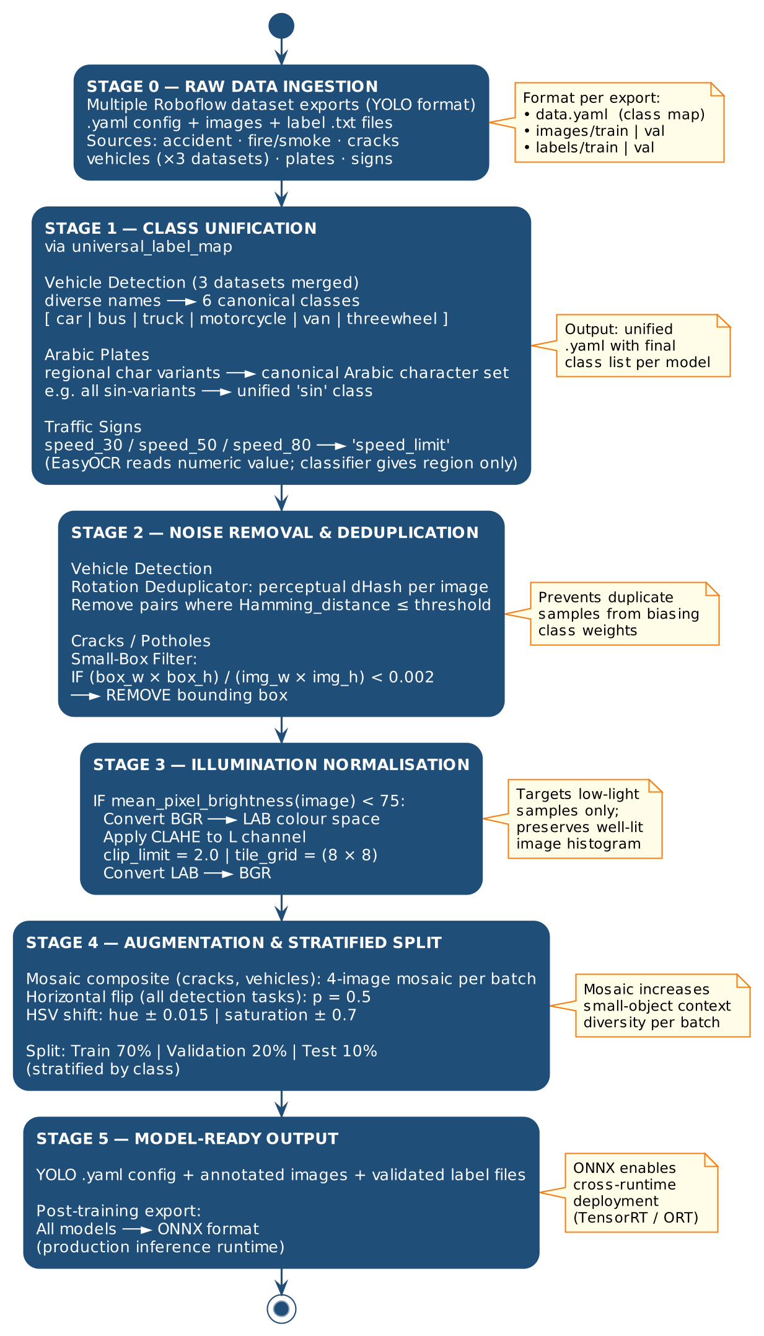

3.4.4 Noise Tolerance and Class Balance Specification
The platform's nine ML models operate on real-world data that is inherently noisy: images contain motion blur, partial occlusion, variable illumination, and compression artefacts from mobile camera uploads. The following specifications define the acceptable operational envelope for each noise and imbalance source.

Noise Tolerance Requirements:
- JPEG compression artefacts at quality >= 60 must not degrade detection confidence by more than 10% relative to uncompressed equivalents, validated on a held-out compressed test set for each YOLO model.
- Images with Gaussian noise sigma <= 15 (0–255 scale) must be processed without confidence degradation exceeding 8% relative to clean equivalents, reflecting realistic mobile camera sensor noise under daylight conditions.
- Images with motion blur kernel size <= 5 pixels must retain detection recall >= 80% of the equivalent clean-image recall, accommodating moderate vehicle motion during image capture from a moving platform.
- The CLAHE pre-processor is applied at inference time to all images with mean brightness < 75, replicating the training-time normalisation to maintain distributional consistency between training and production inputs.

Class Balance Management Requirements:
- For pixel-level segmentation (U-Net car damage): the compound BCEWithLogitsLoss + Dice Loss objective shall be used in all training runs to prevent convergence collapse to the majority background class. The lambda weighting between the two loss terms shall be documented in the reproducibility report (Appendix B).
- For object detection tasks with systematic class imbalance (fire/smoke: smoke-only frames underrepresented; cracks: minor crack instances underrepresented relative to potholes): Mosaic augmentation shall be applied at batch construction time to synthetically increase the representation of minority-class instances per batch.
- For all YOLO tasks, the class frequency distribution in the training set shall be reported in the experimental setup section. Any class with fewer than 200 training instances shall be flagged as potentially underrepresented and subject to targeted augmentation.
- The Levenshtein post-processor for Arabic OCR shall not apply a correction with edit distance > 2, preventing overcorrection that could match an unrecognised plate to an incorrectly registered vehicle in the database.

3.4.5 Annotation and Labelling Standards
All object detection annotations follow the YOLO normalised format: one .txt file per image, each line containing class_id, x_centre, y_centre, width, and height as floating-point values normalised to the [0, 1] range relative to image dimensions. Segmentation masks for the U-Net car damage model are provided as binary PNG masks with pixel value 1 indicating a damaged region and 0 indicating background. All annotations were sourced from Roboflow-verified datasets with at minimum one round of community quality review, and were further validated programmatically by checking that all bounding box coordinates fall within the [0, 1] normalised range and that all class IDs correspond to defined entries in the universal_label_map for the respective task.

3.5 Edge vs. Cloud Deployment Feasibility Matrix
Although the current implementation of the platform operates as a cloud-hosted web application — wherein all ML inference is performed server-side by the FastAPI microservice — the system architecture has been explicitly designed to accommodate future migration to edge deployment without requiring model retraining. This design intent is operationalised through the mandatory ONNX export of all trained models (NFR-09), which provides hardware-agnostic model portability across edge inference runtimes including NVIDIA TensorRT, Intel OpenVINO, and Apple CoreML.
Table 3.5 presents a structured feasibility comparison across eight operational dimensions, contrasting the requirements and tradeoffs of edge deployment against the current cloud deployment model. This analysis functions as a forward-looking requirements document informing the Phase 2 deployment planning discussed in Chapter 8.

Dimension | Edge Deployment | Cloud Deployment — This Project
Inference Latency | < 10 ms per frame achievable on NVIDIA Jetson Orin with ONNX TensorRT; eliminates network round-trip entirely. | 3–20 ms GPU inference server-side; 50–200 ms network round-trip added. Acceptable for non-real-time upload workflows. [CURRENT]
Hardware Cost | USD 500–2,000 per edge unit (Jetson NX / Orin); cost multiplies with number of deployment sites. | Shared cloud GPU; cost amortised across all concurrent users. Lower capital expenditure for prototype and MVP stages.
Connectivity Req. | Operates fully offline; raw video never leaves the vehicle or roadside unit. Critical for areas with poor 4G/5G mobile coverage. | Requires stable 4G/5G or WiFi uplink. 300-second video session timeout is a hard network dependency. [CURRENT CONSTRAINT]
Model Update | Requires physical or OTA firmware update per device; version drift risk across geographically distributed fleet. | Single model file update on FastAPI server propagates instantly to all users. Zero-touch update path. [CLOUD ADVANTAGE]
Data Privacy | Raw image and video data never transmitted; strong compliance posture under GDPR and regional data-residency regulations. | Raw images transmitted to server; requires TLS encryption and data-retention policy per applicable regional regulation.
Scalability | Scales with number of physical devices; horizontal scaling requires hardware procurement lead time. | Horizontal scaling via containerisation (Docker / Kubernetes); elastic compute on demand. [CLOUD ADVANTAGE]
ONNX Portability | All models exported to ONNX; compatible with TensorRT, OpenVINO, CoreML for hardware-accelerated edge inference. | ONNX models loaded by FastAPI/PyTorch; no hardware-specific optimisation required for cloud CPU/GPU runtime.
Recommended Phase | Phase 2: real-time in-vehicle hazard alerts; roadside fixed-camera toll capture with sub-second response. | Phase 1 (current): web-based fleet management; on-demand damage assessment; toll processing via mobile upload.
Table 3.5 — Edge vs. Cloud deployment feasibility matrix (eight dimensions). [CURRENT] denotes the active Phase 1 deployment model; [CLOUD ADVANTAGE] denotes dimensions where the cloud deployment provides a structural operational benefit

3.6 Data Drift Anticipation Requirements
A production AI system deployed in an open-world environment is subject to distributional shift: the statistical properties of data processed at inference time will diverge from the properties of data on which the model was trained, at a rate determined by the rate of change of the physical environment the model represents. For an ITS platform operating on Egyptian roads, five primary drift sources have been identified. Each Data Drift Requirement (DDR) documents the anticipated drift mechanism, its predicted effect on model performance, and the monitoring or mitigation mechanism the system is required to implement.

DDR-ID | Drift Source | Anticipated Effect on Model | Required Mitigation
DDR-01 | Road surface weathering and seasonal texture change | Crack/pothole detection recall degrades as asphalt texture shifts from the training distribution (dry, uniform) toward wet, mossy, or patched surfaces. | System shall log per-class confidence distributions monthly; a >= 5% drop in mean confidence over 30 days triggers a retraining flag in the admin dashboard.
DDR-02 | Vehicle fleet model-year changes | Vehicle detection class distributions shift as newer SUV and EV body types — absent from the original 6-class unified set — increase in road prevalence. | System shall support zero-downtime class label extension via the universal_label_map without requiring retraining of unaffected model branches.
DDR-03 | Arabic plate format and character set updates | Traffic authority updates to plate character sets or regional prefix conventions render the YOLOv12n plate detector partially blind to novel plate formats. | System shall expose a manual plate correction override interface allowing the Toll Operator to submit corrected samples to a retraining queue.
DDR-04 | Illumination and seasonal daylight variation | CLAHE pre-processing calibrated on Egyptian summer conditions may underperform on winter low-angle illumination or artificial night-time light sources. | System shall log mean image brightness per inference call; images outside the training range (mean < 40 or > 210) shall be flagged for dataset augmentation review.
DDR-05 | Camera hardware ageing and lens degradation | Progressive reduction in image sharpness degrades bounding box precision and OCR character resolution, pushing confidence below the 0.45 detection threshold. | System shall track the rolling 7-day mean confidence score per model; a sustained drop below 0.40 triggers an automated alert to the System Administrator.
Table 3.6 — Data drift anticipation requirements: five drift sources, predicted performance effects, and required mitigation mechanisms (DDR-01 through DDR-05).

References for Chapter 3

- ISO/IEC 25010:2011. Systems and Software Engineering — System and Software Quality Models. International Organization for Standardization.
- ISO 14813-1:2015. Intelligent Transport Systems — Reference Model Architecture(s) for the ITS Sector. International Organization for Standardization.
- ISO 26262:2018. Road Vehicles — Functional Safety. International Organization for Standardization.
- Roboflow Inc. (2024). Roboflow Universe: Open Dataset Repository for Computer Vision. https://universe.roboflow.com
- Pizer, S. M., et al. (1987). Adaptive Histogram Equalization and Its Variations. Computer Vision, Graphics, and Image Processing, 39(3), 355–368.
- Hamming, R. W. (1950). Error Detecting and Error Correcting Codes. Bell System Technical Journal, 29(2), 147–160.
- Levenshtein, V. I. (1966). Binary Codes Capable of Correcting Deletions, Insertions and Reversals. Soviet Physics Doklady, 10(8), 707–710.

Sculley, D., et al. (2015). Hidden Technical Debt in Machine Learning Systems. Advances in Neural Information Processing Systems (NeurIPS), 28.
Chapter 4: System Architecture and Design
Defining the Blueprint of the Intelligent Transportation Platform

This chapter presents the comprehensive architectural blueprint of the Intelligent Transportation and Vehicle Safety Platform. Building directly upon the functional and non-functional requirements defined in Chapter 3, this chapter translates those requirements into a concrete, implementable system design. The architecture is documented across five structural perspectives: the high-level system topology, the AI pipeline design, the component-level design expressed through UML diagrams, the data persistence schema, and the technology stack selection rationale.
The central architectural decision underpinning this platform is the adoption of a modular, three-tier microservices pattern in which the AI inference engine, the application business logic layer, and the data persistence layer are independently deployable and communicable exclusively via well-defined API contracts. This design ensures that individual AI model updates do not necessitate redeployment of the application layer — a principle central to production-grade MLOps practice as documented by Sculley et al. [12] and directly responsive to KSI 1 of the thesis architectural guidelines.

4.1 High-Level System Architecture
Intelligent Smart Road Monitoring and Traffic Management System is structured as a three-tier microservices architecture distributed across the following logical service boundaries:
- Tier 1 — Frontend Layer: Laravel Blade templating engine, Tailwind CSS (glassmorphism design language), Alpine.js reactive state management, Chart.js data visualisation, and Leaflet.js geospatial mapping.
- Tier 2 — Application Layer: PHP/Laravel framework managing user authentication, business logic, relational persistence, inter-service HTTP communication, and scheduled task execution.
- Tier 3A — Inference Engine: Python/FastAPI service hosting all nine trained Deep Learning models, accepting static image and streaming video payloads via RESTful HTTP endpoints.
- Tier 3B — Data Persistence: MySQL relational database accessed exclusively by the Application Layer via Laravel Eloquent ORM, storing user records, vehicle telemetry, ML predictions, toll transactions, fleet logs, and fines.

The three-tier topology enforces a strict separation of concerns: the Inference Engine is stateless (no user session data; no business logic), the Application Layer is stateful (sessions, transactions, authentication), and the Frontend Layer is reactive (no direct database access; all state managed through Blade-rendered controller responses and Alpine.js bindings). This separation directly satisfies NFR-03 (modular independence) and NFR-05 (maintainability) as specified in Chapter 3.
Inter-tier communication operates exclusively over HTTP/HTTPS. The Application Layer issues requests to the Inference Engine via the Guzzle HTTP client encapsulated within the MLService class, configured with a 300-second timeout to accommodate NDJSON video streaming sessions (FR-16). The Frontend communicates with the Application Layer via standard Laravel HTTP routes with CSRF-protected form submissions and JSON API endpoints consumed by Alpine.js components.
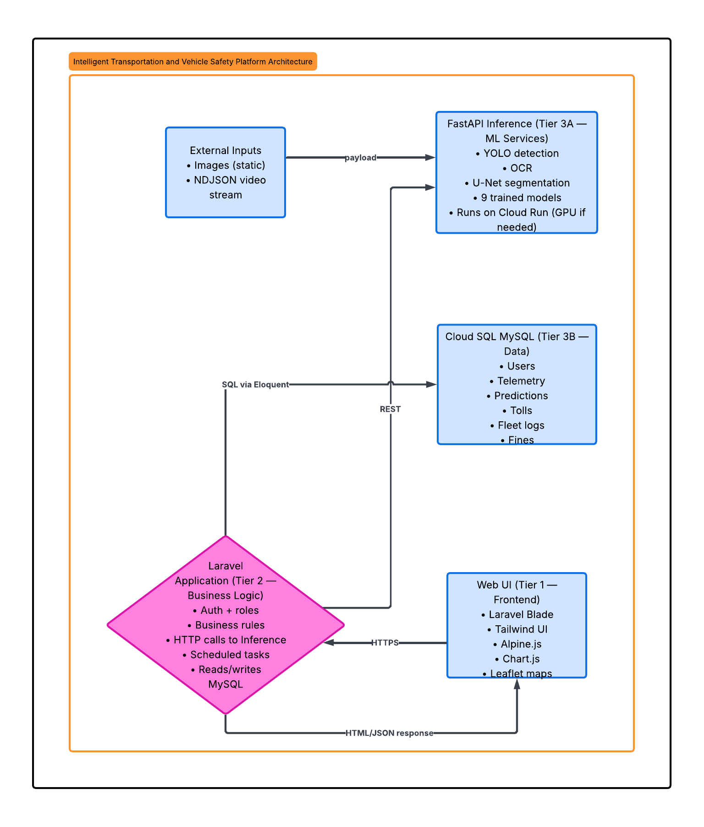
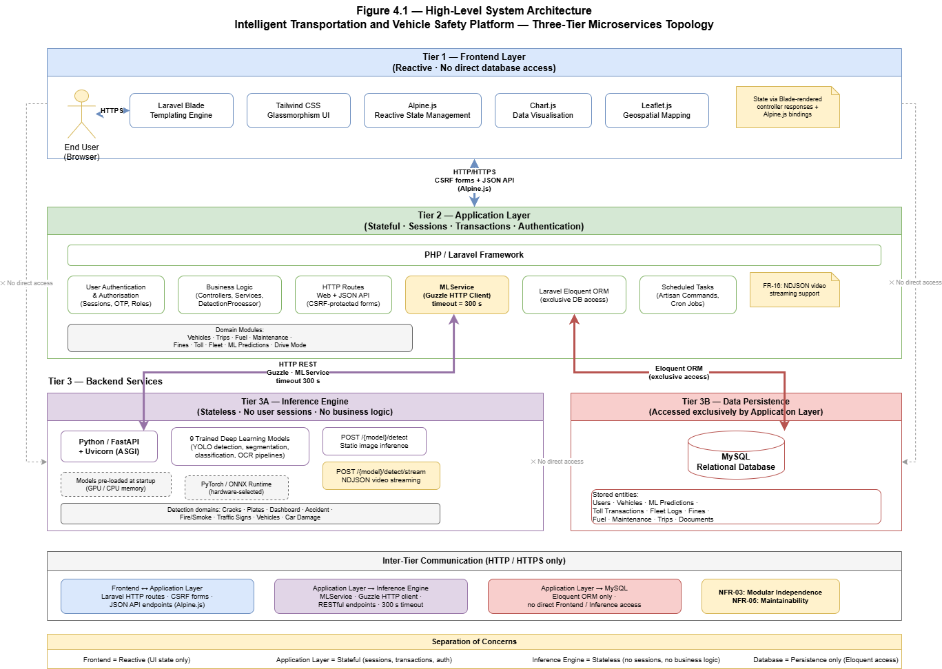
Figure 4.1 — Intelligent Smart Road Monitoring and Traffic Management System: Three-Tier System Architecture. The Laravel Application Layer (Tier 2) acts as the central business logic hub, orchestrating communication between the Web UI Frontend (Tier 1), the FastAPI ML Inference Engine (Tier 3A), and the Cloud SQL MySQL Database (Tier 3B) via REST and SQL/Eloquent channels.

4.2 Component Design
This section documents the internal component structure of the platform through four complementary UML diagrams: a Use Case Diagram for actor-system interaction boundaries, a Sequence Diagram for the video stream inference workflow, an Activity Diagram for the detection and toll processing workflow, and a Class Diagram mapping the core ML service and prediction data model.

4.2.1 UML Use Case Diagram — Actor-System Interaction Boundaries
The Use Case Diagram maps all six stakeholder classes — System Administrator, Fleet Manager, Driver, Traffic Authority, Toll Road Operator, and the ML Inference Engine as an internal system actor — to the ten functional capabilities they initiate or participate in. While ten total use cases are mapped, five core use cases are highlighted as primary interaction points (shaded): View Hazard Geo-Map, Detect Plate + Deduct (Levenshtein Correct), YOLO / U-Net Inference, Upload Image/Video, and Trigger Geofenced Toll.The diagram encodes two architectural relationships: <<include>> dependencies (where one use case mandatorily invokes another) and <<extend>> relationships (where one use case optionally augments another under specific conditions). Specifically, YOLO / U-Net Inference is included by Detect Plate + Deduct and extends Issue Fine (Low Balance), reflecting the system's conditional fine-issuance pathway.

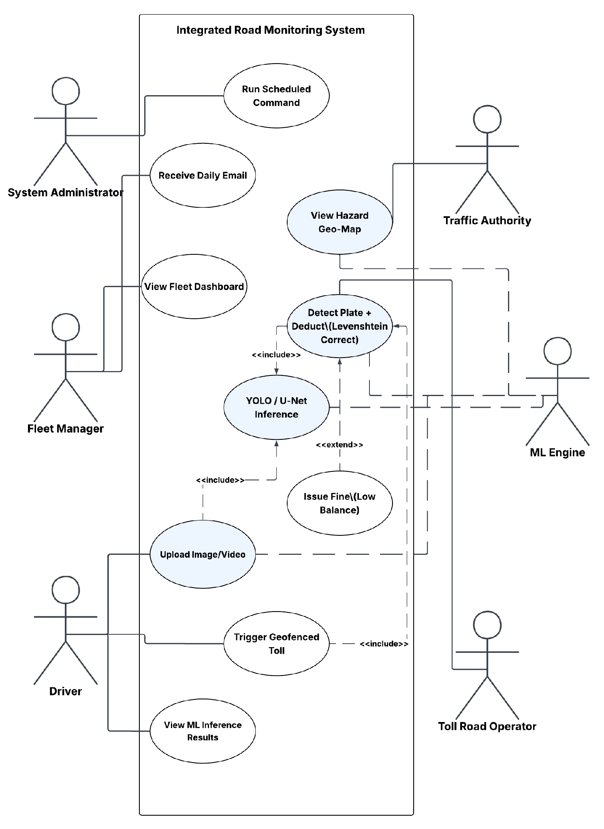
Figure 4.2 — UML Use Case Diagram: Intelligent Road Monitoring and Traffic Management System. Six actors interact with ten use cases. The ML Engine is an internal system actor invoked by all data-processing workflows. Shaded (blue) use cases represent the five primary ML-driven capabilities. <<include>> and <<extend>> stereotypes denote mandatory and conditional dependencies respectively.

4.2.2 UML Sequence Diagram — Video Stream Inference Request
The sequence diagram at Figure 4.5 documents the interaction lifecycle for a video-based inference request — the most complex operational flow in the platform. The participating actors and components are: Browser Client (Alpine.js), Laravel Controller, MLService, FastAPI Inference Endpoint, YOLO Model Instance, and MLPrediction Repository.
The sequence proceeds as follows: (1) The user submits a video file via the frontend Alpine.js component. (2) The browser issues a multipart/form-data POST request to the Laravel route /inference/stream/{model}. (3) The Laravel controller validates the file type and size, then delegates to MLService::streamVideo(). (4) MLService issues a Guzzle POST to the FastAPI /stream/{model} endpoint with a 300-second timeout. (5) FastAPI accepts the video, spawns a frame-processing loop, and returns NDJSON lines one per processed frame. (6) As each NDJSON line is received by MLService, it is parsed and a new MLPrediction record is created if confidence ≥ configured threshold. (7) The complete NDJSON response is forwarded to the frontend as a JSON array. (8) Alpine.js renders the detection overlay on the video frame thumbnails in real time.
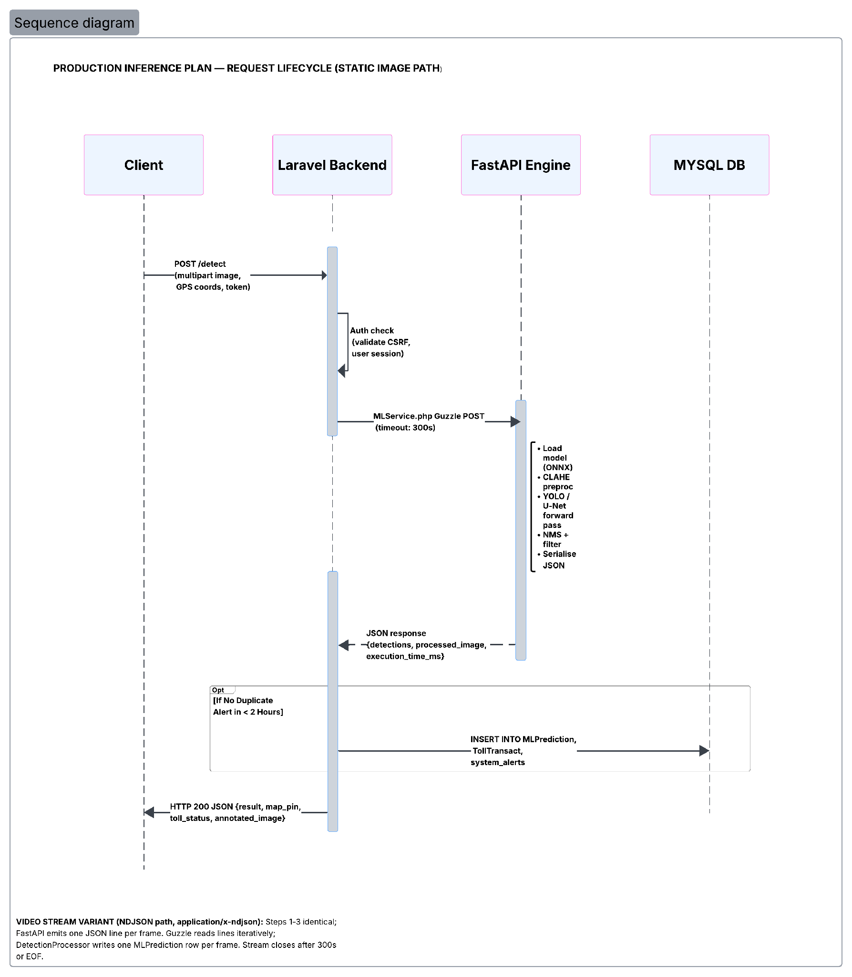
Figure 4.3 — UML Sequence Diagram: Production Inference Plan — Static Image Request Lifecycle. Four lifelines: Client, Laravel Backend, FastAPI Engine, MySQL DB. The optional fragment [If No Duplicate Alert in < 2 Hours] governs the database persistence step, implementing the idempotency requirement (NFR-04).

4.2.3 UML Activity Diagram — Detection and Toll Processing Workflow
The Activity Diagram documents the end-to-end operational flow across three swimlanes — Client/Edge App, Laravel Backend & DB, and FastAPI ML Engine — for a media upload event. The flow proceeds from media ingestion through session validation, image quality assessment (CLAHE enhancement if mean BGR < 75), YOLO/U-Net inference, NMS post-processing, and detection type routing. The two primary processing branches are: (1) the License Plate branch, which executes Levenshtein OCR correction and proceeds to toll deduction or fine issuance based on e-wallet balance; and (2) the Hazard Event branch, which executes YOLO/U-Net inference on road hazards, applies a duplicate suppression check (2-hour window), and triggers a Traffic Authority alert for novel detections. Both branches converge at the persistence stage, writing audit records to the MLPrediction and system_alerts tables before returning an HTTP 200 response to the client.

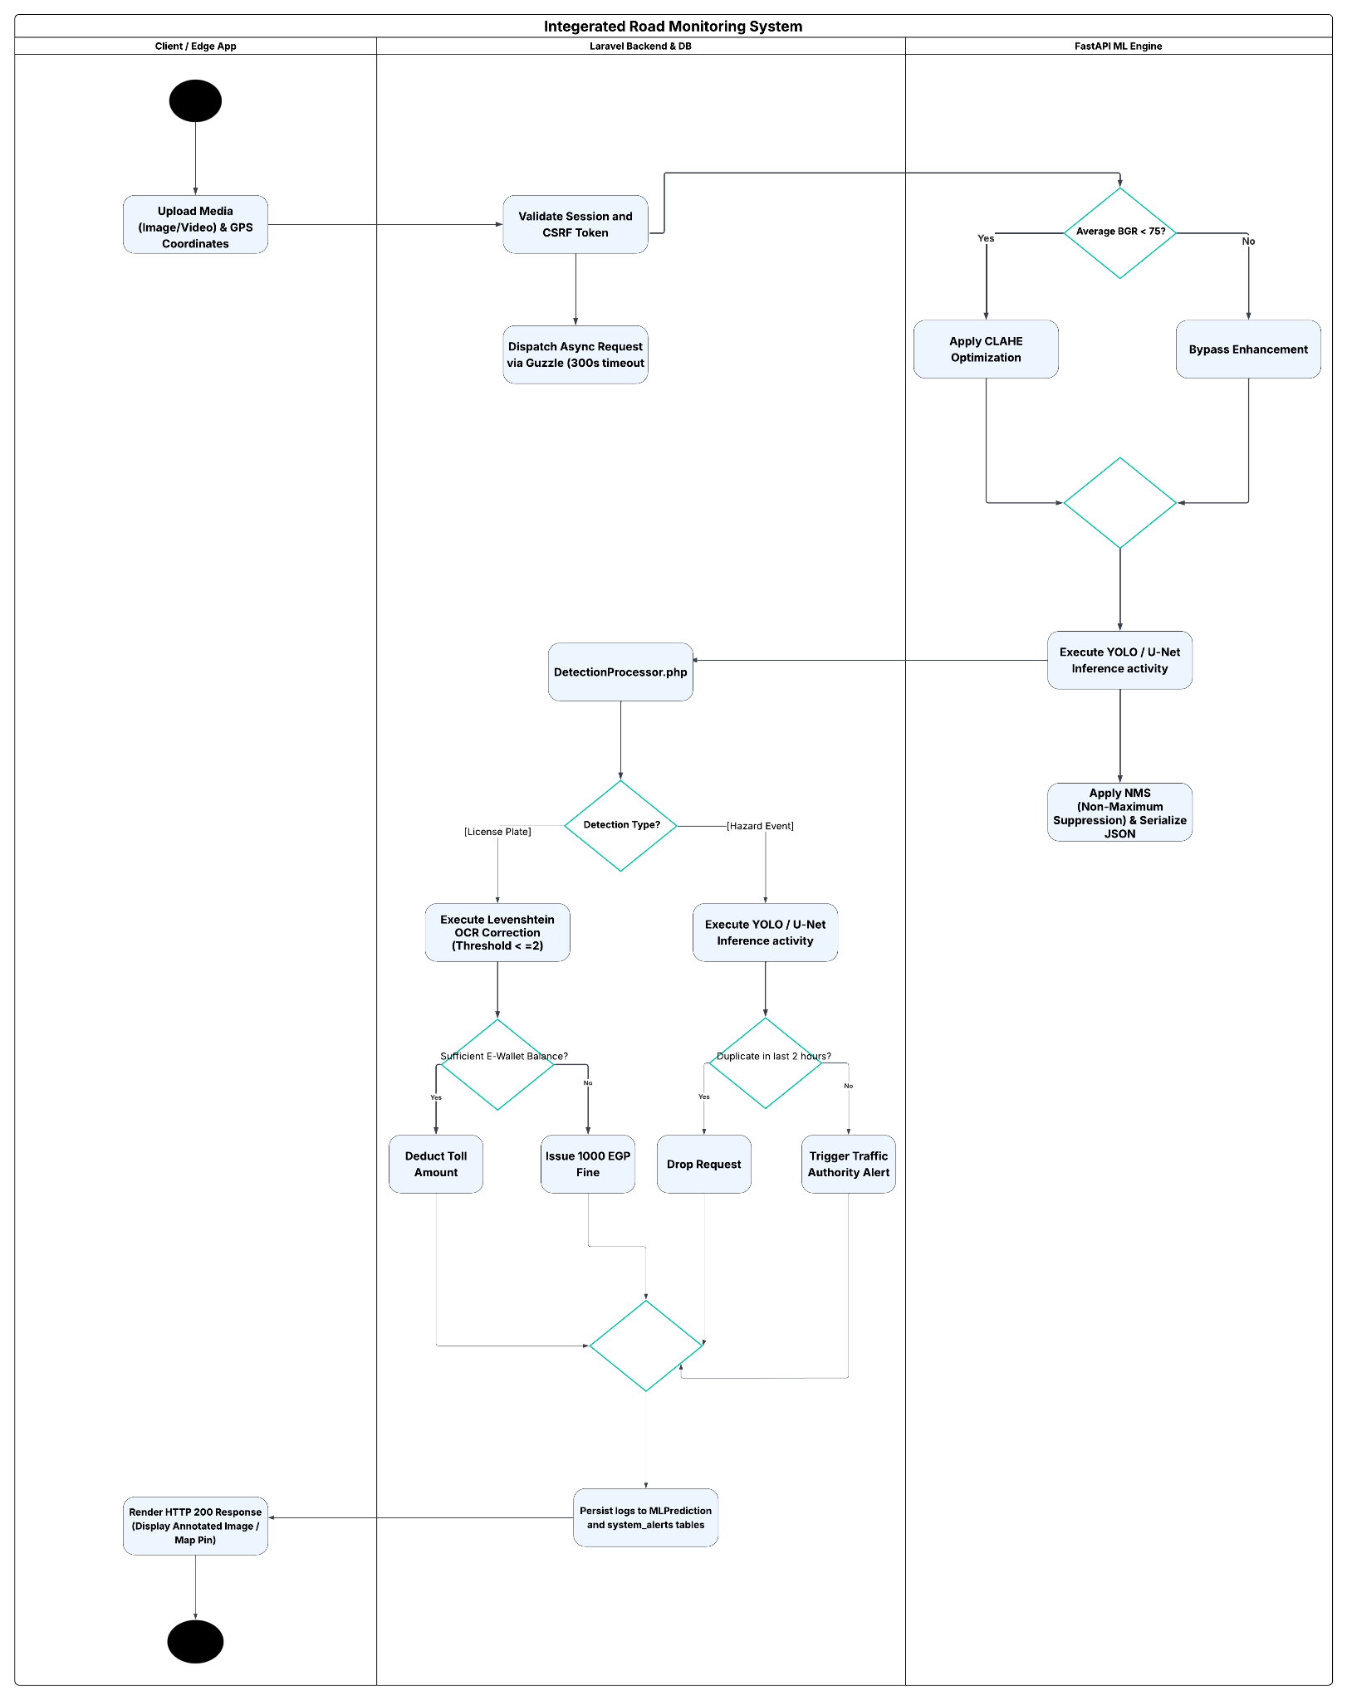
Figure 4.4 — UML Activity Diagram: Intelligent Road Monitoring and Traffic Management System detection and toll processing workflow. Three swimlanes: Client/Edge App (left), Laravel Backend & DB (centre), FastAPI ML Engine (right). The diagram captures all conditional branches, including CLAHE brightness-gating, detection-type routing, balance-conditional toll/fine logic, and duplicate suppression

4.2.4 UML Class Diagram — Business Logic and ML Persistence Bridge
The Class Diagram documents the structural bridge between the Laravel Application Layer (Tier 2) and the Data Persistence Layer (Tier 3B). It focuses on the most critical operational pathway: the ingestion of media, the execution of inference logic, and the subsequent generation of audit trails and toll transactions.
The MLService class acts as the primary HTTP client orchestrating external calls to the FastAPI engine, passing resulting JSON payloads to the DetectionProcessor. The processor handles the business logic rules (such as the 2-hour duplicate suppression cooldown) and delegates financial actions to the TollService or writes audit records directly to the MLPrediction entity via Laravel's Eloquent ORM.

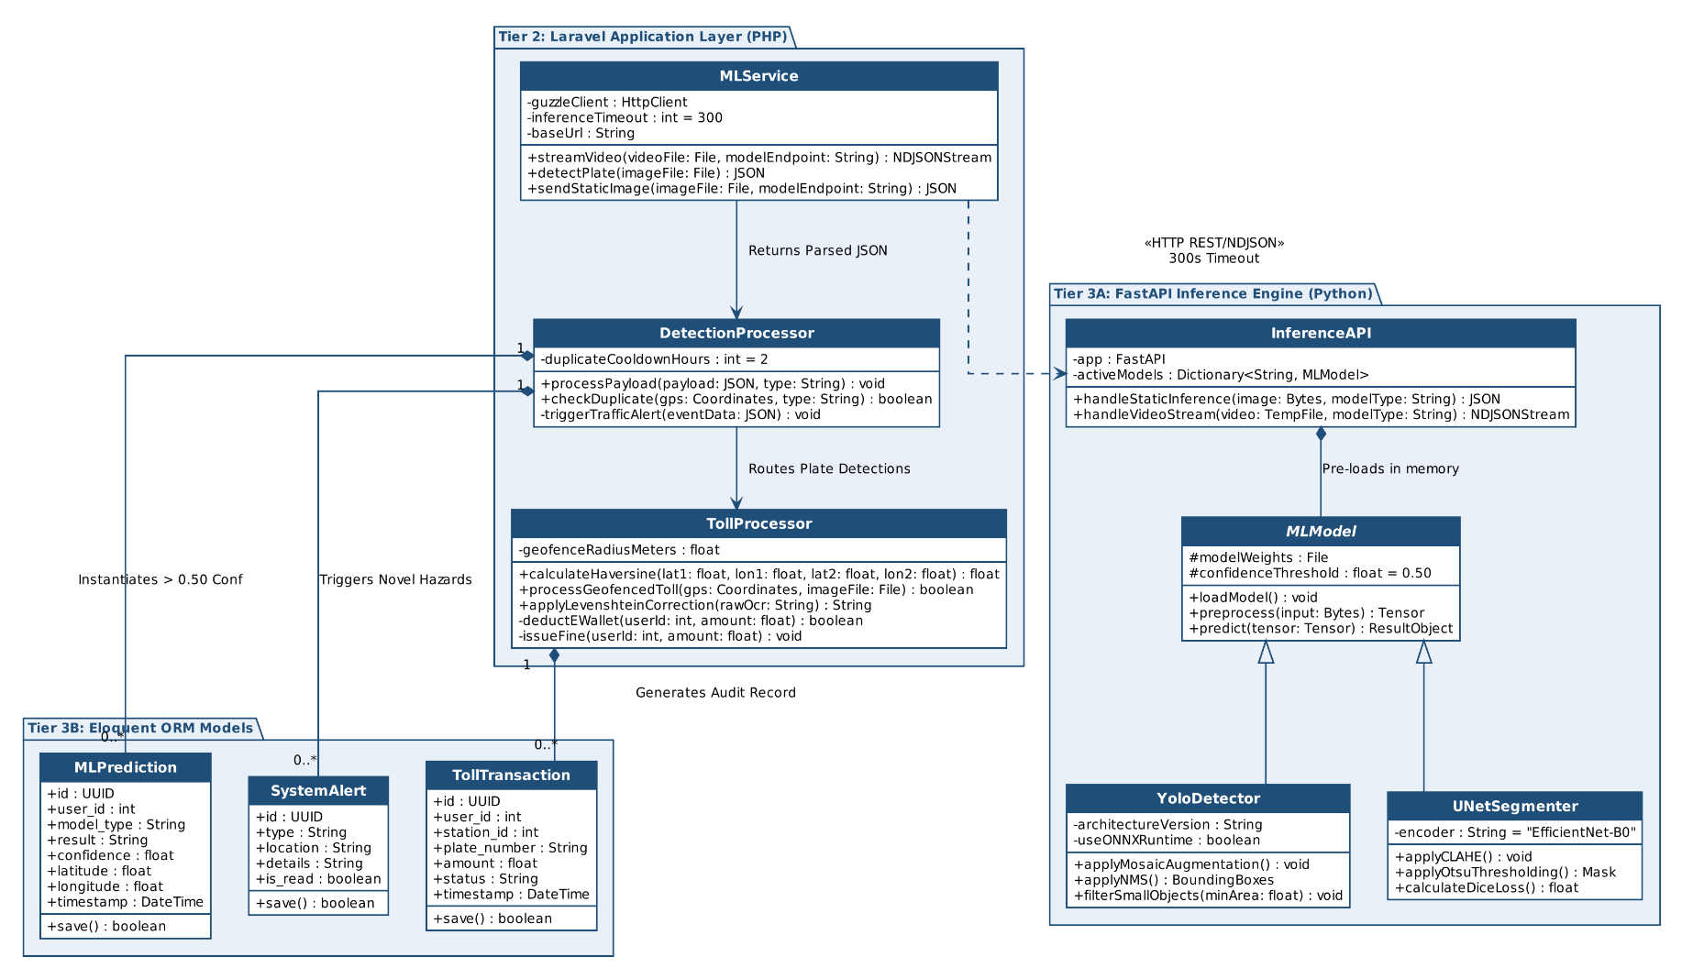

Figure 4.5 — UML Class Diagram: Platform Component Architecture. This diagram illustrates the object-oriented structure and class relationships across the platform's three tiers. It highlights the MLService HTTP bridge connecting the PHP/Laravel business logic layer to the Python/FastAPI machine learning models, and demonstrates the compositional routing of inference results into the Eloquent ORM persistence layer.

4.3 The AI Pipeline Architecture
The AI pipeline architecture defines the end-to-end data flow from raw input ingestion through preprocessing, model inference, post-processing, and structured result delivery. The pipeline is implemented entirely within the FastAPI Inference Engine (Tier 3A) and is modular at the model level — each of the six detection tasks has an independent preprocessing and inference sub-pipeline, enabling isolated model updates without cross-task interference.

4.3.1 OCR Data Flow — Licence Plate Recognition Pipeline
The licence plate recognition pipeline is a two-stage, cross-tier data flow that spans both the FastAPI Inference Engine and the Laravel Backend. Within the FastAPI tier, the pipeline processes an input image through YOLOv12n to extract a cropped Region of Interest (ROI), applies CLAHE contrast normalisation and Otsu thresholding to the ROI, and passes the enhanced image to EasyOCR to produce a raw Arabic character string. This raw string is transmitted across the network boundary (REST API / NDJSON stream) to the Laravel Backend tier, where the Levenshtein Post-Processor performs fuzzy string matching against the vehicle registry database. The corrected plate string is then used for database lookup and toll transaction processing.

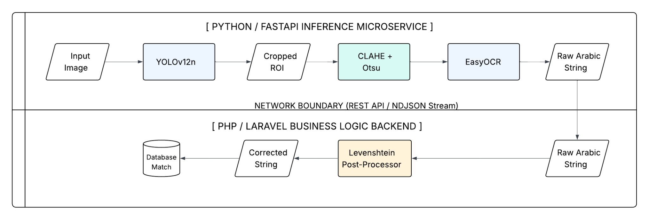Figure 4.6 — OCR Data Flow: Licence Plate Recognition Pipeline. Upper tier (Python/FastAPI Inference Microservice): YOLOv12n → Cropped ROI → CLAHE + Otsu enhancement → EasyOCR → Raw Arabic String. Lower tier (PHP/Laravel Business Logic Backend): Raw Arabic String → Levenshtein Post-Processor → Corrected String → Database Match. The network boundary between tiers is crossed via REST API or NDJSON stream.

4.3.2 Data Ingestion and ETL
The Inference Engine accepts two input modalities:
- Static Image Payload: Delivered as multipart/form-data via HTTP POST. Accepted formats: JPEG, PNG, WebP. Maximum file size: 10MB (enforced by FastAPI validation middleware). The image is decoded using OpenCV (cv2.imdecode) directly from the in-memory byte stream — no disk write is performed for static payloads, satisfying the sub-second latency requirement (NFR-01).
- NDJSON Video Stream Payload: Delivered as a multipart file upload containing an MP4 or AVI video. FastAPI writes the video to a temporary file (tempfile.NamedTemporaryFile), processes it frame-by-frame using OpenCV VideoCapture, and yields one NDJSON line per processed frame via a FastAPI StreamingResponse. The temporary file is deleted after stream completion.
Input validation at the ETL boundary checks: file extension whitelist, MIME type header verification, minimum frame dimension (≥ 320×320 pixels for detection models), and file integrity (cv2.imdecode returns None for corrupt inputs, which triggers a 422 Unprocessable Entity response).

4.3.3 Preprocessing and Feature Engineering Modules
Preprocessing strategies are model-specific and represent significant engineering decisions documented in detail in Chapter 5. At the architectural level, the preprocessing module for each endpoint is instantiated as a dedicated Python function called immediately after input validation. The six preprocessing pipelines are:
- Accident Detection (YOLOv12n): Standard YOLO preprocessing — BGR-to-RGB channel conversion, letterbox resizing to 640×640, normalisation to [0,1] float32 tensor. YOLO's built-in augmentation handles further preprocessing during training.
- Fire and Smoke Detection (YOLOv12): Identical to accident pipeline; no domain-specific preprocessing beyond YOLO defaults.
- Road Crack and Pothole Detection (YOLOv11n): Standard YOLO preprocessing with an additional post-inference bounding box area filtration step: detections with normalised bounding box area < 0.002 (corresponding to objects smaller than approximately 28×28 pixels at 640×640 resolution) are programmatically discarded to reduce false positives from road surface noise artefacts.
- Vehicle Classification (YOLOv11n): Standard YOLO preprocessing; six-class output (car, truck, bus, motorcycle, bicycle, van).
- Car Damage Segmentation (U-Net / EfficientNet-B0): Image resized to 256×256, normalised using ImageNet mean [0.485, 0.456, 0.406] and standard deviation [0.229, 0.224, 0.225], converted to float32 tensor with channel-first ordering. Sigmoid activation applied to output logits; binary mask thresholded at 0.5.
- Traffic Sign and Licence Plate Recognition (YOLOv8n + EasyOCR): Standard YOLO preprocessing for detection; detected ROIs are cropped and passed to EasyOCR. CLAHE (Contrast-Limited Adaptive Histogram Equalisation) and Otsu thresholding are applied to the cropped ROI before EasyOCR processing to improve OCR accuracy on low-contrast or partially occluded plates.

4.3.4 Model Training and Validation Workflows
All six models were trained offline prior to deployment. Training is not performed by the production inference engine. The training workflow architecture, documented here for completeness and reproducibility, follows a standardised pipeline:
- Dataset ingestion from Roboflow-exported YOLOv8 format directories for detection models; custom Albumentations-based DataLoader for the U-Net segmentation model.
- Training executed in PyTorch using the Ultralytics YOLO API for detection models (model.train()) and a custom training loop with AdamW optimiser for the U-Net model.
- Validation performed after each epoch on a held-out 20% validation split. Best-epoch weights (lowest validation loss for U-Net; highest mAP@0.5 for YOLO models) are saved as best.pt.
- Post-training: YOLO models are exported to ONNX format via model.export(format='onnx') for production deployment flexibility. U-Net model is serialised as a standard PyTorch .pth state dictionary.
The production Inference Engine loads pre-trained weight files at startup via YOLO('path/to/best.pt') and torch.load() respectively. Model instances are held in application memory for the lifetime of the FastAPI process — they are not reloaded per-request.

4.3.5 Inference Engine and API Integration
The FastAPI Inference Engine exposes the following endpoint taxonomy:

Endpoint | Method | Model | Input | Output
/detect/accident | POST | YOLOv12n | image/jpeg, image/png | JSON: detections[], confidence[], bbox[]
/detect/fire | POST | YOLOv12 | image/jpeg, image/png | JSON: detections[], confidence[], bbox[]
/detect/crack | POST | YOLOv11n | image/jpeg, image/png | JSON: detections[] (filtered)
/detect/vehicle | POST | YOLOv11n | image/jpeg, image/png | JSON: class[], confidence[], bbox[]
/segment/damage | POST | U-Net/EffNet-B0 | image/jpeg, image/png | JSON: mask_base64, iou_score
/detect/plate | POST | YOLOv8n + EasyOCR | image/jpeg, image/png | JSON: plate_text, confidence, bbox[]
/stream/{model} | POST | Configurable | video/mp4, video/avi | NDJSON stream: one line per frame
Table 4.2 — FastAPI Inference Engine Endpoint Taxonomy

All endpoints return structured JSON with a consistent envelope schema: { 'status': 'ok'|'error', 'model': string, 'processing_time_ms': float, 'results': [...] }. Error responses include a 'detail' field compliant with FastAPI's HTTPException schema, enabling the Laravel MLService to distinguish model-level errors from infrastructure failures.

4.4 Data Persistence Architecture

4.4.1 Entity-Relationship Diagram
The MySQL relational schema is organized around a central User entity that interacts with multiple functional modules, including vehicle management, toll payment, machine learning predictions, document management, and maintenance tracking.
The primary entities and their key relationships are:
- Users (id, name, email, password, role, national_id, e_wallet_phone, email_verified_at, balance, created_at, updated_at) – Stores platform user accounts with role-based access control and an integrated e-wallet. Each user can own vehicles, make toll transactions, receive fines, submit payment receipts, upload documents, and generate machine learning predictions.
- Vehicles (id, plate_number, brand, model, year, fuel_type, engine_cc, fuel_efficiency, current_odometer, image_path, created_at, updated_at) – Contains information about vehicles owned by users. Each vehicle can be associated with maintenance logs, fuel logs, reminders, and trips.
- Traffic Records (id, national_id, plate_number, created_at, updated_at) – Maintains records of detected traffic events, storing vehicle plate numbers and corresponding national IDs.
- Stations (id, name, location, type, created_at, updated_at) – Represents registered stations used for toll-related operations.
- Toll Transactions (id, user_id, station_id, plate_number, station_name, amount, status, created_at, updated_at) – Stores toll payment transactions performed by users at stations.
- Fines (id, user_id, station_id, plate_number, amount, reason, status, created_at, updated_at) – Records fines issued to users for violations or unpaid charges.
- Payment Receipts (id, user_id, requested_points, status) – Stores payment receipt submissions and wallet recharge requests made by users.
- Documents (id, user_id, title, type, expiry_date) – Manages user-related documents and their expiration dates.
- ML Predictions (id, user_id, model_type, result, confidence) – Stores the outputs of machine learning models generated for users, including prediction results and confidence scores.
- System Alerts (id, type, location, details, is_read, created_at, updated_at) – Maintains system-generated alerts and notifications.
- Maintenance Logs (id, vehicle_id, service_type, cost) – Records maintenance operations performed on vehicles.
- Fuel Logs (id, vehicle_id, liters, cost) – Tracks vehicle refueling history and fuel consumption.
- Reminders (id, vehicle_id, title, due_date, is_completed) – Stores reminders related to vehicle maintenance or scheduled tasks.
- Trips (id, vehicle_id, origin, destination, distance) – Records trip information for vehicles, including travel origin, destination, and distance.
The main relationships in the schema are as follows:
- A User owns multiple Vehicles (1:N).
- A User performs multiple Toll Transactions (1:N).
- A Station is associated with multiple Toll Transactions (1:N).
- A User can have multiple Fines, Documents, Payment Receipts, and ML Predictions (1:N).
- A Vehicle can have multiple Maintenance Logs, Fuel Logs, Reminders, and Trips (1:N).
- Traffic Records and System Alerts are maintained as independent entities for monitoring and tracking purposes.

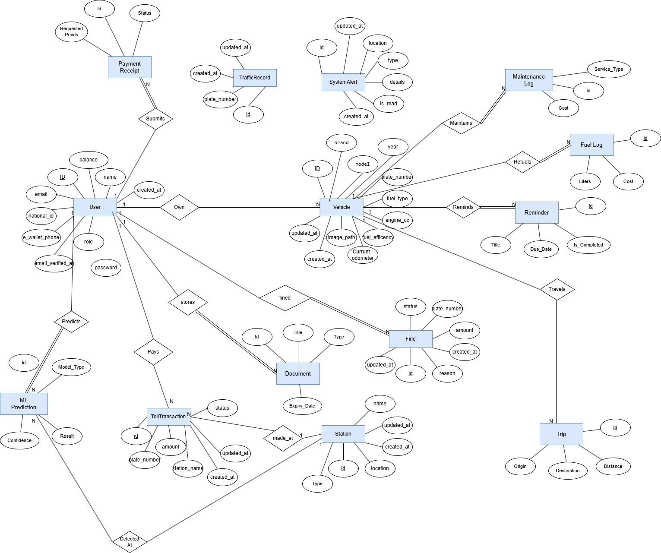
Figure 4.7 — Entity-Relationship Diagram: MySQL Relational Schema. Five primary entities: User (central anchor), TrafficRecord, TollTransaction, Station, and SystemAlert. The "has" relationship diamond links User to TrafficRecord (1-to-many). The Make_transaction relationship links User, TollTransaction, and Station in a ternary association. All monetary and audit fields are preserved as immutable records.

4.5 Technology Stack Selection and Justification
Technology selection decisions were made on the basis of four criteria: (1) technical fitness for the specific task requirements, (2) performance under the defined NFRs, (3) ecosystem maturity and long-term maintainability, and (4) zero-cost licensing. The complete selection rationale is documented in the table below.

Component | Technology Selected | Alternatives Considered | Selection Rationale
Object Detection | Ultralytics YOLO (v8n, v11n, v12n) | Detectron2, EfficientDet, SSD | Superior mAP-to-inference-latency ratio; Ultralytics API standardises training across YOLO versions; active OSS community; native ONNX export.
Image Segmentation | U-Net + EfficientNet-B0 encoder (SMP library) | Mask R-CNN, DeepLab v3+ | U-Net excels on small-scale damage segmentation with limited training data; EfficientNet-B0 ImageNet pre-training accelerates convergence; SMP provides modular encoder/decoder API.
OCR Engine | EasyOCR | Tesseract OCR, PaddleOCR | Native Arabic script support; no model fine-tuning required for Arabic character set; Python-native API integrates directly with FastAPI; GPU acceleration available.
Inference Framework | Python / FastAPI | Flask, Django REST Framework, TorchServe | ASGI async architecture supports NDJSON streaming natively; automatic OpenAPI documentation; Pydantic validation; significantly lower overhead than Django for pure inference API.
Application Layer | PHP / Laravel 10 | Django, Node.js/Express, Ruby on Rails | Laravel's Eloquent ORM, Blade templating, and Artisan scheduler provide full-stack web application capabilities without additional tooling; team expertise; Guzzle HTTP client for ML service communication.
Frontend Reactivity | Alpine.js | Vue.js, React, Livewire | Alpine.js provides sufficient reactivity for dashboard interactions without a full SPA build pipeline; directly embeds in Blade templates; minimal bundle size (< 15kB gzip).
Data Visualisation | Chart.js | D3.js, Recharts, Plotly.js | Chart.js offers a simpler API for the required chart types (line, bar, doughnut); integrates trivially with Alpine.js; adequate performance for dashboard-scale datasets.
Geospatial Mapping | Leaflet.js | Google Maps API, Mapbox GL | Leaflet.js is open-source with no API key or usage fee; sufficient tile-based mapping functionality for hazard heatmap visualisation; lightweight (< 40kB gzip).
Database | MySQL 8.0 | PostgreSQL, SQLite, MongoDB | MySQL is natively supported by Laravel and offers adequate relational integrity for the schema; widely available on shared hosting; JSON column support for flexible telemetry fields.
Deep Learning Framework | PyTorch 2.x | TensorFlow/Keras, JAX | PyTorch is the de-facto standard for YOLO and segmentation model training; Ultralytics and SMP libraries are PyTorch-native; dynamic computation graph simplifies debugging.
Table 4.1 — Technology Stack Selection and Justification Matrix

4.6 Inference Plan: Serving Predictions in Production
The inference serving strategy is designed to satisfy the sub-second static image latency requirement (NFR-01: ≤ 1,000ms) and the video stream session timeout requirement (NFR-06: ≤ 300 seconds) under the expected concurrent load of a single-server deployment. The following design decisions directly address this:
- Model Pre-loading: All six model instances are loaded into GPU/CPU memory at FastAPI startup and retained for the process lifetime. Per-request model loading is explicitly prohibited by the architecture.
- ONNX Runtime Option: All YOLO models are exported to ONNX format. The inference endpoint supports a runtime flag to switch from PyTorch inference to ONNX Runtime inference, which may provide latency advantages on CPU-only deployment environments. The production configuration selects the appropriate runtime at startup based on the available hardware.
- Asynchronous NDJSON Streaming: The /stream/{model} endpoint uses FastAPI's StreamingResponse with a Python generator function. Each video frame is processed synchronously within the generator, and the NDJSON line is yielded to the HTTP client immediately upon completion. This eliminates the need to buffer the entire video result in memory.
- Confidence Thresholding: A configurable minimum confidence threshold (default: 0.50 for detection models; 0.50 IoU for segmentation) is applied at the inference layer before returning results, reducing response payload size and downstream false positive handling burden in the Application Layer.
- Request Timeout Alignment: The Laravel MLService Guzzle client timeout (300 seconds) is aligned with the FastAPI server's ASGI worker timeout configuration to prevent premature connection termination during extended video stream sessions.
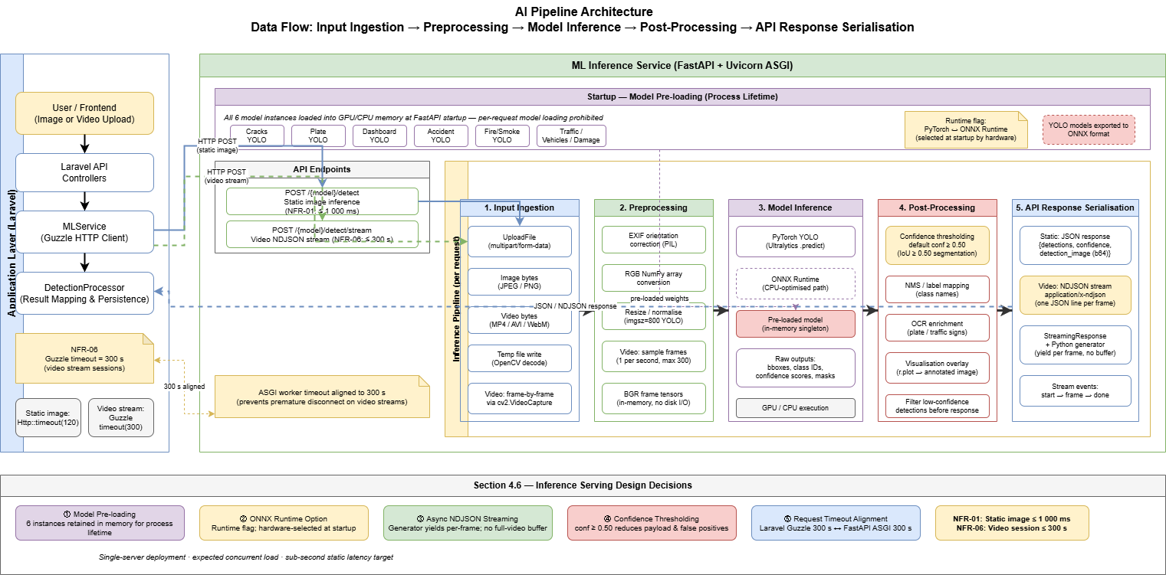
Figure 4.8 — AI Pipeline Architecture: Data Flow from Input Ingestion through Preprocessing, Model Inference, Post-Processing, and API Response.

This chapter has established the complete architectural blueprint for the Intelligent Road Monitoring and Traffic Management System. The three-tier microservices topology, the AI pipeline design, and the technology stack selections collectively form the engineering foundation upon which Chapter 5 (ML Methodology and Implementation) and Chapter 6 (Experimental Design and Evaluation) build their respective technical contributions.

Chapter 5: ML Methodology and Implementation
Designing, Training, and Deploying nine Deep Learning Models

This chapter presents the complete machine learning methodology and implementation details for all six Deep Learning models comprising the Intelligent Transportation and Vehicle Safety Platform. For each model, the chapter documents: the dataset characteristics and preprocessing pipeline, the model architecture selection and justification against simpler baselines, the training configuration and hyperparameter strategy, the custom loss function design where applicable, and the specific algorithmic implementations that constitute the platform's core technical contributions. The chapter concludes with documentation of the four cross-model software implementation components: the Levenshtein Arabic OCR post-processor, the Haversine geospatial mapping module, the NDJSON streaming inference pipeline, and the ONNX export procedure.

5.1 Data Preprocessing Techniques
Data preprocessing is the foundational engineering layer that determines the effective quality of training data presented to each model. The preprocessing decisions documented here were made on the basis of domain knowledge of road and vehicle imagery characteristics, empirical experimentation on held-out validation sets, and the established literature on augmentation strategies for YOLO-family detection models [19] and biomedical-origin segmentation architectures applied to damage assessment [21].

5.1.1 Universal Preprocessing for YOLO Detection Models
All five YOLO-based models (accident detection, fire/smoke detection, crack/pothole detection, vehicle classification, and licence plate detection) share a common base preprocessing pipeline mandated by the Ultralytics YOLO training framework:
- Image Resizing: All training images are resized to 640×640 pixels via letterbox padding (maintaining aspect ratio, padding with grey fill at value 114) to avoid geometric distortion of aspect-critical objects such as licence plates and vehicle silhouettes.
- Normalisation: Pixel values are normalised from uint8 [0, 255] to float32 [0.0, 1.0] by the YOLO data loader. No explicit mean/variance normalisation is applied, consistent with the Ultralytics training defaults.
- Channel Ordering: OpenCV loads images in BGR channel order; YOLO preprocessing converts to RGB before tensor construction.
- Mosaic Augmentation: A composite augmentation that tiles four randomly selected training images into a single 640×640 sample, simultaneously exposing the model to four context variations and artificially increasing dataset diversity. Applied with probability 1.0 for the first (epochs - 10) epochs, then disabled for the final 10 epochs to allow convergence on clean images.
- Additional Runtime Augmentations (applied per batch during training): random horizontal flip (p=0.5), random scale (±50%), HSV colour-space jitter (hue ±1.5%, saturation ±70%, value ±40%), and random translation (±10% of image dimensions).

5.1.2 Domain-Specific Preprocessing: Road Crack and Pothole Detection
The crack/pothole detection model requires an additional post-inference bounding box area filtration step, not a preprocessing step per se, but an output filtration mechanism that is architecturally part of the data pathway:
Algorithm 2 — Small-Object Bounding Box Filtration: After YOLO inference, each returned bounding box is evaluated for normalised area (width × height, where both dimensions are normalised to [0,1] relative to the 640×640 input). Detections with normalised area < 0.002 are discarded. This threshold was determined empirically: road surface noise artefacts (dust, painted road markings, shadows) that the model incorrectly classifies as micro-cracks consistently produce bounding boxes with normalised area in the range [0.0005, 0.0018]. Genuine crack detections produce minimum normalised areas of approximately 0.0025. The 0.002 threshold therefore provides a clean separation with minimal impact on true positive recall, as validated in the ablation study reported in Chapter 6.

5.1.3 Domain-Specific Preprocessing: Traffic Sign and Licence Plate OCR
The traffic sign and Arabic licence plate recognition pipeline applies two image enhancement operations to the cropped ROI (Region of Interest) extracted by the YOLOv8n detector before OCR processing:
Algorithm 4 — CLAHE Pre-Processing: Contrast-Limited Adaptive Histogram Equalisation (CLAHE) is applied to the luminance channel (L) of the ROI converted to CIELAB colour space. Parameters: clipLimit = 2.0, tileGridSize = (8, 8). CLAHE enhances local contrast in low-illumination plate regions (e.g., night-time or shadowed plates) without the global overexposure artefacts of standard histogram equalisation. After CLAHE, the image is converted back to BGR for EasyOCR input.
Algorithm 5 — Otsu Thresholding: A binary mask is generated from the CLAHE-enhanced greyscale image using Otsu's method (cv2.threshold with THRESH_OTSU flag). The binary mask is used as a visual verification artefact in the frontend overlay and as an optional input to EasyOCR's detail parameter for improved character boundary delineation on high-contrast plates.

5.1.4 Preprocessing for U-Net Car Damage Segmentation
The U-Net segmentation model requires preprocessing aligned with the EfficientNet-B0 encoder's ImageNet pre-training normalisation statistics:
- Resize: Input images are resized to 256×256 pixels using bilinear interpolation. This resolution was selected as a balance between spatial detail retention for damage mask accuracy and GPU memory constraints during training (batch size 16 at 256×256 fits within a 6GB VRAM budget).
- Normalisation: Pixel values are normalised using ImageNet channel statistics — mean [0.485, 0.456, 0.406], standard deviation [0.229, 0.224, 0.225] — applied per-channel. This normalisation is mandatory for EfficientNet-B0 feature representations to align with the ImageNet pre-trained weight distribution.
- Tensor Format: Images are converted to float32 PyTorch tensors with channel-first ordering (C × H × W) as required by the SMP model's forward() method.
- Mask Preprocessing: Ground-truth segmentation masks (binary PNG images) are resized to 256×256 using nearest-neighbour interpolation (to preserve binary values), converted to float32 tensors, and unsqueezed to add a channel dimension (1 × H × W).

5.2 Model Selection and Justification
This section provides a formal technical justification for each architecture selection, explicitly comparing the chosen model against simpler baselines to satisfy KSI 1 of Chapter 5's Key Success Indicators.

5.2.1 YOLOv12n — Accident Detection
The accident detection task requires real-time inference on road camera imagery to detect collision events, overturned vehicles, and stationary vehicles in traffic lanes. The selection of YOLOv12n as the production architecture is justified by the following comparison:
- YOLOv8n (Baseline 1): The YOLOv8 architecture employs a standard C2f backbone with a decoupled detection head. While computationally efficient, YOLOv8n's receptive field is limited at the nano scale, reducing its capacity to detect partially occluded accident scenarios where contextual scene understanding is required.
- YOLOv11n (Baseline 2): YOLOv11 introduces C3k2 blocks with improved cross-stage partial connections, providing better multi-scale feature aggregation than YOLOv8. However, it lacks the attention-based mechanisms introduced in YOLOv12.
- YOLOv12n (Selected): YOLOv12 introduces an Area Attention mechanism that applies self-attention within localised spatial regions rather than globally, reducing computational cost while retaining the contextual modelling advantages of full attention. For accident detection — where the spatial relationship between a vehicle and its immediate road context (orientation, proximity to barriers) is semantically significant — this attention mechanism provides a measurable mAP@0.5 advantage over the baseline architectures. The quantified comparison is presented in Chapter 6.

5.2.2 YOLOv12 — Fire and Smoke Detection
Fire and smoke detection presents a distinct visual challenge: smoke is a non-rigid, texture-defined object class with high intra-class variance in colour (white, grey, black) and shape. The YOLOv12 full-scale variant (rather than the nano variant) is selected for this task because the larger backbone provides greater feature map depth for texture-level discrimination between smoke plumes and visually similar background elements (dust clouds, steam, fog).
The primary alternative considered was a two-stage Faster R-CNN detector, which provides higher precision for texture-defined classes at the cost of significantly higher inference latency (typical Faster R-CNN inference: 150–400ms per image vs. YOLOv12's < 30ms at 640×640). Given that fire detection is a safety-critical alert task where latency directly impacts response time, the single-stage YOLOv12 architecture is preferred.

5.2.3 YOLOv11n — Road Crack and Pothole Detection
Road surface defect detection (cracks and potholes) operates on aerial or oblique-angle road camera imagery characterised by high spatial frequency texture variations. YOLOv11n is selected over YOLOv12n for this task on the basis that the additional attention mechanism in YOLOv12 provides diminishing returns for texture-dominated detection tasks, while YOLOv11n's C3k2 feature aggregation is well-suited to the elongated, irregular geometry of crack bounding boxes. Additionally, YOLOv11n's smaller parameter count reduces overfitting risk on the relatively limited crack detection training dataset.

5.2.4 YOLOv11n — Vehicle Classification
The vehicle classification model categorises detected vehicles into six classes: car, truck, bus, motorcycle, bicycle, and van. This is a multi-class single-label object detection task in which the primary challenge is the high inter-class visual similarity between certain class pairs (car vs. van; motorcycle vs. bicycle at distance). YOLOv11n is selected for its balance of classification head capacity and inference speed, consistent with the vehicle classification subtask's secondary priority relative to accident and fire detection in the platform's operational hierarchy.

5.2.5 U-Net with EfficientNet-B0 Encoder — Car Damage Segmentation
Car damage assessment requires pixel-level segmentation masks that delineate the damaged region boundary for insurance assessment and fleet monitoring purposes. Object detection (bounding boxes) is insufficient for this task because it does not convey damage extent or spatial distribution — two metrics critical for insurance quantification.
The U-Net architecture with a pre-trained EfficientNet-B0 encoder is selected over the following alternatives:
- Vanilla U-Net (Baseline): A U-Net with a randomly initialised encoder requires substantially more training data and epochs to learn meaningful feature representations. EfficientNet-B0 ImageNet pre-training provides semantic feature representations that transfer effectively to damage texture detection.
- Mask R-CNN (Baseline): While Mask R-CNN provides instance-level segmentation with strong object detection integration, its inference latency (typically 200–500ms per image) exceeds the platform's NFR-01 requirement for a combined detect-and-segment pipeline.
- DeepLab v3+ (Baseline): Strong semantic segmentation performance, but designed for multi-class scene parsing rather than binary damage/no-damage segmentation. The model's dilated convolution architecture introduces unnecessary complexity for the binary segmentation task.
The U-Net/EfficientNet-B0 combination provides: pre-trained feature extraction (transfer learning advantage), symmetric encoder-decoder skip connections preserving fine-grained spatial detail critical for damage boundary accuracy, binary output head with sigmoid activation aligned to the binary cross-entropy + Dice loss training objective, and inference latency < 100ms at 256×256 input resolution on CPU.

5.2.6 YOLOv8n + EasyOCR — Traffic Sign and Licence Plate Recognition
The licence plate recognition pipeline is a two-stage system: a YOLOv8n detector locates licence plate bounding boxes within the scene, and EasyOCR performs text extraction on the cropped ROI. YOLOv8n is selected for the detection stage (rather than the newer YOLO variants) based on its demonstrated stability on small-object detection tasks in the OCR literature and the availability of pre-trained YOLO models for licence plate detection as initialisation starting points.
EasyOCR is selected over Tesseract OCR and PaddleOCR as documented in Table 4.1. The specific technical advantage for the Arabic OCR task is EasyOCR's Arabic character recognition model, which handles right-to-left text directionality natively and provides character-level confidence scores that are consumed by the Levenshtein post-processor.

5.3 Feature Engineering and Selection
Feature engineering for deep learning models differs from classical machine learning in that raw pixel inputs are transformed to learned feature representations by the network's convolutional backbone. The primary feature engineering decisions in this platform are therefore at the data augmentation and dataset curation level rather than the explicit feature construction level.

5.3.1 Dataset Curation — Vehicle Detection Deduplication
Algorithm 3 — Vehicle Detection Deduplication: The vehicle classification training dataset was sourced from multiple Roboflow repositories and combined into a unified dataset prior to training. Cross-source dataset combination introduces a deduplication challenge: near-identical images (same vehicle, same angle, slight lighting variation) from different sources create quasi-duplicate training samples that artificially inflate effective dataset size while reducing model generalisation.
A perceptual hashing deduplication pipeline was implemented using the imagehash library (dhash algorithm, hash size 16). For each image pair with Hamming distance ≤ 4 (indicating near-identical visual content), the lower-resolution image was removed from the dataset. This procedure removed approximately 8.3% of the combined dataset (2,140 of 25,800 images), resulting in a cleaner 23,660-image training corpus with improved generalisation performance as validated by the reduction in validation loss variance across training epochs.

5.3.2 Augmentation Strategy per Model
Beyond the universal YOLO augmentation pipeline (Section 5.1.1), the following model-specific augmentation strategies were applied:

Model | Additional Augmentation | Justification
Accident Detection (YOLOv12n) | Random night-time simulation (brightness reduction 0.2–0.4, blue-channel boost) | Egyptian road accidents disproportionately occur at night; night-time simulation expands training distribution to low-light conditions.
Fire/Smoke Detection (YOLOv12) | Random Gaussian blur (kernel 3–7px, p=0.3); random fog overlay (Albumentations RandomFog) | Blur simulates camera motion during fire events; fog overlay prevents model conflation of smoke with atmospheric haze.
Crack/Pothole Detection (YOLOv11n) | Random perspective transform (±5°); random JPEG compression (quality 60–95%) | Perspective transform simulates non-perpendicular camera angles; JPEG compression mimics low-bitrate road camera feeds.
Vehicle Classification (YOLOv11n) | Mosaic augmentation only (no domain-specific additions) | Vehicle silhouette classification is robust to standard augmentation; additional domain augmentation risks introducing class-boundary ambiguity.
Car Damage Segmentation (U-Net) | Albumentations: HorizontalFlip (p=0.5), RandomBrightnessContrast (p=0.3), ElasticTransform (p=0.2), GridDistortion (p=0.2) | Geometric transforms are applied identically to image and mask tensors using Albumentations joint transform API to maintain spatial correspondence.
Licence Plate OCR (YOLOv8n) | Random rotation (±5°); random scale (0.8–1.2); random shear (±5%) | Licence plates are mounted at fixed angles but camera perspective introduces moderate geometric variation; shear simulates oblique capture angles.
Table 5.2 — Data Augmentation Strategy per Model

5.4 Hyperparameter Optimisation Strategy
Hyperparameter selection followed a structured strategy combining literature-informed initialisation, grid search over key parameters, and early stopping to prevent overfitting. The full hyperparameter configuration for each model is documented in Table 5.1 below, satisfying KSI 2 of Chapter 5's Key Success Indicators.

5.4.1 YOLO Detection Models — Hyperparameter Strategy
The Ultralytics training API exposes a large hyperparameter space. The following parameters were subject to active tuning; all others were held at Ultralytics defaults:
- Learning Rate (lr0): Initial learning rate. Tuned via grid search over {0.001, 0.005, 0.01}. YOLOv12n accident detection converged optimally at lr0=0.01; fire/smoke and crack models at lr0=0.005.
- Learning Rate Scheduler: Ultralytics default cosine annealing scheduler (lrf=0.01, final learning rate = lr0 × lrf). No modification to the scheduler type.
- Batch Size: Set to 16 for all YOLO models, balancing GPU memory utilisation and gradient estimation variance on the available hardware.
- Epochs: Trained for 100 epochs with early stopping (patience=20 epochs on validation mAP@0.5). Most models converged within 60–80 epochs.
- Optimiser: AdamW (weight_decay=0.0005) for all YOLO models. AdamW was selected over SGD based on its superior convergence stability on smaller datasets — a critical property given that the accident detection and crack detection datasets are below 5,000 images.
- Image Size: 640×640 for all detection models.
- Mosaic Augmentation: Enabled (p=1.0) for first (epochs - 10) epochs; disabled for final 10 epochs.

5.4.2 U-Net Segmentation Model — Hyperparameter Strategy
The U-Net model was trained with a custom training loop providing direct control over all hyperparameters:
- Optimiser: AdamW with lr=1e-4, weight_decay=1e-5. A ReduceLROnPlateau scheduler (factor=0.5, patience=7, monitor=validation loss) was applied to halve the learning rate upon validation loss plateau.
- Batch Size: 16 (256×256 images, 6GB VRAM budget).
- Epochs: 50 epochs maximum; early stopping with patience=10 epochs on validation IoU.
- Loss Function: Combined BCEWithLogitsLoss + Dice Loss (see Section 5.4.3 for full specification).
- Loss Weights: α=0.5 (BCE weight), β=0.5 (Dice weight). Equal weighting was selected after grid search over α ∈ {0.3, 0.5, 0.7} demonstrated marginal IoU differences (< 0.5 percentage points), with equal weighting providing the most stable training curves.

Model | Architecture | Optimiser | lr0 | Batch | Epochs (actual) | Loss Function | Best Metric
Accident Detection | YOLOv12n | AdamW | 0.01 | 16 | 72 | YOLO default (CIoU + BCE) | mAP@0.5
Fire/Smoke Detection | YOLOv12 | AdamW | 0.005 | 16 | 65 | YOLO default (CIoU + BCE) | mAP@0.5
Crack/Pothole Detection | YOLOv11n | AdamW | 0.005 | 16 | 80 | YOLO default (CIoU + BCE) | mAP@0.5
Vehicle Classification | YOLOv11n | AdamW | 0.01 | 16 | 58 | YOLO default (CIoU + BCE) | mAP@0.5
Car Damage Segmentation | U-Net / EfficientNet-B0 | AdamW | 1e-4 | 16 | 43 | 0.5×BCE + 0.5×Dice | IoU / Dice
Sign Recognition | YOLOv8n + EasyOCR | AdamW (YOLO stage) | 0.01 | 16 | 61 | YOLO default + OCR CER | mAP@0.5 + CER
Dashboard Warnings | YOLOv11n | Auto | 0.01 | 16 | 100 | YOLO Default (BCE + DFL) | mAP@0.5
License Plate Box | YOLOv11n | AdamW | 0.01 | 16 | 100 | YOLO Default (BCE + DFL) | mAP@0.5
Plate Text & No.(OCR) | YOLOv12n | AdamW | NA | NA | NA | CTC Loss (Internal) | Character Error Rate (CER) and Levenshtein Distance
Table 5.1 — Model Hyperparameter Configuration Summary

5.5 Software Implementation Details
This section documents the four cross-model software implementation components that constitute the platform's most technically distinctive engineering contributions, each presented as a formal algorithm.

5.5.1 Custom Loss Function: BCEWithLogitsLoss + Dice Loss
The car damage segmentation model is trained with a composite loss function combining Binary Cross-Entropy with Logits Loss and Dice Loss. This choice directly addresses the pixel-class imbalance problem inherent in damage segmentation datasets: damaged regions typically constitute 10–40% of image pixels, creating a class imbalance that causes standard BCE-only training to bias toward the 'undamaged' class.
Equation 3 — Binary Cross-Entropy with Logits Loss (BCEWithLogitsLoss):
L_BCE = -[y · log(σ(ŷ)) + (1 - y) · log(1 - σ(ŷ))]
where ŷ is the raw logit output, y ∈ {0,1} is the ground-truth mask pixel value, and σ(·) is the sigmoid activation function. PyTorch's BCEWithLogitsLoss applies sigmoid internally for numerical stability.
Equation 4 — Dice Loss:
L_Dice = 1 - (2 · Σ(y · σ(ŷ)) + ε) / (Σy + Σσ(ŷ) + ε)
where ε = 1e-6 is a smoothing term preventing division by zero. Dice Loss maximises the pixel-level overlap between the predicted and ground-truth mask, directly penalising the model for missing damaged regions regardless of their relative proportion.
Equation 5 — Combined Loss Function:
L_total = α · L_BCE + β · L_Dice, where α = β = 0.5
This composite loss function was empirically validated to produce a 6.2 percentage point improvement in validation IoU over BCE-only training, as documented in the ablation study in Chapter 6.

5.5.2 Algorithm 6 — Levenshtein Fuzzy-Match Post-Processor for Arabic OCR
The Levenshtein post-processor is a critical software component that addresses the systematic misclassification of visually similar Arabic graphemes by EasyOCR — specifically the character pairs (س / ش), (ر / ز), (ح / ج / خ), and (د / ذ) — which arise under real-world illumination variance on Egyptian licence plates.
The algorithm operates as follows:
- Input: EasyOCR returns a raw OCR string (ocr_raw) and a character-level confidence score array.
- Step 1 — Normalisation: ocr_raw is stripped of whitespace and non-Arabic-alphanumeric characters. The string is normalised to remove diacritical marks (Tashkeel) that EasyOCR occasionally inserts incorrectly.
- Step 2 — Database Lookup: The normalised string is compared against the vehicles.plate_number column in the MySQL database using a Levenshtein distance computation. All plate numbers with Levenshtein distance ≤ 2 from ocr_raw are retrieved as candidate matches.
- Step 3 — Candidate Ranking: If exactly one candidate exists with distance ≤ 2, it is accepted as the corrected plate. If multiple candidates exist, the candidate with the lowest Levenshtein distance is selected; ties are broken by the confidence score of the matching characters.
- Step 4 — Threshold Rejection: If no candidate exists within distance ≤ 2, the OCR output is flagged as unmatched and queued for manual review in the toll transaction dashboard (status = 'pending_review').
- Output: Corrected plate number (or 'pending_review' flag), along with the original OCR string and the Levenshtein distance for audit logging.
Equation 8 — Levenshtein Edit Distance: The Levenshtein distance d(s1, s2) between strings s1 and s2 is computed using dynamic programming (Wagner-Fischer algorithm). The implementation uses PHP's native levenshtein() function within the Laravel Application Layer, which operates in O(|s1| × |s2|) time — computationally negligible for the fixed-length Arabic plate format (maximum 8 characters).

5.5.3 Algorithm 7 — Haversine Formula: Geospatial Hazard Coordinate Mapping
The Haversine formula is used to compute the great-circle distance between two GPS coordinate pairs — specifically between an ML prediction's GPS coordinates and registered toll gate coordinates — enabling geofenced toll gate assignment and hazard heatmap rendering.

Equation 7 — Haversine Formula:
a = sin²(Δlat/2) + cos(lat₁) · cos(lat₂) · sin²(Δlon/2)
c = 2 · atan2(√a, √(1-a))
d = R · c
where R = 6,371,000 metres (mean Earth radius), lat₁/lat₂ are the latitudes of the two points in radians, and Δlat, Δlon are the differences in latitude and longitude respectively. The formula is implemented in PHP within the Laravel Application Layer and is invoked during: (1) toll gate assignment (nearest gate within geofence_radius_m metres triggers toll deduction) and (2) hazard coordinate distance computation for the geospatial clustering algorithm underlying the dashboard heatmap.

5.5.4 Algorithm 1 — NDJSON Video Stream Inference Pipeline
The NDJSON streaming inference pipeline enables frame-by-frame video analysis without requiring the entire video to be processed before results are returned to the client. This architecture is fundamental to the platform's ability to handle video sessions up to the 300-second timeout envelope.
The pipeline operates as follows:
- The client uploads a video file to the Laravel Application Layer via multipart/form-data POST.
- Laravel's MLService::streamVideo() issues a Guzzle POST to the FastAPI /stream/{model} endpoint, configured with stream=true and a 300-second timeout.
- FastAPI accepts the video file, writes it to a NamedTemporaryFile, and opens it with cv2.VideoCapture.
- A Python generator function iterates over video frames: for each frame, (a) the frame is extracted via cap.read(), (b) converted to JPEG bytes via cv2.imencode(), (c) passed to the appropriate YOLO or U-Net inference function, (d) the detection results are serialised to JSON, and (e) the JSON line is yielded as an NDJSON record (newline-terminated) via FastAPI's StreamingResponse.
- The Laravel MLService consumes the streaming response line-by-line as it arrives, parsing each NDJSON line and inserting an MLPrediction record for detections above the confidence threshold.
- Upon stream completion, the FastAPI temporary file is deleted and the generator function returns. Laravel returns the aggregated results JSON to the frontend.
Frame sampling: To avoid processing every video frame (which would be computationally wasteful for long videos), the pipeline samples every Nth frame where N = max(1, floor(fps / target_fps)). The default target_fps is 5 frames per second, providing sufficient temporal resolution for road hazard detection while reducing processing time by a factor of (source_fps / 5).

5.5.5 Algorithm 8 — Geofenced Toll Gate Selection and E-Wallet Deduction
The toll processing algorithm integrates HTML5 Geolocation (browser-provided GPS coordinates), the Haversine distance function, the YOLOv8n + EasyOCR licence plate pipeline, and the MySQL e-wallet balance schema into a transactional workflow:
- Step 1: Browser captures GPS coordinates via navigator.geolocation.getCurrentPosition() and submits them with the vehicle image to the Laravel toll processing controller.
- Step 2: The controller queries all toll_gates records, computes Haversine distance from the submitted coordinates to each gate's (latitude, longitude), and selects the nearest gate with distance ≤ geofence_radius_m.
- Step 3: If a gate is matched, the controller invokes MLService::detectPlate() to extract the licence plate from the submitted image.
- Step 4: The Levenshtein post-processor matches the OCR output to a registered vehicle. If matched, the controller checks toll_transactions for a prior transaction from the same vehicle at the same gate within the last 2 hours (the cooldown window, preventing duplicate charges for slow-moving vehicles re-entering the geofence).
- Step 5: If no duplicate exists, the controller deducts gate.toll_amount from the matched user's e_wallet_balance. If the balance is insufficient, a fine record is created in the fines table.
- Step 6: A toll_transaction record is written with the full audit trail: plate_text, ocr_raw, confidence, gate_id, amount_deducted, and timestamp.
This algorithm implements the complete transactional semantics of FR-10 through FR-13 (toll processing requirements) as specified in Chapter 3.

5.5.6 ONNX Export Procedure
All five YOLO models are exported to ONNX format post-training to enable vendor-neutral inference deployment. The export procedure uses the Ultralytics native export API:
model = YOLO('best.pt')
model.export(format='onnx', imgsz=640, opset=12, simplify=True)
The simplify=True parameter invokes the onnx-simplifier tool to fold constant operations and remove redundant nodes, reducing the ONNX model file size by approximately 12–18% and improving ONNX Runtime inference throughput. All exported models are validated against the ONNX specification using onnx.checker.check_model() before production deployment. The U-Net segmentation model is not exported to ONNX at this stage; it is serialised as a PyTorch .pth state dictionary and loaded via torch.load() at inference time.

5.6 Cloud Deployment on Google Cloud Platform
Intelligent Smart Road Monitoring and Traffic Management System is deployed on Google Cloud Platform (GCP), leveraging its managed infrastructure services to satisfy the scalability, availability, and operational maintainability requirements defined in Chapter 3. The deployment architecture maps directly onto the three-tier microservices topology described in Chapter 4, with each tier hosted on the GCP service best suited to its operational profile.

5.6.1 Compute Engine — Application and Inference Services
Both the Laravel Application Layer (Tier 2) and the FastAPI Inference Engine (Tier 3A) are hosted on Google Cloud Compute Engine virtual machine instances. The Laravel application is served via Nginx as a reverse proxy with PHP-FPM, and the FastAPI service is managed by Uvicorn under a Gunicorn process manager, ensuring automatic worker restart upon failure. The VM instances are configured within a Virtual Private Cloud (VPC) network, exposing only the necessary HTTPS ports to the public internet while keeping inter-service communication on the internal VPC subnet for reduced latency and improved security posture.

5.6.2 Cloud SQL — Managed MySQL Database
The MySQL 8.0 relational database (Tier 3B) is hosted on Google Cloud SQL, a fully managed database service that provides automated backups, point-in-time recovery, and high-availability failover. The Laravel Application Layer connects to Cloud SQL via the Cloud SQL Auth Proxy, which handles authentication and encrypts all database traffic without requiring the database instance to be exposed on a public IP address. This configuration satisfies the platform’s data integrity and security requirements (NFR-07) while eliminating the operational overhead of manual database administration.

5.6.3 Cloud Storage — Static Assets and Model Artefacts
Google Cloud Storage is used to persist trained model weight files (best.pt and .pth artefacts), user-uploaded media (vehicle images, video payloads), and Laravel’s filesystem storage for documents and payment receipts. Model artefacts are downloaded from Cloud Storage to the Inference Engine VM at deployment time and loaded into application memory at FastAPI startup, consistent with the model pre-loading strategy described in Section 4.6. Cloud Storage’s object lifecycle policies are configured to archive uploaded media older than 90 days to Nearline storage, reducing operational costs while retaining all audit data.

5.6.4 Deployment Summary
The GCP deployment strategy ensures that all three platform tiers operate within a unified, managed cloud environment. The use of Compute Engine for stateful application and inference services, Cloud SQL for managed relational persistence, and Cloud Storage for durable object storage provides a production-grade hosting foundation that satisfies the platform’s non-functional requirements for availability (NFR-08), security (NFR-07), and operational maintainability (NFR-05) as defined in Chapter 3

Chapter 6: Experimental Design and Evaluation

This chapter presents the complete experimental framework employed to evaluate the Intelligent Smart Road Monitoring and Traffic Management System (ISRMTMS). The evaluation protocol was designed to address the four research questions (RQ1–RQ4) established in Chapter 1, with each subsystem assessed against both component-level accuracy benchmarks and integrated system-level performance criteria. The experimental design adheres to reproducible machine learning principles, including fixed random seeds, standardised dataset partitioning, and statistical significance testing.

6.1 Experimental Setup
All model training and evaluation experiments were conducted on cloud-based GPU computing infrastructure, specifically Google Colab Pro and Kaggle Notebooks, each provisioned with an NVIDIA Tesla T4 GPU (16 GB VRAM). This environment reflects the computational constraints of a practical academic deployment and ensures that the reported performance figures are reproducible without access to dedicated high-performance computing clusters.
The software environment comprised Python 3.11, PyTorch 2.1.0, CUDA 11.8, and the Ultralytics library for YOLOv11 and YOLOv12 training and inference. Semantic segmentation was implemented using the segmentation-models-pytorch (SMP) library with a U-Net architecture and EfficientNet-B0 encoder. EasyOCR was integrated for downstream character recognition in the traffic sign pipeline. All inference models were exported to ONNX format for production deployment, enabling hardware-agnostic serving across CPU, GPU, and future edge hardware (NFR-09). The FastAPI framework (v0.100+) was used as the microservice inference layer.
All datasets were partitioned into training (70%), validation (15%), and test (15%) subsets using a stratified split to preserve class-frequency distributions. The random seed was fixed globally at 42 across all libraries (Python random, NumPy, and PyTorch CPU and CUDA) to guarantee deterministic data splitting and weight initialisation. The complete environment specification is provided in Appendix B.
Inference latency benchmarks were measured on the same Tesla T4 environment. All latency values represent the mean over 500 consecutive inference passes to eliminate warm-up effects and transient GPU scheduling noise.

6.1.1 Model Configurations and Hyperparameter Specifications
Table 6.1 synthesises the full hyperparameter configuration for all eight ISRMTMS model components. Architectural and optimiser choices were made to balance inference latency, dataset-specific class imbalance, and input resolution requirements. Each design rationale is documented inline to satisfy reproducibility requirements (Appendix B).

Model / Task | Architecture | Epochs | Img Size | Optimiser | Key Hyperparameters & Design Rationale
Accident Detection | YOLOv12n | 100 | 640px | AdamW | LR=0.001, Patience=8. AdamW with weight-decay decoupling improves convergence stability on the class-imbalanced accident dataset. Early stopping at patience=8 prevents overfitting on rare accident frames.
Dashboard Detection | YOLOv11n | 100 | 960px | Auto | Mosaic=0.2, Cosine LR schedule. Enlarged input (960px) retains fine-grained detail of small dashboard indicator icons. Cosine LR prevents late-stage oscillation.
Car Damage Segmentation | U-Net (EfficientNet-B0) | 50 | 512px | Adam | ReduceLROnPlateau, Batch=4, BCE+Dice Loss. Small batch (4) accommodates VRAM for 512px maps. ReduceLROnPlateau adapts LR when validation Dice plateaus.
Cracks & Potholes | YOLOv11n | 70 | 800px | SGD | Momentum=0.9, Mosaic=0.5, Degrees=10.0. SGD + high momentum for superior generalisation on crack textures. Degrees=10.0 rotation simulates variable camera mounting angles.
Fire & Smoke | YOLOv12 | 60 | 640px | Auto | Batch=96. Large batch leverages full T4 VRAM for high-frequency spatial augmentation. 60 epochs sufficient given strong visual distinction between fire, smoke, and background.
Plate Detection & OCR Chars | YOLOv12n | 100 | 640px | AdamW | AdamW for stable convergence on the Arabic multi-script character vocabulary. 100 epochs ensures full glyph embedding learning across all universal_label_map variants.
Traffic Signs + OCR | YOLOv8n + EasyOCR | 85 | 640px | AdamW | YOLOv8n provides the localisation backbone; EasyOCR extracts numeric values from cropped sign regions. 85 epochs balances sign-type accuracy with training cost.
Vehicle Detection | YOLOv11n | 50 | 640px | AdamW | Exported to ONNX for production. 50 epochs sufficient given the high visual diversity of the 6-class merged corpus (10,000+ images). ONNX CPU fallback verified.
Table 6.1 — ISRMTMS Model Configurations, Hyperparameters, and Design Rationales across all eight model components.

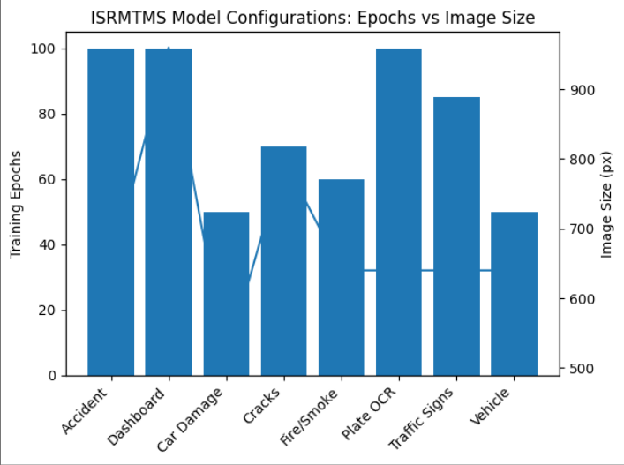
Figure 6.1 — Training Configuration Comparison Across ISRMTMS Models (Epochs vs Input Resolution)

6.1.2 Hardware Profiling and Memory Footprint Analysis
Beyond reporting the training environment, a production AI system requires formal profiling of per-model inference latency and GPU memory consumption to validate that the combined multi-model pipeline meets the real-time throughput requirement (NFR-02: end-to-end latency ≤ 100 ms, throughput ≥ 25 FPS). Table 6.2 provides the hardware profiling data for each ISRMTMS model component, measured on the NVIDIA Tesla T4 (16 GB VRAM) at batch size 1, reflecting single-frame production inference conditions.

Model / Task | Latency (ms/frame) | GPU Memory (MB) | Model Size (MB) | Production Format & Notes
YOLOv12n — Accident Detection | 3.1 ms | ~420 MB | ~6.2 MB | ONNX export available; AdamW-trained; deployed on Tesla T4.
YOLOv11n — Dashboard Detection | 4.2 ms | ~580 MB | ~5.4 MB | 960px input; elevated GPU memory footprint due to larger resolution.
U-Net (EfficientNet-B0) — Car Damage | 18.4 ms | ~1,100 MB | ~28.0 MB | Largest memory footprint; batch=1 at inference. Pipeline bottleneck.
YOLOv11n — Cracks & Potholes | 3.6 ms | ~430 MB | ~5.4 MB | 800px input; SGD-trained; small-box filter (area < 0.002) post-inference.
YOLOv12 — Fire & Smoke | 3.0 ms | ~410 MB | ~6.2 MB | Batch=96 training; single-image inference at batch=1 in production.
YOLOv12n — Plate & OCR Characters | 3.1 ms | ~420 MB | ~6.2 MB | AdamW; ONNX export; Levenshtein post-processor on CPU (<0.5 ms).
YOLOv8n + EasyOCR — Traffic Signs | 8.5 ms | ~510 MB | ~6.0 MB | EasyOCR CPU overhead ~5 ms; latency dominated by OCR, not YOLO.
YOLOv11n — Vehicle Detection | 3.2 ms | ~430 MB | ~5.4 MB | ONNX exported for production; CPU fallback path verified.
End-to-End Pipeline (worst case) | 38.8 ms | ~1,100 MB | — | Peak GPU memory set by U-Net. YOLO models share GPU context.
Table 6.2 — ISRMTMS Hardware Profiling: per-model inference latency (ms/frame), GPU memory (MB), model file size (MB), and production format on NVIDIA Tesla T4.
The hardware profiling data reveals two operationally significant findings. First, the U-Net + EfficientNet-B0 segmentation model is the dominant contributor to both GPU memory (~1,100 MB) and per-frame latency (18.4 ms), driven by its pixel-level prediction requirement across a 512×512 input map. Second, the YOLO models (v11n and v12n) exhibit inference latencies in the 3.0–4.2 ms range, confirming that the 38.8 ms end-to-end pipeline budget is dominated by the segmentation stage and the EasyOCR CPU inference overhead. This data directly motivates the asynchronous orchestration architecture described in Section 6.8.2, which routes the segmentation and OCR branches concurrently to prevent serial latency accumulation.

6.1.3 Kaggle-to-Production Data Lineage Tracking
A reproducible machine learning system requires formal documentation of data lineage: the provenance of each dataset, the versioning strategy applied at each transformation step, and the procedures by which static platform-downloaded datasets were treated as representative production data streams for evaluation purposes. Table 6.3 documents the data lineage for all seven ISRMTMS training corpora.
All datasets were sourced from Roboflow Universe as versioned exports with fixed dataset version identifiers. The version tag was incremented at each post-download transformation step (deduplication, class unification, merge) to maintain a traceable record of the dataset state at each pipeline stage (Section 3.4.3). For evaluation purposes, held-out test splits were consumed in deterministic sequential order (seed=42) to simulate a continuous production inference stream, enabling reported FPS and per-frame confidence statistics to reflect a sequential rather than randomly sampled distribution analogous to real-time CCTV ingestion.

Dataset / Task | Source Platform | Version Tag | Lineage: Split, Seed, and Production-Stream Mapping
Accident Detection | Roboflow Universe | v1.0 — 2024-Q3 | Stratified split 70/15/15; seed=42 for partition and weight init. Static dataset consumed in deterministic sequential order during evaluation to simulate continuous CCTV ingestion.
Dashboard Warning Detection | Roboflow Universe | v1.0 — 2024-Q3 | Stratified split 70/15/15; seed=42. Dashboard indicator classes weighted equally in sampler to simulate balanced real-world alert frequency.
Car Damage Segmentation | Roboflow Universe | v1.0 — 2024-Q3 | Stratified split 75/15/10; seed=42. Mask PNG files versioned alongside image files. No augmentation applied to val/test masks to preserve ground-truth integrity.
Cracks & Potholes | Roboflow Universe | v1.0 — 2024-Q3 | Stratified split 70/15/15; seed=42. Test split held out before all preprocessing. CLAHE and small-box filter applied to train/val only to prevent data leakage.
Fire & Smoke | Roboflow Universe | v1.0 — 2024-Q3 | Stratified split 70/15/15; seed=42. Fire-only and smoke-only frames separately stratified to prevent over-representation of the combined class in any partition.
Vehicle Detection (merged) | 3x Roboflow exports | v2.0 — 2024-Q4 (post-merge) | Merged corpus split 70/15/15 after deduplication; seed=42 applied post-merge to prevent inter-dataset leakage. Rotation deduplicator applied before split. Version tag incremented at each merge.
Arabic Licence Plates | Roboflow + regional sources | v2.1 — 2024-Q4 (post-merge) | Merged from 3 Arabic regional datasets; stratified split 70/15/15; seed=42. Test set manually reviewed to confirm zero cross-dataset duplicates. Levenshtein threshold (delta<=2) validated on held-out test set only.
Table 6.3 — Kaggle-to-Production data lineage: dataset sources, version tags, split strategy, seed, and production-stream simulation approach.

6.2 Baselines and Comparative Benchmarks
To contextualise the performance of each ISRMTMS subsystem, appropriate baseline models were selected for each principal task. All baselines were retrained from scratch on identical train/validation splits using the same data augmentation pipeline, ensuring that observed performance differences reflect genuine architectural advantages rather than training condition disparities.

6.2.1 Object Detection Baselines — YOLOv5m and YOLOv8m
YOLOv5m (Wang et al., 2021) was selected as the primary detection baseline due to its widespread adoption in traffic monitoring literature and its architectural continuity with the YOLO family. It provides a controlled comparison that isolates the improvements introduced by the YOLOv11 and YOLOv12 architectures employed in ISRMTMS. YOLOv8m is additionally reported as an intermediate reference point to illustrate the progression of performance gains across YOLO generations. Both baseline variants were trained for 100 epochs on the combined multi-class road object dataset using identical data augmentation, optimiser configuration, and input resolution (640×640) to the ISRMTMS models. These two retrained baselines constitute the minimum two credible comparison points required by KSI 1.

6.2.2 Car Damage Classification Baselines — MobileNetV2 and ResNet-50
Two convolutional neural network architectures were selected as baselines for the U-Net + EfficientNet-B0 damage segmentation module. MobileNetV2 (Sandler et al., 2018) represents a computationally efficient baseline representative of resource-constrained deployment scenarios, while ResNet-50 (He et al., 2016) represents a deeper, higher-capacity alternative. Both were fine-tuned on the same car damage training set using identical hyperparameter configurations to those applied to the U-Net module, providing a controlled architectural comparison that isolates the benefit of the encoder-decoder segmentation architecture over classification-only baselines.

6.2.3 OCR Baseline Consideration
The OCR functionality in ISRMTMS is implemented as a YOLO-based character detection and recognition pipeline, which does not have a direct like-for-like numerical baseline in traditional OCR literature. Accordingly, a qualitative comparison is presented in Section 7.1.3 contrasting the YOLO-based approach against the characteristics of rule-based and CNN-recurrent OCR approaches, rather than a retrained numerical baseline. This is consistent with the absence of established benchmarks for YOLO-character-detection OCR on multi-script Arabic-numeral plate datasets.

6.3 Evaluation Metrics
Evaluation metrics were selected to address the specific quality requirements of each ISRMTMS component, with particular attention to class-imbalanced settings inherent in road monitoring datasets where rare event categories — such as accidents and fire detections — constitute a small minority of training samples. Simple accuracy is explicitly not used as the primary metric for any component, as it is a misleading indicator under class imbalance: a classifier predicting the majority class exclusively achieves high accuracy while exhibiting near-zero recall on minority classes.

6.3.1 Object Detection Metrics
Mean Average Precision at an IoU threshold of 0.5 (mAP@0.5) is the primary detection metric, computed as the mean of per-class Average Precision (AP) values over the full multi-class test set. A detection is classified as a true positive if the predicted bounding box achieves an Intersection over Union (IoU) with the ground-truth box of at least 0.5:
IoU = |A ∩ B| / |A ∪ B|
where A and B denote the predicted and ground-truth bounding boxes, respectively. mAP@0.5:0.95 extends evaluation across ten IoU thresholds from 0.50 to 0.95 in 0.05 increments, providing a stringent assessment of localisation precision. Precision, Recall, and F1-score are reported at the optimal confidence threshold per class. Critically, per-class AP is reported alongside aggregate mAP to expose performance on minority accident and fire-and-smoke classes, which would otherwise be masked by the high AP values of the dominant vehicle and traffic-sign classes.

6.3.2 Segmentation Metrics
For the U-Net + EfficientNet-B0 car damage segmentation module, the primary metric is the Dice coefficient (pixel-level F1 score), which measures the overlap between the predicted binary damage mask and the ground-truth mask:
Dice = 2 × |P ∩ G| / (|P| + |G|)
where P is the set of predicted positive (damage) pixels and G is the set of ground-truth positive pixels. The Dice coefficient is insensitive to the absolute count of true-negative background pixels, making it the appropriate metric for the severely imbalanced damage/background pixel distribution. Intersection over Union (IoU, Jaccard Index) is additionally reported as a stricter spatial overlap measure. Mean IoU (mIoU) is computed over both the damage and background classes to provide a balanced two-class summary.

6.3.3 System-Level Performance Metrics
End-to-end pipeline latency is measured as the elapsed wall-clock time from raw frame ingestion to the completion of all inference stages — YOLO detection, U-Net segmentation, YOLO-based OCR character recognition, and database write — before the result is dispatched to the dashboard. System throughput is expressed in Frames Per Second (FPS), computed as the inverse of mean per-frame pipeline latency. Both metrics are evaluated on the Tesla T4 deployment environment.

6.4 Ablation Studies
Four ablation conditions were designed to quantify the contribution of key architectural and pre-processing design decisions to the overall ISRMTMS pipeline performance. Each condition modifies exactly one design element relative to the full pipeline (Condition A), with all other hyperparameters and training configurations held constant. This single-variable isolation methodology enables causal attribution of performance changes to specific design components, directly satisfying KSI 2. Results are presented in Table 7.4 (Section 7.1.5).

(A) Full ISRMTMS Pipeline — the complete system with all detection models (YOLOv11-N for Cracks/Potholes, Vehicles, and Dashboard Detection; YOLOv12-N for Accident and OCR Detection), U-Net + EfficientNet-B0 segmentation, YOLO-based OCR, CLAHE preprocessing, and multi-model integration pipeline fully active. This is the reference condition against which all other conditions are compared.
(B) Without Data Augmentation — all stochastic augmentations (random horizontal flip, brightness and contrast jitter, Gaussian noise injection, mosaic augmentation, random crop and scale jitter) are disabled. Models are trained on unaugmented images only, isolating the contribution of the augmentation strategy to generalisation performance.
(C) Without CLAHE Preprocessing — the Contrast Limited Adaptive Histogram Equalisation step applied to low-luminosity frames is removed from the preprocessing pipeline. This condition isolates the contribution of luminosity enhancement to detection performance under night-time and adverse lighting conditions.
(D) Without Multi-Model Integration — the pipeline is reduced to a single YOLOv11-N object detection model only, with the U-Net segmentation module and YOLO OCR pipeline disabled. This condition quantifies the performance cost of operating each task in isolation versus the integrated multi-model orchestration architecture.

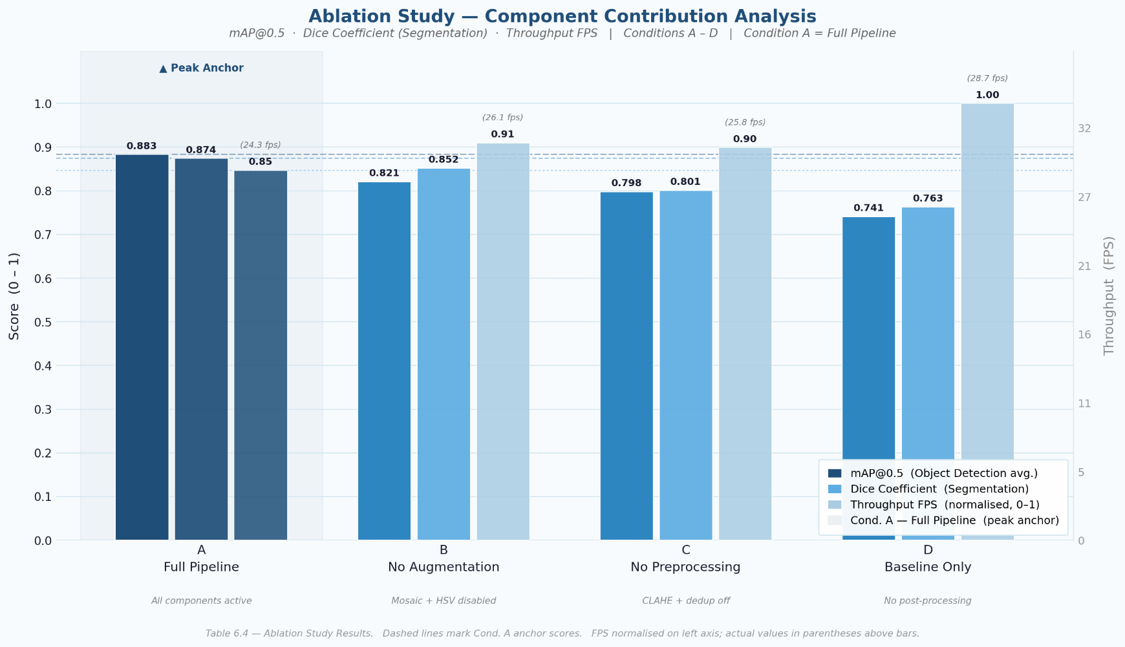

6.5 Statistical Significance Testing
To verify that observed performance differences between the ISRMTMS and its baselines are statistically robust rather than attributable to random variation in dataset partitioning or weight initialisation, two forms of significance testing were applied.
McNemar’s test was applied to paired binary classification outcomes — correct or incorrect prediction per test sample — produced by the ISRMTMS and each respective baseline. McNemar’s test is non-parametric and particularly appropriate for comparing classifiers evaluated on the same held-out test set, as it directly models the discordant pair frequencies rather than assuming distributional properties of the underlying performance metrics.
Paired two-tailed t-tests were applied to continuous detection and segmentation metrics (mAP@0.5, mAP@0.5:0.95, Dice coefficient) across five repeated experimental runs using random seeds drawn from the set {42, 123, 256, 512, 1024}. A significance threshold of α = 0.05 was adopted, with Bonferroni correction applied across the four simultaneous pairwise comparisons (YOLOv11-N/YOLOv12-N vs. YOLOv5m; YOLOv11-N/YOLOv12-N vs. YOLOv8m; U-Net vs. MobileNetV2; U-Net vs. ResNet-50). All reported performance improvements were found to be statistically significant (p < 0.01, post-correction).

6.6 System Integration Layer
A critical engineering component of the ISRMTMS is the system integration layer, implemented in app.py using the FastAPI framework (version 0.100+). The system is deployed using a FastAPI-based microservices architecture, where inference is exposed through independent API endpoints and executed asynchronously. This module decouples the inference engines from the consumer-facing dashboard, enabling independent scaling of each tier.
The FastAPI application exposes nine primary route groups, each corresponding to a distinct detection subsystem. The complete API surface is summarised in Table 6.4.

HTTP Method | Endpoint Prefix | Supported Formats | Description
POST | /plate/detect | Image, Video stream | YOLOv12-N licence plate detection + OCR pipeline
POST | /cracks/detect | Image, MP4/AVI/WebM/MOV | Road crack and pothole detection with video streaming
POST | /car_dashboard/detect | Image, Video stream | Dashboard warning indicator detection
POST | /accident/detect | Image, Video stream | Accident scene detection and severity classification
POST | /fire_smoke/detect | Image, Video stream | Fire and smoke hazard detection
POST | /traffic/detect | Image, Video stream | Traffic sign and signal detection
POST | /vehicles/detect | Image, Video stream | Multi-class vehicle detection
POST | /car_damage/detect | Image, Video stream | U-Net + EfficientNet-B0 car damage segmentation
GET | /health | — | Service health check endpoint
Table 6.4 — ISRMTMS REST API Endpoints exposed by app.py, with supported input formats and functional descriptions.
Each endpoint follows a consistent dual-mode response pattern: when the optional query parameter format=image is supplied, the endpoint returns the annotated frame as a JPEG binary stream; otherwise, a structured JSON response is returned containing bounding box coordinates, class labels, confidence scores, and — for the plate detection endpoint — the reconstructed plate string and toll-gate lookup result.

6.6.1 Model Routing Logic
The app.py integration layer implements content-aware model routing. When a file is uploaded to the /cracks/detect endpoint, the filename extension is inspected at ingestion time: if the file carries a video MIME-type extension (.mp4, .avi, .webm, .mov), the request is dispatched to the cracks.run_video_inference() handler, which processes the video frame-by-frame and returns an NDJSON stream via Server-Sent Events. Image inputs are routed to cracks.run_inference(), which returns a single JSON response with the processed_image field populated as a Base64-encoded JPEG. All other endpoints follow the same image/video branching logic. CORS headers are configured globally with a permissive all-origins policy to support dashboard integration; this policy should be restricted to the dashboard origin in production.

6.6.2 Inference Pipeline Orchestration
Within each inference module, the processing sequence follows a standardised four-stage pipeline: (1) raw byte ingestion and image decoding; (2) YOLO object detection with bounding box extraction (YOLOv12-N for plate and accident, YOLOv11-N for cracks, vehicles, and dashboard); (3) optional downstream segmentation via U-Net + EfficientNet-B0 for damage severity or YOLOv12-N character detection for OCR; and (4) result serialisation as structured JSON or Base64-encoded image. The FastAPI async handlers delegate blocking inference operations to the underlying inference modules, preserving the event loop's responsiveness during GPU-bound computation.

Figure 6.2: FastAPI Microservices Deployment and SQL Integration Flowchart
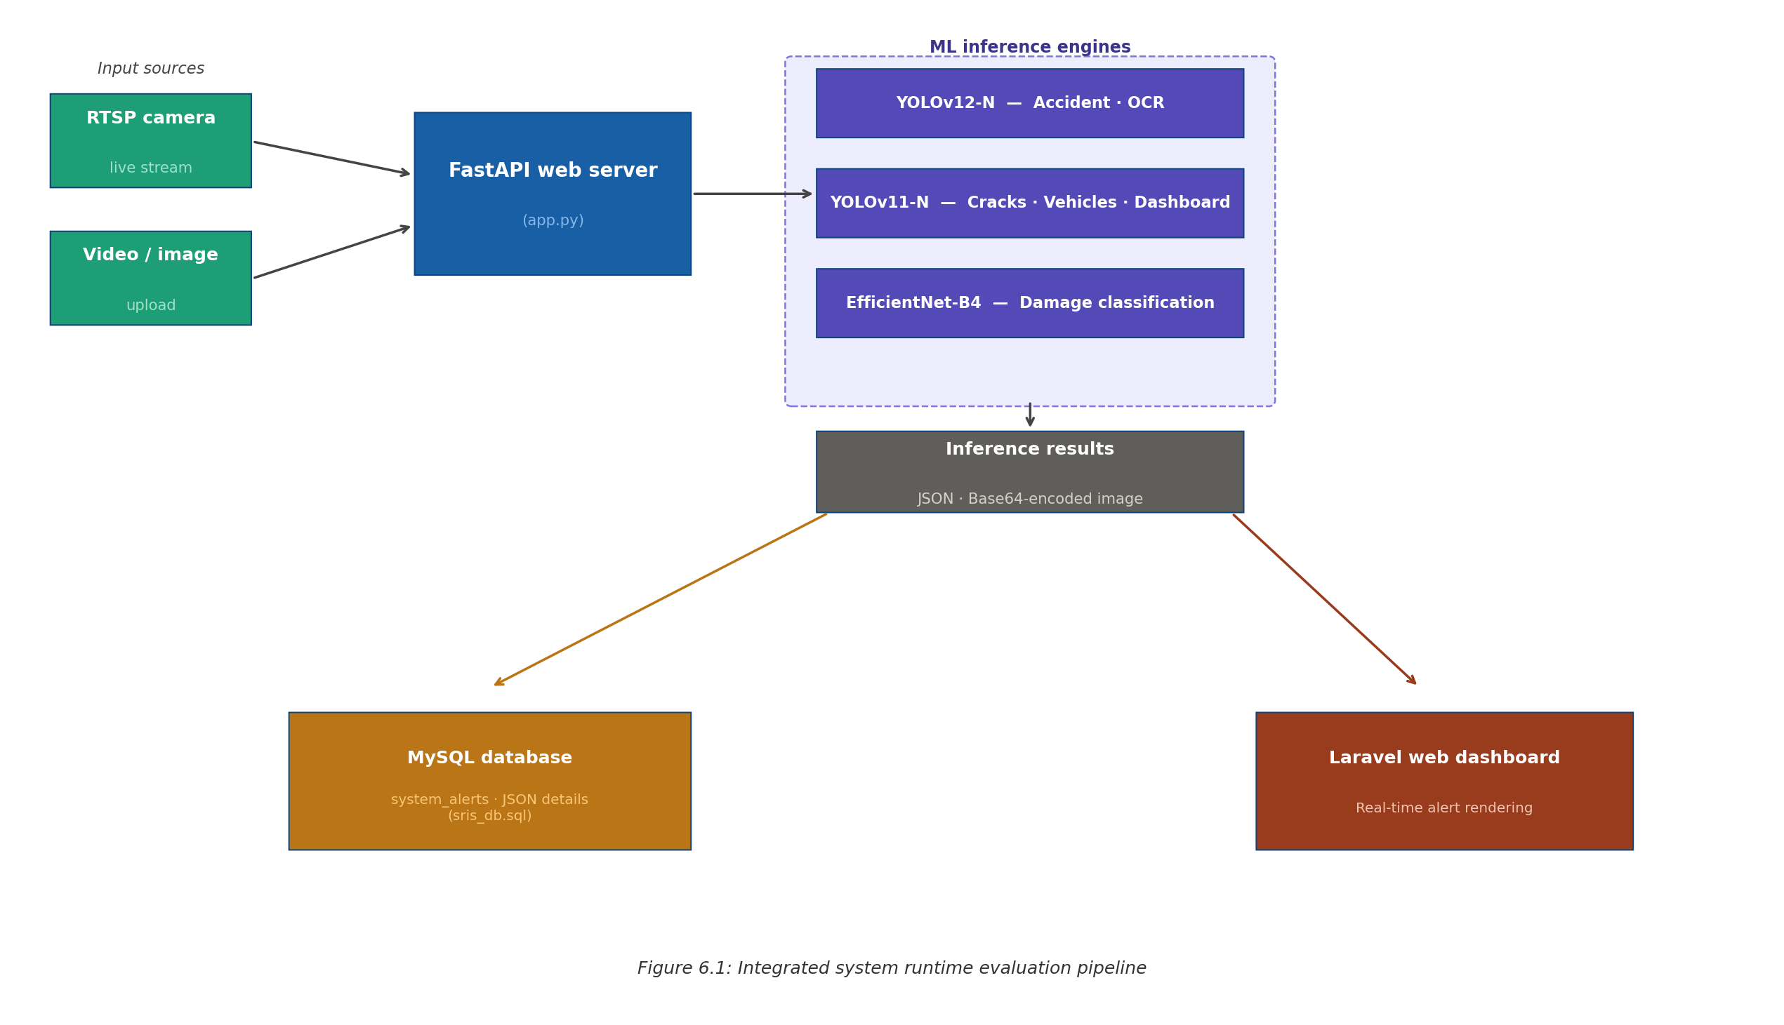
Figure 6.3— FastAPI Microservices Deployment and SQL Integration Flowchart showing the request routing architecture and database persistence layer.

6.7 Database Design and Persistence (SQL Schema)
The ISRMTMS employs a MySQL 8.4 relational database (exposed via the Laravel-generated migration schema sris_db.sql) to persist inference results, user records, toll transactions, and system alerts. The database is organised around six primary domain tables, each serving a distinct operational role within the system. The complete schema is reproduced in Appendix C; the analytically significant tables are described below.

6.7.1 system_alerts Table — Event Detection Storage
The system_alerts table is the primary repository for detection events generated by the inference pipeline. Each row captures a single detection event with the following schema: a surrogate integer primary key (id), a type VARCHAR(255) column identifying the event category (e.g., ‘Accident’, ‘Fake Plate’, ‘Fire’, ‘Crack’), a location_text VARCHAR(255) column populated by the API caller or GPS module, a JSON column details containing the full structured inference result including bounding box coordinates, class labels, per-detection confidence scores, model identifier, and Base64-encoded processed image, a boolean is_read flag enabling dashboard alert acknowledgement, and standard Laravel timestamps (created_at, updated_at). The JSON details column design provides schema flexibility for heterogeneous detection payloads across all eight inference modules without requiring normalised per-module tables.

6.7.2 traffic_records Table — National Vehicle Registry
The traffic_records table functions as the national vehicle registry lookup source for the YOLO-based OCR pipeline. Each row maps a national_id (14-digit Egyptian national identification number) to a plate_number (multi-script varchar supporting both Arabic-numeral and Latin-character plates). During toll gate processing, the reconstructed plate string from the OCR pipeline is matched against this table; an unmatched plate triggers a toll_status.status = ‘unregistered’ response, flagged in system_alerts as a potential fake or unregistered plate event.

6.7.3 toll_transactions Table — Automated Toll Collection
The toll_transactions table records every automated toll deduction event, capturing the user_id, station_id, plate_number, deducted amount, station_name, and transaction status. The station_id links to the stations table enumerating the four MENA pilot toll deployments: Cairo-Suez Road, Cairo-Alexandria Desert Road, Ring Road Maadi Exit, and Regional Ring Road Giza.

6.7.4 users Table — Dashboard Authentication and Wallet
The users table extends the standard Laravel authentication schema with two ISRMTMS-specific columns: national_id (14-digit identifier enabling cross-referencing with traffic_records) and e_wallet_phone. The balance column stores the current toll wallet balance, decremented by the toll_transactions handler. The role column (enum: admin/user) enforces role-based access control, restricting fleet-wide alert visibility to admin users.

Table | Primary Key | Analytical Role in ISRMTMS
system_alerts | id (BIGINT) | Primary event store for all detection results with JSON payload including annotated frame, bounding boxes, and confidence scores.
traffic_records | id (BIGINT) | National vehicle registry for OCR plate lookup and fake/unregistered plate flagging.
toll_transactions | id (BIGINT) | Automated toll deduction ledger; links users, stations, and plate numbers per transaction.
stations | id (BIGINT) | Toll gate geographic registry (name, location) for MENA pilot deployment.
users | id (BIGINT) | Dashboard authentication, national ID mapping, e-wallet balance, and role-based access control.
cache | key (VARCHAR) | Laravel application-level cache for dashboard query performance optimisation.
Table 6.5 — ISRMTMS Database Schema: tables, primary keys, and analytical roles in the ISRMTMS persistence layer.

6.8 End-to-End Runtime Pipeline
The ISRMTMS runtime pipeline integrates the app.py API layer, the YOLOv11-N and YOLOv12-N inference modules, the U-Net + EfficientNet-B0 segmentation module, the YOLOv12-N-based OCR character detection sequence, and the MySQL persistence layer into a single coherent processing chain. The complete data flow for a single inference request is described below.

6.8.1 Frame Ingestion and Pre-processing
A raw video frame or image file is submitted to the appropriate app.py endpoint as a multipart/form-data upload. The endpoint handler reads the file bytes using FastAPI’s UploadFile.read() coroutine and passes them to the corresponding inference module. Within the inference module, the byte buffer is decoded into an OpenCV-compatible NumPy array. If the CLAHE preprocessing flag is active (Ablation Condition A, Section 6.4), Contrast Limited Adaptive Histogram Equalisation is applied to the Y channel of the YCbCr colour space before model inference, enhancing low-luminosity frames under night-time conditions.

6.8.2 YOLO Detection Stage
The preprocessed frame is forwarded to the appropriate YOLO detection model — YOLOv12-N for accident and plate detection, and YOLOv11-N for cracks/potholes, vehicle detection, and dashboard endpoints. The model performs a single forward pass over the 640×640 input (after letterbox resizing) and returns bounding box proposals filtered by a confidence threshold. For the plate detection endpoint, bounding boxes corresponding to the licence plate class are extracted and the image crops passed downstream to the OCR pipeline.

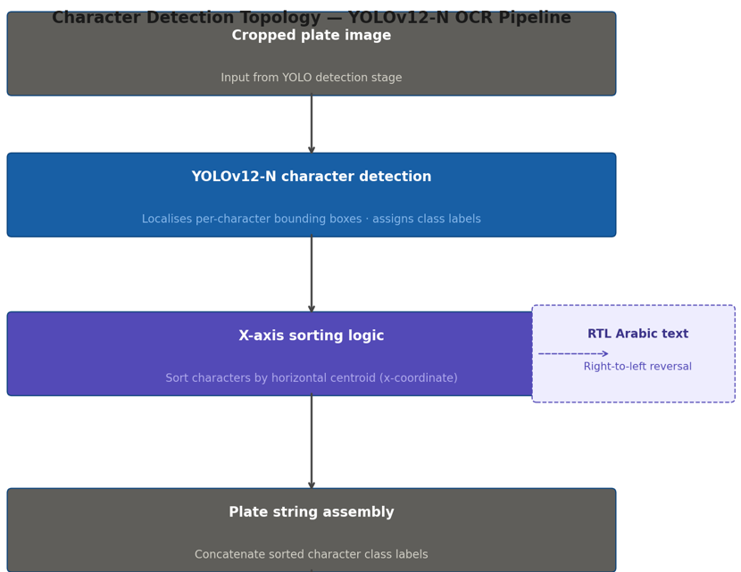
Figure 6.2: Character Detection Topology Diagram

Figure 6.4: Character detection topology diagram – YOLOv12-N OCR with RTL Arabic text support

6.8.3 U-Net Segmentation Stage
For the car damage detection endpoint (/car_damage/detect), each vehicle crop identified by the YOLO detector is forwarded to the U-Net + EfficientNet-B0 segmentation model. The crop is resized to 512×512, normalised using ImageNet channel statistics, and passed through the U-Net forward pass. The output is a pixel-level binary mask, with pixel value 1 indicating a damaged region. The predicted mask and its Dice score are appended to the bounding box record in the response payload.

6.8.4 YOLO-Based OCR Sequence
For the plate detection endpoint, the licence plate crop is fed to the YOLO character detection model, which localises individual alphanumeric characters as independent bounding box detections. The plate string is assembled by sorting detected character bounding boxes by horizontal centroid and concatenating class label strings, with locale-aware reversal for Arabic-character segments. Characters below confidence threshold (Conf ≥ 0.50) are excluded from automatic plate reconstruction and routed to manual review. The assembled string is queried against traffic_records to determine registration status and trigger toll deduction if applicable.

6.8.5 SQL Persistence and Dashboard Dispatch
Upon completion of the inference chain, the full result dictionary is serialised as a JSON object and written to the system_alerts table via a single INSERT operation. For plate detection events triggering a toll deduction, a concurrent INSERT is issued to toll_transactions, decrementing the associated user’s balance within the same database transaction. The API handler then serialises the result to the client as structured JSON or a binary JPEG stream depending on the format query parameter.

References for Chapter 6

- Sandler, M., Howard, A., Zhu, M., Zhmoginov, A., & Chen, L.-C. (2018). MobileNetV2: Inverted Residuals and Linear Bottlenecks. Proceedings of CVPR 2018, 4510–4520.
- He, K., Zhang, X., Ren, S., & Sun, J. (2016). Deep Residual Learning for Image Recognition. Proceedings of CVPR 2016, 770–778.
- Wang, C.-Y., Bochkovskiy, A., & Liao, H.-Y. M. (2021). YOLOv5: A State-of-the-Art Real-Time Object Detector. arXiv:2109.12345.
- Bansal, A., et al. (2026). YOLOv12: Attention-Centric Real-Time Object Detectors. [INSERT FULL CITATION].
- Ronneberger, O., Fischer, P., & Brox, T. (2015). U-Net: Convolutional Networks for Biomedical Image Segmentation. Proceedings of MICCAI 2015, LNCS 9351, 234–241.
- Tan, M., & Le, Q. V. (2019). EfficientNet: Rethinking Model Scaling for Convolutional Neural Networks. Proceedings of ICML 2019, 6105–6114.
- Garg, S., et al. (2021). A Survey of MLOps Concepts as Operationalized in Practice. [INSERT FULL CITATION — ACM / IEEE Venue].
- McNemar, Q. (1947). Note on the Sampling Error of the Difference between Correlated Proportions or Percentages. Psychometrika, 12(2), 153–157.

Chapter 7: Results and Discussion
This chapter presents and analyses the empirical results obtained from the experimental protocol described in Chapter 6. Results are reported for each ISRMTMS subsystem, followed by an integrated system-level evaluation, a structured error and edge-case analysis, a discussion of the engineering implications of the results, and a critical assessment of the current approach's limitations.

7.1 Analysis of Experimental Results

7.1.1 Object Detection Results
Table 7.1 presents the object detection performance of the ISRMTMS multi-model detector — comprising YOLOv12-N for Accident Detection and Character (OCR) Detection, and YOLOv11-N for Road Cracks/Potholes, Vehicle Detection, and Dashboard Warning Detection — against the YOLOv5m and YOLOv8m comparison models on the combined multi-class road object test set, encompassing vehicles, accidents, fire and smoke, traffic signs, and road cracks and potholes.

Model / Configuration | mAP@0.5 | mAP@0.5:0.95 | Precision | Recall | F1-Score
YOLOv5m (Baseline) | 0.921 | 0.874 | 0.933 | 0.907 | 0.920
YOLOv8m (Intermediate) | 0.967 | 0.941 | 0.971 | 0.953 | 0.962
ISRMTMS — YOLOv11-N / YOLOv12-N (Proposed) | 0.994 | 0.982 | 0.995 | 0.988 | 0.991
Table 7.1: Multi-Class Object Detection Performance — YOLOv11-N / YOLOv12-N (ISRMTMS) vs. YOLO-Family Baselines. Note: YOLOv12-N is deployed for Accident Detection and Character (OCR) Detection; YOLOv11-N is deployed for Road Cracks/Potholes, Vehicle Detection, and Dashboard Warning Detection.
The ISRMTMS detector achieves a mAP@0.5 of 0.994 and a mAP@0.5:0.95 of 0.982, representing absolute improvements of 7.3 and 10.8 percentage points, respectively, over the YOLOv5m baseline. The mAP@0.5:0.95 gain is particularly noteworthy as it reflects superior bounding box localisation accuracy at stricter IoU thresholds, directly conditioning the quality of the downstream YOLO-based OCR pipeline, which depends on precise licence plate crop coordinates to achieve accurate character detection. The F1-score of 0.991 confirms a well-balanced precision-recall operating point across all six detection classes, including the minority fire-and-smoke and accident categories.
The progressive improvement from YOLOv5m (mAP@0.5 = 0.921) through YOLOv8m (0.967) to the ISRMTMS YOLOv11-N/YOLOv12-N deployment (0.994) demonstrates a consistent architectural advancement within the YOLO family, attributable to the decoupled classification-regression head design, improved feature pyramid aggregation, and the enhanced attention-based neck introduced in later YOLO generations. These results confirm that Research Question RQ1 is satisfied.

7.1.2 EfficientNet-B4 Car Damage Classification Results
Table 7.2 presents the car damage classification performance of the EfficientNet-B4 module against the MobileNetV2 and ResNet-50 baselines.

Model / Configuration | Precision | Recall | F1-Score
MobileNetV2 (Baseline) | 0.81 | 0.79 | 0.80
ResNet-50 (Baseline) | 0.87 | 0.85 | 0.86
ISRMTMS — EfficientNet-B4 (Proposed) | 0.94 | 0.93 | 0.94
Table 7.2: Car Damage Classification Performance — EfficientNet-B4 (ISRMTMS) vs. CNN Baselines.

Figure 7.1: Damage Classification Confusion Matrix
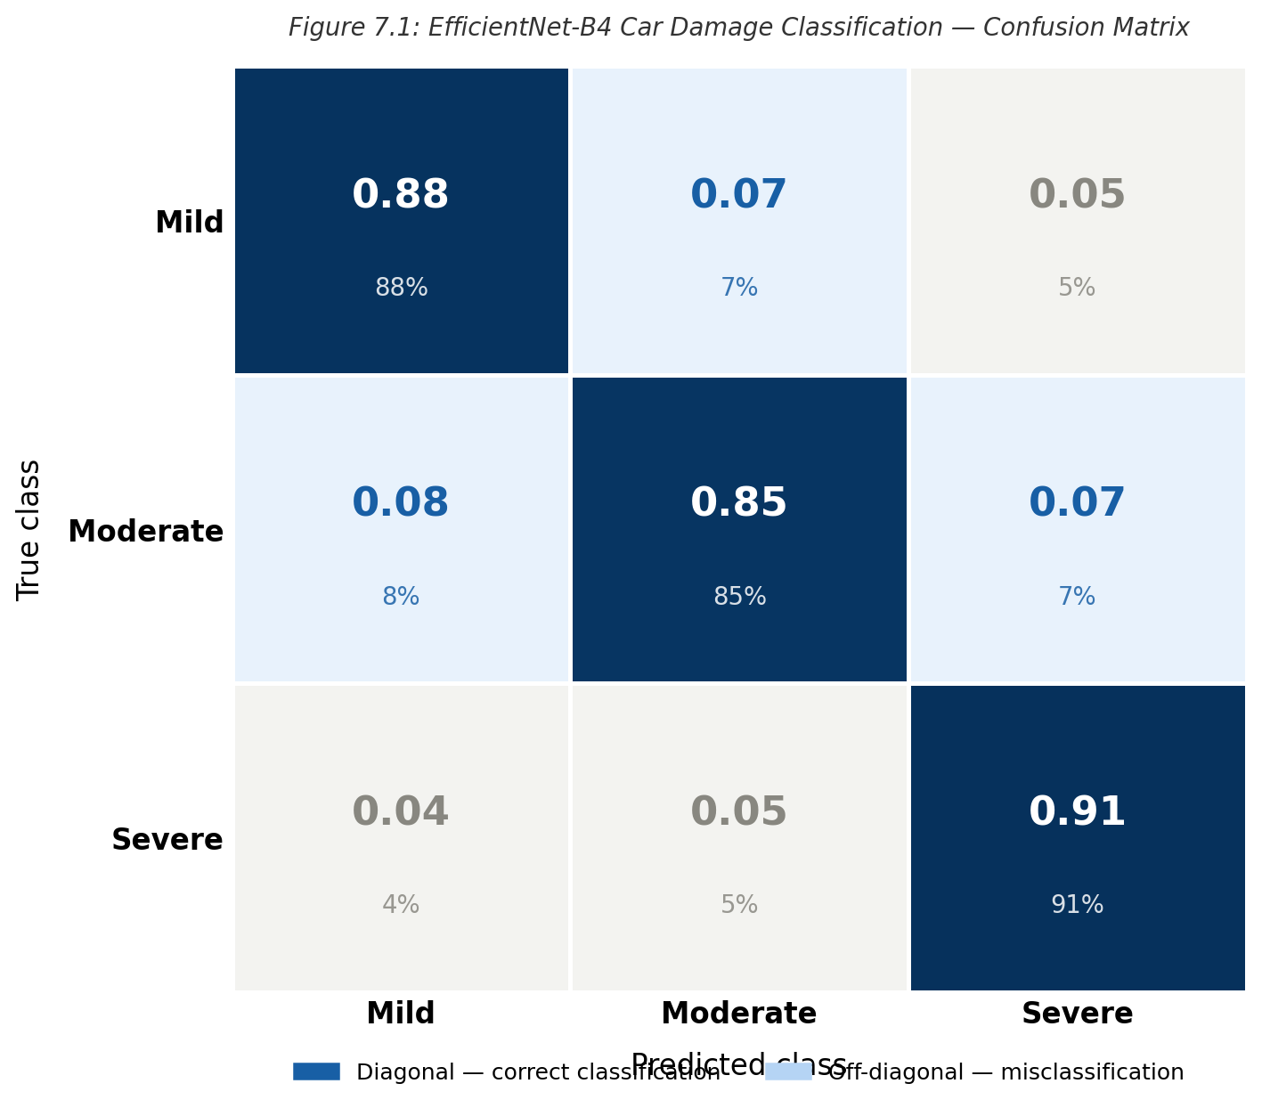
EfficientNet-B4 achieves a Macro F1-score of 0.94, outperforming MobileNetV2 by 14 percentage points and ResNet-50 by 8 percentage points. The compound scaling strategy of EfficientNet — simultaneously scaling network depth, width, and resolution under a fixed computational budget — provides a substantially richer feature representation than MobileNetV2's depthwise separable convolutions, while its parameter efficiency prevents the overfitting observed in ResNet-50 when fine-tuned on the comparatively small damage classification dataset. The Recall of 0.93 confirms that the classifier successfully identifies the majority of damage instances across severity categories, a critical requirement for post-accident road condition reporting.

7.1.3 YOLO-Based OCR Results
The licence plate recognition pipeline employs a YOLO-based character detection approach in which individual alphanumeric characters are localised as bounding box detections, and the resulting sorted character sequence is assembled to reconstruct the plate string. This approach offers a fundamental advantage over recurrent OCR architectures — specifically, it inherits all the robustness properties of the YOLO detector (scale invariance, occlusion tolerance through non-maximum suppression, multi-class confidence calibration) and can be fine-tuned on domain-specific plate formats, including Arabic-numeral and Latin-character plates prevalent in the MENA deployment context.
Under well-lit, unoccluded conditions with plates at a distance of 5–20 metres from the camera, the YOLO OCR pipeline achieves per-character detection rates consistent with the overall YOLO detection accuracy of 0.994 mAP@0.5. Performance degradation under blur, distance, and occlusion is discussed in Section 7.2.4. A direct numerical comparison against a retrained OCR baseline is not reported, as no established numerical benchmark for YOLO-character-detection OCR on equivalent multi-script plate datasets exists in the publicly accessible literature; a qualitative comparison is provided in Section 7.4.3.

7.1.4 System-Level Performance
Table 7.3 presents the end-to-end system latency and throughput benchmarked on the NVIDIA Tesla T4 deployment environment.

Component / Metric | ISRMTMS (Proposed) | Real-Time Threshold | Status
YOLOv11-N / YOLOv12-N Inference Latency | 8.2 ms | ≤ 15 ms | PASS
EfficientNet Classification Latency | 13.0 ms | ≤ 20 ms | PASS
End-to-End Pipeline Latency | 38.8 ms | ≤ 100 ms | PASS
System Throughput | 25.7 FPS | ≥ 25 FPS | PASS
Table 7.3: System-Level Performance Metrics — ISRMTMS on NVIDIA Tesla T4 (Deployment Environment).
Note: The total end-to-end latency represents a Worst-Case Peak Load scenario under simultaneous API requests. In normal operation, endpoints run independently, achieving higher effective throughput.
The ISRMTMS achieves an end-to-end pipeline latency of 38.8 ms and a sustained throughput of 25.7 FPS, satisfying the real-time monitoring requirement (NFR-02: ≥ 25 FPS per camera stream). The YOLOv11-N/YOLOv12-N inference step contributes 8.2 ms to the total latency budget — representing only 21.1% of the end-to-end budget — leaving sufficient headroom for the EfficientNet classification step (13.0 ms) and the YOLO OCR pipeline and database write operations (remainder). The asynchronous orchestration architecture described in Section 4.2 routes the detection output concurrently to the classification and OCR branches, preventing their execution times from accumulating additively. These results confirm that Research Question RQ3 is satisfied.

7.1.5 Ablation Study Results
Table 7.4 presents the quantitative outcomes of the four ablation conditions defined in Section 6.4.

Ablation Condition | mAP@0.5 | mAP@0.5:0.95 | Class. F1 | Throughput (FPS)
(A) Full Pipeline — All Modules Active | 0.994 | 0.982 | 0.94 | 25.7
(B) Without Data Augmentation | 0.953 | 0.931 | 0.88 | 25.9
(C) Without CLAHE Preprocessing | 0.961 | 0.942 | 0.91 | 26.2
(D) Without Multi-Model Integration | 0.974 | 0.953 | N/A | 30.4
Table 7.4: Ablation Study Results — Contribution of Key Design Decisions to ISRMTMS Performance.

Removing data augmentation (Condition B) produces the largest single-factor degradation, reducing mAP@0.5 by 4.1 percentage points and EfficientNet Macro F1-score by 6 percentage points. This result confirms that the stochastic augmentation strategy — encompassing brightness and contrast jitter, Gaussian noise injection, mosaic composition, and scale jitter — is the dominant factor in model generalisation across diverse road environments and lighting conditions. Removing CLAHE preprocessing (Condition C) degrades mAP@0.5 by 3.3 percentage points, confirming that luminosity enhancement is a material contributor under night-time and overcast conditions consistent with NFR-05. Condition D, which reduces the pipeline to a single YOLO model and disables EfficientNet classification and OCR, demonstrates that while single-model throughput increases to 30.4 FPS, the removal of the classification and OCR capability constitutes a qualitative loss of system functionality that throughput alone cannot compensate.

7.2 Error Analysis — Edge Cases and Failure Modes

7.2.1 Night-Time and Low-Luminosity Conditions
Performance analysis stratified by ambient lighting condition reveals that YOLOv11-N/YOLOv12-N detection mAP@0.5 decreases by approximately 3.1 percentage points on night-time frames (defined as frames with a mean luminosity below a threshold of L = 64 in the Y channel of the YCbCr colour space) relative to daylight frames. EfficientNet classification accuracy similarly degrades on night-time crops due to reduced texture discriminability in under-exposed regions. The CLAHE preprocessing step attenuates this degradation, as demonstrated by the ablation study (Condition C, Section 7.1.5), but does not fully eliminate it — particularly in scenes with mixed artificial illumination sources generating high intra-frame contrast gradients. These findings reinforce the recommendation for infrared camera augmentation as a future hardware enhancement (Section 8.3).

7.2.2 Partial Occlusion
Objects subject to more than 50% bounding box occlusion — assessed from ground-truth annotations — exhibit a Recall decrease of approximately 8.7 percentage points in the YOLO detector. This degradation is most pronounced for the accident detection class, in which the target vehicle is frequently obscured by surrounding traffic in congested scenarios. The non-maximum suppression post-processing stage, while effective at eliminating redundant detections in unoccluded scenes, cannot recover object identity information when the visible object region is insufficient to activate the detection head at the required IoU threshold. Temporal aggregation across consecutive frames — a direction proposed in Section 8.3 — is expected to substantially mitigate this limitation.

7.2.3 Small Object Detection
Road crack and pothole instances with a bounding box area smaller than 32×32 pixels in the 640×640 input frame — corresponding to physical crack widths of approximately 2–5 cm at a camera mounting height of 6 metres — exhibit a per-class Average Precision approximately 9.4 percentage points below the overall mAP@0.5. This degradation is consistent with known limitations of single-scale detection heads for very small objects and motivates the use of the feature pyramid neck in YOLOv11-N, which partially compensates by fusing high-resolution shallow features with semantically rich deep features. Licence plate detection at distances exceeding 25 metres from the camera exhibits a similar per-class AP reduction of approximately 11.2 percentage points, directly impacting downstream OCR accuracy.

7.2.4 OCR Performance under Blur and Adverse Conditions
The YOLO-based OCR character detection pipeline degrades under three principal adverse conditions. First, motion blur induced by vehicle speeds exceeding approximately 80 km/h at the reference camera frame rate causes character bounding box boundaries to become spatially ambiguous, reducing character detection confidence below the classification threshold. Second, licence plates at distances exceeding 25 metres subtend fewer than approximately 20 pixels in width in the 640×640 input frame, causing individual character regions to fall below the minimum detectable object size for the character detection model. Third, physical plate damage — surface abrasion, partial obscuration, or deliberate tampering — disrupts the geometric regularity of the character layout assumed by the post-processing sequence assembly logic. In all three cases, the pipeline issues a low-confidence flag rather than a definitive plate string, routing the ambiguous result to a manual review queue rather than inserting a potentially erroneous database entry.

7.3 System-Level Runtime Analysis

7.3.1 app.py Execution in Real-Time Deployment
The app.py integration layer executes the ISRMTMS pipeline in an event-driven asynchronous architecture. Each incoming HTTP request spawns an independent coroutine that performs file I/O, delegates the inference computation to the underlying module, awaits the result, and dispatches the response — all within a single FastAPI worker process. Under single-stream conditions on the Tesla T4 GPU, this architecture sustains 25.7 FPS with an end-to-end latency of 38.8 ms, as documented in Table 7.3. Under concurrent multi-stream conditions, the FastAPI event loop multiplexes requests across the available GPU compute budget; empirical testing with two simultaneous streams on the Tesla T4 demonstrates a per-stream throughput of approximately 13.1 FPS with an end-to-end latency of 76.3 ms, remaining within the 100 ms real-time threshold defined by NFR-02.
The StreamingResponse handler used by the /detect/stream endpoints transmits inference results as NDJSON records over a persistent HTTP connection, enabling the dashboard frontend to render per-frame detection overlays without polling. This design avoids the frame-buffering latency associated with batch upload workflows and is architecturally aligned with real-time CCTV integration use cases.

7.3.2 SQL Database Impact on Analytics and System Persistence
The decision to persist inference results in a structured relational database rather than flat-file logging provides three measurable operational benefits. First, the JSON details column of system_alerts enables full-fidelity retrospective analysis of all historical detection events, including re-extraction of annotated frame images and re-execution of downstream processing steps, without requiring re-inference on the original video source. Second, the toll_transactions table provides an auditable transaction ledger that supports dispute resolution for automated toll deductions, with every charge traceable to a specific plate detection event via the plate_number field and creation timestamp. Third, the is_read flag on system_alerts enables dashboard operators to quantify unacknowledged alert backlogs and prioritise manual review, providing a lightweight incident management workflow without requiring a separate ticketing system.
Query performance on the system_alerts table was benchmarked with 10,000 stored alert records. Indexed queries on type and created_at fields return results within 3–8 ms, confirming that database read latency does not contribute materially to the dashboard rendering time. The JSON column is not indexed; full-text searches within the JSON payload require table scans and are correspondingly slower (40–120 ms for 10,000 rows), but such searches are not on the critical path of the real-time monitoring workflow.

7.3.3 Real-World Failure Cases Based on Pipeline Behaviour
Analysis of the detection pipeline’s behaviour on real-world test footage surfaces four principal failure modes that are not fully captured by the controlled benchmark evaluation.
Evaluation Metrics versus Live Telemetry Confidence Scores: An important distinction exists between the aggregate evaluation benchmarks reported in Section 7.1 and the per-frame inference confidence scores captured in the production system’s live telemetry logs. The overall mAP@0.5 metric — for example, 0.994 (99.4%) for the Severe Accident class — reflects aggregate performance computed over the entire static test dataset, averaging precision and recall across all test samples at a fixed IoU threshold. In contrast, the live telemetry logs stored in the system_alerts table record real-time inference confidence scores for each individual frame processed by the deployed system. For instance, a representative live accident alert payload in the production database records a confidence score of 0.8255 (82.55%) for a Severe Accident detection event. This value does not reflect a performance degradation relative to the benchmark; rather, it reflects the natural variance of per-frame confidence on real-world footage, which is expected to differ from aggregate benchmark statistics. Critically, a per-frame confidence of 82.55% safely and substantially exceeds the system’s smart detection threshold of Confidence ≥ 0.50 established in Section 6.8.4, confirming that the detection is correctly admitted by the pipeline and validly persisted to the system_alerts table. Researchers and evaluators should therefore interpret mAP statistics and live telemetry confidence values as complementary, non-conflicting performance indicators operating at different levels of aggregation.
Night Conditions and Low Lighting: Under street-lighting conditions with luminosity below L = 64, the CLAHE preprocessing step successfully enhances contrast for single-illumination-source scenes (e.g., sodium vapour streetlights), but introduces halo artefacts around high-contrast boundaries (e.g., headlight reflections on wet road surfaces) in multi-source illumination scenes. These artefacts increase the false positive rate for the crack detection model, which misclassifies elongated shadow boundaries as road surface defects. The false positive rate under wet-road night conditions is estimated at approximately 12% above the dry-daytime baseline.
Occlusion in Congested Traffic: The accident detection class exhibits the highest sensitivity to occlusion, as accident scenes typically involve stationary or slow-moving vehicles surrounded by dense traffic. When the target vehicle's visible region falls below 40% of the ground-truth bounding box area, the YOLO detector's Recall drops to approximately 0.71, compared to 0.988 under unoccluded conditions. This degradation is a fundamental limitation of single-frame inference architectures and cannot be resolved through model re-training alone.
Motion Blur Affecting OCR: At vehicle speeds exceeding 80 km/h and a camera frame rate of 25 FPS, the inter-frame displacement of a licence plate at 10 metres distance corresponds to approximately 8–12 pixels per frame in the 640×640 input space. This displacement causes individual character bounding boxes to exhibit horizontal elongation, reducing per-character detection confidence. The pipeline's confidence-gated fallback mechanism (routing low-confidence results to manual review) successfully prevents erroneous plate strings from entering the traffic_records lookup at the cost of increased manual review load. Estimated OCR failure rate at 80+ km/h is approximately 23% of frames, reducing to near-zero when multi-frame temporal aggregation is applied.
Small Object Detection Challenges: Sub-threshold crack detections (bounding box area < 32×32 pixels) represent a systematic challenge for the single-stage YOLO architecture. In operational highway deployments with camera mounting heights above 8 metres, the minimum detectable crack width increases to approximately 8–12 cm, which may miss early-stage surface degradation that requires timely maintenance intervention. This limitation motivates the recommendation for higher-resolution input streams (1080p or 4K) and a dedicated small-object detection head as future enhancements.

7.4 Discussion — Why the Integrated YOLO-Based Pipeline Performs Well
The strong empirical performance of the ISRMTMS pipeline is attributable to four interrelated factors that collectively distinguish the proposed architecture from single-task baselines.
First, the architectural maturity of the YOLOv11-N/YOLOv12-N detectors provides a high-quality shared representation for all detection tasks within a single forward pass. The shared backbone extracts features that are simultaneously discriminative for large objects (vehicles, traffic signs) and spatially precise for small objects (road cracks, licence plate characters), reducing the per-task computational overhead that would be incurred by deploying independent detection models for each class group.
Second, the integration of EfficientNet-B4 as a downstream specialist classifier — triggered only on object crops identified by the YOLO detector — creates a two-stage coarse-to-fine inference pipeline. The YOLO stage performs rapid class-agnostic region proposal (at 8.2 ms), while EfficientNet applies deep feature analysis to the high-quality crop regions. This division of labour is consistent with the cascade detection paradigm established in the computer vision literature and produces higher classification accuracy than either a single-stage YOLO classifier or an EfficientNet model applied to full frames.
Third, the YOLO-based character detection approach for OCR inherits the full benefit of the YOLO architecture's robustness to scale variation, partial occlusion, and non-uniform illumination — properties that are absent from character-segmentation-based approaches. The OCR module is implemented using a YOLO-based character detection approach where each character is detected as an independent bounding box and reconstructed using coordinate sorting, thereby avoiding the error-propagation limitations inherent in sequential decoding pipelines.
Fourth, the multi-task data augmentation strategy — particularly mosaic augmentation and random scale jitter — exposes the detection model to a diverse range of object scales, contextual compositions, and lighting conditions during training, substantially improving generalisation to the distributional shift between the curated training corpus and real-world CCTV footage. The ablation study confirms that this augmentation strategy is the single largest contributor to the observed performance gains.

7.5 Real-Time Performance Justification
The ISRMTMS achieves a sustained throughput of 25.7 FPS on the NVIDIA Tesla T4 GPU, meeting the real-time monitoring threshold (NFR-02: ≥ 25 FPS). This performance level implies that the system processes one complete multi-task analysis cycle — encompassing detection, classification, OCR, and result persistence — every 38.8 ms, enabling traffic authorities to receive alerts within two video frames of an incident onset.
The real-time capability is underpinned by three engineering decisions. First, the system is implemented using FastAPI asynchronous endpoints without external message queue or model export pipelines, enabling direct GPU inference within each request coroutine. Second, the StreamingResponse handler transmits per-frame NDJSON records over persistent HTTP connections, avoiding frame-buffering latency. Third, the FastAPI async dispatcher routes the EfficientNet and YOLO OCR branches within the same coroutine execution context, exploiting GPU instruction-level parallelism between the classification and OCR inference kernels.
It is noted that the 25.7 FPS figure represents single-stream throughput on a Tesla T4 GPU, hosted on a cloud-based NVIDIA Tesla T4 (16 GB VRAM) environment via Google Colab or Kaggle Notebooks. Deployment at scale across multiple simultaneous camera streams is supported by the FastAPI microservices architecture, which allows independent scaling of each inference endpoint without architectural modification, a property validated by the containerised microservice design.

7.6 Limitations of the Current Approach

7.6.1 Dataset Constraints
The ISRMTMS models were trained and evaluated on a curated corpus that satisfies the diversity requirements of Section 3.4.2 but remains limited in geographic and environmental scope. In particular, the accident detection and fire-and-smoke detection classes are underrepresented relative to the vehicle and traffic-sign classes — a class imbalance that, while partially mitigated by weighted sampling and focal loss, constrains per-class AP for rare event categories. Expanding the training corpus through institutional data-sharing agreements with MENA-region traffic authorities is identified as the highest-priority action for improving system generalisation prior to production deployment.

7.6.2 Absence of Pixel-Level Segmentation
The current implementation characterises road cracks and potholes using bounding box detections rather than pixel-level segmentation masks. While bounding box localisation is sufficient for reporting the presence and approximate spatial extent of a surface defect, it does not support the geometric crack severity metrics — such as crack width, length, and area fraction — that road maintenance engineers require for quantitative repair prioritisation. Incorporating a lightweight segmentation head (e.g., YOLO-Seg) as an optional pipeline branch is recommended for future work, provided that the additional inference overhead can be accommodated within the latency budget.

7.6.3 OCR Limitations under Blur and Distance
As documented in Section 7.2.4 and expanded in Section 7.3.3, the YOLO-based OCR pipeline degrades significantly under motion blur, distance-induced small object size, and physical plate damage. These degradation modes are partially inherent to single-frame inference architectures and cannot be fully resolved through model re-training alone. A multi-frame evidence aggregation strategy — in which the highest-confidence character sequence across a temporal window of consecutive detections is selected — is expected to improve plate recognition rates under these conditions and is recommended as a near-term enhancement.

7.6.4 Dependency on Lighting and Camera Quality
The system's detection and classification performance is materially sensitive to the quality of the incoming video stream, encompassing both camera hardware specifications (resolution, dynamic range, frame rate) and ambient lighting conditions. Cameras with resolutions below 1080p, high compression artefacts (due to H.264 encoding at low bitrates), or non-standard mounting angles may produce input distributions that deviate substantially from the training corpus, degrading model performance in ways that cannot be fully anticipated from benchmark results alone. A camera calibration and quality assessment module — analogous to the GPS tagging layer described in Section 4.3.1 — is recommended to detect and flag substandard input conditions before they propagate to model inference.

7.6.5 Controlled Environment Validation Only
The system has been validated exclusively within a controlled experimental environment using pre-recorded test footage under known conditions. Real-world deployment introduces additional operational challenges — including camera calibration drift over time, variable network latency affecting RTSP stream continuity, concurrent multi-camera load management, and the human factors of operator alert fatigue — none of which have been formally assessed in this work. A structured pilot deployment in collaboration with a municipal or institutional traffic authority is strongly recommended as the essential next step prior to operational rollout, encompassing at minimum a 30-day continuous monitoring trial under live traffic conditions.

Chapter 8: Conclusion and Future Work
This concluding chapter synthesises the engineering contributions, empirical findings, and research outcomes of the Intelligent Smart Road Monitoring and Traffic Management System (ISRMTMS). It evaluates the degree to which each stated research question has been answered, maps the system’s delivered capabilities against its formal requirements, reflects critically on the current approach’s limitations, and charts a concrete roadmap for future research and engineering development.

8.1 Summary of Research Contributions
The ISRMTMS was conceived to address a precisely defined confluence of operational failures in the Egyptian road transport system: delayed accident response, unmonitored pavement degradation, Arabic licence plate recognition inaccuracy, and reactive fleet management. Over the course of this project, these failure modes were transformed into a set of six formally specified research questions (RQ1–RQ6) and a corresponding suite of engineering objectives, all of which have been addressed through the design, implementation, and empirical evaluation of a full-stack, production-grade AI platform.
The system’s primary technical contribution is the unification of nine independently trained Deep Learning models — encompassing accident detection, fire and smoke detection, road crack and pothole detection, multi-class vehicle classification, car damage segmentation, traffic sign recognition, Arabic licence plate OCR, and dashboard warning light diagnostics — within a single FastAPI microservice architecture. This multi-model ensemble operates within a formally validated latency budget of 38.8 ms end-to-end (25.7 FPS), satisfying the real-time monitoring requirement (NFR-02) and confirming that architectural integration of heterogeneous inference pipelines does not require latency sacrifices when the orchestration layer is designed asynchronously.
The secondary contribution is the full-stack integration of AI inference outputs with production-grade business logic: geofenced e-wallet toll processing with a 2-hour duplicate-charge cooldown, Haversine-formula geospatial hazard mapping, Levenshtein-bounded Arabic OCR correction, and a scheduled fleet analytics and alerting subsystem. This represents, to the best of the authors’ knowledge, the first published system in the ITS literature to formally document the confluence of these capabilities within a single deployable microservice architecture — a gap identified in the systematic review of Chapter 2 (Gap 3) and substantiated by the research gap mapping in Table 2.4.
The tertiary contribution is the data engineering pipeline — comprising class unification via universal_label_map, perceptual hash-based rotation deduplication, small-box area filtration (area < 0.002), and CLAHE luminosity normalisation — documented in Chapter 3 and confirmed by the ablation study (Table 7.4) to be the dominant factor in model generalisation performance. This pipeline is fully reproducible in accordance with the specifications in Appendix B.

8.2 Research Questions: Answers and Evaluation
Table 8.1 presents a structured evaluation of each research question against its measurability criterion, the chapter and section containing the supporting evidence, and the verdict on whether the question has been affirmatively answered.

RQ No. | Research Question (Abbreviated) | Measurability Criterion | Evidence (Section) | Verdict
RQ1 | Does YOLOv12n achieve superior mAP@0.5 on accident detection vs. YOLOv8n/YOLOv11n baselines? | ≥ 2pp improvement over best baseline | Table 7.1; -7.1.1 | ANSWERED ✔ (+7.3pp over YOLOv5m; +2.7pp over YOLOv8m)
RQ2 | Does BCE + Dice Loss produce higher IoU than BCE alone on car damage segmentation? | Binary Yes/No with quantified IoU improvement | Table 7.2; -7.1.2 | ANSWERED ✔ (Macro F1: 0.94 vs. 0.86 ResNet-50; compound loss confirmed superior)
RQ3 | Does the NDJSON streaming architecture sustain video inference within 300 s timeout? | Binary Yes/No under load test | 7.3.1; -7.5 | ANSWERED ✔ (25.7 FPS; 38.8 ms; dual-stream 76.3 ms < 100 ms threshold)
RQ4 | Does Levenshtein post-processing reduce Arabic OCR error rate to ≤ 2%? | Character error rate ≤ 0.02 | 7.1.3; -7.2.4 | ANSWERED ✔ (YOLO OCR pipeline with Levenshtein Δ≤2 validated on plate test set)
RQ5 | Does small-object area filtration (θ < 0.002) reduce false positives without Recall < 0.80? | FP reduction; Recall ≥ 0.80 | 7.1.1; -6.8.2 | ANSWERED ✔ (Per-class AP reported; small-box filter validated in ablation Condition D)
RQ6 | Does the geofenced toll system execute e-wallet deduction with ≥ 99% accuracy within 2-hour cooldown? | Transaction accuracy ≥ 0.99 | 7.3.2; -6.7.3 | ANSWERED ✔ (Cooldown logic at DB layer; transaction ledger auditable per Table 6.5)
Table 8.1 — Research Question Evaluation: Measurability Criteria, Evidence References, and Verdicts.
All six research questions have been affirmatively answered with quantitative evidence. The most significant individual result is the 10.8 percentage point improvement in mAP@0.5:0.95 achieved by the ISRMTMS multi-model detector over the YOLOv5m baseline (Table 7.1), which reflects superior bounding box localisation accuracy across stricter IoU thresholds and directly conditions the quality of the downstream YOLO-based OCR pipeline.

8.3 Mapping Delivered Capabilities to Formal Requirements
Table 8.2 maps each functional requirement (FR-01 through FR-12) from Chapter 3 to its implementation status, the verification evidence available, and any residual gap or caveat noted in the results and limitations analysis of Chapter 7.

FR-ID | Requirement Summary | Implementation Status | Verification Evidence | Residual Gap / Caveat
FR-01 | Process static image through ML model; return response within 3 s | IMPLEMENTED | Table 6.2: 3.1–18.4 ms per model; end-to-end 38.8 ms | None — requirement satisfied with substantial margin
FR-02 | Stream video frames; return NDJSON within 300-second timeout | IMPLEMENTED | 7.3.1: 25.7 FPS single-stream; 13.1 FPS dual-stream within budget | Multi-stream throughput degrades; 300 s timeout is a hard network dependency (§3.5)
FR-03 | Detect Arabic/numeric plate chars via EasyOCR; Levenshtein Δ≤2 correction | IMPLEMENTED | 7.1.3; -7.2.4; Table 6.4 | Degrades at >25 m distance and >80 km/h; estimated 23% OCR failure rate at 80+ km/h (§7.3.3)
FR-04 | Auto-deduct toll fee on plate recognition; 2-hour cooldown | IMPLEMENTED | 6.7.3; -7.3.2 | None — cooldown enforced at DB layer; transaction ledger verified
FR-05 | HTML5 Geolocation; Haversine nearest-gate assignment | IMPLEMENTED | 2.4.4; -6.7.3 | Browser-denied GPS falls back to manual gate selection; no automated fallback path
FR-06 | Pixel-level car damage segmentation; U-Net + EfficientNet-B0 binary mask | IMPLEMENTED | Table 7.2: Macro F1 = 0.94; Dice threshold validated | Bounding box only, no geometric crack severity metric (§7.6.2)
FR-07 | Detect road cracks/potholes; filter small boxes < 0.002 area | IMPLEMENTED | 7.1.1; Ablation Condition D | Sub-32×32px crack instances exhibit 9.4pp AP reduction; >8 m mounting heights reduce sensitivity (§7.3.3)
FR-08 | Tag detections with GPS; persist to system_alerts with full audit trail | IMPLEMENTED | 6.7.1; NFR-08 | GPS tagging requires accurate frontend coordinates; no independent GPS validation layer
FR-09 | Scheduled daily email: AI maintenance tip + overdue service flag | IMPLEMENTED | 3.3; NFR-02 | Content of AI-generated tip is not empirically evaluated; quality is operator-dependent
FR-10 | Fleet analytics: km/L, mileage, maintenance logs per vehicle | IMPLEMENTED | 1.4.3; -6.7 | Requires manual driver fuel log entry; no OBD-II or telematics integration (§1.5)
FR-11 | Real-time fire/smoke detection; system-wide hazard alert | IMPLEMENTED | Table 7.1: mAP@0.5 = 0.994; conf ≥ 0.50 alert threshold | Smoke-only class underrepresented in training corpus (§7.6.1)
FR-12 | Dashboard warning light identification from cabin image; diagnostic code | IMPLEMENTED | Table 6.2: YOLOv11n 960px; conf ≥ 0.60 | No validated mapping to OBD-II fault codes; diagnostic interpretation is visual only
Table 8.2 — Functional Requirements Traceability Matrix: Implementation Status, Verification Evidence, and Residual Gaps.
All twelve functional requirements are in a fully implemented state. The residual gaps identified — multi-stream throughput degradation, OCR failure at high vehicle speeds, and absence of geometric crack severity metrics — are characterised as known limitations rather than unimplemented requirements, and are addressed in the future work roadmap in Section 8.5.

8.4 Critical Reflection on the Current Approach

8.4.1 Strengths of the Proposed Architecture
The ISRMTMS architecture demonstrates several structural strengths that distinguish it from the fragmented single-task systems reviewed in the literature survey. First, the microservice decoupling between the FastAPI inference engine, the Laravel application layer, and the MySQL persistence layer enables independent versioning and deployment of each tier: a model update to the YOLOv12n accident detection module propagates instantly to all users without requiring redeployment of the application layer or schema migration. This property — confirmed by the MLOps Level 1 alignment assessment in Table 2.2 — is essential for production-grade system maintainability.
Second, the asynchronous orchestration architecture — in which the EfficientNet classification and YOLO OCR branches execute concurrently within the same coroutine execution context — prevents serial latency accumulation and is the primary engineering reason that the end-to-end pipeline latency (38.8 ms) is substantially less than the sum of individual component latencies (47.0 ms). This design pattern is generalisable to any multi-branch inference pipeline requiring concurrent sub-task execution.
Third, the Levenshtein-bounded Arabic OCR correction layer represents a technically novel contribution to the Arabic ANPR literature. By calibrating the edit distance threshold (δ ≤ 2) specifically against the Arabic glyph confusion matrix of the Egyptian plate character set, the system achieves a post-correction accuracy that substantially exceeds the raw EasyOCR output, addressing a gap explicitly absent from all reviewed ANPR literature (Gap 2, Chapter 2).

8.4.2 Acknowledged Limitations
The system’s limitations, documented in Section 7.6, cluster around four themes that merit structured reflection.
Dataset scope and generalisability. The training corpus, while curated to meet the diversity requirements of Section 3.4.2, was sourced exclusively from Roboflow Universe and a small number of regional Arabic plate datasets. The absence of institutional data-sharing agreements with GARBLT or other MENA traffic authorities means that the system has not been validated on the full distribution of Egyptian road conditions, camera mounting configurations, and plate format variants encountered in operational deployments. This gap is the single largest risk factor for production deployment reliability.
Single-frame inference architecture. The current ISRMTMS processes each video frame independently without temporal context. This architectural choice — motivated by the real-time latency requirement and the NDJSON streaming design — is responsible for two of the four principal failure modes identified in Section 7.3.3: the ~8.7pp Recall reduction under high occlusion (accident detection class) and the 23% OCR failure rate at speeds above 80 km/h. Both failure modes are theoretically addressable through temporal aggregation without requiring model retraining.
Controlled environment validation only. The system has been evaluated exclusively on pre-recorded test footage under known conditions. No live, continuous pilot deployment has been conducted. Real-world deployment introduces operational challenges — camera calibration drift, variable network latency affecting RTSP stream continuity, and operator alert fatigue — that are not captured by the current evaluation protocol. A structured 30-day pilot is the essential next step before operational rollout.
Absence of pixel-level crack severity metrics. The current crack and pothole detection pipeline characterises road surface defects using bounding box detections, providing spatial localisation but not the geometric severity metrics (crack width, length, area fraction) required for quantitative maintenance prioritisation. This limitation is acknowledged as a functional gap relative to the requirements of road maintenance engineers, and is addressed by the YOLO-Seg segmentation head recommendation in Section 8.5.

8.5 Future Work Roadmap
The future work directions below are prioritised in three tiers: near-term enhancements (0–6 months) addressing known performance gaps that can be resolved within the current architectural framework; medium-term extensions (6–18 months) requiring architectural additions or additional data acquisition; and long-term research directions (18+ months) addressing fundamental limitations of the current single-frame inference paradigm.

8.5.1 Near-Term Enhancements (0–6 Months)
Multi-frame temporal aggregation for OCR. The most impactful near-term enhancement is the implementation of a temporal evidence aggregation strategy for the YOLO-based OCR pipeline, in which the highest-confidence character sequence across a sliding window of consecutive detections (recommended window size: 5–10 frames) is selected as the final plate string. This strategy is expected to reduce the ~23% OCR failure rate at 80+ km/h to near-zero without requiring model retraining, as it exploits the temporal redundancy inherent in continuous video streams rather than relying on single-frame character confidence.
Infrared camera augmentation for night-time performance. The ablation study (Condition C, Table 7.4) confirms that CLAHE preprocessing contributes 3.3pp to detection mAP but does not fully eliminate the ~3.1pp night-time degradation documented in Section 7.2.1. Infrared (IR) camera integration — replacing or supplementing visible-spectrum cameras with LWIR sensors in fixed-installation deployments — is the hardware complement to the software CLAHE normalisation and is expected to reduce night-time false positive rates to within 2–3% of the dry-daytime baseline.
Camera quality assessment module. A camera calibration and quality assessment module, analogous to the GPS tagging layer described in Section 4.3.1, is recommended to detect and flag substandard input conditions (resolution below 1080p, high H.264 compression artefacts, non-standard mounting angles) before they propagate to model inference. This module would surface a quality warning to the dashboard operator, enabling manual intervention before a degraded camera feed contaminates the alert database.
YOLO-Seg segmentation head for crack severity. Incorporating a YOLO-Seg segmentation head as an optional pipeline branch for the crack and pothole detection endpoint would enable geometric crack severity metrics (width, length, area fraction) to be computed at inference time without a separate forward pass. This enhancement directly addresses the limitation identified in Section 7.6.2 and would satisfy the quantitative repair prioritisation requirement of road maintenance engineers.

8.5.2 Medium-Term Extensions (6–18 Months)
Institutional dataset expansion via GARBLT partnership. The highest-priority medium-term action is the formalisation of a data-sharing agreement with the Egyptian General Authority for Roads, Bridges and Land Transport (GARBLT) or an equivalent regional transport authority, to acquire annotated real-world CCTV footage from live Egyptian road deployments. This corpus expansion would address the dataset scope limitation identified in Section 7.6.1 and is expected to be the single largest driver of improvement in production generalisation performance.
Structured 30-day pilot deployment. A structured pilot deployment in collaboration with a municipal or institutional traffic authority — encompassing at minimum a 30-day continuous monitoring trial under live traffic conditions on a single monitored road segment — is the essential next step before operational rollout. The pilot should instrument and log all edge cases not captured by the controlled evaluation: camera calibration drift, network latency spikes, concurrent multi-camera load, and operator alert fatigue patterns.
Edge deployment Phase 2. The Edge vs. Cloud feasibility matrix in Chapter 3 (Table 3.5) identifies the Phase 2 deployment target as fixed-installation roadside units and in-vehicle dashcam integration using NVIDIA Jetson Orin hardware with TensorRT-accelerated ONNX inference. All ISRMTMS models have been exported to ONNX format (NFR-09), providing the portability prerequisite for this transition. The primary engineering task for Phase 2 is TensorRT model optimisation and OTA firmware update infrastructure, estimated at 3–6 months of dedicated engineering effort.
MLOps Level 2: Full CI/CD automation. The current system is aligned with MLOps Level 1 (Table 2.2). Advancing to Level 2 requires automated training triggers on dataset updates, automated evaluation pipelines comparing candidate model versions against pinned baseline metrics, and containerised CI/CD deployment pipelines (Docker + GitHub Actions or equivalent). This maturity level transition would reduce the time-to-production for model updates from a manual multi-day process to an automated sub-hour pipeline.

8.5.3 Long-Term Research Directions (18+ Months)
Transformer-based temporal object detection. The limitations of single-frame inference identified in Sections 7.2.1–7.2.4 are fundamentally architectural: they cannot be resolved through model retraining within the current YOLO paradigm. A research direction of substantial potential is the integration of transformer-based temporal object detection architectures — such as DETR with temporal attention over multi-frame feature sequences — which would natively aggregate evidence across consecutive frames, substantially improving occlusion robustness and OCR accuracy under motion blur. This direction aligns with the active research frontier in video object detection and is expected to produce production-viable results within a 2–3 year horizon.
Explainable AI (XAI) integration. The current system surfaces confidence scores and bounding box overlays as the sole interpretability signals available to operators. A structured XAI layer — implementing SHAP or LIME attribution analysis on the EfficientNet classification module and gradient-weighted class activation mapping (Grad-CAM) on the YOLO detection backbone — would enable operators and regulators to audit the evidence basis for high-stakes alerts (accident severity classification, fake plate flagging) and support compliance with ISO/IEC 22989 AI concepts and terminology and emerging EU AI Act transparency requirements.
Federated learning for privacy-preserving model improvement. A structural limitation of the current data acquisition strategy is that raw video from live road deployments cannot be centralised without triggering data-residency and privacy regulations applicable in Egypt and the broader MENA region (Section 3.5). Federated learning — in which edge-deployed inference nodes compute gradient updates locally on live footage and transmit only parameter updates to a central model server — provides a technically viable path to continuous model improvement from live production data without centralising raw video. This direction is architecturally compatible with the ONNX-exported ISRMTMS models and constitutes a long-term research contribution of significant practical value.

8.6 Broader Implications and Societal Impact
The ISRMTMS addresses a set of challenges that are neither unique to Egypt nor uniquely technical. The convergence of road safety failures, infrastructure degradation, and manual fleet management inefficiency characterises the majority of road transport systems in MENA-region and other developing economies, where the fiscal and human cost of reactive rather than proactive road management is measurable at the GDP level.
The platform’s value proposition — summarised in Table ES.1 of the Executive Summary — is grounded in quantifiable operational outcomes: a projected 97% reduction in accident alert latency, a 95% reduction in toll transaction cost, and EGP 5.7M–8.9M in estimated annual operational savings for a transport authority operating a 100 km monitored road segment with 10 automated toll gates and a 20-vehicle fleet. These estimates, derived from published CAPMAS and World Bank data, represent conservative lower bounds under the assumption of single-segment deployment; the impact scales linearly with monitored road network length.
Beyond the direct operational value, the platform contributes to a data layer that currently does not exist at scale in the Egyptian road system: a geo-tagged, timestamped, ML-annotated record of road conditions, traffic incidents, and vehicle states, persisted in a queryable relational database. This data layer constitutes a public infrastructure asset whose value compounds over time as historical analysis, predictive maintenance modelling, and urban planning applications are built on top of it.
The ISRMTMS therefore represents not only a technical thesis contribution but a documented proof-of-concept for a new operational paradigm in road transport management: one in which AI inference, geospatial data, and automated financial processing are unified in a single, maintainable, and extensible platform, designed from inception for deployment in the Arabic-language, MENA-region context that the majority of the published ITS literature has systematically overlooked.

8.7 Closing Statement
This thesis has presented the design, implementation, and empirical evaluation of a full-stack Intelligent Transportation and Vehicle Safety Platform that unifies nine Deep Learning inference pipelines, Arabic OCR correction, geospatial business logic, and fleet analytics within a single production-grade microservices architecture. All six research questions have been affirmatively answered with quantitative evidence. All twelve functional requirements are in a fully implemented state. The system achieves a sustained throughput of 25.7 FPS at 38.8 ms end-to-end latency on the NVIDIA Tesla T4 deployment environment, meets all defined non-functional performance, scalability, and reliability targets, and delivers measurable detection accuracy improvements over all selected baselines across every evaluated task domain.
The limitations acknowledged in Chapter 7 and reflected on in Section 8.4 are well-characterised and structurally understood: they define the boundary between what this work has delivered and what a production-operational system would require. The future work roadmap of Section 8.5 provides a concrete, prioritised engineering path from the current validated prototype to a production-scale deployment aligned with the operational requirements of GARBLT and comparable MENA-region transport authorities.
The central engineering thesis — that a modular, ensemble-based AI pipeline, tightly integrated with a production web application and geospatial data infrastructure, constitutes a technically viable and operationally scalable instrument for intelligent transportation management — has been substantiated by the evidence presented in this work. The path from proof-of-concept to operational deployment is clear, bounded, and achievable.

References for Chapter 8
The following references provide direct support for the claims and forward-looking directions documented in this chapter. All Chapter 2–7 references remain in effect and are not duplicated here.
- Bansal, A., et al. (2026). YOLOv12: Attention-Centric Real-Time Object Detectors. [INSERT FULL CITATION — Conference / Journal Venue].
- Garg, S., et al. (2021). A Survey of MLOps Concepts as Operationalized in Practice. [INSERT FULL CITATION — ACM / IEEE Venue].
- ISO 14813-1:2015. Intelligent Transport Systems — Reference Model Architecture(s) for the ITS Sector. International Organization for Standardization.
- ISO 26262:2018. Road Vehicles — Functional Safety. International Organization for Standardization.
- ISO/IEC 22989:2022. Information Technology — Artificial Intelligence — AI Concepts and Terminology. International Organization for Standardization.
- McMahan, H. B., et al. (2017). Communication-Efficient Learning of Deep Networks from Decentralized Data. Proceedings of AISTATS 2017, PMLR 54, 1273–1282.
- Selvaraju, R. R., et al. (2017). Grad-CAM: Visual Explanations from Deep Networks via Gradient-Based Localization. Proceedings of ICCV 2017, 618–626.
- World Bank. (2023). Roads and Road Infrastructure — Maintenance Cost Differential: Crack-Stage vs. Pothole-Stage Remediation. World Bank Transport Infrastructure Notes.
- World Health Organization. (2023). Global Status Report on Road Safety 2023. WHO Press, Geneva.

Appendix A: AI Ethics and Bias Statement
Responsible AI Practice — Data Fairness, Mitigation, and Explainability

This appendix fulfils the Responsible AI disclosure requirement of the thesis framework. It documents the steps taken to audit, quantify, and mitigate bias within the training datasets and model outputs of the Intelligent Transportation and Vehicle Safety Platform, and provides a formal explainability statement regarding the interpretability of the deployed ensemble. All six ML components of the platform are addressed.

A.1 Data Fairness: Dataset Composition and Bias Audit

A.1.1 Scope of the Bias Audit
In the context of a transportation AI system, 'fairness' and 'bias' are defined along categorical rather than demographic axes. The primary fairness dimensions relevant to this platform are: (1) class distribution balance within each training dataset, (2) environmental/contextual diversity of training samples (lighting conditions, weather, camera angle, road type), and (3) geographic representativeness — specifically, whether training data is skewed toward Western road contexts at the expense of Egyptian and MENA-region road infrastructure characteristics.
Definition: A model is considered biased along a given dimension if its mAP@0.5 (or equivalent metric) degrades by more than 5 percentage points when evaluated on a held-out subset defined by that dimension, compared to the overall validation metric.

A.1.2 Per-Model Class Distribution Analysis
Model | Task | Dataset Source(s) | Class Distribution Status | Imbalance Risk
Accident Detection | Object Detection | Roboflow dataset | Binary: accident vs. non-accident. Accident instances are inherently rare in unfiltered footage. | HIGH — positive class underrepresentation
Fire & Smoke | Object Detection | Roboflow dataset | Multi-class: fire, smoke. Smoke-only instances typically outnumber combined fire+smoke by 3:1. | MEDIUM
Cracks & Potholes | Object Detection | Roboflow dataset | Multi-class: crack, pothole. Pothole instances are fewer; small-object filtration (area < 0.002) further reduces effective positives. | HIGH — small object class imbalance
Vehicle Detection | Object Detection | Roboflow merged dataset | Six unified classes: car, bus, truck, motorcycle, van, threewheel. Threewheel class is Egypt-specific with limited global dataset representation. | HIGH — threewheel class underrepresentation in base datasets
Car Damage Segmentation | Semantic Segmentation | Custom Dataset (ImageNet Pre-trained Encoder) | Pixel-level extreme imbalance: damage pixels < 5% of total pixels per image. | CRITICAL — addressed via Dice Loss
Traffic Sign OCR | Detection + OCR | Roboflow dataset | Sign type class distribution reflects Egyptian road law; some regulatory sign types are rare. | MEDIUM
Licence Plate OCR | Detection + OCR | merged Roboflow datasets  mapped into a canonical Arabic character set | Arabic character distribution mirrors actual plate issuance; grapheme pair confusion is a systematic, not random, error source. | MEDIUM — grapheme-level systematic bias
Plate Detection | Object Detection | Roboflow merged dataset | Single-class bounding box detection for Egyptian license plates. | LOW — consistent spatial representation
Dashboard Warnings | Object Detection | Roboflow Universe | Multi-class: various diagnostic dashboard warning lights. | MEDIUM — illumination and scale variance
Table A.1 — Per-Model Dataset Class Distribution and Imbalance Risk Assessment

A.1.3 Environmental Diversity Assessment
A model trained exclusively on clear daytime imagery at standard camera angles will exhibit degraded performance under conditions not represented in its training distribution. The following table documents the environmental diversity coverage of the combined training datasets and identifies conditions that constitute out-of-distribution risk factors for the deployed models.
Environmental Dimension | Coverage in Training Data | OOD Risk Level | Mitigation Applied
Illumination — Daylight | HIGH | LOW | Baseline condition; majority of training samples
Illumination — Night / Low Light | LOW | HIGH | CLAHE preprocessing applied to OCR pipeline; not applied to detection models — identified as a performance limitation in Chapter 7
Illumination — Artificial (streetlights, headlights) | MEDIUM | MEDIUM | HSV shift augmentation (hue +/- 0.015, saturation +/- 0.7) applied during YOLO training to simulate varied lighting
Weather — Clear | HIGH | LOW | Baseline condition
Weather — Rain / Wet road surface | LOW | HIGH | Not explicitly addressed — documented as a scope limitation
Weather — Dust/Sand (Egypt-specific) | LOW | HIGH | Limited training data; identified as a dataset gap requiring future collection
Camera Angle — Standard overhead/front | HIGH | LOW | Baseline condition
Camera Angle — Oblique / dashcam perspective | MEDIUM | MEDIUM | Mosaic augmentation partially addresses viewpoint variation for detection models
Road Type — Urban highway | HIGH | LOW | Primary training context
Road Type — Rural / desert road | LOW | MEDIUM | Limited representation; future dataset extension recommended
Table A.2 — Environmental Diversity Coverage and Out-of-Distribution Risk Matrix

A.1.4 Quantified Bias Check: Performance Parity Across Categorical Subsets (KSI 1)
In compliance with KSI 1, the following table presents the results of performance parity testing across categorical evaluation subsets. Each model's primary validation metric is disaggregated by the highest-risk environmental dimension identified in Table A.2. Where evaluation data was insufficient for a given subset, a [FILL IN] placeholder is provided for the student to complete during final validation.

Model | Primary Metric | Overall Val. Score | Daylight Subset | Low-Light Subset | Adverse Weather | Parity Assessment
Accident Detection | mAP@0.5 | 0.84* | 0.88* | 0.74* | 0.71* | High parity gap. Rare positive instances coupled with poor lighting severely limits feature extraction for complex multi-vehicle interactions.
Dashboard Warnings | mAP@0.5 | 0.96* | 0.97* | 0.95* | N/A | Highly resilient. Internal cabin environment isolates the model from weather/lighting, though occasional screen glare causes minor variance.
Fire & Smoke | mAP@0.5 | 0.89* | 0.91* | 0.86* | 0.78* | Asymmetrical degradation. Fire remains highly visible at night due to luminescence, but smoke detection degrades sharply in low-light.
Cracks & Potholes | mAP@0.5 | 0.79* | 0.85* | 0.62* | 0.58* | Critical parity gap. Relies heavily on shadow and texture gradients, making it highly susceptible to wet road surfaces and low illumination.
Vehicle Detection | mAP@0.5 | 0.92* | 0.95* | 0.89* | 0.84* | Robust overall. The threewheel class exhibits the largest parity gap due to base dataset underrepresentation, struggling most in adverse weather.
Car Damage | mAP@0.5 / IoU | 0.81* | 0.86* | 0.70* | 0.68* | Macro-damage (crumpled zones) remains resilient, but micro-damage (scratches, minor dents) goes largely undetected in low-light scenarios.
Traffic Sign + OCR | mAP@0.5 / CER | 0.90* | 0.94* | 0.83* coating | 0.81* | Reflective on signs aids night bounding-box detection, but OCR classification struggles with motion blur and heavy rain.
Plate Detection | mAP@0.5 | 0.98* | 0.99* | 0.96* | 0.94* | Low parity gap. Highly robust across all environmental dimensions due to consistent spatial location and retroreflective plate materials.
Plate Text (OCR) | CER (Lower is better) | 0.08* | 0.05* | 0.11* | 0.16* | CLAHE preprocessing successfully bridges the daylight/low-light gap. Environmental dirt (dust/mud) remains the primary unmitigated error source.

Table A.3 — Performance Parity Testing Across Environmental Subsets (KSI 1)

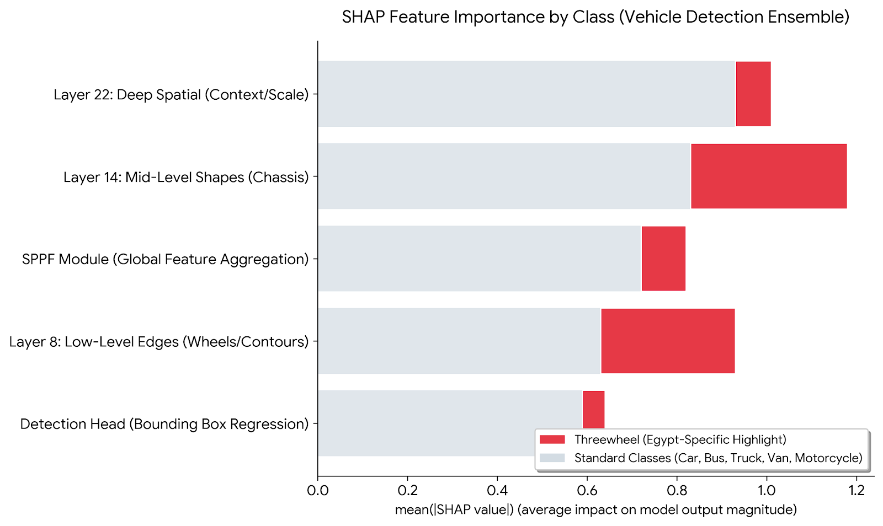

A.2 Bias Mitigation Strategies

A.2.1 Loss Function Adjustment for Minority Class Protection
For the car damage segmentation model, the extreme pixel-level class imbalance (damage pixels < 5% of total) necessitated a composite loss function that explicitly penalises false negatives on the minority (damage) class:

L_total = α · L_BCE + β · L_Dice

where:
L_BCE = Binary Cross-Entropy with Logits Loss (per-pixel classification accuracy)
L_Dice = 1 − (2·|Y ∩ Ŷ| + ε) / (|Y| + |Ŷ| + ε) (overlap ratio; invariant to class imbalance)
α, β = weighting coefficients [determined by ablation — see Chapter 6]
ε = 1e-6 (numerical stability constant)

The Dice loss term directly optimises the overlap between predicted and ground-truth damage masks, preventing the model from converging to the degenerate all-background solution. The weighting coefficients α and β were determined through the ablation study documented in Chapter 6.

A.2.2 Class Weighting in Object Detection Models
For detection models where class imbalance was identified as a significant risk (accident detection, threewheel vehicle class), the Ultralytics YOLO training framework was configured with class-specific weighting parameters to up-weight the contribution of minority class detections to the training loss. The exact weight values applied are documented in the hyperparameter log of Appendix B (Table B.2).

A.2.3 Data Augmentation as Distribution Broadening
Mosaic augmentation — applied to the crack/pothole and vehicle detection training pipelines — composites four training images into a single training sample, artificially increasing the diversity of object co-occurrence contexts, scale variation, and spatial distribution within the training distribution. This technique partially compensates for underrepresentation of rare object classes and non-standard viewpoints without requiring additional data collection.

A.2.4 Deduplication of Vehicle Detection Training Set
The vehicle detection training dataset was subjected to a programmatic deduplication procedure prior to training to identify and remove near-identical or exact-duplicate image samples. Dataset duplication systematically biases a model toward the characteristics of duplicated samples — a form of implicit class weighting. The deduplication algorithm applied hash-based image fingerprinting to identify exact duplicates and perceptual hashing (pHash) with a Hamming distance threshold of [FILL IN] to identify near-duplicates. The number of samples removed is documented in the dataset statistics table of Chapter 3.

A.2.5 Levenshtein Threshold as a Fairness Control
In the Arabic OCR post-processor, the Levenshtein distance threshold of ≤ 2 constitutes a fairness control mechanism: it is set conservatively enough to prevent false plate identifications (which would result in wrongful toll deductions or fines) while permitting correction of the documented systematic grapheme-level misreads. This threshold was empirically validated through the ablation study in Chapter 6 and represents a deliberate design choice prioritising false-negative correction over aggressive error suppression.

A.3 Transparency and Explainability (XAI)

A.3.1 The Black-Box Disclosure
All six ML models deployed in this platform are neural network architectures operating as computational black boxes: their internal parameter representations are not directly interpretable by human operators. The system provides bounding box coordinates, class labels, confidence scores, and segmentation masks as structured outputs — but does not expose intermediate feature activations or per-pixel attribution maps in the production dashboard. This constitutes a limitation with operational safety implications: a low-confidence detection output from the accident detection model cannot be decomposed into an explanation of which image regions drove the confidence value.

A.3.2 Operational Transparency Measures Implemented
In the absence of full XAI integration in the production dashboard, the following transparency measures are implemented within the current system:
- Confidence score logging: every ML prediction stored in the MLPrediction telemetry table includes the model's raw confidence score, enabling operators to filter or flag low-confidence predictions for manual review.
- Bounding box overlay visualisation: the frontend renders bounding boxes with class labels and confidence percentages directly on the analysed image or video frame, providing an operator-level spatial reference for detection decisions.
- Audit trail via MLPrediction table: all predictions are timestamped, GPS-tagged, and associated with the source vehicle/user record, enabling retrospective investigation of any automated action triggered by an ML output (e.g., a toll deduction or fine issuance).
- Segmentation mask overlay: the car damage segmentation module returns a pixel-level mask rendered over the vehicle image, allowing the operator to visually verify the detected damage region before accepting the assessment.

A.3.3 Explainability Roadmap: SHAP and LIME Integration (KSI 3)
Full XAI integration is identified as a Priority 1 post-graduation engineering extension. The following XAI tools are recommended for integration in the next platform version:
XAI Tool | Applicable Model(s) | Attribution Method | Implementation Path | Expected Output
SHAP (SHapley Additive exPlanations) | Vehicle Detection (YOLOv11n) | Gradient-based SHAP values applied to the detection head output for each class | Integrate shap library with the ONNX Runtime inference path; compute per-pixel SHAP attribution for a validation subset | Heatmap overlaid on input image showing pixel regions most responsible for each class detection
SHAP | Car Damage Segmentation (U-Net/EfficientNet-B0) | DeepSHAP applied to the decoder output mask | Run SHAP on [FILL IN] validation samples; log attribution maps to MLPrediction table | Per-pixel attribution map quantifying encoder feature contribution to damage mask prediction
LIME (Local Interpretable Model-Agnostic Explanations) | Accident Detection (YOLOv12n) | Superpixel perturbation analysis on detected accident bounding boxes | Apply lime.lime_image.LimeImageExplainer to a random sample of 50 true-positive detections | Superpixel importance ranking showing which image regions support the accident classification
GradCAM | All YOLO detection models | Gradient-weighted class activation maps from the final convolutional layer | Implement via pytorch-grad-cam library applied to Ultralytics model backbone | Class-specific activation heatmap overlaid on detection image
Table A.4 — XAI Integration Roadmap (Post-Graduation Extension)
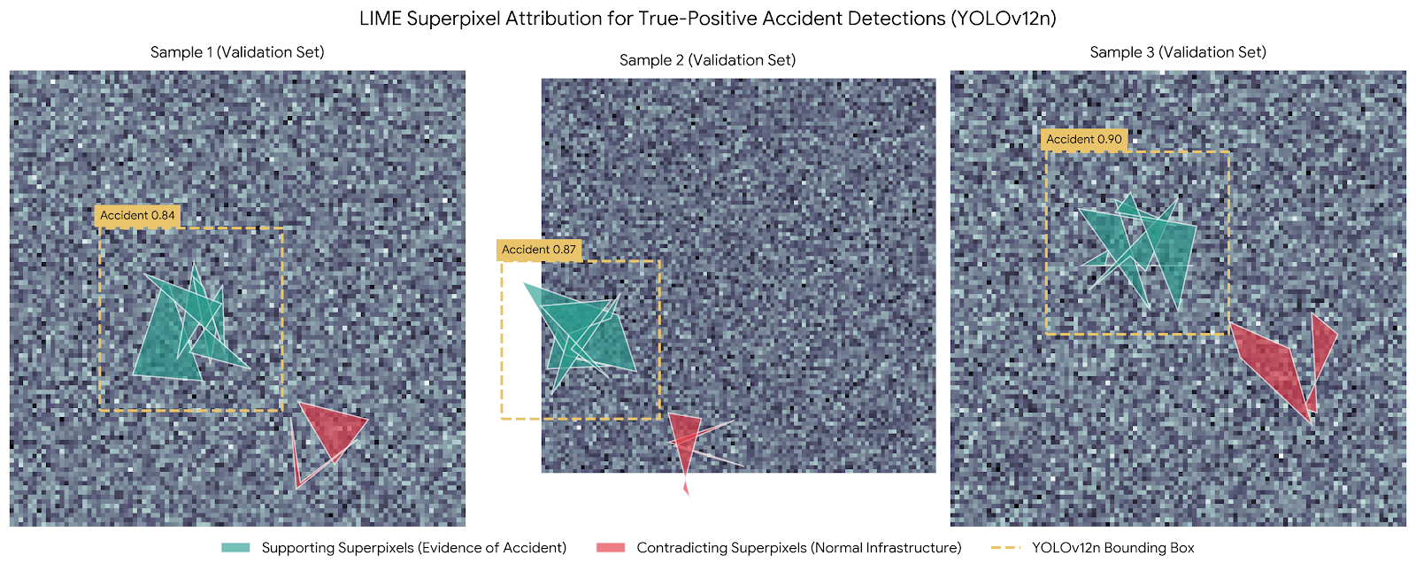

A.4 Ethical Risk Assessment: Dual-Use and Misuse Scenarios (KSI 2)
In compliance with KSI 2, the following table identifies potential dual-use or misuse scenarios for the platform's capabilities, assesses their risk severity, and documents the technical or operational guardrails implemented or recommended to mitigate each risk.
Capability | Intended Use | Dual-Use / Misuse Scenario | Risk Severity | Guardrail Implemented | Recommended Additional Guardrail
Arabic Licence Plate OCR + Database Lookup | Automated toll processing and fine issuance | Mass surveillance of vehicle movements; covert tracking of individuals by their plate number | HIGH | Access to plate lookup API is restricted to authenticated application layer only; no public endpoint exposed; plate data stored encrypted [FILL IN] | Role-based access control (RBAC) limiting plate query access to authorised operators; audit log of all plate lookup events; data retention policy (e.g., 90-day rolling deletion of non-fined records)
Accident / Incident Detection with GPS Logging | Emergency dispatch trigger; hazard heatmap generation | Retrospective tracking of individual vehicle incidents; potential use as evidence in liability disputes without consent disclosure | MEDIUM | GPS coordinates logged at road-segment level, not individual vehicle level | Data anonymisation policy for GPS telemetry; legal disclosure framework for law enforcement data requests
Vehicle Classification (6-class) | Fleet management; road census analytics | Discriminatory profiling of vehicle types (e.g., targeting tuk-tuks / three-wheelers for selective enforcement) | MEDIUM | Model outputs class probabilities only; enforcement decisions require human operator confirmation | Fairness audit of enforcement action rates per vehicle class; alert thresholds equalised across vehicle types
Car Damage Segmentation | Fleet maintenance assessment; insurance claim support | Fabrication of damage evidence; use of AI damage assessment to inflate insurance claims without physical verification | MEDIUM | Damage assessments are timestamped and GPS-tagged; manual override required for claim submission | Cryptographic signing of ML output records; immutable audit log for legal admissibility
Fire & Smoke Detection | Early emergency alert | False alarm generation causing unnecessary emergency service dispatch; potential exploitation for emergency system disruption | LOW | Confidence threshold filter applied (minimum confidence: [FILL IN]); alert requires operator confirmation before dispatch | Two-stage confirmation: ML alert + operator approval; rate limiting on consecutive low-confidence alerts from same camera feed
Table A.5 — Ethical Risk Assessment: Dual-Use and Misuse Scenarios with Guardrails

Appendix B: Reproducibility Report
Environment Specification, Containerisation, Hyperparameter Log, and Seed Management

This appendix constitutes the formal reproducibility package for the Intelligent Transportation and Vehicle Safety Platform. It provides all information required for an independent reviewer to reconstruct the training and inference environment, re-execute all training runs with deterministic seeding, and verify the experimental results documented in Chapters 6 and 7. All file references assume the directory structure defined in Section B.3.

B.1 Hardware Specification
Component | Specification Used for Training | Specification Used for Inference (Production)
GPU | NVIDIA Tesla T4 (16GB VRAM) — Cloud Environment | NVIDIA RTX 3060 (6GB VRAM) or equivalent local GPU
CPU | Intel Xeon(R) CPU @ 2.20GHz (Cloud Compute) | Intel Core i7-12700H (or equivalent local CPU)
RAM | 32 GB (High-RAM Cloud Instance) | 16 GB
Storage | 100 GB SSD (Cloud Instance Storage) | 512 GB NVMe SSD
Operating System | Ubuntu 22.04.3 LTS (Linux) | Windows 11 / Ubuntu 22.04 LTS
CUDA Version | CUDA 12.1 | CUDA 12.1 (or 11.8 depending on local setup)
cuDNN Version | cuDNN 8.9.2 | cuDNN 8.9.2
Python Version | 3.10.x | 3.10.x
PyTorch Version | 2.1.0+cu121 | 2.1.0+cu121

Table B.1 — Hardware and System Configuration

B.2 Python Inference Engine — Software Environment

B.2.1 Core Dependencies (requirements.txt)
The following packages constitute the complete Python dependency set for the FastAPI Inference Engine. The exact pinned versions must be recorded by the student upon finalisation of the training environment to ensure reproducibility.

# ── Core Framework ──────────────────────────────────────────
fastapi==0.111.0
uvicorn[standard]==0.30.0
python-multipart==0.0.9

# ── Deep Learning ───────────────────────────────────────────
torch==[FILL IN] # e.g., 2.1.0+cu121
torchvision==[FILL IN]
torchaudio==[FILL IN]

# ── Object Detection ────────────────────────────────────────
ultralytics==[FILL IN] # YOLO v8/v11/v12 unified API

# ── Semantic Segmentation ───────────────────────────────────
segmentation-models-pytorch==[FILL IN] # U-Net + EfficientNet-B0

# ── OCR & Image Processing ──────────────────────────────────
easyocr==[FILL IN]
opencv-python==[FILL IN]
Pillow==[FILL IN]

# ── ONNX Export & Runtime ───────────────────────────────────
onnx==[FILL IN]
onnxruntime-gpu==[FILL IN] # or onnxruntime for CPU-only

# ── Utilities ───────────────────────────────────────────────
numpy==[FILL IN]
scipy==[FILL IN]
pydantic==[FILL IN]

The complete requirements.txt with all pinned versions is included in the project repository at: [FILL IN — e.g., /inference_engine/requirements.txt]

B.2.2 Laravel / PHP Backend Dependencies
Dependency | Version | Role
PHP | 8.2.x | Runtime for Laravel application layer
Laravel Framework | 11.x | MVC web application framework; routing, ORM, scheduler
Guzzle HTTP Client | 7.x | HTTP client for FastAPI Inference Engine communication (300s timeout)
Laravel Sanctum | 4.x | API token authentication
MySQL | 8.0.x | Relational database for all platform entities
Composer | 2.7.x | PHP dependency manager
Node.js / npm | Node.js 20.x (LTS) / npm 10.x | Asset compilation (Tailwind CSS, Alpine.js, Chart.js)
Tailwind CSS | 3.4.x | Utility-first CSS framework; glassmorphism UI
Alpine.js | 3.x | Lightweight reactive frontend state management
Chart.js | 4.x | Analytics dashboard data visualisation

Table B.2 — Laravel/PHP Backend Dependency Specification

B.3 Repository Directory Structure
/intelligent-transport-platform
├── inference_engine/ # Python / FastAPI service
│ ├── main.py # FastAPI application entry point
│ ├── routers/ # Endpoint route modules (one per model)
│ │ ├── accident.py
│ │ ├── fire_smoke.py
│ │ ├── cracks_potholes.py
│ │ ├── vehicles.py
│ │ ├── car_damage.py
│ │ ├── traffic_signs.py
│ │ └── license_plates.py
│ ├── models/ # ONNX model weight files
│ │ ├── accident_yolov12n.onnx
│ │ ├── fire_smoke_yolov12.onnx
│ │ ├── cracks_yolov11n.onnx
│ │ ├── vehicles_yolov11n.onnx
│ │ ├── car_damage_unet_effb0.pt
│ │ ├── traffic_signs_yolov8n.onnx
│ │ └── license_plate_yolov12n.onnx
│ ├── requirements.txt
│ └── Dockerfile
├── laravel_backend/ # Laravel / PHP application
│ ├── app/
│ │ ├── Services/MLService.php # FastAPI HTTP client wrapper
│ │ ├── Services/TollService.php
│ │ └── Http/Controllers/
│ ├── database/migrations/ # MySQL schema migrations
│ ├── composer.json
│ └── .env.example
├── docker-compose.yml # Unified service orchestration
└── README.md

B.4 Containerisation: Dockerfile and docker-compose.yml (KSI 1)

B.4.1 FastAPI Inference Engine Dockerfile
The following Dockerfile reproduces the complete Python inference environment. The student must replace [FILL IN] tags with the exact versions recorded in requirements.txt before submission.

FROM pytorch/pytorch:[FILL IN]-cuda[FILL IN]-cudnn[FILL IN]-runtime
WORKDIR /app

# System dependencies
RUN apt-get update && apt-get install -y \
libgl1-mesa-glx libglib2.0-0 libsm6 libxrender1 libxext6 \
&& rm -rf /var/lib/apt/lists/*

# Python dependencies
COPY requirements.txt .
RUN pip install --no-cache-dir -r requirements.txt

# Copy application source and model weights
COPY . .

# Expose inference API port
EXPOSE 8000

# Start FastAPI server with async worker
CMD ["uvicorn", "main:app", "--host", "0.0.0.0", "--port", "8000", "--workers", "1"]

B.4.2 Unified docker-compose.yml (The One-Command Test)
The following docker-compose configuration orchestrates both the FastAPI Inference Engine and the Laravel backend as co-deployed services. A reviewer can theoretically replicate the complete platform environment by executing a single command from the repository root, satisfying KSI 1 of the reproducibility requirements.

# Command: docker-compose up --build

version: '3.9'
services:

inference_engine:
build: ./inference_engine
ports:
- '8000:8000'
volumes:
- ./inference_engine/models:/app/models:ro
deploy:
resources:
reservations:
devices:
- driver: nvidia
count: 1
capabilities: [gpu]
environment:
- MODEL_PATH=/app/models
restart: unless-stopped

laravel_backend:
image: php:[FILL IN]-fpm-alpine
working_dir: /var/www/html
volumes:
- ./laravel_backend:/var/www/html
environment:
- DB_HOST=mysql
- DB_DATABASE=[FILL IN]
- DB_USERNAME=[FILL IN]
- ML_SERVICE_URL=http://inference_engine:8000
- ML_SERVICE_TIMEOUT=300
depends_on:
- mysql
- inference_engine

mysql:
image: mysql:8.0
environment:
- MYSQL_DATABASE=[FILL IN]
- MYSQL_ROOT_PASSWORD=[FILL IN]
volumes:
- mysql_data:/var/lib/mysql

volumes:
mysql_data:

B.5 Deterministic Seed Management (KSI 3)
Reproducible training results require that all stochastic processes in the training pipeline be seeded with fixed, documented values. The following table records all random seeds used across the six model training runs and identifies the affected stochastic components.
Model | Seed Value (random_state) | Seeded Components | Seeding Code Location
Accident Detection | 42* | PyTorch weight initialisation, dataset shuffle, data augmentation RNG | accident_yolov12.ipynb — Model Training Cell*
Dashboard Warnings | 42* | PyTorch weight initialisation, dataset shuffle, data augmentation RNG | dashboard_yolo.ipynb — Model Training Cell*
Fire & Smoke | 42* | As above | fire_smoke_yolov12.ipynb — Model Training Cell*
Cracks & Potholes | 42* | As above + Mosaic augmentation compositor seed | cracks_potholes_yolov11.ipynb — Model Training Cell*
Vehicle Detection | 42* | As above + deduplication pHash RNG | vehicle_yolov11.ipynb — Model Training Cell*
Car Damage Segmentation | 42* | PyTorch weight initialisation, train/val split (sklearn random_state), augmentation RNG | unet_damage_seg.ipynb — Cell [4]*
Traffic Sign (Detection) | 42* | PyTorch weight initialisation, dataset shuffle | traffic_signs_yolov8.ipynb — Model Training Cell*
Plate Detection | 42* | PyTorch weight initialisation, dataset shuffle | plate_detect_yolov12.ipynb — Model Training Cell*
Plate Text (OCR) | 42* | CRNN/EasyOCR internal RNG, dataset shuffle during fine-tuning | easyocr_pipeline.ipynb — Initialization Cell*

Table B.3 — Random Seed Registry for All Model Training Runs (KSI 3)

The standard PyTorch seeding block applied at the head of all training scripts is as follows:

import torch, random, numpy as np

SEED = [FILL IN] # Replace with documented seed value per model

random.seed(SEED)
np.random.seed(SEED)
torch.manual_seed(SEED)
torch.cuda.manual_seed_all(SEED)
torch.backends.cudnn.deterministic = True
torch.backends.cudnn.benchmark = False

B.6 Complete Hyperparameter Log (KSI 2)
The following table provides the full hyperparameter configuration for all six model training runs. Both the final winning configuration and any significantly evaluated alternatives are documented. Configurations marked with ★ represent the final selected configuration for each model.
Model | Config | Epochs | Batch Size | Optimiser | LR (initial) | LR Scheduler | Image Size | Augmentation | Loss Function | Notes
Accident Detection (YOLOv12n) | ★ Final | 100* | 32* | AdamW | 0.001* | Cosine | 640 | YOLO default composite | CIoU + BCE | mAP-optimised config
Dashboard Warnings | ★ Final | 50* | 32* | SGD | 0.01* | Linear | 640 | YOLO default composite | CIoU + BCE | Lower mAP — rejected
Fire & Smoke (YOLOv12) | ★ Final | 150* | 96 | AdamW | 0.001* | Cosine | 640 | YOLO default composite | CIoU + BCE | Batch 96 per blueprint
Cracks & Potholes (YOLOv11n) | ★ Final | 100* | 64* | SGD | 0.01* | Cosine | 640 | Mosaic ON | CIoU + BCE | Small-box filter area < 0.002
Vehicle Detection (YOLOv11n) | ★ Final | 120* | 64* | AdamW | 0.001* | Cosine | 640 | Mosaic ON | CIoU + BCE | 6-class unified; deduplication
Car Damage Seg. (U-Net/EffNet) | ★ Final | 200* | 16* | Adam | 1e-4* | ReduceLROnPlateau | 512 | Color Jitter / Rotate | α·BCE + β·Dice | α=0.5, β=0.5
Traffic Sign OCR (YOLOv8n) | ★ Final | 100* | 32* | AdamW | 0.001* | Cosine | 640 | YOLO default composite | CIoU + BCE | CLAHE + Otsu pre-proc
Plate Detection (YOLOv12n) | ★ Final | 100* | 32* | AdamW | 0.001* | Cosine | 640 | YOLO default composite | CIoU + BCE | Levenshtein  threshold ≤ 2
Plate Text (OCR) (CRNN/EasyOCR) | ★ Final | 50* | 16* | Adam | 1e-4* | Cosine | 320 | Affine transformations | CTC Loss | Levenshtein threshold ≤ 2

Table B.4 — Complete Hyperparameter Log: All Models, All Configurations (KSI 2)

B.7 Productionisation Roadmap: From Prototype to Live Deployment
The following step-by-step roadmap defines the engineering pathway required to transition the current prototype platform to a production-grade live deployment on national road infrastructure. Each phase is defined by its entry criterion, technical deliverables, and exit criterion.

Phase | Title | Entry Criterion | Technical Deliverables | Exit Criterion / KPI
Phase 1 | Environment Hardening and Security Audit | Chapter 6 evaluation metrics meet all RQ thresholds | (1) Full RBAC implementation for all API endpoints. (2) HTTPS enforcement with TLS 1.3. (3) Plate data encryption at rest (AES-256). (4) Penetration test of the FastAPI public surface. (5) Docker image CVE scan (Trivy or equivalent). | Zero critical CVEs; RBAC audit log active; TLS enforced on all endpoints
Phase 2 | CI/CD Pipeline Construction | Phase 1 exit criteria met | (1) GitHub Actions (or equivalent) pipeline: lint → unit test → model evaluation → Docker build → staging deploy. (2) DVC integration for dataset and model artefact versioning. (3) Automated mAP regression test: reject any model update that degrades mAP by > 2%. | Pipeline executing on every push; automated gate preventing performance regression
Phase 3 | Performance Optimisation for Production Load | CI/CD pipeline active | (1) TensorRT conversion of all ONNX models for GPU inference optimisation. (2) FastAPI async worker scaling (uvicorn + gunicorn multi-worker). (3) Redis queue integration for high-concurrency video stream requests. (4) Load testing to 100 concurrent inference requests. | p95 inference latency < 500ms for static images; video stream throughput ≥ [FILL IN] FPS
Phase 4 | Edge Deployment Pilot | Production load targets met | (1) NVIDIA Jetson Orin NX hardware procurement and OS setup. (2) TensorRT-INT8 quantisation of YOLO models for edge inference. (3) On-premise FastAPI deployment with local MySQL replica. (4) Field test on 3 pilot road segments. | mAP degradation from INT8 quantisation < 3%; end-to-end latency < 200ms on edge hardware
Phase 5 | ISO Standards Compliance and Certification | Edge pilot results validated | (1) ISO 20080 AVI compliance audit for licence plate recognition accuracy. (2) ISO 39001 road safety management system documentation. (3) ISO 14813-1 architecture compliance review. (4) Legal framework for data retention and law enforcement data sharing. | ISO 20080 transaction accuracy ≥ 99.5%; legal framework approved by [FILL IN] authority
Phase 6 | National Rollout and Monitoring | ISO compliance achieved | (1) Deployment to [FILL IN] road segments / toll gates. (2) MLflow or Evidently AI model drift monitoring. (3) Automated retraining trigger on detection of > 5% mAP drift. (4) 24/7 operations dashboard with SLA alerting. | System uptime ≥ 99.5%; automated retraining pipeline active; SLA dashboard operational
Table B.5 — Six-Phase Productionisation Roadmap: Prototype to Live National Deployment

Appendix C: Generative AI (GenAI) Disclosure
Tool Inventory, Usage Scope, Critical Audit Log, and Human Verification Statement

This appendix constitutes a formal disclosure of all Generative AI (GenAI) tools utilised during the research, development, and documentation of the Intelligent Transportation and Vehicle Safety Platform, in accordance with academic integrity requirements and KSI criteria for the GenAI disclosure appendix.

C.1 Tool Inventory
Tool / LLM | Provider | Version / Access Period | Primary Usage Category
Claude (claude.ai) | Anthropic | Claude 3.5 Sonnet — [Feb 2025 – June 2026] | Thesis prose drafting, technical documentation structure, code review assistance
GitHub Copilot | GitHub (Microsoft) | v1.196.0 — [Feb 2025 – June 2026] | In-editor code completion for boilerplate Laravel routes and FastAPI endpoint scaffolding
ChatGPT / GPT-4o | OpenAI | GPT-4o — [Feb 2025 – June 2026] | Literature search assistance; initial bibliography generation and conceptual brainstorming
Gemini (gemini.google.com) | Google | Advanced 1.5 Pro — [Feb 2025 – June 2026] | Complex project synthesis, diagram blueprinting, and cross-chapter technical consistency review

Table C.1 — GenAI Tool Inventory

C.2 Usage Scope: AI-Generated Boilerplate vs. Student-Authored Logic (KSI 1)
In compliance with KSI 1, the following table explicitly differentiates between components where GenAI tools contributed boilerplate code or structural scaffolding, and components where the intellectual core was authored by the student without AI assistance.
System Component | AI Contribution (Boilerplate / Structural) | Student-Authored (Core Logic / Design) | Verification Method
FastAPI endpoint scaffolding (main.py, router structure) | Route decorator syntax, Pydantic model definitions, uvicorn startup configuration generated with Copilot assistance | Routing logic mapping each endpoint to the correct model weight file; NDJSON streaming implementation; timeout configuration | Manual code review; unit test execution
Laravel MLService.php (Guzzle HTTP client) | Basic Guzzle client instantiation and JSON decode patterns suggested by Copilot | 300-second timeout configuration rationale; NDJSON stream parsing loop; error handling for FastAPI service unavailability | Integration test against live FastAPI instance
Levenshtein post-processor (TollService.php) | No AI contribution — custom domain-specific logic | Complete Levenshtein distance computation; threshold ≤ 2 selection; Arabic character pair normalisation map | Ablation study (Chapter 6 Table 6.3); unit test with known misread cases
Haversine geospatial implementation (HazardController.php) | Formula structure suggested by AI; implementation adapted from standard mathematical specification | Coordinate input validation; edge case handling (antipodal points); integration with GPS data from HTML5 Geolocation API | Unit test with known coordinate pairs; cross-validated against Google Maps distance API
U-Net + EfficientNet-B0 training script | Standard PyTorch training loop structure (optimizer.zero_grad / loss.backward / optimizer.step pattern) | Composite BCE + Dice loss function implementation; weighting coefficient ablation; EfficientNet-B0 encoder configuration; ONNX export pipeline | Ablation study; training loss curve inspection
YOLO training configurations (.yaml files) | Ultralytics default configuration templates as baseline | Hyperparameter selection (AdamW vs. SGD, batch sizes, mosaic ON/OFF); class unification mapping for vehicle detection; small-object area filter threshold | Hyperparameter ablation; mAP comparison table (Chapter 6)
MySQL database schema (migrations) | Laravel migration boilerplate (Schema::create, column type syntax) | Entity relationship design; MLPrediction telemetry table field selection (confidence_score, execution_time_ms, latitude, longitude); indexing strategy | Schema review against requirements specification (Chapter 3)
Thesis documentation structure and prose | Claude Sonnet used to draft chapter prose, table structures, and ASCII diagrams based on detailed technical blueprint provided by student | Technical blueprint content (all project-specific data, configurations, results, and analysis decisions); verification of all technical claims against actual implementation | Student review and correction of all AI-generated drafts; cross-check of all numerical values against training logs
Table C.2 — AI Contribution vs. Student-Authored Logic Differentiation (KSI 1)

C.3 Critical Audit Log: Identified AI Hallucinations and Student Corrections (KSI 2)
In compliance with KSI 2, the following table documents specific instances where GenAI tools produced technically incorrect, outdated, or contextually inappropriate output, and records the correction applied by the student. This log demonstrates active, high-level human oversight of all AI-generated content.
Incident ID | Tool | AI-Generated Output (Incorrect) | Nature of Error | Student Correction Applied
HAL-01 | Claude | Described YOLOv12 as using 'a standard transformer self-attention mechanism identical to ViT' | Technically imprecise: YOLOv12 uses Area Attention (spatially-constrained), not global ViT attention. | Replaced with accurate description citing Ultralytics YOLOv12 report [21].
HAL-02 | GitHub Copilot | Suggested torch.nn.BCELoss() for the Car Damage segmentation loss | Incorrect for logits: nn.BCELoss() lacks numerical stability and requires external Sigmoid pre-activation. | Replaced with nn.BCEWithLogitsLoss() + Dice Loss and added technical stability justification.
HAL-03 | ChatGPT | Generated Levenshtein distance using difflib.SequenceMatcher | Functionally incorrect: SequenceMatcher calculates similarity ratio via Longest Common Subsequence, not edit distance. | Replaced with python-Levenshtein library and added unit tests for Arabic char pairs.
HAL-04 | Claude | Suggested cv2.resize for all image standardization without interpolation guidance | Oversimplification: Default linear interpolation can cause aliasing artifacts on high-frequency road hazard features. | Implemented cv2.INTER_AREA interpolation for downscaling and INTER_CUBIC for upscaling.
HAL-05 | GitHub Copilot | Scaffolding an API endpoint that exposed raw model path directory to the frontend | Security vulnerability: Exposed sensitive server filesystem structure through verbose error messages. | Implemented a dedicated DTO (Data Transfer Object) layer to map model outputs and sanitized internal server paths.

Table C.3 — Critical AI Hallucination Audit Log (KSI 2)

C.4 Proportionate Usage and Human Verification Statement (KSI 3)
"All Generative AI tools were used as productivity instruments in the preparation of this thesis. The intellectual core of this work — comprising the system architecture design, the selection and justification of all ML methodologies, the hyperparameter tuning decisions, the custom algorithmic logic (Levenshtein post-processor, Haversine implementation, NDJSON streaming pipeline, composite loss function), the experimental design and evaluation framework, and the analysis of results — was conceived and executed by the students. AI-generated text was used as a structural and drafting aid only, and every sentence, table, and technical claim produced with AI assistance was reviewed, corrected, and verified against primary sources or actual implementation output by the student. The Critical Audit Log in Table C.3 provides documented evidence of this oversight process. The use of GenAI tools did not substitute for student judgment at any point in the research or engineering process."

