Description of Client Table Attributes

The table represents a list of clients with essential attributes for managing financial transactions and client status. Below is a detailed description of each attribute:

1. CIN (National Identification Number)
- Type: String
- Description: This field contains the client’s unique identification number. It is used to authenticate and uniquely identify each client in the database.
- Example: 07498188

2. Name
- Type: String
- Description: Contains the client’s name (individual or company). The first letter is automatically capitalized for uniform display.
- Example: Wahbi

3. Email
- Type: Email (String)
- Description: Stores the client's email address, used for communication and notifications (invoices, promotions, alerts, etc.).
- Example: wahbi@example.com

4. Phone
- Type: Numeric (String)
- Description: The client’s phone number, used for direct contact and SMS notifications.
- Example: +216 466156116

5. Address
- Type: String
- Description: The client’s physical address, useful for billing and deliveries.
- Example: 20 Tunisia Bardo

6. Client Type
- Type: Dropdown list (Enum: Company, Individual)
- Description: Defines whether the client is a company or an individual.
  - Company: May require more complex services and payments.
  - Individual: A personal user with simpler needs.
- Example: Company

7. Payment Method
- Type: Dropdown list (Enum: Bank Transfer, Credit Card, Cash)
- Description: Indicates the client’s preferred payment method.
  - Bank Transfer: Secure payment via bank transactions.
  - Credit Card: Fast and online transactions.
  - Cash: Used for direct payments in stores.
- Example: Credit Card

8. Used Currencies
- Type: Dropdown list (Enum: Dinar, Dollar, Euro)
- Description: Specifies the client’s preferred currency for all transactions and billing.
- Example: Euro

9. Registration Date
- Type: Date (Format: DD/MM/YYYY)
- Description: The date when the client registered in the system. It helps track client longevity and apply automatic rules such as status changes after a period of inactivity.
- Example: 15/02/2023

10. Status
- Type: Dropdown list (Enum: Active, Inactive, Blocked)
- Description: Defines the client’s current status in the system.
  - Active: A client regularly making transactions.
  - Inactive: A client who hasn’t made a transaction in over 5 months.
  - Blocked: A client restricted due to fraud or unpaid bills.
- Example: Active

Summary of Attributes and Types
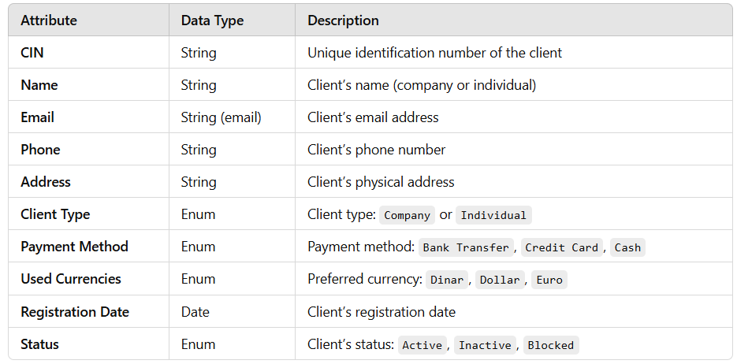

Rules and Automations
- Automatic Status Updates:
  - If a client does not issue an invoice for 5 consecutive months, their status is automatically changed to Inactive.
  - A client can be Blocked due to unpaid bills or fraudulent activities.
- Archiving Inactive Clients:
  - Inactive clients are transferred to an archived database for predictive analysis.
  - This helps study retention trends and anticipate future behavior.
- Currency Standardization:
  - The chosen currency allows for unified calculations and financial results.
  - Ensures consistency in invoices and financial reports.

Conclusion
This table is designed to efficiently manage clients by considering their identification, payment methods, status, and preferred currency. Through automation rules, the company can optimize client account management and improve financial analysis. 🚀

