Documentation of Backend Development for Authentication System

1. Introduction
This documentation provides a detailed explanation of the backend development for the authentication system, including the setup, implementation, and security measures applied to ensure a robust and scalable solution.

2. Project Initialization
2.1 Node.js Project Setup
- A new Node.js project was initialized using npm init.
- A .gitignore file was created to exclude unnecessary files like node_modules.
- Installed essential dependencies:
npm install express mongoose dotenv cors bcrypt jsonwebtoken joi
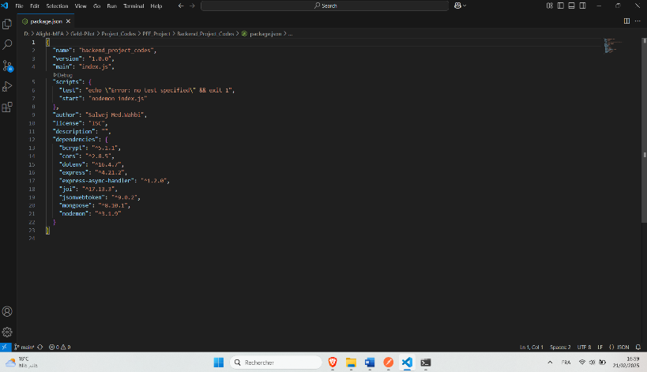

2.2 Express Server Setup
- Created an Express server with middleware for JSON parsing and error handling.
- Configured CORS to allow secure frontend-backend communication.
- Implemented structured routing for better project organization.
2.3 MongoDB Connection
- Established a connection to a local MongoDB database using mongoose.
- Configured environment variables in a .env file for database credentials.

3. Project Architecture
3.1 Folder Structure
The backend follows a structured architecture for better maintainability:
backend/
│-- models/ # Mongoose schemas
│-- routes/ # Express routes
│-- controllers/ # Business logic
│-- middleware/ # Authentication and validation
│-- config/ # Database connection and environment setup
│-- tests/ # Postman and Jest testing
│-- server.js # Main server file
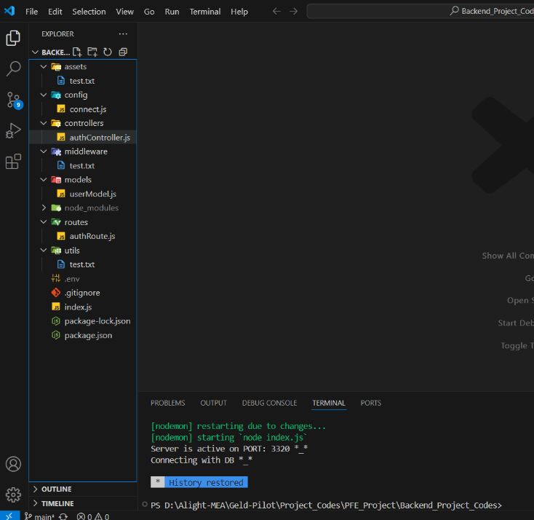

4. User Authentication System
4.1 User Model (Mongoose Schema)
- Created a User schema with the following fields:
  - name (String, required)
  - phone (String, length(8))
  - profilePhoto (Object)
  - isAdmin (Boolean, Default : false)
  - email (String, unique, required)
  - password (String, encrypted)
  - createdAt (Date, auto-generated)
- Used bcrypt to hash passwords before saving them to the database.
4.2 Authentication Controllers
- Register Controller:
  - Validates input using joi.
  - Hashes the password using bcrypt before saving.
  - Returns a JWT token upon successful registration.
- Login Controller:
  - Checks email and password validity.
  - Generates a JWT token for session management.

5. Security Implementation
5.1 JWT Tokenization
- Implemented JWT for secure authentication.
- Token generated on login and stored securely.
- Middleware added to protect private routes.

5.2 Data Validation with Joi Middleware
- Implemented input validation for registration and login requests.
- Ensured only valid data is processed.
5.3 Password Encryption
- Used bcrypt to hash passwords before storing them in MongoDB.
- Prevents unauthorized access in case of data breaches.
5.4 Security Best Practices
- Used environment variables to store sensitive information.
- Implemented error handling to prevent information leaks.
- Limited API request rates to mitigate brute force attacks.

6. API Testing
6.1 Postman Testing
- Tested API endpoints (register, login, protected routes).
- Verified input validation, JWT authentication, and error handling.
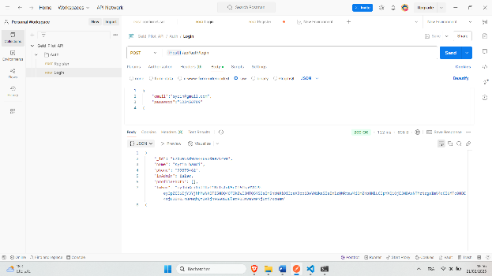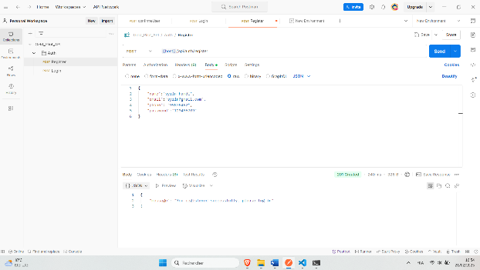
6.2 Frontend Integration
- Configured CORS to enable smooth frontend-backend communication.
- Tested authentication flow with the frontend (Gelp Pilot Platform).

7. Final Full-Stack Testing
- Conducted end-to-end testing to validate login/logout flow.
- Ensured JWT-based access control is correctly implemented.
- Debugged potential issues for a seamless user experience.

8. Conclusion
This documentation outlines the key steps in developing a secure and scalable authentication system. The implementation includes structured backend development, JWT authentication, data validation, and encryption techniques to ensure security and reliability. The backend was successfully integrated with the Gelp Pilot frontend, providing a smooth authentication experience.

