Monthly Fixed Expenses Declaration Table – Documentation

1. Introduction
The Monthly Fixed Expenses Declaration table is designed to track and manage recurring business expenses within a company specializing in software and website development. This document provides an overview of the table’s structure, attributes, and constraints to ensure proper financial management.
2. Table Description
This table records various fixed and variable expenses incurred by the company on a monthly basis. It helps in budgeting, financial planning, and optimizing cost management.
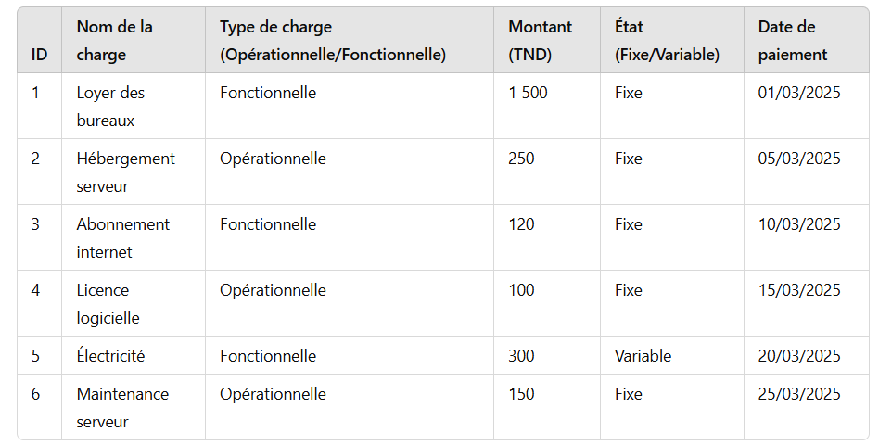

3. Table Structure
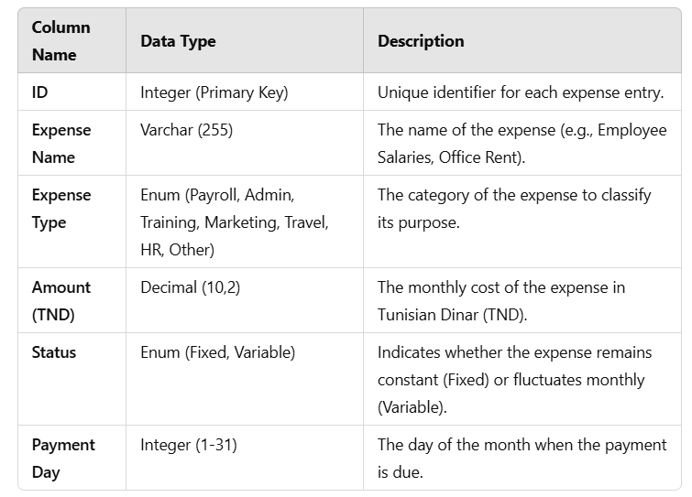
4. Constraints and Business Rules
- Primary Key: ID serves as the unique identifier for each record.
- Expense Type Constraint: The Expense Type column only allows predefined categories (Payroll, Admin, Training, Marketing, Travel, HR, Other).
- Status Constraint: The Status column only accepts either Fixed or Variable values.
- Amount Constraint: The amount must be a positive value greater than zero.
- Payment Day Constraint: The value must be between 1 and 31, representing a valid calendar day.
5. Use Case
This table is useful for:
- Managing monthly financial obligations.
- Analyzing and categorizing business expenses.
- Budgeting and forecasting costs for upcoming months.
- Ensuring timely payments to avoid penalties.

6. Conclusion
The Monthly Fixed Expenses Declaration table is a critical component of financial management within a company. Proper implementation and adherence to constraints ensure accurate expense tracking, enabling informed decision-making for business operations.

