Cairo University  
Faculty of Computers and Artificial Intelligent

**CS251**

**Software Engineering I**

Parking Garage

Software Design

Team Names

Mohamed tarek fathi

Ahmed adel emad

Mohamed Youssef

Fady osama

Month & Year

Contents

Instructions [To be removed] 3

Team 3

Document Purpose and Audience 3

System Models 3

I. Class diagrams 3

Important Algorithm 4

II. Sequence diagrams 5

Class - Sequence Usage Table 6

Ownership Report 6

Policy Regarding Plagiarism: 7

# Team

|  |  |  |  |
| --- | --- | --- | --- |
| **ID** | **Name** | **Email** | **Mobile** |
| 20200794 | Mohamed tarek fathi |  |  |
| 20200025 | Ahmed adel emad |  |  |
| 20200487 | Mohamed Youssef sultan |  |  |
| 20200369 | Fady osama nasif |  |  |

# Document Purpose and Audience

purpose create system for owner of garage ,by the system owner can easy reserve a slot for cars;

Audience : owners of garages

document : simpley it explain what are steps of building projects like usecse its represent who will use the system and functions will be build in the project

# System Models

## I. Class diagrams

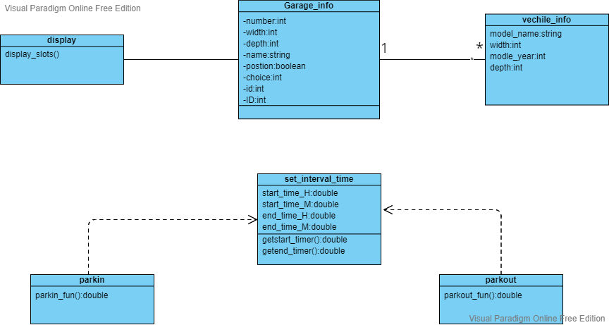

|  |  |  |
| --- | --- | --- |
| **Class ID** | **Class Name** | **Description & Responsibility** |
| 1 | Garage_info | Get number of total ,available and unavailable slots |
| 2 | Parking | Get area of slot and check availability of slot |
| 3 | Vehicle_info | Info of vehicle and parking functions |
| 4 | Park out | Calculate fees and total income |
| 5 | Set_interval_time | Get duration , set arrival time , set time out and set the period details |
| 6 | Display | Get info from classes and display it |

### Important Algorithm

* **If any method in a class is implementing an algorithm (complex enough), then you should describe it here.**

## 

## II. Sequence diagrams

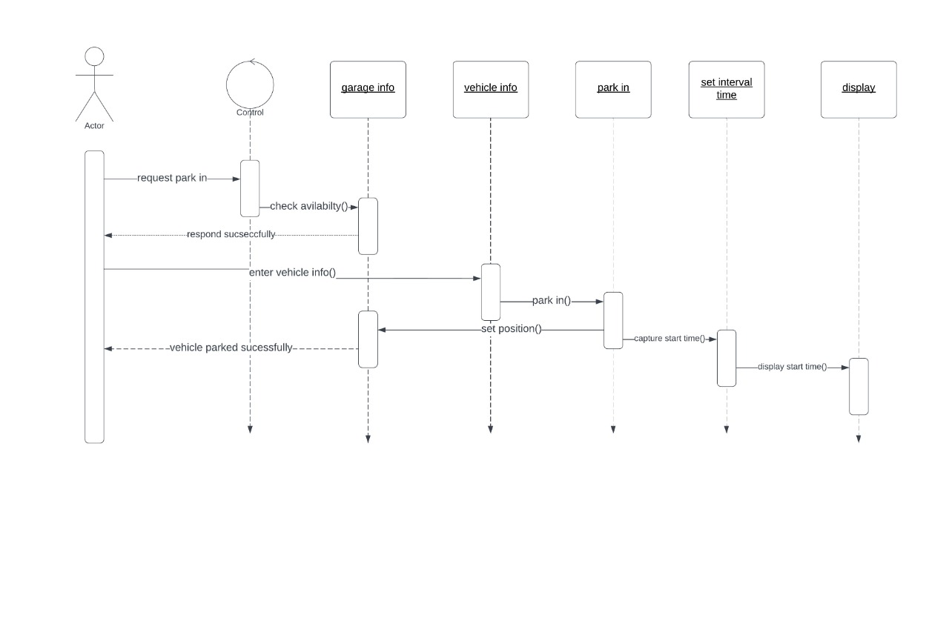

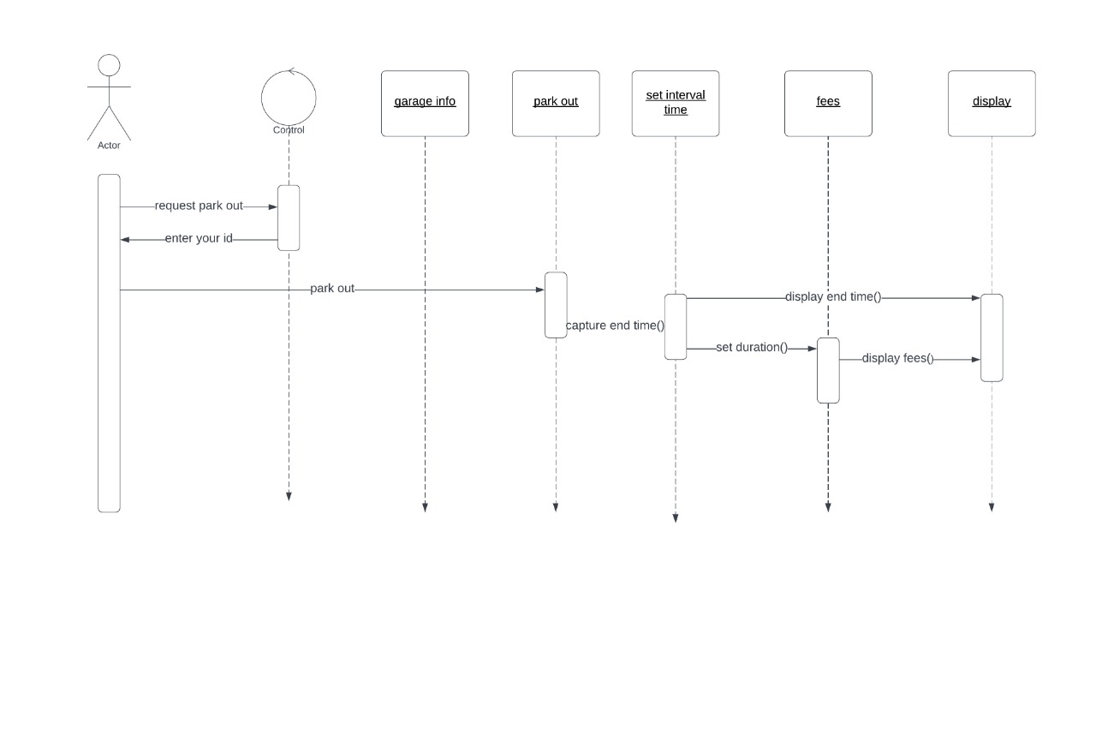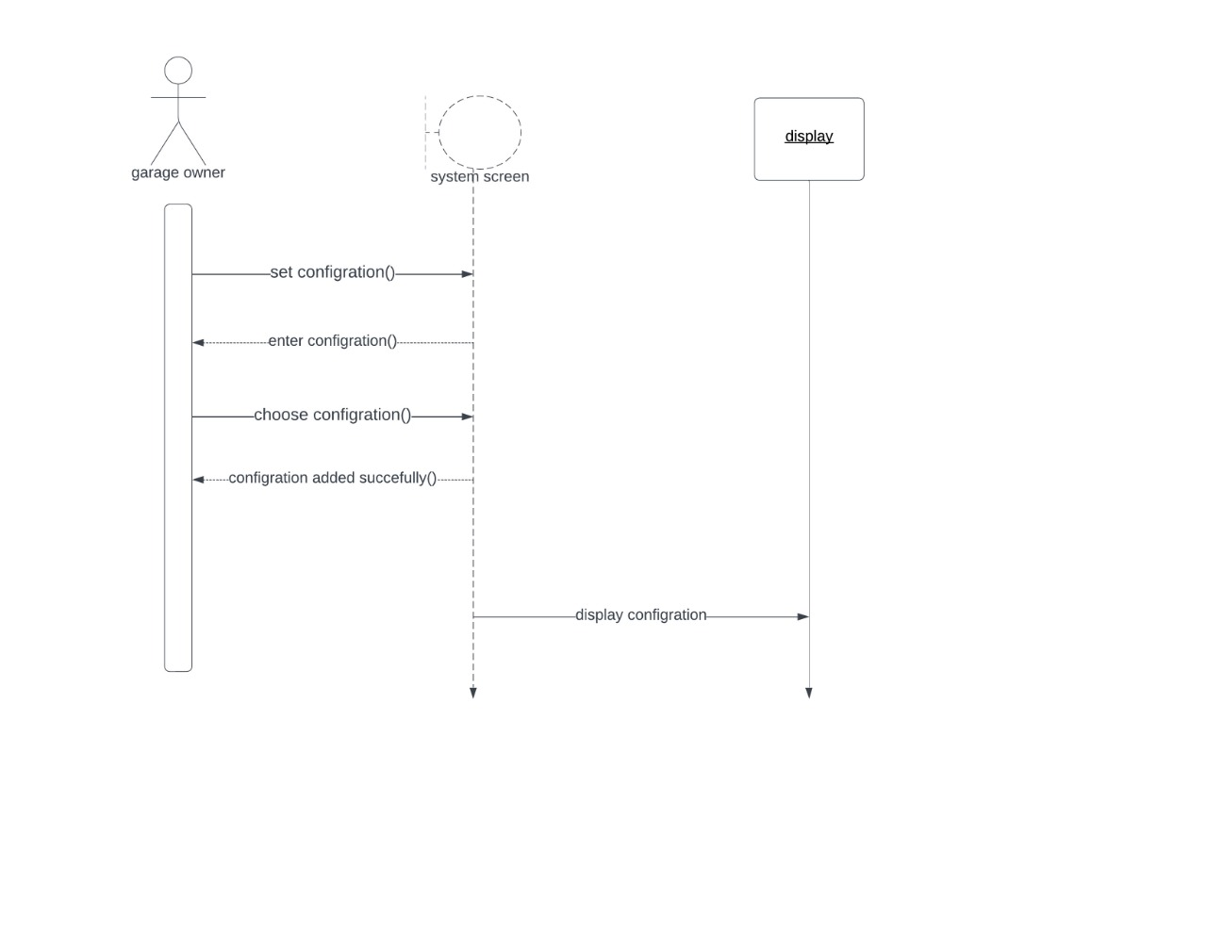

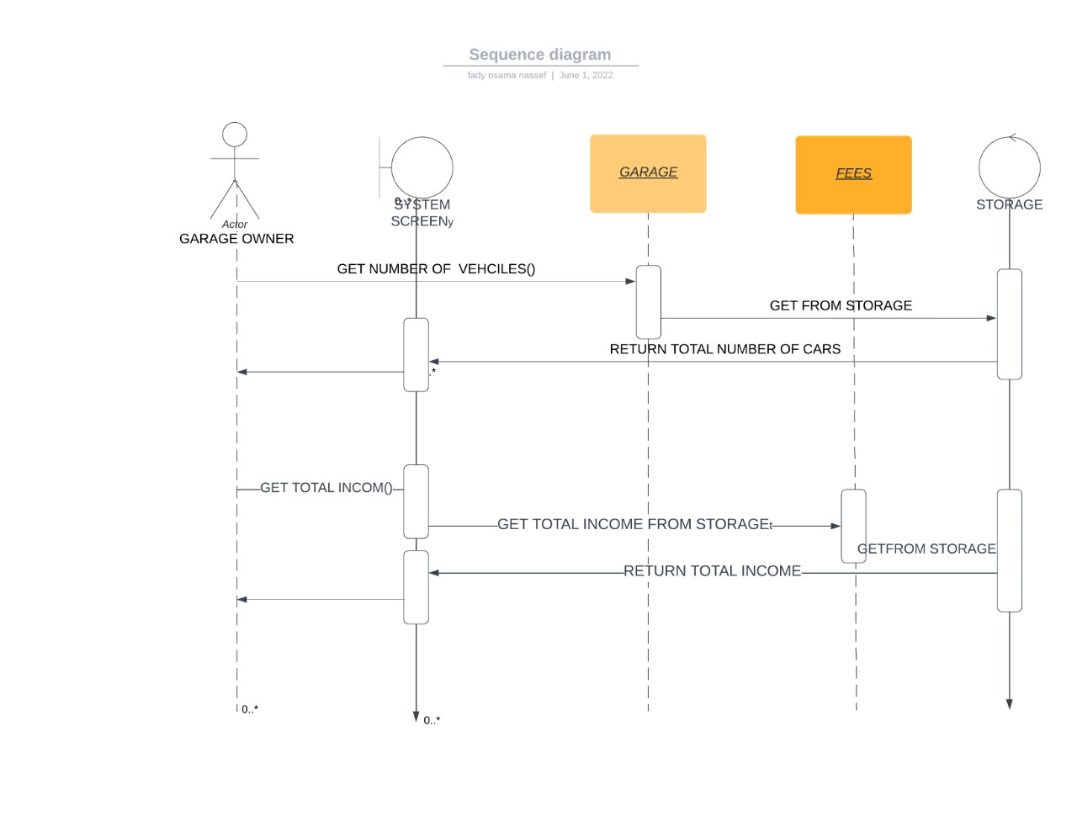

### 

### Class - Sequence Usage Table

| **Class Name** | **Sequence Diagrams** | **Overall used methods** |
| --- | --- | --- |
| E.g. Employee | 1, 3, 5 (means Seq Ids 1, 3, 5 used Employee class) | Save, GetData |
|  |  |  |

# 

# Ownership Report

|  |  |
| --- | --- |
| **Item** | **Owners** |
| Sequence diagram | *Mohamed Youssef , fady osama* |
| Class diagram | *Mohamed tarek* |