1. **Which city/town has the highest property value?**

**For answering this question, I needed to first group the TOTAL VALUE by City to get the summations of property values for each city, and I visualized that as a bar plot as it was the perfect fit for that analysis, and finally I sorted the Cities by the highest total property value and then filtered them to include only the top ten Cities, here’re the top 5 Cities with the highest total property values:**

1. Boston: Average TOTAL VALUE in thousands: 1,160.5 K
2. Charlestown: Average TOTAL VALUE in thousands: 773.9 K
3. South Boston: Average TOTAL VALUE in thousands: 740.4 K
4. Jamaica Plain: Average TOTAL VALUE in thousands: 609.1 K
5. Chestnut Hill: Average TOTAL VALUE in thousands: 568.3 K

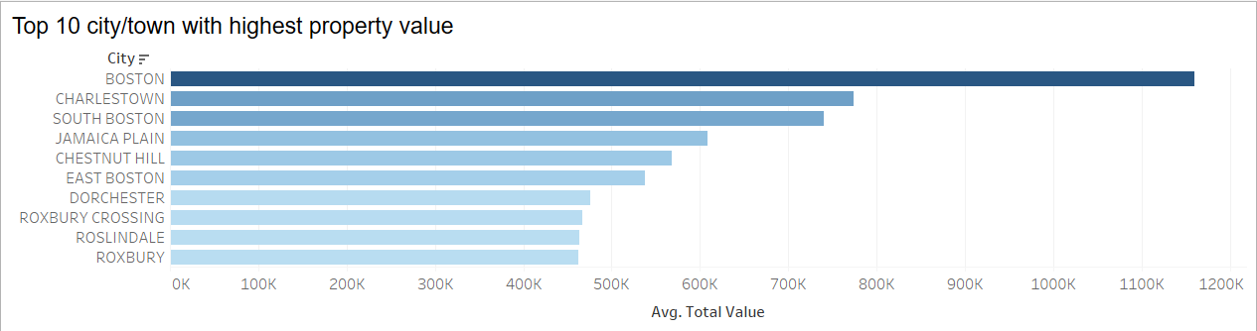

1. **Potential cities to invest in?**

**For this analysis, I calculated a running summation of the average property value per City and year for the past decade, and then I plotted that calculation using a line chart that’s the best in viewing the time change for the average value for each cities’ properties, hear are the top five cities that I suggest we can invest in:**

* 1. Boston: Running Sum of Avg. TOTAL VALIJE in thousands: 21,827 K
  2. South Boston: Running Sum of Avg. TOTAL VALIJE in thousands: 10,817 K
  3. Charlestown: Running Sum of Avg. TOTAL VALIJE in thousands: 9,644 K
  4. Jamaica Plain: Running Sum of Avg. TOTAL VALIJE in thousands: 9,254 K
  5. Brighton: Running Sum of Avg. TOTAL VALIJE in thousands: 7,471K

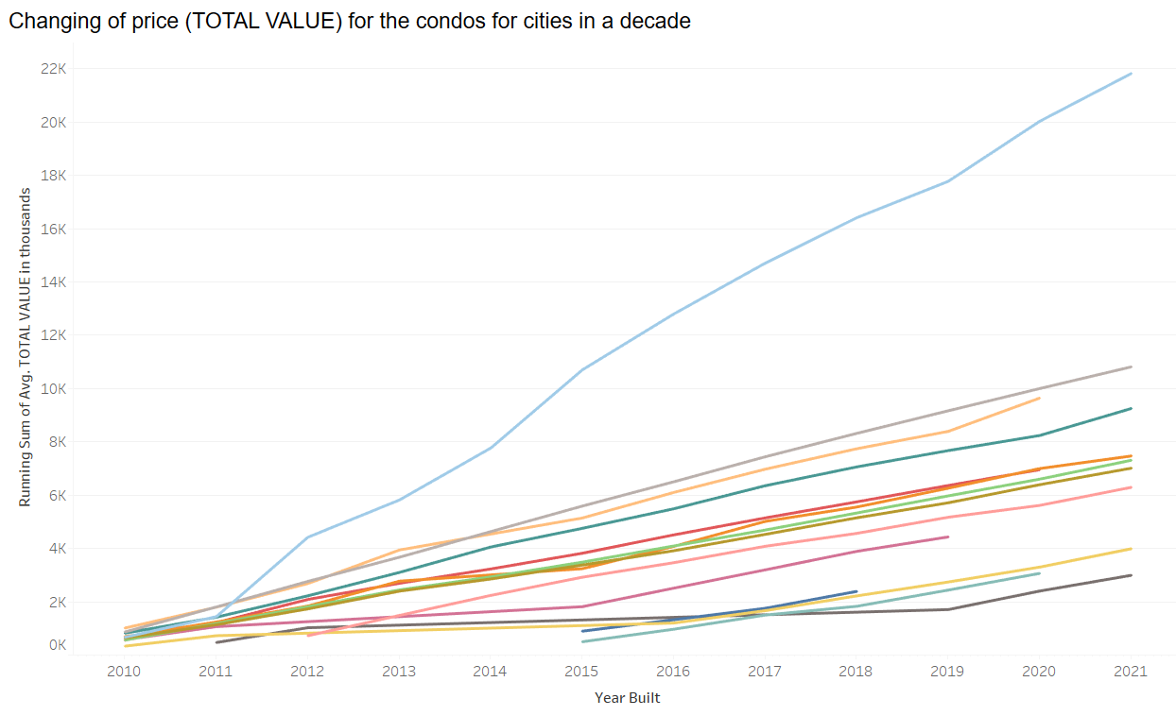

1. **Which year has the most condos built?**

**In this analysis, we needed to show the years with the highest property values, so I grouped the property counts by decades to get the total count of each city and decade, then I decided to plot that a bar plot and not a line chart since this was a top-N question, not a time-change one, so here are the top 5 decades with the highest count of properties built:**

* 1. 1890s: 8,581 properties built
  2. 1900s: 8,573 properties built
  3. 2010s: 7,854 properties built
  4. 2000s: 6,012 properties built
  5. 1920s: 5,571 properties built

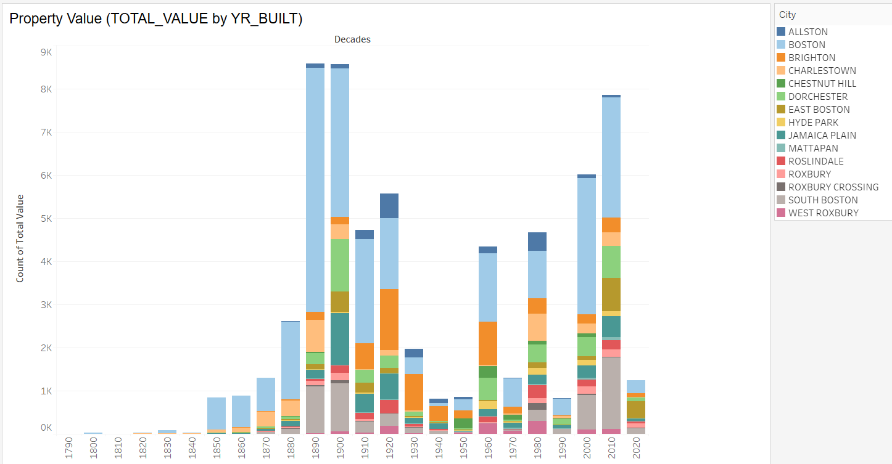

1. **Which factors affect the total property value/ the condo price?**

**This the most complex of all, as in this analysis I needed to plot a one scatter plot but also I needed to give it a parameter of the feature/attribute/column that I needed to show its relationship with the target feature that is the property value, so it wasn’t just a simple 2-feature graph, but I designed it to be in the form of 2-feature graph, but to also have its features dynamic so the view can switch between more than one one-to-one relationship, by that I could design a graph to show the relationship between the property value and these 5 numerical features:**

* 1. Bed Rooms: Not much of a positive correlation 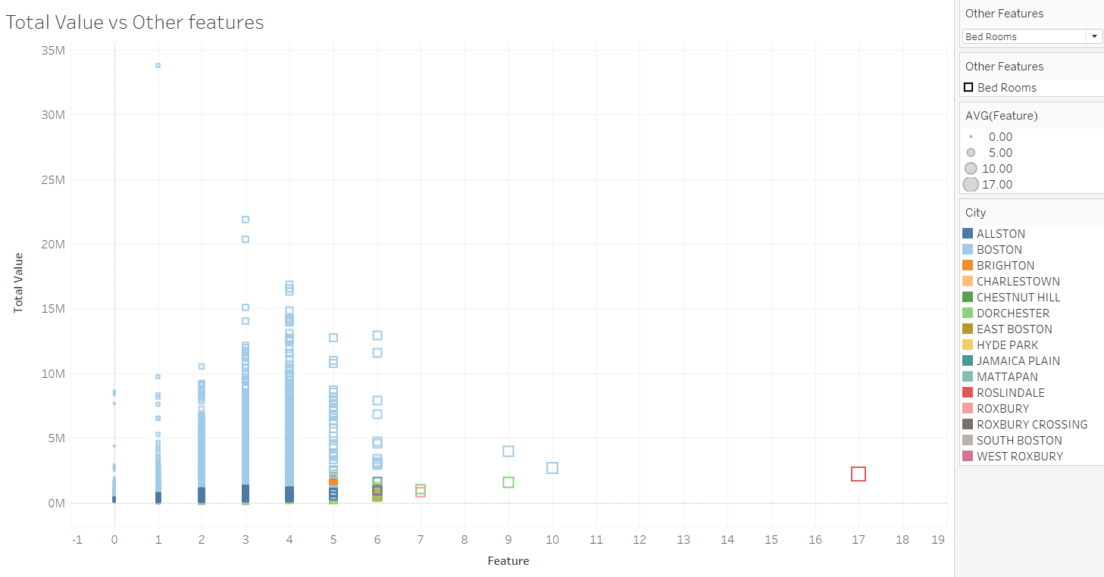
  2. Full Baths: Not much of a positive correlation 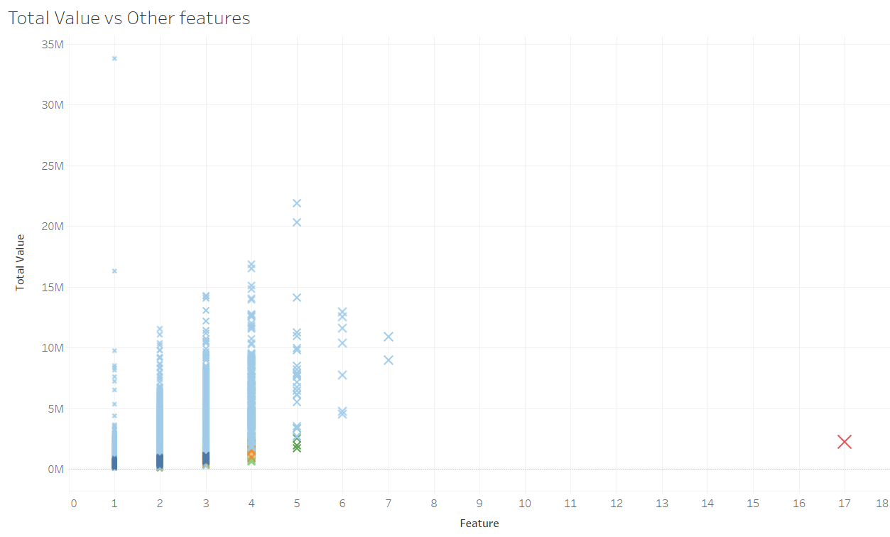
  3. Living Area: Strong positive correlation 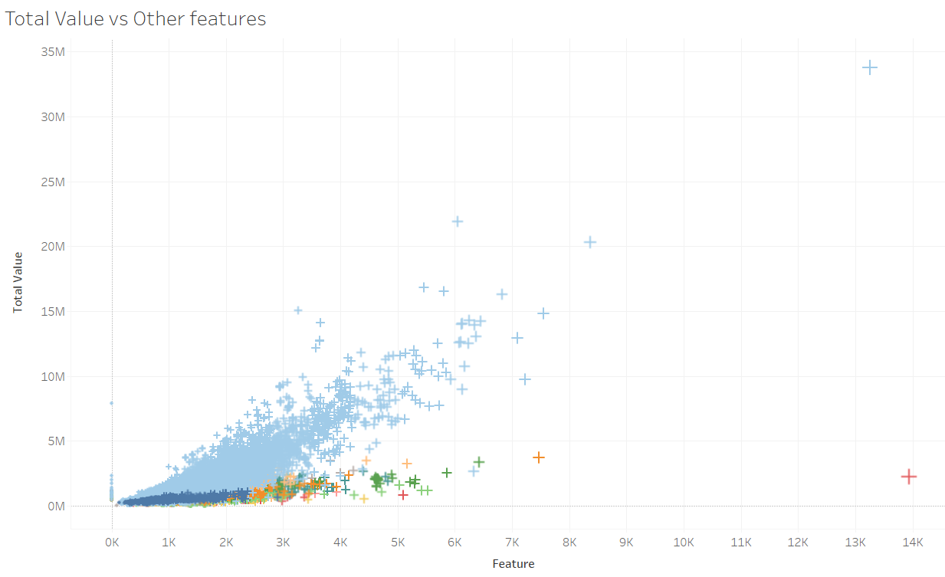
  4. Number Parking: Not much of a positive correlation 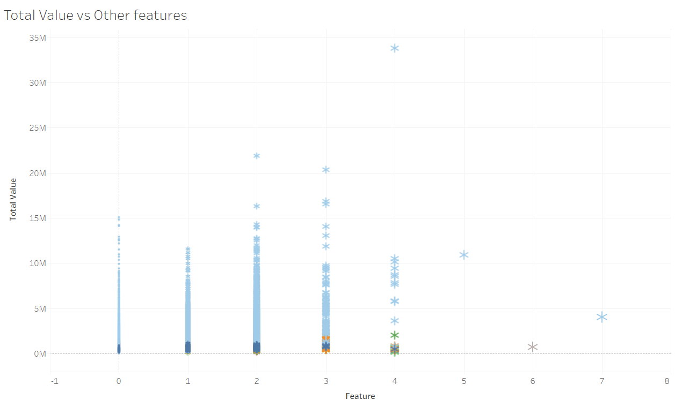
  5. Total Rooms: Slightly strong positive correlation 