

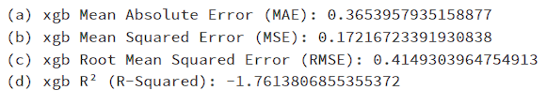

1. That means that the average of the absolute distances between the predictions line and the actual values is 0.365.
2. That means that the average of the squared distances between the predictions line and the actual values is 0.17.
3. That means that the average of the root of the squared distances between the predictions line and the actual values is 0.415.
4. That means that -176% of the variance of the predictions are explained by the variance of the actual values.







That means that 77.1% of the actual data (Incident Levels) was predicted (Classified) correctly.





That means that 45.8% of the actual data (Years) was predicted (Classified) correctly.





That means that 15.9% of the actual data (Months) was predicted (Classified) correctly.





That means that 6.2% of the actual data (Days of month) was predicted (Classified) correctly.



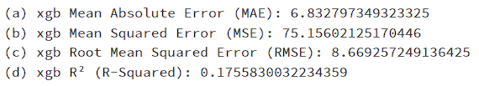

1. That means that the average of the absolute distances between the predictions line and the actual values is 6.8, in other words, if the model predicted that in some specific day there'll be 35 incidents, the actual number of incidents would probably lay between 28-42 incidents (35 +- 6.8 Rounded).
2. That means that the average of the squared distances between the predictions line and the actual values is 75.16.
3. That means that the average of the root of the squared distances between the predictions line and the actual values is 8.7.
4. That means that 17.6% of the variance of the predictions are explained by the variance of the actual values.



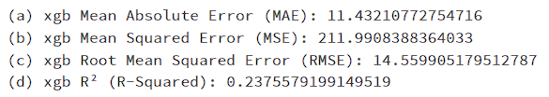

1. That means that the average of the absolute distances between the predictions line and the actual values is 11.4, in other words, if the model predicted that in some specific day there'll be 35 incidents, the actual number of incidents would probably lay between 24-46 incidents (35 +- 11.4 Rounded).
2. That means that the average of the squared distances between the predictions line and the actual values is 212.
3. That means that the average of the root of the squared distances between the predictions line and the actual values is 14.56.
4. That means that 23.76% of the variance of the predictions are explained by the variance of the actual values.