

**University of Palestine**

**Faculty of Information Technology**

**Department of MIS**

BY : Mohamed joseph abukahter

120170639

Assignment 1

Operations research

Dr. Ahmed AbuAbsaa

2020

1. Formulate the model of the problem as you learned in OR course

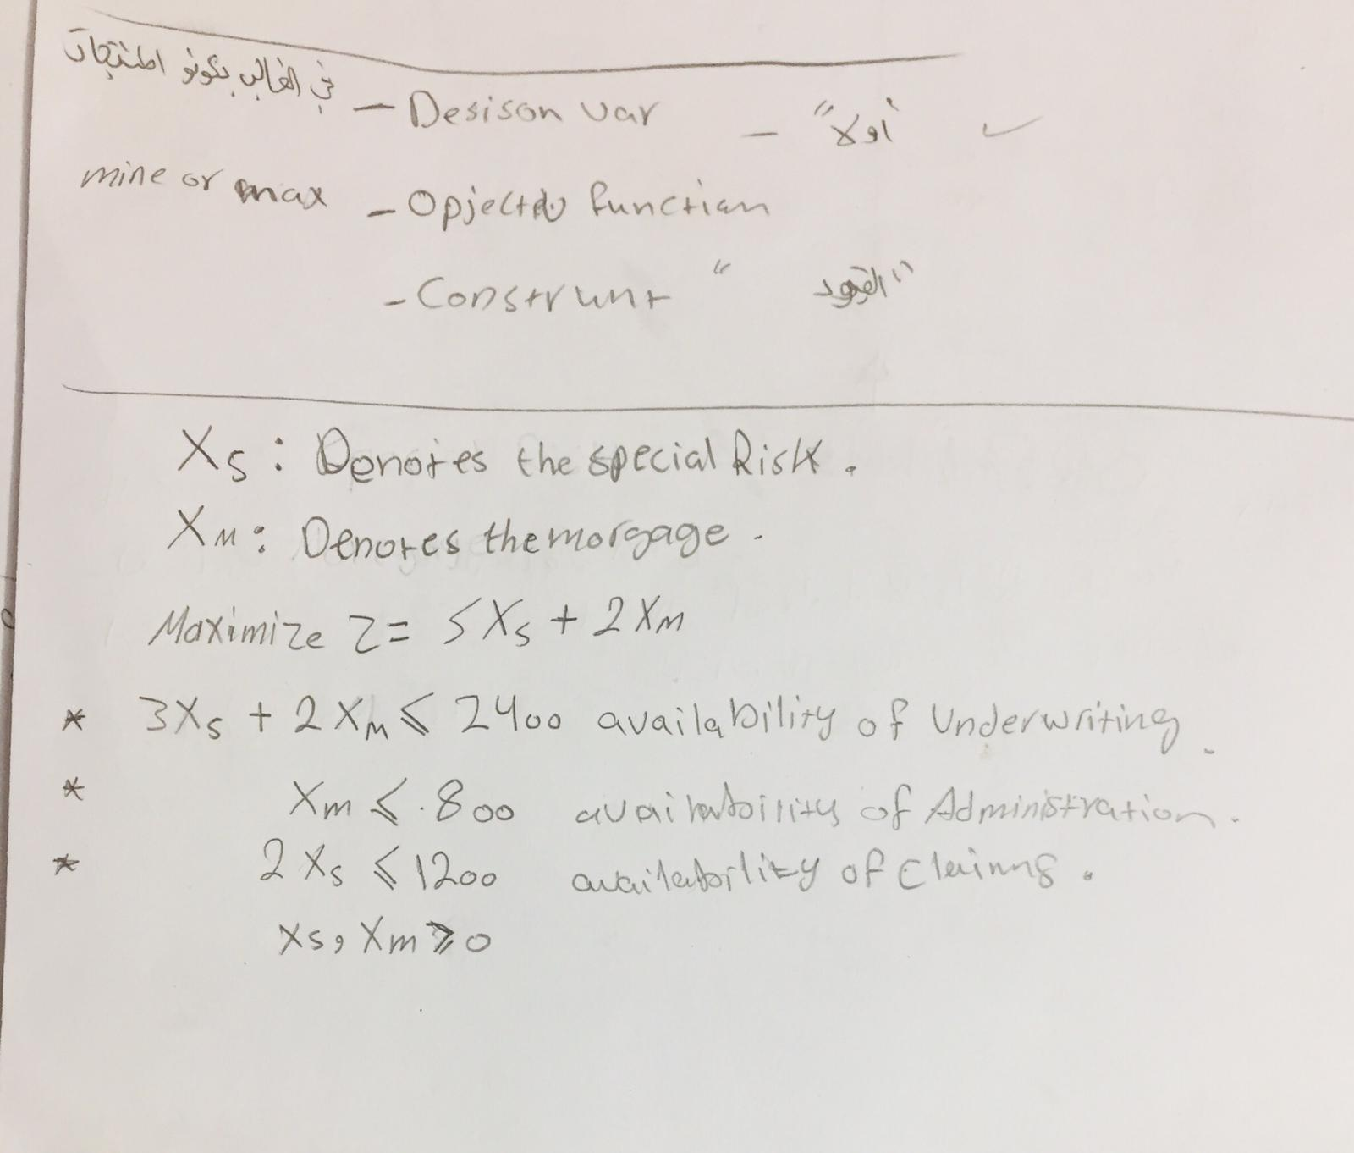

2-Find the optimal solution using Graphical method

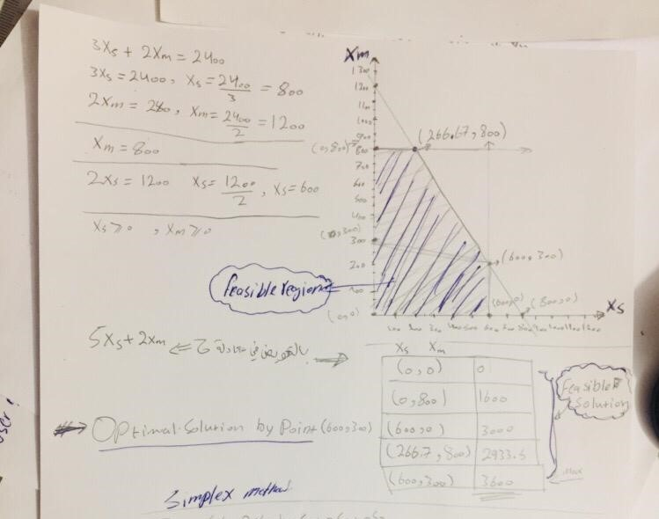

1. Find the optimal solution using Simplex method

