SMART HOME SURVILLANCE

SUMMER PROJECT REPORT
Submitted by
MRUTHULA (2022105531)
in partial fulfillment for the award of the degree of
BACHELOR OF ENGINEERING
in
ELECTRONICS AND COMMUNICATION ENGINEERING
COLLEGE OF ENGINEERING, GUINDY
ANNA UNIVERSITY: CHENNAI 600 025
August – December 2024
ANNA UNIVERSITY: CHENNAI 600 025

BONAFIDE CERTIFICATE

Certified that the summer project report “SMART HOME SURVILLANCE” is the bonafide work of “DARSHANA R (2022105526), MRUTHULA (2022105531), MOHAMED SAHUL HAMEED H (2022105304), KATCHI MYDEEN K (2022105704)” who carried out the project work for EC-5512, 5th semester, Summer Project in the duration August - December 2024 under my supervision. Certified further that to the best of my knowledge the work reported here in does not form part of any other thesis or dissertation on the basis of which a degree or award was conferred on an earlier occasion on this or any other candidate.

SIGNATURE SIGNATURE
Dr.M.A.Bhagyaveni Dr.J.Kamala
HEAD OF THE DEPARTMENT SUPERVISOR
Professor Professor
Department of ECE Department of ECE
College of Engineering Guindy College of Engineering Guindy
Anna University Anna University
Chennai-600025 Chennai-600025

ACKNOWLEDGEMENT

I express my sincere gratitude to the Dean, Dr.K.Easwarakumar, Professor, College of Engineering, Guindy for her support throughout the project.
I express my sincere gratitude to my Head of the Department Dr.M.A.Bhagyaveni, Professor, Department of Electronics & Communication Engineering for her enthusiastic encouragement and support throughout the project.
I present my sincere thanks and gratitude to my project supervisor and co-ordinator, Dr.J.Kamala, Professor, Department of Electronics and Communication Engineering for her whole hearted support, patience, valuable guidance, technical expertise and encouragement in my project.
I thank all the teaching and non-teaching staff of the Department of Electronics and Communication Engineering, for their kind help and co-operation during the course of my project.

ABSTRACT

The Smart Home Surveillance System is an advanced security solution designed to provide real-time monitoring, intelligent motion detection, and efficient video recording. Using a Raspberry Pi, it enables live streaming to devices on the same Wi-Fi network, allowing homeowners to view their property in real-time. The system's motion detection feature activates video recording only when activity is detected, conserving storage and reducing unnecessary footage. When motion is sensed, it sends automated alerts to the user's email for prompt notification. This cost-effective system offers a user-friendly interface for managing live and recorded footage, ensuring reliable and secure monitoring for modern smart homes.

TABLE OF CONTENTS

S.NO. | TITLE | PAGE NO.
1 | INTRODUCTION | 6
2 | HARDWARE SETUP | 7
3 | COMPONENTS
 | - RASPBERRY PI 4 MODEL B | 9
 | - RASPBERRY PI CAMERA MODULE V2 | 13
 | - IR SENSOR | 14
 | 4. BUZZER | 17
4 | CONNECTIONS | 15
5 | CODE | 16
6 | WORKING | 20
7 | CONCLUSION | 21

INTRODUCTION

In recent years, smart home technologies have gained significant popularity due to their ability to enhance security, convenience, and energy efficiency. One of the key components of a smart home is an efficient surveillance system that ensures the safety of the occupants and the property. This project focuses on developing a cost-effective and user-friendly smart home surveillance system using the Raspberry Pi 4. This smart surveillance system offers an efficient solution for home security by combining motion detection, live streaming, and automated video storage, all while utilizing the affordable and versatile Raspberry Pi 4 platform.

HARDWARE SETUP

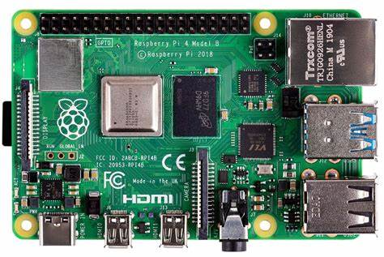
RASPBERRY PI 4 MODEL B

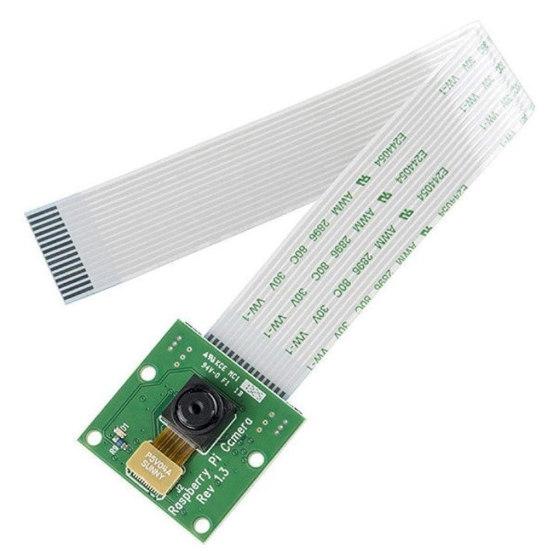
RASPBERRY PI CAMERA MODULE V2

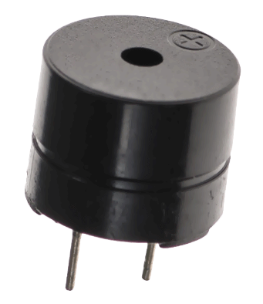

BUZZER
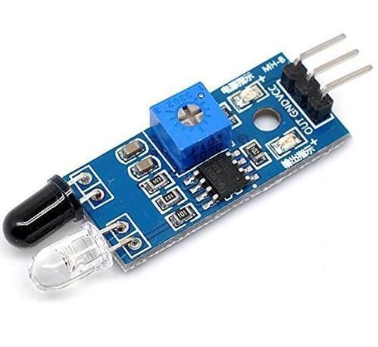
IR SENSOR

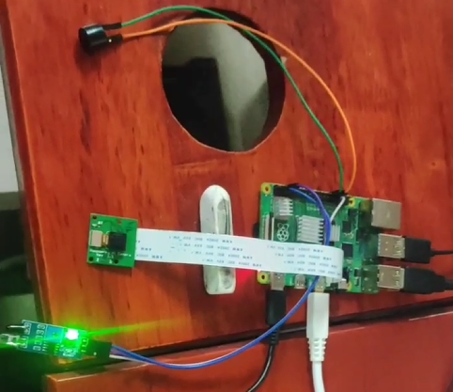

2. COMPONENTS USED
2.1 RASPBERRY PI 4 MODEL B
Raspberry Pi is the name of a series of single-board computers made by the Raspberry Pi Foundation, a UK charity that aims to educate people in computing and create easier access to computing education.
The Raspberry Pi launched in 2012, and there have been several iterations and variations released since then. The original Pi had a single-core 700MHz CPU and just 256MB RAM, and the latest model has a quad-core CPU clocking in at over 1.5GHz, and 4GB RAM. The 3 price point for Raspberry Pi has always been under $100 (usually around $35 USD), most notably the Pi Zero, which costs just $5. All over the world, people use the Raspberry Pi to learn programming skills, build hardware projects, do home automation, implement Kubernetes clusters and Edge computing, and even use them in industrial applications.
The Raspberry Pi is a very cheap computer that runs Linux, but it also provides a set of GPIO (general purpose input/output) pins, allowing you to control electronic components for physical computing and explore the Internet of Things (IoT).

Raspberry pi pin diagram:
Voltages:
From the above diagram, we can see that there are two 5V pins and two 3V3 pins on the board. It also has several ground pins (0V). All these pins are unconfigurable.
Outputs:
A GPIO pin can be designated as an output pin. The pin set as output pin can be set to 3V3(high) or 0V(low).
Inputs :
A GPIO pin can be designated as an input pin. The pin set as input pin can be read as 3V3(high) or 0V(low).
You can use internal pull-up or pull-down resistors. You can see in the above diagram, GPIO2 and GPIO3 pins have fixed pull-up resistors but for the other pins, you can configure it in software.
Alternative Functions:
GPIO pins can be used with a variety of alternative functions. Among them, some are available on all pins and others on specific pins.
PWM: Pulse-width modulation:
Software PWM are available on all the pins whereas Hardware PWM are available on GPIO12, GPIO13, GPIO18, and GPIO19.
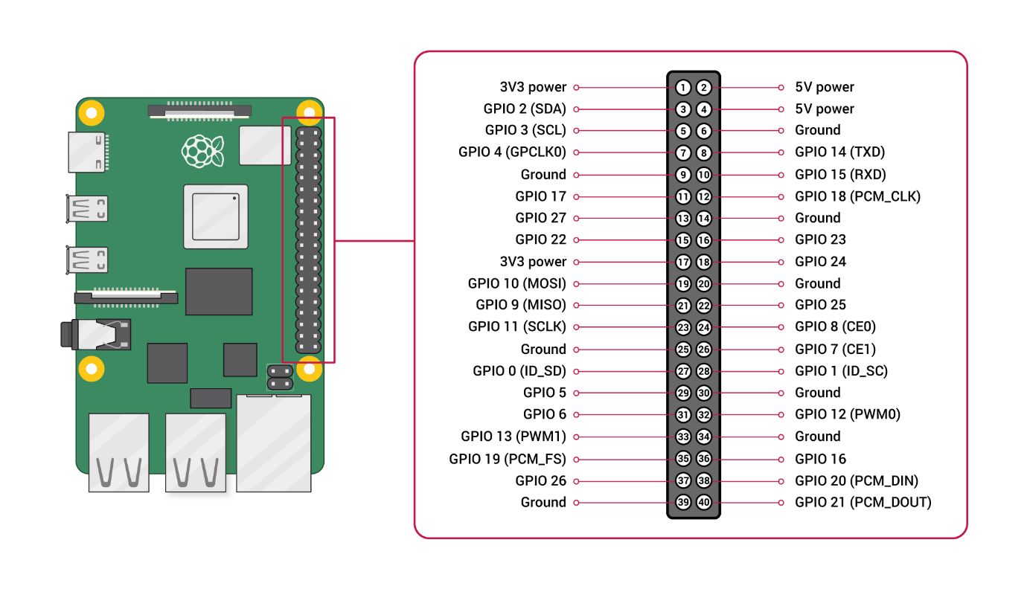
Raspberry pi architecture:
Raspberry Pi mainly consists of the following blocks:
• Processor: Raspberry Pi uses Broadcom BCM2835 system on chip which is an ARM processor and Video core Graphics Processing Unit (GPU). It is the heart of the Raspberry Pi which controls the operations of all the connected devices and handles all the required computations.
• HDMI: High-Definition Multimedia Interface is used for transmitting video or digital audio data to a computer monitor or to digital TV. This HDMI port helps Raspberry Pi to connect its signals to any digital device such as a monitor digital TV or display through an HDMI cable
. • GPIO ports: General Purpose Input Output ports are available on Raspberry Pi which allows the user to interface various I/P devices.
• Audio output: An audio connector is available for connecting audio output devices such as headphones and speakers.
• USB ports: This is a common port available for various peripherals such as a mouse, keyboard, or any other I/P device. With the help of a USB port, the system can be expanded by connecting more peripherals.
• SD card: The SD card slot is available on Raspberry Pi. An SD card with an operating system installed is required for booting the device.
• Ethernet: The ethernet connector allows access to the wired network, it is available only on the model B of Raspberry Pi.
• Power supply: A micro USB power connector is available onto which a 5V power supply can be connected.
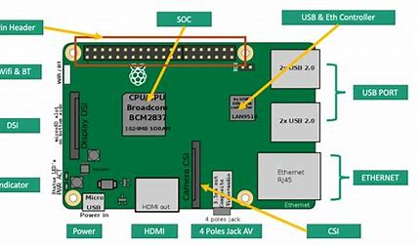
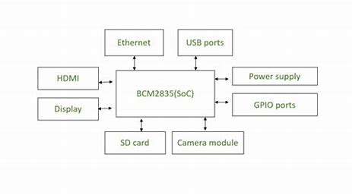

RASPBERRY PI CAMERA MODULE V2:
The Pi Camera Module captures light through its lens, converts it into electrical signals using its image sensor, processes these signals into digital images, and then sends the data to the Raspberry Pi for display or storage.
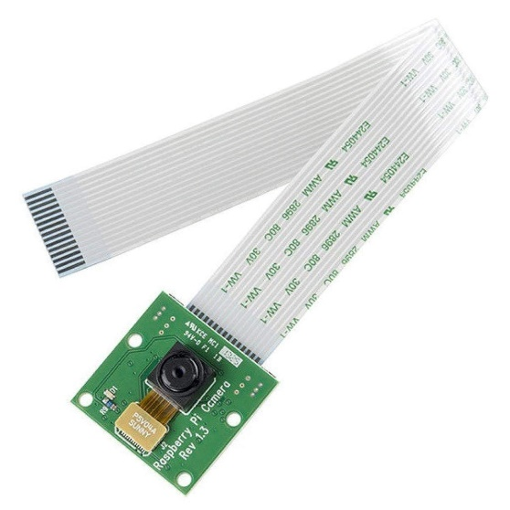
The Pi Camera Module, used with Raspberry Pi computers, operates based on the principles of digital imaging. Here’s a simplified overview of its working principle:
- Image Sensor: The Pi Camera Module contains an image sensor, typically a CMOS (Complementary Metal-Oxide-Semiconductor) sensor. This sensor converts light into electrical signals. The sensor is made up of millions of tiny light-sensitive elements called pixels.
- Light Capture: When you point the camera at a scene, light enters through the lens and hits the image sensor. Each pixel on the sensor captures a portion of the light and converts it into an electrical signal proportional to the light intensity.
- Image Processing: The electrical signals from the image sensor are processed by an onboard chip. This chip converts the raw data from the sensor into a digital image format.
- Data Transfer: The processed image data is then transferred to the Raspberry Pi through a dedicated camera interface (CSI - Camera Serial Interface). This interface is designed for high-speed data transfer between the camera module and the Raspberry Pi’s processor.
- Image Display/Storage: The Raspberry Pi’s software can then display the image on a screen, store it on a storage device, or perform further processing as required.

IR SENSOR :
An infrared (IR) sensor works by emitting infrared light from an LED, which is then reflected off an object back to the sensor. A photodiode or phototransistor detects this reflected light and converts it into an electrical signal. This signal is then processed to determine the presence, distance, or position of the object. The processed information is outputted for further use, such as in proximity detection, distance measurement, or object detection applications.

IR Emitter: The sensor has an IR LED (Light Emitting Diode) that emits infrared light. This light is invisible to the human eye but can be detected by the sensor.
IR Emission: The IR LED produces a beam of infrared light that is directed toward the target area. The IR light usually has wavelengths in the range of 700 nm to 1 mm.
Reflection or Transmission: When the emitted IR light hits an object or surface, it can either be reflected back to the sensor or transmitted through it, depending on the nature of the object.
IR Detector: The sensor has a photodiode or phototransistor that detects the reflected IR light. This component is sensitive to infrared wavelengths and converts the received light into an electrical signal.
Signal Processing: The electrical signal generated by the photodiode or phototransistor is usually weak and needs to be amplified and processed. This is done by an internal signal processing unit, which might include amplifiers, filters, and analog-to-digital converters.
Distance Measurement: In distance-measuring applications, the time it takes for the IR light to travel to the object and back is measured. This is often done using time-of-flight techniques. The distance to the object can be calculated based on the speed of light and the time delay.
Output Signal: After processing, the sensor outputs a signal that can be used to determine the presence, distance, or position of an object. This output can be in the form of an analog voltage, digital signal, or other formats, depending on the sensor design and application.
Applications: IR sensors are used in a variety of applications including proximity detection, object counting, obstacle avoidance in robots, and in various safety and automation systems.
Environmental Factors: The performance of IR sensors can be affected by environmental factors such as ambient light, temperature, and the reflectivity of the target surface. Some IR sensors are designed to compensate for these factors to maintain accuracy.

BUZZER:
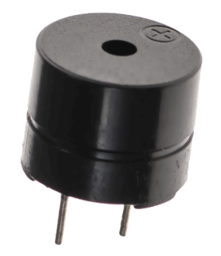
A piezoelectric buzzer works by utilizing the piezoelectric effect, which involves a material that generates an electric charge when subjected to mechanical stress. Inside the buzzer, this material often a piezoelectric crystal or ceramic is connected to an alternating current (AC) power source.
When AC voltage is applied, the material vibrates due to the piezoelectric effect, creating mechanical oscillations. These oscillations are transferred to a diaphragm or resonator attached to the piezoelectric material, which then produces audible sound waves.
The frequency of the sound is determined by the frequency of the applied AC voltage. This principle allows piezoelectric buzzers to be compact and efficient for generating sound in various electronic devices.

CONNECTIONS

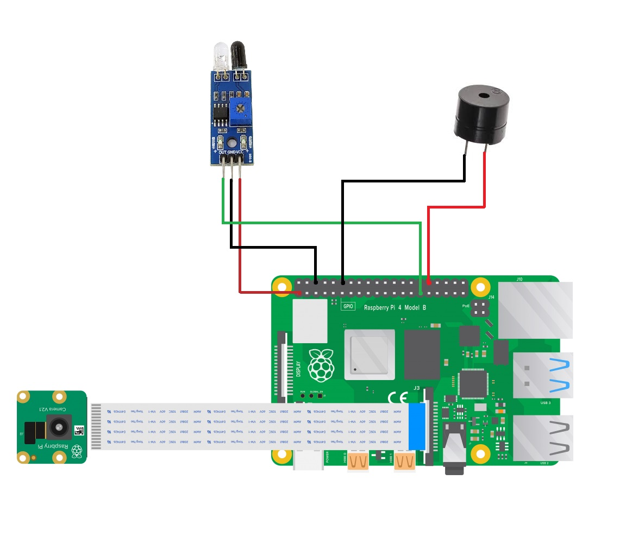
Connection for IR Sensor :
- Red – VCC of IR sensor to 3.3V power of Raspberry pi 4.
- Black – GND of IR sensor to GND of Raspberry pi 4.
- Green – OUT of IR sensor to GPIO5 of Raspberry pi 4.

Connection for Buzzer :
- Red – Positive terminal of Buzzer to GPIO12 of Raspberry Pi 4.
- Black – Negative terminal of Buzzer to GND of Raspberry Pi 4.

Connection for Camera :
- Connect the Raspberry Pi Camera Module V2 into the Camera Port of the Raspberry Pi
CODE FOR INTERFACING WITH RASPBERRY PI 4
The coding for
from gpiozero import Buzzer, Button
import io
import time
import picamera
import smtplib
from flask import Flask, Response
from threading import Thread
from datetime import datetime
from email.mime.multipart import MIMEMultipart
from email.mime.text import MIMEText
from email.mime.base import MIMEBase
from email import encoders

# Initialize Flask application
app = Flask(_name_)

# Initialize IR sensor, buzzer, and camera
ir_sensor = Button(5) # Replace 4 with the correct GPIO pin number
buzzer = Buzzer(12) # Replace 12 with the correct GPIO pin number
camera = picamera.PiCamera()
camera.rotation = 180
camera.resolution = (640, 480)
camera.framerate = 24

# Generator function to continuously generate video frames for livestreaming
def generate_frames():
stream = io.BytesIO()
for _ in camera.capture_continuous(stream, 'jpeg', use_video_port=True):
stream.seek(0)
yield (b'--frame\r\nContent-Type: image/jpeg\r\n\r\n' + stream.read() + b'\r\n')
stream.seek(0)
stream.truncate()

# Route to serve the video feed
@app.route('/video_feed')
def video_feed():
return Response(generate_frames(), mimetype='multipart/x-mixed-replace; boundary=frame')

# Function to send an email with the recorded video
def send_email(subject, body, to_email, filename):
from_email = 'katchimydeen001@gmail.com' # Your email address
from_password = 'decg vwaa yflu bamo' # Your email password
smtp_server = 'smtp.gmail.com' # SMTP server address
smtp_port = 587 # Port for TLS

msg = MIMEMultipart()
msg['From'] = from_email
msg['To'] = to_email
msg['Subject'] = subject

msg.attach(MIMEText(body, 'plain'))

with open(filename, 'rb') as attachment:
part = MIMEBase('application', 'octet-stream')
part.set_payload(attachment.read())
encoders.encode_base64(part)
part.add_header(
'Content-Disposition',
f'attachment; filename={filename}',
)
msg.attach(part)

try:
with smtplib.SMTP(smtp_server, smtp_port) as server:
server.starttls() # Upgrade to a secure TLS connection
server.login(from_email, from_password)
server.send_message(msg)
print(f"Email sent to {to_email} with attachment {filename}")
except Exception as e:
print(f"Failed to send email: {e}")

# Function to handle IR sensor detection
def detect_ir():
while True:
if ir_sensor.is_pressed:
print("IR sensor triggered!")
buzzer.on() # Turn on the buzzer
timestamp = datetime.now().strftime('%Y%m%d_%H%M%S')
filename = f"/home/project/Documents/Motion Detector/Intruder_{timestamp}.h264"
camera.start_recording(filename)
time.sleep(10) # Record video for 10 seconds
camera.stop_recording()
buzzer.off() # Turn off the buzzer
print(f"Video has been recorded: {filename}")

# Send the recorded video via email
email_subject = "IR Sensor Triggered: Video Recording"
email_body = "An IR sensor was triggered. Please find the recorded video attached."
recipient_email = "darshanarajasekar@gmail.com" # Replace with the recipient's email address
send_email(email_subject, email_body, recipient_email, filename)
else:
# Print no IR sensor trigger message
print("No IR sensor trigger detected.")
time.sleep(1) # Check the sensor every second

# Main block to run the Flask server and handle IR sensor detection
if _name_ == '_main_':
# Start the IR sensor detection thread
ir_thread = Thread(target=detect_ir)
ir_thread.start()

# Start the Flask application
app.run(host='0.0.0.0', port=5000, threaded=True)

WORKING
- Raspberry Pi OS is installed on an SD card and inserted it into the Raspberry Pi. This serves as the base operating system for the surveillance system.
- A camera module(Pi cam) is connected to the Raspberry Pi, which is configured for real-time live streaming.
- Users can access the live stream by entering the IP address into a web browser on a device connected to the same network.
- An infrared (IR) sensor is integrated with the Raspberry Pi to detect motion. The system continuously monitors the IR sensor’s input to check whether motion is detected.
- When the IR sensor detects motion, it triggers the system to start recording video.
- Once the motion is detected and the IR sensor is triggered, a connected buzzer sounds, providing an immediate audible alert.
- The video is recorded only during the period of motion, optimizing storage space. The footage is saved locally on the SD card.
- After the recording is completed, the system automatically sends the recorded video to a specified email address.
- This ensures that the user is instantly notified with the footage for security.
CONCLUSION
Smart Home Surveillance System is a productive, and intelligent solution to be developed for modern home security. For this system, real-time live streaming, motion-triggered recording, and immediate alerts have been achieved using a Raspberry Pi, a Pi camera, and an infrared sensor. For instance, owing to smart usage of resources, recording occurs only when there is any motion, thus saving the storage and immediately sending notifications regarding any type of security breach through an email alert along with attached footage. This setup will be reliable and easy to use as a home security solution.

REFERENCES
- https://www.raspberrypi.com/products/raspberry-pi-4-model-b/specifications/
- https://github.com/raspberrypi
- The Official Raspberry Pi Beginners Guide 5th Edition

