|  |  |  |  |
| --- | --- | --- | --- |
|  | Name | Edu mail | B.N |
| 1 |  | Muhammed195867@feng.bu.edu.eg | 775 |

The title

Artificial intelligence

Introduction

#### Let's start with the history of artificial intelligence and put a question which is (can machines think?) then we answer this question and give the date of each year that affected on artificial intelligence then we mentioned the importance and uses of artificial intelligence which used in many fields such as medical sciences, air transport, Banking and Financial Institutions and gaming. Then we mentioned the types of artificial intelligence which are seven types which are reactive machine, limiting memory, Theory of mind, Self aware, artificial narrow intelligence, Artificial General intelligence, artificial super Intelligence.

Then we mentioned the pros and cons of artificial intelligence

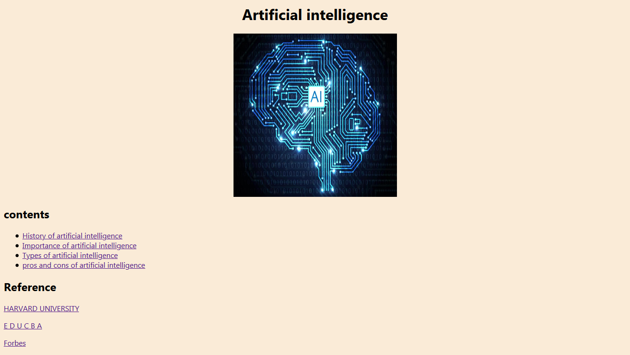Screenshots of web page

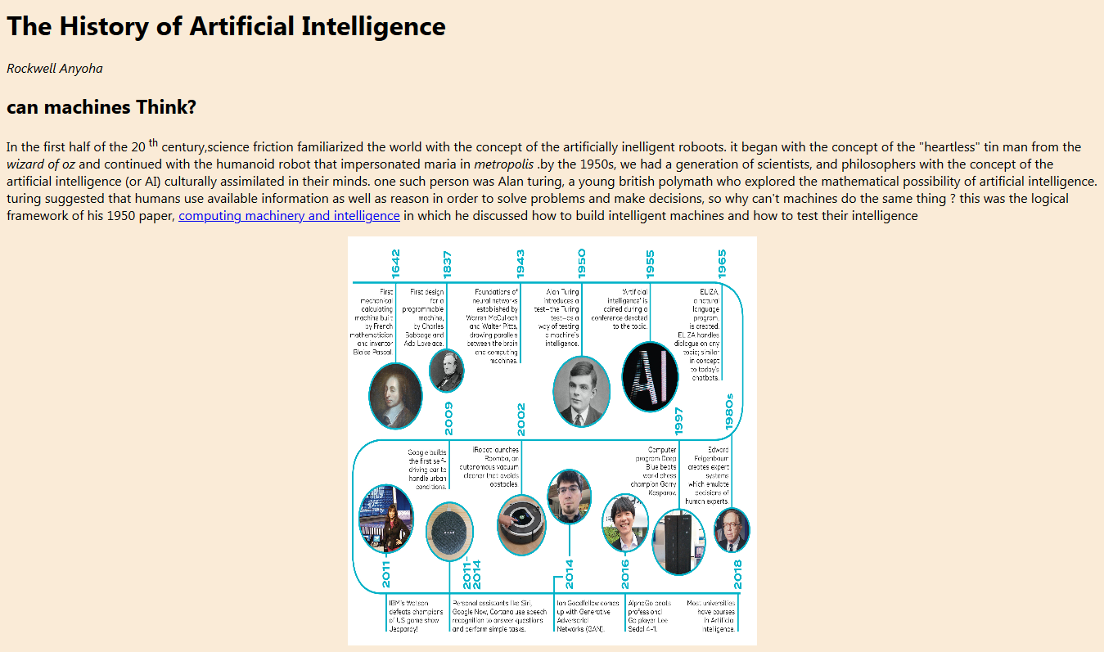

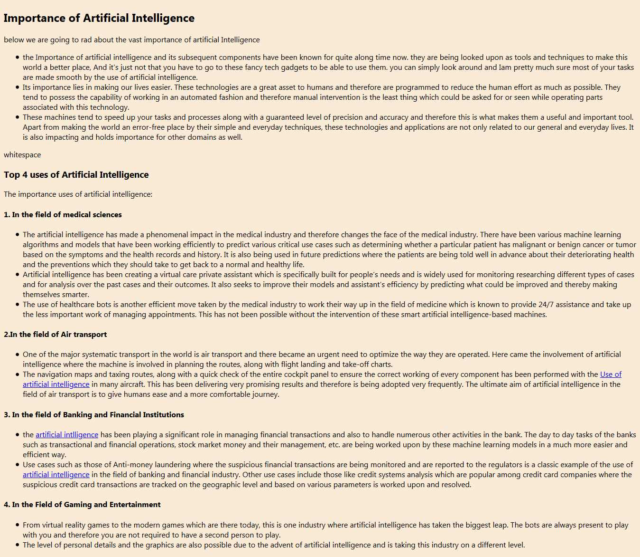

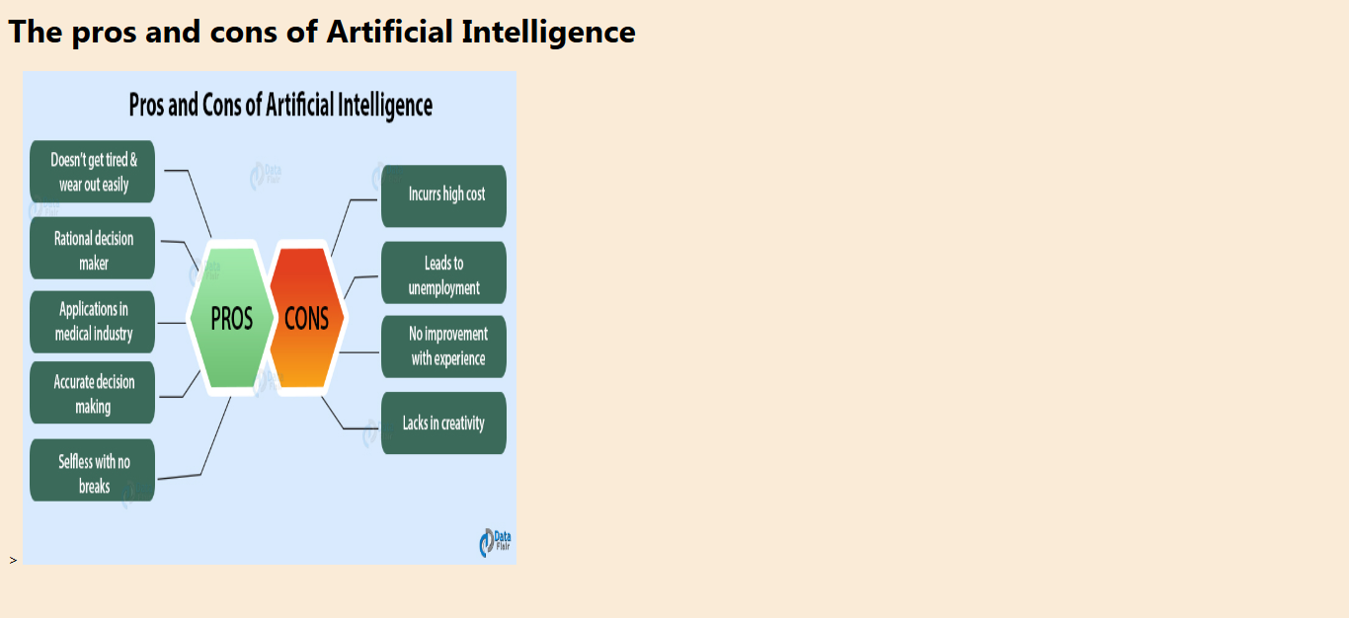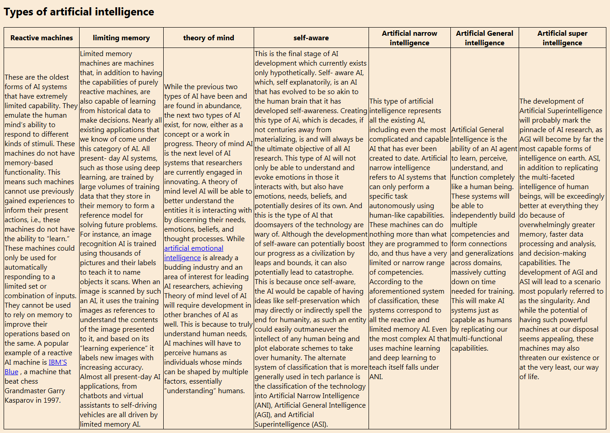

Source codes

