***Exploratory Data Analysis (EDA):***

*In this section, we will explore the dataset to gain a better understanding of its characteristics and relationships. The dataset contains information about customer orders for an E-commerce.*

* **Summary statistics**

This is a summary of the main descriptive statistics of the dataset, including mean, median, standard deviation, minimum and maximum values, and any outliers.

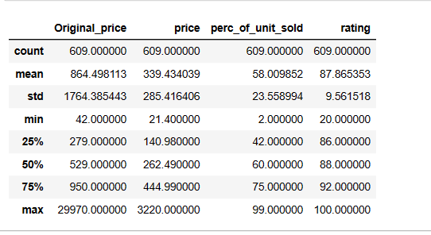

* **Visualizations**

We Created visualizations such as histograms, box plots, scatter plots, heat map, to help illustrate the distributions, relationships, and patterns in the data. Here are some of the data Visualizations.

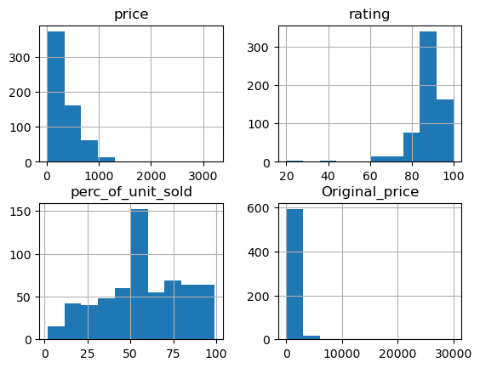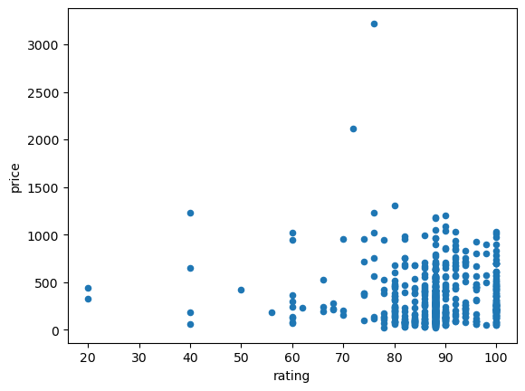

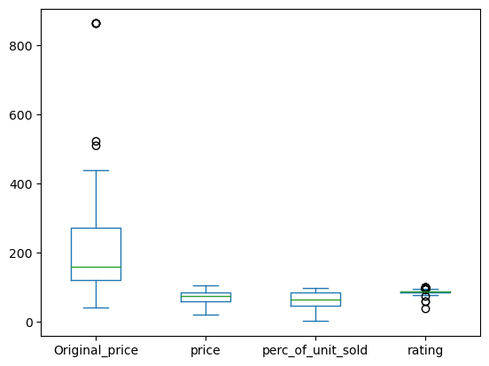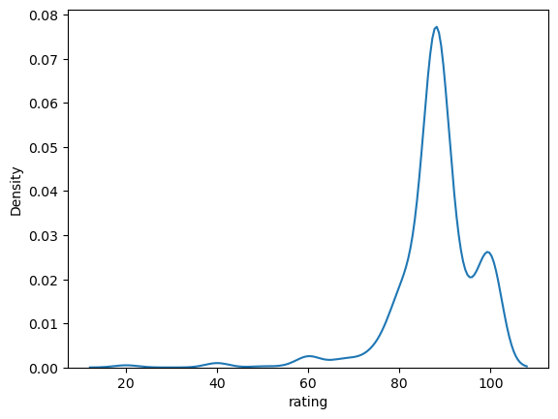

* **correlation**

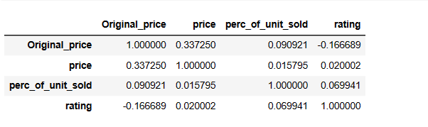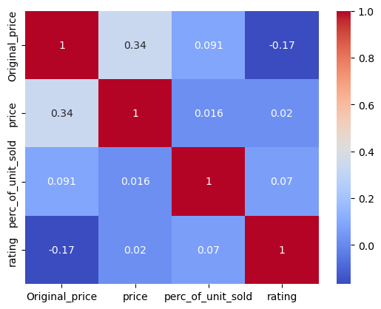The correlation coefficient calculate the intensity in the linear relationship between the variables involved in a correlation analysis, is usually a value without units which is located between 1 and -1, here is The correlation in this dataset.

* **Outliers and missing data:**

Outliers and missing data are common issues that can affect the validity of statistical analysis. First, we need to Identify any outliers and missing data in the dataset then handled them during the data cleaning process. To handle the missing value in the dataset we change the missing values using statistical methods (mean, median).

To handle the outliers, we removed it to clean the data.

